1. 10110
11110
1 10100 → 10101 → 01010

2. If you get repeated acks for an earlier sequence it will retransmit segment s before the timeout.

3. a: 100, b: 120, c: 120
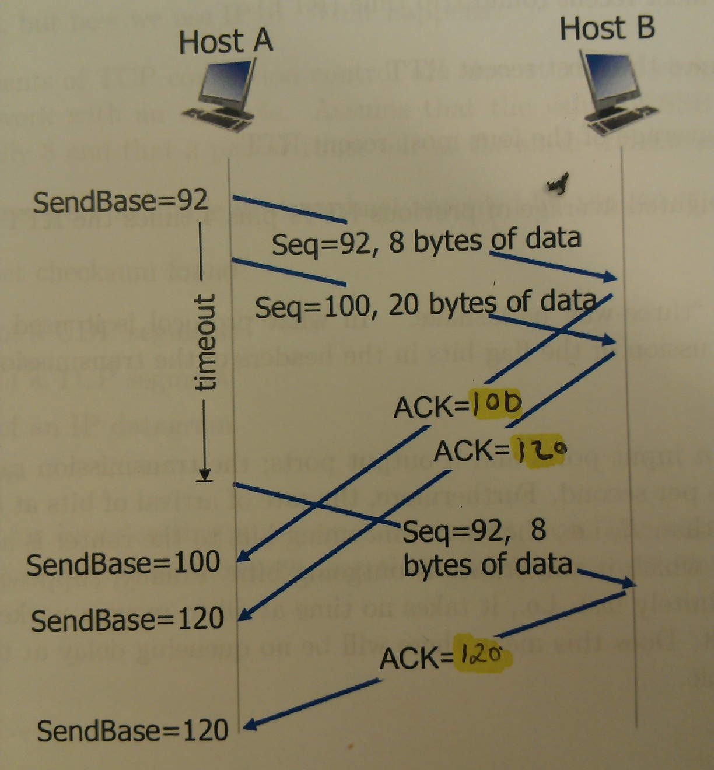

4.
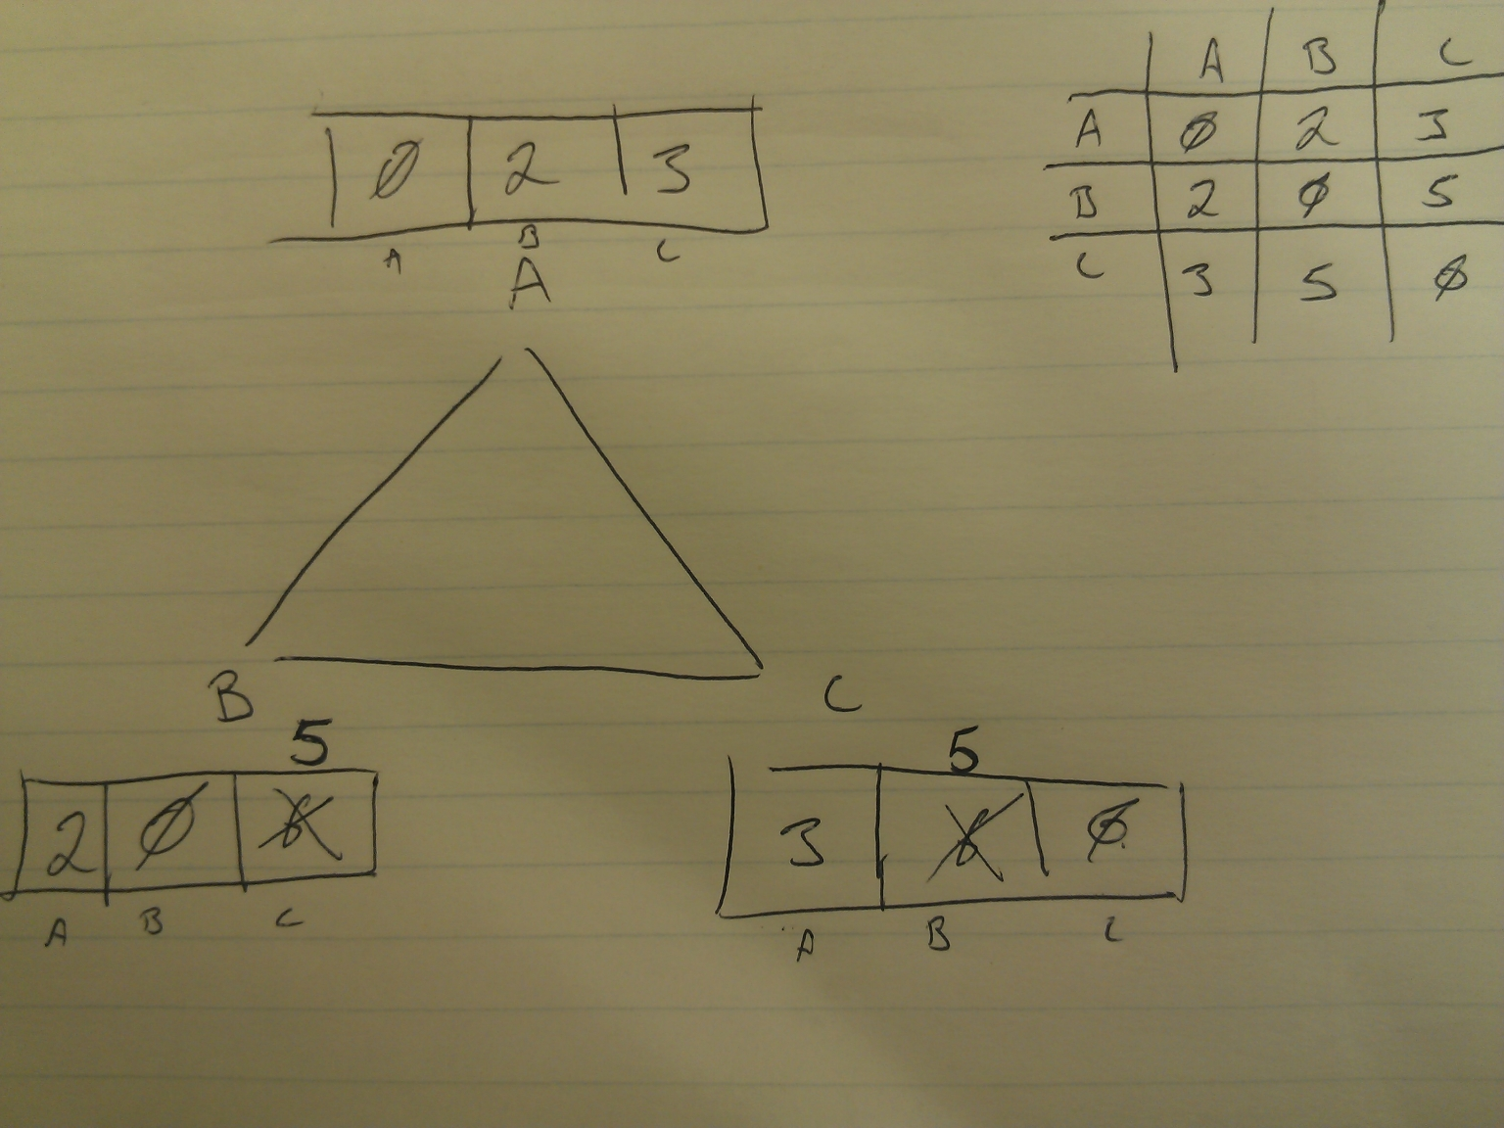

5. NAT is Network Address Translation is used to translate from the private IP addresses found on home, corporate, etc networks to an external network. Some problems associated with NAT are interference with P2P applications, and violation of end-to-end rules.

6. D best describes how timeout values are determined.

7. The three way handshake is a way of initiating a connection and terminating a connection used by the TCP protocol. It works by sending a SYN to the server, the sequence number is random value. A SYN-ACK is sent in response , the ACK is one higher than the SYN sent to the server, and the SEQ chosen is another random number. Finally the client sends an ACK back to the server. The ACK is one more than the last SEQ number, and the SEQ is set to the last ACK value received. The server and client both acknowledged the connection so its active now. The same thing happens when a connection is terminated, but the SEQ is replaces with a FIN.

8. No, there can be a queuing delay. The input port rate is not given, plus, if the transmission rate is equal to the rate of arrival there can be queuing if a burst of packets all arrive at the same port. The rate of arrival is an average so sometimes there can be a queue while other times there is not.

9. Upload pic from camera, come back later.

10. There will be three datagrams sent, each of size 1480, 1480, and 1020 respectively. The receiver knows which datagrams belong together because the ID flag will be set and they can be matched.

11. Slow start works by doubling the number of packets transmitted at each transmission round until the SSH is reached, at this point the number of transmitted packets is only increased by one for each additional transmission round. Once a packet is dropped the number of transmitted packets is decreased by one half and the process continues.

For instance slow start would run and send 1, 2, 4, and 8 packets, once the SSH thresh is reached 9, and 10 packets would be sent. After the sixth group of packets is sent, a timeout could occur in which the number of packets sent would decrease to 5, and each time after the number sent would increase by one until a timeout or dropped packet would occur.

12. There are 4094 usable IP addresses.

13. D, all of the above are correct.

14. A method of broadcast routing other than uncontrolled flooding could be sending the update point to point, to each receiver instead of having every receiver send it on every port.

