1. Transmission Delay = L/R
Propagation Delay = d/s

Link 1 trans delay = 4x10**3 b / 1x10**8 b/s = 4x10**-5 seconds = .04 milliseconds
Link 1 prop delay = 2x10**3 m / 3*10**8 m/s = 6.6x10**-6 seconds = .006 milliseconds
Link 2 trans delay = 4x10**3 b / 1x10**9 b/s = 4x10**-6 seconds = .004 milliseconds
Link 2 prop delay = 5x10**5 m / 3*10**8 m/s = 1.6x10**-3 seconds = 1.6 milliseconds
Link 3 trans delay = 4x10**3 b / 1x10**8 b/s = 4x10**-5 seconds = .04 milliseconds
Link 3 prop delay = 3x10**3 m / 3*10**8 m/s = 1x10**-5 seconds = .01 milliseconds
end-to-end delay = 1.7 ms.

2. 56 bytes * 8 = 448 bits
448 bits / 64 bits/sec = 7 ms
448 bits / (2x10**3) = .224 ms
Propagation delay = 10 ms

Total time = 17.224 ms

3. (NL+ (L- x))/R
= (4 packet*1500 bytes + (1500 bytes-750 bytes))*8 / 2097152 bits/sec
= (6000 bytes + 750 bytes)*8 / 2097152 bits/sec
= 6750*8 bytes / 2097152 bits/sec
= 54000 bits / 2097152 bits/sec
= 2.57x10**-3 seconds
= 2.57 milliseconds

- R = M(Rs+Rc)/R

- a) arrTime = L/Rs
b) Because the packets are sent back to back the second packet could potentially arrive at the input queue of the second link before the second link is done sending the first packet. Because the bottleneck is on the second link it can cause the transmission of the first packet to be delayed enough that it is still in progress as the second packet arrives. To prevent queuing T must be determined by the following inequality:
L/Rs + T >= L/Rc

6. It would be significantly faster to send the data via mail, in fact even media mail would be faster than transferring across that link, keeping in mind that is the slowest physical delivery method...
I came to this conclusion because:
40TB * 1000 = 40,000GB
40000GB * 1000 = 40,000,000MB
100Mbps/8 = 12.5MBps
((40,000,000/12.5)MBps)/86,400 seconds per day ~~ 37 days transferred
vs. 5-7 business days mailed

7.
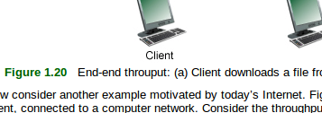
The word throughput is spelled wrong.

<---------------------------

8.

Expected Result: 3.446000 msecs.

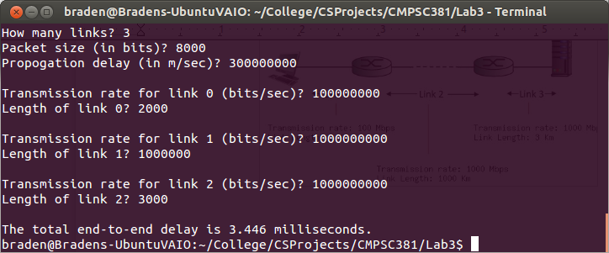

8. (Continued)

Expected Result: 6.476667 msecs.

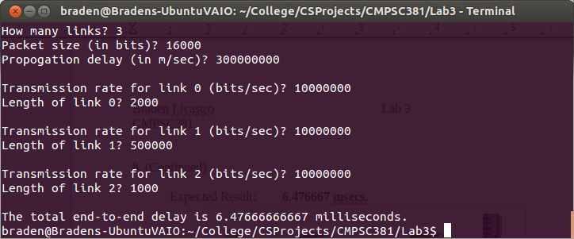

8. (Continued) Problem of my own:

Expected: 19578 milliseconds

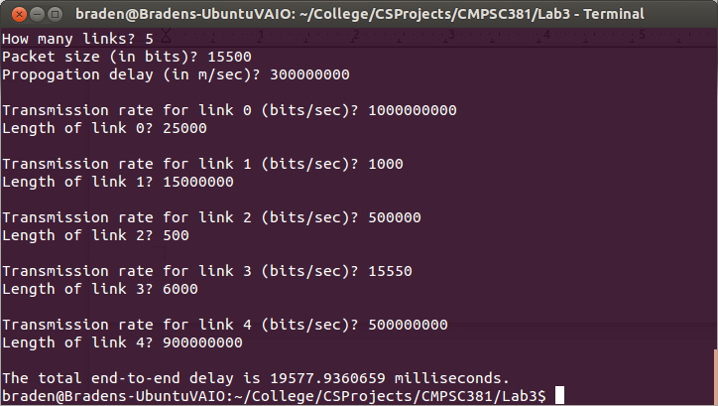

9. As whole class mid day:
Instantaneous throughput: 2.16 MB/s max
726 kB/s min
Average throughput: 1.71 MB/s

In dorm 2:30 am Saturday night:
Instantaneous throughput: 2.53 MB/s max
284 kB/s min
Average throughput: 1.74 MB/s

Overall the averages didn't show a significant difference in speed during different network loads and times of day. The mins and maxes could be different based on current loads, but seeing that the min was lower at the same time that the high was higher I can't use that as conclusive data to determine the impact of time of day.

