2.
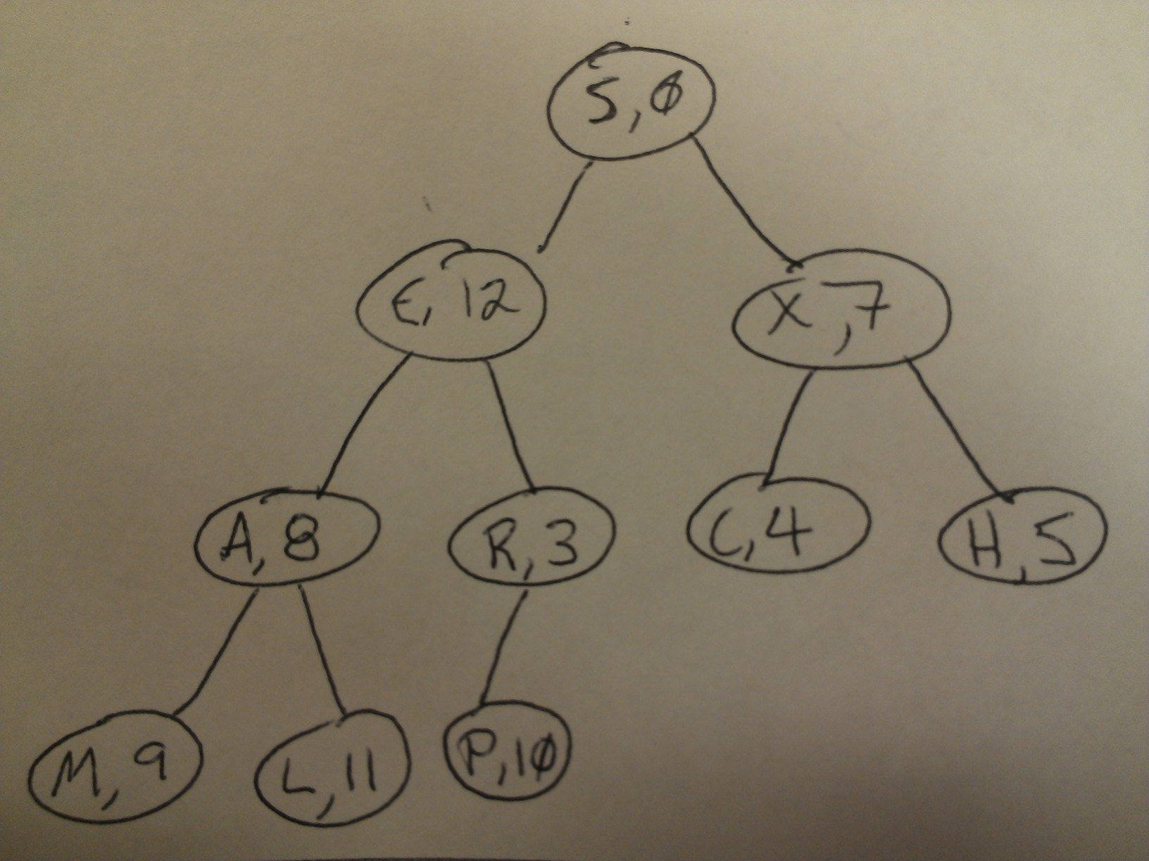

Indented text tree;

H 5
X 7
C 4
S 0
R 3
P 10
E 12
L 11
A 8
M 9

5. If the tree holds true to a random-key distribution it should take approximately log*n time to determine the depth of a key in the tree.

6. In the worst case scenario the depth will take time proportional to n to determine the depth of the key in the tree.

