Question 1 Tests:

Directed Graph with 3 vertices:
3 4
0: 2 1
1: 2
2: 1

Directed Graph with 4 vertices:
4 6
0: 3 1
1: 3
2: 3 1
3: 1

Directed Graph with 5 vertices:
5 8
0: 4 1
1: 4
2: 4 1
3: 4 1
4: 1

Directed Graph with 6 vertices:
6 10
0: 5 1
1: 5
2: 5 1
3: 5 1
4: 5 1
5: 1

Question 2 Results

Graph 1: eulerian
Graph 2: not eulerian
Graph 3: eulerian
Graph 4: not eulerian

Question 3 Extra Credit:

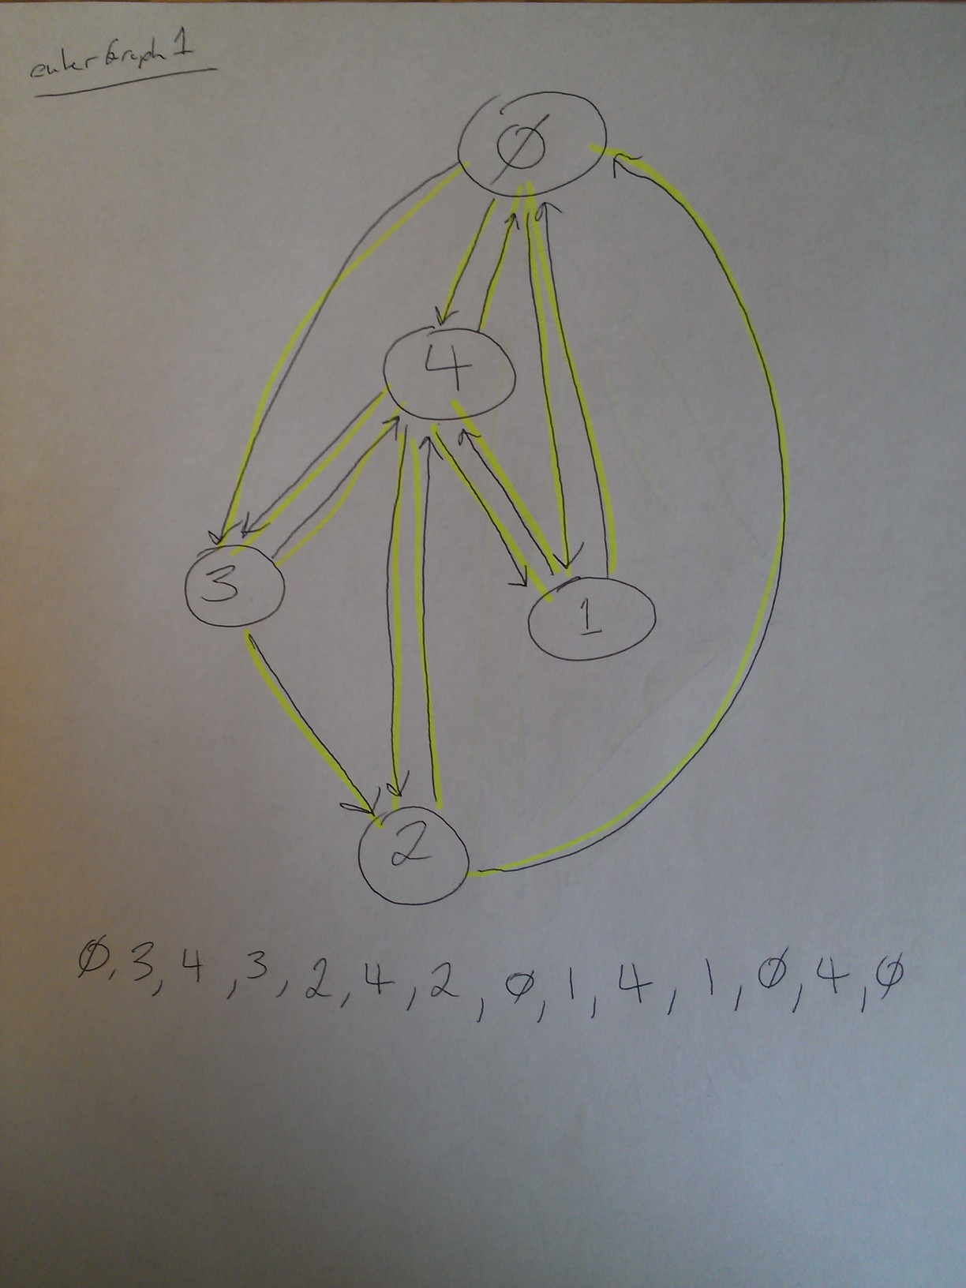

Question 3 Extra credit (Continued)

