# Braden Licastro
# CMPSC 210
# Fall Semester - 2011
# Lab 7
# Exercise 3
# MIPS String Reverser

.data
.align 1

inString: .word 0 # Make space for the sentence to be reversed (input string).
in1: .asciiz "How many characters are in the sentence?: "
# Declare in1 to be sentence length
in2: .asciiz "Input a sentence to be reversed: "
# Declare in2 to be the sentence
out1: .asciiz "\nInput: "
# Declare out1 to be input -output
out2: .asciiz "\nOutput: "
# Declare out2 to be output -output

.text
.globl main
main: add $t0, $zero, $zero # Set $t0 to zero

li $v0, 4 # System call for printing strings
la $a0, in1 # Load address for printing
syscall # Print out the string
li $v0, 5 # System call for input
syscall # Read in the integer
addi $s0, $v0, -1 # Set the end of the string to be changed

li $v0, 4 # System call for printing strings
la $a0, in2 # Load the address for printing
syscall # Print out the string

input:
li $v0, 12 # System call for reading in characters
syscall # Read the sentence characters in
add $t1, $v0, $zero # Move the input character into a temporary register
sb $t1, inString($t0) # Store the character in the string

addi $t0, $t0, 1 # Increment the input counter: $t0++
slt $t1, $s0, $t0 # Is $s0 less than the length of the sentence yet?
beq $t1, $zero, input # Continue to loop until the whole sentence has been input

sb $zero, inString($t0) # Put a zero in the end of the string as a termination, keeps extra prints away

li $v0, 4 # System call for printing strings
la $a0, out1 # Load the address for printing
syscall # Print out the string

li $v0, 4 # System call for printing strings
la $a0, inString # Load the address for printing the sentence
syscall # Print out the string

add $a1, $zero, $s0 # Give the
jal reverse # Reverse the stored sring

li $v0, 4 # System call for printing strings
la $a0, out2 # Load the address for printing the string
syscall # Print out the string

li $v0, 4 # System call for printing strings
la $a0, inString # Load the address for printing the string
syscall # Print out the string

li $v0, 10 # System call for a soft exit
syscall # Exit the program

reverse:
add $t0, $a0, $zero # Move the address of the string to $t1
add $t1, $zero, $zero # Start the first register at the first character
add $t2, $s0, $zero # Start the second register at the last character

pointerloop:
add $t3, $t0, $t1 # Add the starting address to the location of our left hand letter
lb $t4, 0($t3) # Load the byte located at the registers address into yet another temp
add $t5, $t0, $t2 # Add the starting address to the location of our right hand letter
lb $t6, 0($t5) # Load the byte located at the registers address into yet anotherrrrr temp

sb $t4, 0($t5) # Move the byte from the second register to the first register
sb $t6, 0($t3) # Move the byte from the first register to the second register

addi $t1, $t1, 1 # Increment the first register by one to get to the next character
addi $t2, $t2, -1 # Decrement the second register by one to get to the next character.
slt $t6, $t2, $t1 # If the first and second registers are the same set $t6 to 1 otherwise 0
beq $t6, $zero, pointerloop # The string hasn't been completely reversed? Re-loop the pointers!

jr $ra # Jump out of the loop and back into the program

I/O I:
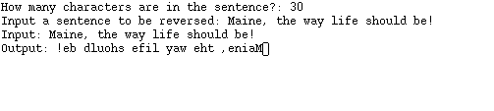
I/O II:
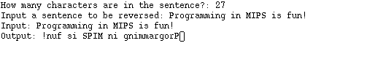
I/O III:
A palindrome, just for fun. Enjoy!

