1. Source: 141.195.226.61 Port: 80

2. Destination: 128.119.245.12 Port: 80
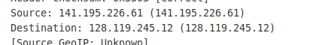

3. Skip

4. The sequence number is 0. It is identified as a syn segment because the syn flag is set.
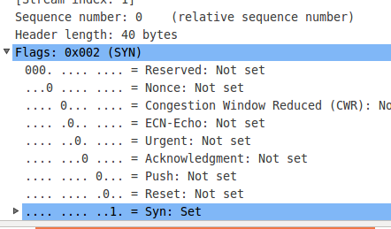

5. The sequence number is 0. The acknowledgement field has a value of 1, and it was determined it based off of previous acknowledgement numbers. It is a synack segment because the syn flag is set and the ack flag is set.
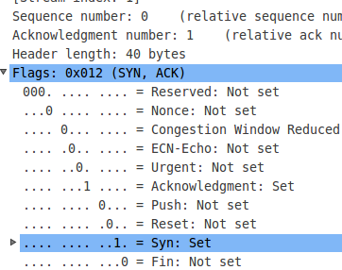

6. The sequence number is 1.

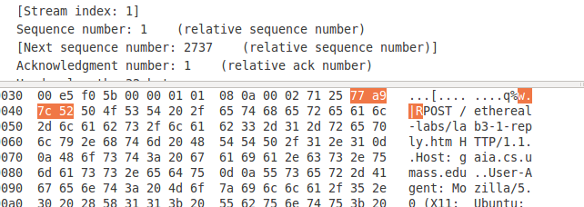
7. The sequence number of the first 6 segments (and post) are:
1 Sent: 2007596114 RTT: N/A ERTT: N/A
2737 Sent: 2007596114 RTT: 0 ms ERTT: 0.125 ms
5473 Sent: 2007596144 RTT: 1 ms ERTT: 1.125 ms
8209 Sent: 2007596145 RTT: 0 ms ERTT: 1.016 ms
10945 Sent: 2007596145 RTT: 0 ms ERTT: 1.016 ms
13681 Sent: 2007596145 RTT: 0 ms ERTT: 1.017 ms
17785 Sent: 2007596145 RTT: 0 ms ERTT: 1.017 ms
(Only included last packets seq image to cut down on large numbers of the same screen shot.)
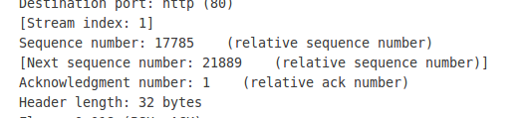
8. The length of each of the first six TCP segments is:
2770 bytes
2770 bytes
2770 bytes
2770 bytes
2770 bytes
4138 bytes

9. The minimum buffer space is advertised as 229, and this value never changed throughout the entire file transfer.

10. Almost every segment was resent at least once, I looked for the same data being transmitted over.

11. I was seeing the ack appearing for almost every single packet, sometimes with overlap of already sent segments.

12. I was unable to calculate this as many of the segments appeared to be sent at the same exact time, and many were never acknowledged and resent several times.

13. Slowstart began at time 0, ended at time .1. Congestion avoidance isn't apparent. The data differs from the perfect scenario because of many real world transmitting problems such as dropped packets, timeouts, etc. This is visible in the file.

14. Slow start isn't clearly shown as there were dropped packets immediately after starting. Congestion avoidance first became apparent at .09 seconds, and was clearly shown continually afterwords.

