1A.
Destination: | Next Router: | Number of Hops:
H1 | -- | 0
H2 | A | 2
H3 | A | 4

1B.
No, you should not do this because the data will be traveling along the same path so it is unnecessary and redundant.

2.
It would take three time slots. The first run would transfer x and y from the first two ports, next run would transfer x and y from the second and third ports, and the last time slot would transfer z from the third port.

3.
This would take 4 time slots. The first run would transfer x and y from the first and second port. Second run would transfer x from the second. Third run would transfer x from the third, and fourth run would transfer z from the third port.

4.
a.
Prefix Match | Link Interface
11100000 | 0
11100001 00000000 | 1
11100001 | 2
otherwise | 3

b.
IP Number | Interface:
11001000 10010001 01010001 01010101 | 3
11100001 00000000 11000011 00111100 | 1
11100001 10000000 00010001 01110111 | 2

5. a. One IP that can be assigned in this network would be 128.119.40.130
b. The networks would have the following prefixes:
128.119.40.64/28
128.119.40.80/28
128.119.40.96/28 , and
128.119.40.112/28

6.
The MP3 is 5 million bytes
Each datagram can carry 1500 bytes – 20 bytes for header = 1480 bytes of data

The number of datagrams needed will be
(5x10^6 byte MP3)/1480 byte datagram = 3378.37837838 datagrams needed, so round 3379 datagrams needed

7.
a. answer in 6_router.out
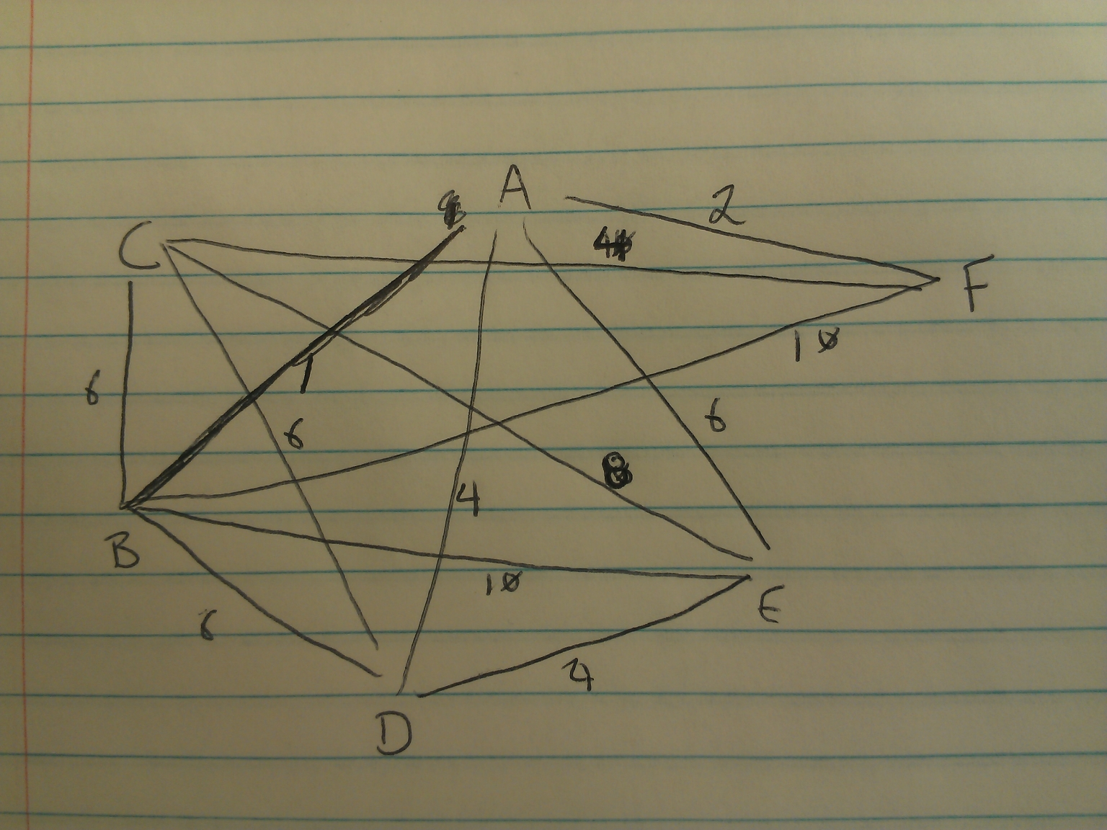

b. answer in 8_router.out
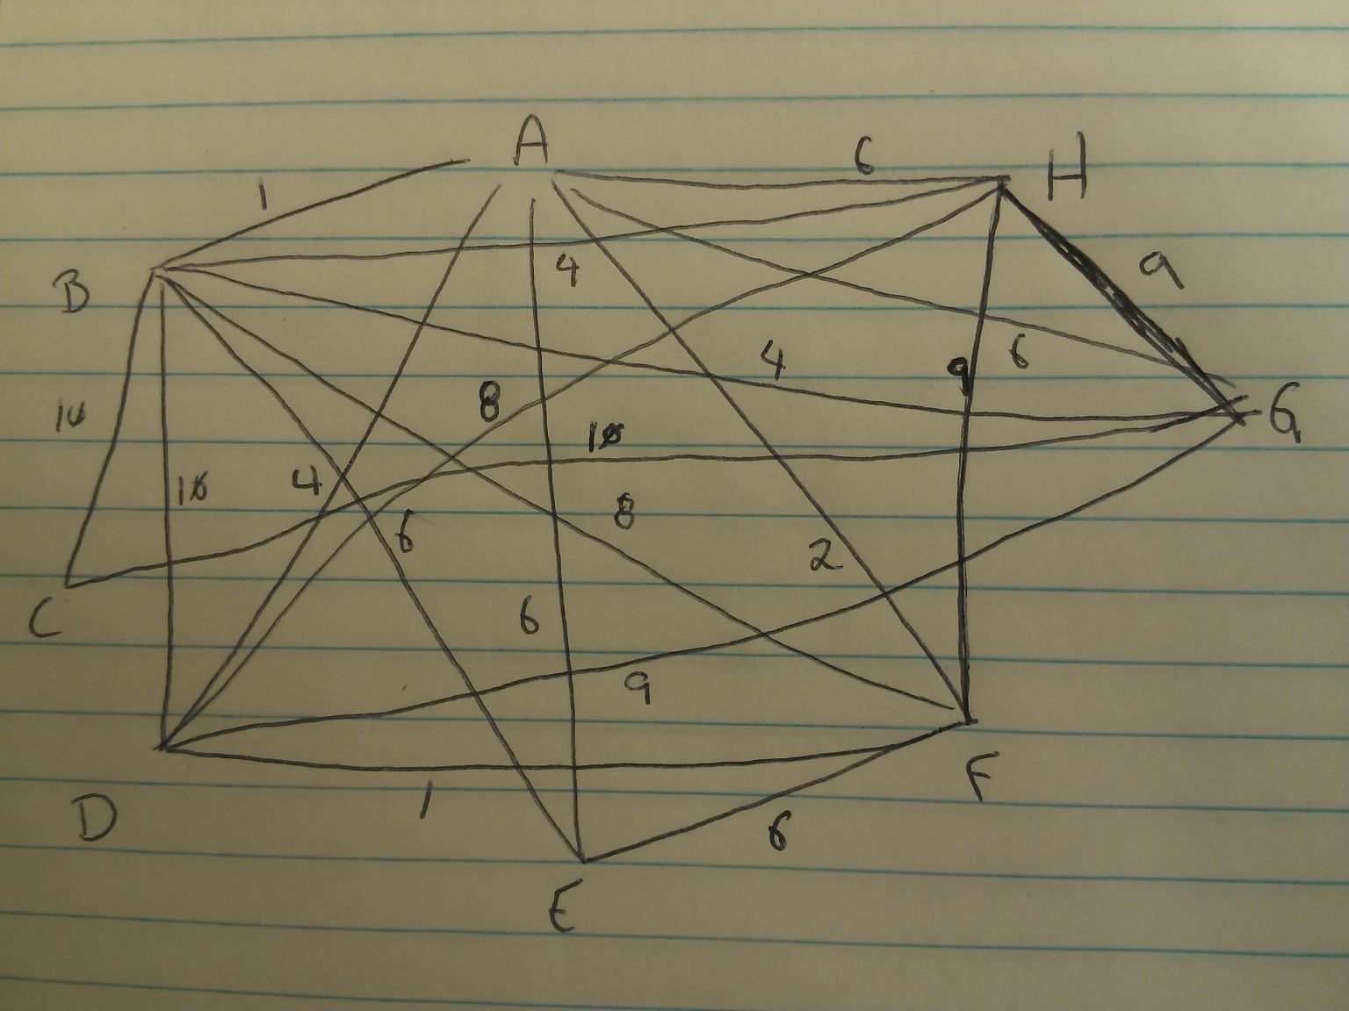

c.
