6. I found through my experiments that it is always beneficial to use QuickInsertion Sort on an array with less than 30-35 values, above this, regardless of the cutoff number, Quick Sort will always be more efficient. From my tests I also determined that on an array of size smaller than 30-35 the most efficient point is reached with a cutoff number set approximately ½ to 1/3 of the array size. I determined this by creating a shell script that would take a set of instructions and would run the two algorithms side by side incrementing just the array size, cutoff, or both and storing the information in an output file neatly to be analyzed.

Variable array size:
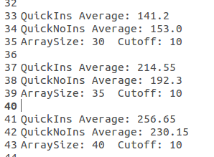

Variable cutoff:
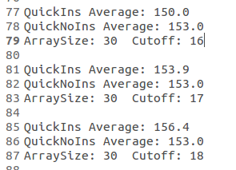

Variable array size and variable cutoff point:

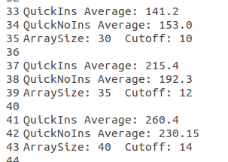

The data collected and used is located in files called:
FixedArraySize.txt - Cutoff variable, arraySize fixed
FixedCutoff.txt - Fixed Cutoff, arraySize Variable
AllVariable.txt - Variable Cutoff, arraySize Variable

(a) The call to StdRandom.setSeed was included to make sure that the experiment would be run with similar test values. This would make sure that the results would be able to be used to compare the performance of the different algorithms

(b) The program prints out the values of a[3], a[6], an a[9] because it allows you to match the data points after the array has been sorted to ensure that the data that was sorted was the same. This allows you to verify the data used to test the algorithms.

(c) Shuffle was disabled in the quicksort method because it introduces a random element that makes it harder to compare the two versions of quicksort.

