
Tutorial
08.07.2010
Manuel Renz & Matthias Ziegler






Inhaltsverzeichnis
1 Inhaltsverzeichnis 2
2 Lizenz 4
3 Einleitung 5
1 Installation der Umgebung 6
1.1 Voraussetzungen 6
1.1.1 Mindest-‘Systemvoraussetzungen 6
1.2 Installation des Enterprise Architect 7
1.3 Installation und Konfiguration der Entwicklungsumgebung 7
1.3.1 Vorbereitungen 7
1.3.2 Installation des JDKs 8
1.3.3 Installation von Eclipse 8
1.3.4 Installation von openArchitectureWare 8
1.3.5 Einstellen des Workspace Verzeichnisses 8
1.3.6 Einstellen des Java Compiler compliance Levels 9
1.3.7 Installation weiterer Plug-Ins 11
1.3.8 Bereitstellen der Enterprise Architect API 12
1.4 Import der bereitgestellten Cartridges 13
1.4.1 Importieren der Cartridges von CD 15
1.4.2 Starten der Generatoren 16
3 Anwendung des BVA-Generators anhand eines Beispiels 18
3.1 Erstellen des Beispiel Modells 18
3.2 Anwendung der Standard BVA Stereotypen 20
3.3 Anwendung Benutzerdefinierter Validatoren 21
3.3.1 Erstellen eines benutzerdefinierten BVA Profils 21
3.3.2 Erstellen eines benutzerdefinierten BVA Stereotypen 23
3.3.3 Verwenden des benutzerdefinierten BVA Profils 27
3.3.4 Implementieren des benutzerdefinierten Validators 27
3.4 Durchführen des Exports mit dem bva.exporter 30
3.4.1 Anpassen der exporter.properties 30
3.4.2 Starten des Exportvorgangs 31
3.5 Durchführen der Code Generierung mit dem bva.generator 32
3.6 Anmerkung zum Beispielmodell 33
4 Anwendung des JPA-Generators anhand eines Beispiels 34
4.1 Überblick 34
4.2 Erstellen des Beispiel Modells 35
4.2.1 Exportvorgang aus dem Enterprise Architect in XMI 39
4.2.2 Generierung von Javacode 42
4.2.3 DDL-Generierung 49
5 Tutorial für die gemeinsame Verwendung des JPA- und BVA-Generators 51
3.6.1 UML-Modell 51
3.6.2 Exportvorgang aus dem Enterprise Architect in XMI 52
3.6.3 Generierung von Javacode 52
4 Wichtige Hinweise zur Modellierung mit dem Enterprise Architect 54
4.1 Neues Enterprise Architect Projekt erstellen 55
4.2 Neue UML-Klasse erstellen 56
4.3 Attribute erstellen und bearbeiten 57
4.4 Methoden erstellen und bearbeiten 58
4.5 Beziehungen erstellen 59
4.6 UML-Profil einhängen 60
4.7 Stereotypen auf ein UML-Element anwenden und löschen 61
4.8 Tagged Values bearbeiten 62
4.9 Bekannte Bugs 64
4.9.1 Tagged Values mit Option Show Fully Qualified Tags 64
4.9.2 Mehrere gleiche Tagged Values für ein UML-Element 65
4.9.3 Beim Löschen von Stereotypen werden zugehörige Tagged Values nicht mit gelöscht 67
6 Abbildungsverzeichnis 68
7 Tabellenverzeichnis 70
8 Literaturverzeichnis 71
9 Stichwortverzeichnis 72

License
THE WORK (AS DEFINED BELOW) IS PROVIDED UNDER THE TERMS OF THIS CREATIVE COMMONS PUBLIC LICENSE ("CCPL" OR "LICENSE"). THE WORK IS PROTECTED BY COPYRIGHT AND/OR OTHER APPLICABLE LAW. ANY USE OF THE WORK OTHER THAN AS AUTHORIZED UNDER THIS LICENSE OR COPYRIGHT LAW IS PROHIBITED.
BY EXERCISING ANY RIGHTS TO THE WORK PROVIDED HERE, YOU ACCEPT AND AGREE TO BE BOUND BY THE TERMS OF THIS LICENSE. TO THE EXTENT THIS LICENSE MAY BE CONSIDERED TO BE A CONTRACT, THE LICENSOR GRANTS YOU THE RIGHTS CONTAINED HERE IN CONSIDERATION OF YOUR ACCEPTANCE OF SUCH TERMS AND CONDITIONS.
1. Definitions
- "Adaptation" means a work based upon the Work, or upon the Work and other pre-existing works, such as a translation, adaptation, derivative work, arrangement of music or other alterations of a literary or artistic work, or phonogram or performance and includes cinematographic adaptations or any other form in which the Work may be recast, transformed, or adapted including in any form recognizably derived from the original, except that a work that constitutes a Collection will not be considered an Adaptation for the purpose of this License. For the avoidance of doubt, where the Work is a musical work, performance or phonogram, the synchronization of the Work in timed-relation with a moving image ("synching") will be considered an Adaptation for the purpose of this License.
- "Collection" means a collection of literary or artistic works, such as encyclopedias and anthologies, or performances, phonograms or broadcasts, or other works or subject matter other than works listed in Section 1(f) below, which, by reason of the selection and arrangement of their contents, constitute intellectual creations, in which the Work is included in its entirety in unmodified form along with one or more other contributions, each constituting separate and independent works in themselves, which together are assembled into a collective whole. A work that constitutes a Collection will not be considered an Adaptation (as defined below) for the purposes of this License.
- "Creative Commons Compatible License" means a license that is listed at http://creativecommons.org/compatiblelicenses that has been approved by Creative Commons as being essentially equivalent to this License, including, at a minimum, because that license: (i) contains terms that have the same purpose, meaning and effect as the License Elements of this License; and, (ii) explicitly permits the relicensing of adaptations of works made available under that license under this License or a Creative Commons jurisdiction license with the same License Elements as this License.
- "Distribute" means to make available to the public the original and copies of the Work or Adaptation, as appropriate, through sale or other transfer of ownership.
- "License Elements" means the following high-level license attributes as selected by Licensor and indicated in the title of this License: Attribution, ShareAlike.
- "Licensor" means the individual, individuals, entity or entities that offer(s) the Work under the terms of this License.
- "Original Author" means, in the case of a literary or artistic work, the individual, individuals, entity or entities who created the Work or if no individual or entity can be identified, the publisher; and in addition (i) in the case of a performance the actors, singers, musicians, dancers, and other persons who act, sing, deliver, declaim, play in, interpret or otherwise perform literary or artistic works or expressions of folklore; (ii) in the case of a phonogram the producer being the person or legal entity who first fixes the sounds of a performance or other sounds; and, (iii) in the case of broadcasts, the organization that transmits the broadcast.
- "Work" means the literary and/or artistic work offered under the terms of this License including without limitation any production in the literary, scientific and artistic domain, whatever may be the mode or form of its expression including digital form, such as a book, pamphlet and other writing; a lecture, address, sermon or other work of the same nature; a dramatic or dramatico-musical work; a choreographic work or entertainment in dumb show; a musical composition with or without words; a cinematographic work to which are assimilated works expressed by a process analogous to cinematography; a work of drawing, painting, architecture, sculpture, engraving or lithography; a photographic work to which are assimilated works expressed by a process analogous to photography; a work of applied art; an illustration, map, plan, sketch or three-dimensional work relative to geography, topography, architecture or science; a performance; a broadcast; a phonogram; a compilation of data to the extent it is protected as a copyrightable work; or a work performed by a variety or circus performer to the extent it is not otherwise considered a literary or artistic work.
- "You" means an individual or entity exercising rights under this License who has not previously violated the terms of this License with respect to the Work, or who has received express permission from the Licensor to exercise rights under this License despite a previous violation.
- "Publicly Perform" means to perform public recitations of the Work and to communicate to the public those public recitations, by any means or process, including by wire or wireless means or public digital performances; to make available to the public Works in such a way that members of the public may access these Works from a place and at a place individually chosen by them; to perform the Work to the public by any means or process and the communication to the public of the performances of the Work, including by public digital performance; to broadcast and rebroadcast the Work by any means including signs, sounds or images.
- "Reproduce" means to make copies of the Work by any means including without limitation by sound or visual recordings and the right of fixation and reproducing fixations of the Work, including storage of a protected performance or phonogram in digital form or other electronic medium.
2. Fair Dealing Rights. Nothing in this License is intended to reduce, limit, or restrict any uses free from copyright or rights arising from limitations or exceptions that are provided for in connection with the copyright protection under copyright law or other applicable laws.
3. License Grant. Subject to the terms and conditions of this License, Licensor hereby grants You a worldwide, royalty-free, non-exclusive, perpetual (for the duration of the applicable copyright) license to exercise the rights in the Work as stated below:
- to Reproduce the Work, to incorporate the Work into one or more Collections, and to Reproduce the Work as incorporated in the Collections;
- to create and Reproduce Adaptations provided that any such Adaptation, including any translation in any medium, takes reasonable steps to clearly label, demarcate or otherwise identify that changes were made to the original Work. For example, a translation could be marked "The original work was translated from English to Spanish," or a modification could indicate "The original work has been modified.";
- to Distribute and Publicly Perform the Work including as incorporated in Collections; and,
- to Distribute and Publicly Perform Adaptations.
- For the avoidance of doubt:
  - Non-waivable Compulsory License Schemes. In those jurisdictions in which the right to collect royalties through any statutory or compulsory licensing scheme cannot be waived, the Licensor reserves the exclusive right to collect such royalties for any exercise by You of the rights granted under this License;
  - Waivable Compulsory License Schemes. In those jurisdictions in which the right to collect royalties through any statutory or compulsory licensing scheme can be waived, the Licensor waives the exclusive right to collect such royalties for any exercise by You of the rights granted under this License; and,
  - Voluntary License Schemes. The Licensor waives the right to collect royalties, whether individually or, in the event that the Licensor is a member of a collecting society that administers voluntary licensing schemes, via that society, from any exercise by You of the rights granted under this License.
The above rights may be exercised in all media and formats whether now known or hereafter devised. The above rights include the right to make such modifications as are technically necessary to exercise the rights in other media and formats. Subject to Section 8(f), all rights not expressly granted by Licensor are hereby reserved.
4. Restrictions. The license granted in Section 3 above is expressly made subject to and limited by the following restrictions:
- You may Distribute or Publicly Perform the Work only under the terms of this License. You must include a copy of, or the Uniform Resource Identifier (URI) for, this License with every copy of the Work You Distribute or Publicly Perform. You may not offer or impose any terms on the Work that restrict the terms of this License or the ability of the recipient of the Work to exercise the rights granted to that recipient under the terms of the License. You may not sublicense the Work. You must keep intact all notices that refer to this License and to the disclaimer of warranties with every copy of the Work You Distribute or Publicly Perform. When You Distribute or Publicly Perform the Work, You may not impose any effective technological measures on the Work that restrict the ability of a recipient of the Work from You to exercise the rights granted to that recipient under the terms of the License. This Section 4(a) applies to the Work as incorporated in a Collection, but this does not require the Collection apart from the Work itself to be made subject to the terms of this License. If You create a Collection, upon notice from any Licensor You must, to the extent practicable, remove from the Collection any credit as required by Section 4(c), as requested. If You create an Adaptation, upon notice from any Licensor You must, to the extent practicable, remove from the Adaptation any credit as required by Section 4(c), as requested.
- You may Distribute or Publicly Perform an Adaptation only under the terms of: (i) this License; (ii) a later version of this License with the same License Elements as this License; (iii) a Creative Commons jurisdiction license (either this or a later license version) that contains the same License Elements as this License (e.g., Attribution-ShareAlike 3.0 US)); (iv) a Creative Commons Compatible License. If you license the Adaptation under one of the licenses mentioned in (iv), you must comply with the terms of that license. If you license the Adaptation under the terms of any of the licenses mentioned in (i), (ii) or (iii) (the "Applicable License"), you must comply with the terms of the Applicable License generally and the following provisions: (I) You must include a copy of, or the URI for, the Applicable License with every copy of each Adaptation You Distribute or Publicly Perform; (II) You may not offer or impose any terms on the Adaptation that restrict the terms of the Applicable License or the ability of the recipient of the Adaptation to exercise the rights granted to that recipient under the terms of the Applicable License; (III) You must keep intact all notices that refer to the Applicable License and to the disclaimer of warranties with every copy of the Work as included in the Adaptation You Distribute or Publicly Perform; (IV) when You Distribute or Publicly Perform the Adaptation, You may not impose any effective technological measures on the Adaptation that restrict the ability of a recipient of the Adaptation from You to exercise the rights granted to that recipient under the terms of the Applicable License. This Section 4(b) applies to the Adaptation as incorporated in a Collection, but this does not require the Collection apart from the Adaptation itself to be made subject to the terms of the Applicable License.
- If You Distribute, or Publicly Perform the Work or any Adaptations or Collections, You must, unless a request has been made pursuant to Section 4(a), keep intact all copyright notices for the Work and provide, reasonable to the medium or means You are utilizing: (i) the name of the Original Author (or pseudonym, if applicable) if supplied, and/or if the Original Author and/or Licensor designate another party or parties (e.g., a sponsor institute, publishing entity, journal) for attribution ("Attribution Parties") in Licensor's copyright notice, terms of service or by other reasonable means, the name of such party or parties; (ii) the title of the Work if supplied; (iii) to the extent reasonably practicable, the URI, if any, that Licensor specifies to be associated with the Work, unless such URI does not refer to the copyright notice or licensing information for the Work; and (iv) , consistent with Ssection 3(b), in the case of an Adaptation, a credit identifying the use of the Work in the Adaptation (e.g., "French translation of the Work by Original Author," or "Screenplay based on original Work by Original Author"). The credit required by this Section 4(c) may be implemented in any reasonable manner; provided, however, that in the case of a Adaptation or Collection, at a minimum such credit will appear, if a credit for all contributing authors of the Adaptation or Collection appears, then as part of these credits and in a manner at least as prominent as the credits for the other contributing authors. For the avoidance of doubt, You may only use the credit required by this Section for the purpose of attribution in the manner set out above and, by exercising Your rights under this License, You may not implicitly or explicitly assert or imply any connection with, sponsorship or endorsement by the Original Author, Licensor and/or Attribution Parties, as appropriate, of You or Your use of the Work, without the separate, express prior written permission of the Original Author, Licensor and/or Attribution Parties.
- Except as otherwise agreed in writing by the Licensor or as may be otherwise permitted by applicable law, if You Reproduce, Distribute or Publicly Perform the Work either by itself or as part of any Adaptations or Collections, You must not distort, mutilate, modify or take other derogatory action in relation to the Work which would be prejudicial to the Original Author's honor or reputation. Licensor agrees that in those jurisdictions (e.g. Japan), in which any exercise of the right granted in Section 3(b) of this License (the right to make Adaptations) would be deemed to be a distortion, mutilation, modification or other derogatory action prejudicial to the Original Author's honor and reputation, the Licensor will waive or not assert, as appropriate, this Section, to the fullest extent permitted by the applicable national law, to enable You to reasonably exercise Your right under Section 3(b) of this License (right to make Adaptations) but not otherwise.
5. Representations, Warranties and Disclaimer
UNLESS OTHERWISE MUTUALLY AGREED TO BY THE PARTIES IN WRITING, LICENSOR OFFERS THE WORK AS-IS AND MAKES NO REPRESENTATIONS OR WARRANTIES OF ANY KIND CONCERNING THE WORK, EXPRESS, IMPLIED, STATUTORY OR OTHERWISE, INCLUDING, WITHOUT LIMITATION, WARRANTIES OF TITLE, MERCHANTIBILITY, FITNESS FOR A PARTICULAR PURPOSE, NONINFRINGEMENT, OR THE ABSENCE OF LATENT OR OTHER DEFECTS, ACCURACY, OR THE PRESENCE OF ABSENCE OF ERRORS, WHETHER OR NOT DISCOVERABLE. SOME JURISDICTIONS DO NOT ALLOW THE EXCLUSION OF IMPLIED WARRANTIES, SO SUCH EXCLUSION MAY NOT APPLY TO YOU.
6. Limitation on Liability. EXCEPT TO THE EXTENT REQUIRED BY APPLICABLE LAW, IN NO EVENT WILL LICENSOR BE LIABLE TO YOU ON ANY LEGAL THEORY FOR ANY SPECIAL, INCIDENTAL, CONSEQUENTIAL, PUNITIVE OR EXEMPLARY DAMAGES ARISING OUT OF THIS LICENSE OR THE USE OF THE WORK, EVEN IF LICENSOR HAS BEEN ADVISED OF THE POSSIBILITY OF SUCH DAMAGES.
7. Termination
- This License and the rights granted hereunder will terminate automatically upon any breach by You of the terms of this License. Individuals or entities who have received Adaptations or Collections from You under this License, however, will not have their licenses terminated provided such individuals or entities remain in full compliance with those licenses. Sections 1, 2, 5, 6, 7, and 8 will survive any termination of this License.
- Subject to the above terms and conditions, the license granted here is perpetual (for the duration of the applicable copyright in the Work). Notwithstanding the above, Licensor reserves the right to release the Work under different license terms or to stop distributing the Work at any time; provided, however that any such election will not serve to withdraw this License (or any other license that has been, or is required to be, granted under the terms of this License), and this License will continue in full force and effect unless terminated as stated above.
8. Miscellaneous
- Each time You Distribute or Publicly Perform the Work or a Collection, the Licensor offers to the recipient a license to the Work on the same terms and conditions as the license granted to You under this License.
- Each time You Distribute or Publicly Perform an Adaptation, Licensor offers to the recipient a license to the original Work on the same terms and conditions as the license granted to You under this License.
- If any provision of this License is invalid or unenforceable under applicable law, it shall not affect the validity or enforceability of the remainder of the terms of this License, and without further action by the parties to this agreement, such provision shall be reformed to the minimum extent necessary to make such provision valid and enforceable.
- No term or provision of this License shall be deemed waived and no breach consented to unless such waiver or consent shall be in writing and signed by the party to be charged with such waiver or consent.
- This License constitutes the entire agreement between the parties with respect to the Work licensed here. There are no understandings, agreements or representations with respect to the Work not specified here. Licensor shall not be bound by any additional provisions that may appear in any communication from You. This License may not be modified without the mutual written agreement of the Licensor and You.
- The rights granted under, and the subject matter referenced, in this License were drafted utilizing the terminology of the Berne Convention for the Protection of Literary and Artistic Works (as amended on September 28, 1979), the Rome Convention of 1961, the WIPO Copyright Treaty of 1996, the WIPO Performances and Phonograms Treaty of 1996 and the Universal Copyright Convention (as revised on July 24, 1971). These rights and subject matter take effect in the relevant jurisdiction in which the License terms are sought to be enforced according to the corresponding provisions of the implementation of those treaty provisions in the applicable national law. If the standard suite of rights granted under applicable copyright law includes additional rights not granted under this License, such additional rights are deemed to be included in the License; this License is not intended to restrict the license of any rights under applicable law.
http://creativecommons.org/licenses/by-sa/3.0/legalcode

Einleitung
Dieses Tutorial besteht im Wesentlichen aus den Praxisteilen der Diplomarbeiten „Erstellung eines MDA-Generators für Validierungen auf Basis der Bean-Validation-API“ und „Erstellung eines MDA-Generators für CRUD-Operationen in einer Persistenzschicht auf Basis der Java Persistence API“, welche die Grundlage für droMDAry bilden. Die Kapitel wurden für das droMDAry Tutorial angepasst und zusammengefasst.
Das Tutorial gliedert sich in folgende Abschnitte:
- Installation und Konfiguration der verschiedenen Softwarepakete
- Verwendung der Generatoren (BVA/JPA)
- Hinweise zur Verwendung des Enterprise Architects

Installation der Umgebung
Prinzipiell lässt sich die Installation in folgende Punkte gliedern:
- Download und Installation der verschiedenen Softwarepakete
- Konfiguration der Eclipse Umgebung und installation diverser Plugins
- Import der Generatoren

Voraussetzungen
Die Entwicklung von droMDAry wurde unter Windows durchgeführt. Verwendete Software-Tools sowie auch der MDA-Generator funktionieren unter Windows XP / Vista / 7 einwandfrei. Die Kompatibilität mit Linux/Unix/Mac wurde nicht getestet. Für das Software-Werkzeug Enterprise Architect gibt es jedoch eine CrossOver-Version für Linux und Mac. Weitere Hinweise dazu findet man auf der folgenden Homepage:
http://www.sparxsystems.com/support/faq/ea_on_linux.html
Falls die Entwicklungsumgebung Eclipse bereits installiert ist, sollte unbedingt geprüft werden ob die im Kapitel 1.3.3 und 1.3.7 angegebenen Anforderungen erfüllt werden, um sicherzustellen, dass alle benötigten Plug-Ins in der korrekten Version vorliegen.
Eclipse gibt es auch in einer Version für Linux und Mac. Mehr Informationen dazu findet man auf der Homepage von Eclipse unter
http://www.eclipse.org/.

Mindest-‘Systemvoraussetzungen
- CPU mit 1,8 GHz
- 1 GB Arbeitsspeicher
- 600 MB Festplattenspeicher
Diese Angaben gelten für das Windows Betriebssystem XP/Vista. Weitere Betriebssysteme wurden nicht getestet.

Installation des Enterprise Architect
Die aktuelle Trial Version kann von der Homepage der Herstellers unter http://www.sparxsystems.de/enterprise-architect/download-trial/
heruntergeladen werden.
Auf dieser Homepage gibt es die Möglichkeit, den Punkt „EA Trial Version“ anzuklicken, um sich die aktuelle Version des Enterprise Architect auf den eigenen Rechner zu speichern. Die Trial Version ist für 30 Tage gültig. Nach diesem Zeitraum kann mit dem Tool nicht mehr gearbeitet werden. Unter http://www.sparxsystems.de/enterprise-architect/ea-price/
findet man alle nötigen Informationen zum Kauf des Werkzeugs Enterprise Architect.
Während der Implementierung der Generatoren wurde die Version 7.5 Build 845 verwendet.
Nachdem der Installationsvorgang gestartet wurde, müssen nur die wenigen Anweisungen des Installationsassistenten bestätigt werden. Das Tool ist somit fertig installiert.

Installation und Konfiguration der Entwicklungsumgebung
Im folgenden Abschnitt werden die nötigen Schritte zur Installation einer voll funktionsfähigen Entwicklungsumgebung basierend auf Eclipse und openArchitectureWare erläutert.

Vorbereitungen
Bevor mit der Installation und Konfiguration begonnen werden kann, müssen alle benötigten Softwarekomponenten heruntergeladen worden sein. Im folgenden eine Liste der Pakete mit den entsprechenden Versionsnummern sowie eines Links zur Downloadseite des Herstellers.
- Java SE Development Kit 6u14 (JDK) http://java.sun.com/javase/downloads/index.jsp
- Eclipse IDE for Java EE Developers 3.4 SR2 (Ganymede) http://www.eclipse.org
- openArchitectureWare 4.3.1 SDK (oAW) als ZIP Datei
http://www.openarchitectureware.org/staticpages/index.php/download

Installation des JDKs
Die gesamte Toolchain ist auf eine funktionsfähige Java Umgebung angewiesen, daher muss diese zuerst Installiert werden. Java muss mindestens in der Version 1.5 verfügbar sein. Neuere 1.6er Versionen sind laut „openArchitectureWare“ FAQ ebenso unterstützt. Nichtsdestotrotz kann die aktuellste Version installiert werden, da das „Compiler Compliance Level“ im Nachgang auf 1.5 eingestellt werden kann.
Die Installation des JDK kann ohne weitere Anpassungen mit den Standardvorgaben des Installationsassistenten durchgeführt werden.

Installation von Eclipse
Die heruntergeladene ZIP Datei eclipse-jee-ganymede-SR2-win32.zip entpackt man in einen beliebigen Ordner. Die J2EE Edition wurde gewählt da sie schon einige der benötigten Plug-Ins beinhaltet und diese somit nicht mehr separat heruntergeladen werden müssen.
In dieser Beschreibung wird das Archive direkt nach c:\ entpackt, d.h. die Entwicklungsumgebung ist unter c:\eclipse zugänglich.

Installation von openArchitectureWare
Das heruntergeladene openArchitectureWare ZIP Archive wird in dasselbe Verzeichnis entpackt, in das auch das Eclipse Archive entpackt wurde, in diesem Fall also c:\. Dadurch wird das openArchitectureWare Plug-In als neues Feature zur Eclipseinstallation hinzugefügt.

Einstellen des Workspace Verzeichnisses
Die Entwicklungsumgebung wird nun mittels c:\eclipse\eclispe.exe gestartet.
Beim ersten Start wird automatisch ein neuer Workspace unter c:\Dokumente und Einstellungen\<Benutzer>\workspace angelegt. Da die Leerzeichen im Pfad später zu Problemen führen können, wird besser ein eigener Workspace in einem anderen Verzeichnis erstellt. Prinzipiell kann auch ein bereits bestehender Workspace verwendet werden. Sollte es dabei jedoch zu unvorhergesehenen Problemen kommen, empfiehlt es sich einen separaten Workspace anzulegen. Um dies zu erreichen wählt man über das Menü „File → Switch Workspace → Other“, den gewünschten Workspace-Ordner aus (siehe dazu Abbildung 1: Screenshot vom Workspace Launcher).
Im Folgenden wird angenommen, dass ein eigener, noch leerer Workspace als c:\workspace angelegt wurde.
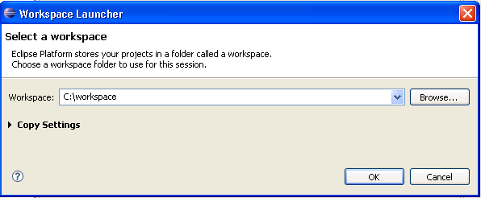
Abbildung 1: Screenshot vom Workspace Launcher

Einstellen des Java Compiler compliance Levels
Da die Toolchain nicht 100% mit Java 1.6 kompatibel ist, muss das Java Compiler Compliance Level auf 1.5 eingestellt werden. Dies geschieht im „Preferences“ Dialog den man über den Menüpunkt „Window → Preferences“ erreicht. Dort kann man unter dem Eintrag „Java → Compiler → Compiler compliance level“ die Java Version auf die Version 1.5 setzen (siehe dazu Abbildung 2: Screenshot vom Preferences Dialog des Java Compiler).
Mit dieser Einstellung wird die Java Version für den gesamten Workspace auf 1.5 festgelegt. Alternativ kann man dies auch mit den projektspezifischen Einstellungen bei jeder Cartridge separat einstellen. Dies kann im Einzelfall jedoch leicht einmal vergessen werden und ist daher recht fehleranfällig. Da in diesem Tutorial mit einem separaten Workspace gearbeitet wird, ist es ohnehin unproblematisch diese Einstellung für alle Projekte vorzugeben.
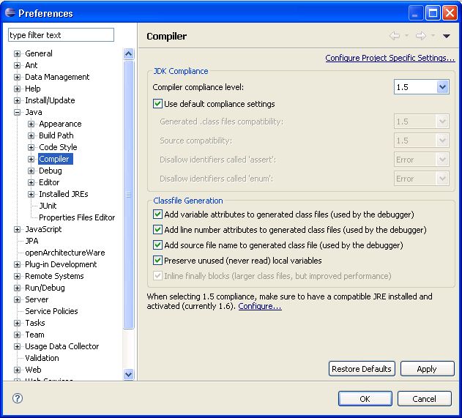
Abbildung 2: Screenshot vom Preferences Dialog des Java Compilers
In der verwendeten J2EE Eclipse Distribution sind schon die meisten benötigten Plug-Ins enthalten, die für ein funktionierendes openArchitectureWare benötigt werden. Dazu gehören:
- Eclipse Modeling Framework (EMF) in der Version 2.4.2
- Eclipse Web Standard Tools (WST) in der Version 3.0.2
- Eclipse Plug-in Development Environment (PDE) in der Version 3.4.2
Damit openArchitectureWare jedoch mit UML2 bzw. XMI Daten umgehen kann, müssen noch zwei weitere Plug-Ins installiert werden. Diese Plug-Ins können mit dem integrierten Update Manager von der Eclipse Ganymed Update Site heruntergeladen werden. Dazu öffnet man über das Menü „Help → Software Updates“ den „Software Updates und Add-ons“ Dialog und aktiviert das Register „Available Software“. In der nun dargestellten Liste müssen die Einträge „Ganymede Update Site“ und darunter „Model and Model Development“ geöffnet werden. Hier wählt man nun die Plug-Ins „UML2 End-User Features 2.2.2“ sowie „UML2 Extender SDK 2.2.2“ aus und installiert diese per Klick auf „Install“ (siehe dazu Abbildung 3: Screenshot vom Eclipse Software Update Manager).
Die Plug-Ins werden nun automatisch heruntergeladen und installiert. Wenn dieser Vorgang erfolgreich abgeschlossen wurde, wird man aufgefordert den Eclipse erneut zu starten, was man mit einem Klick auf „Yes“ bestätigt.

Installation weiterer Plug-Ins
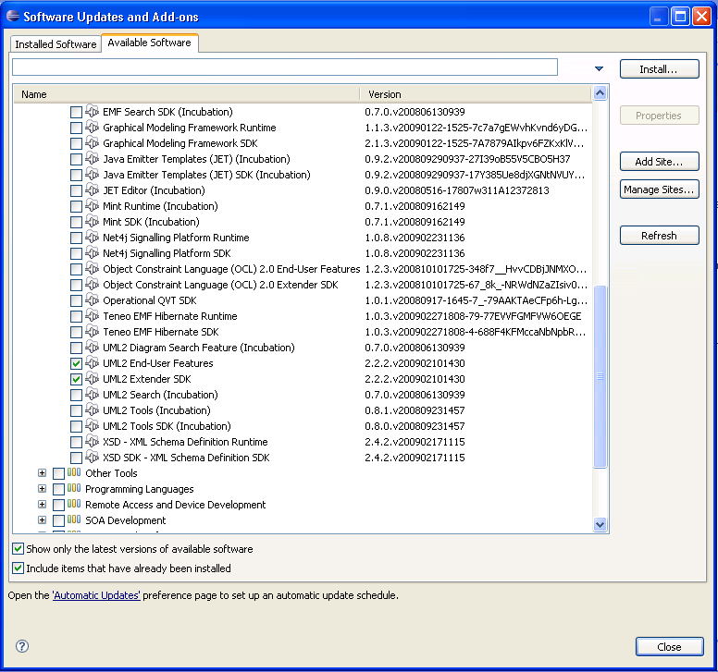
Abbildung 3: Screenshot vom Eclipse Software Update Manager
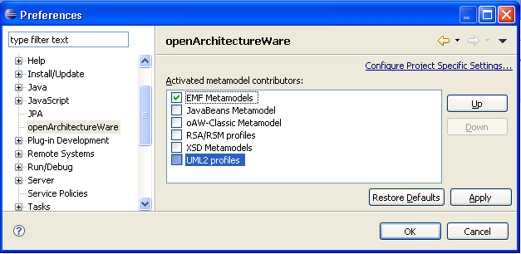
Abbildung 4: Screenshot vom Preferences Dialog zum Verwalten der verfügbaren Metamodelle in openArchitectureWare
Hier muss nun der Eintrag „UML2 profiles“ aktiviert und an die erste Stelle verschoben werden (siehe dazu Abbildung 4: Screenshot vom Preferences Dialog zum Verwalten der verfügbaren Metamodelle in openArchitectureWare und Abbildung 5: UML2 Profile in openArchitectureWare aktivieren).
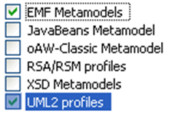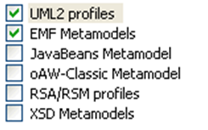
Abbildung 5: UML2 Profile in openArchitectureWare aktivieren

Bereitstellen der Enterprise Architect API
Damit der eingesetzte UML2 Exporter über das Enterprise Architect API auf die Projektdateien zugreifen kann, muss die DLL die diese API zur Verfügung stellt, in einem Verzeichnis verfügbar sein auf das über die Umgebungsvariable PATH zugegriffen werden kann.
Die benötigte DLL liegt im Enterprise Architect Installationsverzeichnis, also „c:\Program Files\Sparx Systems\EA\Java API“ oder „c:\Program Files\Sparx Systems\EA Trial\Java API“, heißt „SSJavaCOM.dll“ und kann bspw. einfach in das System32 Verzeichnis der Windowsinstallation kopiert werden.
Nun sind alle Voraussetzungen an die Umgebung erfüllt um die bereitgestellten Cartridges benutzen zu können.

Import der bereitgestellten Cartridges
Im letzten Kapitel wurde die Installation und Konfiguration der Entwicklungsumgebung erläutert. Jetzt können die Cartridges, die auf der mitgelieferten CD im Unterordner „<CD-Laufwerk>:\Cartdriges“ zu finden sind, in den zuvor angelegten Eclipse Workspace importiert werden.
Insgesamt müssen sechs Cartridges in den Workspace importiert werden.
- bva.exporter
- bva.generator
- jpa.exporter
- jpa.generator
- common.exporter
- common.generator
Die Exporter Cartridges sind jeweils für den Export der Enterprise Architect Modelle zuständig und die Generator Cartridges für die Generierung des Java Quellcodes aus den zuvor exportierten Modellen.

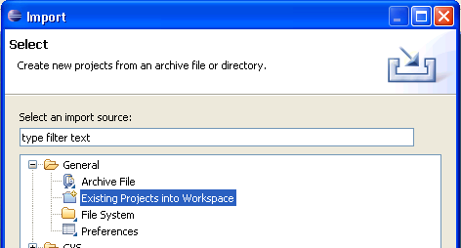
Abbildung 6: Screenshot des Importassistenten
Da es sich um zwei getrennte Cartridges handelt, die einzeln lauffähig sind, gibt es die Exporter und Generatoren jeweils für beide Cartridges als separate Projekte.
Die „Common“ Cartridges haben hierbei eine Sonderfunktion, denn sie verbindet dir BVA und JPA Cartridges für den Fall, dass aus einem Enterprise Architect Modell in einem Durchlauf beide Generate, also BVA und JPA, erzeugt werden sollen.
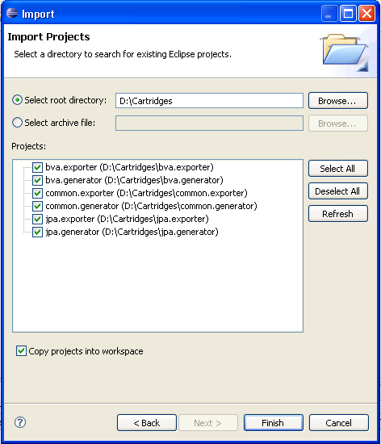
Abbildung 7: Screenshot des Assistenten zum auswählen der Cartridges

Importieren der Cartridges von CD
Über den Menüpunkt „File → Import“ wird der Importassistent aufgerufen. Dort öffnet man den Eintrag „General“ und wählt „Existing Projects into Workspace“ aus (siehe dazu Abbildung 6: Screenshot des Importassistenten).
Mit einem Klick auf „Next“ gelangt man zur Auswahl der zu importierenden Projekte. Die Option „Select root directory“ ist bereits aktiviert, so dass man nun mit einem Klick auf „Browse“ den Unterordner „Cartridges“ auf der mitgelieferten CD auswählen kann und diesen mit einem Klick auf OK bestätigt.
Nun werden alle verfügbaren Eclipse Projekte die sich im ausgewählten Ordner befinden aufgelistet. Da die Projektdateien von Eclipse nicht nur verknüpft sondern richtig in das Workspace Verzeichnis kopiert werden sollen, muss die Option „Copy into workspace“ aktiviert sein (siehe dazu Abbildung 7: Screenshot des Assistenten zum auswählen der Cartridges). Mit einem Klick auf „Finish“ wird der Importvorgang gestartet. Alle Projekte werden nun im Workspace angelegt und die dazugehörige Dateien kopiert. Sobald dieser Vorgang abgeschlossen ist sollten die Cartridges im „Project Explorer“ angezeigt werden (siehe dazu Abbildung 9: Screenshot des Project Explorers nach dem erfolgreichen Import).
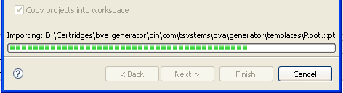
Abbildung 8: Screenshot des Importvorgangs
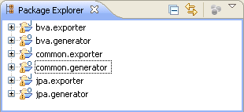
Abbildung 9: Screenshot des Project Explorers nach dem erfolgreichen Import
Nach dem erfolgreichen Import steht ein bereits Demonstrations Modell zur Verfügung, mit dem die Umgebung auf Funktionsfähigkeit geprüft werden kann.

Starten der Generatoren
Die Code Generierung ist in zwei Schritte aufgeteilt, zuerst muss das EA Modell in EMF exportiert werden und dann im zweiten Schritt wird basierend auf dem EMF Modell der Code generiert.
Der Exportvorgang für die Profile wird mit einem Rechtsklick auf die entsprechende Workflow Datei (common.exporter/oaw/profile.oaw) und anschließend mit einem Klick auf „Run As… → oAW Workflow“ gestartet. In der Eclipse Konsole kann der weitere Fortschritt beobachtet werden. Sobald der Workflow abgeschlossen ist erscheint folgende Meldung im Konsolenfenster.
- 75061 INFO WorkflowRunner - workflow completed in 74026ms!
Hinweise: Sollte sich eine Demo Version des Enterprise Architects im Einsatz befinden, öffnet sich im Hintergrund mehrmals eine Meldung, die per Klick auf Continue Trial bestätigt werden muss.
Um den Export des eigentlichen Modells zu starten, muss nun auch noch die Date common.exporter/oaw/workflow.oaw gestartet werden.
Jetzt liegen alle benötigen Modell Information im EMF vor und die Quellcodegenerierung kann gestartet werden.
Dazu wird die Datei common.generator/src/main/resources/workflow.oaw auf dieselbe Weise wie zuvor gestartet. Nun werden die abstrakten sowie die Interfaceklassen im Verzeichnis /src/generated/java mit samt den Packages generiert. Die Implementierungsklassen werden hingegen einmalig unter /src/main/java erstellt. Bei allen weiteren Generierungsvorgängen werden diese Dateien nicht überschrieben um manuelle Änderungen am Quellcode zu schützen. Wenn diese Klassen auch neugeneriert werden sollen, müssen diese manuell gelöscht werden.
Per default werden die BVA und JPA Generatoren ausgeführt, die kann jedoch auf einfache Weise in der common.generator/src/main/resources/workflow.properties Datei ab Zeile 32 angepasst werden.
Auch hier kann der Vorgang in der Eclipse Konsole beobachtet werden. Die erfolgreiche Generierung wird mit der Meldung
INFO - Written 9 files to outlet [default](./src/generated/java)
INFO - workflow completed in 3335ms!
quittiert.

Anwendung des BVA-Generators anhand eines Beispiels
In diesem Kapitel wird anhand eines anschaulichen Beispiels die Verwendung des BVA Generators erklärt. Dies geschieht in mehreren Schritten. Zunächst wird ein Modell erstellt, in welchem die BVA Stereotypen angewendet werden sollen. Dabei wird zum einen ein Standardvalidator verwendet und zum anderen wird erklärt wie ein benutzerdefinierter Validator erstellt und verwendet wird. Dann wird in einem weiteren Schritt das Modell mit dem common.exporter in XMI transformiert sowie mit dem common.generator der Quellcode generiert.

Erstellen des Beispiel Modells
Zuerst muss ein UML-Modell erstellt werden das als Basis für die Generierung genutzt werden soll. Als Grundlage für dieses Beispiel soll ein Klassenmodell dienen das einen einfachen Buchkatalog beschreibt. Dieser Buchkatalog soll aus drei Klassen bestehen:
- Autor
- Verlag
- Buch
Es ist hierbei nicht das Ziel die Beziehung zwischen den Klassen im Detail zu modellieren und zu generieren, da dies die Aufgabe des JPA Generators ist.
Das fertige Modell, wie es in dieser Anleitung erstellt wird, ist bereits im Workspace unter „bva.exporter/Model/BVA_Tutorial.EAP“ zu finden.
Für die einzelnen Klassen sollen die Attribute wie folgt angelegt werden (Hinweise zur Modellierung mit dem Enterprise Architect sind im Kapitel 4 zu finden):
Autor
- alter (int)
- nachname (String)
- vorname (String)
- strasse (String)
- plz (String)
Verlag
- strasse (String)
- verlagName (String)
- plz (String)
Buch
- auflage (int)
- buchId (int)
- titel (String)
- isbn (String)
Wenn das Modell fertiggestellt ist sollte es ähnlich wie in Abbildung 10 dargestellt, aussehen.
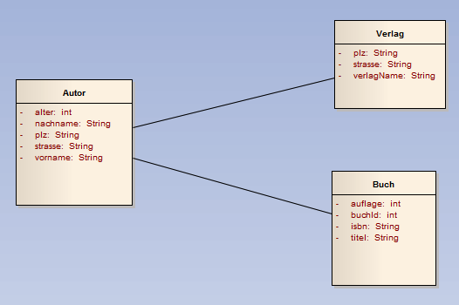
Abbildung 10: Einfaches UML-Modell für das BVA Beispiel
Um nun die Möglichkeiten der BVA Cartridge zu veranschaulichen, sollen folgende Attribute mit entsprechenden Regeln validiert werden:
- Autor::plz → genau 5 Stellen, bestehend aus Zahlen
- Verlag::plz → genau 5 Stellen, bestehend aus Zahlen
- Buch::isbn → 13 Stellen, nur Ziffern, mit Prüfsummenberechnung

Anwendung der Standard BVA Stereotypen
Zunächst muss das mitgelieferte Profil „SimpleJSR303“, welches auf der CD unter „/bva.exporter/Profil/SimpleJSR303_profile.xml“ verfügbar ist, in das Modell eingehängt werden. Eine ausführliche Anleitung zum Einhängen von UML Profilen findet man in Kapitel 4.6.
Nun stehen alle Standardvalidatoren über die „Ressource View“ des Enterprise Architects zur Verfügung und der Stereotyp „BVA_Pattern“ kann nun, wie in Kapitel 4.7. beschrieben, auf die Attribute Autor::plz und Verlag::plz angewendet werden.
Bei beiden plz Attributen wird nun mittels der Tagged Values des Stereotypen BVA_Pattern, die Validierungsregel für die Postleitzahl hinterlegt (Siehe dazu Tabelle 1: Tagged Values für die PLZ Validierung und Abbildung 11: Screenshot der Tagged Values des Stereotyp "BVA_Pattern").

Tag Name | Value
message | Invalid PLZ
regexp | [0-9]{5,5}
Tabelle 1: Tagged Values für die PLZ Validierung
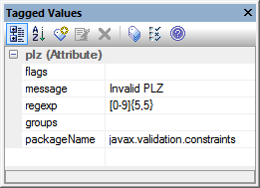
Abbildung 11: Screenshot der Tagged Values des Stereotyp "BVA_Pattern"

Anwendung Benutzerdefinierter Validatoren
Im Falle des Attributes Buch::isbn handelt es sich um eine 13 stellige Zahl, die zum EAN Code kompatibel ist. Die letzte Ziffer ist eine Prüfsumme die aus den zwölf vorherigen Ziffern berechnet werden kann. Da diese Validierung nicht mit den im JSR-303 definierten Standardvalidatoren realisiert werden kann, muss nun ein benutzerdefinierter Validator erstellt werden. Dies geschieht grundsätzlich in drei Schritte:
- Anlegen des benutzerdefinierten Profils und des Stereotyps
- Anlegen der benutzerdefinierten Java Annotation
- Erstellen einer Implementierung des benutzerdefinierten Validators

Erstellen eines benutzerdefinierten BVA Profils
Da für den benutzerdefinierten Validator „Isbn“ noch kein Stereotyp existiert, muss dieser nun in einem eigenem Profil definiert werden.
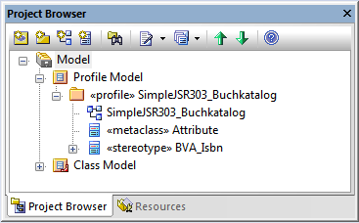
Abbildung 12: Beispiel Profilstruktur für benutzerdefinierte Validatoren
Für diesen Zweck soll eine Profilstruktur wie in Abbildung 12 dargestellt, angelegt werden. Dazu geht man wie folgt vor:
- Rechtsklick auf Model
- „New View…“
- Im „Create New View“ Dialog im Feld Name „Profile Model“ eingeben und mit OK bestätigen.
- Rechtsklick auf die soeben erstellte View und „Add → Add Package…“ auswählen
- Im nun geöffneten „New Package Dialog“ SimpleJSR303_Buchkatalog als Package Namen eingeben (siehe Abbildung 13: Screenshot vom "New Model Package" Dialog im EA) und mit OK bestätigen.
- Den Dialog „New Diagramm“ mit Okay bestätigen.
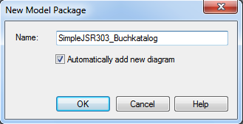
Abbildung 13: Screenshot vom "New Model Package" Dialog im EA
Die Projektstruktur ist jetzt bereits vollständig (siehe dazu Abbildung 14: Screenshot Projektstruktur ohne Stereotyp <<profile>>). Das Package SimpleJSR303_Buchkatalog muss nun lediglich mit dem Stereotyp <<profile>> ausgezeichnet werden, damit es als Profil einsatzbereit ist. Dazu klickt man doppelt auf das Package SimpleJSR303_Buchkatalog und wählt im nun geöffneten Dialog im Feld Stereotype den Eintrag profile aus (siehe dazu Abbildung 15: Screenshot vom Package Dialog im EA).
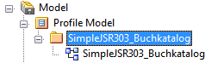
Abbildung 14: Screenshot Projektstruktur ohne Stereotyp <<profile>>
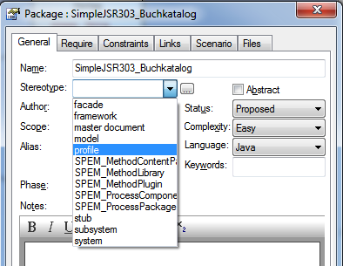
Abbildung 15: Screenshot vom Package Dialog im EA

Erstellen eines benutzerdefinierten BVA Stereotypen
Um nun einen benutzerdefinierten BVA Stereotypen anzulegen öffnet man das SimpleJSR303_Buchkatalog Diagramm, das automatisch unterhalb des neuen Packages SimpleJSR303_Buchkatalog angelegt wurde mit einem Doppelklick auf .
Im Enterprise Architect sollte auf der linken Seite automatisch die Toolbox mit den Profil Elementen geöffnet worden sein (siehe dazu Abbildung 16: Screenshot der Profil Toolbox im EA).
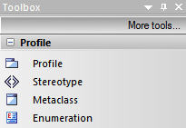
Abbildung 16: Screenshot der Profil Toolbox im EA
Der neue Stereotyp soll nur auf Attribute angewendet werden können, daher muss er von der Metaklasse Attribute abgeleitet werden. Dazu zieht man das Toolboxelement Metaclass per Drag’n’Drop auf die Diagrammfläche. Beim freigeben der Maustaste wird automatisch der Create New Metaclass Dialog geöffnet. In diesem Dialog wählt man als Element Attribute aus und bestätigt diesen mit einem Klick auf OK (siehe dazu Abbildung 17: Screenshot des Create New Metaclass Dialogs im EA). Als nächstes zieht man ebenfalls per Drag’n’Drop das Toolboxelement Stereotype auf die Diagrammfläche. Auch hier öffnet sich automatisch ein Dialog, in welchem man den gewünschten Namen, nämlich BVA_Isbn, eingibt. Der Präfix BVA_ ist hierbei zwingend erforderlich. Zusätzlich müssen dem Stereotyp nun noch einige Attribute hinzugefügt werden, die später im Modell als Tagged Values zur Verfügung stehen sollen.
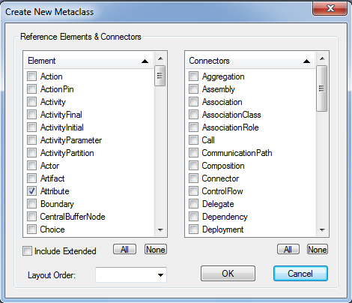
Abbildung 17: Screenshot des Create New Metaclass Dialogs im EA
Dazu klickt man auf den Registerreiter Details und dort auf den Button Attributes. Im nun geöffneten Dialog „BVA_Isbn Attributes“ werden folgende Attribute angelegt (siehe dazu und Abbildung 18: Screenshot der BVA_Isbn Attribute).

Attribut Name | Initial Value
message (String) | Invalid ISBN
packageName (String) | com.tsystems.bva.buchkatalog
Tabelle 2: Attribute des BVA_Isbn Stereotyps

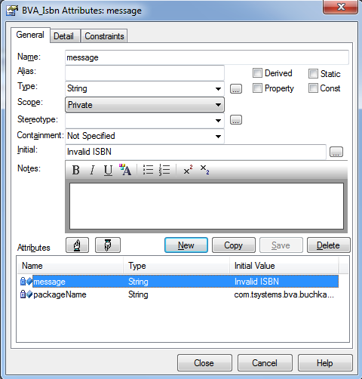
Abbildung 18: Screenshot der BVA_Isbn Attribute
Eine ausführliche Beschreibung zum Anlegen von Attributen findet man in Kapitel 4.3. Mit einem Klick auf Close wird dieser Vorgang abgeschlossen.
Nun muss der Stereotyp nur noch von der Metaklasse ableiten und das Profil ist fertig. Dazu Klickt man einmal mit der linken Maustaste auf den Stereotypen, sodass die sogenannte „Quick Link“ Funktion, wie in Abbildung 19 dargestellt, eingeblendet wird.
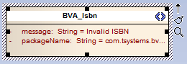
Abbildung 19: Stereotyp mit eingeblendetem Quick Link Symbol
Nun kann man den kleinen schwarzen Pfeil anklicken und per Drag’n’Drop auf die Metaklasse ziehen. Beim Loslassen erscheint ein Popupmenü in welchem man auf Extend klickt (siehe dazu Abbildung 20: Ableiten von einer Metaklasse). Fertig ist das benutzerdefinierte Profil.
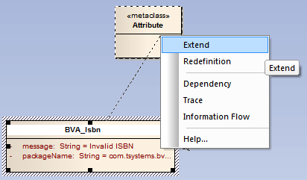
Abbildung 20: Ableiten von einer Metaklasse
Um das eben erstellte Profil im Beispiel Modell verwenden zu können muss dieses zuerst exportiert werden, damit es später über die „Ressourcen View“ wieder importiert werden kann.
Mit einem Rechtsklick auf eine freie Stelle im Profildiagramm öffnet man das Kontextmenü und wählt dort den Punkt „Save as Profile…“ um den Exportdialog zu öffnen. Im nun angezeigten Dialog wählt man eine passende Stelle zum Speichern aus (siehe dazu Abbildung 21: Screenshot vom Profil Export Dialog).
Das exportierte Profil ist bereits Workspace unter „bva.exporter/Profile/SimpleJSR303_Buchkatalog.xml“ zu finden.
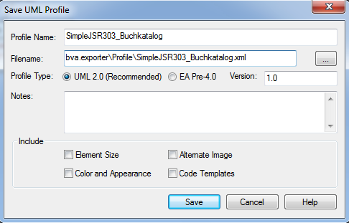
Abbildung 21: Screenshot vom Profil Export Dialog

Verwenden des benutzerdefinierten BVA Profils
Das exportierte Profil muss nun noch in das Beispiel Modell „eingehängt“ werden. Eine Anleitung dazu ist unter Kapitel 4.6 zu finden. Jetzt kann der neue benutzerdefinierte Stereotyp auf das Attribut Buch::isbn wie im Kapitel 4.7 erklärt angewendet werden.

Implementieren des benutzerdefinierten Validators
Damit der benutzerdefinierte Validator auch tatsächlich funktioniert wenn später Quellcode generiert wird und nicht zu einem Fehler führt, muss dieser natürlich auch Java seitig implementiert sein.
Da die verwendeten BVA Stereotypen auf echte Java Annotationen „gemapped“ werden, muss für den benutzerdefinierten Stereotyp BVA_Isbn die entsprechende Java Annotation @Isbn implementiert werden. Die Validierungslogik wird allerdings nicht direkt in der Annotation implementiert sondern in einer separaten Java-Klasse namens IsbnValidator. Wenn die Implementierung des Validators bereits vorliegt, muss nur sichergestellt sein, dass das Package im bva.generator Projekt im Build Path korrekt konfiguriert ist.
package com.tsystems.bva.buchkatalog;

import static java.lang.annotation.ElementType.*;
import static java.lang.annotation.RetentionPolicy.*;

import java.lang.annotation.Documented;
import java.lang.annotation.Retention;
import java.lang.annotation.Target;

import javax.validation.Constraint;

import com.tsystems.bva.buchkatalog.IsbnValidator;

@Target( { FIELD })
@Retention(RUNTIME)
@Constraint(validatedBy = IsbnValidator.class)
@Documented
public @interface Isbn {

String message() default "{validator.isbn}";

Class<?>[] groups() default {};

}
Abbildung 22: Quellcode der Java Annotation @Isbn
Benutzerdefinierte Java Annotationen, wie in Abbildung 22 dargestellt, sind seit Java 1.5 möglich. Wichtig sind die Stichwörter @Target, @Retention und @Constraint.
@Target definiert eine Liste der Java Elemente die annotiert werden dürfen. Möglich sind u.a. Type, Field, Method und Annotation_Type.
@Retention muss auf RUNTIME eingestellt sein, da die Annotationen eben auch noch zur Laufzeit vorhanden sein müssen.
@Constraint(validatedBy = IsbnValidator.class) gibt die Klasse an die zur Validierung der Daten genutzt werden soll.
Die Methoden message() und groups() müssen bei der BVA deklariert sein. Weitere eigene Methoden sind möglich und sollten parallel zu den definierten Tagged Values erstellt werden.
Nun muss noch der Validator wie in Abbildung 23: Quellcodeausschnitt der Klasse IsbnValidator gezeigt, implementiert werden. Der Validator implementiert das ConstrainValidator Interface, welches zwei Typ Parameter spezifiziert. Der erste Parameter spezifiziert den Annotation Typ und der zweite den Datentyp der Elemente, die der Validator verarbeiten kann. Mit der initalize() Methode kann auf alle Attribute zugegriffen werden, die die Annotation definiert (Bei Pattern wäre das bspw. regexp und flag). Die eigentlichen Validierungsregeln werden in der Methode isValid(…) implementiert. Die auf der CD vorhandene Implementierung beinhaltet zusätzlich eine einfache Prüfsummenberechnung.

package com.tsystems.bva.buchkatalog;

import javax.validation.ConstraintValidator;
import javax.validation.ConstraintValidatorContext;

import com.tsystems.bva.buchkatalog.Isbn;

public class IsbnValidator implements ConstraintValidator<Isbn, String> {

public void initialize(Isbn constraintAnnotation) {
// nothing to do
}

public boolean isValid(String isbn,
ConstraintValidatorContext constraintContext) {
// Here the ISBN-13 validation rules must be implemented
// according to Wikipedia http://de.wikipedia.org/wiki/ISBN
if (isbn == null)
return false;

if (isbn.length() != 13)
return false;

// Calculate checksum
// ...
}
}
Abbildung 23: Quellcodeausschnitt der Klasse IsbnValidator
Beide Klassen werden in dem Package erstellt das zuvor in der , unter packageName festgelegt wurde.

Durchführen des Exports mit dem bva.exporter
In diesem Beispiel nutzen wir nicht den common.exporter sondern explizit den bva.exporter. Die hier beschriebenen Einstellungen können aber auch auf dieselbe Weise im common.exporter vorgenommen werden.
Bevor der Exporter gestartet werden kann muss erst noch sichergestellt werden, dass das zuvor in Enterprise Architect erstellte Modell sowie das benutzerdefinierte Profil, korrekt in den Prozess eingebunden sind.

Anpassen der exporter.properties
Dazu müssen in der Datei bva.exporter/oaw/exporter.properties noch einige Dinge beachtet werden.
Im ersten Schritt muss das erstellte Modell zur Verwendung konfiguriert werden. Dazu muss nun im Abschnitt „Model definition“ das erstellte Modell referenziert werden. Mit der Property model.ea_file gibt man den relativen oder auch absoluten Pfad zur Enterprise Architect Datei an. Die model_file Angabe gibt an, an welcher Stelle das XMI des Modells abgelegt werden soll (die Endung *.uml ist beabsichtigt). Die Property model_pkg gibt den voll qualifizierten Namen des Packages an, unterhalb dessen sich das Modell befindet (Angaben wie in Kapitel 3.1). Weiterhin muss noch der Diagramm Name mit der Property model_name Angegeben werden. Zu guter Letzt gibt es noch die Property output_slot die nicht verändert werden darf, da sie für die interne Weiterverarbeitung notwendig ist.
# Model definition
model.ea_file = Model/BVA_Tutorial.EAP
model_file = Model/model.uml
model_pkg = Model/Class Model/BVATutorial
model_name = BVATutorial
output_slot = model
Abbildung 24: Konfiguration des Modells mit der exporter.properties Datei
Die Angabe bei custom_profile_pkg bezeichnet den vollqualifizierten Namen des Packages wie es im Enterprise Architect angelegt wurde und bei custom_profile_name wird dann entsprechend nur der tatsächliche Profilname aufgeführt.
Besonders wichtig ist die Angabe der custom_profile_file Property, da diese den Speicherplatz für das exportierte EMF kompatible XMI angibt. Hierbei ist es wichtig dass diese Datei bereits existiert bevor mit dem nächsten Schritt fortgefahren wird.
Hinweis: Mit custom_profile_file ist nicht die mit dem Profile Exporter des Enterprise Architects manuell erzeugte Datei aus Kapitel 3.3.1 gemeint, sondern die Datei die das Ergebnis der Model-to-Model Transformation des bva.exporters, enthalten soll. Auch die Endung *.uml ist kein Tippfehler sondern so beabsichtigt
Die Property custom_profile.ea_file verweist auf die Enterprise Architect Datei, in welcher das Profil erstellt wurde. In diesem Fall ist es die Model/BVA_Tutorial.EAP Datei.
Hinweis: Es ist nicht zwingend notwendig, dass das Projekt Modell und das Profil in derselben Enterprise Architect Datei modelliert werden.
In Abbildung 25 ist der komplette Abschnitt, der das benutzerdefinierte Profil betrifft, abgebildet.
# Custom Profile definition
custom_profile_pkg = Model/Profile Model/SimpleJSR303_Buchkatalog
custom_profile_name = SimpleJSR303_Buchkatalog
custom_profile_file = Profile/SimpleJSR303_Buchkatalog.profile.uml
custom_profile.ea_file = Model/BVA_Tutorial.EAP
custom_profile_dir = Profile
Abbildung 25: Konfiguration des benutzerdefinierten Profils mit der exporter.properties Datei

Starten des Exportvorgangs
Da nun alle Vorbereitungen getroffen wurden kann der Exportvorgang mit einem Rechtsklick auf die Datei bva.exporter/oaw/profile_exporter.oaw und anschließendem mit einem Klick auf „Run As… → oAW Workflow“ gestartet werden. In der Eclipse Konsole kann der weitere Fortschritt beobachtet werden. Sobald der Workflow abgeschlossen ist erscheint folgende Meldung im Konsolenfenster.
75061 INFO WorkflowRunner - workflow completed in 74026ms!
Hinweise: Sollte sich eine Demo Version des Enterprise Architects im Einsatz befinden, öffnet sich im Hintergrund mehrmals eine Meldung, die per Klick auf Continue Trial bestätigt werden muss.
Die selbe Vorgehensweise muss nun auch noch auf die Datei bva.exporter /oaw/model_exporter.oaw angewendet werden.
Nun liegen alle benötigten Modelle im EMF kompatiblen XMI Format vor.

Durchführen der Code Generierung mit dem bva.generator
Um die Quellcodegenerierung zu starten klickt man mit einem Rechtsklick auf die Datei bva.generator/src/main/resources/profile_exporter.oaw und anschließend auf „Run As… → oAW Workflow“. Nun werden die abstrakten sowie die Interfaceklassen im Verzeichnis bva.generator/src/generated/java mit samt den Packages generiert. Die Implementierungsklassen werden hingegen einmalig unter bva.generator/src/main/java erstellt. Bei allen weiteren Generierungsvorgängen werden diese Dateien nicht überschrieben um manuelle Änderungen am Quellcode zu schützen. Wenn diese Klassen auch neugeneriert werden sollen, müssen diese manuell gelöscht werden.
Auch hier kann der Vorgang in der Eclipse Konsole beobachtet werden. Die erfolgreiche Generierung wird mit der Meldung
INFO - Written 9 files to outlet [default](./src/generated/java)
INFO - workflow completed in 3335ms!
quittiert.
Um zu überprüfen ob die Generierung tatsächlich erfolgreich war, kann man bspw. in der generierten Klasse AbstractBuch nachschauen, ob der benutzerdefinierte Validator BVA_Isbn wie folgt generiert wurde:
@com.tsystems.bva.buchkatalog.Isbn(message = "Invalid ISBN")
private java.lang.String isbn = null;

Dasselbe gilt für die BVA_Pattern Validatoren in den Klassen AbstractAutor und AbstractVerlag die wie folgt aussehen müssen:
@javax.validation.constraints.Pattern(
message = "Invalid PLZ", regexp = "[0-9]{5,5}")
private java.lang.String plz = null;

Anmerkung zum Beispielmodell
Das zweimalige definieren der identischen Validierungsregel für die plz Attribute ist im Beispiel etwas unschön gewählt.
Man stelle sich vor, dass zu einem späteren Zeitpunkt die PLZ Validierung angepasst werden soll, da eine vorher nicht bekannte Einschränkung berücksichtigt werden muss, z.B. dass Feldpost mit einer vierstelligen PLZ ausgezeichnet wird.
Um die Konsistenz der Validierungsregeln für Postleitzahlen bei späteren Änderungen sicherstellen zu können, sollte also besser ein benutzerdefinierter Validator namens BVA_Plz verwendet werden.
Dieses Vorgehen hätte mehrere Vorteile: Zum einen kann der Validator problemlos in späteren Projekten wiederverwendet werden und zum anderen ist bei einer Änderung sichergestellt, dass diese an allen Stellen an denen ein BVA_Plz Validator eingesetzt wird auch tatsächlich zum Tragen kommt.

Anwendung des JPA-Generators anhand eines Beispiels
Dieses Kapitel ist ein Tutorial und dient als Einarbeitung in den MDA-Generator. Anhand eines anschaulichen Beispiels lernt man schnell und einfach die erforderlichen Schritte für die Codegenerierung. Von der Erstellung des UML-Modells mit dem Werkzeug Enterprise Architect über vollständig generierten Javacode bis hin zur Generierung einer DDL-Datei.

Überblick
UML-Modell erstellen
Enterprise Architect Projekt erstellen
JPA-Profil in das UML-Modell einhängen
UML-Klassen mit Attributen erstellen
Stereotypen anwenden
Tagged Values verwenden
Beziehungen modellieren

Exportvorgang aus dem Enterprise Architect in XMI
Voraussetzungen schaffen
Exportieren des JPA-UML-Profils aus dem Enterprise Architect Projekt in XMI
Exportieren des UML-Modells aus dem Enterprise Architect Projekt in XMI

Generierung von Javacode
Workflow Konfiguration
JPA Konfiguration
Javacode generieren

DDL-Generierung

Abbildung 26: Überblick über das Tutorial

Erstellen des Beispiel Modells
- Enterprise Architect Projekt erstellen
Damit ein UML-Modell erstellt werden kann, ist es notwendig, ein neues Enterprise Architect Projekt mit dem Namen Tutorial zu erstellen. Die dafür erforderlichen Schritte sind im Kapitel 4.1 beschrieben. Ablageverzeichnis der Projektdatei sollte das Verzeichnis /Ihr Workspace/jpa.exporter/Model/ sein.
Die Klassen Class1 bis Class3 sowie das Interface1 in der Resources View sollte man entfernen. Sie werden beim Anlegen des Enterprise Architect Projekts automatisch erzeugt. Das Package System sowie das Diagramm System bitte in JpaTutorial umbenennen.
- JPA-Profil in das UML-Modell einhängen
Um das JPA-UML-Profil im Modell verwenden zu können, kann dies wie in Kapitel 4.6 eingehängt werden. Die dafür benötigte XML-Datei SimpleJSR220.xml ist auf der mitgelieferten CD im Profil Ordner zu finden.
- UML-Klassen mit Attributen erstellen
Nun kann das Modell, welches im Beispiel ein reines Entitäten-Modell ist, erstellt werden. Als erstes ist die Klasse „Autor“ mit den Attributen „vorname“, „nachname“, „strasse“ vom Typ String sowie „alter“ und „plz“ von Typ Integer zu erstellen. Die Schritte für die Erstellung und Bearbeitung von Klassen und Attributen sind im 4.2 und Kapitel 4.3 zu finden.
Weitere Klassen mit Attributen (alle haben den Scope „private“), die man erstellen muss:
- Klasse: Buch
  - Attribut: buchId vom Typ int
  - Attribut: auflage vom Typ int
  - Attribut: titel vom Typ String
  - Attribut: isbn vom Typ int
- Klasse: Verlag
  - Attribut: verlagName vom Typ String
  - Attribut: strasse vom Typ String
  - Attribut: plz vom Typ int
- Klasse: Taschenbuch
  - Attribut: format vom Typ String
Somit sind alle Klassen für das Beispielmodell erstellt. Jede Klasse wird später 1:1 mit allen Attributen auf die Datenbank gemappt. Dies bedeutet, jede Klasse entspricht einer Tabelle in einer Datenbank.
- Stereotypen anwenden
Nun kann man die entsprechenden Stereotypen aus dem JPA-UML-Profil auf die UML-Elemente anwenden. Da der MDA-Generator nach dem KISS-Prinzip (Keep it simple and stupid) arbeitet, sind nur wenige Angaben nötig, um eine lauffähige Java-Persistenzschicht zu generieren.
Der Stereotyp „JPA_Entity“ muss zwingend auf jede Klasse angewendet werden, damit diese Klasse später auf eine Datenbank gemappt werden kann. Natürlich sind auch Klassen, welche keine Entitäten sind, im Modell modellierbar und werden somit nicht auf die Datenbank abgebildet. In diesem Fall muss man den Stereotyp „JPA_Entity“ nicht auf eine Klasse anwenden.
Alle anderen Stereotypen sind optional. D.h. wenn man keine weiteren Stereotypen anwendet, generiert der MDA-Generator die für die Persistenzschicht notwendigen Annotationen und Id‘s implizit (wird als Standardfall bezeichnet). Dadurch wird der Modellierungsvorgang stark vereinfacht und dem Entwickler viel Arbeit abgenommen.
Im Standardfall wird der Javacode für Entity-Klassen und Attribute wie folgt generiert:
- Der Klassenname im Modell entspricht dem Tabellenname in der Datenbank
- Das Datenbankschema entspricht dem im „jpa.properties“-File angegebenen Schema
- Jedes Attribut im Modell wird als Attribut für die Datenbank gemappt (Annotation „JPA_Column“)
- Der Attributname im Modell entspricht auch dem Namen in der Datenbank (Annotation „JPA_Column“ ohne Tagged Value)
- Für jede Klasse wird eine Attribut mit dem Namen „id“ vom Typ Integer inkl. der Annotation „@Id“ erzeugt (Primärschlüssel)
Falls man nicht den Standardfall verwenden möchte, sind optionale Stereotypen aus dem JPA-UML-Profil anzuwenden. Wenn noch nicht geschehen, muss der Stereotyp „JPA_Entity“ nun auf alle Klassen im Beispielmodell angewendet werden. Wie dies mit dem Enterprise Architect funktioniert, kann man im Kapitel 4.7 nachlesen.
Im Beispielmodell enthält nur die Klasse „Buch“ eine explizit definierte Id und somit den optionalen Stereotyp „JPA_Id“. Für die anderen Klassen wird implizit eine Id generiert, da diese für die eindeutige Identifikation eines Datensatzes zwingend notwendig ist. Hier ist es notwendig die Id explizit zu definieren, da diese Klasse im Beispiel einen fachlich zusammengesetzten Primärschlüssel enthalten soll. Um das im Beispielmodell zu realisieren, muss auf die Attribute „buchId“ und „auflage“ der Stereotyp „JPA_Id“ angewendet werden. Sobald es mehr als ein angewendeten „JPA_Id“ Stereotyp in einer Klasse gibt, erkennt der MDA-Generator automatisch, dass eine Primärschlüsselklasse generiert werden muss. Die Primärschlüsselklasse ist zur korrekten Identifizierung eines Datensatzes, der nur durch mehrere Primärschlüssel identifiziert werden kann, da.
Als Beispiel für eine weitere optionale Angabe wird der Stereotyp „JPA_Column“ auf das Attribut „strasse“ der Klasse „Autor“ angewendet. Damit ist explizit definiert, dass dieses Attribut auch als Attribut in der Datenbank verwendet wird. Wenn bei dieser Annotation nichts mehr geändert wird, wäre sie unnötig. Denn der Standardfall deckt diesen, wie oben erwähnt, mit ab. Damit diese Angabe nicht unnötig ist, ist dafür ein Tagged Value zu verwenden (siehe Punkt 5.). Sobald in einer Klasse auf ein Attribut die „JPA_Column“ Annotation angewendet wird, muss für alle anderen Attribute, welche in einer Datenbank auch als Attribute erscheinen sollen, die Annotation ebenfalls gesetzt werden. Ansonsten werden diese Attribute in einer Datenbank ignoriert.
- Tagged Values verwenden
Der Datenbankname des Attributs „strasse“ der Klasse „Autor“ soll im Beispiel nicht dem Namen des Attributs im Modell entsprechen, sondern dem Namen „str“. Jetzt kommen die Tagged Values ins Spiel. Manche Stereotypen aus einem Profil haben Tagged Values (siehe Error: Reference source not found). Welcher Stereotyp welche Tagged Values enthält, kann man auf der mitgelieferten CD im Profil Ordner in der Datei „SimpleJSR220-profile.pdf“ anschauen. Zurück zum Name des Attributs „strasse“. Der Tagged Value „name“ muss nun in der Tagged Values View im Enterprise Architect auf „str“ gesetzt werden. Wie dieser Schritt funktioniert, ist im Kapitel 4.8 erklärt.
- Beziehungen modellieren
Der letzte Schritt für die Erstellung des UML-Modells ist, die Beziehungen zwischen den einzelnen Klassen im Modell einzutragen. Wie das mit dem Enterprise Architect realisiert wird, kann im Kapitel 4.5 nachgelesen werden. Die Klassen stehen in folgenden Beziehungen zueinander:
- Autor:Verlag / *:* (ManyToMany) / Typ: Association
- Autor:Buch / 1:* (OneToMany)/ Typ: Aggregation
- Buch:Taschenbuch / Typ: Ableitung (Taschenbuch ist von Buch abgeleitet)
Für die Beziehung „Autor:Verlag“ ist es nicht notwendig, die Multiplicity anzugeben, da der MDA-Generator ohne eine Angabe der Multiplicity implizit eine „*:*“ (ManyToMany) Beziehung annimmt.
Das nun fertig modellierte UML-Modell sollte wie folgt aussehen:
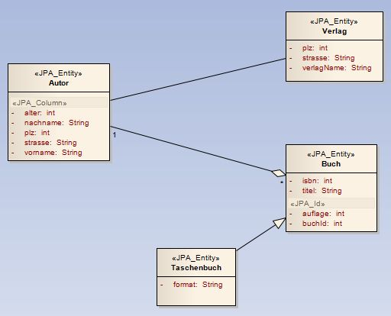
Abbildung 27: UML-Beispielmodell

Exportvorgang aus dem Enterprise Architect in XMI
Der Exportvorgang findet in der oAW-Umgebung im Projekt jpa.exporter statt. Um eine optimale Unterstützung in der oAW-Umgebung (Eclipse) zu haben, wechselt man am besten in die openArchitectureWare Perspektive. In diese gelangt man über das Menü Window – Open Perspective – Other… – openArchitectureWare. Desweiteren ist es zu empfehlen, über die Navigator Ansicht im Workspace zu navigieren. Diese kann über das Menü Window – Show View – Navigator geöffnet werden.
- Voraussetzungen schaffen
Im Auslieferungszustand ist die Datei „SimpleJSR220-profile.eap“ im Verzeichnis „Model“ vorhanden. Falls diese Datei nicht in diesem Verzeichnis liegt, ist es notwendig, sie aus dem Profil Ordner der mitgelieferten CD, in das Verzeichnis /Ihr Workspace/jpa-exporter/Model zu kopieren. Diese Datei enthält das komplette JPA-UML-Profil und wird nachher in das XMI-Format transformiert. Man wundert sich vielleicht, warum das Profil nochmals in einer separaten Enterprise Architect Projektdatei enthalten ist, da es schon im UML-Modell eingehängt ist. Da aber das eingehängte Profil im UML-Modell nur als UML-Erweiterung dient sowie bei der Transformation in XMI nicht als separates Profil transformiert und somit aus oAW nicht wiederverwendet werden kann, muss es in einer einzelnen Datei zur Verfügung stehen. Desweiteren soll es möglich sein, mehrere Profile zu verwenden. Um dafür eine saubere und übersichtliche Strategie einzubringen, ist für jedes UML-Profil eine separate Enterprise Architect Projektdatei notwendig.
- Exportieren des JPA-UML-Profils aus dem Enterprise Architect Projekt in XMI
oAW bietet so genannte Workflow-Dateien, welche den Ablauf einer Generierung oder einer Transformation bestimmt. Um den Generierungsprozess zu starten, muss nur die entsprechende Workflow-Datei ausgeführt werden. Die entsprechende Workflow-Datei für den Export- / Transformationsvorgang ist im Verzeichnis /Ihr Workspace/jpa.exporter/oaw/profile.oaw zu finden.
Jedes oAW-Projekt enthält desweiteren eine Properties-Datei, die eine Konfiguration des Generierungsprozesses beinhaltet. Im „jpa.exporter“ Projekt dient die Datei /Ihr Workspace/jpa.exporter/oaw/workflow.properties dazu. Für den Exportvorgang des UML-JPA-Profils, sind folgende Einstellungen notwendig:
1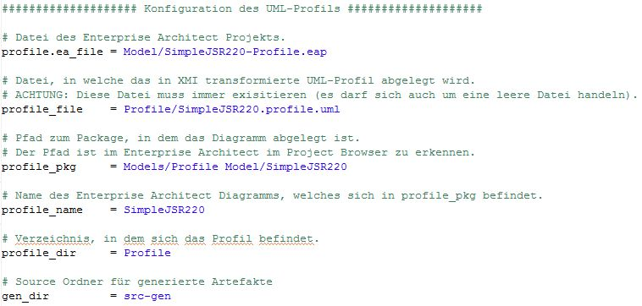
Abbildung 28: workflow.properties – Konfiguration des Profil Exportvorgangs
Desweiteren sollte die Property „project_root“ (Basisverzeichnis) leer sein.
Diese Beispielkonfiguration sowie auch die Konfiguration für das Modell ist bereits in der Datei „workflow.properties“ im Auslieferungszustand enthalten. Weitere Informationen dazu findet man im Kapitel.
Die Datei „SimpleJSR220-Profile.eap“ ist im Auslieferungszustand des Projekts „jpa.exporter“ vorhanden. Zusätzlich ist sie auf der mitgelieferten CD im Profile Verzeichnis zu finden.
Durch diesen Exportvorgang wird die Datei „SimpleJSR220.profile.uml“, die das transformierte XMI-Format hat, generiert.
Per Rechtsklick auf die Datei profile.oaw – Run As – oAW Workflow startet man den Export- / Transformationsvorgang. Falls die Trial Version auf dem PC installiert ist, erscheint ein Dialog mit den Namen „Evalutation Version of Enterprise Architect“. Dieser Dialog kann mit dem Button Continue Trial bestätigt werden. Bei diesem Vorgang wird auf die Datei „SimpleJSR220-Profile.eap“ zugegriffen um es zu transformieren. Voraussetzung ist dadurch ein lauffähiger Enterprise Architect mit einer gültigen Lizenz. In der Konsolen View des Eclipse wurden während des Vorgangs Informationen ausgegeben. Ein erfolgreicher Exportvorgang wird mit folgender Ausgabe bestätigt:
… INFO WorkflowRunner - workflow completed in … ms!
- Exportieren des UML-Modells aus dem Enterprise Architect Projekt in XMI
Für den Exportvorgang des UML-Modells, sind folgende Einstellungen in der Datei „workflow.properties“ notwendig:
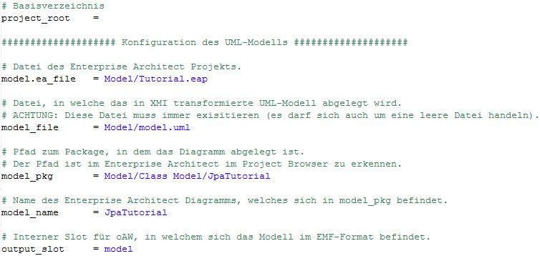
Abbildung 29: workflow.properties – Konfiguration des Modell Exportvorgangs
Das Beispielmodell wurde in Kapitel Error: Reference source not found erstellt und sollte sich bereits im Verzeichnis befinden. Diese Datei wird in XMI transformiert und in der Datei „model.uml“ abgelegt.
Per Rechtsklick auf die Datei model.oaw – Run As – oAW Workflow startet man wieder den Export- / Transformationsvorgang. Anschließend bitte wieder den Enterprise Architect Dialog mit dem Button Continue Trial bestätigen. Der Exportvorgang war erfolgreich, wenn in der Eclipse Konsolen View folgende Ausgabe erscheint:
… INFO WorkflowRunner - workflow completed in … ms!

Generierung von Javacode
Ein Generierungsprozess wird im Projekt „jpa.generator“ durchgeführt. Wie auch im „jpa.exporter“ Projekt gibt es Properties Dateien. Diese sowie auch die Workflow Datei, mit der später der Generierungsprozess gestartet wird, befinden sich im Verzeichnis /Ihr Workspace/jpa.generator/src/main/resources. Im Auslieferungszustand sind die Properties Dateien schon entsprechend konfiguriert. Um schnell einen Einblick zu bekommen, sind die wichtigsten Einstellungsmöglichkeiten trotz der fertigen Konfiguration in diesem Abschnitt erklärt. Wie auch im Exportvorgang sind alle Einstellungen in Properties Dateien zu pflegen.
Im Generator gibt es zwei Properties Dateien:
- workflow.properties -> Konfiguration des Workflows
- jpa.properties -> JPA-Einstellungen
- Workflow Konfiguration
In der „workflow.properties“ Datei gibt es zwei Abschnitte. Der erste Abschnitt betrifft die Konfiguration des JPA-Generators wie z.B. die Einstellung der Ausgabepfade und des UML-Modells sowie des Profils, welche im Exportvorgang erstellt wurden und als Input für den JPA-Generator dienen (siehe Abbildung 30: Konfiguration der JPA-Cartridge in der Datei „workflow.properties).
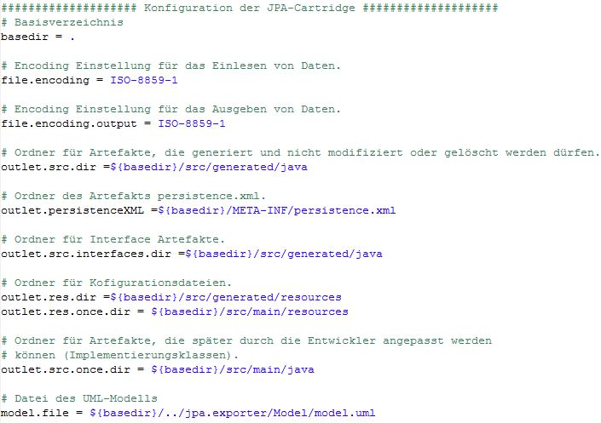
Abbildung 30: Konfiguration der JPA-Cartridge in der Datei „workflow.properties“
Der zweite Abschnitt dient zur Konfiguration der mitbenutzen Javabasic-Cartridge. Mehr Informationen zur Konfiguration der Javabasic Cartridge sind unter
http://fornax.itemis.de/confluence/display/fornax/JavaBasic+(CJB)
zu finden.
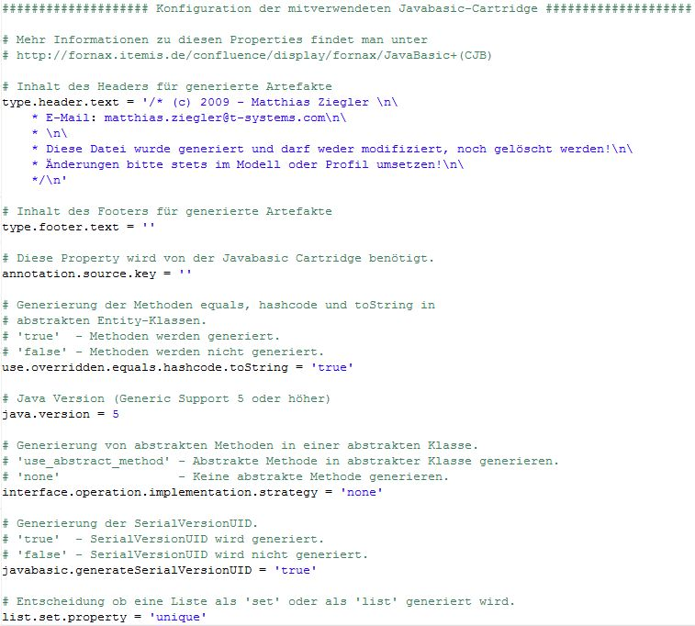
Abbildung 31: Konfiguration der Javabasic-Cartridge in der Datei „workflow.properties“
- JPA Konfiguration
Die Properties Datei „jpa.properties“ ist zur JPA Konfiguration da. Sie definiert den Pfad der „persistence.xml“, weitere Einstellungen zum Mapping der Objekte, das Datenbankschema der Tabellen sowie den Packagename der zu generierenden DAO-Files (siehe Abbildung 32: JPA Konfiguration in der Datei „jpa-properties). Mehr technische Details dazu sind im Kapitel Error: Reference source not found aufgeführt.
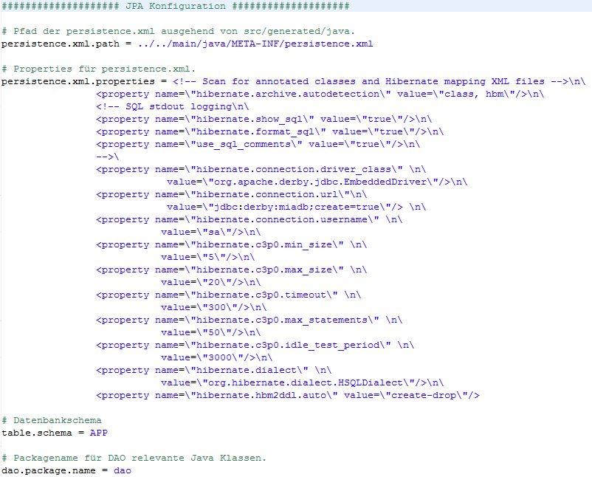
Abbildung 32: JPA Konfiguration in der Datei „jpa-properties“
Wenn beide Properties Dateien fertig konfiguriert sind und das Enterprise Architect Modell sowie das Profil in XMI transformiert wurde, kann der Generierungsprozess gestartet werden. Das Modell und Profil muss man nicht in das Generator Projekt verschieben, es wird direkt aus dem Exporter Projekt gelesen.
- Javacode generieren
Die Datei „workflow.oaw“ per Rechtsklick – Run As – oAW Workflow ausführen. In der Eclipse Konsolen View kann nun kontrolliert werden, ob der Workflow korrekt ausgeführt wurde. Falls dies der Fall ist, wurde für jede Entität ein Interface, eine abstrakte Klasse sowie eine Implementierungsklasse für eigene Methoden generiert. Hierbei gilt es zwischen den generierten Dateien, welche durch einen Entwickler modifiziert werden dürfen und welche nicht, zu unterscheiden. Dateien die nicht modifiziert werden dürfen, befinden sich im Verzeichnis src/generated/java/jpatutorial. Darin sind alle Interfaces und abstrakte Klassen abgelegt. Wenn in diesen Dateien eine Änderung nötig ist, muss dies im UML-Modell geändert werden. Anschließend ist es notwendig, den kompletten Generierungsprozess (inkl. Exportvorgang) wieder durchzuführen. Im Verzeichnis src/main/java/jpatutorial befinden sich alle Implementierungsklassen. Diese werden nur einmalig generiert. Falls ein weiterer Generierungsprozess durchgeführt wird, können die Implementierungsklassen nicht überschrieben werden. So gehen keine Anpassungen eines Entwicklers in der Implementierungsklasse verloren. Falls es dennoch gewünscht ist, die Implementierungsklassen neu zu generieren, muss das Package „JpaTutorial“ einfach gelöscht werden. Anschließend erzeugt der Generator diese Dateien neu.
Um zu verstehen, wie der Generator das UML-Modell in Javacode umsetzt, wird anhand der abstrakten Klassen „AbstractAutor“ und „AbstractBuch“ erklärt (siehe Abbildung 33: Generierte Klasse „AbstractAutor).
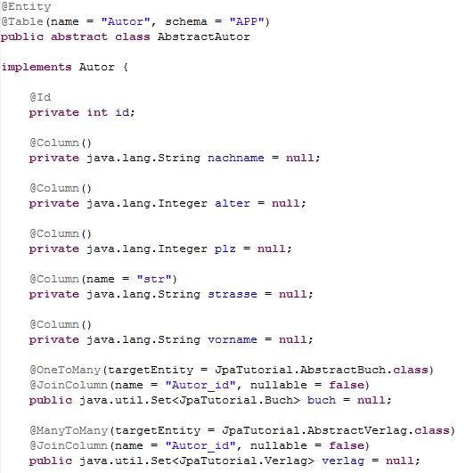
Abbildung 33: Generierte Klasse „AbstractAutor“
Um alle JPA-Annotationen zu unterstützen, ist der Import von „javax.persistence.*“ generiert worden.
Im UML-Modell ist die Klasse Autor mit dem Stereotyp „JPA_Entity“ versehen worden. Dadurch generiert der Generator die Annotation „@Entity“ und damit diese Klasse später auch richtig auf eine Datenbank gemappt werden kann, erzeugt er die Annotation „@Table“ mit den Tagged Values „name“, welcher den Tabellenname beschreibt sowie „schema“, welcher das Schema aus der „jpa.properties“ Datei ausließt.
Für die Klasse Autor ist im UML-Modell keine Id definiert worden. Aus diesem Grund generiert der JPA-Generator automatisch ein Attribut vom Typ Integer und zeichnet diese mit der Annotation „@Id“ aus.
Die Attribute, welche im Modell mit dem Stereotyp „JPA_Column“ ausgezeichnet sind, wurden im Javacode mit der Annotation „@Column“ versehen. Damit sind die Attribute später auch in der Datenbank verfügbar. Speziell für das Attribut „strasse“ ist im UML-Modell der Tagged Value „name“ auf „str“ gesetzt worden, um den Name des Attribut speziell in der Datenbank auf „str“ zu setzen. Aus diesem Grund ist für das Attribut „strasse“ im Javacode auch die „@Column“ Annotation mit dem Tagged Value „name“ generiert worden.
Die Attribute „buch“ und „verlag“ sind dazu da, um die modellierten Beziehungen in Java abzubilden. Die Beziehung „Autor zu Buch“ wurde als „1:*“ Beziehung modelliert. Deswegen wird durch den Generator die Annotation „@OneToMany“ mit dem nötigen Tagged Value „targetEntity“, welche der Zielklasse in der Beziehung entspricht, versehen. Die Annotation „@JoinColumn“ wird für ein korrektes Mapping der Beziehung in die Datenbank generiert. Gleiches Schema gilt für die Beziehung „Autor zu Verlag“, aber eben nur für eine „*:*“ (ManyToMany) Beziehung.
Anschließend wurden die Getter- und Setter sowie die „Equals“ und „Hash Code“ zum Vergleichen der Objekte und die „To String“ Methode generiert.
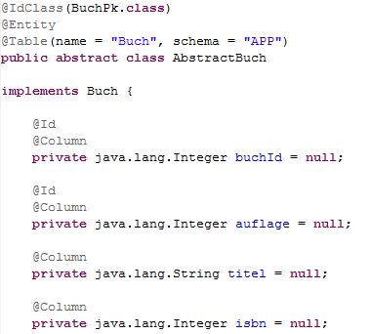
Abbildung 34: Generierte Klasse „AbstractBuch“
In der generierten Klasse „AbstractBuch“ ist an der Annotation „@IdClass“ zu erkennen, dass es einen zusammengesetzten fachlichen Primärschlüssel gibt und eine Primärschlüssel Klasse „BuchPk“ generiert wurde (siehe Abbildung 34: Generierte Klasse „AbstractBuch). Der zusammengesetzte Primärschlüssel besteht aus den Attributen „buchId“ und „auflage“, zu erkennen an der Annotation „@Id“. Ebenfalls erkennbar ist, dass jedes Attribut mit der Annotation „@Column“ annotiert ist, obwohl im Modell dies nicht definiert wurde (Standardfall).
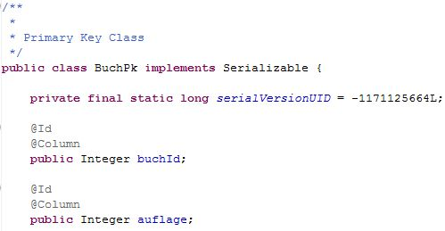
Abbildung 35: Generierte Primärschlüsselklasse „BuchPk.java“
In der Primärschlüsselklasse werden die Attribute nochmals mit den Annotationen „@Id“ und „@Column“ aufgeführt. Dadurch wird der zusammengesetzte fachliche Primärschlüssel richtig in die Datenbank gemappt. Diese Strategie stammt aus einer der vorgeschlagenen Mapping-Strategien des Hibernate Buches.
Im Package DAO sind die benötigten Klassen für die Standard CRUD-Operationen generiert worden. Die Klasse „GenericJpaDAO“ enthält dabei alle wichtigen Methoden dafür. Alle anderen Klassen benötigt die Klasse „GenericJpaDAO“ wiederum, um die Operationen ausführen zu können. Das DAO Package ist, wie von Hibernate beschrieben, aufgebaut. Das gesamte Package wird automatisch generiert und wird vom UML-Modell nicht beeinflusst.
Die durch den zusammengesetzten Primärschlüssel in der Klasse „Buch“ benötigte Primärschlüsselklasse „BuchPk“ wird im selben Package „JpaTutorial“ generiert, in dem auch die abstrakten Klassen und Interfaces liegen. Die Primärschlüsselklasse enthält alle wichtigen Angaben, die für ein korrektes Mapping benötigt werden. Sie ist wie von Hibernate empfohlen, aufgebaut.
Weitere Informationen zu DAO und Primärschlüsselklasse findet man auch im Kapitel Error: Reference source not found.

DDL-Generierung
Die generierte DDL-Datei kann zur Persistierung der Entitäten in eine beliebige Datenbank verwendet werden. Mit diesem Schritt sind alle notwendigen Schritte, von der Modellierung eines UML-Modells, über die Generierung einer Persistenzschicht in Java, bis hin zur Generierung der DDL-Datei, durchgeführt. Wie die DDL-Datei in eine Datenbank persistiert wird, ist nicht Gegenstand dieser Arbeit und wird hier nicht erklärt. Je nach Datenbanktyp ist dieser Schritt unterschiedlich durchzuführen. Klar ist aber, dass die Persistierung ebenfalls mit wenigen einfachen Schritten durchzuführen ist und der dafür zeitliche Aufwand sehr gering ausfällt.
Für die Generierung werden die Hibernate-Tools eingesetzt. Benötigte Bibliotheken befinden sich bereits im lib Verzeichnis und sind im Projekt eingebunden.
Die zur Generierung der DDL-Datei benötigten „persistence.xml“ ist im vorigen Generierungsprozess bereits automatisch erstellt worden. Sie befindet sich im Verzeichnis /Ihr Workspace/jpa.generator/ src/main/java/META-INF.
Um die Generierung der DDL-Datei durchzuführen, muss man die Datei „build.xml“, welche direkt im Basisverzeichnis des Projekts „jpa.generator“ liegt, mit einem Rechtsklick – Run As – Ant Build ausführen. Hierbei bitte aufpassen, es gibt auch die Möglichkeit Ant Build… anzuklicken. Bitte nur Ant Build ausführen.
Daraufhin wird die Datei „sql.ddl“ im Verzeichnis /Ihr Workspace/jpa.generator/ddl generiert. Diese Datei sollte folgenden Inhalt haben:
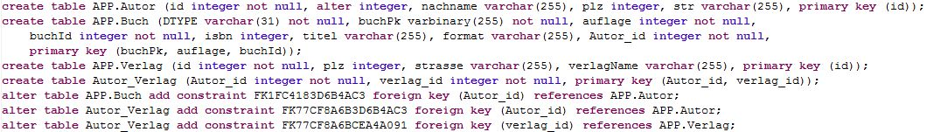
Abbildung 36: Generierte DDL-Datei
Somit ist das Ende des Tutorials erreicht. Wenn man bedenkt, in welch kurzer Zeit eine komplette Persistenzschicht in Java anhand eines UML-Modells generiert wurde, kann man schon grob einschätzen, was für einen großen Vorteil komplexere Softwareprojekte mit diesem Generator haben können.

Tutorial für die gemeinsame Verwendung des JPA- und BVA-Generators
In diesem Kapitel wird anhand eines Beispiels beschrieben, wie der JPA- und BVA-Generator gemeinsam verwendet werden kann. Für diesen Fall ist im Workspace ein weiterer Generator, mit dem Namen Common-Generator entwickelt worden.
Dieses Tutorial beschreibt nur die Schritte genauer, die im vorigen Beispiel noch nicht erklärt wurden.
Äquivalent zu den Projekten „jpa.exporter“, „jpa.generator“, „bva.exporter“, „bva.generator“, gibt es für den Common-Generator ein Projekt „common.exporter“ sowie „common.generator“. Beide Projekte müssen bereits im Workspace importiert sein.

UML-Modell
Da im vorherigen Tutorial bereits ein UML-Modell erstellt wurde, ist das jetzt benötigte UML-Modell mitgeliefert. Es befindet sich auf der CD im Verzeichnis Model des Projektes „common.exporter“.
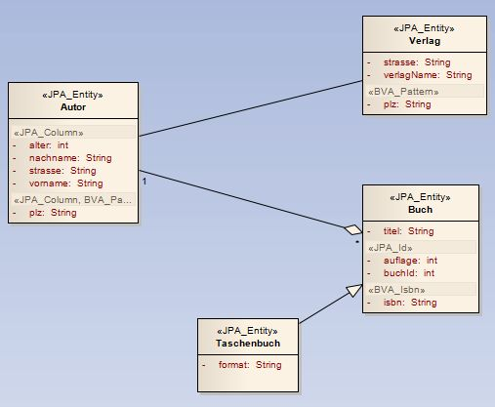
Abbildung 37: UML-Beispiel für den Common Generator
Wie man mit dem Enterprise Architect umgeht sowie weitere Informationen, kann man unter Kapitel 4 nachlesen. Detailliertere Informationen zum Thema Bean Validation API (BVA), findet man in der Diplomarbeit von Herrn Renz.

Exportvorgang aus dem Enterprise Architect in XMI
Der Exportvorgang wird im Projekt „common.exporter“ durchgeführt.
Die entsprechende Konfiguration der „workflow.properties“ Datei ist bereits im Auslieferungszustand des „common.exporter“ Projekts enthalten. Im Prinzip funktioniert die Konfiguration genau wie in Kapitel 4.2.1. Die Besonderheit ist, dass darin nun drei Profile konfiguriert sind. Ein Profil für den JPA-Generator, eines für den BVA-Generator sowie eines für den benutzerdefinierten Validator „Isbn“.
Wenn eine Trial Version des Enterprise Architect im Einsatz ist, erscheint der Evaluierungsdialog des Enterprise Architect für jedes Profil, also drei Mal.
Nachdem die Dateien „profile.oaw“ und „workflow.oaw“ erfolgreich ausgeführt wurden, ist das Profil und Modell aus dem Enterprise Architect in das XMI-Format vollständig exportiert.

Generierung von Javacode
Da nun der JPA- und der BVA-Generator eingesetzt werden kann, gibt es die Möglichkeit, im „common.generator“ Projekt in der „workflow.properties“ Datei, die Generatoren ein- oder aus zuschalten (siehe Error: Reference source not found).
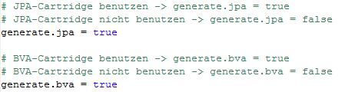
Abbildung 38: Konfigurationsmöglichkeit, welcher Generator im „common.generator“ Projekt zur Generierung verwendet werden soll
Hinweis: Der Common Generator ist vorerst nur zur Verwendung beider Generatoren gleichzeitig implementiert worden. Die Funktion, nur eine der beiden Generatoren einzusetzen, dient als Vorbereitung für später und ist zur Weiterentwicklung eingeplant. Erfolgreich getestet wurde aus Zeitgründen nur der gleichzeitige Einsatz beider Generatoren.
Alle weiteren benötigten Einstellungen sind bereits im Auslieferungszustand enthalten. Weitere Informationen dazu, sind unter Kapitel 4.2.2 bereits äquivalent für den „jpa.generator“ erklärt.
Die „jpa.properties“ müssen immer, auch aus dem „common.generator“ Projekt heraus, im „jpa.generator“ Projekt konfiguriert werden (siehe Kapitel 4.2.2).
Wie auch im „jpa.generator“ Projekt kann man über die Build Datei, welche direkt unter dem Verzeichnis common.generator liegt, die DDL-Datei generieren. In Kapitel 4.2.3 der Diplomarbeit erfährt man mehr darüber.
Nachdem die Datei „workflow.oaw“ erfolgreich ausgeführt wurde und man den JPA- sowie der BVA-Generator zur Generierung verwendet hat, ist in der generierten Datei „AbstractAutor“ folgendes zu sehen:
Abbildung 39: Generiertes Attribut in der Klasse „AbstractAutor“
Für das Attribut „plz“ sind, wie im Modell angegeben, eine Annotation aus dem BVA-Generator sowie eine Annotation aus dem JPA-Generator erzeugt worden.
Die Implementierung des benutzerdefinierten BVA-Validators „Isbn“, findet man im Package „com.tsystems.bva.buchkatalog“ des BVA-Generators.

Wichtige Hinweise zur Modellierung mit dem Enterprise Architect
Dieses Kapitel beschreibt die wichtigsten Schritte, um in kürzester Zeit ein mit dem MDA-Generator kompatibles UML-Modell zu erstellen. Es gibt fast immer mehrere Wege die zum gewünschten Ziel führen. Im Kapitel wird jedoch nur ein Weg, der meiner Ansicht nach einfachste, erklärt. Für weitere Informationen ist eine Dokumentation vom Hersteller Sparx in englischer Sprache unter
http://www.sparxsystems.com/uml_tool_guide/index.html
verfügbar.

Neues Enterprise Architect Projekt erstellen
Um ein neues UML-Modell zu erstellen, muss zuerst ein Enterprise Architect Projekt angelegt werden. Hierzu bitte den Menüpunkt File – New Project… anklicken. Es öffnet sich ein Dialog zur Speicherung der Projektdatei. Wenn der Speicherort ausgewählt wurde, öffnet sich ein weiterer Dialog (siehe Abbildung 40: Screenshot – Auswahl des UML-Modell Typs) zur Auswahl des Modelltyps.
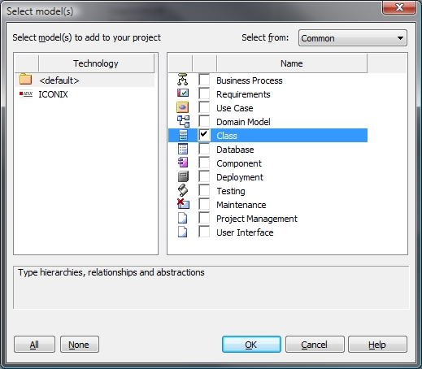
Abbildung 40: Screenshot – Auswahl des UML-Modell Typs
Hier ist Class auszuwählen, um ein kompatibles UML-Modell für den MDA-Generator zu entwerfen. Nachdem dieser Dialog mit OK bestätigt wurde, erscheint rechts in der View „Project Browser“ ein Package mit dem Namen „Class Model“. Dieses Package sowie das darunter liegende „System“ Package muss aufgeklappt werden, damit das Diagramm mit dem Namen „System“ geöffnet und geändert werden kann.
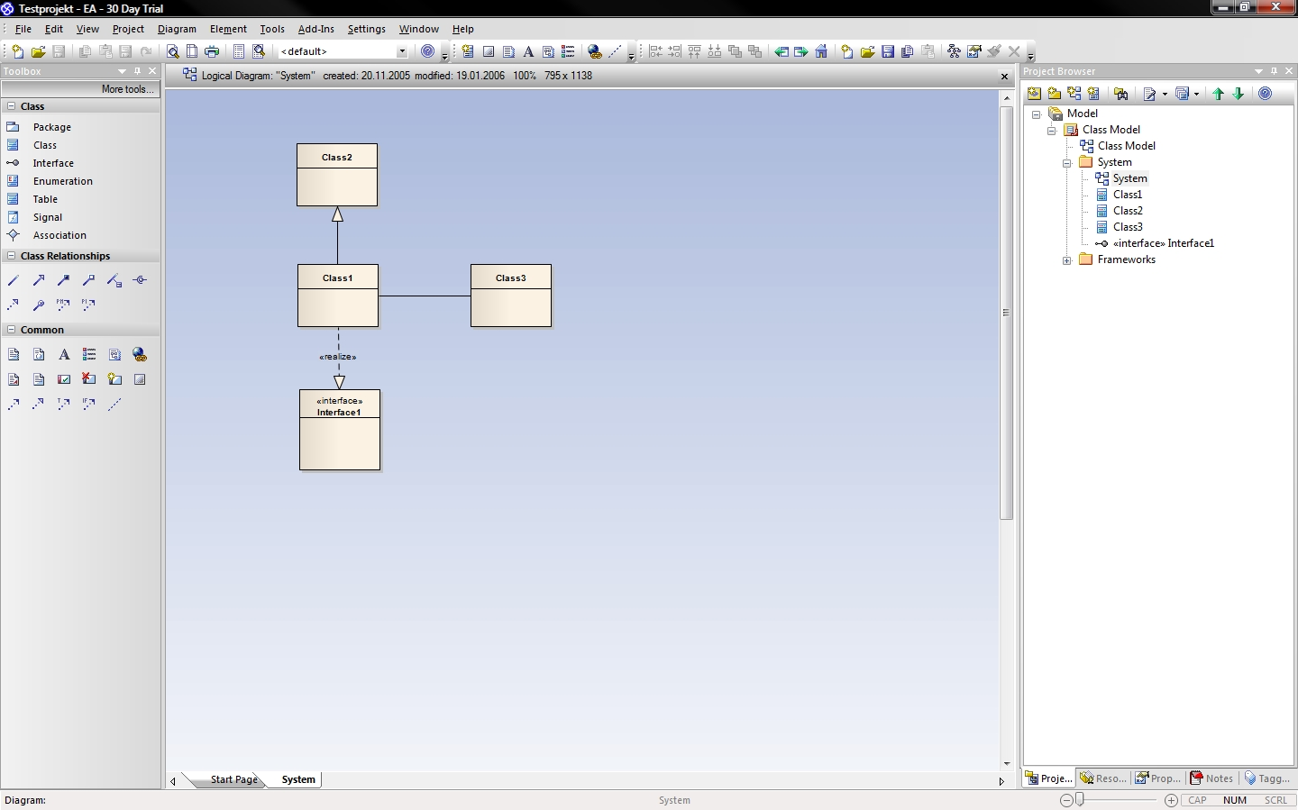
Abbildung 41: Screenshot - Neu erstelltes Enterprise Architect Projekt
Die durch den Enterprise Architect erzeugten Packages, Diagramme und Klassen können nun geändert und umbenannt werden. Um die Namen zu ändern, bitte im „Project Browser“ in den „Properties“, in die man per Rechtsklick auf Package- oder Diagrammname – Properties gelangt, das Feld Name entsprechend ändern. Das Symbol steht für Package und das Symbol für Diagramm.

Neue UML-Klasse erstellen
Eine neue UML-Klasse wird durch das Klicken auf Class, links in der „Toolbox View“ und dass anschließende Ziehen per Drag’n‘Drop auf das Diagramm, erzeugt. Es öffnet sich anschließend der Klassen Dialog. In diesem Dialog können sämtliche Einstellungen für die Klasse vorgenommen werden. Die Stereotypen kann man allerdings erst nach dem Einhängen des Profils angeben. Dieser Vorgang wird in Kapitel 4.6 erklärt.

Attribute erstellen und bearbeiten
Durch doppeltes Klicken auf die UML-Klasse im Diagramm öffnet sich der Klassen Dialog. Im Register Details gibt es die Möglichkeit den Button Attributes… anzuklicken (siehe Abbildung 42: Screenshot – Details Ansicht des Klassen Dialogs)
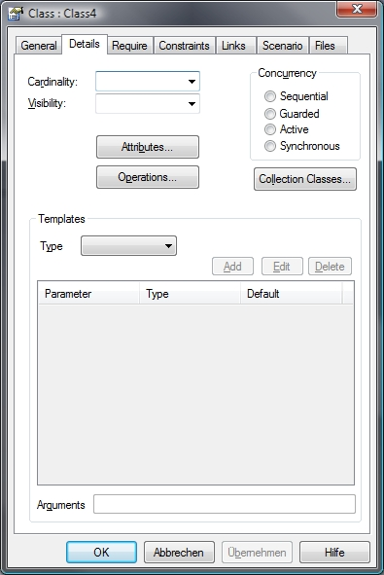
Abbildung 42: Screenshot – Details Ansicht des Klassen Dialogs
Daraufhin erscheint ein weiterer Dialog, um die Attribute anzulegen und zu bearbeiten. Nun müssen die Felder „Name“, „Type“ und „Scope“ ausgefüllt werden. Die Stereotypen können allerdings erst nach dem Einhängen des Profils angegeben werden. Dieser Vorgang wird in Kapitel 4.6 erklärt. Falls der Typ des Attributs nicht im Drop Down Menü zu finden ist, muss man diesen manuell in das Feld eintragen. Wichtig ist beim Anlegen eines Attributs, dass der Save Button geklickt wird sobald die Felder fertig ausgefüllt wurden. Anschließend erscheint in der Attributliste im unteren Bereich des Dialogs das neu erzeugte Attribut (siehe Abbildung 43: Screenshot – Neu erstelltes Attribut in einer UML-Klasse).
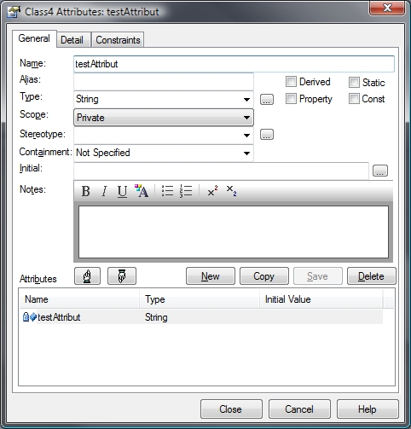
Abbildung 43: Screenshot – Neu erstelltes Attribut in einer UML-Klasse
Um ein Attribut zu bearbeiten, muss man dies in der Attributliste markieren. Nachdem das Attribut fertig bearbeitet wurde, sind mit dem Klick auf den Save Button die Änderungen abgespeichert. Wenn ein Attribut gelöscht werden soll, muss man dies in der Attributliste auswählen und durch den Klick auf den Delete Button löschen.

Methoden erstellen und bearbeiten
Wie auch für Attribute gibt es für Methoden einen eigenen Dialog. In diesen Dialog gelangt man durch doppeltes Klicken auf eine UML-Klasse im Diagramm, dann über den Register Details (siehe Abbildung 42: Screenshot – Details Ansicht des Klassen Dialogs) und über den Operations… Button in diesem Register. Dieser Dialog funktioniert ebenso wie der Dialog für Attribute (siehe Kapitel 4.3). Die Felder „Name“, „Return Type“ und falls es Übergabeparameter gibt, das Feld „Parameters“, müssen angegeben werden. Die Stereotypen kann man allerdings erst nach dem Einhängen des Profils angeben. Dieser Vorgang wird in Kapitel 4.6 erklärt.

Beziehungen erstellen
Der einfachste Weg eine Beziehung zwischen zwei Klassen zu erstellen ist der, indem man eine Klasse durch einen einfachen Linksklick markiert. Es erscheint rechts oben an der markierten Klasse ein Pfeil (siehe Abbildung 44: Screenshot – Markierte UML-Klasse).
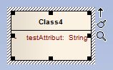
Abbildung 44: Screenshot – Markierte UML-Klasse
Durch einen einfachen Linksklick kann dieser Pfeil auf eine weitere UML-Klasse gezogen werden. Daraufhin erscheint ein Dialog zum Auswählen des Beziehungstyps. Wichtige Typen sind
- Assocation (Assoziation)
- Aggregation
- Composition (Komposition)
- Generalization (Ableitung).
Sobald der Beziehungstyp ausgewählt wurde, ist es notwendig die Kardinalität (im Enterprise Architect wird es Multiplicity genannt) anzugeben. Dazu klickt man doppelt auf die Beziehungsverbindung. Es erscheint ein Dialog mit mehreren Registern. Die beiden Register Source Role und Target Role sind für die Konfiguration interessant. Wie in Abbildung 45 gezeigt, ist die Source Role „TestKlasse1“ und die Target Role „TestKlasse2“. Man muss in beiden Registern die Multiplicity über ein Drop Down Menü angeben. Folgende Angaben sind möglich:
- Source Role Multiplicity: 1, Target Role Multiplicity: 1 -> OneToOne
- Source Role Multiplicity: 1, Target Role Multiplicity: * -> OneToMany
- Source Role Multiplicity: *, Target Role Multiplicity: 1 -> ManyToOne
- Source Role Multiplicity: *, Target Role Multiplicity: * -> ManyToMany
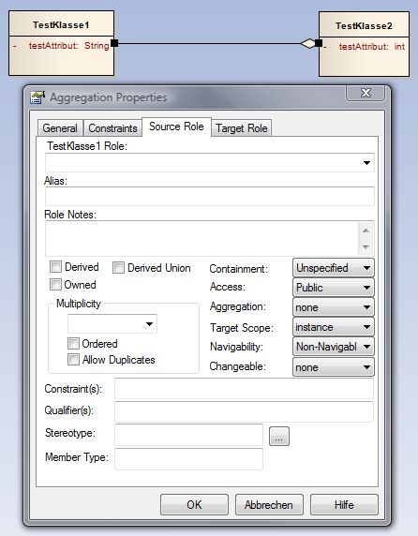
Abbildung 45: Screenshot – Kardinalität einer UML-Beziehung

UML-Profil einhängen
Falls die Resources View im Enterprise Architect noch nicht geöffnet ist, kann man diese über den Menüpunkt View – Resources öffnen. Um ein UML-Profil auszuwählen, kann per Rechtsklick auf UML Profiles – Import Profile und im sich daraufhin öffnenden Dialog der Button … (der Button hat tatsächlich den Namen „…“) geklickt werden. Ein UML-Profil ist stets im XML-Format angegeben. Sobald das UML-Profil über den Datei-Browser ausgewählt wurde, kann über den Import Button das UML-Profil in das Enterprise Architect Projekt eingehängt werden. Die Checkboxen bitte alle im Zustand deaktiviert lassen.

Stereotypen auf ein UML-Element anwenden und löschen
Wenn ein Stereotyp aus einem bestimmten UML-Profil wie z.B. aus dem JPA oder BVA Profil auf ein UML-Element angewendet werden soll, ist das UML-Profil wie in Kapitel 4.6 beschrieben, in das Enterprise Architect Projekt einzuhängen. Zudem wird die Resources View im Enterprise Architect benötigt. Falls diese noch nicht geöffnet ist, kann man sie über den Menüpunkt View – Resources öffnen.
Unter UML Profiles sind die eingehängten Profile zu sehen. Die sich im Profil befindlichen Stereotypen werden darin angezeigt, wenn das Profil in der Resources View aufgeklappt ist (siehe Abbildung 46: Screenshot – UML-Profil in der Resources View).
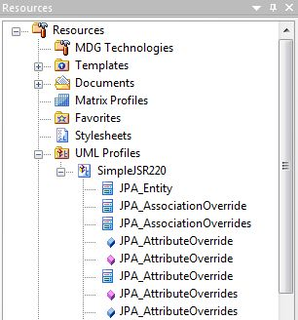
Abbildung 46: Screenshot – UML-Profil in der Resources View
Die Stereotypen werden mit drei verschiedenen Symbolen versehen:
- Dieses Symbol bedeutet, der Stereotyp ist auf eine Klasse anwendbar
- Dieses Symbol bedeutet, der Stereotyp ist auf ein Attribut anwendbar
- Dieses Symbol bedeutet, der Stereotyp ist auf eine Methode anwendbar
Um einen Stereotyp auf ein UML-Element (Klasse, Attribut oder Methode) anzuwenden, ist zuerst die Klasse im Diagramm mit einem einfachen Linksklick und anschließend das gewünschte Element mit einem weiteren einfachen Linksklick zu markieren. Das markierte UML-Element ist am weißen Hintergrund zu erkennen (siehe Abbildung 47: Screenshot – Beispiel eines markierten UML-Elements).
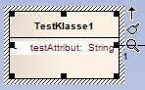
Abbildung 47: Screenshot – Beispiel eines markierten UML-Elements (hier Attribut)
Sobald ein UML-Element markiert ist, kann in der Resources View der entsprechende Stereotyp ausgewählt und per Drag’n’Drop auf das UML-Element gezogen werden. Der Stereotyp erscheint anschließend über dem entsprechenden Element. Diese Vorgehensweise ist für alle UML-Elemente gleich.
Das Löschen von Stereotypen erfolgt je nachdem auf welches UML-Element er angewendet wurde, über den Klassen Dialog (siehe Kapitel 4.2), oder über den Dialog für das Bearbeiten von Attributen (siehe Kapitel 4.3) sowie über den Dialog für das Bearbeiten von Methoden (siehe Kapitel 4.4).
Vorsicht: Sobald ein Stereotyp Tagged Values enthält, löscht der Enterprise Architect die Tagged Values nicht mit. Hier ist es wichtig, die zu dem Stereotyp gehörigen Tagged Values in der Tagged Values View mit dem Delete Button zu löschen. Es ist jederzeit möglich, im mitgelieferten Profil (siehe CD Inhalt im Ordner Profil) nachzuschauen, welche Tagged Values zu einem Stereotyp gehören. Die Tagged Values sind als Attribute modelliert. In Abbildung 48 ist der Stereotyp „OneToMany“ mit seinen Tagged Values „cascade“, „fetch“, „mappedBy“ sowie „targetEntity“ abgebildet.
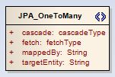
Abbildung 48: Screenshot – Stereotyp „OneToMany” mit Tagged Values

Tagged Values bearbeiten
Tagged Values kann man erst bearbeiten, sobald ein Stereotyp auf ein UML-Element angewendet wurde (siehe Kapitel 4.7) und der Stereotyp Tagged Values enthält.
Um sich Tagged Values anzeigen zu lassen, muss die View Tagged Values geöffnet sein. Diese wird über das Menü View – Tagged Values geöffnet. Anschließend wählt man ein UML-Element (Klasse, Attribut oder Methode) aus. Dafür bitte zuerst die Klasse im Diagramm mit einem einfachen Linksklick und anschließend das gewünschte Element mit einem weiteren einfachen Linksklick markieren. Das markierte UML-Element ist am weißen Hintergrund zu erkennen (siehe Abbildung 47: Screenshot – Beispiel eines markierten UML-Elements). Wenn man in die Resources View wechselt, sind die entsprechenden Tagged Values zu sehen (siehe Abbildung 49: Screenshot – Beispiel Tagged Values View). Vorausgesetzt der Stereotyp beinhaltet Tagged Values.
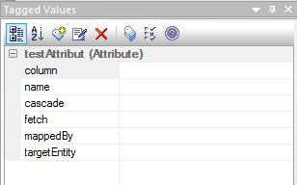
Abbildung 49: Screenshot – Beispiel Tagged Values View für den Stereotyp „OneToMany“
Die Inhalte der Tagged Values kann man nun im rechten Feld anpassen. Falls es sich um ein Tagged Value vom Typ ENUM handelt, wird im entsprechenden Feld ein Drop Down Menü angeboten (siehe Abbildung 50: Screenshot – Tagged Value vom Typ ENUM).
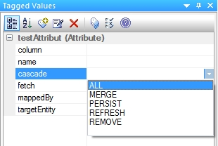
Abbildung 50: Screenshot – Tagged Value vom Typ ENUM
Falls mehrere Stereotypen auf das gleiche UML-Element angewendet wurden und diese Tagged Values enthalten, wird es sehr schnell unübersichtlich welcher Tagged Value zu welchem Stereotyp gehört. Dafür gibt es die Option Show Fully Qualified Tags (siehe Abbildung 51: Screenshot –Tagged Value View mit Option Show Fully Qualified Tags). Vorsicht: Wenn diese Option aktiviert ist, dürfen die Tagged Values nicht verändert werden. Vorher muss die Option erst wieder deaktiviert werden (siehe Kapitel 4.9.1).

Bekannte Bugs
Es gibt leider einige bekannte Bugs im Zusammenhang mit dem Enterprise Architect und dem später erfolgenden Exportvorgang aus dem Projekt in das XMI-Format. Für diese Bugs wurden bisher keine Workarounds gefunden. Genau diese Bugs werden hier aufgeführt, da sie für die Modellierung ausschlaggebend sind. Um in den nächsten Versionen auf Bugfixes hoffen zu können, sind Tickets bei den entsprechenden Entwicklern eröffnet worden.

Tagged Values mit Option Show Fully Qualified Tags
Beschreibung:
Sobald in der Tagged Values View die Option Show Fully Qualified Tags ausgewählt ist und man in dieser View Tagged Values verändert, werden die Tagged Values im Generierungsprozess nicht berücksichtigt und fehlen somit im Javacode. Es ist aber dennoch möglich, sich über die Option Show Fully Qualified Tags kurz einen Überblick zu verschaffen, es dürfen lediglich keine Änderungen durchgeführt werden.
Eigentlich ist diese Funktion sehr hilfreich. Denn sobald mehrere Stereotypen auf ein UML-Element angewendet sind, erkennt man in der Tagged Values View leider nur noch an der Reihenfolge der angewendeten Stereotypen, welcher Tagged Value zu welchem Stereotyp gehört (siehe Abbildung 51: Screenshot –Tagged Value View mit Option Show Fully Qualified Tags).
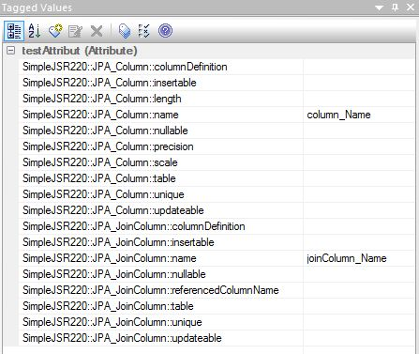
Abbildung 51: Screenshot –Tagged Value View mit Option Show Fully Qualified Tags
Fehlerbeseitigung:
Falls die Option Show Fully Qualified Tags aktiviert wurde, müssen folgende Schritte für jedes UML-Element auf das ein Stereotyp mit Tagged Values angewendet ist, durchgeführt werden:
- UML-Element markieren (Hintergrund des Elements muss weiß sein)
- In der Tagged Values View jeden Tagged Value mit dem Delete Button löschen
- Den auf das UML-Element angewendeten Stereotyp entfernen
Anschließend ist es notwendig, in der Tagged Values View die Option Show Fully Qualified Tags wieder zu deaktivieren.

Mehrere gleiche Tagged Values für ein UML-Element
Beschreibung:
Wenn man auf dasselbe UML-Element mehrere Stereotypen anwendet, die eine gleiche Tagged Value Bezeichnung haben, wird der zuletzt gesetzte Tagged Value Wert für alle Tagged Values mit der gleichen Bezeichnung übernommen.
Beispiel:
In der Klasse „TestKlasse1“ ist auf das Attribut „testAttribut“ die Stereotypen „JPA_Column“ und „JPA_JoinColumn“ angewendet (siehe Abbildung 52: Screenshot – Beispiel mit mehreren angewendeten Stereotypen auf ein Attribut.).
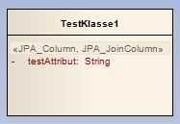
Abbildung 52: Screenshot – Beispiel mit mehreren angewendeten Stereotypen auf ein Attribut.
Beide Stereotypen haben ein Tagged Value „name“ (siehe Abbildung 53: Screenshot – Beispiel mit mehreren gleichen Tagged Values für ein UML-Element). Genau in so einem Fall haben im später generierten Code beide Tagged Values den Wert „joinColumn_Name“ und nicht wie erwartet der Tagged Value „JPA_Column::name“ den Wert „column_Name“ und „JPA_JoinColumn::name“ den Wert „joinColumn_Name“.
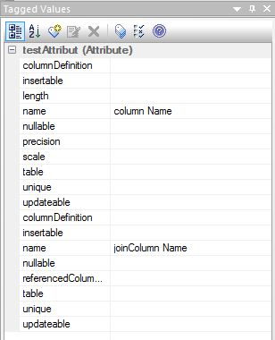
Abbildung 53: Screenshot – Beispiel mit mehreren gleichen Tagged Values für ein UML-Element
Fehlerbeseitigung:
Für diesen Fall gibt es derzeit keine Fehlerbeseitigung.

Beim Löschen von Stereotypen werden zugehörige Tagged Values nicht mit gelöscht
Beschreibung:
Sobald auf ein UML-Element angewendeter Stereotyp gelöscht wird und dieser Tagged Values enthält, werden die Tagged Values nicht mit gelöscht. Sie sind weiterhin in der „Tagged Values View“ zu sehen.
Fehlerbeseitigung:
In der „Tagged Values View“ muss jeder Tagged Value, der zu dem gelöschten Stereotyp gehört, über den Delete Button gelöscht werden.

Abbildungsverzeichnis
Abbildung 1: Screenshot vom Workspace Launcher 9
Abbildung 2: Screenshot vom Preferences Dialog des Java Compilers 10
Abbildung 3: Screenshot vom Eclipse Software Update Manager 11
Abbildung 4: Screenshot vom Preferences Dialog zum Verwalten der verfügbaren Metamodelle in openArchitectureWare 12
Abbildung 32: UML2 Profile in openArchitectureWare aktivieren 12
Abbildung 6: Screenshot des Importassistenten 13
Abbildung 7: Screenshot des Assistenten zum auswählen der Cartridges 14
Abbildung 8: Screenshot des Importvorgangs 15
Abbildung 9: Screenshot des Project Explorers nach dem erfolgreichen Import 15
Abbildung 10: Einfaches UML-Modell für das BVA Beispiel 19
Abbildung 11: Screenshot der Tagged Values des Stereotyp "BVA_Pattern" 20
Abbildung 12: Beispiel Profilstruktur für benutzerdefinierte Validatoren 21
Abbildung 13: Screenshot vom "New Model Package" Dialog im EA 22
Abbildung 14: Screenshot Projektstruktur ohne Stereotyp <<profile>> 22
Abbildung 15: Screenshot vom Package Dialog im EA 23
Abbildung 16: Screenshot der Profil Toolbox im EA 23
Abbildung 17: Screenshot des Create New Metaclass Dialogs im EA 24
Abbildung 18: Screenshot der BVA_Isbn Attribute 25
Abbildung 19: Stereotyp mit eingeblendetem Quick Link Symbol 26
Abbildung 20: Ableiten von einer Metaklasse 26
Abbildung 21: Screenshot vom Profil Export Dialog 27
Abbildung 22: Quellcode der Java Annotation @Isbn 28
Abbildung 23: Quellcodeausschnitt der Klasse IsbnValidator 29
Abbildung 24: Konfiguration des Modells mit der exporter.properties Datei 30
Abbildung 25: Konfiguration des benutzerdefinierten Profils mit der exporter.properties Datei 31
Abbildung 23: Überblick über das Tutorial 35
Abbildung 27: UML-Beispielmodell 39
Abbildung 28: workflow.properties – Konfiguration des Profil Exportvorgangs 40
Abbildung 29: workflow.properties – Konfiguration des Modell Exportvorgangs 41
Abbildung 30: Konfiguration der JPA-Cartridge in der Datei „workflow.properties“ 43
Abbildung 31: Konfiguration der Javabasic-Cartridge in der Datei „workflow.properties“ 44
Abbildung 32: JPA Konfiguration in der Datei „jpa-properties“ 45
Abbildung 33: Generierte Klasse „AbstractAutor“ 46
Abbildung 34: Generierte Klasse „AbstractBuch“ 47
Abbildung 35: Generierte Primärschlüsselklasse „BuchPk.java“ 48
Abbildung 36: Generierte DDL-Datei 50
Abbildung 37: UML-Beispiel für den Common Generator 51
Abbildung 38: Konfigurationsmöglichkeit, welcher Generator im „common.generator“ Projekt zur Generierung verwendet werden soll 52
Abbildung 39: Generiertes Attribut in der Klasse „AbstractAutor“ 53
Abbildung 40: Screenshot – Auswahl des UML-Modell Typs 55
Abbildung 41: Screenshot - Neu erstelltes Enterprise Architect Projekt 56
Abbildung 42: Screenshot – Details Ansicht des Klassen Dialogs 57
Abbildung 43: Screenshot – Neu erstelltes Attribut in einer UML-Klasse 58
Abbildung 44: Screenshot – Markierte UML-Klasse 59
Abbildung 45: Screenshot – Kardinalität einer UML-Beziehung 60
Abbildung 46: Screenshot – UML-Profil in der Resources View 61
Abbildung 47: Screenshot – Beispiel eines markierten UML-Elements (hier Attribut) 62
Abbildung 48: Screenshot – Stereotyp „OneToMany” mit Tagged Values 62
Abbildung 49: Screenshot – Beispiel Tagged Values View für den Stereotyp „OneToMany“ 63
Abbildung 50: Screenshot – Tagged Value vom Typ ENUM 63
Abbildung 51: Screenshot –Tagged Value View mit Option Show Fully Qualified Tags 65
Abbildung 52: Screenshot – Beispiel mit mehreren angewendeten Stereotypen auf ein Attribut. 66
Abbildung 53: Screenshot – Beispiel mit mehreren gleichen Tagged Values für ein UML-Element 66

Tabellenverzeichnis
Tabelle 1: Tagged Values für die PLZ Validierung 20
Tabelle 2: Attribute des BVA_Isbn Stereotyps 25

Literaturverzeichnis
Brawand, U. (2009). UML2Exporter. Von http://uml2ea.blogspot.com/ abgerufen
Eclipse Foundation and Others. (2009). Eclipse Modeling Framework Project. Von http://www.eclipse.org/modeling/emf/ abgerufen
itemis AG. (2009). JavaBasic-Cartridge. Von http://fornax.itemis.de/confluence/display/fornax/JavaBasic+(CJB) abgerufen
Java Community Process (verschiedene Firmen beteiligt). (16. März 2009). JSR 303: Bean Validation 1.0 RC1 Proposed Final Draft. Von http://www.jcp.org/en/jsr/summary?id=303 abgerufen
No Magic Inc. (2009). Magi Draw. Von http://www.magicdraw.com/ abgerufen
Object Management Group. (2009). OMG Model Driven Architecture. Von http://www.omg.org/mda/ abgerufen
Object Management Group. (2009). OMG Modeling and Metadata Specification. Von http://www.omg.org/technology/documents/modeling_spec_catalog.htm#UML abgerufen
openArchitectureWare. (2009). openArchitectureWare Projekt. Von http://www.openarchitectureware.org abgerufen
Wikipedia Foundation and Others. (2009). Wikipedia (English). Von http://en.wikipedia.org/ abgerufen
Wikipedia Stiftung und Andere. (2009). Wikipedia (deutsch). Von http://de.wikipedia.org/ abgerufen

Stichwortverzeichnis

Ableitung 38
Aggregation 38, 59
Annotation 27, 37, 38, 47, 48, 53
Annotationen 46, 48
Assoziation 59
Attribut 36, 37, 47, 48, 57, 61
Attribute 35, 37, 38, 48
Beispiel Modell 18, 35
benutzerdefinierter Stereotyp 23
benutzerdefinierter Validator 21, 27
Beziehung 59
Beziehungen 38, 47
Bug 64
BVA 51, 53, 61
bva.exporter 13
bva.generator 13, 18, 32
Cartridge 13
common.exporter 13
common.generator 13
CRUD-Operationen 48
DDL-Datei 34, 49, 53
Eclipse 6, 7
Eclipse Modeling Framework 10
Enterprise Architect 7, 37, 52, 54
exporter.properties 30
Generalisierung 59
Importieren 15
Installation 7
Java Compiler compliance Levels 9
JDK 7
jpa 35, 40, 49
JPA 61
jpa.exporter 13
jpa.generator 13
Kardinalität 59
Klasse 36, 45, 48, 61
Komposition 59
ManyToMany 59
ManyToOne 59
Mapping-Strategien 48
Metaklasse 23, 26
Methode 47, 61
Methoden 48
Multiplicity 38, 59
oAW 39
OneToMany 38, 47, 59
OneToOne 59
openArchitectureWare 7, 39
Persistenzschicht 36, 49, 50
Persistierung 49
Primärschlüssel 37, 48
Primärschlüsselklasse 37, 48
profile 39
Show Fully Qualified Tags 64
SimpleJSR303 20
Stereotyp 27, 37, 61
Systemvoraussetzungen 6
Tagged Value 20, 62, 64
Tagged Values 38
UML-Klasse 56
UML-Profil 26, 60
workflow 52
Workflow 40
Workspace 8, 9
XMI 64
XMI-Format 41

Siehe dazu CrossOver im Literaturverzeichnis
Siehe dazu openArchitectureWare Website im Literaturverzeichnis
Class, interface, enum etc.
Der Annotation_Type wird benötigt, wenn man eine Annotation mit einer weiteren Annotation auszeichnen möchte. Ermöglicht sozusagen verschachtelte Annotationen.
Von Stereotypen spricht man im UML-Modell und in Java von Annotationen.
Siehe im Literaturverzeichnis den Eintrag „JAVA Persistence with Hibernate“
Siehe im Literaturverzeichnis den Eintrag „JAVA Persistence with Hibernate“
Siehe im Literaturverzeichnis den Eintrag „JAVA Persistence with Hibernate“
Die Extensible Markup Language (engl. für „erweiterbare Auszeichnungssprache“), abgekürzt XML, ist eine Auszeichnungssprache zur Darstellung hierarchisch strukturierter Daten in Form von Textdaten. XML wird u. a. für den Austausch von Daten zwischen Computersystemen eingesetzt, speziell über das Internet.

