Running Log Summary

Data Summary: Numeric Variables
Variable | Mean | SD | Min | Med | Max
date | 20196.8 | 280.6 | 19711.0 | 20213.0 | 20652.0
start_time | 8.7 | 3.3 | 0.1 | 7.6 | 21.2
afternoon | 0.1 | 0.3 | 0.0 | 0.0 | 1.0
dist | 8.6 | 6.0 | 0.8 | 6.1 | 42.2
dist_log | 2.1 | 0.5 | 0.6 | 2.0 | 3.8
pace | 5.3 | 0.5 | 4.5 | 5.2 | 7.7
gain | 21.6 | 34.8 | 0.0 | 8.0 | 272.0
change | -2.5 | 36.4 | -489.2 | 0.0 | 150.0
hills | 4.5 | 6.8 | 0.0 | 2.8 | 53.1
net_change | -0.0 | 1.4 | -11.6 | 0.0 | 18.6
inj_ill | 0.1 | 0.2 | 0.0 | 0.0 | 1.0
sleep | 85.0 | 5.7 | 50.0 | 86.0 | 94.0
vigorous | 59.5 | 25.7 | 5.0 | 62.0 | 99.0
peak | 35.8 | 26.8 | 0.0 | 34.0 | 93.0
temp | 11.5 | 8.7 | -8.0 | 11.0 | 36.0
dew | 2.5 | 6.3 | -22.0 | 2.0 | 24.5
sun | 0.2 | 0.3 | 0.0 | 0.0 | 1.0
weather | 0.0 | 0.2 | 0.0 | 0.0 | 1.0
shoe | 3.8 | 2.2 | 1.0 | 4.0 | 10.0
shoe_dist | 240.5 | 171.1 | 4.0 | 207.0 | 754.4

Data Summary: Categorical Variables
Variable | Category | N | %
dist_fac | 0-2.5 | 8 | 1.9
 | 2.5-7.5 | 243 | 59.1
 | 7.5-15 | 110 | 26.8
 | 15-25 | 38 | 9.2
 | 25+ | 12 | 2.9
type | Easy Effort | 7 | 1.7
 | Medium Effort | 357 | 86.9
 | Hard Effort | 36 | 8.8
 | Race Effort | 11 | 2.7
race | Non-Race | 400 | 97.3
 | Race Effort | 11 | 2.7
surface | Road | 350 | 85.2
 | Treadmill | 48 | 11.7
 | Track | 13 | 3.2
elevation | Base Elevation | 387 | 94.2
 | Low Elevation | 15 | 3.6
 | High Elevation | 9 | 2.2
sh_type | CF Plate | 7 | 1.7
 | Daily Max | 385 | 93.7
 | Nylon Plate | 19 | 4.6

Model Summary
+--------------------------------------------------+----------------+
| | (1) |
+==================================================+================+
| Intercept | 5.697*** |
+--------------------------------------------------+----------------+
| | [5.282, 6.145] |
+--------------------------------------------------+----------------+
| Weather (0 = Good, 0.5 = Okay, 1 = Bad) | 1.013 |
+--------------------------------------------------+----------------+
| | [0.992, 1.034] |
+--------------------------------------------------+----------------+
| Sun (0 = Cloudy, 0.5 = Partly Cloudy, 1 = Sunny) | 1.024** |
+--------------------------------------------------+----------------+
| | [1.007, 1.040] |
+--------------------------------------------------+----------------+
| Medium Effort Run (vs. Easy) | 0.910*** |
+--------------------------------------------------+----------------+
| | [0.878, 0.944] |
+--------------------------------------------------+----------------+
| Hard Effort Run (vs. Easy) | 0.891*** |
+--------------------------------------------------+----------------+
| | [0.858, 0.925] |
+--------------------------------------------------+----------------+
| Race Effort Run (vs. Easy) | 0.819*** |
+--------------------------------------------------+----------------+
| | [0.783, 0.857] |
+--------------------------------------------------+----------------+
| Treadmill (vs. Road) | 0.993 |
+--------------------------------------------------+----------------+
| | [0.974, 1.013] |
+--------------------------------------------------+----------------+
| Track (vs. Road) | 0.963* |
+--------------------------------------------------+----------------+
| | [0.934, 0.993] |
+--------------------------------------------------+----------------+
| Time of Run (0/1, 1 = After Noon) | 1.004 |
+--------------------------------------------------+----------------+
| | [0.991, 1.018] |
+--------------------------------------------------+----------------+
| Low Elevation (vs. Base) | 1.025+ |
+--------------------------------------------------+----------------+
| | [0.998, 1.052] |
+--------------------------------------------------+----------------+
| High Elevation (vs. Base) | 1.073*** |
+--------------------------------------------------+----------------+
| | [1.037, 1.110] |
+--------------------------------------------------+----------------+
| Health Status (0/1, 1 = Recently Injured or Ill) | 1.060*** |
+--------------------------------------------------+----------------+
| | [1.041, 1.079] |
+--------------------------------------------------+----------------+
| Sleep Score | 1.000 |
+--------------------------------------------------+----------------+
| | [0.999, 1.001] |
+--------------------------------------------------+----------------+
| Date (Smooth) | *** |
+--------------------------------------------------+----------------+
| Distance (Smooth) | *** |
+--------------------------------------------------+----------------+
| Temperature and Dew Point (Smooth) | + |
+--------------------------------------------------+----------------+
| Hills (Smooth) | ** |
+--------------------------------------------------+----------------+
| Num.Obs. | 411 |
+--------------------------------------------------+----------------+
| R2 | 0.765 |
+--------------------------------------------------+----------------+
| AIC | -78.1 |
+--------------------------------------------------+----------------+
| BIC | 65.2 |
+--------------------------------------------------+----------------+
| RMSE | 0.22 |
+==================================================+================+
| + p < 0.1, * p < 0.05, ** p < 0.01, *** p < 0.001 |
+==================================================+================+
Table: Running Pace GAM Model, Gamma Function with Log Link

GAM Diagnostics
Method: REML Optimizer: outer newton
full convergence after 10 iterations.
Gradient range [-1.592762e-05,1.871677e-05]
(score 25.99223 & scale 0.001591395).
Hessian positive definite, eigenvalue range [1.592587e-05,196.207].
Model rank = 54 / 54
Basis dimension (k) checking results. Low p-value (k-index<1) may
indicate that k is too low, especially if edf is close to k'.
k' edf k-index p-value
s(date) 20.00 9.36 0.92 0.03 *
s(dist) 3.00 2.48 1.05 0.85
te(temp,dew) 15.00 5.18 1.07 0.93
s(hills) 3.00 1.84 1.06 0.82
---
Signif. codes: 0 ‘***’ 0.001 ‘**’ 0.01 ‘*’ 0.05 ‘.’ 0.1 ‘ ’ 1
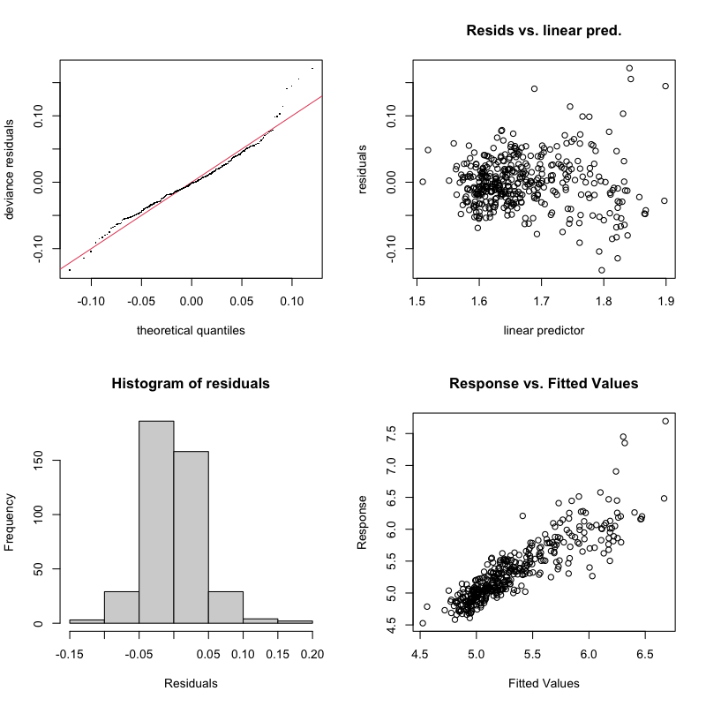

Smooths A
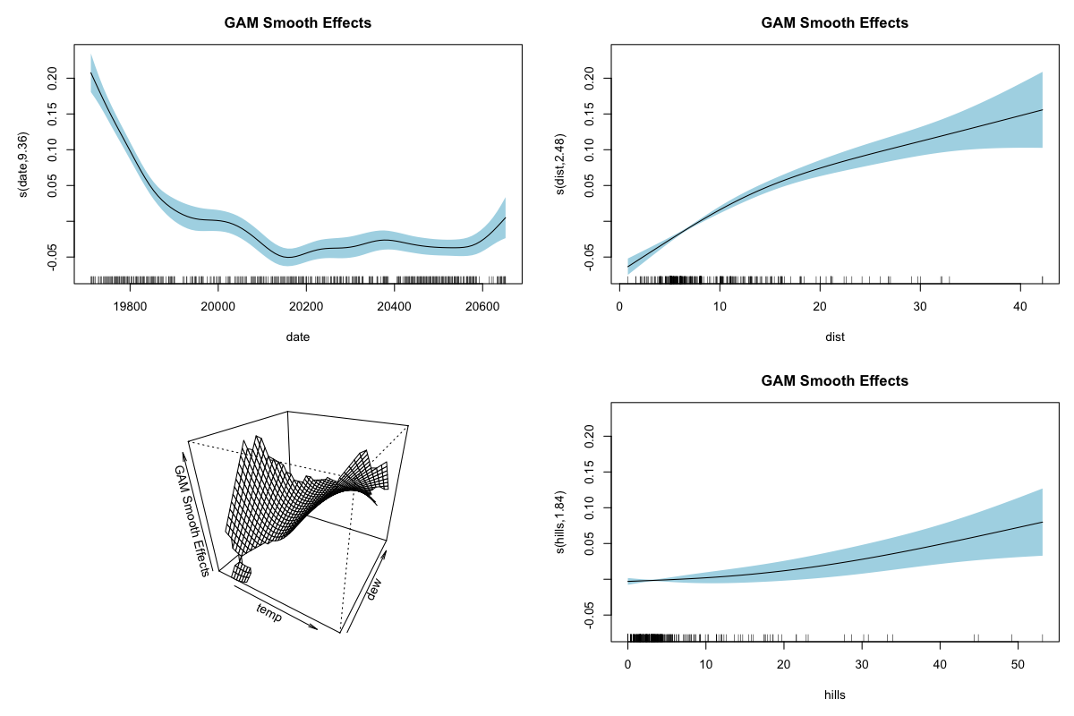

Smooths B
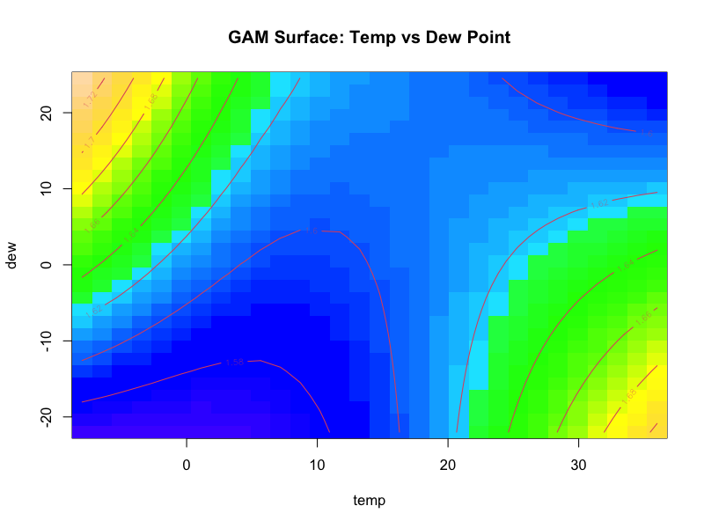

ACF
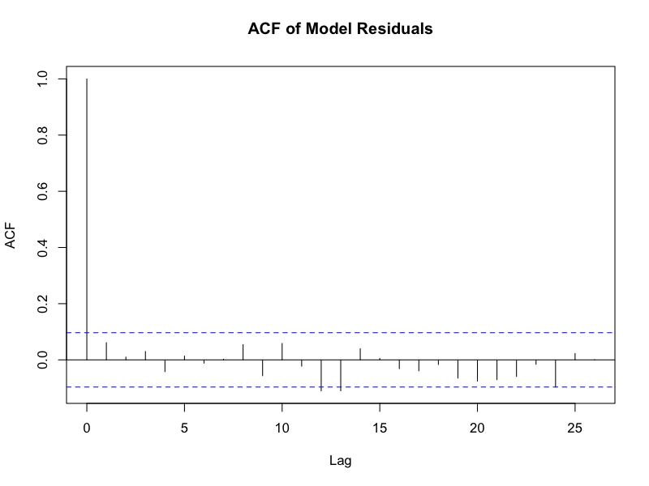

Predictions
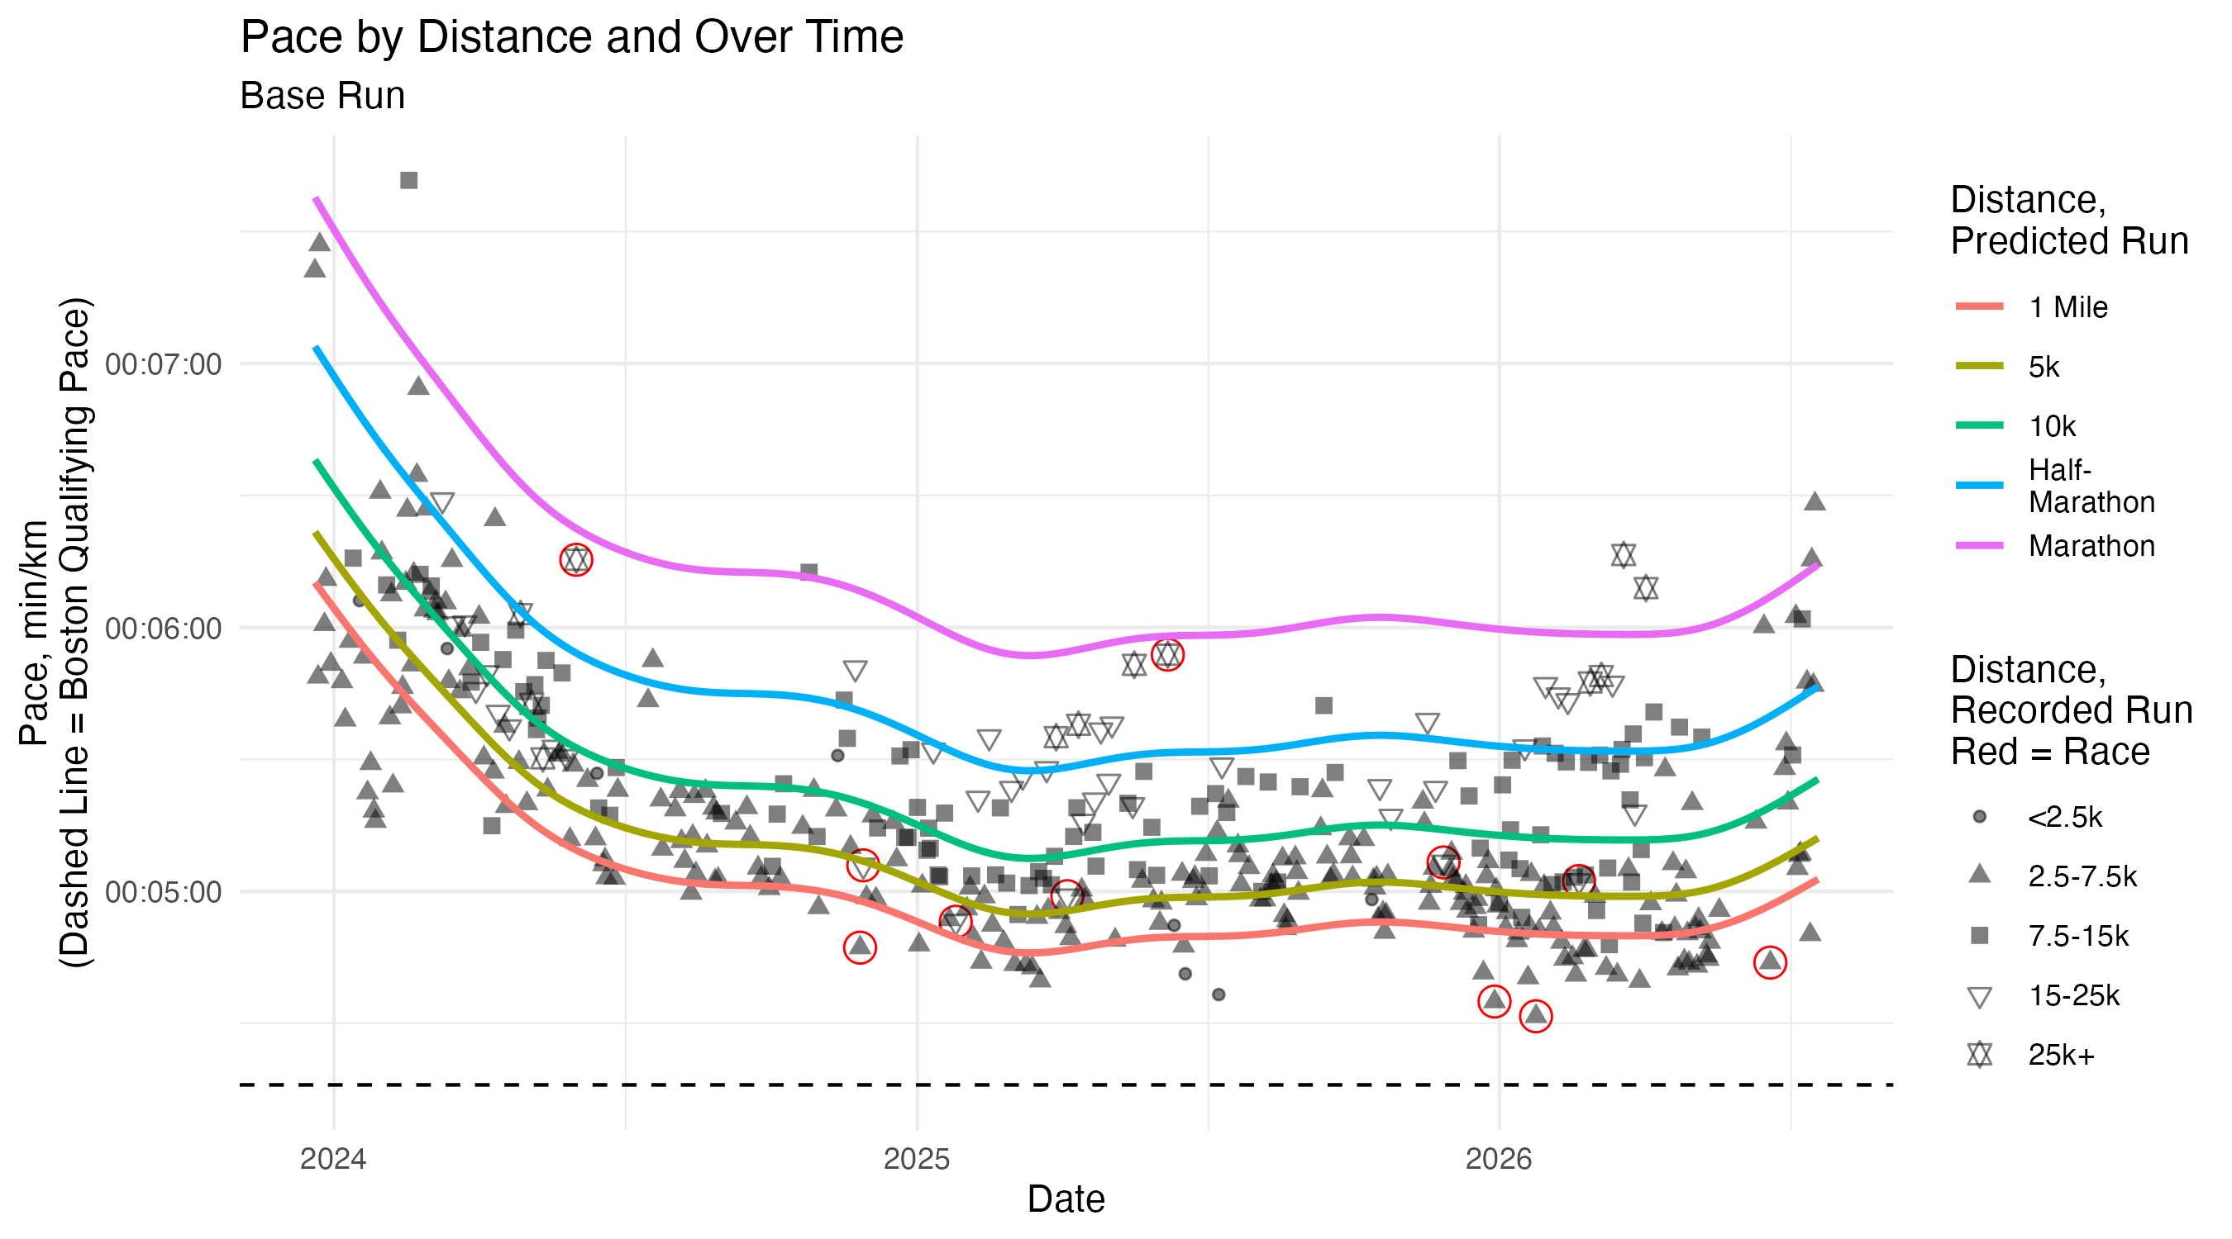

Predictions Marathon
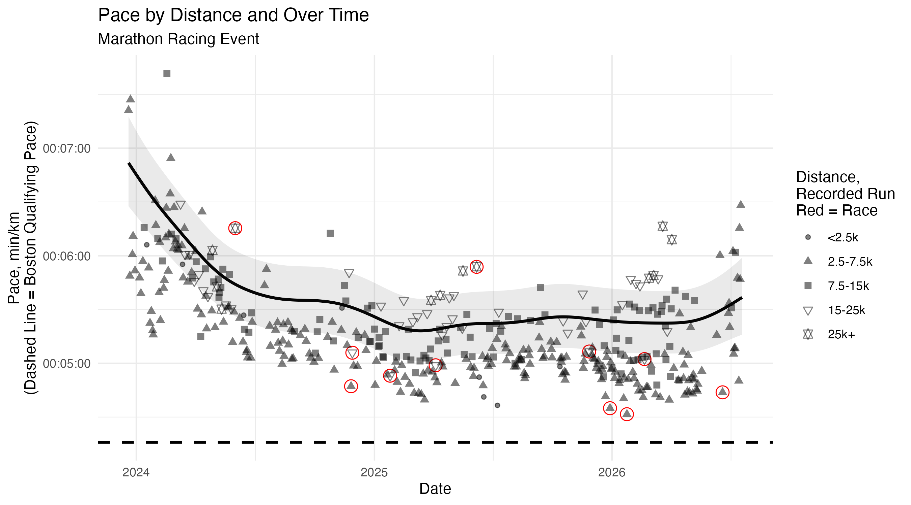

Predictions Race
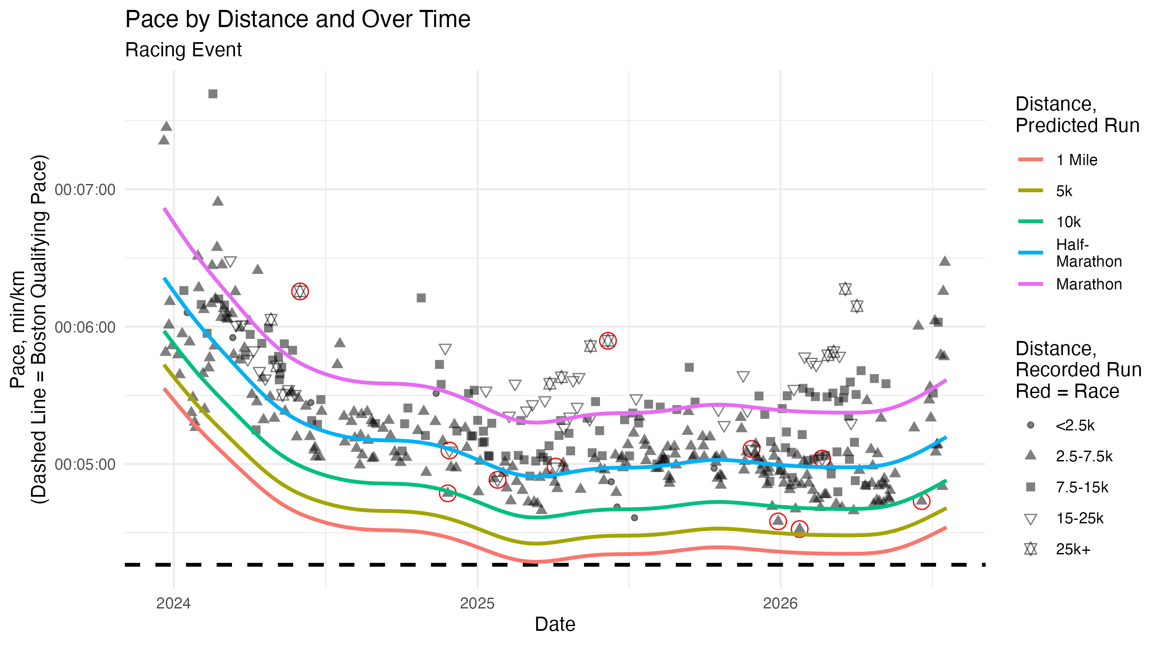

Predictions Today
+---------------+---------+-----------+------------+------------+
| type | dist | pred | pred_lower | pred_upper |
+===============+=========+===========+============+============+
| Easy Effort | 1.60934 | 5M 32.58S | 5M 19.98S | 5M 45.68S |
+---------------+---------+-----------+------------+------------+
| Easy Effort | 5 | 5M 42.86S | 5M 30.21S | 5M 56S |
+---------------+---------+-----------+------------+------------+
| Easy Effort | 10 | 5M 57.57S | 5M 44.29S | 6M 11.36S |
+---------------+---------+-----------+------------+------------+
| Easy Effort | 21.0975 | 6M 20.74S | 6M 5.9S | 6M 36.18S |
+---------------+---------+-----------+------------+------------+
| Easy Effort | 42.195 | 6M 51.17S | 6M 23.64S | 7M 20.68S |
+---------------+---------+-----------+------------+------------+
| Medium Effort | 1.60934 | 5M 2.77S | 4M 52.98S | 5M 12.89S |
+---------------+---------+-----------+------------+------------+
| Medium Effort | 5 | 5M 12.13S | 5M 2.39S | 5M 22.18S |
+---------------+---------+-----------+------------+------------+
| Medium Effort | 10 | 5M 25.52S | 5M 15.27S | 5M 36.1S |
+---------------+---------+-----------+------------+------------+
| Medium Effort | 21.0975 | 5M 46.61S | 5M 34.99S | 5M 58.63S |
+---------------+---------+-----------+------------+------------+
| Medium Effort | 42.195 | 6M 14.31S | 5M 50.83S | 6M 39.37S |
+---------------+---------+-----------+------------+------------+
| Hard Effort | 1.60934 | 4M 56.21S | 4M 46.27S | 5M 6.5S |
+---------------+---------+-----------+------------+------------+
| Hard Effort | 5 | 5M 5.37S | 4M 55.37S | 5M 15.71S |
+---------------+---------+-----------+------------+------------+
| Hard Effort | 10 | 5M 18.47S | 5M 7.83S | 5M 29.47S |
+---------------+---------+-----------+------------+------------+
| Hard Effort | 21.0975 | 5M 39.1S | 5M 27.05S | 5M 51.6S |
+---------------+---------+-----------+------------+------------+
| Hard Effort | 42.195 | 6M 6.21S | 5M 43S | 6M 30.99S |
+---------------+---------+-----------+------------+------------+
| Race Effort | 1.60934 | 4M 32.38S | 4M 21.17S | 4M 44.06S |
+---------------+---------+-----------+------------+------------+
| Race Effort | 5 | 4M 40.8S | 4M 29.43S | 4M 52.64S |
+---------------+---------+-----------+------------+------------+
| Race Effort | 10 | 4M 52.84S | 4M 40.86S | 5M 5.32S |
+---------------+---------+-----------+------------+------------+
| Race Effort | 21.0975 | 5M 11.81S | 4M 58.94S | 5M 25.24S |
+---------------+---------+-----------+------------+------------+
| Race Effort | 42.195 | 5M 36.74S | 5M 15.98S | 5M 58.87S |
+---------------+---------+-----------+------------+------------+
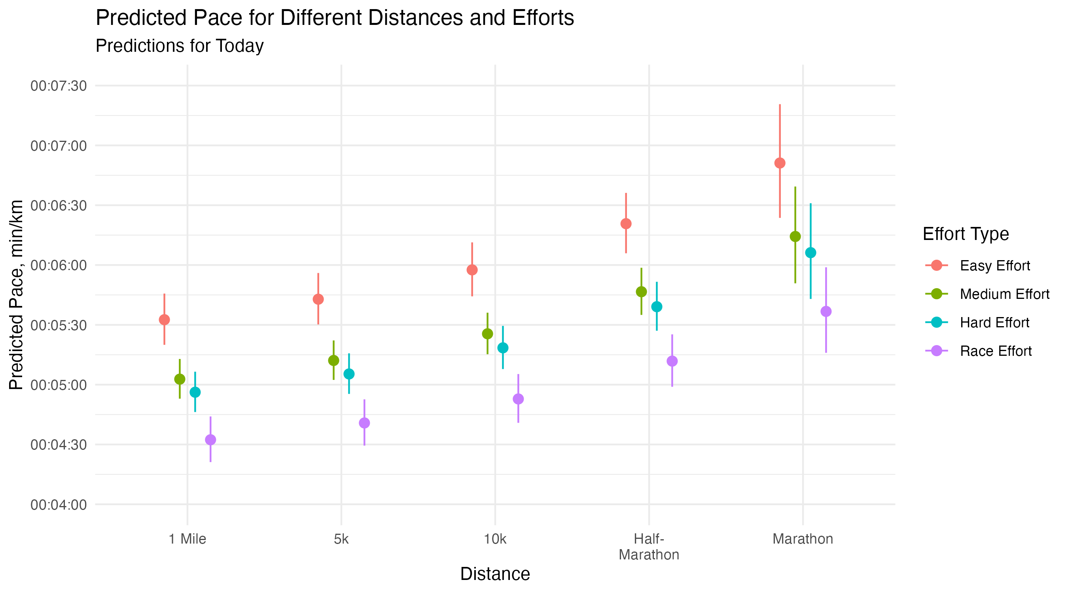

Running Summary Table
+---------+---------------+----------------+------------+------------+
| yr | weekave_peryr | monthave_peryr | yr_start | yr_end |
+=========+===============+================+============+============+
| 2023.00 | 17.60 | 75.42 | 2023-12-20 | 2023-12-31 |
+---------+---------------+----------------+------------+------------+
| 2024.00 | 21.98 | 94.21 | 2024-01-01 | 2024-12-31 |
+---------+---------------+----------------+------------+------------+
| 2025.00 | 27.25 | 116.80 | 2025-01-01 | 2025-12-31 |
+---------+---------------+----------------+------------+------------+
| 2026.00 | 32.91 | 141.03 | 2026-01-01 | 2026-07-20 |
+---------+---------------+----------------+------------+------------+
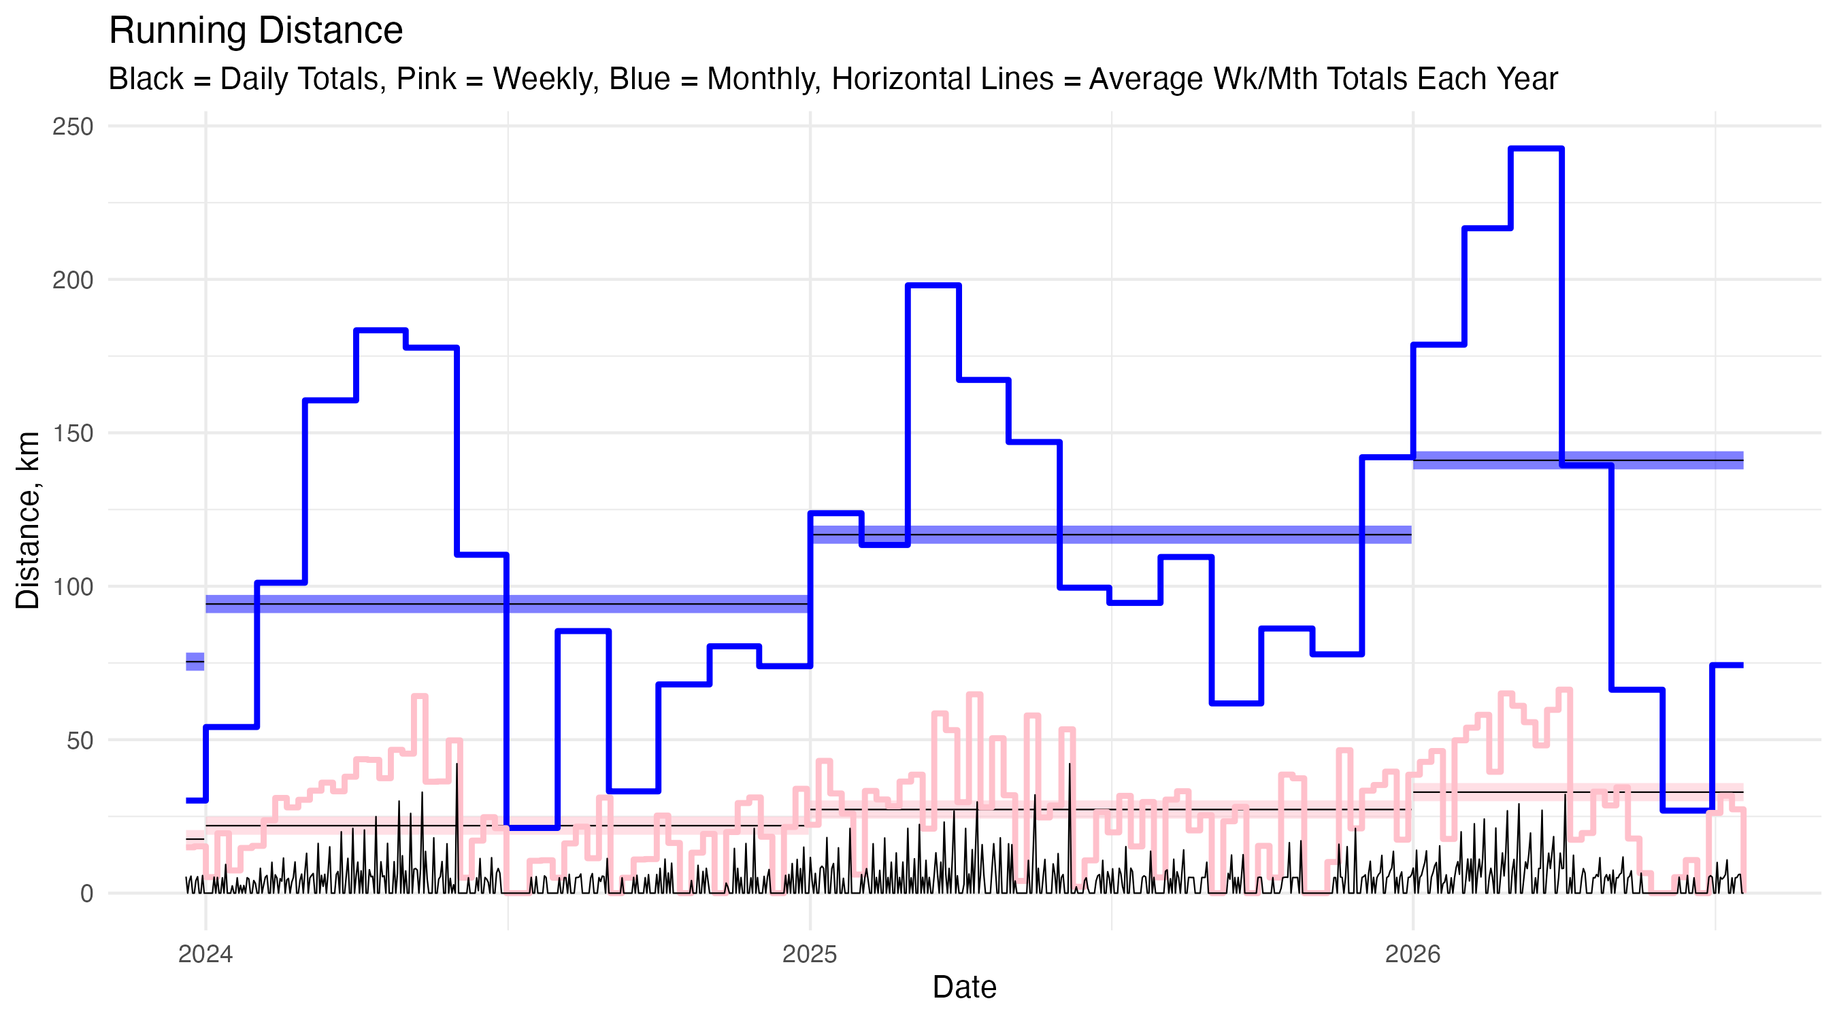

Heart Rate Zones
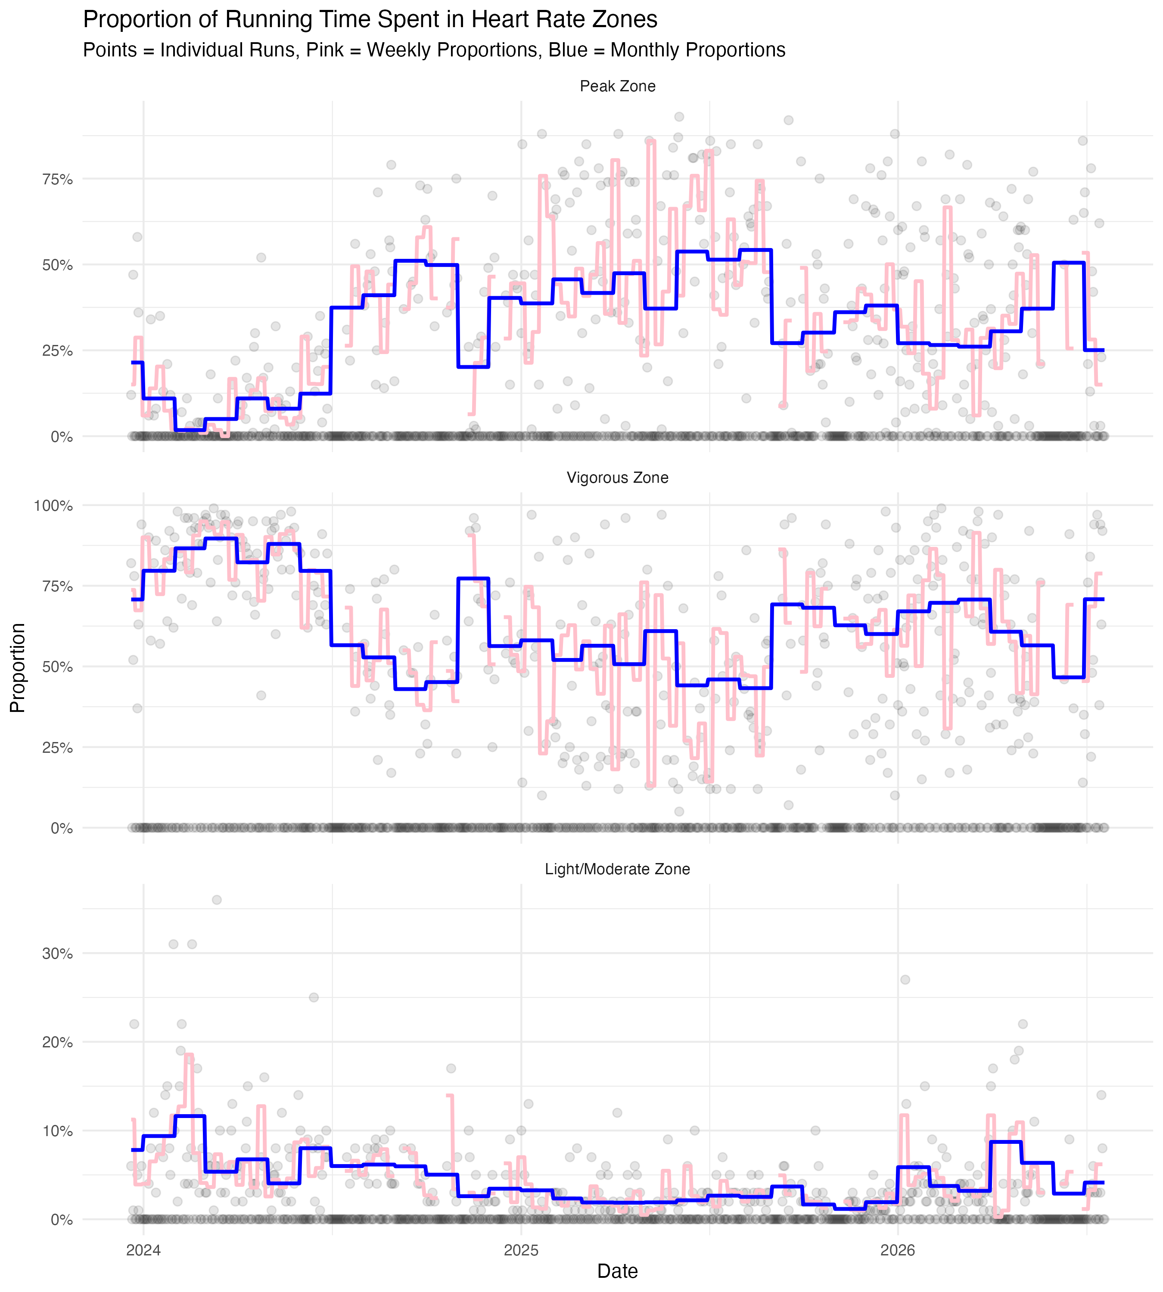

Distance Histogram
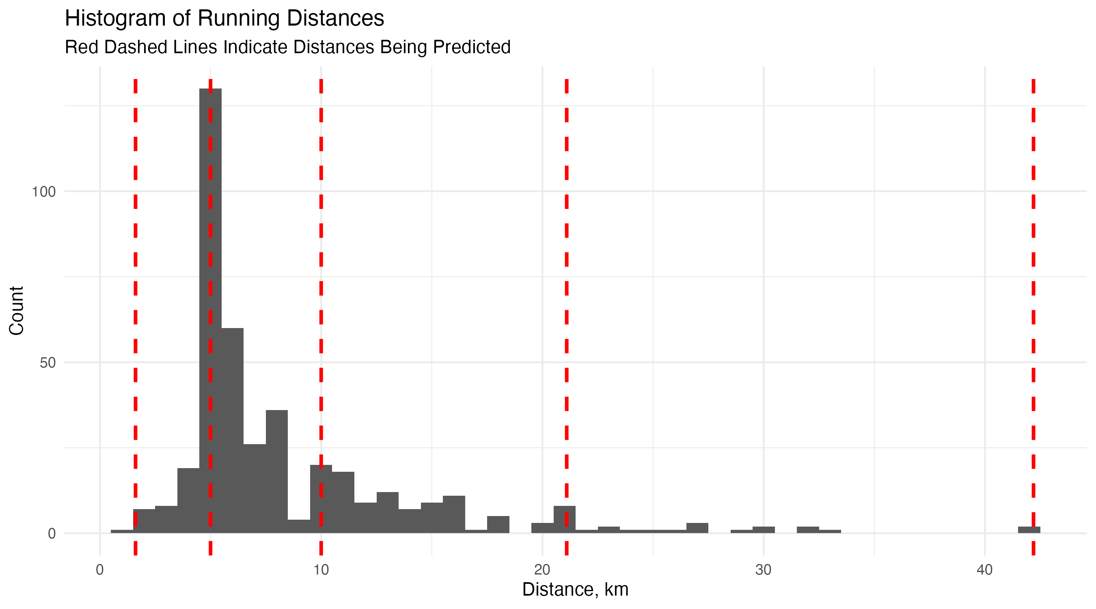

Text Summary
Upcoming Race: Antelope Island Half Marathon
Date: Oct 9, 2026
[1] "5M 33.921188S" "1H 57M 24.902262S"
Total Distance Tracker
Celebrate at 4,880 km and multiples of that
[1] 3545.594
Shoe Tracker
Retire daily trainers at ≥600km, Nylon plate shoes at ≥500km, and CF plate shoes at ≥400km
shoe sh_type total_dist
1 1 Daily Max 754.3850
2 2 Daily Max 447.4735
3 3 Daily Max 507.7750
4 4 Daily Max 456.0650
5 5 Daily Max 593.7775
6 6 Daily Max 325.8376
7 7 Daily Max 193.4800
8 8 Nylon Plate 128.4200
9 9 CF Plate 60.9800
10 10 Daily Max 77.4000

Analysis R Script
# Clear workspace and load libraries
rm(list = ls())
# Libraries and packages
library(dplyr)
library(ggplot2)
library(tidyr)
library(forcats)
library(tibble)
library(lubridate)
library(hms)
library(mgcv)
library(googlesheets4)
library(googledrive)
library(modelsummary)
# # Authentication and Drive info (for workflow run, comment out if running on my computer)
# gs4_auth(path = "google_auth.json")
# drive_auth(path = "google_auth.json")
# Authentication and Drive info (for local run, comment out if running the workflow)
setwd("~/Documents/GitHub/running-log")
gs4_auth()
drive_auth()
# The ID of the Google Drive folder
target_folder <- as_id("1SS550vx5XmxcQI5byIZ_SRVLbKm-z98F")
# A function to handle outliers in both directions for a variable
transform_num <- function(x) {
result <- rep(NA_real_, length(x))
result[which(x == 0)] <- 0
result[which(x > 0)] <- log1p(x[which(x > 0)])
result[which(x < 0)] <- -log1p(-x[which(x < 0)])
return(result)
}
# gg theme
theme_set(theme_minimal())
# Read in data
running <- read_sheet("https://docs.google.com/spreadsheets/d/1O_r313XFN5TJK8Edr80UpJcLwDXKNep2gI0Ga8LmnHE/edit?usp=sharing",
skip = 2)
# Clean data a bit and create new variables
running <- running %>%
mutate(date = as.numeric(ymd(date)),
start_time = as.numeric(as_hms(start_time)) / 3600,
afternoon = if_else(start_time > 12.5, 1, 0),
dist_fac = cut(dist, breaks = c(0, 2.5, 7.5, 15, 25, Inf),
labels = c("0-2.5", "2.5-7.5", "7.5-15", "15-25", "25+")),
dist_log = log1p(dist),
duration = ymd_hms(duration) - ymd_hms("1899-12-30 00:00:00"),
pace = as.numeric(ymd_hms(pace) - ymd_hms("1899-12-30 00:00:00")),
type = case_when(
type %in% c("Race") ~ "Race Effort",
type %in% c("Fast", "Interval") ~ "Hard Effort",
type %in% c("Base", "Hill", "Marathon Race Pace", "Tempo", "Three-One") ~ "Medium Effort",
type %in% c("Easy") ~ "Easy Effort",
.default = type
) %>% factor(levels = c("Easy Effort", "Medium Effort", "Hard Effort", "Race Effort")),
race = fct_other(type, keep = "Race Effort", other_level = "Non-Race") %>%
fct_relevel("Non-Race"),
surface = factor(surface, levels = c("Road", "Treadmill", "Track")),
elevation = case_when(
elevation <= 800 ~ "Low Elevation",
elevation > 800 & elevation <= 1600 ~ "Base Elevation",
elevation > 1600 ~ "High Elevation",
.default = as.character(elevation)
),
elevation = fct_relevel(elevation, "Base Elevation", "Low Elevation", "High Elevation")) %>%
# Now create a variable for shoe mileage, after first making sure the data is
# in order by date (though that should already be the case)
arrange(as.Date(date)) %>%
group_by(shoe) %>%
mutate(shoe_dist = cumsum(dist)) %>%
ungroup() %>%
relocate(date, start_time, afternoon, dist, dist_log, dist_fac, duration, pace,
gain, change, hills, net_change, inj_ill, sleep, vigorous, peak,
type, race, surface, elevation, temp, dew, sun, weather, shoe, sh_type)
# Model
my_mod <- gam(pace ~ s(date, k = 21) + # change over time, one of main predictors
s(dist, k = 4) + # distance effect, other main predictor
weather + sun + te(temp, dew, k = 4) + # run conditions
type + s(hills, k = 4) + surface + afternoon + elevation + # run characteristics
# NOTE: Add s(net_change) if I get enough data to have it be accurate
inj_ill + sleep, # personal and equipment conditions
data = running,
method = "REML",
family = Gamma(link = "log"))
coef_names <- c("Intercept", "Weather (0 = Good, 0.5 = Okay, 1 = Bad)",
"Sun (0 = Cloudy, 0.5 = Partly Cloudy, 1 = Sunny)",
"Medium Effort Run (vs. Easy)", "Hard Effort Run (vs. Easy)",
"Race Effort Run (vs. Easy)", "Treadmill (vs. Road)",
"Track (vs. Road)", "Time of Run (0/1, 1 = After Noon)",
"Low Elevation (vs. Base)", "High Elevation (vs. Base)",
"Health Status (0/1, 1 = Recently Injured or Ill)",
"Sleep Score",
"Date (Smooth)", "Distance (Smooth)",
"Temperature and Dew Point (Smooth)", "Hills (Smooth)")
# Using Gamma function because, based on the response vs. fitted values plot,
# it seems like the variance increases with the mean
# Using log link so that predictions are always positive
# Note that interpretation of coefficients is on the log scale, so interpret
# them as percent changes (e.g. 0.02 = 2% increase in pace)
# Once I have enough race data, I might want to do s(dist, by = race) as a
# term to allow for different distance effects based on whether it
# was a race
# Google Drive files to be able to address the model
# Overall look at variables
datasummary_skim(running, output = "model_1skim.txt")
skim_num_df <- datasummary_skim(running, type = "numeric", output = "data.frame") %>%
select(-any_of(c("Histogram", "Var.1", "Unique", "Missing Pct.")))
colnames(skim_num_df) <- c("Variable", "Mean", "SD", "Min", "Med", "Max")
skim_num_md <- knitr::kable(skim_num_df, format = "markdown", digits = 1)
skim_cat_df <- datasummary_skim(running, type = "categorical", output = "data.frame") %>%
select(-any_of(c("Var.1")))
colnames(skim_cat_df) <- c("Variable", "Category", "N", "%")
skim_cat_md <- knitr::kable(skim_cat_df, format = "markdown", digits = 1)
# Coefficients Table
modelsummary(my_mod,
output = "model_1summary.txt",
title = "Running Pace GAM Model, Gamma Function with Log Link",
stars = TRUE,
coef_rename = coef_names,
exponentiate = TRUE,
statistic = "conf.int",
conf_level = 0.95)
# GAM Diagnostics on the Smooths and Overall Model
gam_diagnostics <- capture.output(gam.check(my_mod))
writeLines(gam_diagnostics, "model_2gamcheck.txt")
png("model_2gamcheck.png", width = 800, height = 800, res = 100)
par(mfrow = c(2, 2)) # Forces the 4 plots into a 2x2 grid
gam.check(my_mod)
dev.off() # Closes the canvas and saves the file
# Smooths
png("model_3smoothsA.png", width = 1200, height = 800, res = 100)
plot(my_mod,
pages = 1,
scheme = 1,
shade.col = "lightblue",
main = "GAM Smooth Effects")
dev.off()
# Temperature and Dew Tensor Product Smooth
png("model_3smoothsB.png", width = 800, height = 600, res = 100)
vis.gam(my_mod,
view = c("temp", "dew"),
plot.type = "contour", # or "persp" for 3D
color = "topo",
main = "GAM Surface: Temp vs Dew Point")
dev.off()
# Autocorrelation Function
png("model_4acf.png", width = 800, height = 600, res = 100)
acf(resid(my_mod), main = "ACF of Model Residuals")
dev.off()
# Just a note for one of the things put on the graph: the Boston Qualifying Time
# for my age group for 2026 is 3:00:00, which is a pace of 4:16 min/km
# Predicted Pace
# New Data
# Paces to predict
fig_width <- 9
fig_height <- 5
my_dists <- c(1.60934, 5, 10, 21.0975, 42.195)
n_dists <- length(my_dists)
my_daterange <- seq(min(running$date, na.rm = TRUE),
as.numeric(Sys.Date()))
n_dates <- length(my_daterange)
new_data <- tibble(
date = rep(my_daterange, n_dists),
dist = rep(my_dists, each = n_dates), # distances above,
weather = 0, # not raining or bad weather
sun = 0.5, # Partially sunny
temp = mean(running$temp, na.rm = TRUE), # average temp
dew = mean(running$dew, na.rm = TRUE), # average dew point
type = factor("Medium Effort", levels = levels(running$type)), # A base run
hills = mean(running$hills, na.rm = TRUE), # hilliness metric
# net_change = mean(running$net_change, na.rm = TRUE), # net elevation change
surface = factor("Road", levels = c("Road", "Treadmill", "Track")),
afternoon = 0, # not afternoon
elevation = factor("Base Elevation", # normal elevation for my runs
levels = c("Base Elevation", "Low Elevation", "High Elevation")),
inj_ill = 0, # no injury or illness
sleep = mean(running$sleep, na.rm = TRUE) # average sleep score
)
preds <- predict(my_mod, newdata = new_data, se.fit = TRUE)
# Note: Using exponentiation below rather than type = "response" in the predict
# function because I want to get standard errors on the log scale and then
# transform those to the response scale
new_data <- new_data %>%
mutate(date = as.Date(date),
dist = factor(dist),
# Step 1: Calculate limits on the Log Scale
log_fit = preds$fit,
log_lower = preds$fit - 1.96 * preds$se.fit,
log_upper = preds$fit + 1.96 * preds$se.fit,
# Step 2: Exponentiate to get back to "Minutes per km"
# Then multiply by 60 to get seconds for the hms() function
pred = lubridate::hms(hms::hms(exp(log_fit) * 60)),
pred_lower = lubridate::hms(hms(exp(log_lower) * 60)),
pred_upper = lubridate::hms(hms(exp(log_upper) * 60)))
shapes <- c(20, 17, 15, 6, 11)
g_out <- ggplot() +
geom_hline(yintercept = period(minutes = 4, seconds = 16),
linetype = "dashed") +
geom_point(data = running %>% filter(type == "Race Effort"),
aes(x = as.Date(date), y = hms(pace * 60)),
size = 4, shape = 1, color = "red") +
geom_point(data = running, aes(x = as.Date(date), y = hms(pace * 60),
shape = dist_fac),
alpha = 0.5, size = 2) +
geom_line(data = new_data, aes(x = date, y = pred, color = dist, group = dist),
linewidth = 1) +
scale_shape_manual(values = shapes,
labels = c("<2.5k", "2.5-7.5k", "7.5-15k", "15-25k", "25k+")) +
scale_color_discrete(labels = c("1 Mile", "5k", "10k", "Half-\nMarathon", "Marathon")) +
labs(title = "Pace by Distance and Over Time",
subtitle = "Base Run",
x = "Date",
y = "Pace, min/km\n(Dashed Line = Boston Qualifying Pace)",
shape = "Distance,\nRecorded Run\nRed = Race",
color = "Distance,\nPredicted Run")
g_out
ggsave("running_1.png", g_out, width = fig_width, height = fig_height, dpi = 300, bg = "white")
# Racing predicted values
race_data <- tibble(
date = rep(my_daterange, n_dists),
dist = rep(my_dists, each = n_dates), # distances above,
weather = 0, # not raining or bad weather
sun = 0.5, # Partially sunny
temp = mean(running$temp, na.rm = TRUE), # average temp
dew = mean(running$dew, na.rm = TRUE), # average dew point
type = factor("Race Effort", levels = levels(running$type)), # A race
hills = mean(running$hills, na.rm = TRUE), # hilliness metric
# net_change = mean(running$net_change, na.rm = TRUE), # net elevation change
surface = factor("Road", levels = c("Road", "Treadmill", "Track")),
afternoon = 0, # not afternoon
elevation = factor("Base Elevation", # normal elevation for my runs
levels = c("Base Elevation", "Low Elevation", "High Elevation")),
inj_ill = 0, # no injury or illness
sleep = mean(running$sleep, na.rm = TRUE) # average sleep score
)
preds_race <- predict(my_mod, newdata = race_data, se.fit = TRUE)
race_data <- race_data %>%
mutate(date = as.Date(date),
dist = factor(dist),
# Step 1: Calculate limits on the Log Scale
log_fit = preds_race$fit,
log_lower = preds_race$fit - 1.96 * preds_race$se.fit,
log_upper = preds_race$fit + 1.96 * preds_race$se.fit,
# Step 2: Exponentiate to get back to "Minutes per km"
# Then multiply by 60 to get seconds for the hms() function
pred = lubridate::hms(hms::hms(exp(log_fit) * 60)),
pred_lower = lubridate::hms(hms(exp(log_lower) * 60)),
pred_upper = lubridate::hms(hms(exp(log_upper) * 60)))
# Racing plots
g_out_2 <- ggplot(race_data %>% filter(dist == "42.195"),
aes(x = date)) +
geom_hline(yintercept = period(minutes = 4, seconds = 16),
linewidth = 1, linetype = "dashed") +
geom_point(data = running %>% filter(type == "Race Effort"),
aes(x = as.Date(date), y = hms(pace * 60)),
size = 4, shape = 1, color = "red") +
geom_point(data = running, aes(x = as.Date(date), y = hms(pace * 60),
shape = dist_fac),
alpha = 0.5, size = 2) +
geom_line(aes(y = pred), linewidth = 1) +
geom_ribbon(aes(ymin = pred_lower, ymax = pred_upper), alpha = 0.1) +
scale_shape_manual(values = shapes,
labels = c("<2.5k", "2.5-7.5k", "7.5-15k", "15-25k", "25k+")) +
labs(title = "Pace by Distance and Over Time",
subtitle = "Marathon Racing Event",
x = "Date",
y = "Pace, min/km\n(Dashed Line = Boston Qualifying Pace)",
shape = "Distance,\nRecorded Run\nRed = Race",
color = "Distance,\nPredicted Run")
g_out_2
ggsave("running_2.png", g_out_2, width = fig_width, height = fig_height, dpi = 300, bg = "white")
g_out_3 <- ggplot() +
geom_hline(yintercept = period(minutes = 4, seconds = 16),
linewidth = 1, linetype = "dashed") +
geom_point(data = running %>% filter(type == "Race Effort"),
aes(x = as.Date(date), y = hms(pace * 60)),
size = 4, shape = 1, color = "red") +
geom_point(data = running, aes(x = as.Date(date), y = hms(pace * 60),
shape = dist_fac),
alpha = 0.5, size = 2) +
geom_line(data = race_data, aes(x = date, y = pred, color = dist, group = dist),
linewidth = 1) +
scale_shape_manual(values = shapes,
labels = c("<2.5k", "2.5-7.5k", "7.5-15k", "15-25k", "25k+")) +
scale_color_discrete(labels = c("1 Mile", "5k", "10k", "Half-\nMarathon", "Marathon")) +
labs(title = "Pace by Distance and Over Time",
subtitle = "Racing Event",
x = "Date",
y = "Pace, min/km\n(Dashed Line = Boston Qualifying Pace)",
shape = "Distance,\nRecorded Run\nRed = Race",
color = "Distance,\nPredicted Run")
g_out_3
ggsave("running_3.png", g_out_3, width = fig_width, height = fig_height, dpi = 300, bg = "white")
# Make a summary table of predictions for an easy effort, medium effort, hard
# effort, and race effort if I were to do a run today
my_efforts <- levels(running$type)
today_dat <- tibble(
date = as.numeric(Sys.Date()),
dist = rep(my_dists, length(my_efforts)), # distances above,
weather = 0, # not raining or bad weather
sun = 0.5, # Partially sunny
temp = mean(running$temp, na.rm = TRUE), # average temp
dew = mean(running$dew, na.rm = TRUE), # average dew point
type = factor(rep(my_efforts, each = length(my_dists)), levels = levels(running$type)),
hills = mean(running$hills, na.rm = TRUE), # hilliness metric
# net_change = mean(running$net_change, na.rm = TRUE), # net elevation change
surface = factor("Road", levels = c("Road", "Treadmill", "Track")),
afternoon = 0, # not afternoon
elevation = factor("Base Elevation", # normal elevation for my runs
levels = c("Base Elevation", "Low Elevation", "High Elevation")),
inj_ill = 0, # no injury or illness
sleep = mean(running$sleep, na.rm = TRUE))
today_preds <- predict(my_mod, newdata = today_dat, se.fit = TRUE)
today_paces <- today_dat %>%
mutate(
date = as.Date(date),
dist = factor(dist),
log_fit = today_preds$fit,
log_lower = today_preds$fit - 1.96 * today_preds$se.fit,
log_upper = today_preds$fit + 1.96 * today_preds$se.fit,
pred_sec = exp(log_fit) * 60,
pred_lower_sec = exp(log_lower) * 60,
pred_upper_sec = exp(log_upper) * 60,
pred = lubridate::hms(hms::hms(pred_sec)),
pred_lower = lubridate::hms(hms::hms(pred_lower_sec)),
pred_upper = lubridate::hms(hms::hms(pred_upper_sec))
) %>%
select(type, dist, pred_sec, pred_lower_sec, pred_upper_sec, pred, pred_lower, pred_upper)
pd <- position_dodge(width = 0.4)
g_out_3.5 <- ggplot(today_paces, aes(x = dist, y = pred_sec, color = type, group = type)) +
geom_errorbar(
aes(ymin = pred_lower_sec, ymax = pred_upper_sec),
width = 0,
position = pd
) +
geom_point(
size = 2.5,
position = pd
) +
scale_x_discrete(labels = c("1 Mile", "5k", "10k", "Half-\nMarathon", "Marathon")) +
scale_y_continuous(
limits = c(240, 450),
breaks = seq(240, 450, by = 30),
labels = function(x) hms::hms(x)
) +
labs(
title = "Predicted Pace for Different Distances and Efforts",
subtitle = "Predictions for Today",
x = "Distance",
y = "Predicted Pace, min/km",
color = "Effort Type"
)
ggsave("running_3.5.png", g_out_3.5,
width = fig_width, height = fig_height, dpi = 300, bg = "white")
datasummary_df(today_paces |> select(type, dist, pred, pred_lower, pred_upper),
"running_3.5.txt")
race_data <- race_data %>%
mutate(date = as.Date(date),
dist = factor(dist),
# Step 1: Calculate limits on the Log Scale
log_fit = preds_race$fit,
log_lower = preds_race$fit - 1.96 * preds_race$se.fit,
log_upper = preds_race$fit + 1.96 * preds_race$se.fit,
# Step 2: Exponentiate to get back to "Minutes per km"
# Then multiply by 60 to get seconds for the hms() function
pred = lubridate::hms(hms::hms(exp(log_fit) * 60)),
pred_lower = lubridate::hms(hms(exp(log_lower) * 60)),
pred_upper = lubridate::hms(hms(exp(log_upper) * 60)))
# Make a plot of my running distance over time, but with weekly (pink) and
# monthly (blue) moving averages
# First I need to fill in the zero days
running_full <- running %>%
mutate(date = as.Date(date)) %>%
complete(date = as.Date(my_daterange)) %>%
mutate(dist = if_else(is.na(dist), 0, dist),
week_start = floor_date(date, "week", week_start = 1),
month_start = floor_date(date, "month"),
yr = year(date)) %>%
group_by(week_start) %>%
mutate(dist_weekly = sum(dist)) %>%
ungroup() %>%
group_by(month_start) %>%
mutate(dist_monthly = sum(dist)) %>%
ungroup()
running_summary <- running_full %>%
group_by(yr) %>%
summarize(
weekave_peryr = sum(dist) / (n() / 7),
monthave_peryr = sum(dist) / (n() / 30),
yr_start = min(date),
yr_end = max(date),
.groups = "drop"
)
g_out_4 <- running_full %>%
ggplot(aes(x = date, y = dist)) +
geom_segment(data = running_summary,
aes(y = monthave_peryr, yend = monthave_peryr,
x = yr_start, xend = yr_end),
color = "blue", linewidth = 3, alpha = 0.5) +
geom_segment(data = running_summary,
aes(y = monthave_peryr, yend = monthave_peryr,
x = yr_start, xend = yr_end),
color = "black", linewidth = 0.25) +
geom_segment(data = running_summary,
aes(y = weekave_peryr, yend = weekave_peryr,
x = yr_start, xend = yr_end),
color = "pink", linewidth = 3, alpha = 0.5) +
geom_segment(data = running_summary,
aes(y = weekave_peryr, yend = weekave_peryr,
x = yr_start, xend = yr_end),
color = "black", linewidth = 0.25) +
geom_step(aes(y = dist_monthly), color = "blue", linewidth = 1) +
geom_step(aes(y = dist_weekly), color = "pink", linewidth = 1) +
geom_line(linewidth = 0.25) +
labs(title = "Running Distance",
subtitle = "Black = Daily Totals, Pink = Weekly, Blue = Monthly, Horizontal Lines = Average Wk/Mth Totals Each Year",
x = "Date",
y = "Distance, km")
g_out_4
ggsave("running_4.png", g_out_4, width = fig_width, height = fig_height, dpi = 300, bg = "white")
datasummary_df(running_summary, "running_4.txt")
# Make a plot showing the proportion of my time running that is spent in the
# peak heart rate zone
# The main variable of interest is peak, which is the percentage of a given run
# spent in the peak heart rate zone, from 0 to 100
# For a given period, I should take (100 - peak) and multiply it, for each run,
# by the duration of the run — then, divide that by the total duration of all
# runs in that period, to get the proportion of time not spent in the peak zone
# Note that the duration variable is already in minutes
# Note that, in contrast to the running distance graph produced above, I want
# this to be a moving calculation, so I will do it with a rolling window
# I want to do this just for a moving 30-day period
# Lastly note that I want this to be a moving 30-day period, and not all days
# are included in the data, so I will first create a full sequence of dates
running_zones <- running %>%
mutate(date = as.Date(date)) %>%
complete(date = as.Date(my_daterange)) %>%
mutate(week_start = floor_date(date, "week"),
month_start = floor_date(date, "month"),
yr = year(date)) %>%
arrange(date) %>%
select(date, week_start, month_start, yr, peak, vigorous, duration) %>%
mutate(peak = if_else(is.na(duration), 0, peak / 100),
vigorous = if_else(is.na(duration), 0, vigorous / 100),
light_moderate = if_else(is.na(duration), 0, 1 - peak - vigorous),
peak_time = peak * duration,
vigorous_time = vigorous * duration,
light_moderate_time = light_moderate * duration,
duration = if_else(is.na(duration), as.difftime(0, units = "mins"), duration),
peak_time = as.numeric(peak_time),
vigorous_time = as.numeric(vigorous_time),
light_moderate_time = as.numeric(light_moderate_time),
duration = as.numeric(duration)) %>%
group_by(week_start) %>%
mutate(prop_peak_week = sum(peak_time, na.rm = TRUE) / sum(duration, na.rm = TRUE),
prop_vigorous_week = sum(vigorous_time, na.rm = TRUE) / sum(duration, na.rm = TRUE),
prop_light_moderate_week = sum(light_moderate_time, na.rm = TRUE) / sum(duration, na.rm = TRUE)) %>%
ungroup() %>%
group_by(month_start) %>%
mutate(prop_peak_month = sum(peak_time, na.rm = TRUE) / sum(duration, na.rm = TRUE),
prop_vigorous_month = sum(vigorous_time, na.rm = TRUE) / sum(duration, na.rm = TRUE),
prop_light_moderate_month = sum(light_moderate_time, na.rm = TRUE) / sum(duration, na.rm = TRUE)) %>%
ungroup() %>%
arrange(date) %>%
select(date, peak, vigorous, light_moderate, starts_with("prop")) %>%
rename(prop_peak_day = peak, prop_vigorous_day = vigorous, prop_light_moderate_day = light_moderate) %>%
pivot_longer(cols = starts_with("prop"),
names_to = c("zone", ".value"),
names_pattern = "prop_(.*)_(day|week|month)") %>%
rename(prop_daily = day, prop_weekly = week, prop_monthly = month) %>%
# rename values in the zone variable to "Peak Zone", "Vigorous Zone", "Light/Moderate Zone"
mutate(zone = case_when(
zone == "peak" ~ "Peak Zone",
zone == "vigorous" ~ "Vigorous Zone",
zone == "light_moderate" ~ "Light/Moderate Zone"),
zone = factor(zone, levels = c("Peak Zone", "Vigorous Zone", "Light/Moderate Zone")))
# Now make the plot
g_out_5 <- running_zones %>%
ggplot(aes(x = date)) +
geom_point(aes(y = prop_daily), size = 2, alpha = 0.1) +
geom_line(aes(y = prop_weekly), color = "pink", linewidth = 1) +
geom_line(aes(y = prop_monthly), color = "blue", linewidth = 1) +
scale_y_continuous(labels = scales::percent_format(accuracy = 1)) +
labs(title = "Proportion of Running Time Spent in Heart Rate Zones",
subtitle = "Points = Individual Runs, Pink = Weekly Proportions, Blue = Monthly Proportions",
x = "Date",
y = "Proportion") +
facet_wrap(~zone, ncol = 1, scales = "free_y")
g_out_5
ggsave("running_5.png", g_out_5, width = fig_width, height = fig_height * 2, dpi = 300, bg = "white")
# Histogram of distances with the ones I'm predicting marked
g_out_6 <- ggplot(running, aes(x = dist)) +
geom_histogram(binwidth = 1) +
geom_vline(xintercept = my_dists, color = "red", linewidth = 1,
linetype = "dashed") +
labs(title = "Histogram of Running Distances",
subtitle = "Red Dashed Lines Indicate Distances Being Predicted",
x = "Distance, km",
y = "Count")
g_out_6
ggsave("running_6.png", g_out_6, width = fig_width, height = fig_height, dpi = 300, bg = "white")
# For Antelope Island Half Marathon
my_predict <- tibble(
date = as.numeric(ymd("2026-10-09")), dist = 21.0975,
hills = (150 + (150 - (0)))/21.0975,
inj_ill = 0, sleep = mean(running$sleep),
type = factor("Race Effort", levels = levels(running$type)),
surface = factor("Road", levels = c("Road", "Treadmill", "Track")),
temp = 17, dew = 3, sun = 0.5, afternoon = 0,
elevation = factor("Base Elevation",
levels = c("Base Elevation", "Low Elevation", "High Elevation")),
weather = 0
) %>%
predict(my_mod, newdata = .) %>%
`[`(1) %>%
exp() %>%
`*`(c("Predicted Pace" = 60, "Predicted Marathon Time" = 60 * 21.0975)) %>%
hms::hms() %>%
lubridate::hms()
# Total distance run
total_dist <- sum(running$dist)
# When I get to 4,880km I want to celebrate (that is the equivalent of running
# across the US)
# Total distance for each pair of shoes
shoes <- running %>%
group_by(shoe, sh_type) %>%
summarize(total_dist = sum(dist))
# Should change for new shoes at 500-800km, but since I am a larger guy maybe
# more like 400-600km
# Save out some text
sink("running_7.txt")
cat("Upcoming Race: Antelope Island Half Marathon\n")
cat("Date: Oct 9, 2026\n")
print(my_predict)
cat("\n\n")
cat("Total Distance Tracker\n")
cat("Celebrate at 4,880 km and multiples of that\n")
print(total_dist)
cat("\n\n")
cat("Shoe Tracker\n")
cat("Retire daily trainers at ≥600km, Nylon plate shoes at ≥500km, and CF plate shoes at ≥400km\n")
print(as.data.frame(shoes))
cat("\n")
sink()
# -------------------------------------------------------------------------
# Compile a single Markdown string to render everything for NotebookLM
# -------------------------------------------------------------------------
rmd_text <- c(
"---",
"title: 'Running Log Summary'",
"output: word_document",
"---",
"",
"# Data Summary: Numeric Variables",
skim_num_md,
"",
"# Data Summary: Categorical Variables",
skim_cat_md,
"",
"# Model Summary",
"```text",
readLines("model_1summary.txt"),
"```",
"",
"# GAM Diagnostics",
"```text",
readLines("model_2gamcheck.txt"),
"```",
"![](model_2gamcheck.png)",
"",
"# Smooths A",
"![](model_3smoothsA.png)",
"",
"# Smooths B",
"![](model_3smoothsB.png)",
"",
"# ACF",
"![](model_4acf.png)",
"",
"# Predictions",
"![](running_1.png)",
"",
"# Predictions Marathon",
"![](running_2.png)",
"",
"# Predictions Race",
"![](running_3.png)",
"",
"# Predictions Today",
"```text",
readLines("running_3.5.txt"),
"```",
"![](running_3.5.png)",
"",
"# Running Summary Table",
"```text",
readLines("running_4.txt"),
"```",
"![](running_4.png)",
"",
"# Heart Rate Zones",
"![](running_5.png)",
"",
"# Distance Histogram",
"![](running_6.png)",
"",
"# Text Summary",
"```text",
readLines("running_7.txt"),
"```",
"",
"# Analysis R Script",
"```r",
readLines("running.R"),
"```"
)
# Write to file and render to Word
writeLines(rmd_text, "notebooklm_summary.Rmd")
rmarkdown::render("notebooklm_summary.Rmd")
# -------------------------------------------------------------------------
# Google Drive Uploads
# -------------------------------------------------------------------------
# Define files to upload (Removed all PDFs)
files_to_upload <- c(
"model_1skim.txt", "model_1summary.txt", "model_2gamcheck.txt",
"model_2gamcheck.png", "model_3smoothsA.png", "model_3smoothsB.png",
"model_4acf.png", "running_1.png", "running_2.png", "running_3.png",
"running_3.5.txt", "running_3.5.png", "running_4.png", "running_4.txt",
"running_5.png", "running_6.png", "running_7.txt", "running.R"
)
# Upload the individual files iteratively
for (file in files_to_upload) {
if (file.exists(file)) {
drive_put(media = file, path = target_folder, name = file)
}
}
# Upload the stitched NotebookLM summary and force conversion to Google Docs
if (file.exists("notebooklm_summary.docx")) {
drive_put(
media = "notebooklm_summary.docx",
path = target_folder,
name = "Running_Log_NotebookLM",
type = "document" # This triggers the native Google Docs conversion
)
}

