Setting up an IA AGENT  
start by creating a new folder,  
crerate a document .txt we gonna call requirements and put this list inside :  
langchain

wikipedia

langchain-community

langchain-openai

langchain-anthropic

python-dotenv

pydantic

2. Use pip install -r .\requirements.txt in the same creation directory to install all of the dependencies and the libs needed mentioned above

Its preferably better to create your own virtual environment to have a better management of the pc and everything

I created a venv calling it venv1 using the command “python -m venv venv1” and used “venv1\Scripts\activate” too activate the venv

We will be using tools.py for the tools we are gonna be using and main.py for the main code

We will be using another document called .env for our Gpt api key or anthropic api key  
for this version, we are gonna use chatopenia and claude, but there is a LLM that is free and is really nice to use, it is using groq llm (you will be limited at 50 tokens the minitue and 10k credits the minute so infinite for personal use : 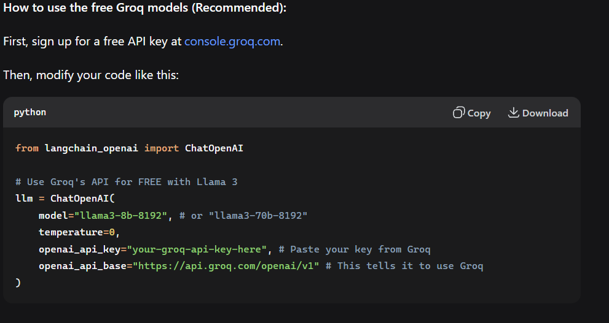

For this app we gonna be using either openai or claude so in the .env document we put : OPENAI_API_KEY="" your open ai api

ANTHROPIC_API_KEY="" your anthropic api

So we can use the api key ready

Now thisis the site where u get your api key from :platform.openai.com/api-keys

For claude or anthropic u use this site instead : console.anthropic.com/settings/keys

Log in and create a free key and voila and do not share this with anyone.  
  
after adding your key into the .env doc how I showed you before don’t forget to comeback to the main.py and run it to try it, we are gonna try by asking a basic question and print the answer, for ex: “why don’t people ride cows?” And print the answer

Of course we will have to run the program from our venv using ”python .\main.py”