*Article*

Blockchain and AI-based EV optimal Scheduling at Charging Station

# Dron Patel

1 Department of Computer Science and Engineering, Institute of Technology, Nirma University, Ahmedabad, Gujarat, India;

**\*** Correspondence: [sudeep.tanwar@nirmauni.ac.in](mailto:sudeep.tanwar@nirmauni.ac.in) (S.T.), and [rajesh.gupta@nirmauni.ac.in](mailto:rajesh.gupta@nirmauni.ac.in) (R.G.)

1 **Abstract:** Over the decade, the automotive industry has entirely transitioned towards electric vehicles (EVs)

2 as a key technology to cut down the greenhouse gas emissions from the environment. However, coordination

3 between EV and CS raises various security, cost-efficiency, and reliability challenges that need to be tackled

4 for optimal and efficient charging scheduling. Thus, we focus on the blockchain and Artificial Intelligence

5 (AI)-based EV optimal scheduling scheme based on the dynamic EV charging time. For that, we implement

6 various machine learning models such as Random Forest (RF Regressor), Light Gradient-Boosting Machine

7 (LGBM Regressor), Extreme Gradient Boosting (XGB Regressor), and Gradient Boosting (Regressor) for

8 predicting EV charging time. Based on the AI-based prediction, optimal EV scheduling is performed at the

9 charging station (CS) using blockchain and Interplanetary File System (IPFS). The smart contract of the

10 proposed scheme is executed and deployed in the Remix Integrated Development Environment (IDE) with

11 various functionalities. Finally, the performance evaluation of the proposed scheme is analyzed with various

12 parameters such as mean square error (MSE), mean absolute error (MAE), and error prediction.

13 **Keywords:** Electric vehicle, Artificial Intelligence, Optimal scheduling, Blockchain, IPFS.

14 **1. Introduction**

15 The evolution of transportation, predominantly fueled by oil and gasoline over many decades,

16 not only brought unprecedented mobility but also revealed many complex issues related to

17 the environment and how it affects the finances in the country worldwide. While traditional

18 transportation brought convenience, it also had several drawbacks of its own. The heavy use

19 of fossil fuels like oil and gasoline resulted in detrimental environmental effects. The vehicle

20 emissions also contributed towards air pollution, resulting in health problems and affecting the

21 surroundings. Moreover, fluctuating oil prices often impose uncertainties, affecting the individual

22 and the economy [1].

23 Amidst these challenges, the advent and evolution of electric vehicles (EVs) marked a major

24 shift. The EVs powered by cleaner energy sources like electricity and renewable energy posed

25 themselves as a promising alternative. The adoption of EVs brought forth several advantages.

26 The EVs produce zero tailpipe emissions, reducing air pollution and greenhouse gas emissions

27 and contributing to a breathable environment and cleaner air quality. They became more efficient

28 than internal combustion engines, converting a high amount of energy from batteries to power

29 vehicles. Moreover, they have the potential to integrate with renewable energy sources, which

30 can help develop a sustainable transportation system. EVs also have a lower operating cost due to

31 the lower electricity prices compared to oil and gasoline. Also, the maintenance cost of EVs is

32 less compared to fuel-powered vehicles, which makes it a better option for customers seeking to

33 buy a vehicle for any purpose [2].

34 With the advent of EVs, people started getting attracted towards it. Therefore, they started

35 preferring EVs instead of fuel-powered vehicles. This made the production and sale of EVs

36 go high. Now, the EVs take a long time to charge themselves. Thus, managing the charging

37 station (CS) efficiently is essential to avoid heavy load. For this reason, optimal scheduling of the

38 CS is required, which involves managing the EVs to optimize energy usage, grid stability, and

39 cost-effectiveness [3]. This helps manage peak loads in the smart grid by distributing charging

Version April 2, 2024 submitted to *Journal Not Specified* <https://www.mdpi.com/journal/notspecified>

40 demands efficiently, reducing stress during high-demand periods. Efficient charging scheduling

41 also helps minimize the energy cost for both the EV owner and the CS operator by taking

42 advantage of off-peak electricity rates or optimizing the energy usage patterns. Moreover, it

43 contributes to grid stability and reliability by avoiding sudden surges of demands and supporting

44 a more balanced energy distribution [4].

45 Many researchers [5] [6] [7] [8] have contributed and have shed light on EV optimal

46 scheduling at charging stations. Towards this goal, Zhang *et al.* [9] proposed a two-level optimal

47 scheduling strategy for the EV aggregator which is based on charging urgency. In their proposed

48 model, the vehicles are divided into levels based on their urgency and then the two-level strategy

49 is proposed. Finally, the effectiveness of the strategy is then verified by numerical example

50 simulation. The main thing is that they have not used any recent upcoming technologies that

51 could have been useful to them and could have yielded more output. Furthermore, Kapoor *et*

52 *al.* [10] discussed a multi-objective framework for EVs that caters to the interests of multiple

53 stakeholders. They have incorporated stochastic models for EV behaviours with probability

54 distribution functions, which can prove to be computationally intensive tasks.

55 Akil *et al.* [11] designed a smart coordination approach in managing charging process.

56 They used the parking time of the EVs to do so and aimed at mitigating the uncoordinated

57 charging impacts that strain the grid equipment at street charging points. The proposed model

58 also incorporated different EV types with diverse characteristics into the coordination approach.

59 This framework can be a challenge when it has to be scaled up at a city-wide level and that can

60 limit this model. The authors of [12] studied a method specially tailored for merchant-owned

61 charging facilities with multiple chargers. The proposed method focuses on an optimal EV

62 charging method that aims to minimize the cost incurred by considering various factors. This

63 approach utilized a mixed-integer linear optimization challenge with three-dimensional matrices

64 to address the problem. This also makes it a complex approach requiring high computational

65 resources and advanced software. Further, Lu *et al.* [13] also focused on a multi-objective

66 optimization for scheduling a DC micro-grid comprising a PV system and an EV CS. The main

67 aim of the framework is to optimize the electricity purchasing costs and energy circulation of

68 storage batteries by considering multiple objectives. Mathematical models are built to achieve the

69 proposed scheme. The main drawback of this is that it requires real-time and accurate data, which

70 is quite difficult in this fluctuating and dynamic environment. No security mechanism is discussed

71 in the EV scheduling schemes proposed by the aforementioned researchers that can cause data

72 vulnerability issues during the charging procedure. Also, various fluctuating parameters such as

73 energy demand, energy consumption, and charging time affect the EV charging scheduling at the

74 CS. Thus, we have proposed an Artificial Intelligence (AI)-based EV optimal scheduling at the

75 CS integrated with blockchain and Interplanetary File System (IPFS) technology to secure data

76 communication during charging procedure.

77 *1.1. Research Contributions*

78 Following are the research contributions of this paper.

79 • We propose a blockchain and AI-based EV optimal scheduling at the CS considering the

80 aspect of EVs charging time.

81 • We apply various machine learning models to yield the optimal charging time prediction for

82 scheduling EV at the CS efficiently.

83 • The performance evaluation of the proposed scheme is evaluated and analyzed considering

84 various metrics such as mean square error (MSE), mean absolute error (MAE), and error

85 prediction.

86 *1.2. Organization of the Paper*

87 The rest of the paper is organized as follows. Section II presents the system model and

88 problem formulation of the proposed scheme. Section III elaborated the proposed scheme in

89 detail. Next, Section IV presents the performance evaluation of the proposed scheme. Finally, the

90 paper is concluded with future work in Section V.

# 91 2. System Model and Problem Formulation

92 *2.1. System Model*

93 The proposed blockchain and AI-based EV *ϱ* optimal charging framework focuses on

94 accomplishing the beneficial and efficient EV *ϱ* scheduling at the CS *γ*. Foremost, EVs and

95 the charging request arrive at the CS that provides energy based on their charging time. But, to

96 schedule EV *ϱ* at the CS *γ*, we need to consider various associated parameters of EV *ϱ* such

97 as state-of-charge (SoC) and energy demand request energy from the CS corresponding to the

98 charging prices. So, we have focused on the aspect of EV charging time Ψ that needs to be

99 predicted to schedule arriving EVs at the CS.

100 Thus, we apply and implement various machine learning models such as RF Regressor,

101 LGBM Regressor, XGB Regressor, and GB Regressor to analyze and predict the EV charging

102 time based on the various associated EVs energy data such as SoC, charging start time *Cθ*, and

103 charging finish time *Cϑ*. After predicting the EV charging time with the best accuracy, the

104 charging scheduling is performed based on the minimum charging time for efficient CS allocation

105 and reducing the delay for EVs waiting in the queue for charging. Now, we have adopted the

106 decentralized and immutable characteristics of the blockchain to store and access the EV energy

107 and schedule transactions through a content-addressing protocol, i.e., IPFS. The main objective

108 of considering the IPFS is to avail cost-efficient charging for EVs at the CS.

109 *2.2. Problem Formulation*

110 The AI-based proposed scheme utilizes blockchain to secure the energy data communication

111 between EVs *ϱ* {*ϱ*1, *ϱ*2, . . . , *ϱv*} *ϱV* and CS *γ* for achieving the optimal charging scheduling at

∈

112 the CS. For that, we need to highlight the parameters involved in the EV scheduling at the CS and

113 these parameters decide the order of EV charging and their priority at the CS. Consequently, EVs

114 corresponding to the SoC *ξ*, energy demand *ϵ*, start time *Cθ*, and finish time *Cϑ* communicate

115 with the CS, which provides them with the available charging prices Ξ, which is represented as

116

follows:

*v*

( ∑ *ϱV*, *γ*) = *ξϱV* ∥ *ϵϱV* ∥ *Cθ ϱV* ∥ *CϑϱV* ∥ Ξ (1)

*V*=1

117 Furthermore, EV energy and scheduling data is used to predict the charging time of the arriving

118 EVs at the CS after implementing various machine learning models such as RF Regressor, LGBM

119 Regressor, XGB Regressor, GB Regressor in which GB Regressor yields the best results in terms

120 of minimum mean square error (MSE). Moreover, there is no guarantee of secure EV energy data

121 and the predicted charging time Ψ communication with the CS for safe and protected charging

122 allocation. Thus, a blockchain platform is adopted in the proposed scheme that provides security

123 during the communication between EV *ϱ* and CS *γ* by utilizing public *Bκ* and private keys *Bλ*.

124 The additional usage of IPFS ∆ with the blockchain saves the data storage cost of the participants

125 involved in the charging scheduling in the proposed scheme. IPFS return the hash keys *β* and *ν*

126 to the EV and CS to avail secure access to the data for further energy transactions through the

127 blockchain network. Thus, the consideration of blockchain for protecting and preserving the EV

128 energy data *Ed* is mentioned as follows:

*α*

*v d Secure κ λ*

*V*=1

129

∑ *ϱV* (*Eα*) **−** −→ {*B* , *B*

} (2)

∆ (*β*,*ν*) *v d*

∑ *ϱV* (*Eα*) (3)

**—** →

*V*=1

130

131

132

Thus, after performing the secure energy data transactions through blockchain, the predicted charging time Ψ is considered to allocate the EVs at the CS. Therefore, optimal charging allocation Υ at the CS based on the predicted charging time is formulated as follows:

*v*

Υ = *Op* ∑ *ϱ*(*ξ*, *ϵ*, *Cθ*, *Cϑ*), *γ*(Ξ) (4)

{ }

*V*=1

133 Thus, the blockchain and AI-based proposed scheme ensures efficient EV scheduling at the CS,

134 making it reliable for the other EVs waiting in the queue for charging.

135 **3. Proposed scheme**

136 Figure 1 shows the blockchain and AI-based proposed scheme that schedules EVs at the

137 CS optimally and efficiently. The proposed scheme is classified into three layers, i.e., EV Layer, Prediction and Blockchain Layer, and Optimal Scheduling Layer.

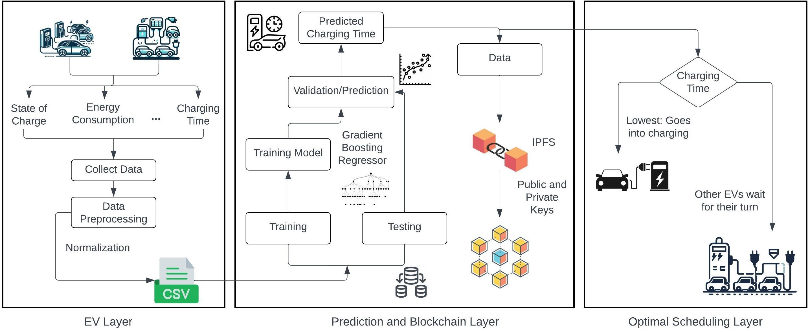

|  |  |
| --- | --- |
|  | **Figure 1.** proposed scheme. |
| 138 |  |
| 139 | *3.1. EV Layer* |
| 140 | In the proposed scheme, the EVs *ϱ* approach the CS *γ* in order to get their batteries charged. |
| 141 | This is the initiating stage of the proposed scheme where a communication between the EV and |
| 142 | the CS takes place in order to decide upon the priority for charging. |

143

*ϱV* −→ {*ϱ*1, *ϱ*2, . . . , *ϱv*

*arrive*

} **−** −→

*γ* (5)

*ϱ communication*

**— − − −** → *γ* (6)

144 Now, in order to calculate the priority of charging, it is necessary to compute the charging time

145 *ψ*. For that, the energy data *Ed* of the EVs is collected which contains the SoC (*ξ*), energy

*α*

146 consumption (*ϵ*), start time (*Cθ*), and finish time (*Cϑ*). On the basis of the collected data, the CS

147 may also provide the charging prices Ξ to the EV owners.

*Ed* = {*ξ*, *ϵ*, *Cθ*, *Cϑ*, Ξ, . . . , *ψ*} (7)

*α*

148 The collected data of the EVs is then combined to make a dataset (*η*) that can be used further in

149 the process of predicting the charging time for scheduling the EVs. We have used the standard

150 data for EV optimal scheduling that was available online with the features mentioned above

151 [14]. Before the data can be fed to the models, it is necessary to perform data pre-processing

152 in order to avoid any errors at the time of training the models. Therefore, data pre-processing

153 steps like removing null values (*τ*), removing noise from the data (*σ*), normalization ( ), etc.,

N

154 are performed in order to generate the final dataset (*ϕ*).

**—** −→ *ϕ* (8)

*η τ*,*σ*,N

155 The prepared dataset is then forwarded to the prediction and blockchain layer where the data is

156 fed to the models to make the predictions and to store the data securely using blockchain.

157 *3.2. Prediction and Blockchain Layer*

158 Once the data is prepared and pre-processed, the final data is then fed to the models in

159 order to train them in making predictions for the charging time. We have used machine learning

160 regressors like the Random Forest Regressor (RF), Light Gradient Boosting Regressor (LGBM),

161 Extreme Gradient Boosting Regressor (XGB), and Gradient Boosting Regressor. These models

162 were used in order to predict continuous data of charging time of the EVs and the best model was

163 selected on the basis of Mean Squared Error (MSE). The Gradient Boosting Regressor (Π) was

164 able to predict the values more accurately than the other models and produced the least MSE

165 value which corresponds to a better performance.

−→ *ψpred* (9)

*ϕ* Π

166 The Eq. 10 represents the equation for Gradient Boosting Algorithm that was used in predicting

167 the charging time for the EVs based on the data that was fed to it.

168

where:

*F*(*x*) =

*M*

∑ *δmhm*(*x*) (10)

*m*=1

169 • F(x) : Gradient Boosting Model

170 • M : Number of weak learners

171 • *hm*(*x*) : Individual weak learners

172 • *δm* : Contribution of weak learner *hm*(*x*)

173 • *x* : Input to the model

174 After we have everything ready from training the model to predicting the charging time, it is

175 important to secure the data (**D**) in order to avoid any misuse of it. In order to secure the data, we

176 integrate the Blockchain technology as it also provides an easy way to access the data quickly.

177 We have used the Interplanetary File System (IPFS) *φ* in order to solve the cost issues and also to

178 store the data blocks using hash. The data makes a request to the IPFS protocol which in turn

179 returns hashkeys (*π*).

**D** *φ*

−→ *π* (11)

180 Using these hashkeys, the data is securely stored and can be easily accessed by the public (*φpublic*)

181 and private (*φprivate*) keys that are produced.

*φpublic*, *φprivate* −→ **D** (12)

*φ*

182 Once the prediction is made and the data is secured and stored safely, the scheduling of charging

183 is done in the optimal scheduling layer.

184 *3.3. Optimal Scheduling Layer*

185 From the predictions made in the prediction and blockchain layer, the EVs are optimally

186 scheduled for charging based upon their predicted charging time. The EV with the lowest charging

187 time (*ψlowest*) gets the chance to charge ( ) first. They are evaluated based on their charging

C

188 time and are arranged in an ascending order of their predicted charging time. These predicted

189 charging time may contain some amount of error but these are negligible as we have hypertuned

190 the proposed model to produce the least amount of error possible. The other EVs with more

191 charging time have to wait for their turn until the EV completes its charging. This is how optimal

192 scheduling (*ω*) for charging EVs take place at the CS.

*ψlowest* −→ C

*ω* =

otherwise −→ wait

(13)

193 Therefore, blockchain and AI-based proposed scheme efficiently schedule EV at the CS in the

194 secure and protected manner.

195 **4. Performance Evaluation**

196 In this section, we evaluate the performance of the proposed scheme in order to check the EV

197 charging time efficiency for optimal scheduling. We have implemented various machine learning

198 models such as Random Forest (RF Regressor), Light Gradient-Boosting Machine (LGBM

199 Regressor), Extreme Gradient Boosting (XGB Regressor), and Gradient Boosting (Regressor).

200 We have evaluated these models based on their MSE, MAE, and error prediction, i.e., the

201 difference between the actual and predicted value of the charging time of the EV. Moreover, the

202 blockchain-based smart contract of the proposed scheme is executed in Remix IDE for secure EV

203 scheduling at the CS.

204 *4.1. Mean Square Error*

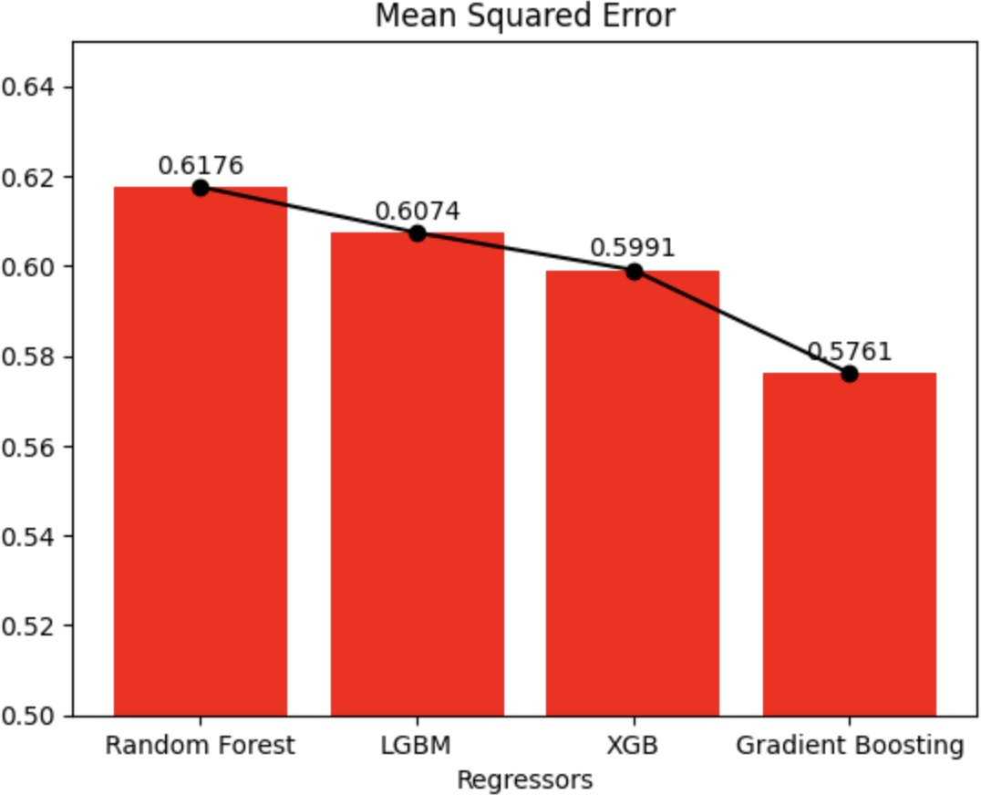

**Figure 2.** Mean square error.

205 Figure 2 illustrates the comparison between the MSE values of various machine learning

206 models selected for predicting the continuous data in the proposed scheme. The prediction models

207 are implemented for predicting the charging time of an EV. The MSE gives a clear idea of how

208 well a model’s prediction aligns with its predictions. The squared value makes it easy to make the

209 errors large to make it sensitive to significant deviation between the actual value and predicted

210 value. In the figure, we observe that the RF Regressor has the highest value of MSE, which means

211 that it generates the highest error value while predicting the EV charging time. On the other hand,

212 GB Regressor is considered the best performing model with the MSE value of 0.5761, which

213 accurately predicts charging time, ameliorating the proposed scheme’s performance.

214 *4.2. Mean Absolute Error*

215 Sometimes, the dataset contains many outliers that may have a substantial difference between

216 the actual and predicted values. Hence, it is important to check on those outliers. Thus, MAE

217 is essential for the comparison between different models. The MAE directly works upon the

218 values, which makes it less sensitive to outliers. Therefore, the outliers make a linear impact on

219 the value of MAE, which helps find out which model has more outliers in it. Figure 3 illustrates

220 the comparison of MAE values between different regressors used for predicting the EV charging

221 time for optimal scheduling. Based on the prediction, it is perceived that the LGBM Regressor

222 has the highest value of MAE, which means that it has more outliers than other models. On the

223 other hand, RF Regressor has the lowest MAE value, which came out to be 0.4199.

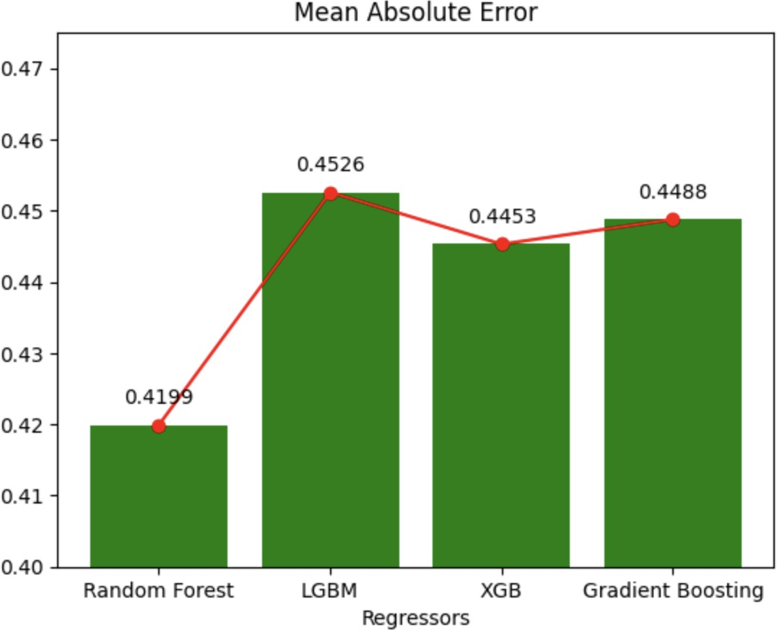

**Figure 3.** Mean absolute error.

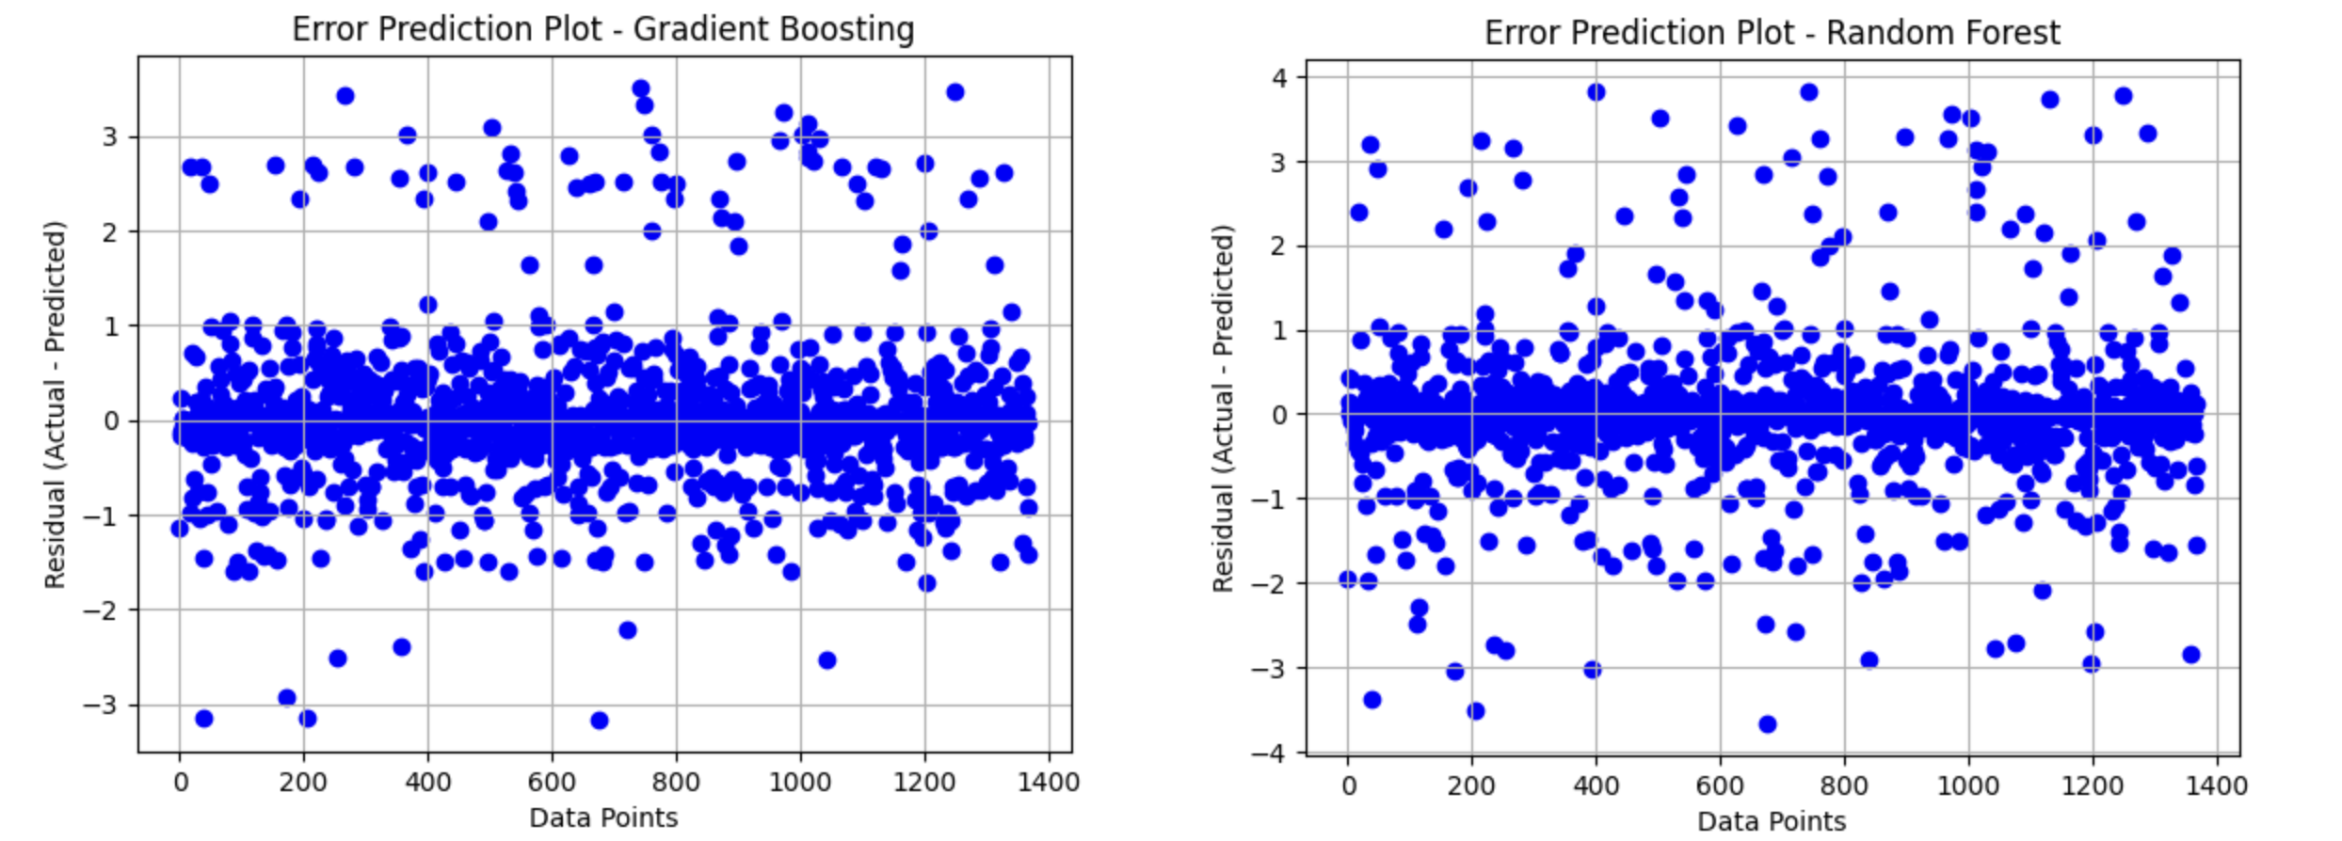

(**a**) Gradient Boosting Regressor (**b**) Random Forest Regressor

**Figure 4.** Error Prediction

224 *4.3. Error Prediction*

225 Figure 4 compares machine learning models, which are RF Regressor and GB Regressor,

226 to check upon the error produced while predicting the EVs charging time. It is shown in Figure

227 4(**b**), which represents the errors produced by the RF Regressor, that the range of error goes

228 from -4 to +4, which means that the model has a significant amount of deviation in predicting the

229 charging time for the EVs. We also see that the scattered plot is not much populated at the 0 mark,

230 which depicts that the model was not much efficient in predicting the charging time correctly. On

231 the other hand, in Figure 4(**a**), which illustrates the scatter plot for the errors that occurred in

232 GB Regressor while predicting charging time, we see that it is densely populated at the 0 mark.

233 Moreover, the error range is also less when compared to the RF Regressor. The dense population

234 at the 0 mark shows that the RF Regressor model efficiently predicts the charging time.

# 235 5. Proposed Implementation Interface

236 Figure 5 depicts the Ethereum blockchain-based smart contract of the proposed scheme

237 deployed and executed in the Remix IDE for highlighting the secure EVs energy transactions for

238 optimal charging scheduling at the CS. Furthermore, it shows the smart contract functionalities

239 considered to achieve the EV scheduling based on the predicted charging time.

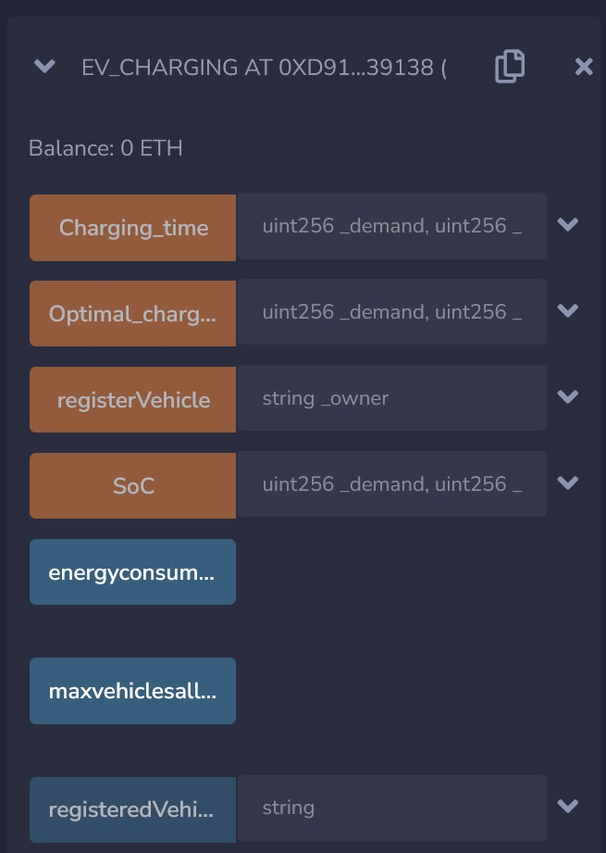

**Figure 5.** Proposed implementation interface.

240  **6. Conclusion**

241 In this paper, we propose an AI-based secure and optimal EV scheduling scheme utilizing the

242 immutable and decentralized characteristics of the blockchain. The proposed scheme combines

243 blockchain with the cost-efficient IPFS protocol to avail the beneficial and economical charging

244 scheduling for the EVs. Moreover, we apply and implement various machine learning models to

245 predict the EVs charging time that impacts their charging allocation during the charging procedure.

246 Based on the charging time prediction, EVs with the minimum charging time is considered for

247 charging at the CS. Additionally, we implement and execute the smart contract of the proposed

248 EV scheduling scheme based on the charging time in the Remix IDE to reflect the secure and

249 confidential EV scheduling transactions. Finally, the performance evaluation of the proposed EV

250 scheduling scheme is simulated and analyzed along with various metrics such as MSE, MAE,

251 and error prediction.

.

252 **References**

253 1. Gupta, V.; Kumar, R.; Reddy, S.K.; Panigrahi, B. EV Benefit Evaluation in a Collaborative Scheduling

254 Environment with Penalties for Unscheduled EVs. 2018 8th IEEE India International Conference on

255 Power Electronics (IICPE), 2018, pp. 1–6. doi:[10.1109/IICPE.2018.8709582](https://doi.org/10.1109/IICPE.2018.8709582).

256 2. Suryakiran, B.; Nizami, S.; Mishra, S.; Verma, A. An Optimal Continuous-time Constrained EV

257 Scheduling Strategy for Parking Lots. 2022 IEEE PES 14th Asia-Pacific Power and Energy Engineer-

258 ing Conference (APPEEC), 2022, pp. 1–6. doi:[10.1109/APPEEC53445.2022.10072191](https://doi.org/10.1109/APPEEC53445.2022.10072191).

259 3. Khaki, B.; Chung, Y.W.; Chu, C.; Gadh, R. Hierarchical Distributed EV Charging Scheduling in

260 Distribution Grids. 2019 IEEE Power Energy Society General Meeting (PESGM), 2019, pp. 1–5.

261 doi:[10.1109/PESGM40551.2019.8973928](https://doi.org/10.1109/PESGM40551.2019.8973928).

262 4. Said, D.; Cherkaoui, S.; Khoukhi, L. Scheduling protocol with load managementfor EV charg-

263 ing. 2014 IEEE Global Communications Conference, 2014, pp. 362–367. doi:[10.1109/GLO-](https://doi.org/10.1109/GLOCOM.2014.7036835)

264 [COM.2014.7036835](https://doi.org/10.1109/GLOCOM.2014.7036835).

265 5. Chen, F.; Zhu, S.; Zhang, L.; Huang, J. Optimal Scheduling for EV Charging Stations with Varying

274 Power Limits Based on MADDPG Algorithm. 2023 3rd Power System and Green Energy Conference

275 (PSGEC), 2023, pp. 343–347. doi:[10.1109/PSGEC58411.2023.10255946](https://doi.org/10.1109/PSGEC58411.2023.10255946).

276 6. Saner, C.B.; Trivedi, A.; Srinivasan, D. An EV Charging Scheduling Methodology to Reduce Demand

277 and Energy Charges in Industrial and Commercial Sites. 2022 IEEE PES Innovative Smart Grid

278 Technologies - Asia (ISGT Asia), 2022, pp. 285–289. doi:[10.1109/ISGTAsia54193.2022.10003640](https://doi.org/10.1109/ISGTAsia54193.2022.10003640).

279 7. Jain, A.; Jangid, B.; Barala, C.P.; Bhakar, R.; Mathuria, P. TOU Price based Optimal Scheduling

280 of EV Clusters. 2022 22nd National Power Systems Conference (NPSC), 2022, pp. 290–295. [doi:](https://doi.org/10.1109/NPSC57038.2022.10069334)

281 [10.1109/NPSC57038.2022.10069334](https://doi.org/10.1109/NPSC57038.2022.10069334).

282 8. Siddique, Z.; Jaiswal, S.; Chaturvedi, V.; Maheshwari, A. Game Theory based EV Charge Scheduling:

283 A Comprehensive Review. 2021 Innovations in Power and Advanced Computing Technologies

284 (i-PACT), 2021, pp. 1–6. doi:[10.1109/i-PACT52855.2021.9696445](https://doi.org/10.1109/i-PACT52855.2021.9696445).

285 9. Zhang, Y.; Yang, X.; Li, B.; Cao, B.; Li, T.; Zhao, X. Two-Level Optimal Scheduling Strategy

286 of Electric Vehicle Charging Aggregator Based on Charging Urgency. 2022 4th International

287 Conference on Smart Power Internet Energy Systems (SPIES), 2022, pp. 1755–1760. [doi:](https://doi.org/10.1109/SPIES55999.2022.10082570)

288 [10.1109/SPIES55999.2022.10082570](https://doi.org/10.1109/SPIES55999.2022.10082570).

289 10. Kapoor, A.; Gangwar, P.; Sharma, A.; Mohapatra, A. Multi-Objective Framework for Optimal

290 Scheduling of Electric Vehicles. 2020 21st National Power Systems Conference (NPSC), 2020, pp.

291 1–6. doi:[10.1109/NPSC49263.2020.9331921](https://doi.org/10.1109/NPSC49263.2020.9331921).

292 11. Akil, M.; Dokur, E.; Bayindir, R. Optimal Scheduling of on-Street EV Charging Stations. 2022 IEEE

293 20th International Power Electronics and Motion Control Conference (PEMC), 2022, pp. 679–684.

294 doi:[10.1109/PEMC51159.2022.9962880](https://doi.org/10.1109/PEMC51159.2022.9962880).

295 12. Vidanalage, I.; Sabillon, C.; Venkatesh, B.; Torquato, R.; Freitas, W. Scheduling of Merchant-Owned

296 EV Charging at a Charging Facility with Multiple Chargers. 2018 IEEE Electrical Power and Energy

297 Conference (EPEC), 2018, pp. 1–6. doi:[10.1109/EPEC.2018.8598415](https://doi.org/10.1109/EPEC.2018.8598415).

298 13. Lu, X.; Liu, N.; Chen, Q.; Zhang, J. Multi-objective optimal scheduling of a DC micro-grid consisted

299 of PV system and EV charging station. 2014 IEEE Innovative Smart Grid Technologies - Asia (ISGT

300 ASIA), 2014, pp. 487–491. doi:[10.1109/ISGT-Asia.2014.6873840](https://doi.org/10.1109/ISGT-Asia.2014.6873840).

301 14. Tanwar, A. Residential EV Charging Data. [https://www.kaggle.com/datasets/anshtanwar/residential-](https://www.kaggle.com/datasets/anshtanwar/residential-ev-chargingfrom-apartment-buildings)

302 [ev-chargingfrom-apartment-buildings](https://www.kaggle.com/datasets/anshtanwar/residential-ev-chargingfrom-apartment-buildings), 2023. [Online; Accessed 20-11-2023].