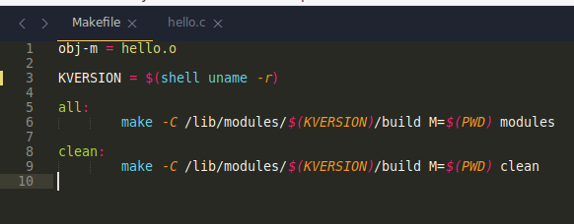
Before we create the kernel module, we have to create the specific Makefile, which will look like this:

After we have this finished, we have to test the methods “all” and “clean” to see if they work:

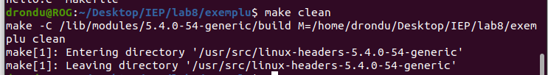
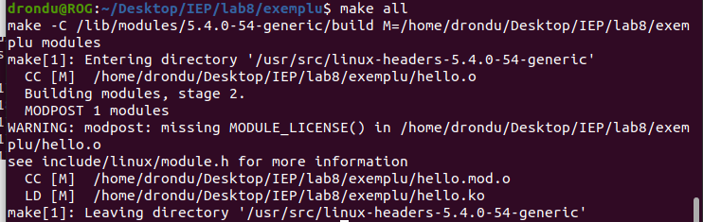

After we have the Makefile working, we have to create our kernel module, which should look like(hello.c/cpp file):
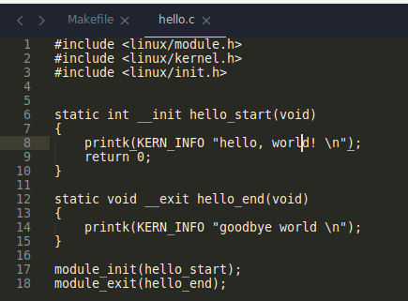

After we execute “make” command in terminal we get the ‘.ko’ file are searching fore:
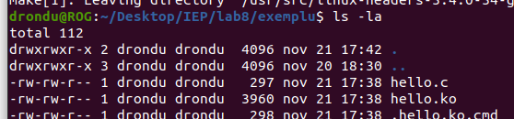

To see all existent kernel modules we have this command “lsmod”. After executing this command you should see something like:
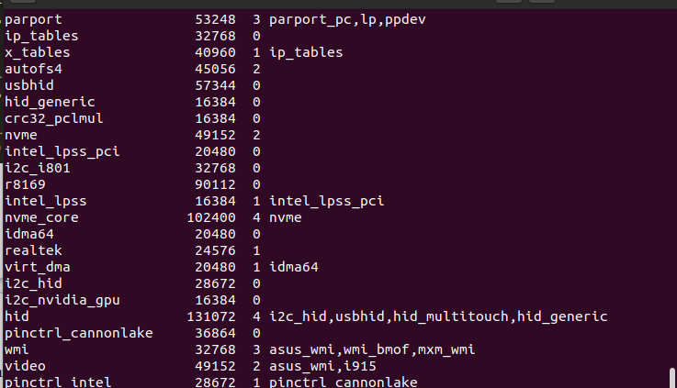

If we search for our module, we can see that it does not exist yet (lsmod | grep hello):
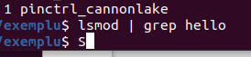

To insert our module we need to execute “sudo insmod ./hello.ko”. If we execute the grep again we will find our module there:
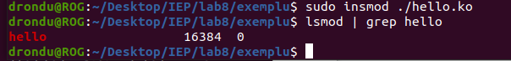

To check if our module works we can execute this command “dmesg”:
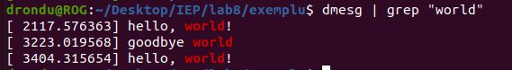

Also, to remove this module, you must execute the following command: “sudo rmmod hello”.

