A

Project Report on

**FITNESS CENTER DATABASE SYSTEM**

Developed by

**Jigar Patel– IT033, Department of IT**

**Pavan Joshi - IT035, Department of IT**

**Guided By**

**Internal Guide:**

**Name (Prof. Roshni M. Raval)**

**Department of Information Technology**

**Faculty of Technology**

**DD University**



**Department of Information Technology**

**Faculty of Technology, Dharmsinh Desai University**

**College Road, Nadiad-387001**

**October - 2019**

## DHARMSINH DESAI UNIVERSITY

## NADIAD-387001, GUJARAT



## CERTIFICATE

### This is to certify that the project entitled

### “FITNESS CENTER DATABASE MANAGEMENT SYSTEM”

is a bonafied report of the work carried out by

1. **Mr. Jigar Patel** Student ID No: 17ITUOS061
2. **Mr. Pavan Joshi** Student ID No: 17ITUBS062

of Department of Information Technology, Semester V, under the guidance and supervision for the subject Database Management System. She was involved in Project during academic year 2019-2020.

Prof. Roshni M. Raval (Project Guide) Department of Information Technology,

Faculty of Technology,

Dharmsinh Desai University, Nadiad

Date:

Prof. Vipul Dabhi

Head , Department of Information Technology,

Faculty of Technology,

Dharmsinh Desai University, Nadiad

Date:

**Acknowledgement**

The success and final outcome of this project required a lot of guidance and assistance from many people and we are extremely privileged to have got this all along the completion of our project. All that we have done is only due to such supervision and assistance and I would not forget to thank them.

I respect and thank Prof. Vipul Dabhi Sir, for providing me an opportunity to do the project work in DDU and giving us all support and guidance, which made us, complete the project duly. I am extremely thankful to Prof. Roshni Raval Ma’am for providing such a nice support and guidance, although she had a busy schedule managing other affairs.

**PROJECT BY:**

**Jigar Patel (IT-43)**

**Pavan Joshi (IT-35)**

TABLE OF CONTENTS

**I. Certificate I**

**II. Acknowledgement III**

**1. SYSTEM OVERVIEW**

1.1 Current system

1.2 Objectives of the Proposed System

1.3 Advantages of the Proposed system (over current)

**2. E-R DIAGRAM**

2.1 Entities…………………………………………………………………………..

2.2 Relationships……………………………………………………………………

2.3 Mapping Constraints……………………………………………………………

**3. DATA DICTIONARY**

**4. SCHEMA DIAGRAM**

**5. DATABASE IMPLEMENTION**

5.1 Create Schema

5.2 Insert Data values

5.3 Queries (Based on functions, group by, having, joins, sub query etc.)

5.4 PL/SQL Blocks (Procedures and Functions)

5.5 Views

5.6 Functions

5.7 Procedures

5.8 Triggers

5.9 Cursors.

**6. FUTURE ENHANCEMENTS OF THE SYSTEM**

**7. BIBLIOGRAPHY……………………………………………………………………………………………………………**

**1. SYSTEM OVERVIEW**

**2. E-R DIAGRAM**

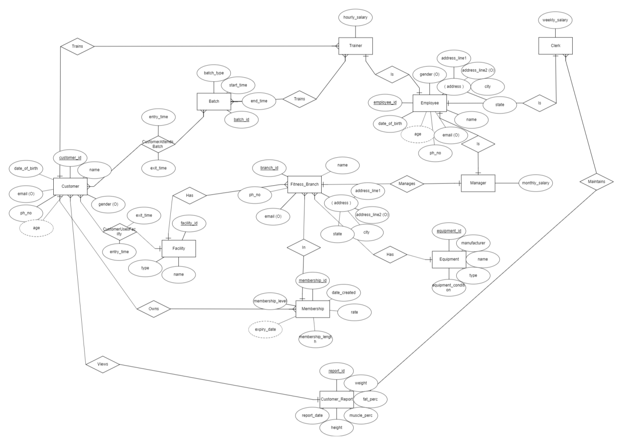

**2.1 ENTITIES:**

FITNESS_BRANCH

MANAGER

TRAINER

CLERK

MEMBERSHIP

CUSTOMER

BATCH

EMPLOYEE

CUSTOMER_REPORT

EQUIPMENT

FACILITY

**2.2 RELATIONSHIP**

FITNESS_BRANCH – HAS – FACILITY

FITNESS_BRANCH - MANAGER

FITNESS_BRANCH – MEMBERSHIP

FITNESS_BRANCH – HAS – EQUIPMENT

MANAGER –IS – EMPLOYEE

CLERK – IS - EMPLOYEE

TRAINER-IS – EMPLOYEE

CUSTOMER_REPORT – CLERK

CUSTOMER- CUSTOMER_REPORT

CUSTOMER- TRAINER

CUSTOMER- FACILITY

CUSTOMER- MEMBERSHIP

CUSTOMER- BATCH

BATCH-TRAINER

**2.3 MAPPING CONSTRAINS**