A

Project Report on

**Online Food Ordering & Delivery System**

Developed by

**Kacha Dhruv – IT036, Department of IT**

**Khyati Maheshwari- IT045, Department of IT**

**Guided By**

**Internal Guide:**

**Name (Prof. Roshni M. Raval)**

**Department of Information Technology**

**Faculty of Technology**

**DD University**



**Department of Information Technology**

**Faculty of Technology, Dharmsinh Desai University**

**College Road, Nadiad-387001**

**October - 2019**

## DHARMSINH DESAI UNIVERSITY

## NADIAD-387001, GUJARAT



## CERTIFICATE

### 

### This is to certify that the project entitled FOOD ORDERING AND DELIVERY SYSTEM

is a bonafied report of the work carried out by

1. **Miss Khyati Maheshwari** Student ID No: 17ECUOS063
2. **Mr. Dhruv Kacha** Student ID No: 17ECUOS063

of Department of Information Technology, Semester V, under the guidance and supervision for the subject Database Management System. She was involved in Project during academic year 2019-2020.

Prof. Roshni M. Raval (Project Guide) Department of Information Technology,

Faculty of Technology,

Dharmsinh Desai University, Nadiad

Date:

Prof. Vipul Dabhi

Head , Department of Information Technology,

Faculty of Technology,

Dharmsinh Desai University, Nadiad

Date:

**Acknowledgement**

The success and final outcome of this project required a lot of guidance and assistance from many people and we are extremely privileged to have got this all along the completion of our project. All that we have done is only due to such supervision and assistance and I would not forget to thank them.

I respect and thank Prof. Vipul Dabhi Sir, for providing me an opportunity to do the project work in DDU and giving us all support and guidance, which made us, complete the project duly. I am extremely thankful to Prof. Roshni Raval Ma’am for providing such a nice support and guidance, although she had a busy schedule managing other affairs.

**PROJECT BY:**

**Dhruv Kacha (IT-36)**

**Khyati Maheshwari (IT-43)**

**Contents of PROJECT REPORT**

**Content Page No.**

1) Project Title 1

2) Certificate 2

3) Acknowledgement 3

4) System Overview 5

-- Current system

-- Objectives of the proposed system

5) E.R.Diagram 6

-- Entities

-- Relationships

--Mapping Constraints

6) Database Schema/Table Definition 7

-- Table Name

-- Field Name

-- Data type

-- Field size

-- Constraint (e.g. auto generated, primary key, foreign key)

-- Validation (e.g. not null, default value)

7) Implementation 15

-- Output

**8)** Conclusion 24

9) Bibliography 25

1. **SYSTEM OVERVIEW •**

* In this project we will see how an online food delivery system is managed using database system.
* Customers will order the dishes they want from the desired restaurants .
* The restaurants will confirm the order, prepare it and keep it ready to be delivered.
* A delivery boy will be assigned to deliver the order at the customer’s registered address.

This is how our system works here.

* 1. **CURRENT SYSTEM** •

Current system works in the same way described above the only difference is it doesn’t use database system. So many functionality which database provides is not seen here.

* 1. **OBJECTIVES OF THE PROPOSED SYSTEM •**

System we discussed here would be beneficial and time saving. •

It uses procedure, triggers, cursors and function to make database work faster. •

Human efforts are decreased due to this system.

Also, it is more advantageous to customers who shift to Gold Status.

* 1. **ADVANTAGES OF THE PROPOSED SYSTEM •**

1. **E-R DIAGRAM:**

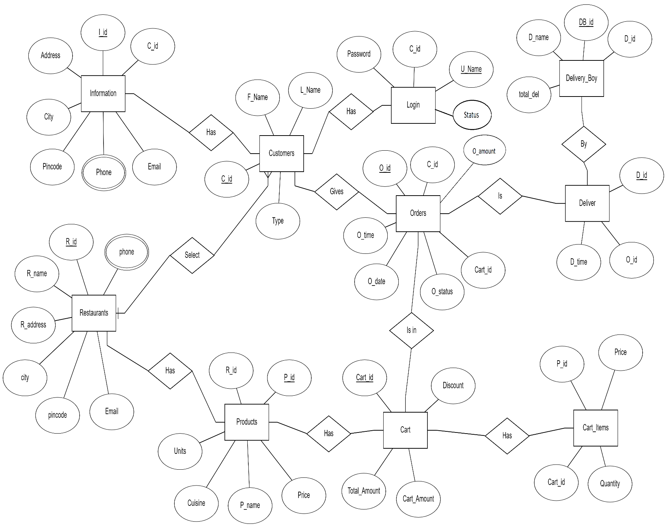

* 1. **ENTITIES:**

Login

Customer

Information

Restaurants

Products

Cart

Cart_Items

Orders

Deliver

Delivery_Boy

* 1. **RELATIONSHIPS:**

Customer-Login

Customer-Information

Customer-Orders

Restaurants-Products

Cart-has-Products

Cart-has-Cart_Items

Orders-is-Deliver

Deliver-is-Delivery_Boy

* 1. **MAPPING CONSTRAINTS:**

Customer-has-Login (1-1)

Customer-has-Information (1-1)

Customer-gives-Orders (1-*)

Restaurants-has-Products (*-1)

Cart-has-Products (1-*)

Cart-has-Cart_Items (1-*)

Orders-is-Deliver (1-1)

Deliver-by-Delivery_Boy (*-1)

1. **DATA DICTIONARY**
2. **TABLE : LOGIN**

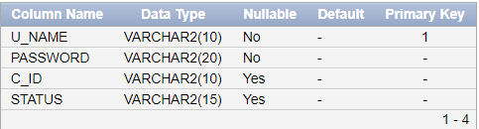

1. **TABLE : CUSTOMERS**

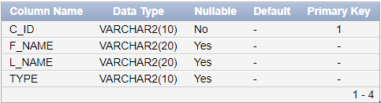

1. **TABLE : INFORMATION**

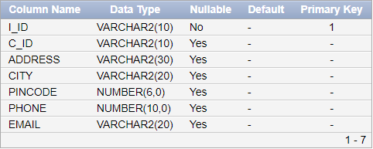

1. **TABLE : RESTAURANTS**

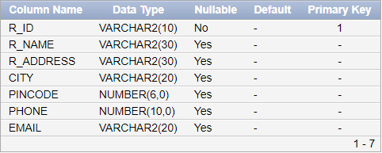

1. **TABLE : PRODUCTS**

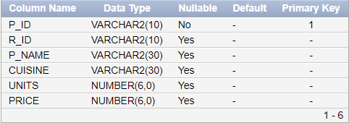

1. **TABLE : CART**

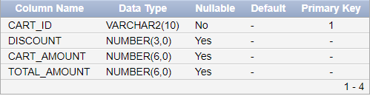

1. **TABLE : CART_ITEMS**

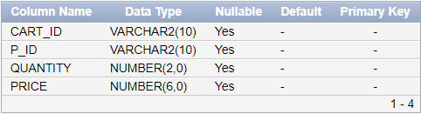

1. **TABLE : ORDERS**

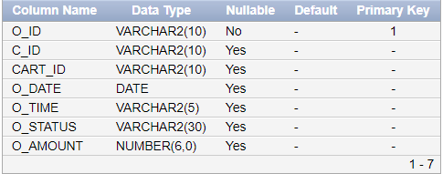

1. **TABLE : DELIVER**

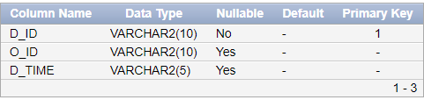

1. **TABLE : DELIVERY_BOY**

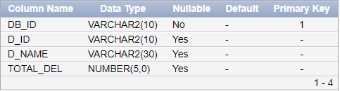

1. **SCHEMA DIAGRAM**

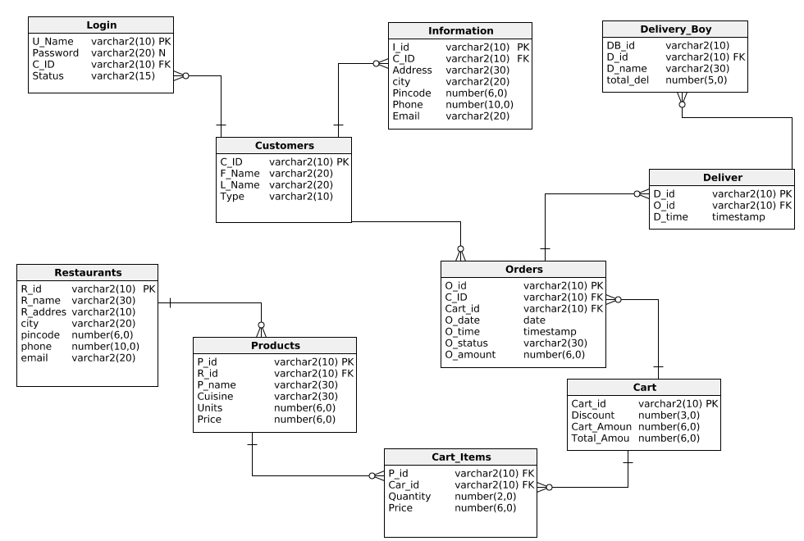

1. **DATABASE IMPLEMENTATION**

**5.1 CREATE SCHEMAS AND INSERT VALUES:**

1. **TABLE : LOGIN**

CREATE TABLE LOGIN

(U_NAME VARCHAR(10) PRIMARY KEY,

PASSWORD VARCHAR2(20) NOT NULL,

C_ID VARCHAR2(10) REFERENCES CUSTOMERS(C_ID));

INSERT ALL

INTO LOGIN VALUES('COURTNEY','A001','C001')

INTO LOGIN VALUES('MANNIX','A002','C002')

INTO LOGIN VALUES('KYRA','A003','C003')

INTO LOGIN VALUES('CHESTER','A004','C004')

INTO LOGIN VALUES('STEWART','A005','C005')

SELECT * FROM DUAL;

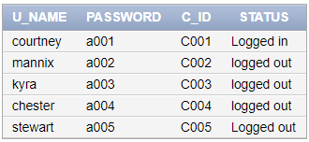

1. **TABLE : CUSTOMERS**

CREATE TABLE CUSTOMERS

(C_ID VARCHAR2(10) PRIMARY KEY,

F_NAME VARCHAR2(20),

L_NAME VARCHAR2(20),

TYPE VARCHAR2(10));

INSERT ALL

INTO CUSTOMERS VALUES ('C001','COURTNEY','BOYD','GOLD')

INTO CUSTOMERS VALUES ('C002','MANNIX','PAUL','REGULAR')

INTO CUSTOMERS VALUES ('C003','KYRA','RILEY','GOLD')

INTO CUSTOMERS VALUES ('C004','CHESTER','BUCHANAN','REGULAR')

INTO CUSTOMERS VALUES ('C005','STEWART','CORTEZ','REGULAR')

SELECT * FROM DUAL;

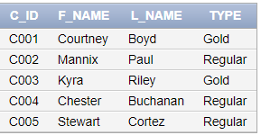

1. **TABLE : INFORMATION**

CREATE TABLE INFORMATION

(I_ID VARCHAR2(10) PRIMARY KEY,

C_ID VARCHAR2(10) REFERENCES CUSTOMERS(C_ID),

ADDRESS VARCHAR2(30),

CITY VARCHAR2(20),

PINCODE NUMBER(6,0),

PHONE NUMBER(10,0),

EMAIL VARCHAR2(20));

INSERT ALL

INTO INFORMATION VALUES('I001','C001','7874 Nulla Avenue', 'Rajkot', 360000, 9584632014, 'arcu@Nuncmauris.org')

INTO INFORMATION VALUES('I002','C002','Ap 100 2300 Sem', 'Baroda', 390000, 9698344741, 'nibh@neque.edu')

INTO INFORMATION VALUES('I003','C003','4759843 Faucibus', 'Surat', 395009, 9856381824, 'pretium.et@eget.net')

INTO INFORMATION VALUES('I004','C004','PO Box 875 1436 Gravida Street','Ahmedabad', 380001, 9584632014, 'odio@odio.edu')

INTO INFORMATION VALUES('I005','C005','2733 Id Ave', 'Gandhinagar', 382002, 2169204824, 'eu@molestie.ca')

SELECT * FROM DUAL;

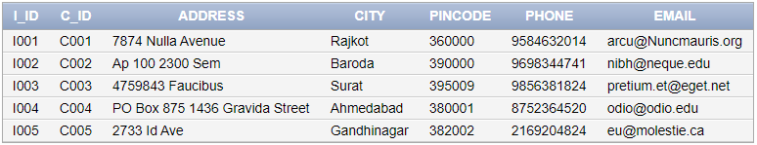

1. **TABLE : RESTAURANTS**

CREATE TABLE RESTAURANTS

(R_ID VARCHAR2(10) PRIMARY KEY,

R_NAME VARCHAR2(30),

R_ADDRESS VARCHAR2(30),

CITY VARCHAR2(20),

PINCODE NUMBER(6,0),

PHONE NUMBER(10,0),

EMAIL VARCHAR2(20));

INSERT INTO RESTAURANTS VALUES('R002','Sw Restaurant','P.O. Box 903, 7586 Pretium St.','Rajkot',360003,9978140784,'sw@gmail.com')

INSERT INTO RESTAURANTS VALUES('R001','Dominos Pizza','P.O. Box 742, 3039 Sit St.','Rajkot',360000,8192956147,'dominos@gmail.com')

INSERT INTO RESTAURANTS VALUES('R003','Dominos Pizza','6991 Aliquam St.','Surat',395009,9315248752,'dominos@gmail.com')

INSERT INTO RESTAURANTS VALUES('R004','Dosa Hub','Ap #363-9051 Dolor. Avenue','Baroda',390000,9342265786,'dosahub@gmail.com')

INSERT INTO RESTAURANTS VALUES('R005','Macd Burgers','7691 Phasellus Street','Ahmedabad',380001,963154663,'macdb@gmail.com')

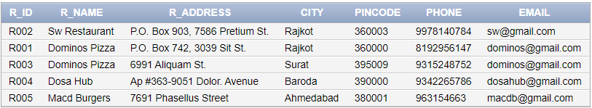

1. **TABLE : PRODUCTS**

CREATE TABLE PRODUCTS

(P_ID VARCHAR2(10) PRIMARY KEY,

R_ID VARCHAR2(10) REFERENCES RESTAURANTS(R_ID),

P_NAME VARCHAR2(30),

CUISINE VARCHAR2(30),

UNITS NUMBER(6,0),

PRICE NUMBER(6,0));

INSERT INTO PRODUCTS VALUES('P001','R001','Indi Tandoori Paneer','Pizza',30,235);

INSERT INTO PRODUCTS VALUES('P002','R001','Veg Loaded','Pizza',50,135);

INSERT INTO PRODUCTS VALUES('P006','R002','Paneer Kadai','Main Course',50,170);

INSERT INTO PRODUCTS VALUES('P007','R002','Paneer Butter Masala','Main Course',50,170);

INSERT INTO PRODUCTS VALUES('P018','R002','Butter Milk','Beverages',50,30);

INSERT INTO PRODUCTS VALUES('P019','R003','Indi Tandoori Paneer','Pizza',30,235);

INSERT INTO PRODUCTS VALUES('P020','R003','Veg Loaded','Pizza',50,135);

INSERT INTO PRODUCTS VALUES('P024','R004','Dosa hub special','South Indian',30,170);

INSERT INTO PRODUCTS VALUES('P025','R004','Butter dosa','South Indian',50,60);

INSERT INTO PRODUCTS VALUES('P026','R004','Masala dosa','South Indian',50,110);

INSERT INTO PRODUCTS VALUES('P027','R004','Mysore Masala dosa','South Indian',50,120);

INSERT INTO PRODUCTS VALUES('P028','R004','Cheese Dosa','South Indian',50,150);

INSERT INTO PRODUCTS VALUES('P029','R005','veg Cheese Burger','Burger',30,80);

INSERT INTO PRODUCTS VALUES('P030','R005','Paneer Burger','Burger',50,100);

INSERT INTO PRODUCTS VALUES('P031','R005','Fries','Fries',50,60);

INSERT INTO PRODUCTS VALUES('P032','R005','Iced tea','Beverages',50,76);

INSERT INTO PRODUCTS VALUES('P033','R005','Black forest','Dessert',50,100);

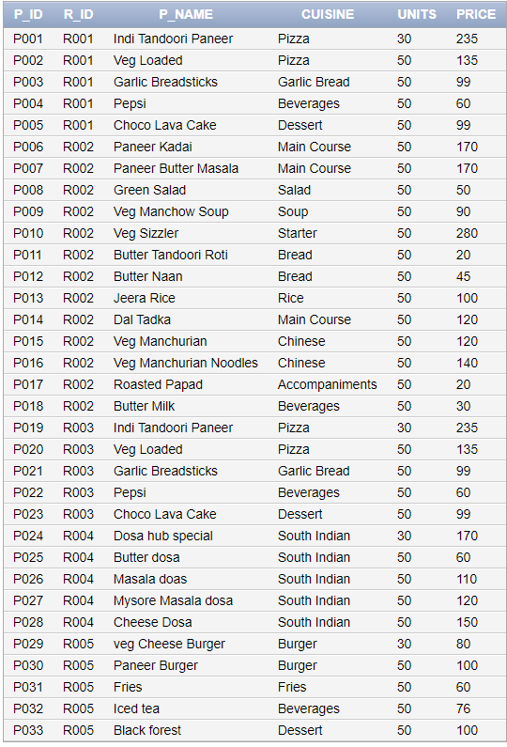

1. **TABLE : CART**

CREATE TABLE CART

(CART_ID VARCHAR2(10) PRIMARY KEY,

DISCOUNT NUMBER(3,0),

CART_AMOUNT NUMBER(6,0),

TOTAL_AMOUNT NUMBER(6,0));

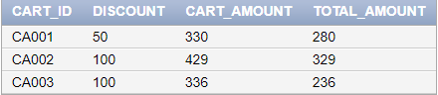

1. **TABLE : CART_ITEMS**

CREATE TABLE CART_ITEMS

(CART_ID VARCHAR2(10) REFERENCES CART(CART_ID),

P_ID VARCHAR2(10) REFERENCES PRODUCTS(P_ID),

QUANTITY NUMBER(2,0),

PRICE NUMBER(6,0));

INSERT INTO CART_ITEMS VALUES('CA001','P007',1,170);

INSERT INTO CART_ITEMS VALUES('CA001','P012',2,90);

INSERT INTO CART_ITEMS VALUES('CA001','P017',2,40);

INSERT INTO CART_ITEMS VALUES('CA001','P018',1,30);

INSERT INTO CART_ITEMS VALUES('CA002','P002',2,270);

INSERT INTO CART_ITEMS VALUES('CA002','P004',1,60);

INSERT INTO CART_ITEMS VALUES('CA002','P005',1,99);

INSERT INTO CART_ITEMS VALUES('CA003','P029',2,160);

INSERT INTO CART_ITEMS VALUES('CA003','P032',1,76);

INSERT INTO CART_ITEMS VALUES('CA003','P033',1,100);

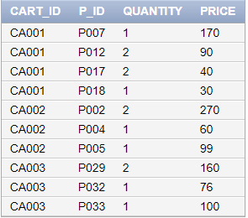

1. **TABLE : ORDERS**

CREATE TABLE ORDERS

(O_ID VARCHAR2(10) PRIMARY KEY,

C_ID VARCHAR2(10) REFERENCES CUSTOMERS(C_ID),

CART_ID VARCHAR2(10) REFERENCES CART(CART_ID),

O_DATE DATE,

O_TIME VARCHAR(5),

O_STATUS VARCHAR(30),

O_AMOUNT NUMBER(6,0));

INSERT INTO ORDERS VALUES('O002','C001','CA002',08/20/2019,'6:00','On the way',329);

INSERT INTO ORDERS VALUES('O003','C004','CA003',08/27/2019,'11:00','On the way',236);

INSERT INTO ORDERS VALUES('O001','C001','CA001',01/24/2019,'9:33','Delivered',280);

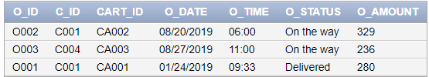

1. **TABLE : DELIVER**

CREATE TABLE DELIVER

(D_ID VARCHAR2(10) PRIMARY KEY,

O_ID VARCHAR2(10) REFERENCES ORDERS(O_ID),

D_TIME VARCHAR2(5));

INSERT INTO DELIVER VALUES('D001','O001','10:00');

INSERT INTO DELIVER VALUES('D002','O002',null);

INSERT INTO DELIVER VALUES('D003','O003',null);

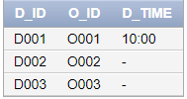

1. **TABLE : DELIVERY_BOY**

CREATE TABLE DELIVERY_BOY

(DB_ID VARCHAR2(10) PRIMARY KEY,

D_ID VARCHAR2(10) REFERENCES DELIVER(D_ID),

D_NAME VARCHAR2(30),

TOTAL_DEL NUMBER(5,0));

INSERT INTO DELIVERY_BOY VALUES('DB001','D001','Alex',2);

INSERT INTO DELIVERY_BOY VALUES('DB002','D002','John',1);

INSERT INTO DELIVERY_BOY VALUES('DB003','D003','Dhruv',0);

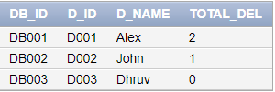

**5.3 QUERIES**

1. **Find all restaurants located in Rajkot:**

SELECT R_NAME FROM RESTAURANTS WHERE CITY='rajkot';

**OUTPUT:**

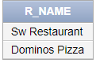

1. **All restaurants located in Rajkot who deliver desserts:**

SELECT R.R_NAME,P.P_NAME,P.PRICE FROM RESTAURANTS R,PRODUCTS P WHERE

R.CITY='rajkot' AND

P.R_ID=R.R_ID AND

P.CUISINE='dessert';

**OUTPUT:**

2

1. **All restaurants located near you:**

SELECT R.R_NAME FROM RESTAURANTS R,CUSTOMERS C,INFORMATION I WHERE

C.C_ID='C001' AND

C.C_ID=I.C_ID AND

R.PINCODE=I.PINCODE

**OUTPUT:**

3

1. **SHOW ALL YOUR DELIVERED ORDERS WITH DELIVERY TIME**

SELECT O.O_ID AS "ORDER ID",O.O_DATE AS "ORDER DATE",O.O_TIME AS "ORDER TIME",D.D_TIME AS "DELIVER TIME" FROM

ORDERS O,DELIVER D WHERE

O.C_ID='C001' AND

D.O_ID=O.O_ID AND

O.O_STATUS='Delivered';

**OUTPUT:**

4

1. **SHOW ALL ORDERS OF CUSTOMERID=C001 WHOSE TOTAL AMOUNT IS GREATER THAN 100**

SELECT * FROM ORDERS WHERE O_AMOUNT>100 AND C_ID='C001';

**OUTPUT:**

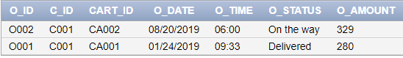

1. **SHOW THE DELIVERY BOY NAME OF THE LAST ORDER OF CUSTOMER 1**

SELECT D_NAME FROM DELIVERY_BOY WHERE

D_ID=(SELECT D_ID FROM DELIVER WHERE

O_ID=(SELECT O_ID FROM ORDERS WHERE O_STATUS='On the way' AND C_ID='C001'));

**OUTPUT:**

6

1. **SHOW ALL ORDERS OF CUTOMER1 FROM JANUARY**

SELECT * FROM ORDERS WHERE C_ID='C001' AND

EXTRACT(MONTH FROM O_DATE)=1;

**OUTPUT:**

7

1. **SHOW PRODUCTS WITH QUANTITY AND PRICE OF YOUR LAST ORDER**

SELECT P.P_NAME,P.PRICE,CI.QUANTITY,CI.PRICE FROM PRODUCTS P,CART_ITEMS CI,CART C,ORDERS O WHERE

CI.CART_ID=C.CART_ID AND

O.CART_ID=C.CART_ID AND

O.O_STATUS='On the way' AND

O.C_ID='C001' AND

P.P_ID=CI.P_ID;

**OUTPUT:**

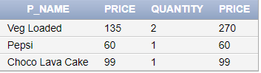

1. **FIND OUT TOTAL NO. OF RESTAURANTS IN ALL CITIES**

SELECT CITY,COUNT(R_ID) FROM RESTAURANTS GROUP BY CITY;

**OUTPUT:**

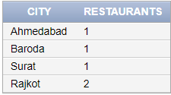

1. **SEARCH ONE RESTAURANT AND SHOW ALL PRODUCTS WITH PRICE FROM LOW TO HIGH**

SELECT P.P_NAME,P.PRICE FROM PRODUCTS P,RESTAURANTS R WHERE

R.R_NAME='MACD BURGERS' AND

P.R_ID=R.R_ID ORDER BY

P.PRICE;

**OUTPUT:**

