Submission Draft

Proposal for a Ghana RPAS Practical Training,
Qualification and Digital Assessment Framework
A competency-based, system-assessed model for RPAS pilot training, practical testing and training-organisation oversight

Field | Description
Prepared for | Government of Ghana, Ghana Civil Aviation Authority (GCAA), and relevant partner institutions
Proposal status | Pre-approval technical proposal for discussion. Not an official GCAA directive or approved qualification standard.
Core basis | GCAA RPAS framework, GCAD Part 28, Ghana-specific pilot training concept, and v3 radius-based RTK practical assessment model
Budget basis | 15-trainee sequential course model: classroom → simulator → practical flight → RTK automated assessment
Recommended planning budget | USD $127,380 (equipment + RTK automated assessment system + contingency + import/logistics allowance)
Date | 24 July 2026

Important note: the qualification names, practical-test dimensions, scoring model and budget are proposed design elements. Official names, legal effect, licensing authority and implementation conditions are to be confirmed by GCAA.

1. Executive Summary
This proposal sets out a Ghana-focused RPAS practical training, qualification and digital assessment framework. It is designed to support a transition from time-based and manual training records toward competency-based assessment using online theory testing, simulator logs, RTK flight-data capture and structured training-organisation oversight.
The proposed Basic Pilot practical standard is built around an 8-figure practical flight task. The planned flight path is assessed through a radius-based error model: the scoring zones are measured from the nominal path centreline, not by corridor diameter.
The proposed system also introduces a scalable qualification pathway: RPAS Basic Pilot, RPAS Professional Pilot endorsements, RPAS Instructor, RPAS Training Manager / Safety Supervisor, Training Organisation Approval and Operator Certificate integration. These names are proposal labels and must be aligned with GCAA's official RPL, ROC, RTOC and related authorisation structures before implementation.
For initial deployment, the recommended operating model is a 15-trainee sequential course: classroom instruction, simulator training, practical flight training and RTK automated assessment. The recommended planning budget is USD $127,380, excluding VAT, customs duties, Ghana inland transport, insurance, GCAA fees, facility fit-out, instructor fees, airfare and lodging.

Design pillar | Proposed approach | Expected result
Competency-based | Use simulator tasks, online tests and RTK flight data rather than relying primarily on logged flight hours. | More objective evidence of competence.
System-assessed | Use automated scoring and data integrity controls to reduce subjective examiner discretion. | Greater consistency and auditability.
GCAA-aligned | Use GCAA RPAS categories and existing Part 28 terminology as the regulatory reference point. | Easier policy discussion and phased adoption.
Institutional quality | Tie training approval to instructors, safety supervisors, records, manuals and safety controls. | Improved training-organisation oversight.

Status of information

Type | Meaning in this proposal | Examples
Official basis | Items reflected from GCAA publications or current GCAA RPAS resources. | RPAS = RPA + RPS + C2; all unmanned aircraft are subject to GCAD Part 28; GCAA RPAS Safety Training is linked to registration.
Proposal | Design choices recommended for the Ghana pilot model but not yet confirmed as GCAA official test standards. | Rcourse 5m/7m/10m, rerror 1m/2m/3m scoring zones, 70-point pass threshold.
For GCAA confirmation | Items that require formal review, approval or calibration with GCAA and local stakeholders. | Official qualification names, certificate authority, GPS/ATTI policy, weather minima, retest rules, data retention period.

2. Regulatory and institutional basis
This proposal is designed to sit within Ghana’s existing RPAS framework rather than replace it. The following points are treated as official reference points for discussion.
Official basis | Implication for this proposal | Source
GCAA RPAS concept | GCAA describes RPAS as a system consisting of the Remotely Piloted Aircraft (RPA), Remote Pilot Station (RPS), and Command and Control (C2) link. | [1]
Applicability of Part 28 | GCAA guidance states that unmanned aircraft, whether piloted, autonomous or a combination, are subject to GCAD Part 28. | [1]
RPAS classification | Part 28 classifies RPAS as Small (MTOW up to 1.5 kg), Light (more than 1.5 kg and up to 7 kg), and Large (more than 7 kg). | [2]
Training and commercial operation controls | Part 28 includes RTOC and ROC concepts, RPL-related requirements, 400 ft AGL and VLOS/BVLOS-related controls. | [2]
Existing safety training | GCAA RPAS Safety Training is presented as a prerequisite for drone registration and is structured into three modules with an 80% pass mark and a certificate valid for one year. | [3]
RPAS application ecosystem | GCAA RPAS Resources include applications for RPAS import, use, BVLOS/above 400 ft AGL operation, RPAS Pilot Licence and other related processes. | [4]
PROPOSAL The proposed training and assessment model should be submitted as a pilot framework for GCAA review, not as a replacement for existing permits, registrations, RPL, ROC or RTOC requirements.
FOR GCAA CONFIRMATION The relationship between the proposed Basic Pilot, Professional Pilot and Instructor designations and GCAA's official licensing/authorisation framework should be formally mapped before launch.

3. Proposed Ghana RPAS qualification pathway
Stage | Proposed designation | Purpose | Core requirements
1 | RPAS Basic Pilot | Low-risk VLOS pilot qualification for entry-level and recreational users. | Online theory assessment, simulator tasks, 8-figure RTK practical assessment.
2 | RPAS Professional Pilot | Operational endorsement for sector-specific work. | Basic Pilot, sector training, scenario-based task evaluation.
3 | RPAS Instructor | Training qualification for Basic and Professional courses. | Professional Pilot endorsement, one-year operational experience, instructor training and teaching assessment.
4 | Training Manager / Safety Supervisor | Training quality and safety oversight role. | Professional background, instructor experience, safety management course and assessment.
5 | Training Organisation Approval | Institutional approval for professional RPAS education. | Instructor, safety supervisor, facilities, equipment, manuals, records and safety controls.
6 | Operator Certificate integration | Commercial and public operator pathway. | Organisation, equipment, SOPs, SMS, insurance and operational capability review.
FOR GCAA CONFIRMATION These names are proposed operational labels. Their legal effect, certificate wording and equivalence to existing GCAA instruments must be decided by GCAA.

3.1 Professional Pilot endorsement examples
Sector | Example endorsement | Operational focus
Agriculture | Professional Pilot - Agriculture | Spraying support, crop monitoring, pest surveillance and plant-health assessment.
Mapping | Professional Pilot - Mapping | Aerial photography, orthomosaic capture, 3D mapping and ground-control workflows.
Inspection | Professional Pilot - Inspection | Powerline, bridge, solar farm and industrial asset inspection.
Public Safety | Professional Pilot - Public Safety | Disaster response, search support, rescue support and incident reporting.
Maritime / Environment | Professional Pilot - Maritime / Environmental Monitoring | Coastal, water-quality, forest and environmental monitoring.
Security Surveillance | Professional Pilot - Security Surveillance | Perimeter monitoring, illegal-mining surveillance and critical-facility monitoring.
Drone Sports / Education Support | Professional Pilot - Drone Sports / Education Support | Drone sports facilitation, public outreach and education assistance.

4. Practical flight-test and RTK assessment standard
The Basic Pilot practical standard is centred on a figure-8 flight course and a radius-based automated scoring method. The course radius (Rcourse) and scoring error radius (rerror) are separate variables.
Variable | Meaning |  | Proposed values |  | Note
P | Pilot position |  | 15 m behind take-off point T |  | Common baseline for all classes.
T | Take-off and landing point |  | Start/return reference point |  | Can be linked to the RTK reference coordinate system.
C | Actual figure-8 crossing point |  | T to C = Rcourse |  | The figure-8 path crosses at C.
Rcourse | Course circle radius |  | Small 5 m / Light 7 m / Large 10 m |  | Course geometry parameter.
rerror | Scoring error radius |  | 1 m / 2 m / 3 m |  | Measured from the planned path centreline. Not diameter-based.
GCAA class | MTOW basis | Operating basis |  | Proposed Rcourse | Design purpose
Small RPAS | ≤ 1.5 kg | VLOS |  | 5 m | Basic control, position and altitude stability.
Light RPAS | > 1.5 kg to ≤ 7 kg | VLOS |  | 7 m | Inertia, speed and turning-radius control.
Large RPAS | > 7 kg | VLOS or BVLOS with prior authorisation |  | 10 m | Safety distance, braking, emergency procedures.

4.1 Radius-based auto scoring
Zone | rerror criterion | Meaning | Sample score | Assessment interpretation
A Zone | r ≤ 1 m | Target corridor | 100 | Precise flight.
B Zone | 1 m < r ≤ 2 m | Minor deviation | 80 | Passable control.
C Zone | 2 m < r ≤ 3 m | Major deviation | 60 | Borderline performance.
D Zone | r > 3 m | Course deviation | 0 | Safety cap and auto-fail rules apply.

Proposed formula: Final Score = 100×P1 + 80×P2 + 60×P3 + 0×Pout - safety/procedure penalties
P1, P2, P3 and Pout represent the proportion of samples within the A, B, C and D zones respectively. The passing score is proposed at 70 points or higher, provided that no automatic failure condition is triggered.

Automatic failure / cap condition | Treatment | Purpose
D Zone continuous for 2 seconds or more | Automatic failure | Prevents sustained course deviation.
D Zone cumulative time over 5% of the course | Automatic failure | Prevents unsafe flight from being hidden by average scoring.
Safety line or test-field boundary breach | Automatic failure | Protects people and facilities.
Missing crossing point, wrong direction or skipped sequence | Zero for section or automatic failure | Ensures course completion and sequence compliance.
Crash, rollover, obstacle contact or loss of control | Automatic failure | Maintains basic flight safety.
C Zone residence over 25% | Maximum score cap of 75 | Controls repeated unstable deviations.
Any D Zone entry | Maximum score cap of 90 | Reflects the seriousness of a course deviation.

Figure 1. Proposed practical test course and radius-based auto scoring standard.
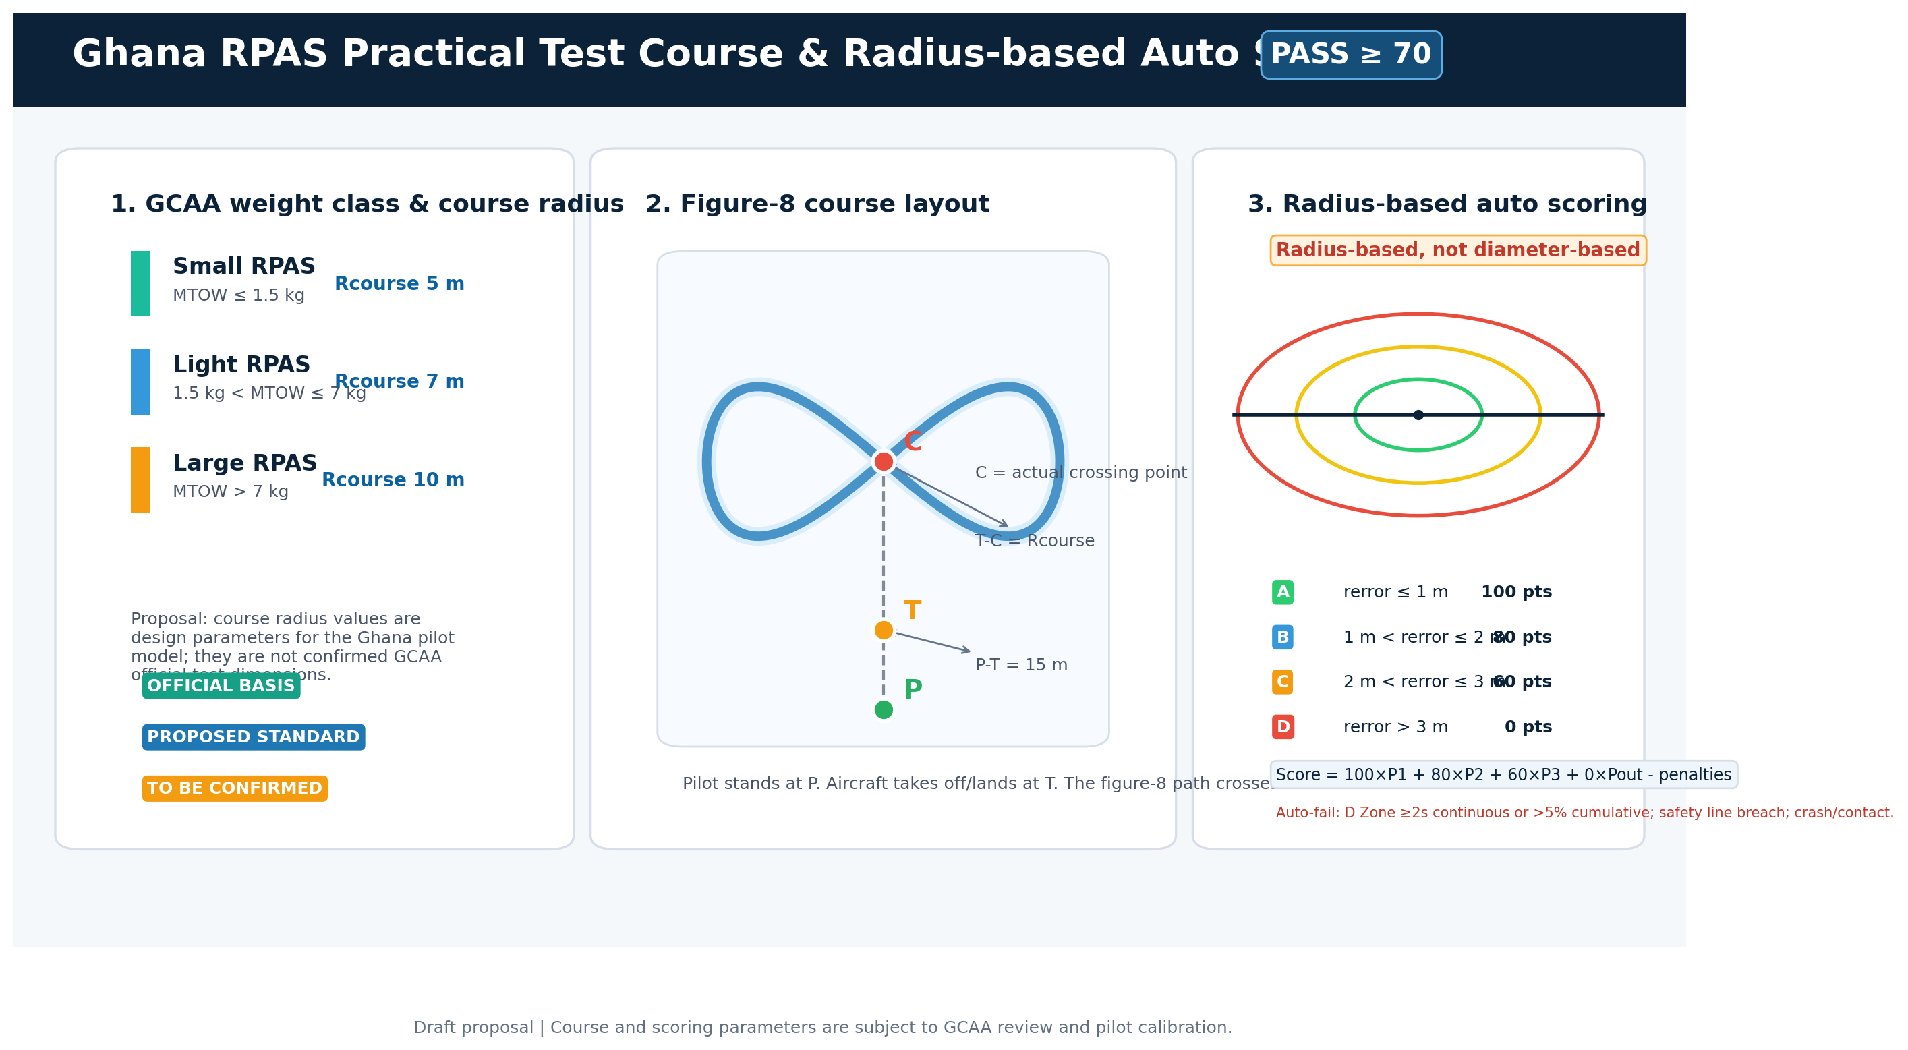

5. Digital assessment system and data integrity
The proposed model minimises subjective examiner judgement by combining online theory testing, simulator logs and RTK practical flight data. The examiner’s role is primarily to verify identity, check equipment, control field safety, start and end the test, and record exceptions.
The RTK practical assessment should record position, altitude, speed, path deviation, hover stability, waypoint/crossing-point achievement and landing error as source logs. The assessment result should be stored with the original data to support audit and recalibration.
Control item | Proposed requirement
Pre-test equipment check | RTK base/rover status, reference coordinate, Fix status, battery and storage device must be checked before each test.
Antenna offset | Each aircraft's RTK antenna mounting offset should be recorded and applied to scoring calculations.
Original logs | Raw logs should be preserved in a non-editable or audit-controlled format with the result report.
Signal loss / time sync | RTK signal loss, missing samples, time synchronisation error or reference-point misconfiguration should trigger retest or invalidation rules.
Pilot calibration | Weather limits, wind thresholds, sampling rate, rerror calculation method and retest rules should be calibrated through the first pilot cohort.
PROPOSAL The RTK automated assessment system is presented as one integrated line item in the budget. Product-level details and vendor confirmations should be handled in procurement documents, not in the policy proposal.

6. Training organisation approval and oversight
The proposed approval model treats an RPAS training organisation as an accountable education and safety system, not simply as a classroom with aircraft.
Area | Minimum proposed requirement
Personnel | At least one Instructor and one Training Manager / Safety Supervisor.
Facilities | Classroom, simulator area, briefing/debriefing area and maintenance-practice space.
Equipment | Training drones, simulator equipment, RTK assessment equipment and field safety equipment.
Documents | Training Manual, Operations Manual and Safety Manual.
Records | Trainee records, simulator logs, RTK assessment logs, maintenance records and incident records.
Safety | Emergency response plan, risk assessment template, accident/incident reporting procedure.
Oversight | Acceptance of GCAA inspection, renewal review and corrective-action follow-up.

6.1 Training Manager / Safety Supervisor
Subject | Weight | Purpose
RPAS safety management | 25% | Hazard identification, risk matrix and emergency response.
Training-organisation management | 20% | Training records, instructor management, equipment management and quality control.
Practical assessment safety control | 20% | Field control, RTK assessment process and emergency stop criteria.
Accident and incident reporting | 15% | Investigation, reporting structure and recurrence prevention.
Regulations and approval criteria | 10% | GCAA approval, training organisation approval and renewal review.
Scenario-based judgement | 10% | Decision-making in realistic training-organisation situations.

7. Initial 2026 Master Instructor Foundation Course
Item | Proposed content
Course name | Ghana RPAS Master Instructor Foundation Course
Timing | Early September 2026, two-week course
Location | GATA 6th-floor training facility, subject to host confirmation
Participants | Approximately 15 candidates
Target audience | Manned-aircraft pilots, existing drone-qualified personnel, GCAA/GATA/ATU stakeholders and relevant public-sector participants.
Course purpose | Develop the initial instructor cohort while validating the Ghana RPAS training, assessment and qualification framework.
Module | Content
Regulation and institutions | Ghana RPAS framework, airspace, authorisations and training organisation approval.
System principles | Flight control, GPS/RTK, IMU, GCS, failsafe and battery systems.
Simulator | Basic flight, figure-8 flight, emergency procedures and mission flight.
Practical assessment | RTK-based figure-8 course and mission-type assessment.
Instructional method | Lesson design, briefing, flight coaching and debriefing.
Assessment operation | Online theory test, simulator logs and RTK assessment-data management.
Safety management | Risk assessment, incident reporting, emergency response and safety supervision.
Framework design | Qualification framework, training organisation criteria and assessment-procedure drafts.

7.1 Expected pilot-course outputs
- Ghana RPAS Digital Assessment Model v0.1
- Ghana RPAS Qualification Framework v0.1
- 8-Figure RTK Practical Test Standard v0.1
- Professional Pilot Endorsement Framework v0.1
- Instructor Training Manual v0.1
- Training Manager / Safety Supervisor Standard v0.1
- Training Organisation Approval Criteria v0.1
- Online Theory Test Bank v0.1
- Simulator Training Module v0.1

8. Implementation roadmap
Phase | Core activity | Main outputs
1 | Train the initial instructor cohort using GATA facilities. | Instructor candidates, framework draft and assessment draft.
2 | Pilot the Basic Pilot course with online theory, simulator tasks and figure-8 RTK practical assessment. | Calibrated difficulty, tolerances and pass criteria.
3 | Open sector-specific Professional Pilot endorsement courses. | Agriculture, mapping, inspection, public safety and other endorsement standards.
4 | Institutionalise Instructor and Training Manager / Safety Supervisor pathways. | Mandatory staffing criteria for training organisations.
5 | Approve and scale professional training organisations. | Accra, Kumasi and hub-and-spoke expansion model.
6 | Prepare regional extension across West Africa. | ECOWAS and African technical-university network model.

9. Equipment and budget plan for the 15-trainee sequential model

The budget model assumes one 15-trainee cohort moving sequentially through classroom instruction, simulator training, practical flight training and RTK automated assessment. The RTK automated assessment system is kept as one consolidated budget line.
Scenario | Equipment subtotal | RTK automated assessment system | Subtotal | 15% contingency | Import/logistics allowance | Total planning budget
Lean | $34,200 | $31,726 | $65,926 | $9,889 | $6,840 | $82,655
Recommended | $67,330 | $31,726 | $99,056 | $14,858 | $13,466 | $127,380
Resilient | $84,560 | $31,726 | $116,286 | $17,443 | $16,912 | $150,641

RECOMMENDATION Adopt the Recommended scenario as the baseline pilot budget: USD $127,380. The Lean scenario is suitable only for minimum proof-of-concept operation, while the Resilient scenario provides stronger spare capacity and failure tolerance.
Figure 2. Recommended budget structure and equipment groups.

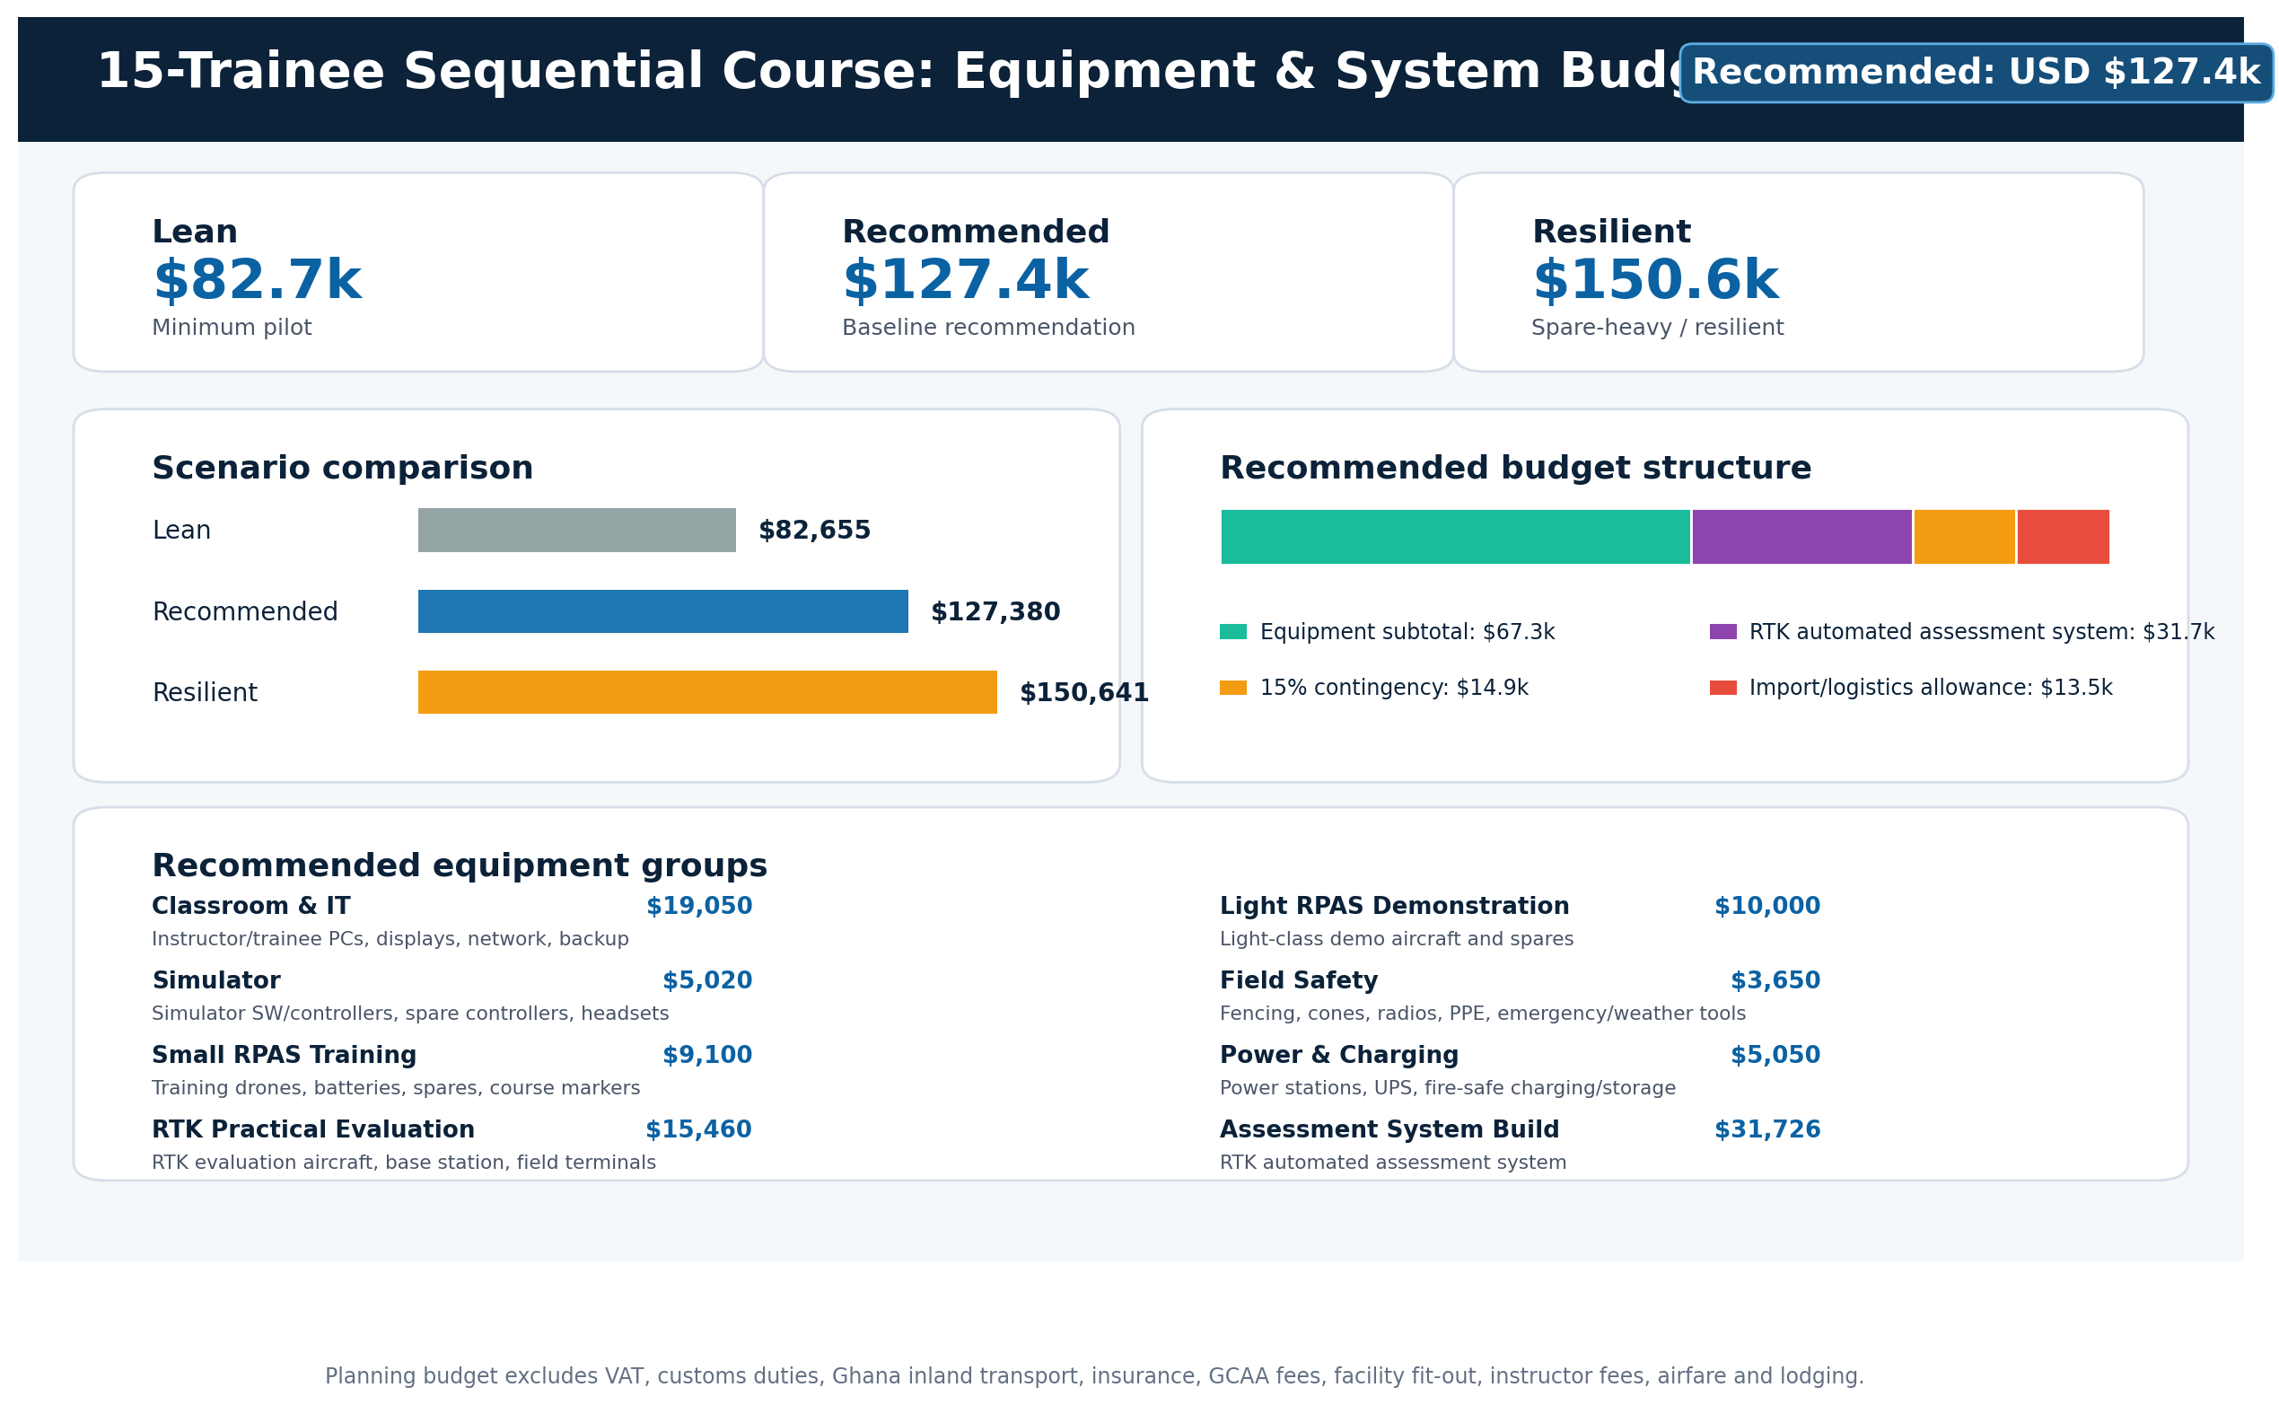

9.1 Recommended equipment groups
Equipment group | Main components | Recommended amount
Classroom & IT | Instructor and trainee PCs, displays, network and backup storage. | $19,050
Simulator | Simulator software/controller sets, spare controllers and headsets. | $5,020
Small RPAS Training | Small training aircraft, batteries, consumables and course markers. | $9,100
RTK Practical Evaluation | RTK evaluation aircraft, RTK base station, field tablets and log accessories. | $15,460
Light RPAS Demonstration | Light-class demonstration aircraft, batteries and maintenance spares. | $10,000
Field Safety | Safety fencing, cones, radios, PPE, emergency and weather equipment. | $3,650
Power & Charging | Portable power, UPS, fire-safe charging/storage and cabling. | $5,050
Assessment System Build | Consolidated RTK automated assessment system line item. | $31,726

9.2 Budget exclusions and procurement controls
The planning budget excludes VAT, customs duties, Ghana inland transport, insurance, GCAA fees, facility fit-out, instructor fees, airfare and lodging. These should be added during procurement and implementation planning.
Control | Proposed procurement treatment
Vendor quotation | Obtain updated local or regional quotations before purchase, especially for RTK equipment and software integration.
System acceptance | Conduct field calibration and acceptance testing with sample flight data before using automated results for official decisions.
Data integrity | Require raw log retention, audit trail and standardised result reports.
Scalability | Separate one-time development/configuration costs from per-set hardware/software quantities.
Regulatory clearance | Confirm import, registration, use and pilot licensing requirements through GCAA before equipment shipment or field use.

10. Items for GCAA confirmation
Topic | Decision to be confirmed | Why it matters
Official approval scope | Qualification names, training organisation criteria and certificate/approval issuing authority. | Prevents confusion with existing RPL, ROC, RTOC and permit structures.
Existing RPAS Safety Training | Whether it is a prerequisite, common module or recognised equivalent for the Basic Pilot pathway. | Avoids duplication and aligns with current registration training.
RTK assessment criteria | Tolerance values, altitude criteria, sampling rate, standard aircraft and retest thresholds. | Ensures defensible and repeatable scoring.
GPS/ATTI policy | Whether GNSS-aided flight, ATTI/manual mode or class-based differentiation should apply. | Aligns skills assessment with safety and equipment realities.
Weather minima | Wind, visibility, rain, night-operation and test-interruption thresholds. | Prevents unsafe or incomparable test conditions.
Online test security | Initial online-form controls and long-term GCAA LMS/portal requirements. | Protects examination integrity.
Training organisation staffing | Initial dual-hatting allowance and timeline for separating instructor and safety supervisor roles. | Supports phased expansion without compromising oversight.
High-risk operations | BVLOS, night flight, delivery, security surveillance, counter-drone and military/police missions. | Keeps high-risk activities outside the initial general qualification until separate controls are approved.

11. Expected benefits
- Improved fairness and transparency in RPAS practical assessment by reducing dependence on manual flight-hour logs and examiner discretion.
- A stronger training-organisation quality-management model using instructors, safety supervisors, manuals, records and GCAA oversight.
- A national RPAS training infrastructure that can use GATA training space for education, simulation, assessment and certification preparation.
- Sector-specific workforce development for agriculture, public safety, maritime monitoring, environmental monitoring, mapping and infrastructure inspection.
- A platform for regional extension through ECOWAS and African technical-university networks after successful pilot validation in Ghana.

12. References and source basis
Ref. | Source | URL / note
[1] | GCAA, Remotely Piloted Aircraft Systems / Drones guidance page | https://www.gcaa.com.gh/web/remotely-piloted-aircraft-system-2/
[2] | Ghana Civil Aviation (Remotely Piloted Aircraft Systems) Directives, 2018, Part 28 | https://www.gcaa.com.gh/web/wp-content/uploads/2018/directives/GCA_FLIGHT_STANDARDS_DIRECTIVE/PART_28_REMOTELY_PILOTED_AIRCRAFT_SYSTEMS_DIRECTIVES.pdf
[3] | GCAA RPAS Safety Training Portal | https://www.gcaa.com.gh/rpas/
[4] | GCAA RPAS Resources page | https://www.gcaa.com.gh/web/rpas-resources/
[5] | User-provided source draft | Ghana RPAS Digital Assessment & Qualification Framework v3 / Korean v3 document uploaded for this proposal
[6] | User-provided budget workbook | Ghana_RPAS_15pax_Sequential_Budget_Simplified_v3.1_260724.xlsx

End of proposal

