Centre for Environment and Agricultural Development (CEAD)

Annual Report 2023 – 2024

About CEAD
The Centre for Environment and Agricultural Development (CEAD) is a non-governmental organization committed to empowering farmers, women, youth, and rural communities through sustainable agriculture, environmental stewardship, and community-based development initiatives. CEAD acts as the outreach and extension wing of the Pondicherry Institute of Agricultural Sciences (PIAS), ensuring that academic knowledge and research innovations are translated into real-world applications for rural transformation.

Foreword from the Director
It is with immense pride that I present the CEAD Annual Report for 2023–2024. This year has been transformative in our mission to build sustainable livelihoods and resilient communities. Through training programmes, farmer interaction meetings, youth capacity building, and collaborations with academic and research institutions, CEAD has impacted hundreds of individuals across Puducherry and neighboring regions.
Key highlights include large-scale training in mushroom cultivation, herbal product making, organic farming, and agro-tourism; collaborative research on soil health and climate-smart agriculture; and extensive outreach programmes in schools, villages, and farmer communities. CEAD remains dedicated to creating inclusive, eco-conscious solutions for rural development.
— Dr. C. Ganeche
Founder & Director, CEAD
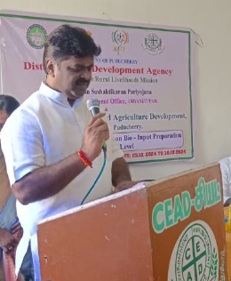
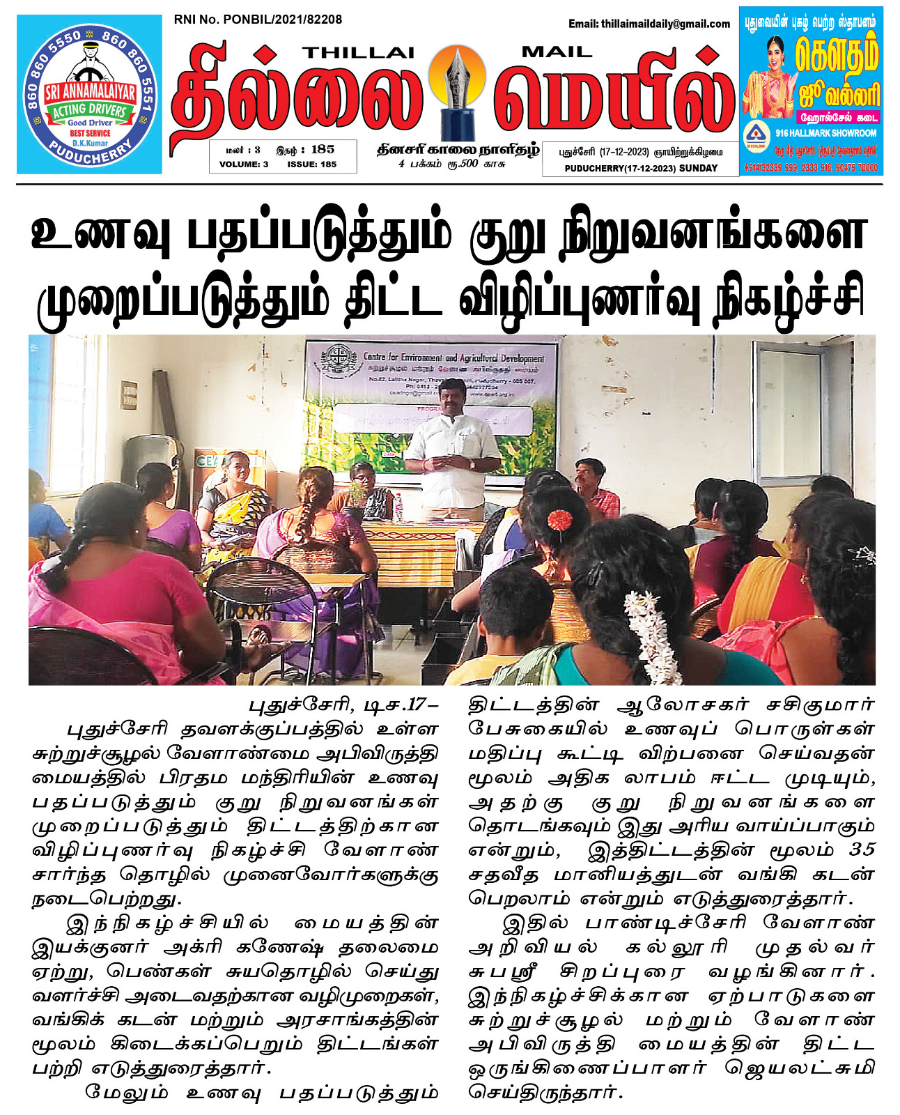
Major Activities 2023–2025

Agriculture and Training Programmes
Conducted workshops on soil health, organic farming, and natural pest management.
Organized farmer–student interaction programmes in Puducherry and Tamil Nadu.
Demonstrations on vermicompost, azolla cultivation, and biopesticides.

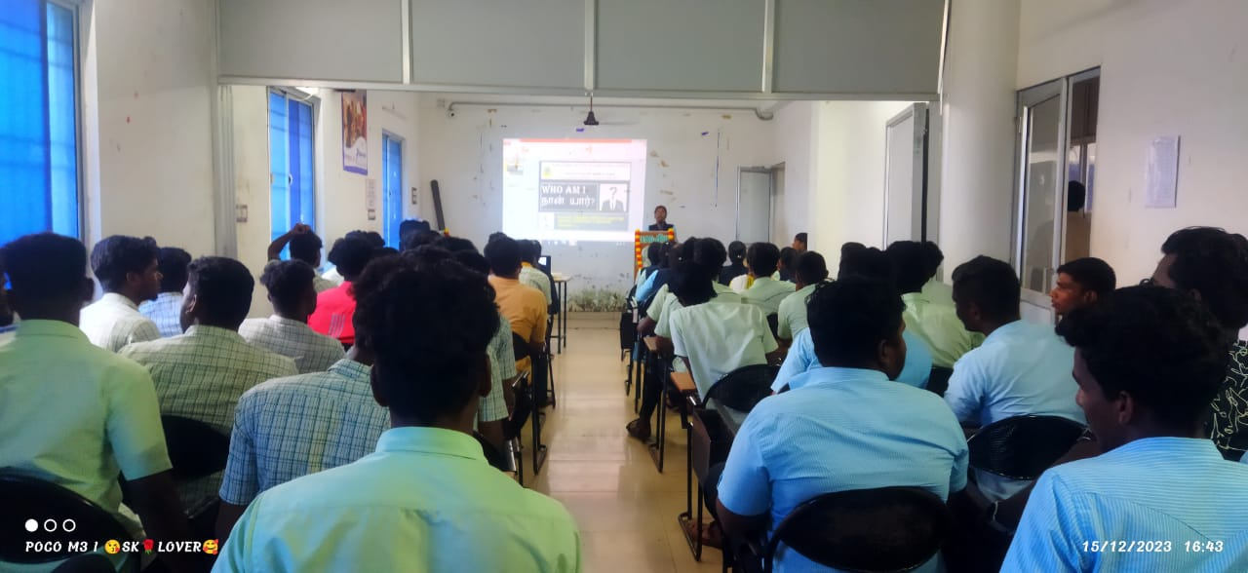
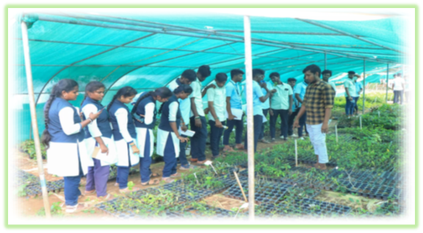

Research and Innovation
Organic paddy variety trials with natural inputs.
Vermiwash and vermin composting pilot units established.
Herbal garden projects focusing on medicinal plants.
Studies on salinity tolerance and soil health improvement

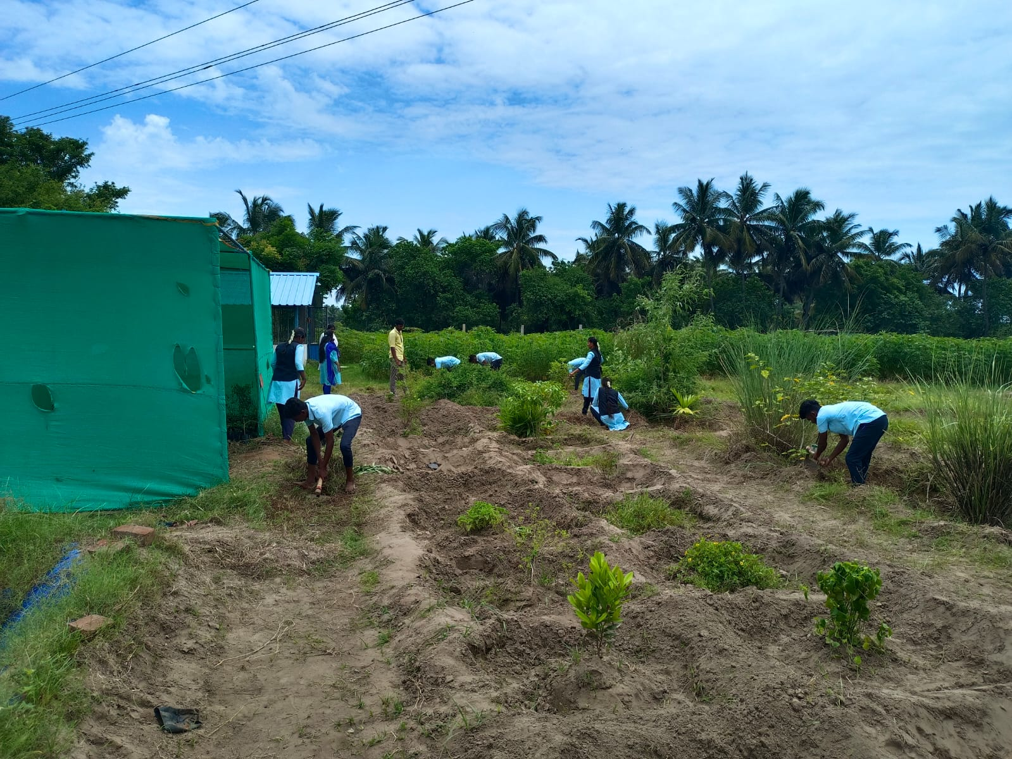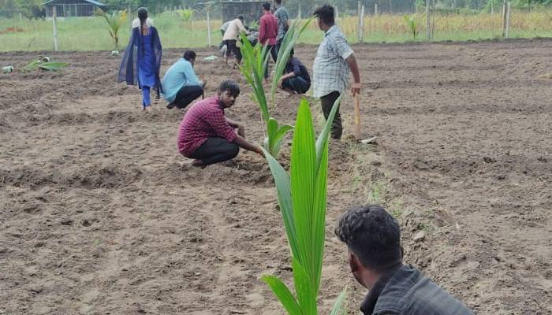
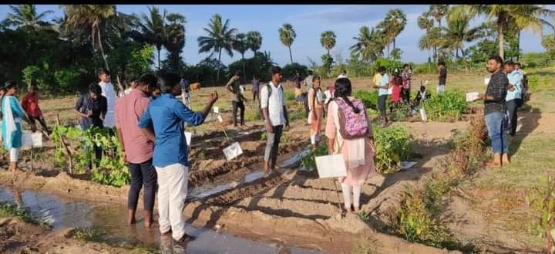

Livelihood & Entrepreneurship Support
Certificate programmes on mushroom cultivation, apiculture, millet products, and herbal cosmetics.
Training rural youth, women, and SHGs for income generation.
Micro-business incubation support in agri-products.
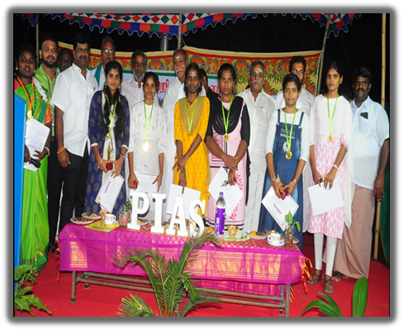

Community Engagement
Farmer meetings in villages of Puducherry.
School eco-education tours introducing herbal gardens, vermicompost, and mushroom units.
PMFME scheme training on food preservation and value addition.
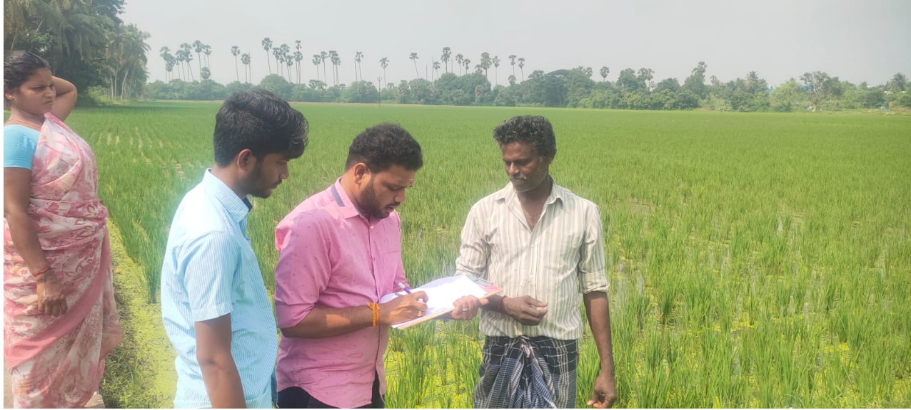
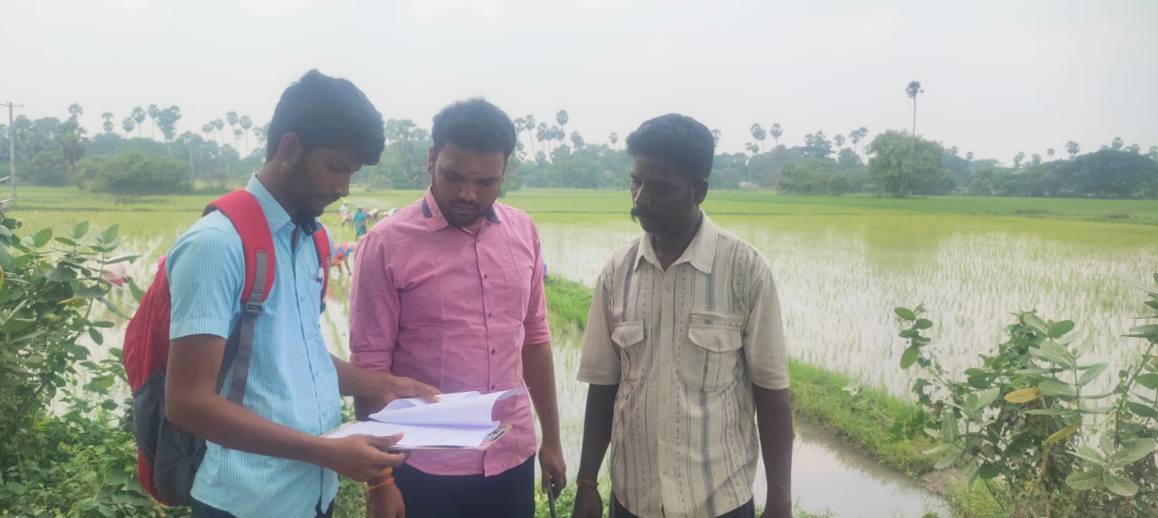
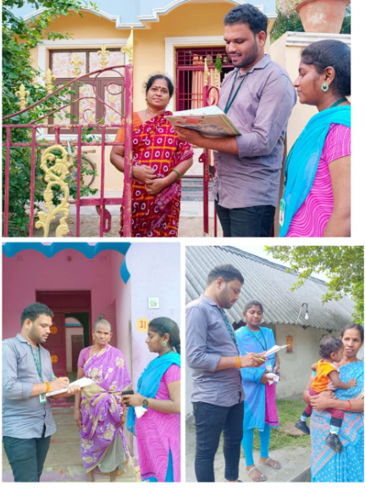

Environment and Sustainability
Expanded the Herbal Garden with 15 new medicinal plant species, QR-coded learning boards, and guided tours.
Strengthened the Nakshatra Garden Tree Planting Programme to promote indigenous species and biodiversity.
Developed azolla production units and delivered bio control training sessions for eco-friendly farming solutions.
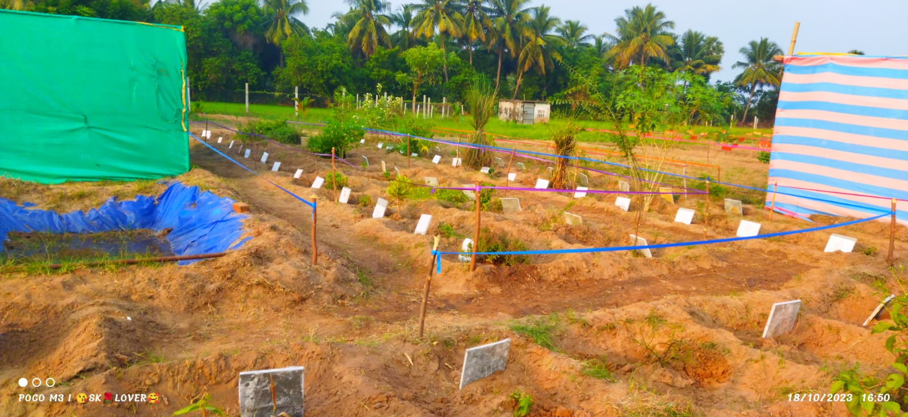

Achievements & Impact (2023–2024)
300+ farmers trained in organic and sustainable practices.
150+ students and SHG members benefited through livelihood training.
Research outputs: vermin wash production, herbal garden trials, micro greens cultivation.
Demonstration models established: herbal gardens, terrace gardens, azolla ponds.

Future Plans (2023–2024)
Expansion of agri-business incubation and training centres.
Development of new herbal and organic product lines.
Strengthening youth and women entrepreneurship models.
Scaling outreach to more villages in Puducherry and Tamil Nadu.



