Centre for Environment and Agricultural Development (CEAD)

Annual Report 2024 – 2025

About CEAD
The Centre for Environment and Agricultural Development (CEAD) is a non-governmental organization committed to empowering farmers, women, youth, and rural communities through sustainable agriculture, environmental stewardship, and community-based development initiatives. CEAD acts as the outreach and extension wing of the Pondicherry Institute of Agricultural Sciences (PIAS), ensuring that academic knowledge and research innovations are translated into real-world applications for rural transformation.

Foreword from Director
It is with immense pride that I present the CEAD Annual Report for 2024–2025. This year has been transformative in our mission to build sustainable livelihoods and resilient communities. Through training programmes, farmer interaction meetings, youth capacity building, and collaborations with academic and research institutions, CEAD has impacted hundreds of individuals across Puducherry and neighboring regions.
Key highlights include large-scale training in mushroom cultivation, herbal product making, organic farming, and agro-tourism; collaborative research on soil health and climate-smart agriculture; and extensive outreach programmes in schools, villages, and farmer communities. CEAD remains dedicated to creating inclusive, eco-conscious solutions for rural development.
— Dr. C. Ganeche
Founder & Director, CEAD
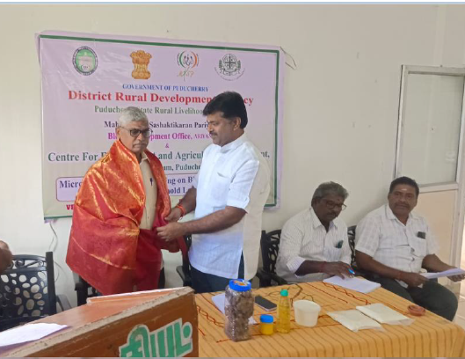
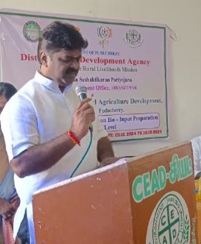
Major Activities 2024–2025

Agriculture and Training Programmes
Conducted training programmes in mushroom cultivation, herbal soap making, organic farming practices, vermin composting, nursery techniques, and agro-tourism.
Empowered more than 100 rural youth, women, and SC/ST students with hands-on training in sustainable farming and value-added product development.
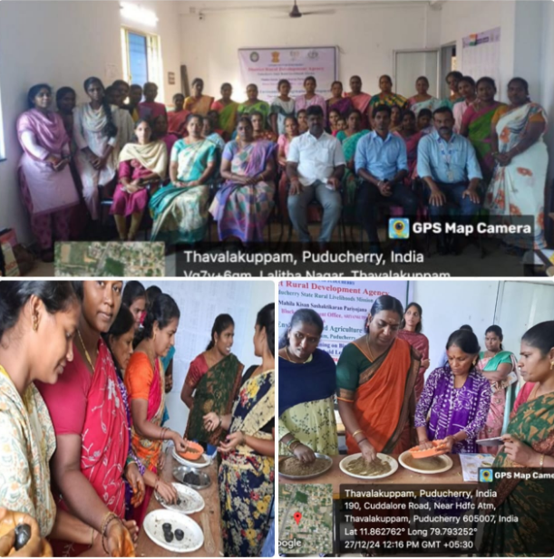
Facilitated internships and exposure visits for diploma students and young farmers to research centers and innovative farms.

Research and Innovation
Undertook collaborative research with PIAS on organic farming, soil health, microgreens cultivation, pest management using bio control methods, and medicinal plant trials.
Extended research findings to farmer groups and rural communities through field demonstrations.
Integrated student research projects with community-oriented action studies.
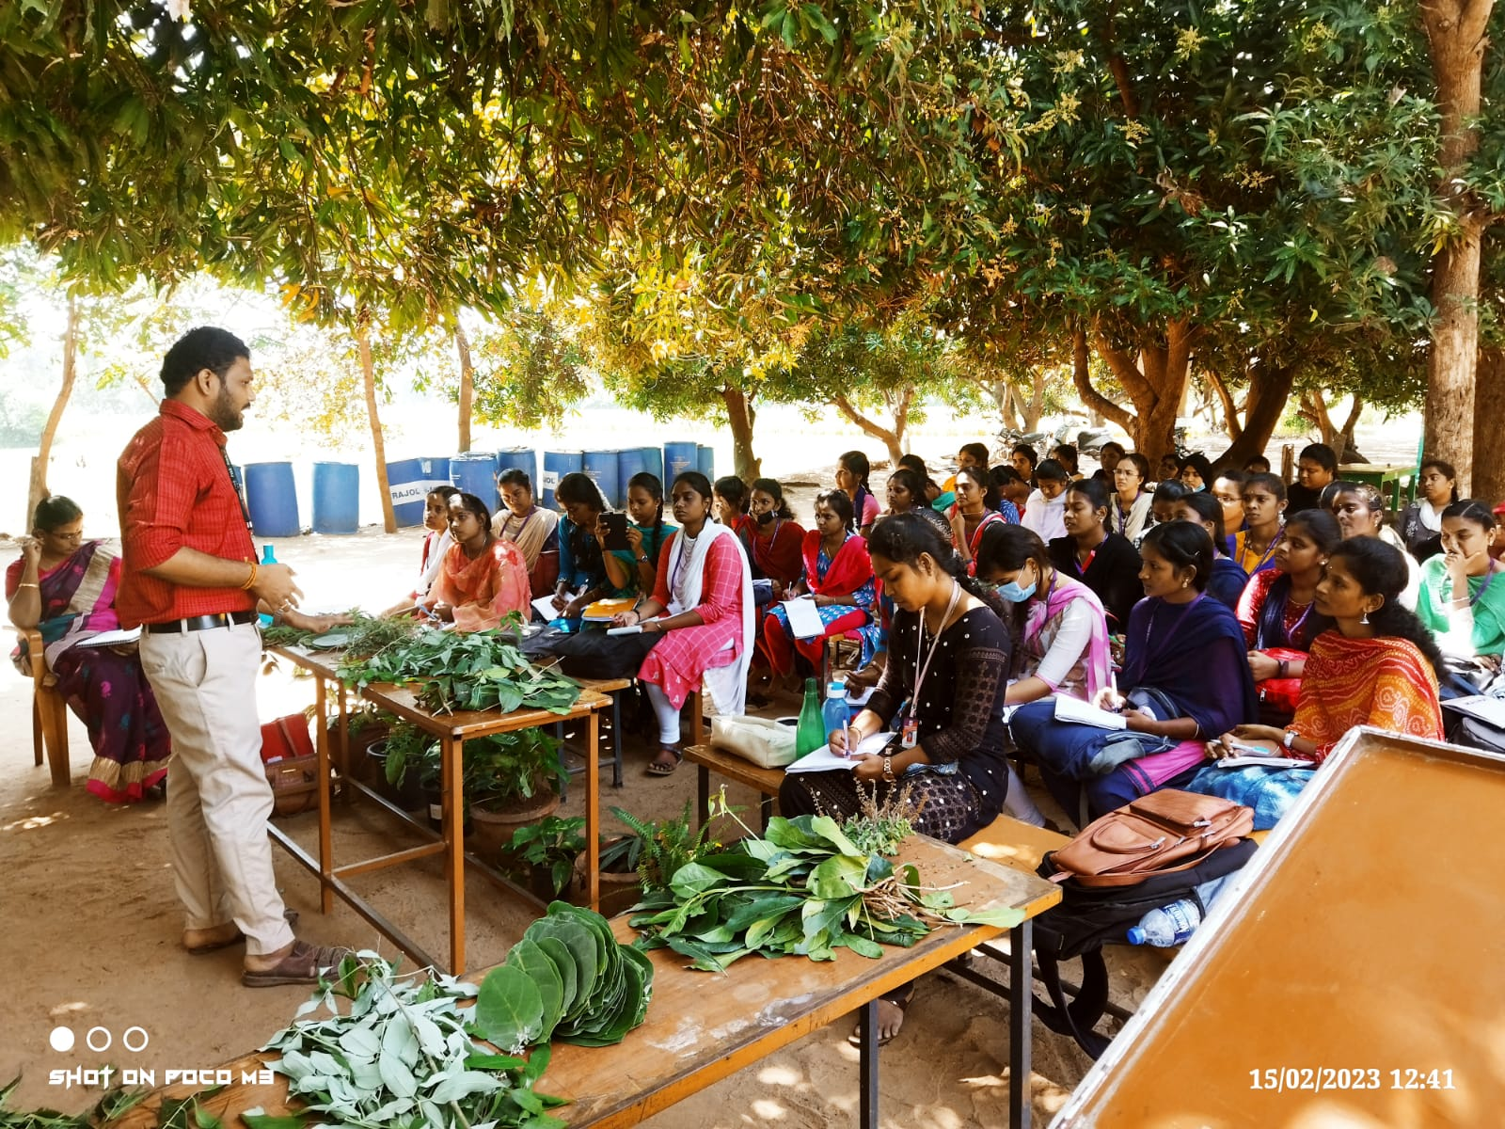
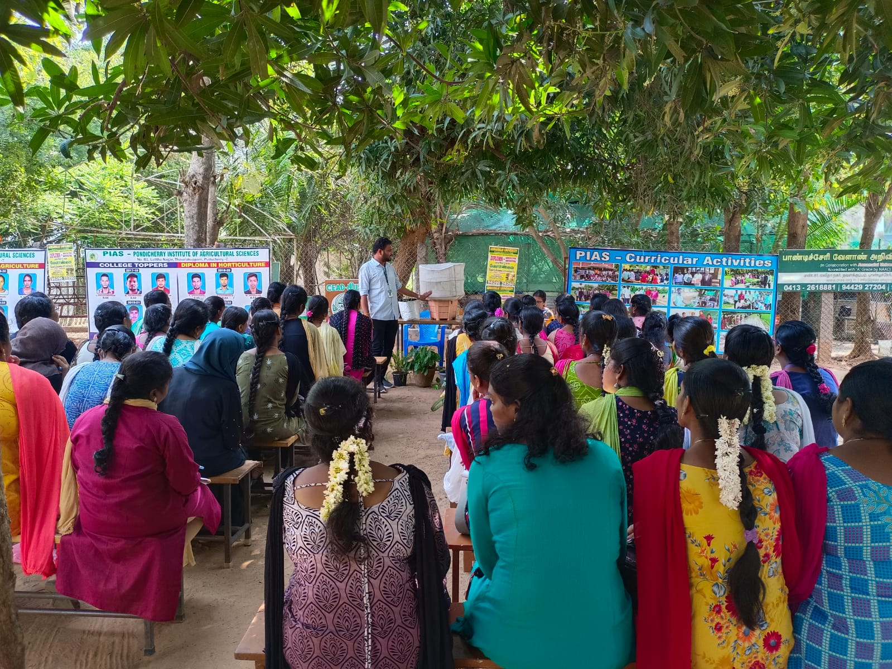

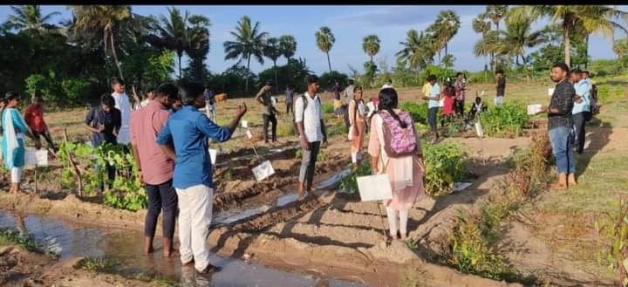

Extension and Outreach Initiatives
Organized farmer interaction meetings on organic inputs, seasonal pest control, and market access.
Conducted school agro-education visits, exposing students to herbal gardens, mushroom cultivation, vermicomposting, terrace gardening, and azolla farming.
Developed green campus demonstration units such as herbal gardens, guava orchards, coconut plantations, and azolla ponds.
Celebrated World Soil Day with quizzes, poster competitions, and farmer workshops on soil conservation.
Conducted a community medical camp on World Hypertension Day (17 May 2025) in collaboration with MGMCRI, benefiting over 70 participants including farmers and students.
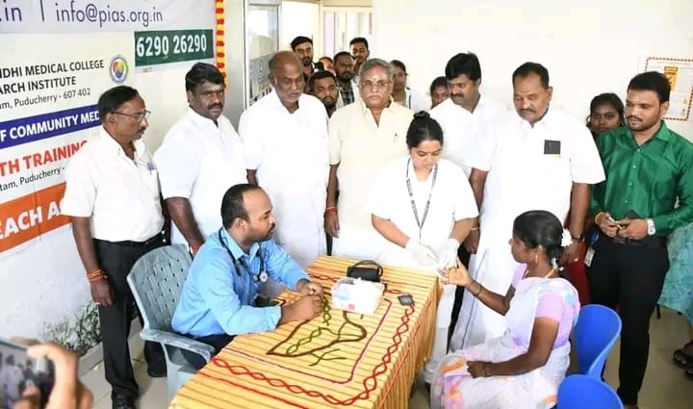

Women and Livelihood Empowerment
Promoted women’s entrepreneurship through herbal product training, soap making, and value addition of agricultural produce.
Trained rural women and SHG members in sustainable income-generating activities such as vermicomposting, herbal gardening, and mushroom cultivation.
Encouraged SC/ST youth and women to enroll in certificate courses for self-employment opportunities.
.

Environment and Sustainability
Expanded the Herbal Garden with 15 new medicinal plant species, QR-coded learning boards, and guided tours.
Strengthened the Nakshatra Garden Tree Planting Programme to promote indigenous species and biodiversity.
Developed azolla production units and delivered bio control training sessions for eco-friendly farming solutions.
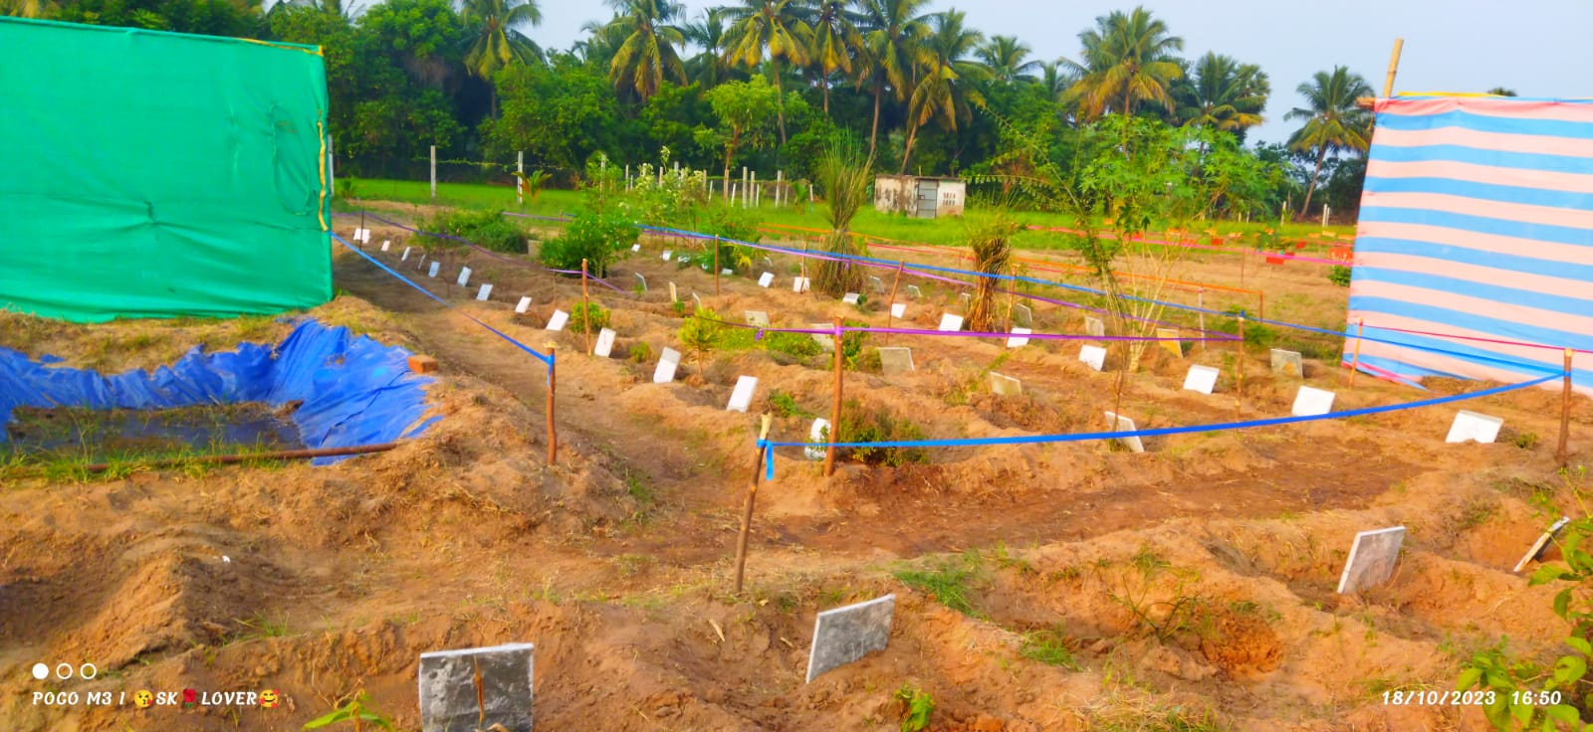

Way Forward 2025–2026
Looking ahead, CEAD aims to strengthen its role in rural transformation by:
Expanding certificate programmes in organic farming, herbal product manufacturing, apiculture, drone applications, and urban farming.
Launching the Agri-Business Incubation Centre (ABIC) to support student and farmer-led startups.
Deepening collaborations with universities, government departments, and NGOs to scale climate-smart agriculture and rural entrepreneurship.
Continuing to empower rural communities with knowledge, skills, and sustainable practices that foster resilience and self-reliance.



