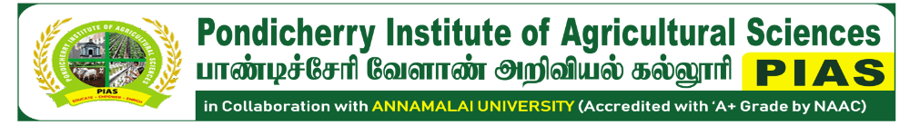
No: 82, Lalitha Nagar, Thavalakuppam, Puducherry – 605 007
📞 9442927204 / 9629026290 🌐 www.pias.org.in ✉ piasagri.cead@gmail.com

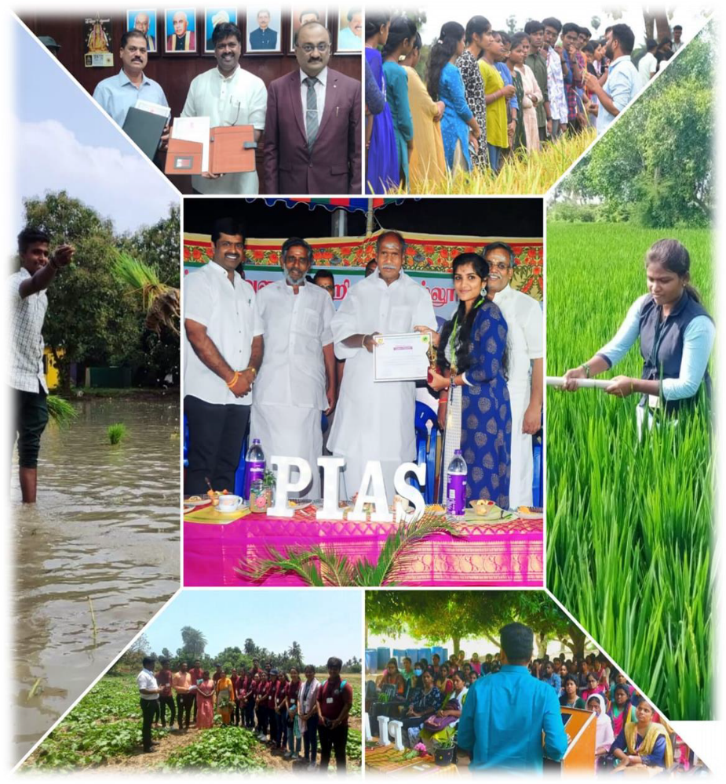
ANNUAL REPORT
2024-2025
From the Chairman’s Desk – Annual Report 2024–2025
As we reflect on the year 2024–2025, it is with great pride and gratitude that I present this report. This academic year has been transformative for PIAS—academically, institutionally, and in community impact.
We launched multiple initiatives focused on natural farming, rural entrepreneurship, and student-led research. Our short-term training programmes in mushroom cultivation, herbal soap making, and agro-tourism empowered over 100 rural youth, including women, SC/ST students, and smallholder farmers.
Significantly, this year we submitted our proposal to Pondicherry University for the affiliation of B.Sc. Agriculture and Horticulture programmes. This bold step signifies our evolution from a diploma institution to a potential undergraduate college with a broader academic vision.
Our collaborations with the Centre for Sustainability and Climate Studies and KVKs are opening up new possibilities in climate-smart agriculture, soil health research, and natural input trials. I deeply appreciate the dedication of our faculty, the energy of our students, and the support of our community and partners.
Together, let us continue to build PIAS as a beacon of sustainable agricultural education and rural empowerment in Puducherry and beyond.

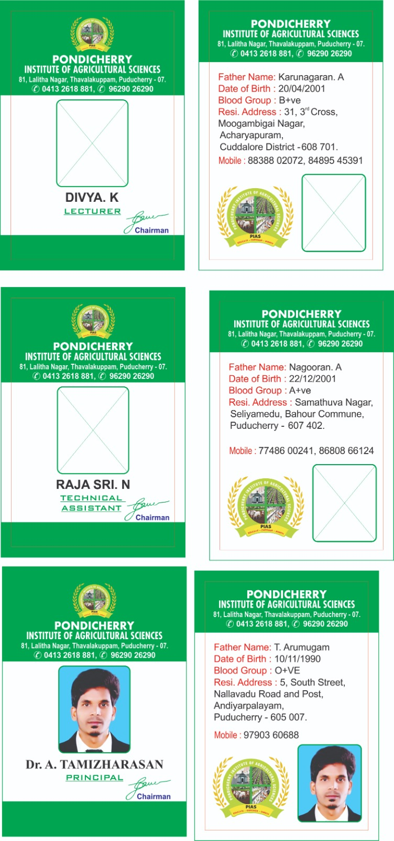
Dr. C. Ganeche
Chairman, PIAS

TABLE OF CONTENTS

- Introduction………………………………………………………………………… | 4
- Vision and Mission………………………………..………………………………... | 6
- Governance & Committees………………………………………………………… | 8
- Academic Programmes……………………………………....................................... | 13
- Curricular & Co-curricular Activities………………………………………………. | 18
- Research Achievements…………………………………………………………….. | 23
- Extension and Outreach Initiatives…………………………………………………. | 26
- Institutional Developments…………………………………………………………. | 29
- Collaborations and Industry Interface ……………………………………………... | 31
- Student Development Programmes………………………………………………… | 33
- Infrastructure Enhancements……………………………………………………….. | 35
- Way Forward……………………………………………………………………….. | 37

1. Introduction

1.1. Institutional Overview
The Pondicherry Institute of Agricultural Sciences (PIAS), established in 2017, stands as a pioneering institution in Puducherry, dedicated exclusively to offering Diploma programmes in Agriculture and Horticulture. With a steadfast commitment to advancing agricultural education, PIAS holds the distinction of being the first and only institute in the Union Territory to provide such diploma-level training. Since its inception, PIAS has evolved into a centre of academic excellence, catering to the educational and vocational aspirations of rural and semi-urban youth, particularly from Puducherry and neighbouring states. Strategically situated between the Pondicherry–Cuddalore state highway corridor, PIAS occupies a sprawling two-acre eco-conscious campus equipped with modern classrooms, fully functional laboratories, experimental farms, greenhouses, and a terrace garden. The institute’s central location and well-planned infrastructure ensure accessibility and optimal conditions for both classroom-based and hands-on field learning.
PIAS operates under the visionary leadership of its Founder and Chairman, Dr. C. Ganache, is an accomplished agricultural professional with a Master’s degree in Agriculture and a completed Ph.D. in Ecology and Environmental Sciences. His commitment to sustainable development is deeply rooted in his long-standing association with the Centre for Environment and Agricultural Development (CEAD)—a platform through which he has led various green and community-based agricultural initiatives across the Union Territory of Puducherry for over two decades. Mr. Ganache’s holistic approach to education and rural empowerment has significantly shaped the ethos and mission of PIAS. Affiliated with Annamalai University, one of India’s oldest and most respected institutions, PIAS benefits from a strong academic partnership. It has also been re-accredited with an ‘A+’ grade by the National Assessment and Accreditation Council (NAAC), reflecting its commitment to maintaining high standards in curriculum delivery, infrastructure, governance, and institutional values. This recognition highlights PIAS as a model institution known for its distinctive academic environment, value-driven pedagogy, and social responsibility.
The academic framework at PIAS is designed to provide a multidimensional learning experience. Students are exposed not only to theoretical knowledge but also to hands-on experiential learning through regular fieldwork, farm-based experiments, study tours, and industry interactions. The curriculum is enriched with certificate and value-added courses in areas such as mushroom cultivation, terrace gardening, herbal medicine, vermicomposting, and organic farming techniques. These initiatives equip students with practical skills aligned with current agricultural demands and green technologies. A core tenet of PIAS is its value-based education system, which emphasizes discipline, punctuality, and social responsibility. The institute maintains a supportive and nurturing environment that fosters emotional intelligence, leadership, and ethical behavior. Through a series of motivational talks, career guidance sessions, leadership development workshops, and personal counselling programs, students are empowered to face personal and professional challenges with confidence and clarity. Faculty members at PIAS are not just academic instructors but also mentors and guides who invest in the holistic development of every student.
PIAS promotes an inclusive and student-centric learning environment, encouraging participation in national and regional seminars, debates, workshops, and competitions. The students of PIAS have consistently earned accolades in intercollegiate events, demonstrating their readiness for future leadership roles in agriculture and allied sectors. Moreover, PIAS’s commitment to environmental sustainability is evident in its campus practices. From the establishment of herbal and Nakshatra gardens to azolla ponds, terrace gardens, and the plantation of traditional and high-value crops, the institute actively engages students in ecological farming models. These green practices not only enhance the biodiversity of the campus but also instil in students the principles of ecological stewardship and sustainable agriculture.
In conclusion, the Pondicherry Institute of Agricultural Sciences is more than just an educational institution; it is a transformative platform for young minds aspiring to make a meaningful impact in the fields of agriculture and environmental sustainability. Through a combination of academic rigor, practical training, value-based learning, and community engagement, PIAS continues to shape socially responsible, technically skilled, and environmentally conscious agricultural professionals.
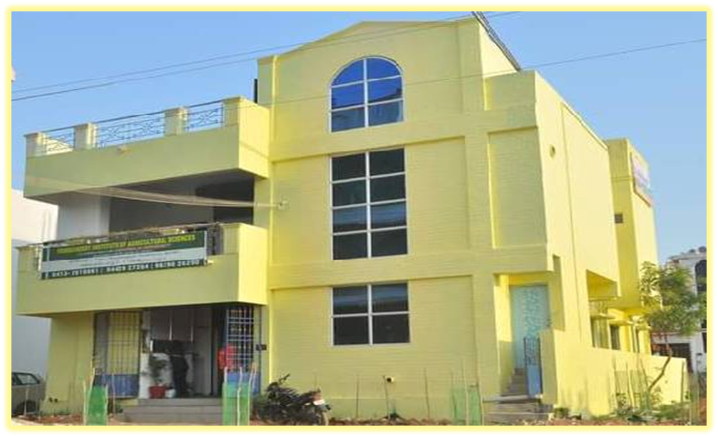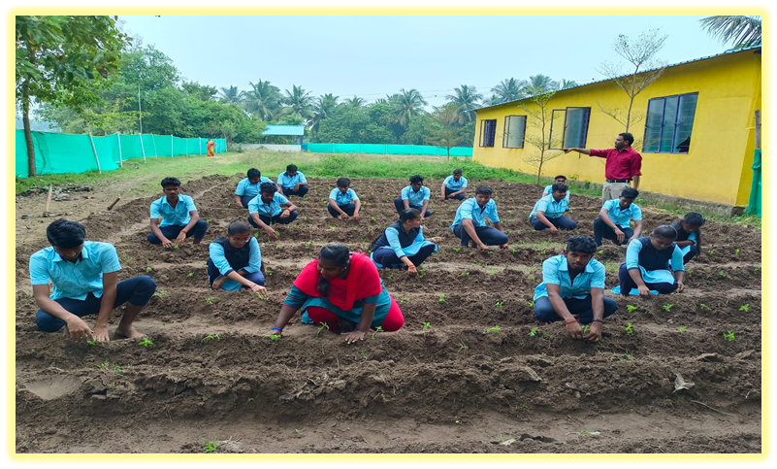
PIAS Campus & Farm

2.2. Vision and Mission
The Pondicherry Institute of Agricultural Sciences (PIAS) aspires to be a leading institution in agricultural education, research, and rural development. Our vision is to foster a vibrant learning ecosystem rooted in academic excellence, innovation, sustainability, and social responsibility. PIAS aims to nurture globally competent, environmentally conscious, and socially committed professionals who will lead the transformation of rural communities and tackle contemporary challenges such as food security, climate change, and ecological sustainability.
PIAS is dedicated to delivering transformative agricultural education that blends traditional wisdom with modern science and innovation. Our mission is aligned with India’s national priorities including Doubling Farmers' Income, Sustainable Development Goals (SDGs), and Climate-Smart Agriculture.
We are committed to:
- Providing practical and technology-driven education that integrates field-based learning with theoretical excellence.
- Developing multidisciplinary agricultural leaders equipped with global outlooks, entrepreneurial skills, and a strong scientific foundation.
- Instilling values such as truth, fairness, tolerance, cooperation, and environmental stewardship in every learner.
- Collaborating with rural communities, farmers, and NGOs to share knowledge, strengthen capacities, and promote inclusive agricultural development.
- Enhancing life skills, communication, and critical thinking, enabling students to succeed in careers, lead meaningful lives, and contribute to society at large.
Our mission is lived every day—through our classrooms, demonstration plots, field visits, community outreach, and research initiatives that collectively drive positive impact in agriculture.
The PIAS Insignia symbolizes the institute’s core motto:  “Educate, Empower, and Enrich”  It represents the values and aspirations of PIAS through the following key elements: | 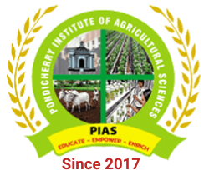
- Pondicherry Secretariat Emblem
Denotes our connection to the heritage and governance of the Union Territory of Puducherry, reflecting institutional pride and public service commitment.

- The Plant
Stands for agriculture, growth, and sustainability, symbolizing our academic focus on crop science and ecological farming.

- The Students
Represent the future of agriculture. Their presence in the emblem affirms our commitment to student-cantered learning and leadership development.

- The Cow
Symbolizes the allied agricultural sectors—particularly animal husbandry—which are essential for income diversification and integrated farming systems.
Together, these components reflect PIAS’s identity as a progressive, inclusive, and mission-driven institution, committed to shaping a greener, more resilient agricultural future.

3. Governance & Committees
The effective functioning of the Pondicherry Institute of Agricultural Sciences (PIAS) is supported by a structured governance framework involving a range of academic, administrative, and student welfare committees. These committees ensure transparency, quality, institutional development, and student-centric progress. Each committee is guided by dedicated staff members and works collaboratively to uphold academic excellence, research innovation, and campus safety.

3.1. Academic Governance Committees

3.1.1. Academic Planning & Curriculum Committee (APCC)
To review and enhance the academic curriculum in alignment with evolving trends in agricultural education and regulatory standards.
Responsibilities:
- Designing and updating course syllabus
- Scheduling academic calendars and timetables
- Introducing and monitoring value-added courses
- Assessing course outcomes and student feedback

In-charge:
- Convener: Dr. A. Thamizharasan
- Members: Mr. P. Manikandan, Ms. Divya

3.1.2. Board of Studies (BoS)
To approve academic programme structures and ensure curriculum relevance and quality.
Responsibilities:
- Finalizing course content and structure
- Ensuring compliance with Annamalai University guidelines
- Recommending instructional materials

In-charge:
- Chairperson: Dr. C. Ganache
- Faculty Representatives: Dr. A. Thamizharasan, Mr. P. Manikandan, Mr. Karl marks Miss. R.Vinitha and Ms. Divya
- External Experts: Dr. Anandan M.sc., PhD (Assistant Professor, Department of Agronomy, Faculty of Agriculture, Annamalai University, Tamilnadu);
Dr. Durairaj M.sc., PhD (Assistant Professor, Department of Agricultural extension, Faculty of Agriculture, Annamalai University, Tamilnadu)

3.2. Administrative & Strategic Committees

3.2.1. Governing Body
To provide policy direction, strategic planning, and administrative oversight.
Responsibilities:
- Reviewing institutional development plans
- Approving budgets and infrastructure proposals
- Facilitating partnerships and MoUs

Chairperson: Dr. C. Ganeche
Members: Principal, External Academic Expert, Parent Representative

3.2.2. Institutional Development Committee
To oversee campus development, digital initiatives, and sustainability projects.
Responsibilities:
- Infrastructure expansion and maintenance
- Green campus projects (e.g., Herbal Garden, Nakshatra Vanam)
- Aesthetic and functional campus planning

In-charge:
- Coordinator: Dr. A. Thamizharasan and Mr. P. Manikandan
- Members: Mr. Karl marks Miss. R.Vinitha, Mr. Divya, Farm Manager, Technical Assistant

3.3. Examination and Evaluation Committees

3.3.1. Examination Committee
To ensure smooth conduct of examinations in compliance with university regulations.
Responsibilities:
- Preparing schedules and managing logistics
- Securing question papers and coordinating with evaluators
- Conducting both internal and external assessments

In-charge:
- Chief Superintendent: Dr. A. Thamizharasan
- Coordinators: Mr. P. Manikandan, Mr. Karl marks, Ms. R.Vinitha, Ms. Divya

3.3.2. Results Review & Moderation Committee
To ensure the accuracy, fairness, and timely release of examination results.
Responsibilities:
- Reviewing and finalizing marks
- Handling discrepancies and grievances
- Publishing provisional and final results

In-charge:
- Head of Evaluation: Dr. A. Thamizharasan
- Members: Course Coordinators and Department Representatives

3.4. Student Support and Welfare Committees

3.4.1. Anti-Ragging Committee
To ensure a safe, inclusive, and disciplined campus environment.
Responsibilities:
- Monitoring student behaviour
- Conducting awareness and counselling programs
- Enforcing UGC anti-ragging guidelines

In-charge:
- Chairperson: Mrs. B. Sathya
- Student Welfare Officer: Mr. P. Manikandan
- Members: Class Mentors, Parent Representative

3.4.2. Student Grievance Redressal Committee
To address and resolve student concerns in an effective and impartial manner.
Responsibilities:
- Receiving and investigating complaints
- Ensuring timely redressal
- Promoting student welfare and satisfaction

In-charge:
- Convenor: Mrs. B. Sathya
- Members: Mr. P. Manikandan, Ms. Divya and Ms. N. Rajasri

3.5. Skill Development and Career Services Committees

3.5.1. Placement & Career Guidance Cell
To prepare students for employment and link them with potential employers.
Responsibilities:
- Organizing campus interviews and industry visits
- Conducting career orientation and training
- Collaborating with agriculture-related firms and nurseries

In-charge:
- Coordinator: Mr. P. Manikandan
- Training Officers: Mrs. B. Sathya, Ms. Divya

3.5.2. Internship and Industrial Training Committee
To coordinate practical training and field exposure for students.
Responsibilities:
- Arranging internships with agri-industries and research centres
- Supervising student performance during training
- Gathering feedback from host institutions

In-charge:
- Convener: Dr. A. Thamizharasan
- Field Coordinators: Mr. P. Manikandan, Ms. Divya, Ms. N. Rajasri

3.6. Co-curricular and Extension Committees

3.6.1. Cultural Committee
To promote student engagement through cultural and traditional events.
Responsibilities:
- Organizing festivals, annual day functions, and competitions
- Supporting participation in inter-collegiate cultural events

In-charge:
- Convenor: Dr. A. Thamizharasan
- Support Staff: Mr. P. Manikandan, Ms. Divya

3.6.2. Extension and Community Outreach Committee
To build community relationships and provide agricultural training to stakeholders.
Responsibilities:
- Organizing farmer interaction programs
- Conducting school visits and demonstrations
- Promoting agro-tourism and training
In-charge:
- Coordinator: Dr. A. Thamizharasan
- Outreach Team: Mr. P. Manikandan, Ms. R.Vinitha and Ms. Divya

6.7. Research and Innovation Committees

6.7.1. Research Coordination Committee
To promote institutional research, innovation, and academic publication.
Responsibilities:
- Supporting research in sustainable agriculture
- Coordinating MoUs and collaborative projects
- Facilitating faculty and student research activities

In-charge:
- Chairperson: Dr. A. Thamizharasan
- Faculty Researchers: Mr. Manikandan Ms. Divya
- Research Assistants: Ms. N. Rajasri

4. Academic Programmes
The Pondicherry Institute of Agricultural Sciences (PIAS) is committed to offering high-quality, practical, and industry-relevant education in the disciplines of Agriculture and Horticulture. The academic programmes are designed to provide students with a solid theoretical foundation, hands-on training, and an ecologically responsible mindset. These programmes align with national agricultural priorities, sustainable farming practices, and the developmental needs of rural communities.

4.1. Diploma in Agriculture
This two-year full-time programme imparts essential knowledge in soil science, crop production, agronomy, organic farming, farm machinery, and agribusiness management. The curriculum is developed in accordance with Annamalai University’s academic guidelines, ensuring credibility and academic rigor.

4.2. Diploma in Horticulture
Focused on fruit and vegetable cultivation, nursery techniques, floriculture, landscaping, and post-harvest technology, this two-year diploma addresses the rising demand for skilled horticultural professionals and promotes entrepreneurship in horticulture-based industries.

4.3. Academic Affiliation
PIAS is affiliated with Annamalai University, a distinguished institution in agricultural education. This affiliation ensures that our academic content, evaluation procedures, and degree recognition meet the quality standards set by the University Grants Commission (UGC) and the National Assessment and Accreditation Council (NAAC).

4.4. Curriculum Structure
Both diploma programmes are structured over four semesters and include:
- Core theory courses
- Practical and laboratory components
- Fieldwork and project-based learning
- Value-added certification courses in:
- Mushroom cultivation and processing
- Apiculture (beekeeping & honey processing)
- Vermicomposting & vermiwash production
- Nursery management & plant propagation
- Value-added food products from millets & pulses
- Bio fertilizer and bio pesticide production
- Terrace gardening & urban farming
- Goat and poultry farming for beginners
- Agro-tourism & natural farm walk design
- Handmade soap & herbal product making
Assessment includes continuous internal evaluation (CIA), mid-semester tests, and final theory/practical examinations. The curriculum is outcome-oriented and prepares students for employment or higher studies.

4.5. Student Intake and Diversity
For the academic year 2024–2025, PIAS has an approved intake of 28 students:
- Diploma in Agriculture – 19 students
- Diploma in Horticulture – 9 students
Admissions are based on 12th standard marks, with priority given to students from rural and agricultural backgrounds. The institute embraces regional diversity, attracting students from Puducherry, Tamil Nadu, and neighboring states.

4.6. Innovative Pedagogy
PIAS integrates modern and practical teaching methods to enhance learning:
- Field-Based Learning: Daily farm exposure for real-time understanding of plant and soil sciences.
- ICT-Enabled Classrooms: Use of digital boards, audiovisuals, and e-learning tools.
- Exposure Visits: Organized study tours to research stations, agri-universities, and farms.
- Skill Training Modules: Mandatory training in vermicomposting, nursery techniques, and sustainable farming.
- Workshops & Self-Development Sessions: Including the “Who Am I?” programme and leadership training to promote holistic growth.

4.7. Outcome-Based Learning
Student performance is evaluated through the OGPA system (Out of 10). Assessments include practical skills, project work, attendance, and participation in extension activities. The programmes aim to produce technically competent, career-ready, and socially responsible graduates.

4.8. Academic Ecosystem

Academic Almanac – 2024–2025
S. No. | Event | Semesters
3 | Class Commencement | 01.09.2024
4 | Mid-Semester Examination | 16.10.2024
5 | Practical Examination | 02.12.2024
6 | Theory Examination | 09.12.2024

S. No. | Event | Semesters
2 | Class Commencement | 21.01.2025
3 | Mid-Semester Examination | 09.03.2025
4 | Theory Examination | 21.05.2025
5 | Practical Examination | 27.05.2025

4.9.

Institutional Profile

- Registered Name: Pondicherry Institute of Agricultural Sciences (PIAS)
- Established: 2017
- Type: Co-educational
- Affiliation: Annamalai University
- Student Identity: PIASians
S. No. | Faculty (2024-2025) | Designation
1 | Dr. A. Thamizharasan | Principal
2 | Mr. P. Manikandan | Lecturer
3 | Ms. R. Vinitha | Assistant Professor
4 | Mr. Karal marks | Lecturer
5 | Ms. Divya | Lecturer
6 | Ms. N. Rajasri | Technical Assistant
7 | Mrs. B. Sathya | Admin
- Current Strength: 28 students (26 boys, 2 girls)
PIAS are now recognized as a leading institution for diploma-level agricultural education in Puducherry. Its commitment to academic excellence, sustainable farming, and community development continues to empower aspiring agriculturists.

4.10. Institutional Committees
- Academic Committee
- Admission Committee
- Career Development Committee
- Examination Committee
- Anti-Ragging Committee
- Sports Committee
These committees play a crucial role in maintaining academic quality, discipline, student welfare, and extracurricular engagement.

4.11. Curricular Development Highlights
PIAS offers:
- Diploma in Agriculture
- Diploma in Horticulture
With additional value-added certifications in:
- Terrace and Herbal Gardening
- Vermicomposting
- Organic & Sustainable Agriculture and etc.
The curriculum is practical in orientation and includes farm-based projects, skill training, and field exposure, ensuring employability and real-world application.

4.12. Teaching, Learning & Evaluation
- Admission Criteria: 12th-grade performance, with preference for students from farming backgrounds.
- Diversity: Students come from a variety of socio-economic and regional backgrounds.
- Pedagogy: Emphasis on experiential learning, hands-on training, and tech-based instruction.
- Evaluation: Semester-based system using OGPA (out of 10) for transparent and consistent assessment.

4.13. Placement & Career Development
The Placement and Career Development Cell (2024–2025) at PIAS continues to serve as a bridge between students and industry, with a growing focus on employability, entrepreneurship, and field-readiness. Through structured guidance, skill-building sessions, and strategic partnerships, the Cell ensures that students are well-prepared to transition from academic life to professional engagement.

Key Activities Conducted:
- Pre-Placement Training
- Resume writing, interview handling, personality development, and communication skills workshops were organized in collaboration with agri-business experts and career consultants.
- Industry Interface Sessions
- Guest lectures and interactive sessions were conducted with professionals from:
  - Agro-input firms
  - Drone technology innovators
  - Nursery management enterprises
  - Organic product entrepreneurs

- Campus Interviews and Job Mapping
- The Cell facilitated direct recruitment through on-campus interviews, exposure visits, and job fairs hosted in collaboration with regional startups and nurseries.

4.13.1. Placement Highlights (2024–2025)
Several diploma students secured opportunities in the following reputed organizations:
Organization | Sector | Location
UCAL Drone Manufacturing Unit | Agri-Tech & Drone Services | Chennai, Tamil Nadu
Shanthi Clonal Nursery | Horticulture & Plant Sales | Vegakollai, Tamil Nadu
Herbal Garden Enterprises (Internship) | Herbal Processing & Packaging | Puducherry
VermiLife Solutions (Internship) | Organic Input Production | Cuddalore District

4.13.2. Internships & Field Training
In addition to placements, students from both diploma programmes participated in industrial internships, skill-based short courses, and hands-on training modules with real-time exposure to:
- Drone-assisted precision farming
- Compost packaging and vermiwash dilution
- Seedling production and nursery protocols
- Food processing and labeling for local markets
These engagements provided practical skill development, enhanced career clarity, and opened pathways for students to consider agri-entrepreneurship and higher studies.

4.14. Governance and Leadership
Under the guidance of Chairman Dr. C. Ganeche, PIAS emphasizes strategic growth, academic innovation, and community outreach. Monthly leadership review meetings are held to assess institutional progress and ensure excellence in all areas—from academics to infrastructure development and student success.

5. Curricular & Co-curricular Activities
At the Pondicherry Institute of Agricultural Sciences (PIAS), academic learning is deeply enriched through a wide range of curricular and co-curricular activities that emphasize hands-on experience, cultural identity, student engagement, and environmental consciousness. These activities are integrated into the academic calendar to enhance student learning, skill development, and social interaction.

8.1. Curricular Enrichment Activities
To supplement classroom-based teaching, PIAS organizes several field-based and experiential learning programmes designed to bridge theoretical knowledge with real-world agricultural practices:

8.1.1. Study Tours and Educational Visits
As part of its experiential learning framework, PIAS organized a series of structured study tours and institutional visits during the academic year 2024–2025. These educational field trips were aimed at enhancing students' understanding of research methodologies, advanced agri-technologies, crop-specific innovations, and post-harvest management practices.
Each visit was carefully planned to align with the curriculum and to expose students to real-world agricultural applications, innovation hubs, and model farms. Faculty members accompanied the students, facilitating discussions, observations, and reflective learning.

Key Institutions Visited:
Institution Name | Focus Area | Location
Tapioca and Castor Research Station (TCRS) | Root crop and oilseed varietal trials | Yethapur, Tamil Nadu
Department of Sericulture | Silk worm rearing, mulberry cultivation | Anaiyamedu, Tamil Nadu
Tamil Nadu Agricultural University (TNAU) | Research labs, smart farming models | Coimbatore, Tamil Nadu
National Research Centre for Banana (NRCB) | Tissue culture, post-harvest tech | Trichy, Tamil Nadu
Horticultural Research Station (HRS) | Cold-climate horticulture and floriculture | Kodaikanal, Tamil Nadu
HC&RI (Horticultural College & Research Institute) | Fruit crops, propagation techniques | Periyakulam, Tamil Nadu
Grapes Research Station | Vineyard management, irrigation systems | Theni, Tamil Nadu

Educational Impact:
- Students interacted with subject-matter scientists and research fellows
- Gained insights into crop-specific R&D, pest control strategies, and agri-business applications
- Observed modern nursery techniques, greenhouse designs, and precision irrigation systems
- Collected documentation and technical handouts for field report submission and classroom discussion
These visits enabled students to connect classroom theory with ground-level applications, promoting critical thinking, research awareness, and real-world career orientation in agriculture and horticulture.
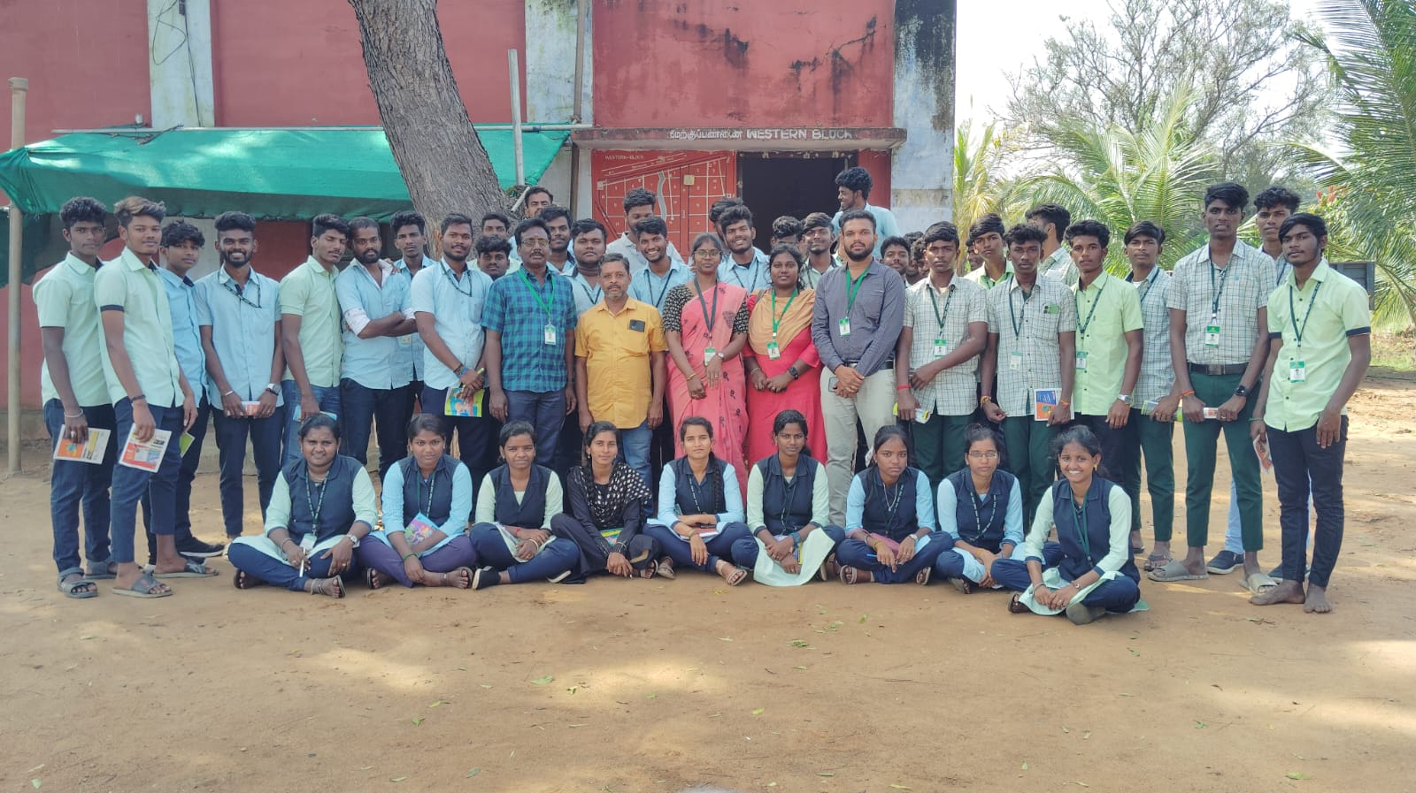
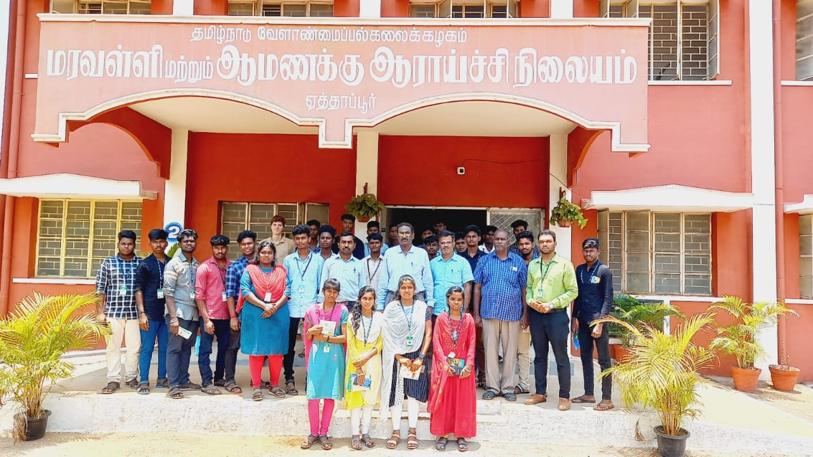
Study tour at research stations

8.2. Medicinal Plant Gardening Project
As part of their practical coursework, students of Pondicherry Institute of Agricultural Sciences (PIAS) actively participated in the development of a dedicated Medicinal Plant Garden on the campus terrace. This hands-on project was designed to provide students with experiential learning in herbal cultivation, plant care, and traditional health practices.
Unlike typical terrace gardens focused on vegetables, this initiative emphasized the cultivation of therapeutic and aromatic plants widely used in Ayurveda, Siddha, and home remedies.

Key Features of the Project:
- Raised garden beds and pots were used to cultivate medicinal species such as:
  - Tulsi (Ocimum sanctum) – immunity booster
  - Aloe vera – for skin health and digestive wellness
  - Vetiver – used for cooling and herbal cosmetics
  - Lemongrass – aromatic herb with anti-inflammatory properties
  - Kalmegh, Brahmi, and Thuthuvalai – traditional respiratory and liver tonics
- Organic inputs including vermicompost and vermiwash produced on campus were applied
- Students practiced labeling, watering, pruning, and pest management using herbal bio pesticides.

Learning and Community Impact:
- Students learned the agronomic practices behind cultivating medicinal plants in limited urban spaces
- The project promoted the idea of self-reliant herbal health care through home gardening
- Visiting students and school groups were oriented through demonstration sessions
- Plans are underway to develop simple herbal product kits (e.g., tulsi tea, aloe gel) as part of entrepreneurship training
This project is a model for urban sustainability, health-conscious cultivation, and student-led green innovation, reinforcing PIAS’s mission to blend academic knowledge with ecological responsibility.
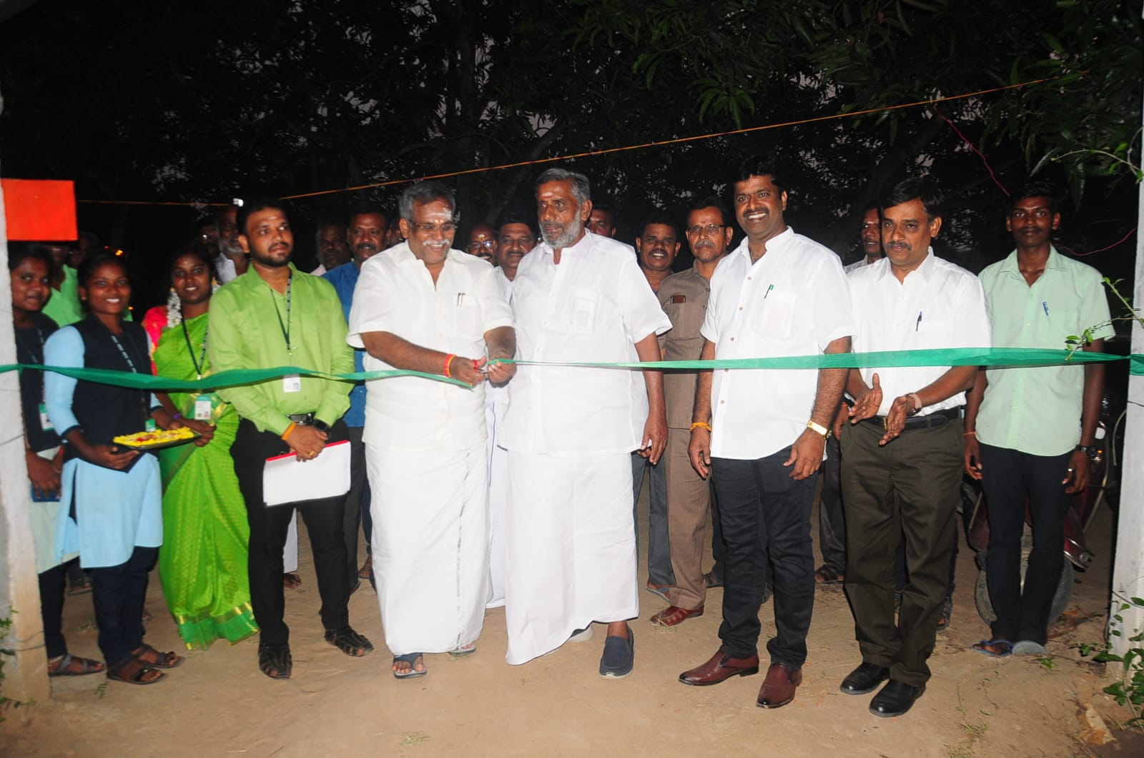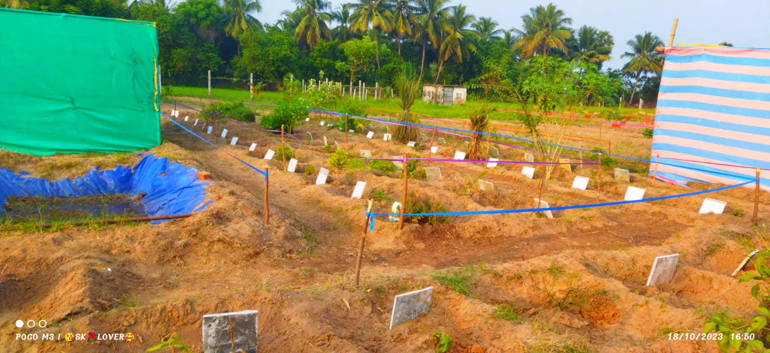

Co-curricular Activities
At PIAS, co-curricular activities are carefully curated to promote cultural expression, community awareness, and leadership qualities among students.

Quiz and Competitions
In celebration of World Soil Day 2024, a quiz competition was conducted to promote awareness of soil conservation, fertility, and sustainable land use practices. Such academic events help foster a spirit of healthy competition and knowledge sharing among students.
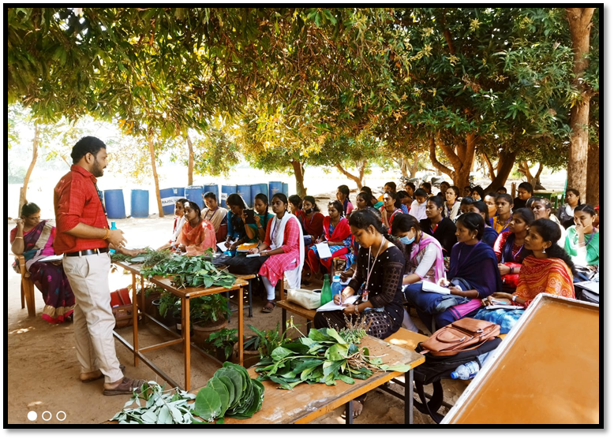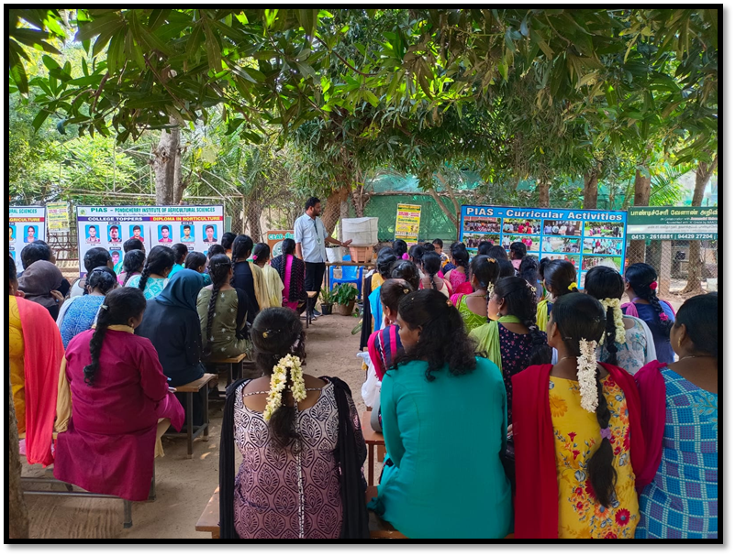
Farmers and soil Day Celebration

Pongal Vizha Celebration
The traditional Tamil harvest festival, Pongal Vizha, was joyfully celebrated on campus with cultural performances, traditional food preparation, rangoli art, and folk games. Students learned about the agricultural significance and cultural values of the event, fostering appreciation for local traditions.
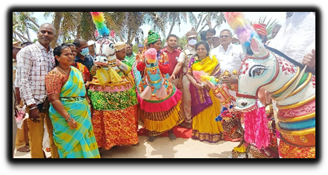
Tamil harvest festival

World Soil Day Observance
Apart from quiz contests, awareness programmes and audio-visual sessions were conducted to highlight the role of soil health in sustainable agriculture. Students showcased models and posters emphasizing soil biodiversity, erosion control, and composting.

Nakshatra Garden Tree Planting
Students participated in the tree planting activity under the Nakshatra Garden project, learning the link between indigenous species, biodiversity, and astrological beliefs in traditional agriculture.
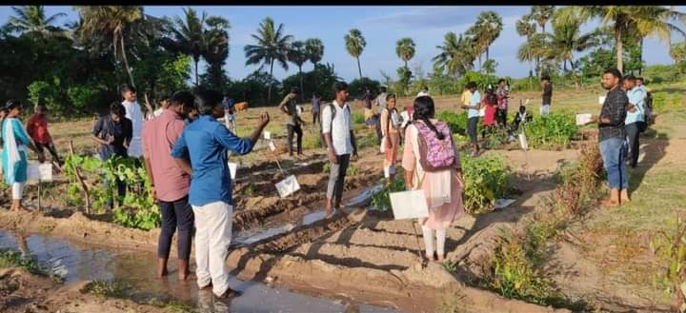
Nakshatra Garden development

Impact on Students
These activities:
- Strengthen learning outcomes through practical involvement
- Promote teamwork, leadership, and planning skills
- Connect students to local culture, nature, and traditional values
- Encourage eco-consciousness and social responsibility

6. Research Achievements
The Pondicherry Institute of Agricultural Sciences (PIAS) places strong emphasis on practice-based, eco-sustainable research, focusing on challenges relevant to regional agriculture and national priorities. Our research efforts are led by committed faculty and actively involve student participation through field trials, pilot studies, and laboratory work, encouraging a research-oriented academic environment even at the diploma level.

Collaborative Research Platforms
Research at PIAS is supported and facilitated through institutional and external collaborations, notably:
- Centre for Environment and Agricultural Development (CEAD) – our in-house partner in sustainable agriculture research and green initiatives.
- Linkages with government departments, local NGOs, and nursery entrepreneurs for field demonstrations, data collection, and dissemination.
- Collaborative projects supported by Centre for Sustainability and Climate Studies, Department of Ecology and Environmental Sciences, Pondicherry University,

Key Research Themes and Ongoing Work

1. Organic Farming with Traditional Paddy Varieties
Faculty and students conducted field-based organic trials using native paddy varieties under organic nutrient management protocols. This project emphasized:
- Zero-chemical input systems
- Use of panchagavya, vermiwash, and botanical extracts
- Assessments of grain yield, disease resistance, and grain quality

2. Soil Health and Biogenic Soil Applications
PIAS has taken up field evaluations of biogenic soils—enriched with earthworm castings, termite processed soil, ant hill soil, organic matter, and beneficial microbes—for:
- Improving soil structure and porosity
- Enhancing microbial biomass and nutrient availability
- Promoting carbon sequestration and erosion resistance

3. Vermicomposting and Vermiwash Production
Multiple pilot-scale vermicomposting units were established on campus using leaf litter, cow dung, and local weeds. Outcomes include:
- Production of nutrient-rich compost
- Extraction and application of vermiwash as a foliar spray
- Biochemical analysis of nutrient profiles (NPK, micronutrients)
- Positive impacts recorded on okra plant growth and flowering

4. Microgreens Cultivation Trials
A recent initiative includes low-cost microgreens cultivation models, using recycled trays and organic media. Studies focus on:
- Nutritional profiling of species like mustard, fenugreek, and radish
- Growth comparisons under shade nets vs. open sun
- Market potential and consumer awareness

5. Biocontrol and Pest Management
As part of plant health management, students engaged in testing botanical biopesticides such as:
- Neem oil sprays
- Garlic and chili extract formulations
- Trichoderma and Pseudomonas fluorescens bioinoculants
The studies aimed to:
- Minimize use of synthetic pesticides
- Improve pest suppression in leafy vegetables and legumes

6. Salinity Tolerance Studies
Faculty-led trials using salinity gradients in controlled plots have begun to evaluate the tolerance capacity of select crop varieties (especially rice and groundnut). Parameters include:
- Germination rate
- Seedling vigor
- Ion accumulation (Na⁺, Cl⁻)

7. Medicinal Plant Cultivation & Evaluation
Under the Herbal Garden project, trials on medicinal plants such as Tulsi, Ashwagandha, and Aloe vera were conducted, studying:
- Growth response to organic inputs
- Pest resistance
- Market linkage with local ayurvedic outlets
Area of the research | No. of Trials/Studies | Lead Faculty/Coordinator
Organic Paddy Varieties | 3 | Mr. P. Mandikandan
Vermicomposting & Vermiwash | 4 | Ms. Dr. A. Thamizharasan
Biogenic Soil and Soil Fertility Studies | 2 | Mr. Dr. A. Thamizharasan
Biocontrol Techniques & Plant Health | 3 | Ms. Dr. A. Thamizharasan
Microgreens Cultivation | 1 | Ms. Divya
Salinity Tolerance Experiments | 1 | Collaborative with CEAD
Medicinal Plants & Herbal Applications | 2 | Mr. P. Mandikandan
Impact and Student Engagement
These research activities:
- Enhance analytical thinking and technical skills among students
- Prepare learners for higher education and entrepreneurship
- Contribute to sustainable rural development models
- Encourage eco-friendly practices applicable to smallholder farming

7. Extension and Outreach Initiatives
At the Pondicherry Institute of Agricultural Sciences (PIAS), agricultural education is envisioned as a dynamic, community-responsive process that goes beyond the confines of classrooms. Our extension and outreach activities are a core component of the institute’s commitment to applied learning, rural development, and eco-conscious knowledge dissemination.
Throughout the academic year 2024–2025, PIAS actively engaged in a wide range of field-level interventions, farmer trainings, school awareness programmes, and green campus projects aimed at enriching both student learning and local livelihoods.

Objectives of the Outreach Programme:
- Facilitate two-way knowledge exchange between students and farming communities
- Train students in communication, technical demonstrations, and rural engagement
- Promote sustainable agricultural models among farmers and SHGs
- Support national goals related to soil health, organic farming, and climate-resilient practices

7.1 Farmer Interaction Meetings
PIAS organized interactive field sessions where farmers, faculty, students, and subject experts came together to share field-based experiences and solutions.
Highlights:
- Discussions on organic input preparation, seasonal pest management, and market access
- Live demonstrations on vermicomposting and microgreen production
- Collaborative sessions during Pongal Vizha and World Soil Day with farmers as key participants

7.2 Exposure Visits and School Agro-Education
As part of its Agro-Education Programme, PIAS welcomed several batches of school and college students for structured one-day exposure visits.
Key Activities Conducted:
- Demonstrations of:
  - Vermicomposting and vermiwash units
  - Herbal garden with labeled medicinal plants
  - Urban terrace gardening systems
  - Mushroom culture area and Azolla ponds
  - Model coconut and guava plantations
- Talks and awareness sessions on:
  - Benefits of organic and locally grown food
  - Importance of conserving traditional biodiversity
  - Role of youth in sustainable farming
These programmes sparked early curiosity in agriculture for school children and also offered PIAS students valuable extension training experience in conducting live demonstrations and handling visitor queries.

7.3 Green Campus Demonstration Units
PIAS continued to strengthen its live learning labs and demonstration farms, which now double as training grounds for visiting students, rural SHGs, and farmer groups.

Azolla Production Units
- Multiple azolla ponds were maintained using recycled cement tanks
- Used as demonstration models for livestock nutrition
- Training offered on propagation, drying, and integration with animal feed

Guava Orchard & Coconut Plantation
- Over 40 guava saplings and 118 coconut seedlings were maintained and monitored
- Students learned key concepts such as:
  - Canopy management
  - Organic pest repellents
  - Water-efficient irrigation (drip & basin)

Biocontrol and Herbal Input Training
- Field sessions on preparing neem-garlic extract, cow urine tonic, and panchagavya
- Hands-on training was extended to interns and field trainees from visiting colleges
These eco-farming units support our campus mission of low-cost, scalable, and replicable farming systems.

7.4 Thematic Days & Community Awareness Events
As part of the annual extension calendar, PIAS observed nationally and internationally recognized days to engage students and local communities in interactive learning.

World Soil Day 2024 (05 December 2024)
- Celebrated with active student and farmer participation
- Activities included:
  - Quiz competition on soil conservation
  - Poster displays and model exhibits (e.g., vermicompost bins, erosion barriers)
  - Farmer sessions on soil organic matter and cover cropping
  - Audio-visual screenings on soil biodiversity

World Hypertension Day Medical Camp (17 May 2025)
- Health camp organized in collaboration with MGMCRI
- Over 70 participants, including PIAS staff, students, and nearby farmers, availed free screening and consultation
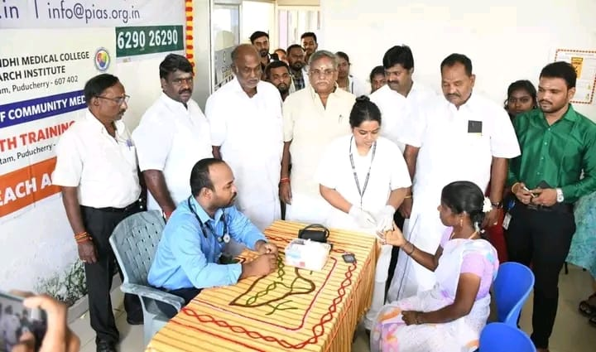
Medical Camp

7.5 Community Training & Demonstration Events
To extend the impact of institutional research and student mini-projects:
- Village-level trainings were held on vermicomposting, herbal gardening, and microgreens
- Student interns conducted peer demonstrations during exposure visits by Bharathidasan Government College for Women and students from Maharashtra
- PIAS participated in local fairs and school eco-day events, promoting organic inputs and youth engagement in agriculture

8. Institutional Developments
The Pondicherry Institute of Agricultural Sciences (PIAS) made steady progress in strengthening its campus infrastructure, digital interface, and green educational spaces during the academic year 2024–2025. These developments aim to create a modern, learner-centric, and environmentally conscious institutional ecosystem.
Under the leadership of Chairman Dr. C. Ganeche, and with active faculty and student participation, the institute has focused on improvements that enhance visibility, accessibility, and sustainable learning environments.

8.1. Website Enhancement and Digital Outreach
Building on the digital foundation laid in the previous year, the PIAS website was upgraded with more interactive and academic features to support students, parents, and external stakeholders.
New Features Introduced:
- Online student feedback and grievance redressal forms
- Photo gallery and event archive for documentation
- Direct download access to research abstracts, internship reports, and value-added course materials
- Updated faculty profiles and programme-specific pages
- Responsive design with improved mobile compatibility
The website now functions as a central hub for academic communication, extension updates, and admissions support, aligning with the institute’s push for paperless administration and smart governance.

8.2. Herbal Garden Expansion and QR Integration
The Herbal Garden, initially developed in 2023, was expanded and enriched this year with new species, functional learning spaces, and smart signage.
Key Enhancements (2024–2025):
- Addition of 15 new medicinal plants, including Ashwagandha, Nithyakalyani, and Lemongrass
- Installation of QR-coded boards linking to student-prepared herbal fact sheets
- Launch of guided walkthroughs for visiting school groups and farmer delegations
- Herbal Garden used for practical demonstrations in Organic Input Production and Medicinal Plant Cultivation
This initiative integrates academic learning with traditional plant knowledge, preparing students for roles in herbal entrepreneurship and sustainable product development.

8.3. Campus Beautification and Wayfinding Systems
Aesthetics and functional accessibility were improved across the campus through targeted landscaping and directional signage projects.
Notable Improvements:
- Revitalization of farm pathways with shaded seating areas using recycled coconut trunks
- Creation of a Tea Garden relaxation zone for student recreation and micro-practical sessions
- Installation of weatherproof name boards for:
  - Classrooms
  - Labs
  - Vermicompost and Mushroom Units
  - Herbal & Orchard Zones
The improvements promote eco-campus development and support student well-being, orientation, and experiential learning.

8.4. Functional Impact and Institutional Value
Together, these developments have:
- Created a student-friendly environment that encourages outdoor learning and self-guided exploration
- Supported NAAC indicators related to green campus practices and infrastructure
- Improved first-time visitor experience with clear navigation and branding
- Contributed to the institution’s identity as a model for sustainable agricultural education

9. Collaborations and Industry Interface
At the Pondicherry Institute of Agricultural Sciences (PIAS), collaborations with research institutions and industries continue to be a strategic priority. These linkages are designed to bridge the gap between classroom learning and industry expectations, while enriching the curriculum with real-world exposure, applied research, and career opportunities for students.
During the academic year 2024–2025, PIAS strengthened its outreach and engagement by expanding academic partnerships, facilitating hands-on training modules, and hosting industry interaction events.

9.1 Institutional Collaborations and Study Exchanges
To foster research orientation and technical skill-building, the institute maintained active engagement with leading agricultural research centers and universities.

National Research Centre for Banana (NRCB), Trichy
- Students participated in a guided exposure programme focusing on banana value chains, pest diagnostics, and post-harvest innovations.
- Discussions were initiated on student internship modules and participation in upcoming farmer interface events hosted by NRCB.

Tamil Nadu Agricultural University (TNAU), Coimbatore
- Faculty and student representatives visited TNAU to explore soil testing infrastructure, bio-input labs, and e-learning platforms.
- Mutual interest expressed in curriculum benchmarking and future workshops on organic certification and IPM (Integrated Pest Management).

Horticultural Research Station (HRS), Kodaikanal
- Horticulture diploma students attended an advanced session on floriculture and high-altitude crop trials.
- Training included clonal propagation of ornamentals and cold-region nursery management.
- Faculty-to-faculty collaboration initiated for training exchanges and co-hosted events.

9.2 Industry Linkages and Placement Support
PIAS continued to nurture strong relationships with industry stakeholders to offer students direct exposure to agri-business models, mechanized operations, and enterprise practices.

Key Partnerships This Year:
- Santhi Clonal Nursery, Vegakollai: Hosted multiple field visits and practical sessions on banana and guava propagation, nursery economics, and direct market linkages.
- Agri-startups and Input Dealers: Delivered workshops on biofertilizers, seed coating materials, and drone spraying tools through demo events on campus.
Although no formal campus interviews were held in 2024–2025, several students’ secured internships and off-campus placements through referrals, skill training, and agri-network recommendations.

9.3 Impact of Collaborations
These partnerships have yielded:
- Increased student exposure to advanced farming systems and lab technologies
- Enhanced faculty-industry interaction for curriculum development and research mentoring
- Opportunities for mini-projects and live demonstrations in areas like vermicomposting, bio-pesticide formulation, and integrated nutrient management
- Foundations for future MoUs, joint certificate programmes, and collaborative funding proposals

Collaboration Snapshot (2024–2025)
Institution / Partner | Type of Engagement | Focus Areas | Activities Conducted
NRCB, Trichy | Research Exchange | Banana tissue culture, value chains | Field Training, Curriculum Discussion
TNAU, Coimbatore | Academic Networking | Agronomy, Organic Farming | Exposure Visit, Knowledge Exchange
HRS, Kodaikanal | Technical Visit | Floriculture, High-altitude Crops | Hands-on Training, Faculty Linkage
Santhi Clonal Nursery, Vegakollai | Nursery & Market Exposure | Propagation, Nursery Business | Internship, Field Demo, Student Projects

This year's focused efforts reinforce PIAS’s growing identity as a practice-based, networked agricultural institute, preparing students not only for jobs but also for innovation and leadership in sustainable agriculture.

10. Student Development Programmes
At the Pondicherry Institute of Agricultural Sciences (PIAS), student development is not viewed as an extracurricular option but as a foundational pillar of holistic agricultural education. During the academic year 2024–2025, PIAS focused on nurturing self-awareness, leadership skills, emotional well-being, and practical readiness among students through an integrated set of developmental initiatives.
These efforts ensure that students emerge as not only competent agricultural technicians but also empathetic individuals, problem solvers, and community leaders.

10.1 “Who Am I?” – Self-Awareness Orientation
Continuing its legacy, PIAS conducted the “Who Am I?” session for first-year students as part of the academic induction programme.
Session Highlights:
- Encouraged reflection on life goals, learning styles, and personal aspirations
- Introduced role models in agriculture and natural farming through video stories
- Facilitated guided self-assessment exercises and group discussions
- Faculty mentors helped students articulate their personal “agri-vision” for the future
Impact: Students gained greater clarity in personal direction, improved peer bonding, and enhanced classroom participation.

10.2 Mentoring and Emotional Support Systems
Recognizing the diverse backgrounds of its students, PIAS strengthened its Class Mentorship Model, ensuring every student had access to structured guidance.
Improvements This Year:
- Introduction of monthly check-in forms for students to confidentially share concerns
- Periodic well-being circles conducted during exam periods and hostel reviews
- Regular academic mentoring on time management, attendance, and career mapping
Outcome: Reduction in dropout risk, higher academic focus, and improved mental wellness indicators.

10.3 Practical Life Skills and Leadership Workshops
In 2024–2025, special emphasis was placed on field-relevant leadership training and communication enhancement:
New Additions:
- Team Dynamics in Agriculture workshop using real-time farm task simulations
- Mock Interview Week with role-play by faculty and alumni mentors
- Public Speaking Booth installed in the Herbal Garden zone for confidence building
Feedback: Students reported increased comfort in presentations, group discussions, and planning student-led events like Pongal Vizha.

10.4 Student Support Materials and Academic Essentials
To reduce economic barriers and promote academic continuity, the institution provided:
- Uniform Kits: Updated fabric and design for dual-use (field + classroom)
- Semester Resource Packs: Textbooks, lab manuals, and record notebooks
- Tool Distribution: Starter kits for hands-on modules like nursery raising, vermicomposting, and plant propagation
Note: This year, QR code-linked reading material was introduced for selected value-added courses, enabling mobile-friendly access to guides.

10.5 Holistic Growth and Institutional Impact
Student development this year was aligned with the broader goal of preparing agri-professionals with integrity, initiative, and interpersonal strength.
Key Results in 2024–2025:
- Increased student-led participation in awareness days and outreach programmes
- Higher attendance in non-credit workshops and certificate sessions
- Greater peer engagement across departments via student clubs and debates
The programme outcomes reflect PIAS’s core belief that knowledge without character is incomplete, and that today’s learners must be nurtured as tomorrow’s ethical leaders in agriculture.

11. Infrastructure Enhancements
During the academic year 2024–2025, the Pondicherry Institute of Agricultural Sciences (PIAS) implemented strategic infrastructure improvements to advance its mission of practice-oriented, eco-conscious agricultural education. These enhancements were focused on modernizing training zones, beautifying learning spaces, and increasing functionality across the campus.
Under the visionary leadership of Chairman Dr. C. Ganeche, with collaborative involvement of faculty and students, each initiative was designed to enrich both pedagogical experiences and the campus environment.

11.1 Mushroom Shed Learning Zone – Refined and Functional
To strengthen hands-on learning in mushroom cultivation, the area surrounding the shed was optimized for both practical utility and environmental value.
Enhancements:
- Addition of student walkways and shaded green pockets around the shed
- Establishment of a compost integration unit using mushroom substrate waste
- New signage boards with mushroom life cycle illustrations for visitor orientation

11.2 Farm Entrance Reworking and Access Facilitation
To streamline logistics and enhance the campus’s first impression, the main farm entry area was upgraded.
Key Changes:
- Eco-welcome signage added at the entrance featuring PIAS insignia and QR links to farm zone maps
- Eco-friendly seating benches created using repurposed coconut trunks
- Improved student gathering space for field briefings and visitor receptions

11.3 Orchard Enrichment & Interactive Agroforestry Trail
To promote perennial crop education, the orchard zone was diversified and converted into an experiential learning path.
New Additions:
- Student-tagged fruit trees with botanical info boards
- Agroforestry plots featuring multi-layer cropping models
- Pathways structured for guided tours and teaching demonstrations

11.4 Azolla and Aquatic Bio-input Units
Recognizing azolla’s value in both soil fertility and livestock nutrition, the pond systems were expanded and upgraded.
Key Features (2024–2025):
- Three new lined beds established with water control valves
- Student-led batch monitoring of growth rate and nutrient cycles
- Collaborative training sessions for farmers and SC/ST self-help groups

11.5 Green Design, Aesthetic Upgrades & Eco-Utilities
In line with its green campus strategy, PIAS introduced targeted upgrades across the landscape.
Highlights:
- Enhanced Tea Garden seating space with shaded pathways and herbal borders
- Installation of directional name boards (weatherproof and multilingual) for:
  - Herbal Garden
  - Biocontrol Unit
  - Field Lab and Orchard Path
- Refurbished mess-side lawn area with flowering plant beds

✅ 11.6 Outcomes and Impact
The infrastructure efforts during 2024–2025 directly supported:
- Student-centered experiential learning
- Accessible and inclusive demonstration spaces
- Greater student ownership in campus design and upkeep
- Strengthening of PIAS’s identity as a sustainable, forward-looking agricultural campus
These improvements serve not only as academic tools but as replicable models for other rural institutions seeking affordable, high-impact agricultural training infrastructure.

12. Way Forward: Future Vision
As the Pondicherry Institute of Agricultural Sciences (PIAS) continues to flourish as a hub for rural innovation and value-based agri-education, the institution sets its sights on a forward-looking, impact-driven agenda. In 2024–2025, PIAS aims to reinforce its reputation as a center that blends academic excellence, eco-entrepreneurship, research culture, and community-connected agricultural practice.
Under the stewardship of Chairman Dr. C. Ganeche, PIAS envisions empowering students to become climate-resilient professionals, innovators, and ethical leaders contributing to the sustainability of India's agricultural sector.

12.1 Expanding Skill-Based Certificate Programmes
PIAS is in the process of introducing a new portfolio of job-oriented, low-investment short-term courses (3 to 6 months) that align with emerging trends and entrepreneurship in agriculture.
Key Modules Proposed (2024–2025):
- Organic Farming & Vermicomposting
- Drone Applications in Precision Agriculture
- Value Addition of Agri-Produce (Jams, Millets, Spices)
- Herbal Product Manufacturing (Soaps, Oils)
- Apiculture & Honey Processing
- Urban Farming & Terrace Gardening
- Sustainable Agri-Packaging Techniques
Salient Features:
- Evening and weekend batch options for SC/ST youth and rural women
- Certificate co-endorsed by CEAD or partnering research institutions
- Use of PIAS's Herbal Garden, Farm Lab, and Mushroom Unit as practical sites
- Hybrid pedagogy: theory + field demos + business planning
These courses are envisioned to build rural enterprise capacity and promote self-employment among young agri-graduates and school dropouts.

12.2 Agri-Business Incubation Center (ABIC) – Phase I Launch
PIAS will initiate Phase I of its proposed Agri-Business Incubation Center (ABIC) to serve as a development hub for youth-led startups and farmer innovations.
ABIC Phase I – 2024–2025 Goals:
- Identify 10+ innovative student ideas or rural models for pilot incubation
- Provide shared tools and workspace (e.g., packaging, bio-input prep stations)
- Offer mentoring in legal registration, GST, branding, e-commerce
- Facilitate schemes like PM-FME, RKVY-RAFTAAR, and NABARD credit links

Incubation Focus Sectors:
- Mushroom-based food kits
- Eco-home farming packages
- Herbal nurseries and seedling propagation
- Farm waste composting units
The center will bridge the gap between learning and enterprise, encouraging students to graduate as job creators, not just job seekers.

12.3 Strengthening Student Research and Rural Innovation
To build a robust undergraduate research culture, PIAS is integrating mini-projects and rural action research into its academic strategy.
Planned Initiatives:
- Annual Student Research Day for presenting project posters and results
- In-house publication of “Agri-Innovators Bulletin” featuring student-faculty articles
- Collaboration with CEAD to publish case studies and extension notes
- Hands-on research topics: vermiwash efficacy, herbal intercrops, biofertilizer trials
Students will gain exposure to data collection, report writing, and scientific communication—core competencies for higher education and grassroots innovation.

12.4 Climate-Smart Demonstration Zones
Recognizing the urgency of sustainable farming, PIAS will scale up its eco-agriculture efforts through demonstration plots and model farms.
Key Developments for 2025:
- Climate-Smart Block: Incorporating rainwater harvesting, crop rotation, and polyhouse cultivation
- “One Student – One Model Plot” Scheme: Hands-on field design, input use, and yield tracking
- Farm Health Cards generated by students for each plot
- Joint outreach events with ICAR-KVKs and allied extension centers
These zones will train students and farmers side-by-side, embedding concepts like resource efficiency and ecological farming into everyday practice.

12.5 Strategic Partnerships and Vision Alignment
PIAS will continue to strengthen collaborations with:
- Pondicherry University (for research & MoUs)
- TNAU & NRC Banana (for technical workshops and exposure)
- Government schemes for SC/ST and women entrepreneurship (via DIC, DCE, or NABARD)
Upcoming 2025 proposals include:
- MoUs for dual certification programmes
- Expansion of agro-tourism for school and college learners
- Proposal submission for DBT/ICAR/CSR funding of the incubation centre

12.6. Conclusion: Cultivating the Future

Institutional Reflection
As we conclude the academic year [e.g., 2024–2025], we reflect with pride on the progress made in building a sustainable, student-centric, and community-responsive agricultural education system at PIAS. Each milestone—from curriculum enrichment and green campus initiatives to collaborative research and skill development—has reinforced our commitment to empowering rural youth and advancing natural farming systems.

Strategic Outlook
Looking ahead, PIAS aims to:
- Introduce B.Sc. degree programmes in Agriculture and Horticulture under university affiliation
- Expand short-term certificate courses for rural, SC/ST, and women beneficiaries
- Strengthen MoUs with institutions like Pondicherry University, TNAU, and NABARD
- Launch an Agri-Business Incubation Cell to support student entrepreneurs
- Deepen our focus on climate-smart agriculture, bio-inputs, and biogenic soil technology
- Enhance digital infrastructure and lab-to-land extension models

Acknowledgements
We sincerely thank:
- The Chairman, faculty, and staff of PIAS for their dedication
- Our students for their passion and participation
- Collaborators such as CEAD, NRCB, KVKs, and research mentors
- Farmers, rural communities, and school partners for embracing our outreach efforts
- Government bodies and CSR institutions for support and recognition

Closing Note

At PIAS, every classroom, every compost pit, and every seed sown tells a story—not only of learning, but of hope, transformation, and resilience. With your continued trust and collaboration, we look forward to many more seasons of growth, harvest, and shared success.
– Team PIAS

