4. Software Interface test

4.1. Cloud Function (API Caller)

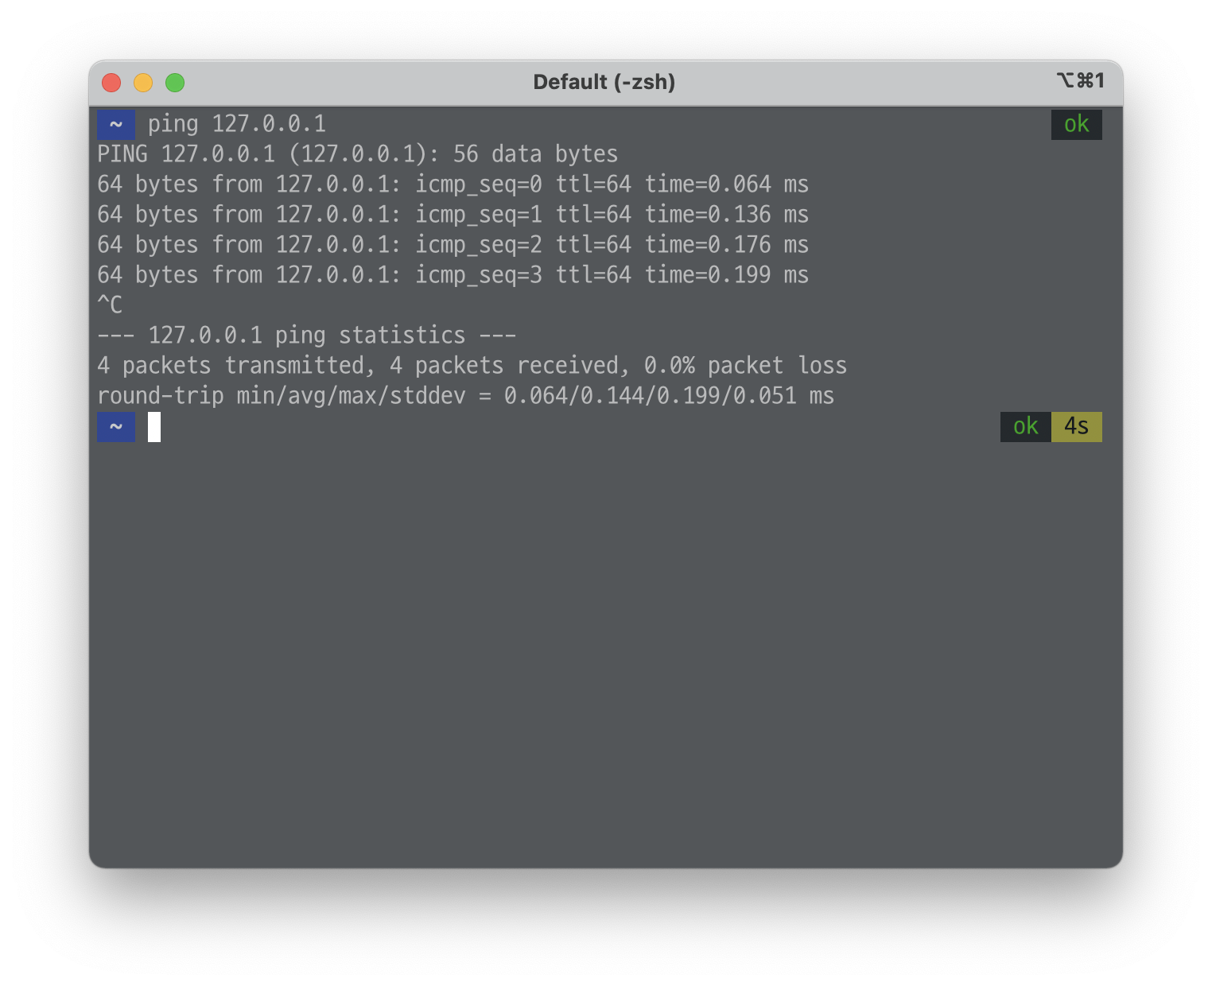4.1.1. Connection test

Figure 1: Ping Command and Result Example

4.1.1.1. 2DMap_API

Test case Object: Caller 와 2DMap_API 사이의 네트워크 연결 test

Test Input:

ping 14.35.156.38

Expected Results:

Ping status: 4 packets transmitted, 4 packets received, 0.0% packet loss

4.1.1.2. PanoramaMap_API

Test case Object: Caller 와 PanoramMap_API 사이의 네트워크 연결 test

Test Input:

ping 14.35.156.35

Expected Results:

Ping status: 4 packets transmitted, 4 packets received, 0.0% packet loss

4.1.1.3. DoorInfo_API

Test case Object: Caller 와 DoorInfo_API 사이의 네트워크 연결 test

Test Input:

ping 14.35.156.36

Expected Results:

Ping status: 4 packets transmitted, 4 packets received, 0.0% packet loss

4.1.1.4. DBGateway_API

Test case Object: Caller 와 DBGateway_API사이의 네트워크 연결 test

Test Input:

ping 14.35.156.40

Expected Results:

Ping status: 4 packets transmitted, 4 packets received, 0.0% packet loss

4.1.2. Validation test

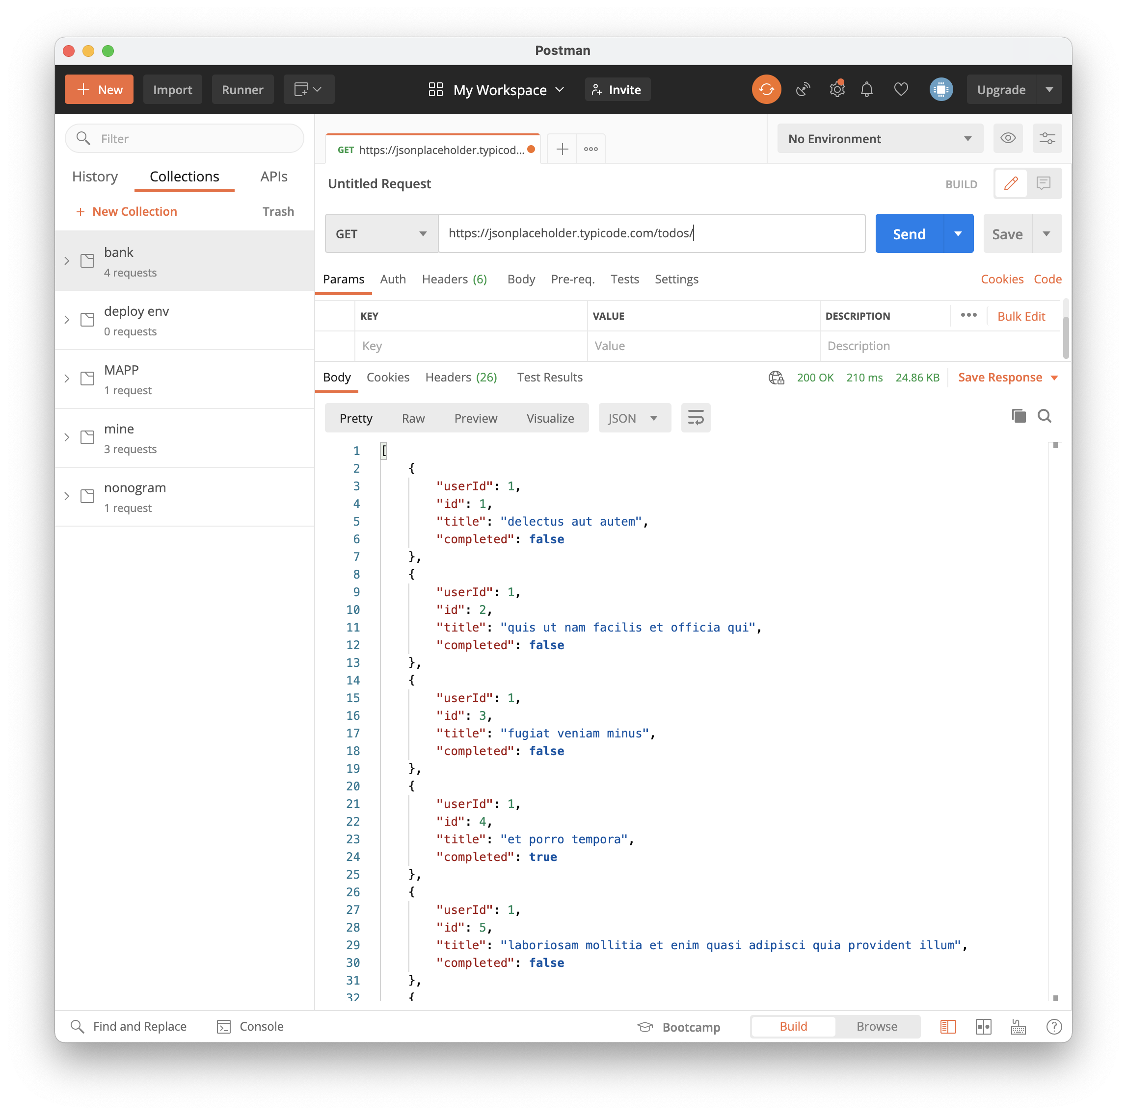

**1: Write down your Request to API and Send it**

**2: Check out received response from API**

Figure 2: Postman Tool Usage Example

4.1.2.1. 2DMap_API

Object: Caller와 2DMap_API 사이에서 작동하는 기능적인 측면의 소프트웨어 인터페이스 Test

Test case 1 Object : 2DMap_API가 올바르게 Caller에게 현재 위치정보를 계산해서 보내주는지 테스트

Test Input1:

| **Attribute** | **Detail** | |
| --- | --- | --- |
| Method | GET | |
| URI | GET: **http**:*//insidecampus/map/gps* | |
| Header | Stations Address Array  (위도, 경도) | [(37.486908, 127.046808), (37.489055, 127.066038), (37.512011, 127.104587)] |
| Header | WIFI AP  Address Array  (위도, 경도) | [(37.488262, 127.066013), (37.488538, 127.065078), (37.488214, 127.064767)] |

Expected Results: 현재 GPS Info

HTTP/1.1 200 OK

Cache-Control: no-cache

Date: {Current Date}

Content-Type: application/json

[

{

"currentGPSLatitude": 37.488295,

"currentGPSLongtitude": 127.065572

}

]

Test case 2 Object: 2DMap_API가 올바르게 두 장소 사이의 최단 경로를 response해주는지 테스트

Test Input2:

| **Attribute** | **Detail** | |
| --- | --- | --- |
| Method | GET | |
| URI | GET: **http**:*//insidecampus/map/path* | |
| Header | Source Coordinates  (위도, 경도) | (37.486908, 127.046808) |
| Header | Destination Coordinates  (위도, 경도) | (37.488262, 127.066013) |

Expected Results:

HTTP/1.1 200 OK

Cache-Control: no-cache

Date: {Current Date}

Content-Type: application/json

[

{

"Source": {

"latitude": 37.486908,

"longtitude": 127.046808

},

"intermediate point 1": {

"latitude": 37.486908,

"longtitude": 127.049808

},

"intermediate point 2": {

"latitude": 37.483948,

"longtitude": 127.076808

},

"intermediate point 3": {

"latitude": 37.483038,

"longtitude": 127.099808

},

"intermediate point 4": {

"latitude": 37.423408,

"longtitude": 127.043308

},

"Destination": {

"latitude": 37.488262,

"longtitude": 127.066013

}

}

]

4.1.2.2. PanoramaMap_API

Object: Caller 와 PanoramaMap_API 사이에서 작동하는 기능적인 측면의 소프트웨어 인터페이스 Test

Test case Object : PanoramaMap_API 가 Caller에게 올바른 Roadmap data을 전송하는지 test

Test Input:

| **Attribute** | **Detail** | |
| --- | --- | --- |
| Method | GET | |
| URI | GET: **http**:*//insidecampus/roadview* | |
| Header | Location Coordinates  (위도, 경도) | (37.486908, 127.046808) |
| Header | Direction  (위도, 경도) | One of (East, West, South, North) |
| Header | Accept-Ranges (Bytes) | 4000 |

Expected Results:

HTTP/1.1 200 OK

Server: WAS/6.0

Content-Length: 1664

Content-type: application/xml

<?xml version="1.0" encoding="UTF-8"?>

**<transfers>**

**<transfer** start-time="2021-05-27T13:10:04.209+01:00" status="Complete" id="414d51205245444841542e434f4f5244ed60b44b03310020"**>**

**<source>**

**<agent** qmgr="REDHAT.SOURCE.QM" name="REDHAT.SOURCE.AGENT" **/>**

**<metadata>**

**<key** value="REDHAT.SOURCE.AGENT" name="com.ibm.wmqfte.SourceAgent" **/>**

**<key** value="REDHAT.DEST.AGENT" name="com.ibm.wmqfte.DestinationAgent" **/>**

**<key** value="192.168.243.133" name="com.ibm.wmqfte.OriginatingHost" **/>**

**<key** value="fteuser" name="com.ibm.wmqfte.MqmdUser" **/>**

**<key** value="414d51205245444841542e434f4f5244ed60b44b03310020" name="com.ibm.wmqfte.TransferId" **/>**

**<key** value="fteuser" name="com.ibm.wmqfte.OriginatingUser" **/>**

**</metadata>**

**</source>**

**<destination>**

**<agent** qmgr="REDHAT.SOURCE.QM" name="REDHAT.SOURCE.AGENT" **/>**

**<metadata>**

**<key** value="REDHAT.SOURCE.AGENT" name="com.ibm.wmqfte.SourceAgent" **/>**

**<key** value="REDHAT.DEST.AGENT" name="com.ibm.wmqfte.DestinationAgent" **/>**

**<key** value="fteuser" name="com.ibm.wmqfte.MqmdUser" **/>**

**<key** value="192.168.243.133" name="com.ibm.wmqfte.OriginatingHost" **/>**

**<key** value="fteuser" name="com.ibm.wmqfte.OriginatingUser" **/>**

**<key** value="414d51205245444841542e434f4f5244ed60b44b03310020" name="com.ibm.wmqfte.TransferId" **/>**

**</metadata>**

**</destination>**

**<stats** retry-count="0" file-warnings="0" file-failures="0" bytes-transferred="67" **/>**

**<transfer-set>**

**<file** result-code="0" mode="text"**>**

**<source-file** name="/home/fteuser/accounts.txt"**>**

**<attribute-values** last-modified="2021-03-17T16:55:17.000Z" file-size="67" disposition="leave" checksum-method="none" **/>**

**</source-file>**

**<destination-file** name="/tmp/accounts.txt"**>**

**<attribute-values** last-modified="2021-04-01T13:10:04.000+01:00" file-size="67" exists-action="error" checksum-method="none" **/>**

**</destination-file>**

**</file>**

**</transfer-set>**

**</transfer>**

**</transfers>**

4.1.2.3. DoorInfo_API

Object: Caller 와 DoorInfo_API 사이에서 작동하는 기능적인 측면의 소프트웨어 인터페이스 Test

Test case object: DoorInfo_API 가 해당 건물에 대해서 올바른 정보를 주는지 Test

Test Input:

| **Attribute** | **Detail** | |
| --- | --- | --- |
| Method | GET | |
| URI | GET: **http**:*//insidecampus/map/location/info* | |
| Header | Coordinates  (위도, 경도) | (37.486908, 127.046808) |

Expected Results: 문 개폐 정보들

HTTP/1.1 200 OK

Cache-Control: no-cache

Date: {Current Date}

Content-Type: application/json

[

{

"opened Door": [1, 3, 4],

"closed Door": [2, 5, 6, 7, 8]

}

]

4.1.3. Defect test

4.1.3.1. 2DMap_API

object: Caller 와 2DMap_API의 에러 추가 발견

Test case 1 Object : 2DMap_API가 Caller에게 잘못된 GPS 요청을 받았을 때 발생할 결함 발견이 목적

Test Input1: (의도적으로 에러를 일으키는 test case, Array가 비어있는 상태)

| **Attribute** | **Detail** | |
| --- | --- | --- |
| Method | GET | |
| URI | GET: **http**:*//insidecampus.com/map/gps* | |
| Header | Stations Address Array  (위도, 경도) | [ ] |
| Header | WIFI AP  Address Array  (위도, 경도) | [ ] |

Expected Results 1:

HTTP/1.1 400 Bad Request

Cache-Control: no-cache

Date: {Current Date}

Test case 2 Object: 2DMap_API가 Caller에게 잘못된 경로 탐색 요청을 받았을 때 발생할 결함 발견이 목적

Test Input2: (의도적으로 에러를 일으키는 test case, 좌표 오류인 상태)

| **Attribute** | **Detail** | |
| --- | --- | --- |
| Method | GET | |
| URI | GET: **http**:*//insidecampus/map/path* | |
| Header | Source Coordinates  (위도, 경도) | ( ) |
| Header | Destination Coordinates  (위도, 경도) | ( ) |

Expected Results 2:

HTTP/1.1 400 Bad Request

Cache-Control: no-cache

Date: {Current Date}

4.1.3.2. PanoramaMap_API

Test case Object : Caller 가 잘못된 로드 뷰 데이터 전송요청시에 발생할 수 있는 에러 추가 발견

Test Input:

| **Attribute** | **Detail** | |
| --- | --- | --- |
| Method | GET | |
| URI | GET: **http**:*//insidecampus/roadview* | |
| Header | Location Coordinates  (위도, 경도) | (37.486908, 127.046808) |
| Header | Direction  (위도, 경도) | One of (East, West, South, North) |
| Header | Accept-Ranges (Bytes) | **0** (받을 데이터 양을 0으로 하여 오류 발생시키기) |

Expected Results:

HTTP/1.1 400 Bad Request

Server: WAS/6.0

Content-Length: 1664

Content-type: application/json

[

{

"messsage": “Byte parameter Error”

}

]

4.1.3.3. DoorInfo_API

Test case object: To check whether it has undetected errors between Caller and DoorInfo_API.

Test case object: DoorInfo_API 가 잘못된 건물 정보 요청에 대해서 발생할 에러 탐색

Test Input:

| **Attribute** | **Detail** | |
| --- | --- | --- |
| Method | GET | |
| URI | GET: **http**:*//insidecampus/map/location/info* | |
| Header | Coordinates  (위도, 경도) | ( ) |

Expected Results: 에러 메시지

HTTP/1.1 400 Bad Request

Cache-Control: no-cache

Date: {Current Date}

4.2. DBGateway_API

4.2.1. Connection test

4.2.1.1. Road View DB

Test case object: To check external software interfaces (connection) between DBGateway_API and Road View DB.

Test Input:

ping 14.35.156.51

Expected Results:

Ping status: 4 packets transmitted, 4 packets received, 0.0% packet loss

4.2.1.2. Gate Info DB

Test case object: To check external software interfaces (connection) between DBGateway_API and Gate Info DB.

Test Input:

ping 14.35.156.52

Expected Results:

Ping status: 4 packets transmitted, 4 packets received, 0.0% packet loss

4.2.1.3. Campus Map DB

Test case object: To check external software interfaces (connection) between DBGateway_API and Campus Map DB.

Test Input:

ping 14.35.156.53

Expected Results:

Ping status: 4 packets transmitted, 4 packets received, 0.0% packet loss

4.2.2. Validation test

4.2.2.1. Road View DB

Test case object: To check external software interfaces (valid functionality) between DBGateway_API and Road View DB.

Test Input:

| **Attribute** | **Detail** | |
| --- | --- | --- |
| Method | GET | |
| URI | GET: **http**:*//14.35.156.51:3306/DB* | |
| Header | Location Coordinates  (위도, 경도) | (37.486908, 127.046808) |
| Header | Direction  (위도, 경도) | One of (East, West, South, North) |
| Header | Accept-Ranges (Bytes) | 4000 |

Expected Results:

HTTP/1.1 200 OK

Server: WAS/6.0

Content-Length: 1664

Content-type: application/xml

<?xml version="1.0" encoding="UTF-8"?>

**<transfers>**

**<transfer** start-time="2021-05-27T13:10:04.209+01:00" status="Complete" id="414d51205245444841542e434f4f5244ed60b44b03310020"**>**

**<source>**

**<agent** qmgr="REDHAT.SOURCE.QM" name="REDHAT.SOURCE.AGENT" **/>**

**<metadata>**

**<key** value="REDHAT.SOURCE.AGENT" name="com.ibm.wmqfte.SourceAgent" **/>**

**<key** value="REDHAT.DEST.AGENT" name="com.ibm.wmqfte.DestinationAgent" **/>**

**<key** value="192.168.243.133" name="com.ibm.wmqfte.OriginatingHost" **/>**

**<key** value="fteuser" name="com.ibm.wmqfte.MqmdUser" **/>**

**<key** value="414d51205245444841542e434f4f5244ed60b44b03310020" name="com.ibm.wmqfte.TransferId" **/>**

**<key** value="fteuser" name="com.ibm.wmqfte.OriginatingUser" **/>**

**</metadata>**

**</source>**

**<destination>**

**<agent** qmgr="REDHAT.SOURCE.QM" name="REDHAT.SOURCE.AGENT" **/>**

**<metadata>**

**<key** value="REDHAT.SOURCE.AGENT" name="com.ibm.wmqfte.SourceAgent" **/>**

**<key** value="REDHAT.DEST.AGENT" name="com.ibm.wmqfte.DestinationAgent" **/>**

**<key** value="fteuser" name="com.ibm.wmqfte.MqmdUser" **/>**

**<key** value="192.168.243.133" name="com.ibm.wmqfte.OriginatingHost" **/>**

**<key** value="fteuser" name="com.ibm.wmqfte.OriginatingUser" **/>**

**<key** value="414d51205245444841542e434f4f5244ed60b44b03310020" name="com.ibm.wmqfte.TransferId" **/>**

**</metadata>**

**</destination>**

**<stats** retry-count="0" file-warnings="0" file-failures="0" bytes-transferred="67" **/>**

**<transfer-set>**

**<file** result-code="0" mode="text"**>**

**<source-file** name="/home/fteuser/accounts.txt"**>**

**<attribute-values** last-modified="2021-03-17T16:55:17.000Z" file-size="67" disposition="leave" checksum-method="none" **/>**

**</source-file>**

**<destination-file** name="/tmp/accounts.txt"**>**

**<attribute-values** last-modified="2021-04-01T13:10:04.000+01:00" file-size="67" exists-action="error" checksum-method="none" **/>**

**</destination-file>**

**</file>**

**</transfer-set>**

**</transfer>**

**</transfers>**

4.2.2.2. Gate Info DB

Test case object: To check external software interfaces (valid functionality) between DBGateway_API and Gate Info DB.

Test Input:

| **Attribute** | **Detail** | |
| --- | --- | --- |
| Method | GET | |
| URI | GET: **http**:*//14.35.156.52:3306/DB* | |
| Header | Coordinates  (위도, 경도) | (37.486908, 127.046808) |

Expected Results: 문 개폐 정보들

HTTP/1.1 200 OK

Cache-Control: no-cache

Date: {Current Date}

Content-Type: application/json

[

{

"opened Door": [1, 3, 4],

"closed Door": [2, 5, 6, 7, 8]

}

]

4.2.2.3. Campus Map DB

Test case object: To check external software interfaces (valid functionality) between DBGateway_API and Campus Map DB.

Test Input:

| **Attribute** | **Detail** | |
| --- | --- | --- |
| Method | GET | |
| URI | GET: **http**:*//4.35.156.53:3306/DB* | |
| Header | Source Coordinates  (위도, 경도) | (37.486908, 127.046808) |
| Header | Accept-Ranges (Bytes) | 4000 |

Expected Results:

HTTP/1.1 200 OK

Server: WAS/6.0

Content-Length: 1664

Content-type: application/xml

<?xml version="1.0" encoding="UTF-8"?>

**<transfers>**

**<transfer** start-time="2021-05-27T13:10:04.209+01:00" status="Complete" id="414d51205245444841542e434f4f5244ed60b44b03310020"**>**

**<source>**

**<agent** qmgr="REDHAT.SOURCE.QM" name="REDHAT.SOURCE.AGENT" **/>**

**<metadata>**

**<key** value="REDHAT.SOURCE.AGENT" name="com.ibm.wmqfte.SourceAgent" **/>**

**<key** value="REDHAT.DEST.AGENT" name="com.ibm.wmqfte.DestinationAgent" **/>**

**<key** value="192.168.243.133" name="com.ibm.wmqfte.OriginatingHost" **/>**

**<key** value="fteuser" name="com.ibm.wmqfte.MqmdUser" **/>**

**<key** value="414d51205245444841542e434f4f5244ed60b44b03310020" name="com.ibm.wmqfte.TransferId" **/>**

**<key** value="fteuser" name="com.ibm.wmqfte.OriginatingUser" **/>**

**</metadata>**

**</source>**

**<destination>**

**<agent** qmgr="REDHAT.SOURCE.QM" name="REDHAT.SOURCE.AGENT" **/>**

**<metadata>**

**<key** value="REDHAT.SOURCE.AGENT" name="com.ibm.wmqfte.SourceAgent" **/>**

**<key** value="REDHAT.DEST.AGENT" name="com.ibm.wmqfte.DestinationAgent" **/>**

**<key** value="fteuser" name="com.ibm.wmqfte.MqmdUser" **/>**

**<key** value="192.168.243.133" name="com.ibm.wmqfte.OriginatingHost" **/>**

**<key** value="fteuser" name="com.ibm.wmqfte.OriginatingUser" **/>**

**<key** value="414d51205245444841542e434f4f5244ed60b44b03310020" name="com.ibm.wmqfte.TransferId" **/>**

**</metadata>**

**</destination>**

**<stats** retry-count="0" file-warnings="0" file-failures="0" bytes-transferred="4000" **/>**

**<transfer-set>**

**<file** result-code="0" mode=”bitset"**>**

**<source-file** name="/home/fteuser/2ndEngineering.png"**>**

**<attribute-values** last-modified="2021-03-17T16:55:17.000Z" file-size="67" disposition="leave" checksum-method="none" **/>**

**</source-file>**

**<destination-file** name="/tmp/campus_map.png"**>**

**<attribute-values** last-modified="2021-04-01T13:10:04.000+01:00" file-size="67" exists-action="error" checksum-method="none" **/>**

**</destination-file>**

**</file>**

**</transfer-set>**

**</transfer>**

**</transfers>**

4.2.3. Defect test

4.2.3.1. Road View DB

Test case object: DBGateway_API가 Road View DB에게 잘못된 요청을 보냈을 때 발생할 수 있는 결함 발견이 목적

Test Input:

| **Attribute** | **Detail** | |
| --- | --- | --- |
| Method | GET | |
| URI | GET: **http**:*//14.35.156..51:3306/DB* | |
| Header | Location Coordinates  (위도, 경도) | (37.486908, 127.046808) |
| Header | Direction  (위도, 경도) | One of (East, West, South, North) |
| Header | Accept-Ranges (Bytes) | **0** (받을 데이터 양을 0으로 하여 오류 발생시키기) |

Expected Results:

HTTP/1.1 400 Bad Request

Server: WAS/6.0

Content-Length: 1664

Content-type: application/json

[

{

"messsage": “Byte parameter Error”

}

]

4.2.3.2. Gate Info DB

Test case object: DBGateway_API가 Gate Info DB에게 잘못된 2D 지도 데이터 요청을 받았을 때 발생할 결함 발견이 목적

Test Input:

| **Attribute** | **Detail** | |
| --- | --- | --- |
| Method | GET | |
| URI | GET: **http**:*//14.35.156.52:3306/DB* | |
| Header | Coordinates  (위도, 경도) | ( ) |

Expected Results:

HTTP/1.1 400 Bad Request

Cache-Control: no-cache

Date: {Current Date}

4.2.3.3. Campus Map DB

Test case Object: DBGateway_API가 Campus Map DB에게 잘못된 2D 지도 데이터 요청을 받았을 때 발생할 결함 발견이 목적

Test Input: (의도적으로 에러를 일으키는 test case, 수신할 Byte 크기가 오류인 상태)

| **Attribute** | **Detail** | |
| --- | --- | --- |
| Method | GET | |
| URI | GET: **http**:*//4.35.156.53:3306/DB* | |
| Header | Source Coordinates  (위도, 경도) | (37.486908, 127.046808) |
| Header | Accept-Ranges (Bytes) | **0** (받을 데이터 양을 0으로 하여 오류 발생시키기) |

Expected Results:

HTTP/1.1 400 Bad Request

Server: WAS/6.0

Content-Length: 1664

Content-type: application/json

[

{

"messsage": “Byte parameter Error”

}

]