**ARCHIVE SYSTEM OF STUDENT SCIENTIFIC ACHIEVEMENTS**

**(eArchive)**

**INFORMATION SYSTEM LIFE CYCLE**

**Planner and performer:**  **Client:** Uroš Preradović

Dušan Radosavljević

Čačak, 2.11.2020

**Content**

1. INFORMTIONAL SYSTEM LIFE CYCLE 4

1.1. Feasibility study 4

1.2. Request aggregation and analysis 4

1.2.1. Data requests 4

1.2.2. Strategy for modeling 4

1.2.3. Modeling data conceptual(E-R) diagram 4

1.2.4. Modeling logical(E-R) diagram 6

1.2.5. Functional requests 6

1.2.6. Functional modeling 7

1.2.6.1 Modeling data flow diagram(DFD) 7

1.2.6.2. Application modelling 7

1.2.6.2.1. Application specification 7

**Pictures:**

**Slika 1 Starting schema** 4

**Slika 2 Second schema(Attribute aggregation - B4)** 5

**Slika 3 Resulting schema(Relationship creation and cardinality determination)** 5

**Slika 4 Entitetno relacijski diagram** 6

**Slika 5 Data flow diagram** 7

1. FEASIBILTY STUDY

Feasible information system for digital student scientific achievements archive per university. Scientific achievements ratified by documentation of scientific papers and official graduation certificates. An intended system for supervised, public, insight to achievements which opens career potentials based upon transparency and availability of official documents. Time and financially most cost-effective solution due to several aspects in comparison with standard university archives:

* Centralized digital system
* Processing and archiving of information in the cloud leading to procurement mitigation
* Permanently accessible system from anyplace with access to internet
* Simplified system administration by merely several authorized cadre
* Mitigation of paperwork, time-consuming paper organization
* Highly implementable and compatible on other systems

1. REQUEST AGGREGATION AND ANALYSIS
   1. Database modelling phases (data oriented approach)
      1. Data requests

* Student scientific papers, studies (authorship and partaking information, date of writing, mentoring information, credible documentation, date of publishing)
* Proof of student scientific achievements (graduation certificates, date of issuing)
* Issuing institution (name, head office, telephone, email, headmaster, offered programs)
* Student personal information (name, surname, address, telephone, e-mail, birthplace, residence)
* University attendance of the student(university, enrolment, index)
* Personal and professional information of mentors (name, surname, subject at time, email, telephone)

2.1.2. Strategy for data modelling

Determined stratagem is top-down, based on exposition of abstract concept of student scientific achievements to further concrete concepts on lower level of abstraction and stratagems characteristics.

* + 1. Modelling E-R diagram



**Slika 1 Starting schema**



**Slika 2 Second schema**



**Slika 3 Third schema**



**Slika 4 Forth schema**



**Slika 5 Fifth schema**



**Slika 6 Sixth schema**



**Slika 7 Seventh schema**



**Slika 8 Eighth schema**



**Slika 9 Resulting schema**

2.1.4. Modelling logical E-R diagram (E-R diagram reverse engineering)

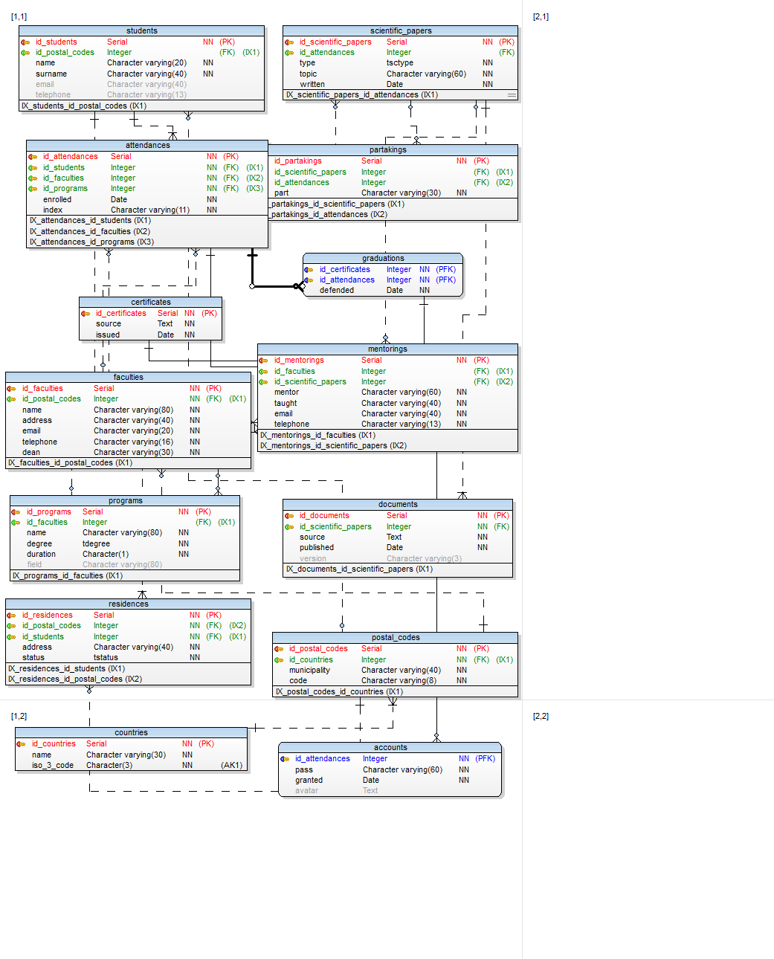

**Slika 10 Logical E-R diagram**

2.2. Application modelling phases (functional oriented approach)

2.2.1 Application requests

* Authorized can access super user account by predetermined credentials
* Authorized inserts and updates information about attendance and graduation of students
* Authorized can create and give an account access to a particular student from a student repository
* Authorized can upload graduation certificates for particular student
* Authorized has insight to all uploaded documents
* Authorized can upload or delete documents on any scientific papers per student
* Student can login to personal account by passed credentials (valid index number and pass)
* Student can upload or delete personal documents on scientific papers
* Student can change personal avatar

2.2.2. Functional analysis (DFD)



**Figure 1 Context diagram**



**Figure 2 Level 1**

2.2.3. Application specification

Provided language for server side configuration is core PHP and for GUI dynamics is core JavaScript with ES6 standard. Implemented external library will be PHPMailer for credential transmission.

Program developing phases:

* reflect entities in the E-R model with class definitions
* define class DBC which extends integrated PDO extension for DB access supported by PGSQL driver
* establish connection with the database server by DBC instance and initialise data manipulation
* form a GUI skeleton with the help of Bootstrap framework
* implement session support module and define session borders
* implement dynamic login and authentication mechanism
* develop authorized account with all mandatory functionalities
* develop visitor tier regarding testimony of scientific achievements

1.3. PROTOTYPING

Prototype version of the application was implemented on 000webhost hosting platform free of charge and supplied with main domain <https://xenostest.000webhostapp.com>.

* 1. VERIFICATION AND VALIDATION

Quality of development of individual phases:

* Data requests – high
* Modelling strategy determination – high
* Modelling E-R and logical E- R – high
* Modelling DFD and EPD – high
* Application modelling – very high
* Application implementation – medium

1.3. PERFORMANCE

Operational version of the application is currently operating on NEOSERV hosting platform with purchased “Green” hosting package, running on xenosproduction.com main domain. Administration and application monitoring managed through cPanel software.