LOCATION BASED RESERVATION MANAGEMENT APPLICATION

***Programmer Velenje, date***

Dušan Radosavljević 28.10.21

Table of Contents

1. REQUEST AGGREGATION AND ANALYSIS 3

1.1 Data aggregation and analysis 3

1.1.1 Application domain 3

1.1.2 Data analysis 4

2. DATABASE AND APPLICATION MODELLING 5

2.1. View modelling 5

2.2. View integration 6

Table of Figures

Figure 1 Administrator view 6

Figure 2 Offeror view 6

Figure 3 Offeree view 7

Figure 4 S1 - Integrated administrator and offeror views 8

Figure 5 Global schema 9

# REQUEST AGGREGATION AND ANALYSIS

## Data aggregation and analysis (data oriented approach)

### Data request description in natural text language

Data requests are in form of structured natural language text which, analyzed, will serve for view modelling.

Application presents reservation management system of public places for which, given the traffic jam, exists need for a priori reservation. Given the geolocation of the offeree, list of offerors are automatically generated on the municipality level.

Application is three tiered, moreover, offeree, offeror and administrator tier for maintenance and supervision.

Offeror is evidenced and authorized by administrator, per demand for application usage, while offeree must personally register.

The following is the description of the stored data.

Administrator is evidencing offeror business information upon demand for application usage. Furthermore is accountable for storing and mediating generated account credentials.

Each offeror is suited with initial reputation, based on responsiveness, compliance and timeliness, which can either grow or degrade with regard to successfulness of reservation management.

By examining offeree complaints, which are indicators of offerors successful reservation management, and having determined credibility of them, administrator is capable of raising or mitigating reputation of the given offeror.

Administrator can assess and save timeframe reservation prohibition for the given offeror in future foreseeable time for continuous non-compliance with the reservation terms by the offeree, which offeror can state in the complaint that proves to be credible.

It is stated that both offeror and offeree can file complaint per reservation. They are also capable of filing counter-complaint as a denial to the subject complaint.

Offeror is granted with a single for insight and management of reservations and reservation requests.

Offeror is able to compose waiting list based on time and seat number of the requests for reservation.

Requests on the waiting list can be potentially supplemented by an assessment of availability for the forthcoming period.

Confirming the request, offeror co-opts it from the waiting list to the reservation list while conserving and mediating confirmation code to the offeree.

In need for reservation cancellation, offeror is supplied with predetermined time for the cancellation.

Offeror is enabled of writing complaints regarding non-compliance of and late reservation cancellation by the offeree.

Based on the geographical coordinates established on the municipality level at the given time, offeree is supplied by a list of offerors for which the requests could be made given the working hours and availability.

Offeree must submit the request an hour before the desired time of reservation.

Stored request includes fullname of the offeree, time of submission, desired reservation time, number of seats, cause and optional note. When composed, request is stored in a request list of an offeree. Upon revocation, it is removed from the same.

In the need for reservation cancellation, offeree is supplied with predetermined time for the checkout.

Offeree is enabled with writing complaints regarding unresponsive, non-complying or untimely reservation management.

### Data analysis

Administrator view:

* Administrator stores offerors business data (name, address, e-mail, telephone, business days and hours) upon consent, if client affirms.
* Administrator stores offerors account credentials, if generated.
* Administrator conserves offerors reputation, as of responsiveness, compliance and timeliness, regarding offeree complaints, if complaint is credible.
* Administrator stores timeframe reservation prohibitions (from beginning to the conclusion date along with the cause) of an offeree for the given offeror, if complaint is credible.

Offeror view:

* Offeror stores availability assessment (estimated time of availability) for request on the waiting list, if assessment could be made.
* Offeror saves requests as reservations upon confirmation, if confirmation is the matter.
* Offeror conserves complaints regarding reservations non-compliance of and late reservation cancellation, if any.

Offerees view:

* Offeree stores requests for the given offeror, if could be made.
* Offeree conserves complaints regarding unresponsive, non-complying and untimely reservation management, if any.

## 1.2. Functional request aggregation and analysis

### 1.2.1. Application domain

Application must persist its data within PostgreSQL database on the database server and implement compatible driver. Database communication must be schema-based configured. Database conceptual model or schema reflects within application modular architecture in the terms of entity definitions for data manipulation. Data manipulation is managed by ORM concept, particularly, imported typeorm module.

Application must implement authentication and authorization mechanisms to the top notch standards permitting users to the further application logic of offerees being permitted to compose requests and offerors permitted to manage, assess and confirm requests as reservations.

Authentication strategy implies implementation of JWT and Passport, interoperable modules.

Algorithm used for database password storage is bcrypt which, as non-built-in module, must be implemented from the equivalently named library.

# DATABASE MODELLING

## 2.1. View modelling

Modelling views for each database user tier based upon analyzed application domain.



Figure 1 Administrator view



Figure 2 Offeror view



Figure 3 Offeree view

## 2.2. View integration

Stepped view integration for preliminary global model:

* Administrator and offeror view integration
  + Inconsistency analysis
    - Absence of naming inconsistency
    - Present structural inconsistency between offeror elements
  + Inconsistence resolving
    - Offeror elements are compatible due to element property presentation inequality
  + Integrated schemas



Figure 4 S1 - Integrated administrator and offeror views

* S1 and offeree view integration into global schema
  + Inconsistency analysis
    - Absence of naming inconsistency
    - Present structural inconsistency between offeror elements
  + Inconsistence resolving
    - Request elements are compatible due to element property presentation inequality
  + Integrated schemas



Figure 5 Global schema

## 2.2. Modelling E-R diagram

Subject diagram is modelled based on reverse engineering of integrated global conceptual schema.

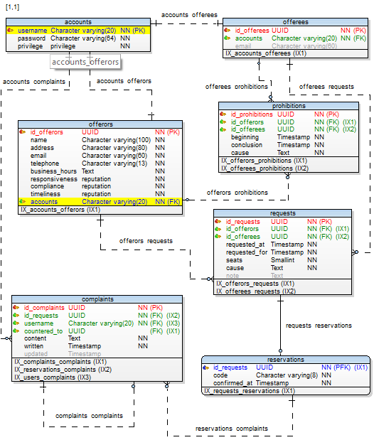

Figure 6 Database E-R diagram

# 3. APPLICATION MODELLING

## 3.1. Modelling DFD

Subject data flow diagram is composed of contextual and firstly levelled diagram where main process is transformed into intended system sub processes.



Figure 7 Context schema



Figure 8 Level 1