Assumed scenario:

Both Test1 and Test2 DHCP servers are dead, rebuild Test3 and Test4, restore from backup and export, rebuild the hot standby and

DC109.metaconstant.net 192.168.3.109 Active Directory, DNS

Test1.metaconstant.net 192.168.3.108 DHCP server

Test2.metaconstant.net 192.168.3.115 DHCP server

Test3.metaconstant.net 192.168.3.59 DHCP server

Test4.metaconstant.net 192.168.3.61 DHCP server

1. VM deploy, join domain, setup DHCP for Test1 and Test2, authorize, setup scope and failover.

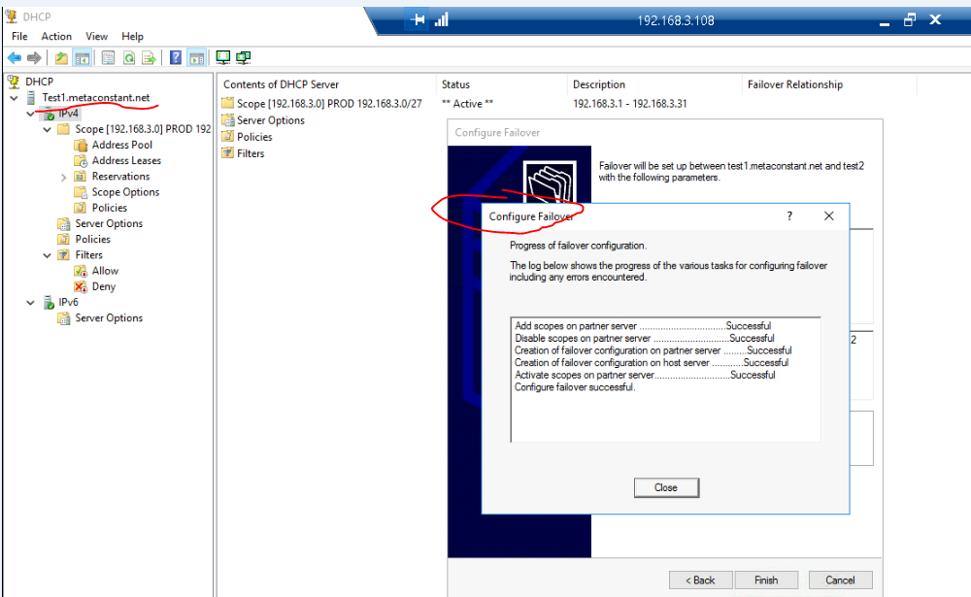

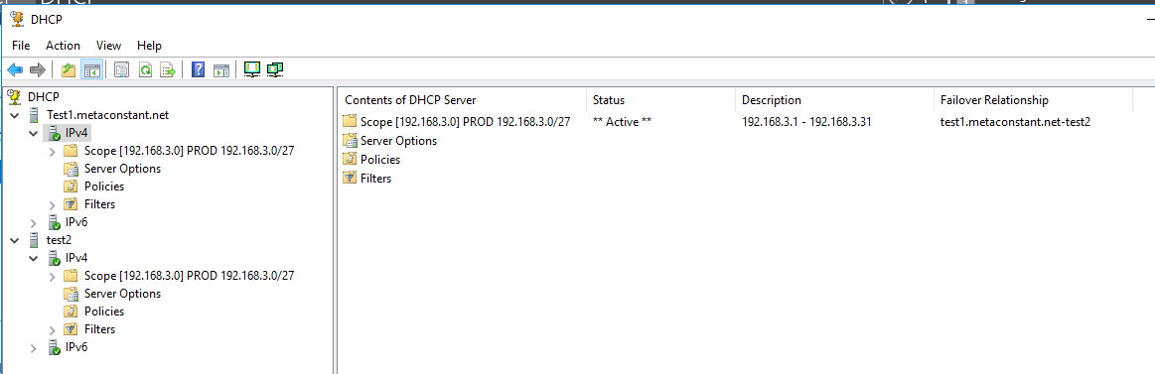

1. From Test 1, Open Powershell for backup, export.

new-item -type Directory -path C:\exportdir\Test1backup -force

Export-DhcpServer -ComputerName "Test2.metaconstant.net" -File "C:\exportdir\Test1_dhcpexport_All.xml" -Leases -force

Export-DhcpServer -ComputerName "Test1.metaconstant.net" -File "C:\exportdir\Test1_dhcpexport_Config.xml" -force

Backup-DhcpServer -ComputerName "Test1.metaconstant.net" -Path “C:\exportdir\Test1backup"

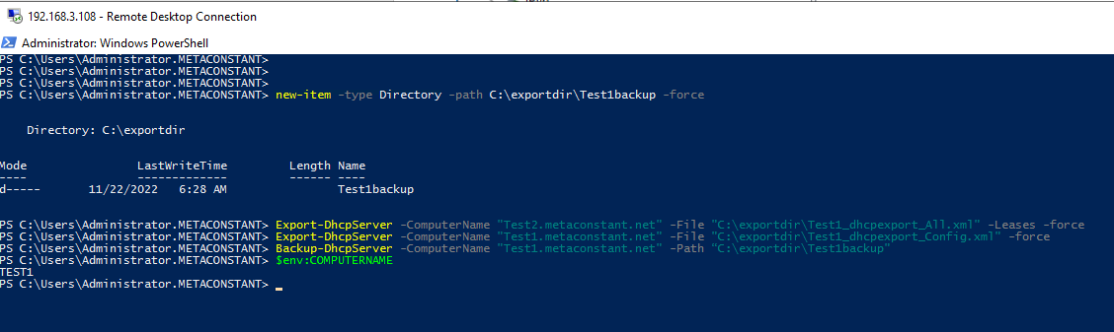

1. From Test 2, Open Powershell for backup, export.

new-item -type Directory -path C:\exportdir\Test2backup -force

Export-DhcpServer -ComputerName "Test2.metaconstant.net" -File "C:\exportdir\Test2_dhcpexport_All.xml" -Leases -force

Export-DhcpServer -ComputerName "Test2.metaconstant.net" -File "C:\exportdir\Test2_dhcpexport_Config.xml" -force

Backup-DhcpServer -ComputerName "Test2.metaconstant.net" -Path "C:\exportdir\Test2backup"

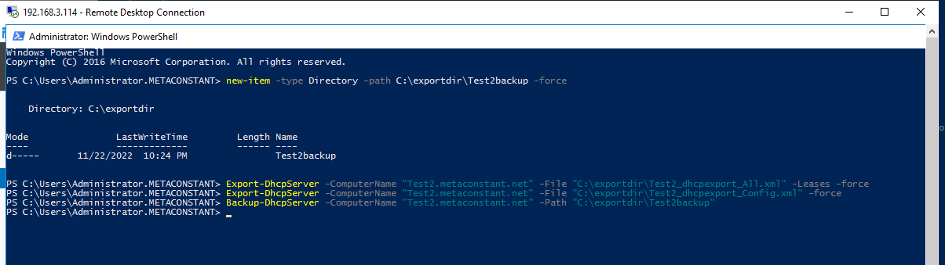

1. Copy the file to a temp place (DC109.metaconstant.com), and power off Test 1 and Test 2.

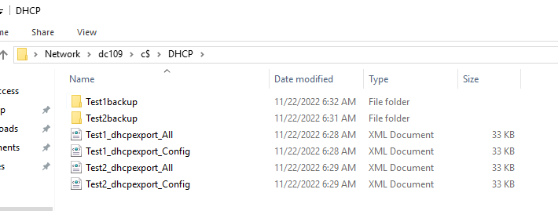

1. VM deploy, join domain, setup DHCP for Test3 and Test4, authorize.

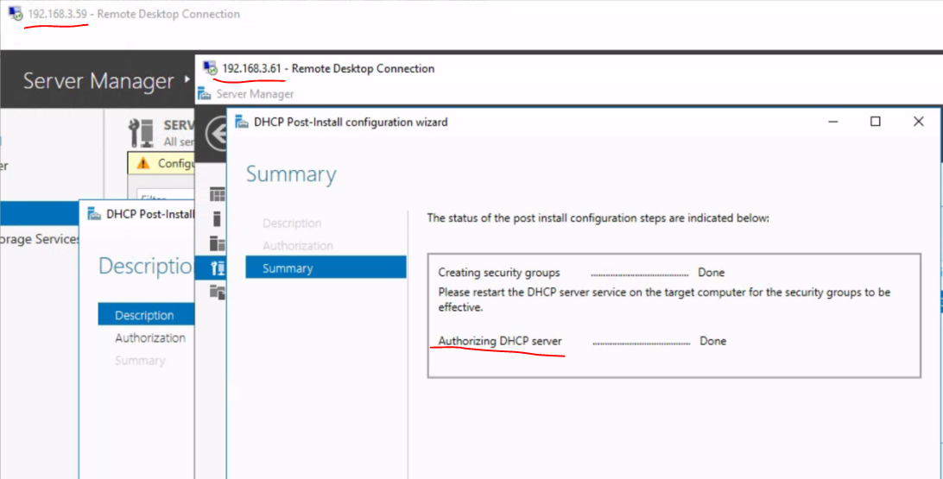

1. Login Test 3, copy backup files, import DHCP config and data

Import-DhcpServer -ComputerName "test3.metaconstant.net" -File "C:\DHCP\Test1_dhcpexport_All.xml" -BackupPath “C:\DHCP\Test1backup” -leases

Import-DhcpServer -ComputerName "test3.metaconstant.net" -File "C:\DHCP\Test1_dhcpexport_Config.xml" -BackupPath “C:\DHCP\Test1backup” -ServerConfigOnly

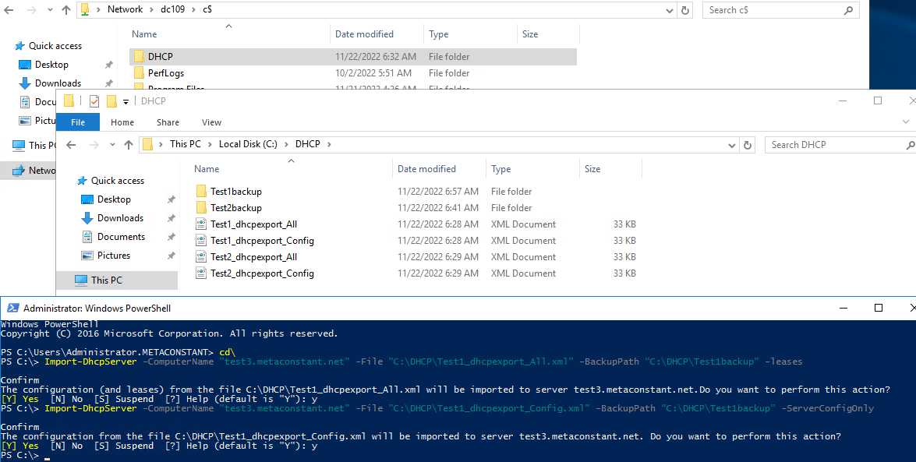

1. Close DHCP manager, reopen and see restored correctly.

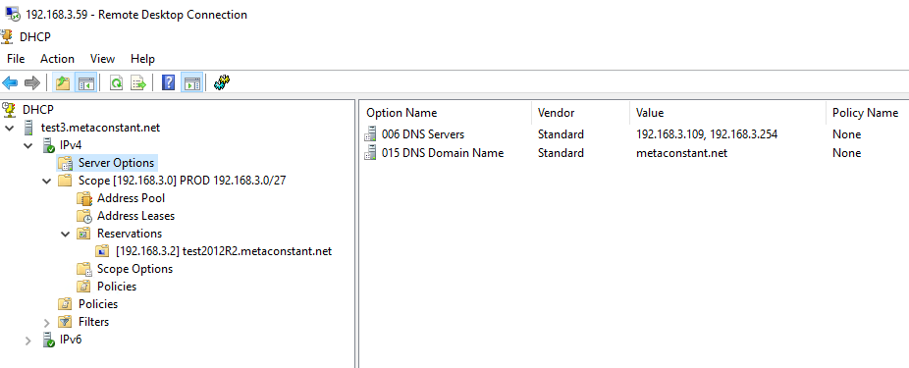

1. Login Test 4, copy backup files, import **DHCP config ONLY**

Import-DhcpServer -ComputerName "test4.metaconstant.net" -File "C:\DHCP\Test2_dhcpexport_Config.xml" -BackupPath “C:\DHCP\Test2backup” -ServerConfigOnly

Or from test 1

Import-DhcpServer -ComputerName "test4.metaconstant.net" -File "C:\DHCP\Test1_dhcpexport_Config.xml" -BackupPath “C:\DHCP\Test1backup” -ServerConfigOnly

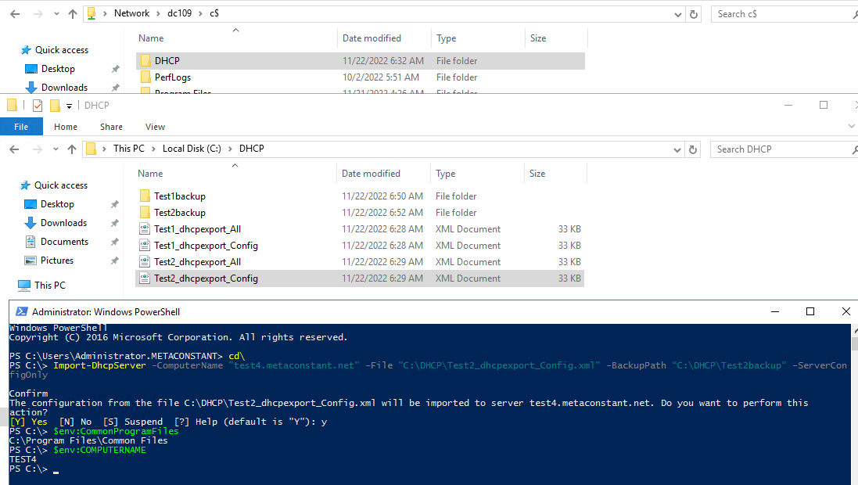

Or from test 1

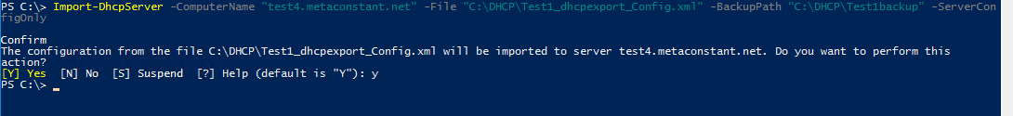

1. Close DHCP manager, reopen and see restored correctly.

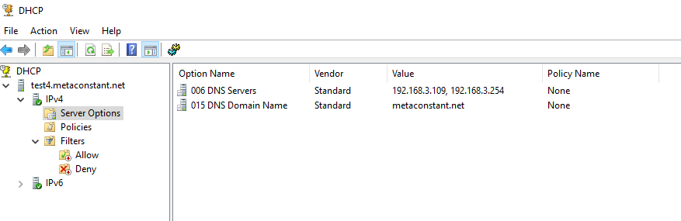

1. From test 3, config test3-test4 failover.

Before config

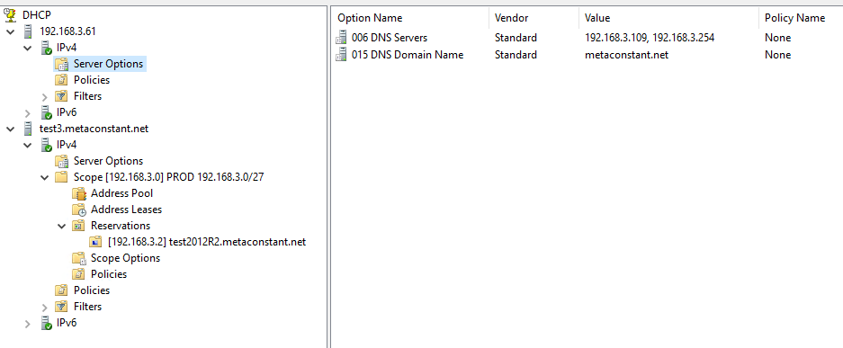

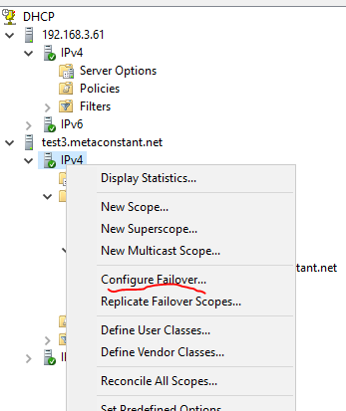 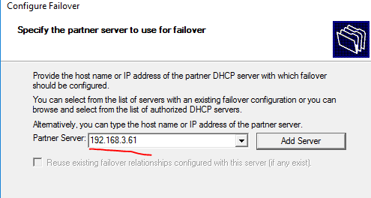

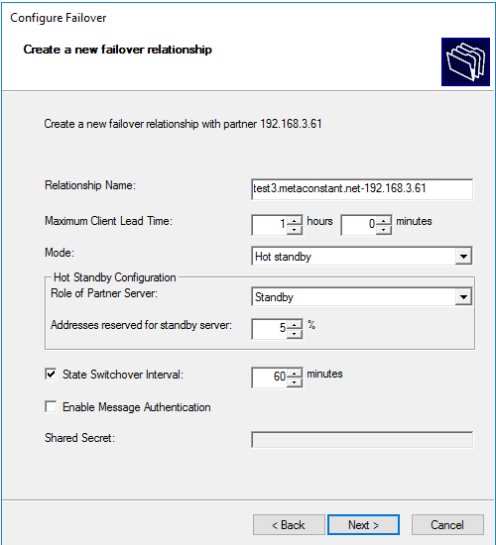 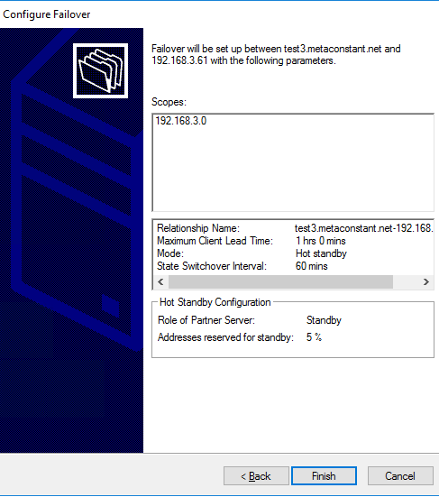

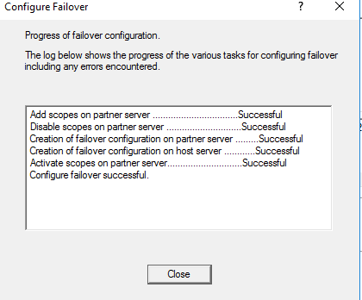

1. Close DHCP manager, wait 1-2 mins, reopen and see failover configured correctly.

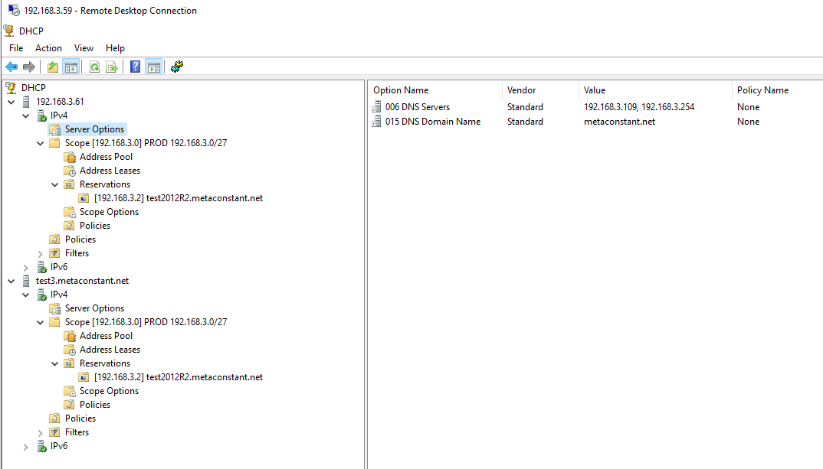

**Discussion points.**

For Test 4, I shall able to restore test 1 config instead of test 2.

Use Restore-DhcpServer instead of Import-DhcpServer? Case by case study and judgement

**Appendix**

Backup = restore to server or another server of same OS version

export = Migrate to server of different OS and extract specific scope (re: Bills post)

<https://learn.microsoft.com/en-us/powershell/module/dhcpserver/export-dhcpserver?view=windowsserver2022-ps>

<https://learn.microsoft.com/en-us/powershell/module/dhcpserver/backup-dhcpserver?view=windowsserver2022-ps>

<https://learn.microsoft.com/en-us/powershell/module/dhcpserver/restore-dhcpserver?view=windowsserver2022-ps>

<https://learn.microsoft.com/en-us/powershell/module/dhcpserver/import-dhcpserver?source=recommendations&view=windowsserver2022-ps>

<https://learn.microsoft.com/en-us/previous-versions/windows/it-pro/windows-server-2012-r2-and-2012/hh831385(v=ws.11)>