**☺ 13 GitHub Working with Remote Repositories**

🡪Create your GITHUB account



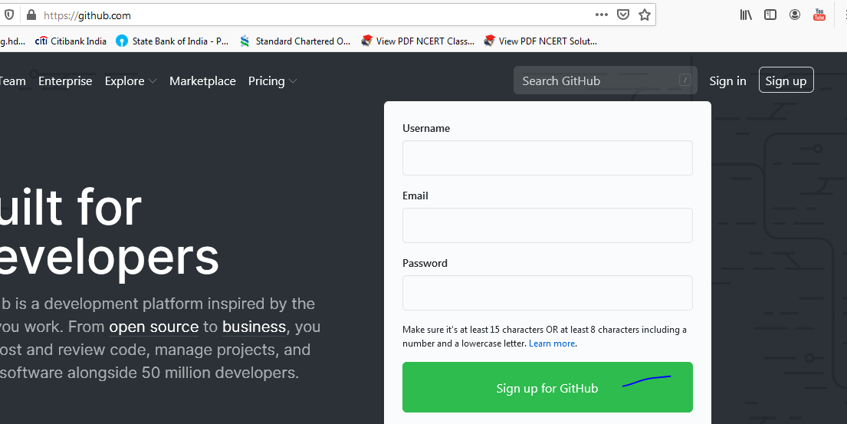

After creating the account

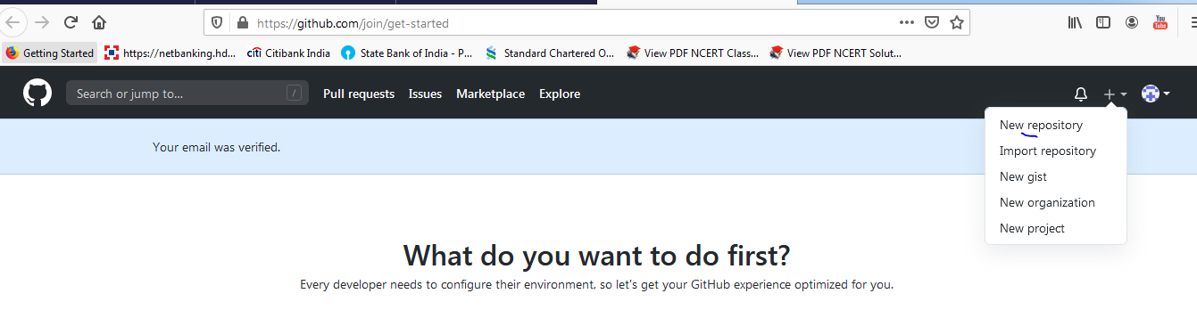

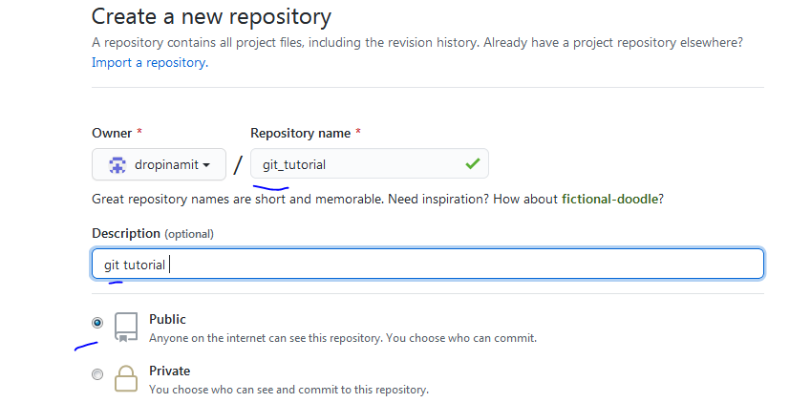

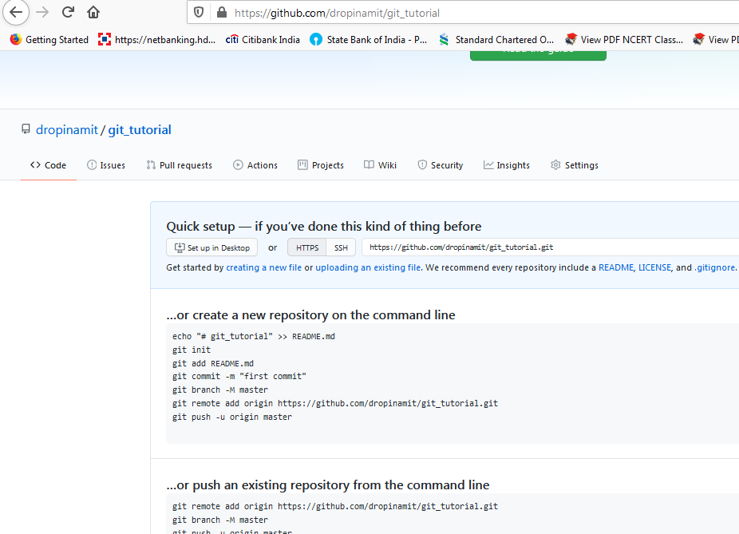

🡪**pull** – to pull the code to local (i.e. to your computer hard drive)

🡪**push** – to push the code into the repository

☺GITHUB is the website which is hosting GIT Repositories.

☺Remote means a website or a repository which is in web i.e. internet

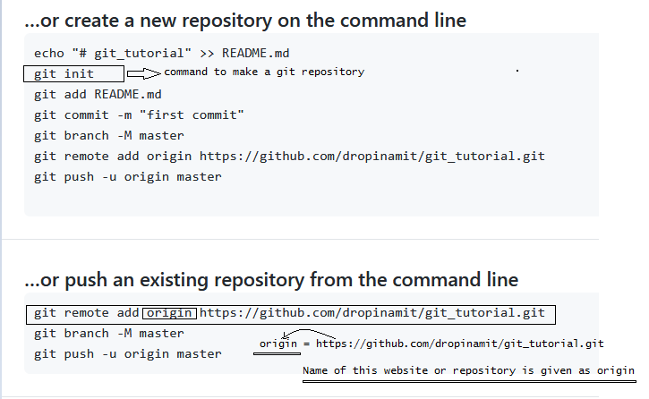

Here we have added a remote named origin which is having the git repository link

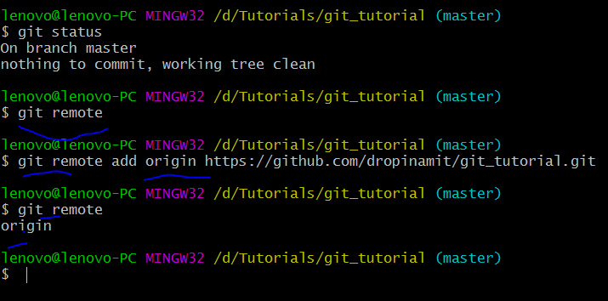

🡪git remote –v : shows the repository to pull and push

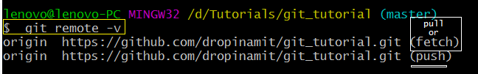

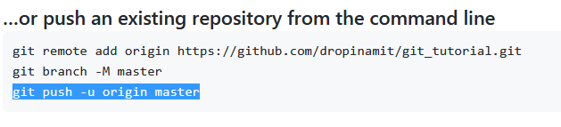

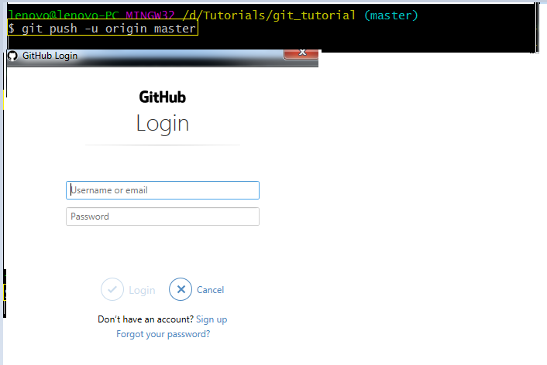

Fill in the credentials

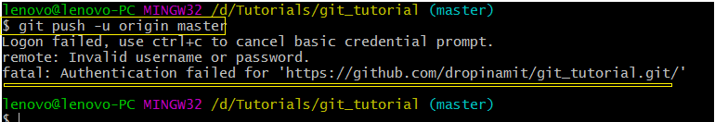

🡪How to get the permission to push?

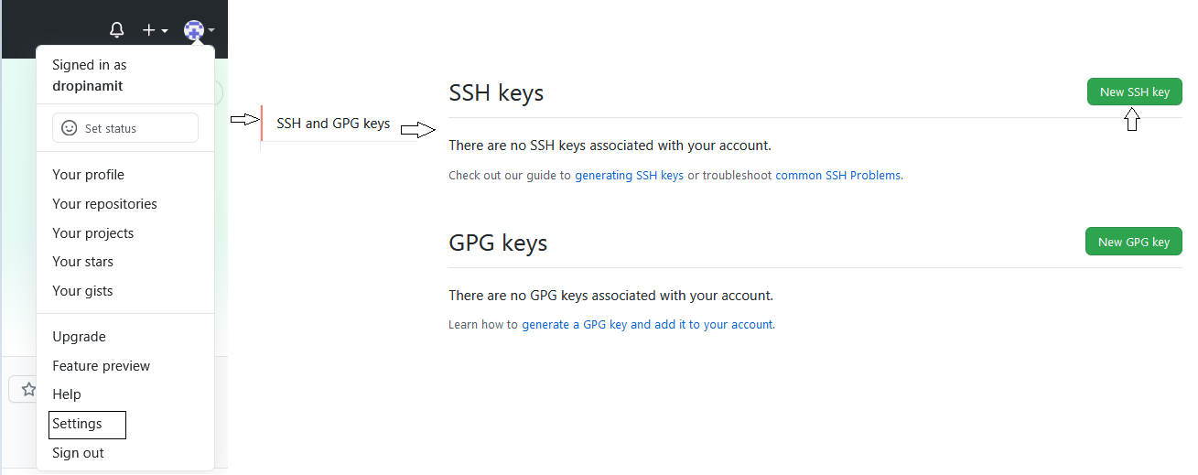

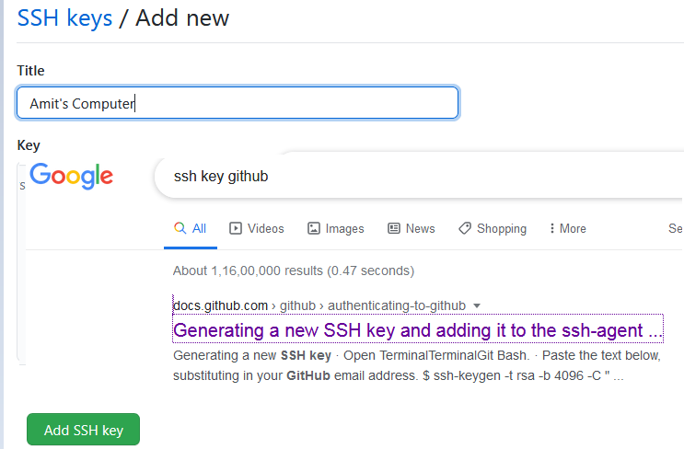

### [Generating a new SSH key](https://docs.github.com/en/github/authenticating-to-github/generating-a-new-ssh-key-and-adding-it-to-the-ssh-agent#generating-a-new-ssh-key)

1. Open Git Bash.
2. Paste the text below, substituting in your GitHub email address.

$ ssh-keygen -t rsa -b 4096 -C "your_email@example.com"

This creates a new ssh key, using the provided email as a label.

> Generating public/private rsa key pair.

1. When you're prompted to "Enter a file in which to save the key," press Enter. This accepts the default file location.

> Enter a file in which to save the key (/c/Users/you/.ssh/id_rsa):[Press enter]

1. At the prompt, type a secure passphrase. For more information, see ["Working with SSH key passphrases"](https://docs.github.com/en/articles/working-with-ssh-key-passphrases).
2. > Enter passphrase (empty for no passphrase): [Type a passphrase]

> Enter same passphrase again: [Type passphrase again]

🡪

lenovo@lenovo-PC MINGW32 /d/Tutorials/git_tutorial (master)

**$ ssh-keygen -t rsa -b 4096 -C "dropmailtoamit@gmail.com"**

Generating public/private rsa key pair.

Enter file in which to save the key (/c/Users/lenovo/.ssh/id_rsa): **<-|**

Created directory '/c/Users/lenovo/.ssh'.

Enter passphrase (empty for no passphrase): **<-|**

Enter same passphrase again: <-|

Your identification has been saved in /c/Users/lenovo/.ssh/id_rsa

Your public key has been saved in /c/Users/lenovo/.ssh/id_rsa.pub

The key fingerprint is:

SHA256:eUa07w0wJ6rOiJbqVSEFk19anDR8D3iIk2yWRs+6gDg dropmailtoamit@gmail.com

The key's randomart image is:

+---[RSA 4096]----+

| o=oBo+ . |

| .oXoO.= . |

| .=.=oo O . |

|. . .oo + B |

|E. . o S o o |

| . o .. o . o |

| o .. . . |

| +. + |

|o+. . o |

+----[SHA256]-----+

🡪

lenovo@lenovo-PC MINGW32 /d/Tutorials/git_tutorial (master)

**$ eval $(ssh-agent -s)**

Agent pid 735

🡪

lenovo@lenovo-PC MINGW32 /d/Tutorials/git_tutorial (master)

**$ ssh-add ~/.ssh/id_rsa**

Identity added: /c/Users/lenovo/.ssh/id_rsa (dropmailtoamit@gmail.com)

🡪

lenovo@lenovo-PC MINGW32 /d/Tutorials/git_tutorial (master)

**$ tail ~/.ssh/id_rsa.pub**

ssh-rsa  dropmailtoamit@gmail.com

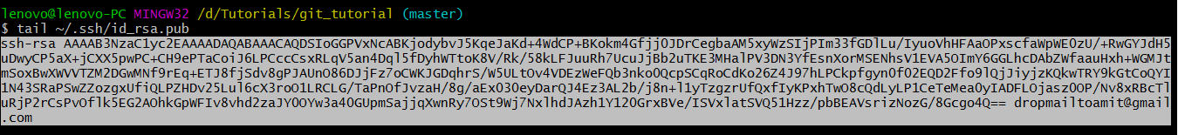

Copy it and paste it

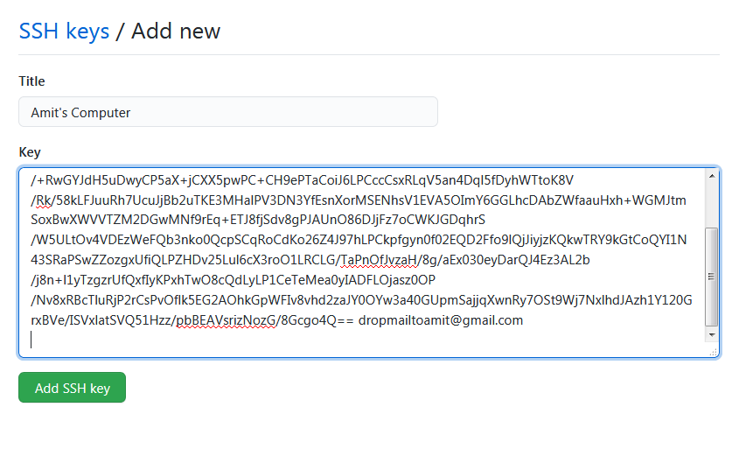

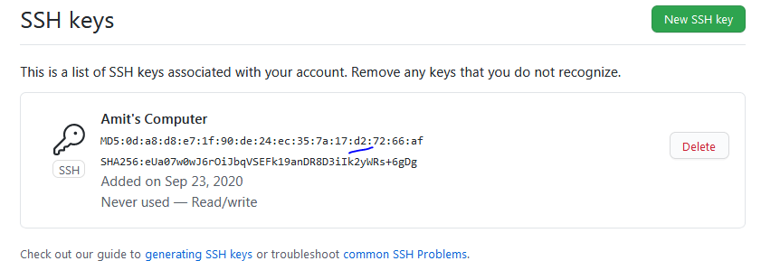

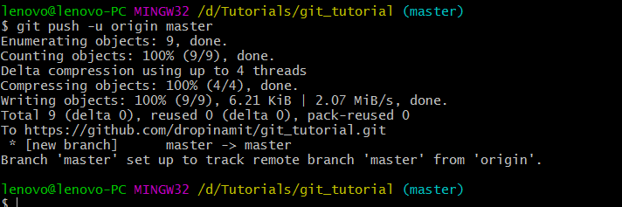

🡪go to your GITHUB and check the push you’ve committed





