Intoduction: Formation of kanji

Total number of kanji is over 100,000; They were coined back in the days in China, and is the top among all languages when it comes to characters amount.
In elementary school, you learn about a thousand characters of that, and about doubled amount of characters for daily life.
In this article, we try to categorize kanjis into 4 different types based on their formation.

Pictogram
These are characters originated from and trying to mimic the shape and appearance of real life objects.
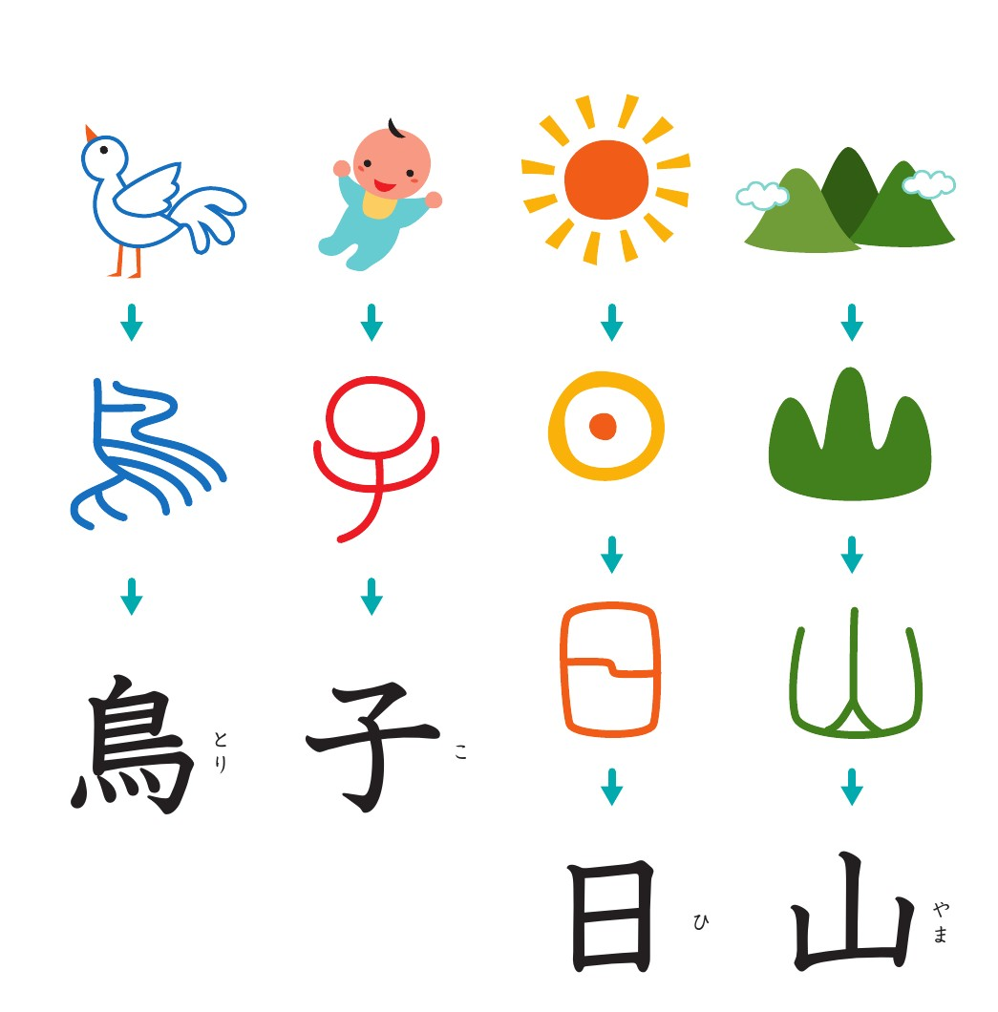図 1: Bird (2nd grade kanji); Child, Sun, Mountain (1st grade kanjis)

More examples

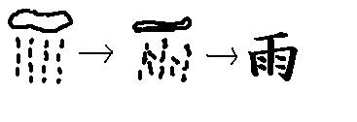  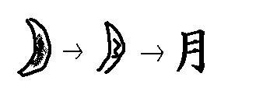 | 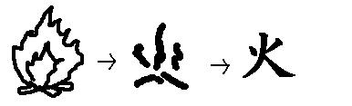 |  | 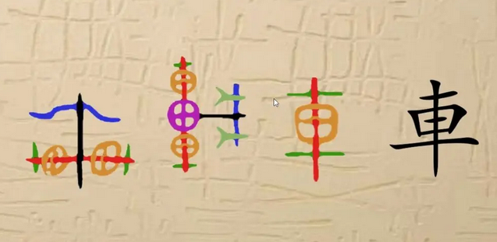 | 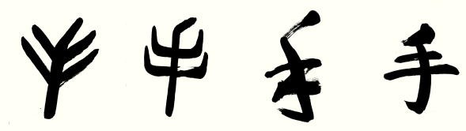
あめ | ひ | つき | くるま | て
rain | fire | moon | car | hand
1st grade | 1st grade | 1st grade | 1st grade | 1st grade

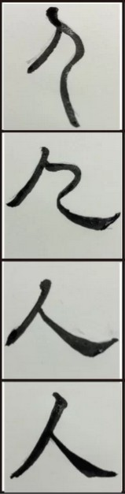  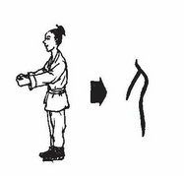 | 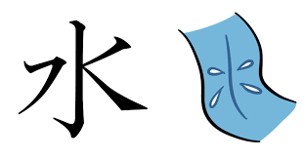 | 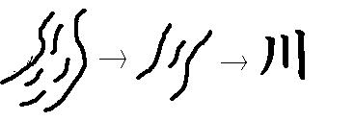 | 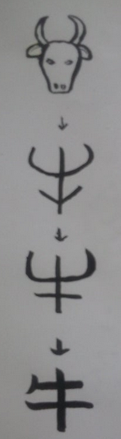 | 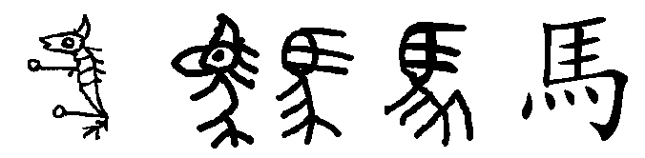
ひと | みず | かわ | うし | うま
person | water | river | cow | horse
1st grade | 1st grade | 1st grade | 2nd grade | 2nd grade

Kanji that indicate abstract ideas
Lines and points to represent abstract ideas that is otherwise impossible to shape.
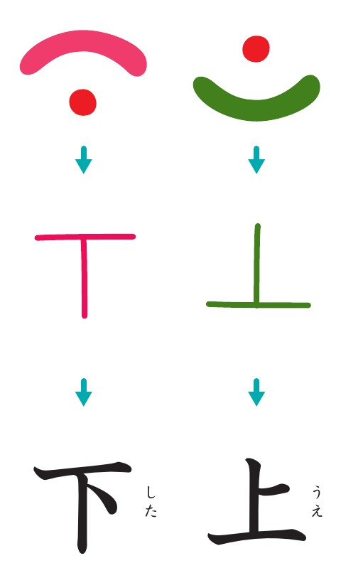図 2: Down, Up (1st grade kanjis)
Other examples

Some characters are made by further more adding lines and points onto pictograms. Here is an example:
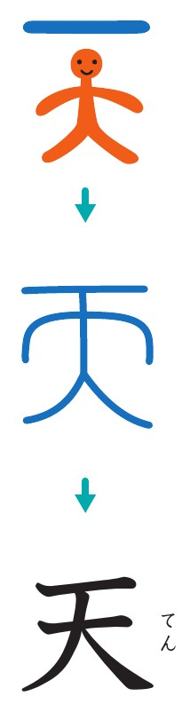図 3: Sky (or heaven, god; 1st grade kanji)
A standing person spreading his arms and legs with an extra line added above, which stands for “a high spot in the sky”.

