艹・草冠
Grass radical

Like growing grass. Used by kanjis that has connections with plants.

Example kanjis with this radical

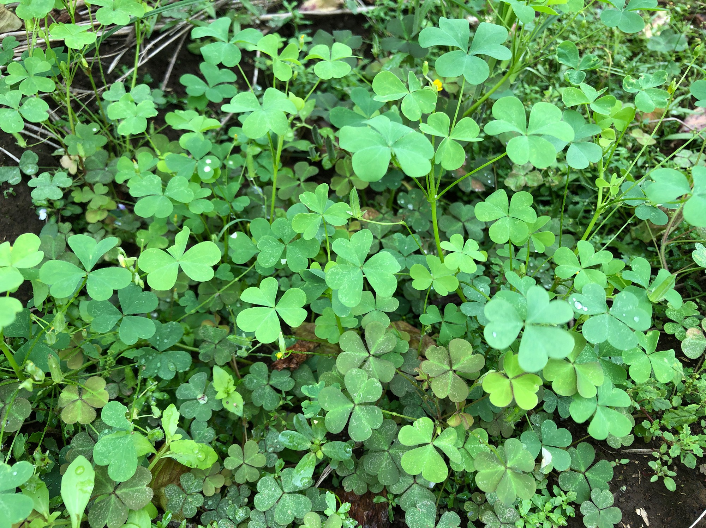
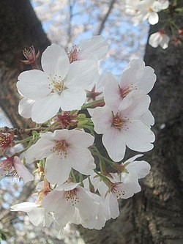
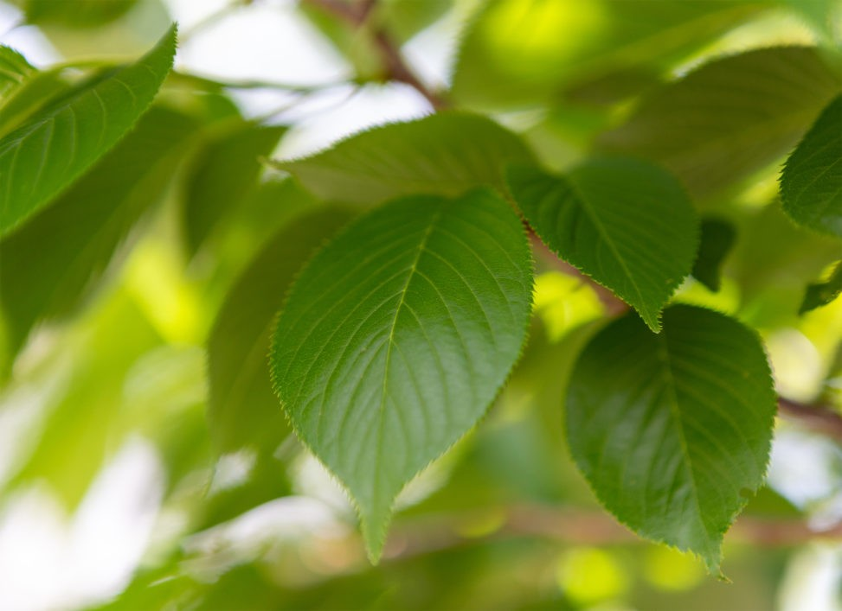
花(はな) | 草(くさ) | 葉(は)
flower | grass | leaf
1st grade | 1st grade | 3rd grade

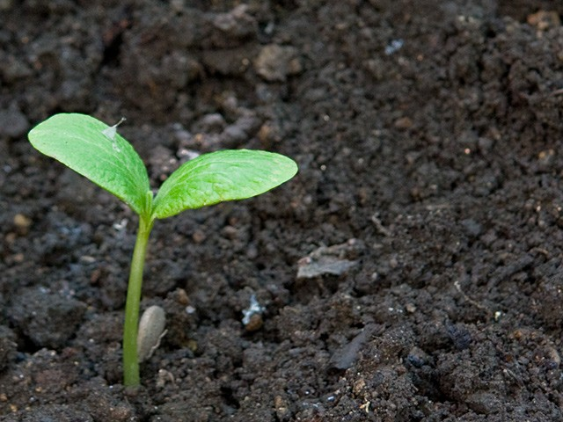 | 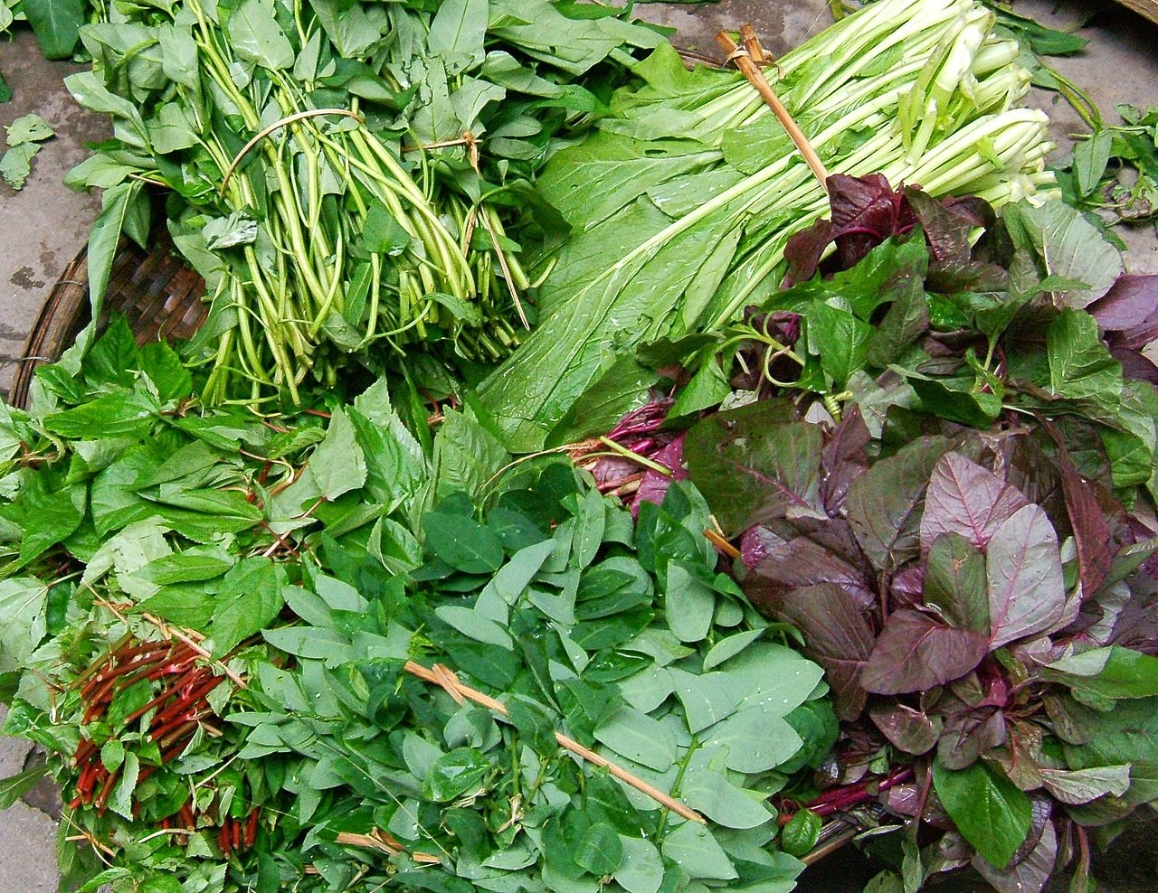 | 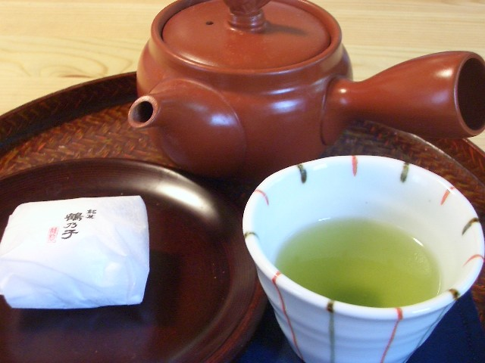
芽(め) | 菜(な) | 茶(ちゃ)
sprouts | vegetable | tea
4th grade | 4th grade | 2nd grade

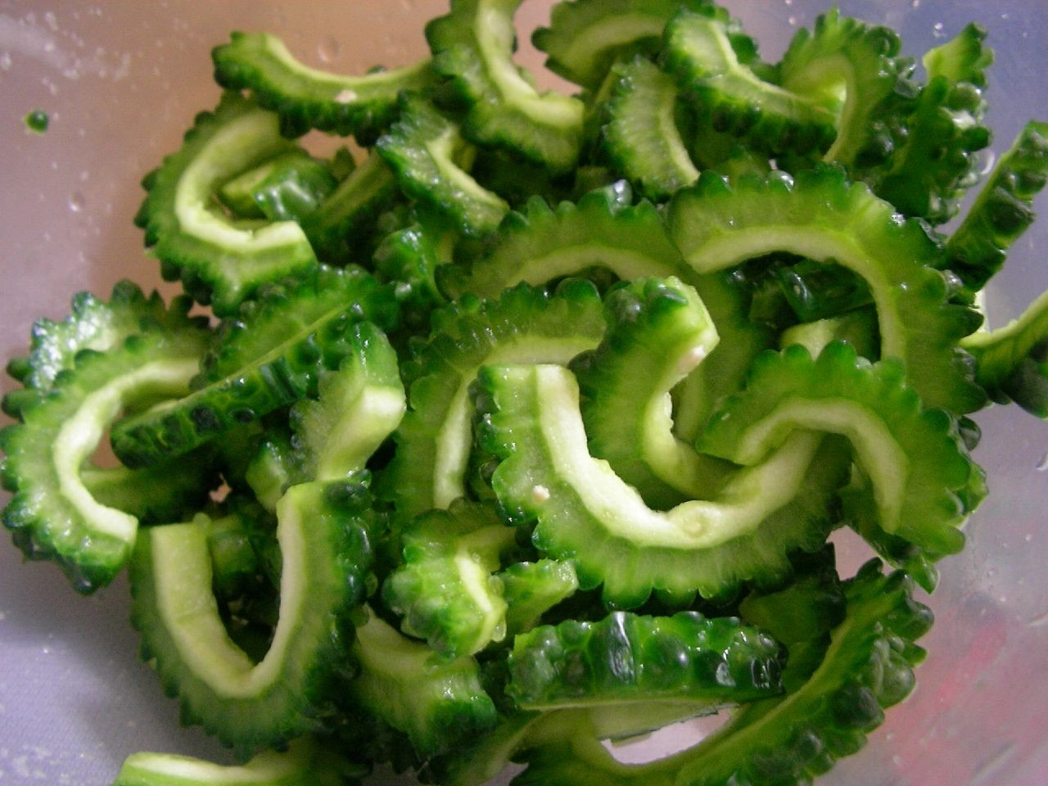 | 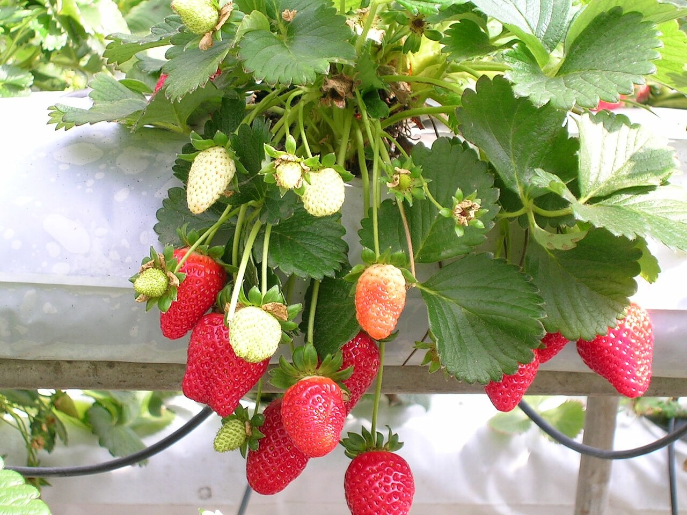 | 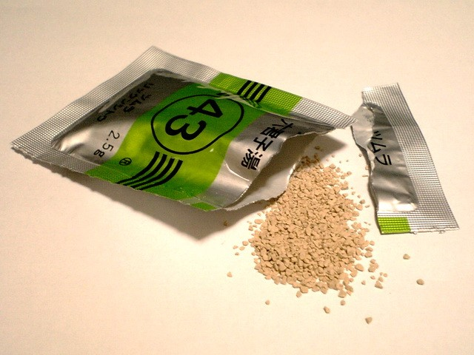
苦(にが) | 苺(イチゴ) | 薬(くすり)
bitter | strawberry | drug
Jōyō kanji  (Common kanji) | Hyōgai kanji  (Unlisted kanji) | 3rd grade




Stroke order

https://happylilac.net/pdf/2019-poster_5.pdf “草が生えている様子。草花に関係した字に使われる。”

