Web-Based Children Information System

Project Proposal

By

Dolawat Wannapira 572115022

Suradis Sutampang 572115058

Department of Software Engineering

College of Arts, Media and Technology

Chiang Mai University

**Project Advisor**

Dr. Chartchai Doungsa-ard

Document History

|  |  |  |  |  |  |  |
| --- | --- | --- | --- | --- | --- | --- |
| Document Name | Version | Status | Date | Viewable | Editable | Responsible |
| Documents | | | | | | |
|  |  |  |  |  |  |  |

DO = DOLAWAT WANNAPIRA

SU = SURADIS SUTAMPANG

CC = DR. CHARTCHAI DOUNGSA-ARD

**Table of Contents**

**Contents Pages**

**ABSTRACT**

**Chapter One | Introduction and Background** 1

**Chapter Two | Literature Review** 2

2.1 Business Review 2

2.1.1 Child Care CRM 2

2.1.2 MyDaycare Plus 3

2.2 Technology Review 4

2.2.1 Visualforce 4

2.2.2 Apex 5

2.2.3 SOQL 6

2.3 Development Tools Review 7

2.3.1 Force.com 7

**Chapter Three | Quality Standard** 8

3.1 ISO 29110 for Very Small Entity (VSE) 8

3.1.1 Project Management Process 8

3.1.2 Software Implementation Process 8

**Chapter Four | Project Plan** 9

4.1 Motivation 9

4.2 Aim and objectives 9

4.2.1 Aim 9

4.2.2 Objectives 9

4.3 Deliverables and limits 10

4.3.1 Deliverables 10

4.3.1.1 System Architecture 10

4.3.2 Document 11

4.3.3 Limits 11

4.4 Software Process 12

4.5 Schedule & Milestones 13

Project Milestone 14

**RERERENCE** 15

**ABSTRACT**

Today, technologies have a many influential in Thailand. Many business began to adapt the technologies to their company especially expense and leave management system. There are a lot of businesses still using the manual expense claim process by the paper based method. From this reasons, the paper based procedure might cause the problem on the complication of tracking the expense requested, the human error of the calculation, as well as the report summary. According to that, our team is developing the web application for expense claim and leave management purposing for reduce the expense management processes, track the expense request, increase the accuracy of calculation and finally for automatically generate the report and graph. In order to develop the Enterprise Workforce Expense and Leave Management web application the developer will use the Iterative software development model as the methodology and the ISO 29110 as the guideline of the development. There are 4 main features in the web application including the Authentication Authorization features, the Expense Item Management features, the Approval and Report feature, and the last feature is Leave Management feature.

**CHAPTER ONE| Introduction & Background**

The issue of social responsibility has attended from the globalization of business. Due to the company take many resources from nature and have an effect on the well-being of people in society. In the past, they do not care the living of people. Then the social deteriorate, it affect to their benefit too. So, adopting the social responsibility into the mission of the company might enhance their product to satisfy the public. Many entrepreneurs have much concern about the corporate social responsibility. They practice giving the benefit to social.

Corporate Social Responsibility (CSR) is business practice to benefit society. A Social Responsibility business has various tactics to give away a portion of company’s proceeds to charity. There are four broad categories of social responsibility that the companies are practicing including Environmental efforts, Philanthropy, Ethical labor practices, and Volunteering. Our company is the Software House, and we implement the customizing software to the customer. According to ours skill and technology, we believe that we can use one’s skill in helping other people, we establish CRM-Charity Foundation aim to help the people by using our expertise in cloud computing and IT consulting technology to improving people’s education and also helping the non-profit organization in the area of technologies. We undertake to help Foundation for Children by giving ten licenses of Salesforce, is a cloud-based software, and customizing the software to keep the children information on cloud.

This is the reason that we customizing the Web-based Children Information system to Foundation for Children by using Salesforce. This web-based application helping the users easy to access the children information. It prevent the children information losing and to enhance the management of children information. Some part of this project is customized by the previous intern. We will implement the Children's Health in Foundation For Children in part of Children Growth System and Medical Information System. Which users can view the children growth information which pass the criteria or not? And users can view the medical record history of each child.

**CHAPTER TWO| Literature Review**

**2.1 Business Review**

### **2.1.1 Child Care CRM**

Child Care CRM is a web-based software as a service (SaaS) solution to help child care organizations of all types and sizes improve their marketing effectiveness and convert more inquiries into enrollments.

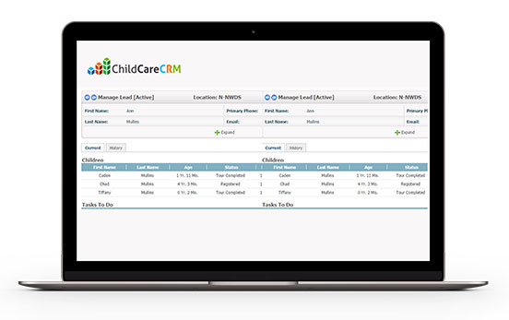

Figure 1: Web application user interface of “ChildCareCRM”

Resource: https://www.childcarecrm.com/tour.php

**Pros**

1. The application provides record child information.

2. The application easy to customize.

3. The application stored on cloud platform.

**Cons**

1. There are the monthly cost.

2. The application not support calculate children growth information.

### **2.1.2 MyDaycare Plus**

MyDaycare Plus is designed to help daycare facilities such as yours seamlessly run their daily operations. This application is a comprehensive software solution that will enable to take care of all administrative functions.

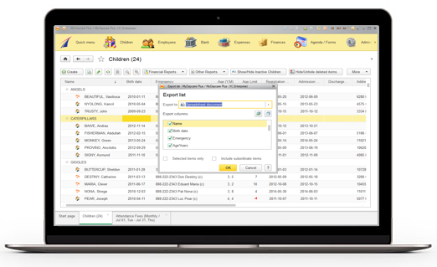

Figure 2: Web application user interface of “MyDaycare Plus”

Resource: http://www.capterra.com/child-care-software/spotlight/132450/MyDaycare%20Plus/First%20BIT%20Canada

http://www.mydaycareplus.com/children.html

**Pros**

1. The application provides simply user interface.

2. The application provides record child information.

3. The application provides print child information.

4. The application stored on cloud platform.

**Cons**

1. There are the monthly cost.

**2.2 Technology Review**

### **2.2.1 Visualforce**

### 

Figure 4: Visualforce logo

Visualforce is the component-based user interface framework for the Force.com platform. The framework includes a tag-based markup language, similar to HTML. Each Visualforce tag corresponds to a coarse or fine-grained user interface component, such as a section of a page, or a field. Visualforce boasts about 100 built-in components, and a mechanism whereby developers can create their own components.

Source: https://developer.salesforce.com/page/An_Introduction_to_Visualforce

**Alternative Technology:**

- Javascript

- Bootstrap

- AJAX

**Why I choose this technology:**

1. This framework is especially for force.com.

2. This framework have many components to use.

3. This framework can work with others framework.

4. This framework use Model-View-Controller paradigm.

### 

### 

### 

### **2.2.2 Apex**



**Figure 5: Apex logo**

Apex is a strongly typed, object-oriented programming language that allows developers to execute flow and transaction control statements on the Force.com platform server in conjunction with calls to the Force.com​ API.

Source:https://developer.salesforce.com/docs/atlas.en-us.apexcode.meta/apexcode/apex_intro_what_is_apex.htm

**Why I choose this technology:**

1. This language is especially for force.com.

2. This language provides built-in support for common Force.com platform

3. This language provides built-in support for unit test creation and execution

4. This language is automatically update when Force.com platform are upgraded

### 

### 

### 

### 

### **2.2.3 SOQL**



Figure 6: SOQL logo

Dynamic SOQL refers to the creation of a SOQL string at runtime with Apex code. Dynamic SOQL enables you to create more flexible applications. For example, you can create a search based on input from an end user, or update records with varying field names.

Source: https://developer.salesforce.com/docs/atlas.en-us.apexcode.meta/apexcode/apex_dynamic_soql.htm

**Alternative Technology:**

- MySQL

- MongoDB

**Why I choose this technology:**

1. This database is a Salesforce build-in.

2. This database could retrieve data from a single object or from multiple objects that are related to one another.

3. This database could count the number of records that meet specified criteria.

4. This database could sort results as part of the query.

5. This database could retrieve data from number, date, or checkbox fields.

## 

## 

## 

## **2.3 Development Tools Review**

### **2.3.1 Force.com**



Figure 7: Force.com logo

Force.com is a Platform as a Service (PaaS) product designed to simplify the development and deployment of cloud-based applications and websites. Developers can create apps and websites through the cloud IDE (Integrated Development Environment) and deploy them quickly to Force.com’s multi-tenant servers.

Source: http://searchsalesforce.techtarget.com/definition/Forcecom

**Why I choose this technology:**

1. This platform is especially for salesforce.

2. This platform build apps lightning fast with drag and drop tools.

3. This platform customize your data model with clicks.

4. This platform customize your UI with clicks or go further with HTML

**CHAPTER THREE| Quality Standard**

**3.1 ISO 29110 for Very Small Entity (VSE)**

ISO/IEC 29110-4-1:2011 is applicable to Very Small Entities (VSEs). A Very Small Entity (VSE) is defined as an enterprise, organization, department or project having up to 25 people. A set of standards and guides have been developed according to a set of VSEs' characteristics and needs. The guides are based on subsets of appropriate standards elements, referred to as VSE profiles. The purpose of a VSE profile is to define a subset of International Standards relevant to the VSE context.

**3.1.1 Project Management Process**

The purpose of the Project Management process is to establish and carry out the tasks of the software implementation project in a systematic way, which allows compliance with the project’s objectives in terms of expected quality, time, and costs. Project Manager contain four main activities.

**Selected processes**

3.1.1.1 Project planning process

3.1.1.2 Project plan execution process

3.1.1.3 Project assessment and control process

3.1.1.4 Project closure process

**3.1.2 Software Implementation Process**

The purpose of the Software Implementation process is to achieve systematic performance of the analysis, design, construction, integration, and test activities for new or modified software products according to the specified requirements.

**Selected processes**

3.1.2.1 Software implementation initiation process

3.1.2.2 Software requirement analysis process.

3.1.2.3 Software architectural and detailed design process

3.1.2.4 Software construction process.

3.1.2.5 Software integration and test process.

3.1.2.6 Software delivery process.

Source: An Innovative Approach to the Development of an International Software Process Lifecycle Standard for Very Small EntitiesRory V. O’Connor, Lero - The Irish Software Engineering Research Centre, Dublin City University, Dublin, Ireland10.4018/ijitsa.2014010101::1Claude Y. Laporte, École de Technologie Supérieure, Montréal, Canada

**CHAPTER FOUR | Project Plan**

**4.1 Motivation**

The Foundation for Children concern about the losing of children information and difficult to update the data. As the volunteer, we expect that cloud technology can resolve these problems. Therefore, we interested to customize the Web-base Children Information system. This web-based application keeps the information on the cloud system. It can help the users to access the children information easier, prevent the children information losing and to enhance the ability to manage the information such as update information.

## **4.2 Aim and objectives**

### **4.2.1 Aim**

1. Provide users to keep the information systematically.

2. Provide users to access the information easier.

3. Provide users easy for tracking the user health.

### **4.2.2 Objectives**

The purpose of the web application is to provide the users to manage children easier and decrease the hidden costs associated. It helps the users to:

- Easy to manage the children information.

- Easy to view the children information.

- Easy to assess the children growth.

- Easy to print out the children's health history.

## 

## 

## **4.3 Deliverables and limits**

### **4.3.1 Deliverables**

#### **4.3.1.1 System Architecture**

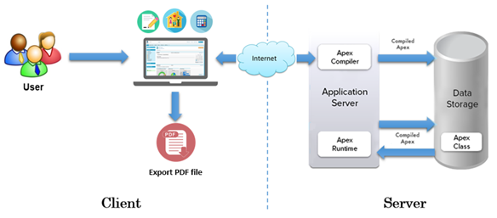

Figure 8: Web-base Children Information System Architecture

The architecture of Web-base Children Information System is shown in Figure 8. This system consist of three parts. The first part is client-side, the user login by using Salesforce system, record children information including inform, family information, visited home, medical, children growth, and children care. Moreover the system can automatically calculate children growth and user can export the PDF of children medical record. The second part is Server-side is use to communicate with web application and database. The web application will send request to the platform application server and server will respond to web application. The last part is database, it for store the data that necessary in the system.

When a developer writes and saves Apex code to the platform, the platform application server first compiles the code into an abstract set of instructions that can be understood by the **Apex runtime interpreter**, and then saves those instructions as metadata.When an end-user triggers the execution of Apex, perhaps by clicking a button or accessing a **Visualforce** page, the platform application server retrieves the compiled instructions from the metadata and sends them through the runtime interpreter before returning the result. The end-user observes no differences in execution time from standard platform requests.

### 

### **4.3.2 Document**

- Proposal

- Project plan

- Software requirement specification

- Software design document

- Testing document

- Traceability record

- Software quality assurance document

### **4.3.3 Limits**

1. Network connection is required for this web application.

2. This web application allow only ten users.

## 

## 

**4.5 Software Process**

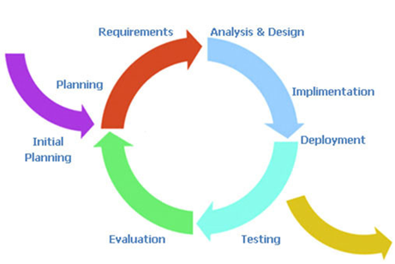

Figure 9: Iterative process model

Iterative Development is a cycle development from gathering the requirements until delivering functionality. This process will break down the process into phase then repeat. At each iterative mean new function will be added.

Therefore, The Web-base Children Information system using the iterative process because It is develop software feature to feature. It will release the complete parts to users for using then continue implement other parts.

## 

## 

## 

## **4.6 Schedule & Milestones**

The schedule of the “Web-based Children Information system” is the timeline to guide the team developer for releasing the functionality on time.

**Process 1: Proposal**

**Process 2 (Progress I):**

**Feature #1: Children growth system**

**Description:** This feature provides the ability to create item

**Users:** Employees, Supervisors and Admin

**Details:**

- Users can create children growth information such as Height, Weight, Head, and Date.

- Users can update children growth information such as Height, Weight, Head, and Date.

- Users can delete children growth information.

- Users can view

**Feature #2: Medical management system**

**Description:** This feature provide for Children health officer.

**Details:**

- Users can create medical information of each child.

- Users can view medical information of each child.

- Users can update medical information of each child.

- Users can delete medical information of each child.

- Users can export the PDF of children medical record.

**Process3 (Progress II):**

**Feature #3: Health condition system**

**Feature #4: Legal detail.**

**Feature #5: Adoption information system**

**Feature #6: Special record system**

**PROJECT MILESTONE**

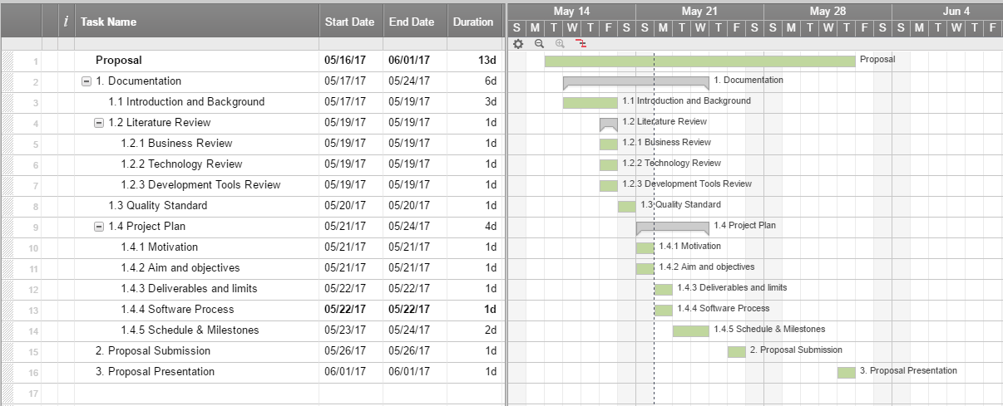

Figure 10: Proposal milestone

**REFERENCES**