Child Cloud Management System

Project Proposal

By

Dolawat Wannapira 572115022

Suradis Sutampang 572115058

Department of Software Engineering

College of Arts, Media and Technology

Chiang Mai University

**Project Advisor**

Dr. Chartchai Doungsa-ard

**Document History**

|  |  |  |  |  |  |  |
| --- | --- | --- | --- | --- | --- | --- |
| Document Name | Version | Status | Date | Viewable | Editable | Responsible |
| Proposal_0.1 | - Add Abstract  - Add Chapter 2  - Business Review  - Technology Review  - Development Tools Review  - Add Chapter 3  - Quality Standard  - Add Chapter 4  - Motivation  - Aims and Objective  - System Architecture  - Deliverable and limits | Draft | 19/05/2017 | DO,SU,CC | DO,SU | DO,SU |
| Proposal_0.2 | - Add Software Process  - Add Schedule & Milestones | Draft | 23/05/2017 | DO,SU,CC | DO,SU | DO,SU |
| Proposal_0.3 | - Add Chapter 1  - Introduction & Background  - Edit Schedule & Milestones  - Add Reference | Draft | 24/05/2017 | DO,SU,CC | DO,SU | DO,SU |
| Proposal_0.4 | - Edit Business Review  - Update Milestone | Draft | 25/05/2017 | DO,SU,CC | DO,SU | DO,SU |
| Proposal_0.5 | - Edit Business Review  - Edit Technology Review  - Edit Abstract | Draft | 02/06/2017 | DO,SU,CC | DO,SU | DO,SU |
| Proposal_0.6 | - Edit Introduction & Background  - Edit Business Review | Draft | 06/06/2017 | DO,SU,CC | DO,SU | DO,SU |
| Proposal_0.7 | - Edit Introduction & Background  - Edit System Architecture | Draft | 08/06/2017 | DO,SU,CC | DO,SU | DO,SU |
| Proposal_0.8 | - Add Cover & Table of Contents  - Edit Introduction & Background  - Edit Business Review  - Edit Deliverable and limits | Draft | 14/06/2017 | DO,SU,CC | DO,SU | DO,SU |
| Proposal_0.9 | - Edit Introduction & Background  - Edit Chapter 1  - Edit Deliverable and limits  - Edit Aim & Objective  - Update Milestone | Draft | 24/06/2017 | DO,SU,CC | DO,SU | DO,SU |

DO = DOLAWAT WANNAPIRA

SU = SURADIS SUTAMPANG

CC = DR. CHARTCHAI DOUNGSA-ARD

**Table of contents**

**Contents Pages**

ABSTRACT 4

CHAPTER ONE| Introduction & Background 5

CHAPTER TWO| Literature Review 6

2.1 Business Review 6

2.1.1 Foundation for Children Workflow 6

2.1.2 Sending Information Workflow 7

2.1.3 Child Cloud Management System 8

2.1.4 Baby Connect 9

2.2 Technology Review 10

2.1.1 Salesforce Framework 10

2.2.2 Apex 11

2.2.3 SOQL 12

2.3 Development Tools Review 13

2.3.1 Force.com 13

CHAPTER THREE| Quality Standard 14

3.1 ISO 29110 for Very Small Entity (VSE) 14

3.1.1 Project Management Process 14

3.1.2 Software Implementation Process 14

CHAPTER FOUR | Project Plan 15

4.1 Motivation 15

4.2 Aim and objectives 15

4.2.1 Aim 15

4.2.2 Objectives 15

4.3 Deliverables and limits 16

4.3.1 Deliverables 16

4.3.1.1 System Architecture 16

4.3.2 Document 17

4.3.3 Limits 17

4.4 Software Process 18

4.5 Schedule & Milestones 19

PROJECT MILESTONE 20

REFERENCES 24

# **ABSTRACT**

Nowadays, The document management in Thailand is difficult, Because most of the company are still use the papers document it makes them hard to organize. Moreover, information-losing while they collect or sending the document to other corporations.

Foundation for children are use the papers document to handle the children information. Moreover, The amount of information of each child in the foundation has a lot. Therefore, the documents that are used for each child so much as it is. Such as Children's Family Information, Health before FCC Information, Health after FFC Information, Doctor Visit Record Information, Children Growth Information, Medical Management Information, Etc.

The cloud system management will be used to handle the document information of Foundation for children that help the foundation to collect the information of children on cloud storage and also easy to update the information or to send the information to another foundation.

# **CHAPTER ONE| Introduction & Background**

Nowadays, There are many problems in Thai society, and the orphaned carelessness problem is the problems that have to solve as soon as possible because orphaned are lack education, lack of moral training. Due the social and economic conditions make children lack parental care far or be orphan.

Foundation for children (FFC) was established for helping children that their parents are not ready to taking care, orphan, and children who have been violated from suffering such as being abused, abandoned and illegal labor to have a better life. Encourage the family role and improve the quality of life of the children such as health, EQ, mental, education, and make the children can live with others in society.

The problems among all of three orphanages are about to send the information document among each of them, paper document losing while they are collecting or sending, and cannot update the document.

Corporate Social Responsibility (CSR) is business practice to benefit society. A Social Responsibility business has various tactics to give away a portion of company’s proceeds to charity. There are four broad categories of social responsibility that the companies are practicing including Environmental efforts, Philanthropy, Ethical labor practices, and Volunteering. CRM Cloud company establish CRM-Charity Foundation aim to help the people by using their expertise in cloud computing and IT consulting technology to improving people’s education and also helping the non-profit organization in the area of technologies. They undertake to help Foundation for Children by giving ten licenses of Salesforce, which is a cloud-based software and customizing the software to keep the children information on cloud.

With the collaboration of CAMT and CRM Cloud, they decide to develop a web-based application called Child Cloud Management System (CCMS) that help the Foundation for children to manage their child information easier and prevents the children information losing and to enhance the management of children information. Some part of this project is customized by the previous senior's projects. The CCMS project is still incomplete, so we continue to implement in part of child development information, education information and forward information.

# **CHAPTER TWO| Literature Review**

## **2.1 Business Review**

### **2.1.1 Foundation for Children Workflow**

The workflow of the Foundation for Children(FFC) is receiving the report from an informer, then analyze the information that matches with the conditions of orphan or not, if the children match the condition, the FFC will notify appointment to child-parent. The child-parent must decide to send their child to FFC or not. If the child-parent decides to send their child to the foundation, then the foundation will input the information of child into the document and send the children to the foundation for taking care of children. The foundation separates the orphanage for taking care of children to three orphanage, which is Baan Tantawan (Newborn – 4 years), Moo Baan Dek Saanrak Kindergarten (4 years – 8 years), and Moo Baan Dek (More than eight years).

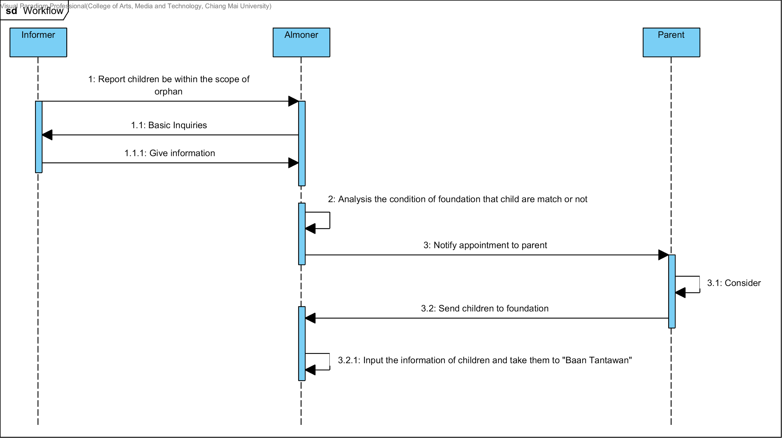

**Figure 1: The Sequence Diagram of Foundation for Children Workflow**

### **2.1.2 Sending Information Workflow**

The orphanage is used the paper document while sending the information. It’s has a problem about the data losing because they have to re-write the paper before sending to another orphanage to taking care of children.

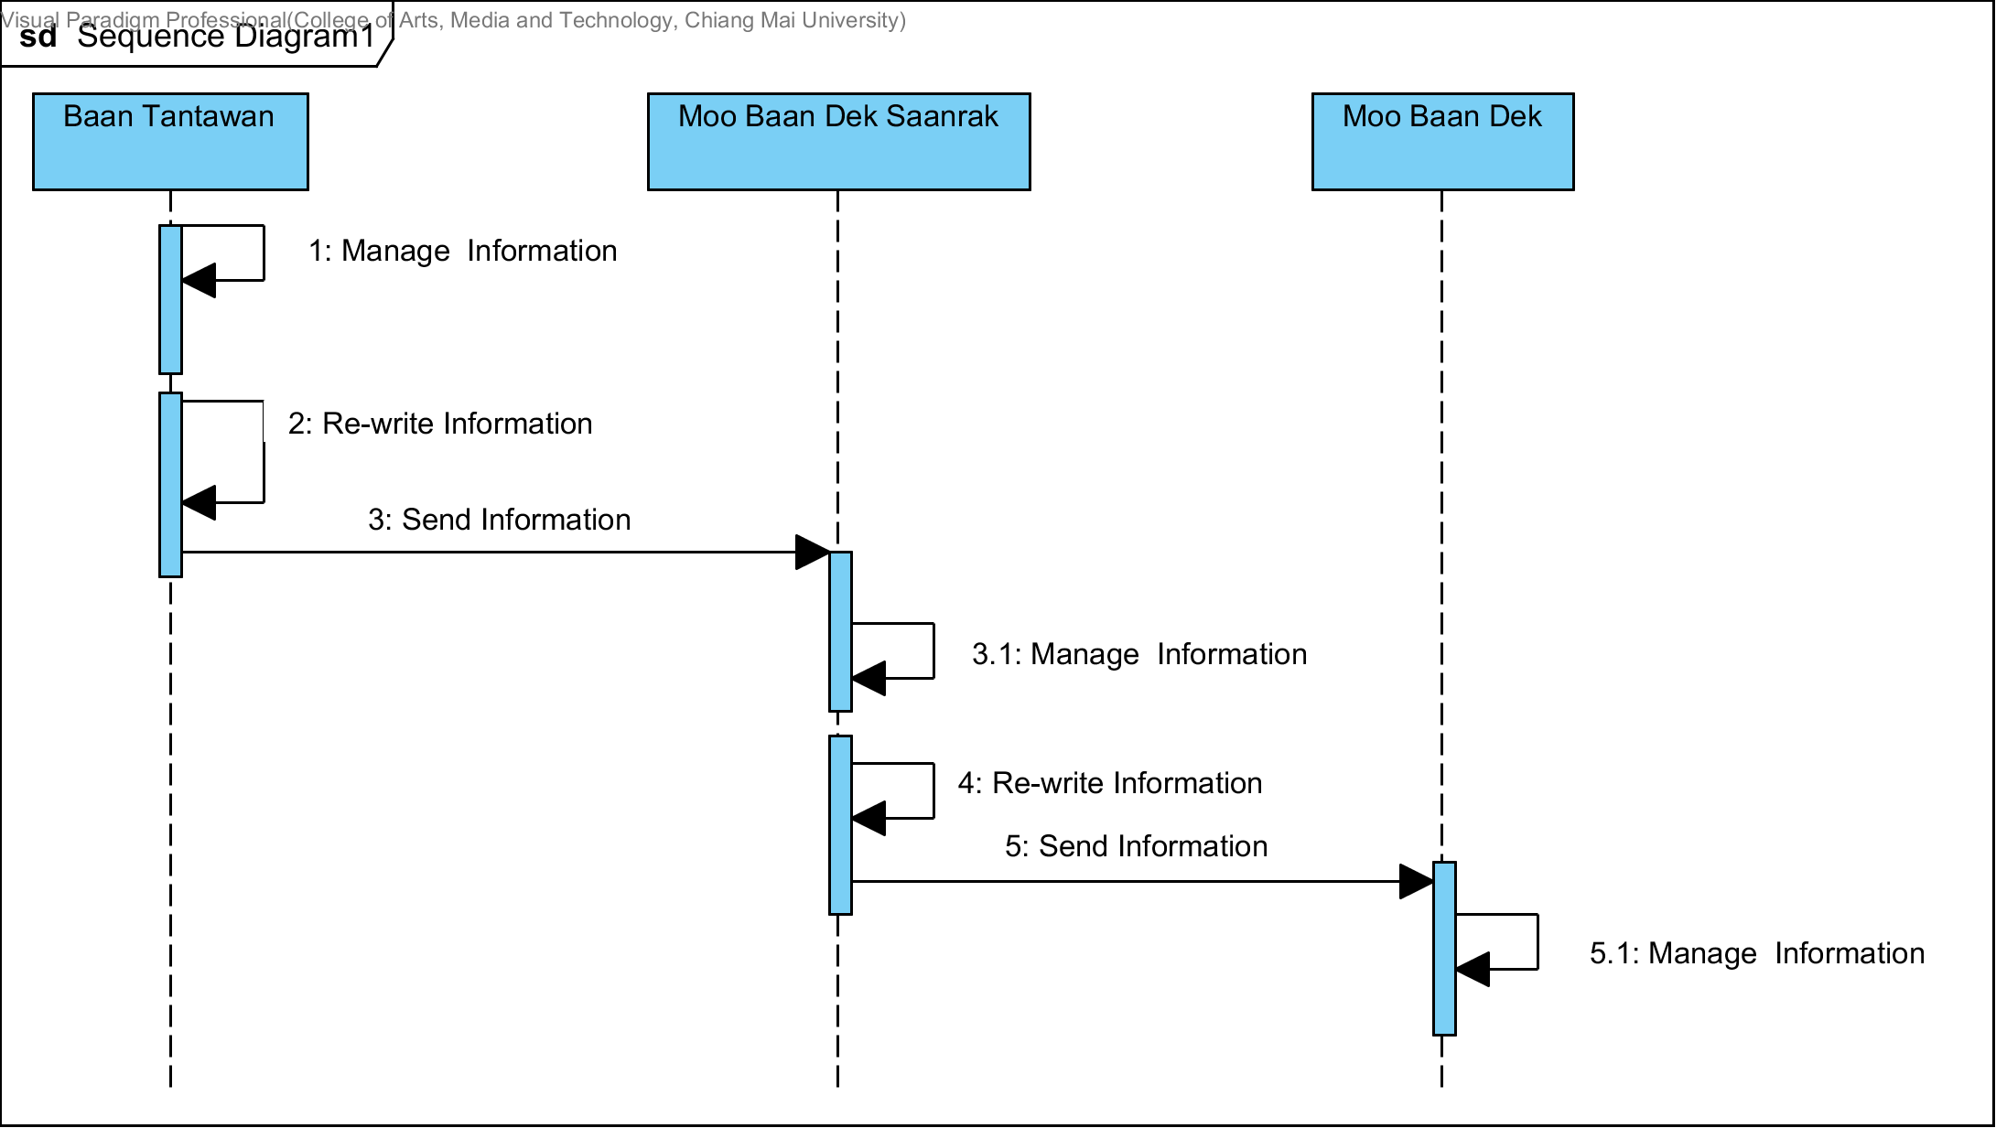

**Figure 2: Diagram of Sending Information Workflow**

### **2.1.3 Child Cloud Management System**

The Child Cloud Management System is the web application that senior students created for help to manage the information of orphan in Foundation of Children. This web-application is used Salesforce framework for developing.

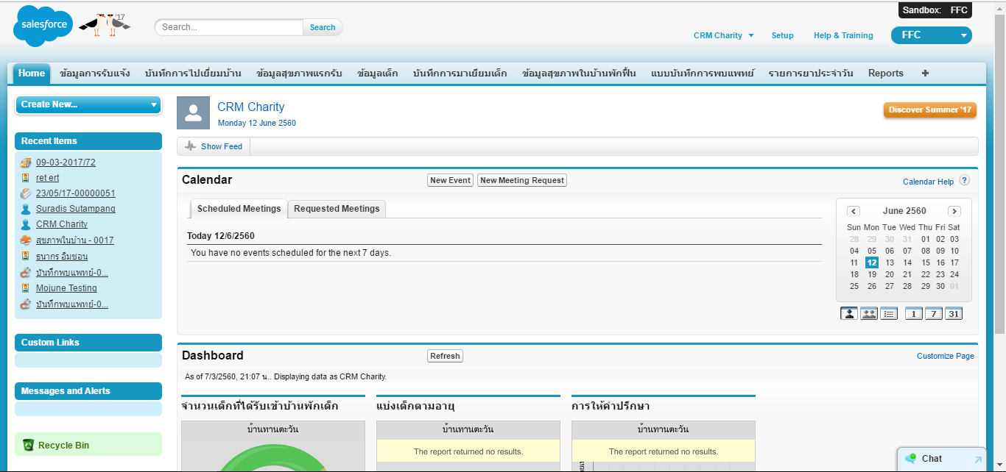

**Figure 3: The User interface of “Child Cloud Management System.”**

This web-application classified each information and provided user to recording and updating child information and stored the information on Salesforce cloud storage. Each page information is including thirteen-feature followings this list.

* Inform Information
* Children Information
* Children's Family Information
* Visited Home Information
* Health before FCC Information
* Health after FFC Information
* Doctor Visit Record Information
* Children Growth Information
* Medical Management Information
* Legal Information
* Special Record Information
* Child Sponsorship Information
* Reason for Leaving Information

### **2.1.4 Baby Connect**

The Baby Connect is the most comprehensive baby tracking application which created by Seacloud Software. It has graphical reports and trending charts, weekly averages, medicine, vaccine and growth tracking, timers, notifications, emails, .csv export, an easy to use interface, unlimited data, and it is the only application that allows user to exchange information in real time with user spouse, babysitter, nanny or daycare.

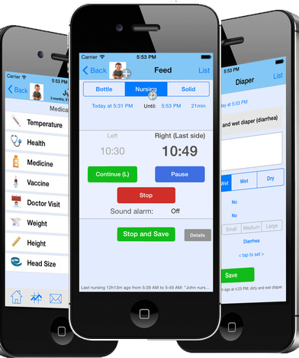

**Figure 4: The User interface of “Baby Connect.”**

**Pros**

1. The application provides a simple user interface.

2. The application provides record child information.

3. The application is designed for maximum security. Everything is password protected.

**Cons**

1. This application has to pay before use.

## **2.2 Technology Review**

### **2.1.1 Salesforce Framework**

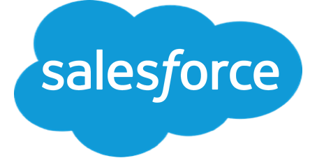

**Figure 5: Salesforce Framework**

The Salesforce Framework Builder gives developers easy-to-use tools to modify characteristics the data, as well as specify the scope of applications or the layout of data on a page. The developers can also define workflows based on user interaction with data, or create reports on the data. The developers can use buttons or custom links to extend the default capabilities of their Force.com application. The developers can set up and modify tabs, which can be associated with a Force.com object, Visualforce page, s-control or any web page. The developers can give users access to tabs, and the user can customize the display of their set of tabs within an application.

**Reasons to Use:**

1. This framework is especially for force.com.

2. This framework has many components to use.

3. This framework can work with others framework.

4. This framework uses Model-View-Controller paradigm.

### 

### **2.2.2 Apex**



**Figure 6: Apex**

The Apex is a strongly typed, object-oriented programming language that allows developers to execute flow and transaction control statements on the Force.com platform server in conjunction with calls to the Force.com​ API. Using the syntax that looks like Java and acts like database stored procedures, Apex enables developers to add business logic to most system events, including button clicks, related record updates, and Visualforce pages. Apex code can be initiated by Web service requests and from triggers on objects.

**Reasons to Use:**

1. This language support for common Force.com platform

2. This language provides built-in support for unit test creation and execution

3. This language is automatically updated when Force.com platform is upgraded

### 

### 

### 

### 

### **2.2.3 SOQL**



**Figure 7: SOQL**

Dynamic SOQL refers to the creation of an SOQL string at runtime with Apex code. Dynamic SOQL enables the developers to create more flexible applications. For example, the developers can create a search based on input from an end user, or update records with different field names.

**Reasons to Use:**

1. This database is a Salesforce build-in.

2. This database could retrieve data from a single object or from multiple objects that are related to one another.

3. This database could count the number of records that meet specified criteria.

4. This database could sort results as part of the query.

5. This database could retrieve data from number, date, or checkbox fields.

## 

## 

## 

## **2.3 Development Tools Review**

### **2.3.1 Force.com**



**Figure 8: Force.com**

Force.com is a platform as a service (PaaS) product designed to simplify the development and deployment of cloud-based applications and websites. Developers can create apps and websites through the cloud IDE (Integrated Development Environment) and deploy them quickly to Force.com’s multi-tenant servers.

**Reasons to Use:**

1. This platform is especially for Salesforce.

2. This platform builds apps lightning fast with drag and drop tools.

3. This platform customizes data model with clicks.

4. This platform customizes UI with clicks or go further with HTML

# **CHAPTER THREE| Quality Standard**

## **3.1 ISO 29110 for Very Small Entity (VSE)**

ISO/IEC 29110-4-1:2011 applies to Very Small Entities (VSEs). A Very Small Entity (VSE) is defined as an enterprise, organization, department or project having up to 25 people. A set of standards and guides have been developed according to a set of VSEs' characteristics and needs. The guides are based on subsets of appropriate standards elements, referred to as VSE profiles. The purpose of a VSE profile is to define a subset of International Standards relevant to the VSE context.

### **3.1.1 Project Management Process**

The purpose of the Project Management process is to establish and carry out the tasks of the software implementation project in a systematic way, which allows compliance with the project’s objectives in terms of expected quality, time, and costs. Project Manager contains four main activities.

**Selected processes**

3.1.1.1 Project planning process

3.1.1.2 Project plan execution process

3.1.1.3 Project assessment and control process

3.1.1.4 Project closure process

### **3.1.2 Software Implementation Process**

The purpose of the Software Implementation process is to achieve the systematic performance of the analysis, design, construction, integration, and test activities for new or modified software products according to the specified requirements.

**Selected processes**

3.1.2.1 Software implementation initiation process

3.1.2.2 Software requirement analysis process.

3.1.2.3 Software architectural and detailed design process

3.1.2.4 Software construction process.

3.1.2.5 Software integration and test process.

3.1.2.6 Software delivery process.

# **CHAPTER FOUR | Project Plan**

## **4.1 Motivation**

The Foundation for Children concern about the losing of children information and difficult to update the data. As the volunteer, we expect that cloud technology can resolve these problems. Therefore, we interested to customize the “Child Cloud Management System.” Child Cloud Management System is the web-based application that keeps the information on the cloud system. It can help the users to access the children information easier, prevent the children information losing, to enhance the ability to manage the information such as update information and define the authorization of each user.

## **4.2 Aim and objectives**

### **4.2.1 Aim**

The purpose of improving the web application is to provide the users to manage children easier and decrease the hidden costs associated. It helps the users to:

1. Manage children information.
2. Send children information between orphanage.
3. secure children information from the unauthorized user.

### **4.2.2 Objectives**

The objective of improving the web application is to provide user to:

* The user can create child’s development information.
* The user can view child’s development information.
* The user can edit child’s development information.
* The user can delete child’s development information.
* The user can create child’s education information.
* The user can view child’s education information.
* The user can edit child’s education information.
* The user can delete child’s education information.
* The user can send child’s information between orphanage.

## 

## 

## **4.3 Deliverables and limits**

### **4.3.1 Deliverables**

#### **4.3.1.1 System Architecture**

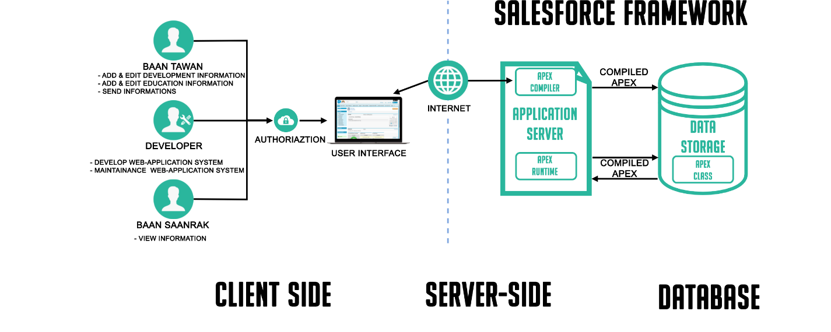

**Figure 9: Child Cloud Management System Architecture**

This system consists of three parts. The first one is a client-side part, the user login by using Salesforce system, recording children development, and education information. Each user has a different role to use this web application by limiting the authorization. Next, the server-side part communicates with web application and database. The web application will send a request to the platform application server, and the server will respond to the web application. Finally, the database, it for store the data that necessary in the system.

When a developer writes and saves Apex code to the platform, the platform application server first compiles the code into an abstract set of instructions that can be understood by the Apex runtime interpreter and then saves those instructions as metadata. When an end-user trigger the execution of Apex, perhaps by clicking a button or accessing a Visualforce page, the platform application server retrieves the compiled instructions from the metadata and sends them through the runtime interpreter before returning the result. The end-user observes no differences in execution time from standard platform requests.

### **4.3.2 Document**

- Proposal

- Project plan

- Quality plan

- Software requirement specification

- Software design document

- Testing plan

- Testing document

- DVD stores relate file, all document and poster files.

- Traceability record

- Software quality assurance document

- Project poster

### **4.3.3 Limits**

1. This web application allows only ten users.

2. This web application support only Thai and English(Thai mostly).

## 

## 

## **4.4 Software Process**

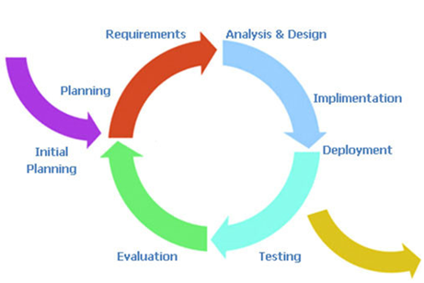

**Figure 10: Iterative process model**

Iterative Development is a cycling development from gathering the requirements until delivering functionality. This process will break down the process into phase then repeat. At each iterative mean new function will be added.

Therefore, The Child Cloud Management System using the iterative process because It is developing software feature to feature. It will release the complete parts to users for using then continue to implement other parts.

## 

## 

## 

## **4.5 Schedule & Milestones**

The schedule of the “Child Cloud Management System” is the timeline to guide the team developer for releasing the functionality on time.

**Process 1: Proposal**

**Process 2 (Progress I):**

**Feature #1: Child’s development information management**

**Description:** This feature provides the ability to manage and track child’s development.

**Process3 (Progress II):**

**Feature #2: Child's education information management.**

**Description:** This feature provides the ability to manage and track child’s education.

**Process4 (Final Progress):**

**Feature #3: Child’s information forwarding.**

**Description:** This feature provides user to forward child’s information between orphanage.

## **PROJECT MILESTONE**

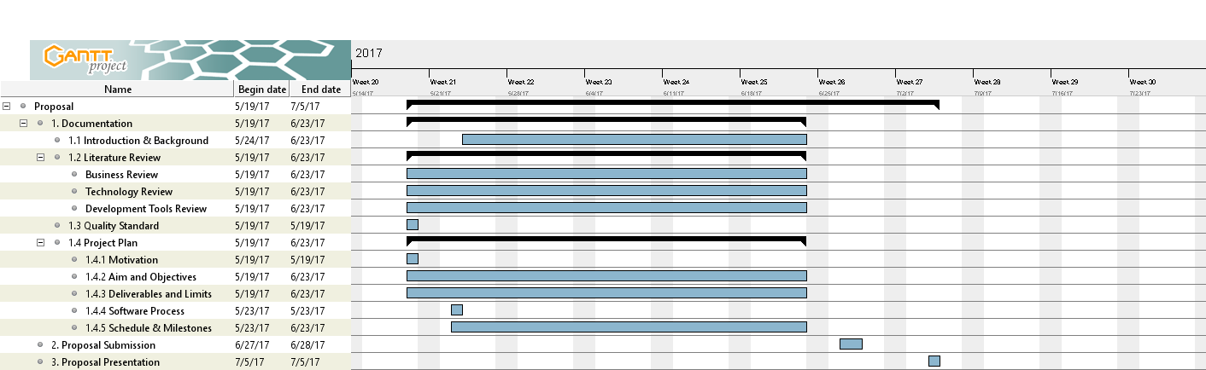

**Figure 11: Proposal milestone**

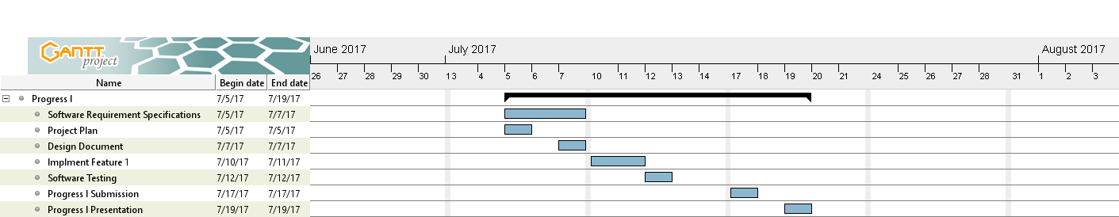

**Figure 12: Progress l Milestone**

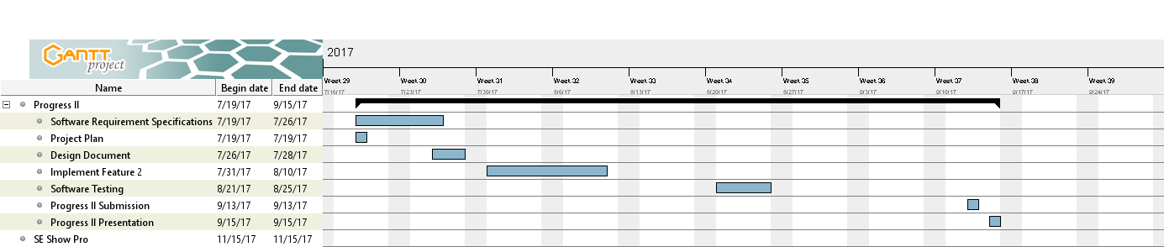

**Figure 13: Progress ll Milestone**

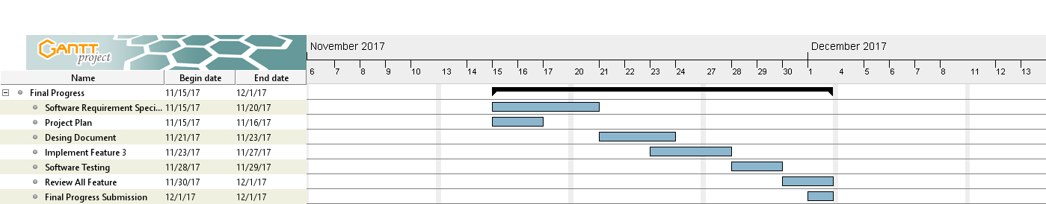

**Figure 14: Final Progress Milestone**

# **REFERENCES**

**[1] Baby Connect Accessed 25 May, 2017, from**

<https://www.baby-connect.com/>

**[2] Salesforce Framework Accessed 25 May, 2017, from**

<https://developer.salesforce.com/page/Application_Framework>

**[3] Apex Accessed 25 May, 2017, from**

<https://developer.salesforce.com/docs/atlas.en-us.apexcode.meta/apexcode/apex_intro_what_is_apex.htm>

**[4] SOQL Accessed 25 May, 2017, from**

<https://developer.salesforce.com/docs/atlas.en-us.apexcode.meta/apexcode/apex_dynamic_soql.htm>

**[5] Force.com Accessed 25 May, 2017, from**

<http://searchsalesforce.techtarget.com/definition/Forcecom>

**[6] ISO 29110 for Very Small Entity (VSE) Accessed 25 May, 2017, from**

<https://www.iso.org/standard/51154.html>