**ABSTRACT**

Nowadays, The document management in Thailand is difficult, Because most of the company are still use the papers document it makes them hard to organize. And information losing while they collect or sending the document to other corporate.

Foundation for children are use the papers document to handle the children information. And The amount of information of each child in the foundation has a lot. Therefore, the documents that are used for each child so much as it is. Such as Children's Family Information, Health before FCC Information, Health after FFC Information, Doctor Visit Record Information, Children Growth Information, Medical Management Information, Etc.

The cloud system management will be used to handle the document information of Foundation for children that help the foundation to collect the information of children on cloud storage and also easy to update the information or to send the information to another foundation.

**CHAPTER ONE| Introduction & Background**

Nowadays, The Orphan problem can occur in different ways such as parent are abandoned, Unwanted pregnancies, Children with Disabilities, Families are too poor for care the children, etc. Foundation for children (FFC) is an organization that cares about orphans. The organization has to verify child information before adopting the child. For example, Before organization adopts a child from a parent are not ready to take care. The organization has to verify the truth that parents are not ready to take care before they adopt the child. FFC consists of 3 section including an orphanage, nursery, and primary school. Problems of FFC are about to send data among all of 3 sections, it hard to keep paper document safe, and when a document from some sections were updated, then it will be effect to document in another section. For example, if the document from orphanage has been updated, it is hard to change document information in nursery and primary school.

Corporate Social Responsibility (CSR) is business practice to benefit society. A Social Responsibility business has various tactics to give away a portion of company’s proceeds to charity. There are four broad categories of social responsibility that the companies are practicing including Environmental efforts, Philanthropy, Ethical labor practices, and Volunteering. With the collaboration of CAMT and CRM Cloud. They decide to develop a system called Child Cloud Management System (CCMS). CCMS has been developing and applied to FFC for two years. The first and second-year development consists of the orphan profile, report form, orphan’s family information, Parenting history, healthy information before adoption, healthy information after adoption, law information, extra information, patronizing information. This is the third year of development. The development process will including We implement the Children's Health in an orphanage. Children's development for preschool age children and Children’s education for school age children.

This is the reason for customizing the Child Cloud Management System to Foundation for Children by using Salesforce. This web-based application is helping the users easy to access the children information. It prevents the children information losing and to enhance the management of children information.

**CHAPTER TWO| Literature Review**

**2.1 Business Review**

**2.1.1 Foundation for Children Workflow**

The workflow of the foundation of children is the informer report to the foundation that they found the children that be within the scope of orphan and give some basic information, Then the foundation analysis information of children that match with the conditions of foundation or not, if the children match the condition the foundation will notify appointment to child-parent. Child-parent must decide to send their child to foundation or not. If child-parent decide to send their child to the foundation, After that, the foundation will input the information of child into the document and send the children to “Baan Tantawan” for taking care of children.

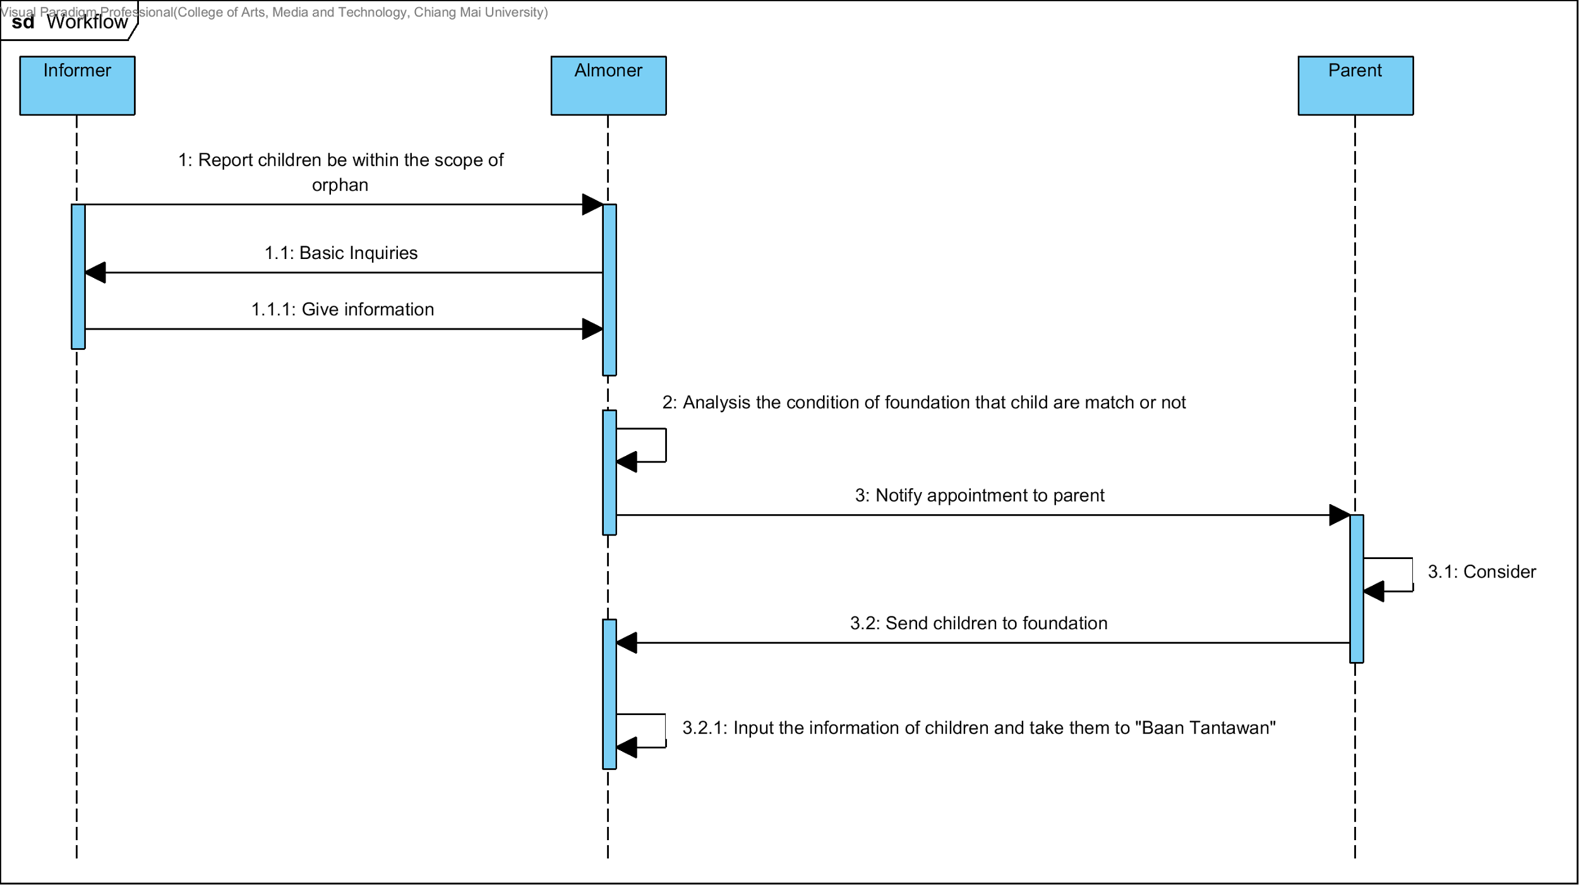

**Figure 1: The Sequence Diagram of Foundation for Children Workflow**

### **2.1.2 Web-Based Information System**

Web-Based Information System is the web application that senior student created for help to manage the information of Foundation of Children in the part of Inform Information, Children Information, Children's Family Information, Visited Home Information, Health before FCC Information, Health after FFC Information, Doctor Visit Record Information, Children Growth Information, Medical Management Information, Legal Information, Special Record Information, Child Sponsorship Information, Reason for Leaving Information

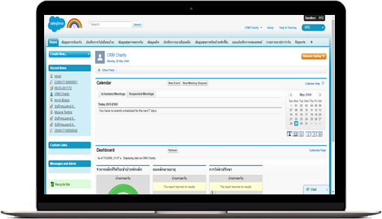

**Figure 2: The User interface of “Web-Based Information System.”**

**Pros**

1. The application provides user for recording child information.

2. The application provides user for updating child information.

3. The application stored on a cloud platform.

**Cons**

1. This web application allows only ten users.

**2.1.3 Baby Connect**

Baby Connect is the most comprehensive baby tracking application on the AppStore. It has graphical reports and trending charts, weekly averages, medicine, vaccine and growth tracking, timers, notifications, emails, .csv export, an easy to use interface, unlimited data, and it is the only application that allows you to exchange information in real time with your spouse, babysitter, nanny or daycare.

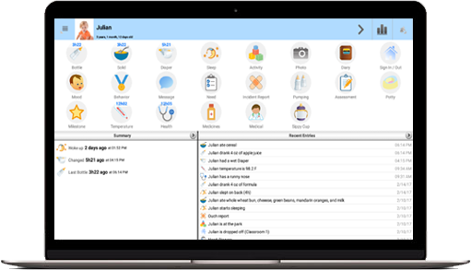

**Figure 3: the User interface of “Baby Connect.”**

**Pros**

1. The application provides a simple user interface.

2. The application provides record child information.

3. The application has been designed for maximum security. Everything is password protected.

**Cons**

1. This application has to pay before use.

**2.2 Technology Review**

**2.1.1 Salesforce Framework**

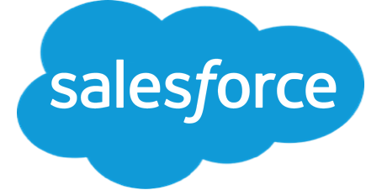

**Figure 4: Salesforce Framework logo**

Salesforce Framework Builder gives you easy-to-use tools to modify characteristics of your data, as well as specify the scope of applications or the layout of data on a page. You can also define workflows based on user interaction with data, or create reports on the data. You can use buttons or custom links to extend the default capabilities of your Force.com application. You can set up and modify tabs, which can be associated with a Force.com object, Visualforce page, s-control or any web page. You can give users access to tabs, and the user can customize the display of their own set of tabs within an application.

**Reasons to Use :**

1. This framework is especially for force.com.

2. This framework has many components to use.

3. This framework can work with others framework.

4. This framework uses Model-View-Controller paradigm.

### 

### **2.2.2 Apex**



**Figure 5: Apex logo**

Apex is a strongly typed, object-oriented programming language that allows developers to execute flow and transaction control statements on the Force.com platform server in conjunction with calls to the Force.com​ API.

**Reasons to Use :**

1. This language is especially for force.com.

2. This language provides built-in support for common Force.com platform

3. This language provides built-in support for unit test creation and execution

4. This language is automatically updated when Force.com platform are upgraded

### 

### 

### 

### 

### **2.2.3 SOQL**



**Figure 6: SOQL logo**

Dynamic SOQL refers to the creation of an SOQL string at runtime with Apex code. Dynamic SOQL enables you to create more flexible applications. For example, you can create a search based on input from an end user, or update records with different field names.

**Reasons to Use :**

1. This database is a Salesforce build-in.

2. This database could retrieve data from a single object or from multiple objects that are related to one another.

3. This database could count the number of records that meet specified criteria.

4. This database could sort results as part of the query.

5. This database could retrieve data from number, date, or checkbox fields.

## 

## 

## 

## **2.3 Development Tools Review**

### **2.3.1 Force.com**



**Figure 7: Force.com logo**

Force.com is a Platform as a Service (PaaS) product designed to simplify the development and deployment of cloud-based applications and websites. Developers can create apps and websites through the cloud IDE (Integrated Development Environment) and deploy them quickly to Force.com’s multi-tenant servers.

**Reasons to Use :**

1. This platform is especially for Salesforce.

2. This platform builds apps lightning fast with drag and drop tools.

3. This platform customizes your data model with clicks.

4. This platform customize your UI with clicks or go further with HTML

**CHAPTER THREE| Quality Standard**

**3.1 ISO 29110 for Very Small Entity (VSE)**

ISO/IEC 29110-4-1:2011 is applicable to Very Small Entities (VSEs). A Very Small Entity (VSE) is defined as an enterprise, organization, department or project having up to 25 people. A set of standards and guides have been developed according to a set of VSEs' characteristics and needs. The guides are based on subsets of appropriate standards elements, referred to as VSE profiles. The purpose of a VSE profile is to define a subset of International Standards relevant to the VSE context.

**3.1.1 Project Management Process**

The purpose of the Project Management process is to establish and carry out the tasks of the software implementation project in a systematic way, which allows compliance with the project’s objectives in terms of expected quality, time, and costs. Project Manager contains four main activities.

**Selected processes**

3.1.1.1 Project planning process

3.1.1.2 Project plan execution process

3.1.1.3 Project assessment and control process

3.1.1.4 Project closure process

**3.1.2 Software Implementation Process**

The purpose of the Software Implementation process is to achieve the systematic performance of the analysis, design, construction, integration, and test activities for new or modified software products according to the specified requirements.

**Selected processes**

3.1.2.1 Software implementation initiation process

3.1.2.2 Software requirement analysis process.

3.1.2.3 Software architectural and detailed design process

3.1.2.4 Software construction process.

3.1.2.5 Software integration and test process.

3.1.2.6 Software delivery process.

**CHAPTER FOUR | Project Plan**

**4.1 Motivation**

The Foundation for Children concern about the losing of children information and difficult to update the data. As the volunteer, we expect that cloud technology can resolve these problems. Therefore, we interested to customize the “Child Cloud Management System.” Child Cloud Management System is the web-based application that keeps the information on the cloud system. It can help the users to access the children information easier, prevent the children information losing, to enhance the ability to manage the information such as update information and define the authorization of each user.

**4.2 Aim and objectives**

**4.2.1 Aim**

1. Provide users to input the education information systematically.

2. Provide users to input the development information systematically.

3. Provide users to access the information from authorization.

**4.2.2 Objectives**

The purpose of the web application is to provide the users to manage children easier and decrease the hidden costs associated. It helps the users to:

- Easy to manage the children education information.

- Easy to view the children’s education information.

- Easy to assess children’s development.

- Easy to forward information.

## 

## 

## **4.3 Deliverables and limits**

### **4.3.1 Deliverables**

#### **4.3.1.1 System Architecture**

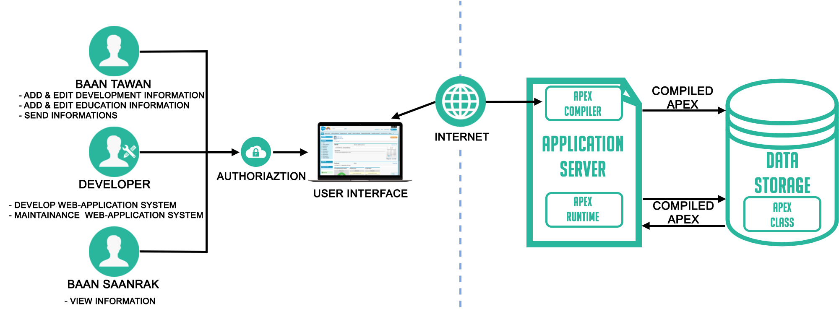

**Figure 8: Child Cloud Management System Architecture**

This system consists of three parts. The first part is client-side, the user login by using Salesforce system, record children development, and education information, Each user has a different role to use this web application by limit the authorization. The second part is Server-side is using to communicate with web application and database. The web application will send a request to the platform application server, and the server will respond to the web application. The last part is a database, it for store the data that necessary in the system.

When a developer writes and saves Apex code to the platform, the platform application server first compiles the code into an abstract set of instructions that can be understood by the Apex runtime interpreter and then saves those instructions as metadata.When an end-user trigger the execution of Apex, perhaps by clicking a button or accessing a Visualforce page, the platform application server retrieves the compiled instructions from the metadata and sends them through the runtime interpreter before returning the result. The end-user observes no differences in execution time from standard platform requests.

**4.3.2 Document**

- Proposal

- Project plan

- Software requirement specification

- Software design document

- Testing document

- Traceability record

- Software quality assurance document

**4.3.3 Limits**

1. This web application allows only ten users.

2. The ID of children may be weird because different user are input the ID differently and the ID can’t be editable.

## 

## 

**4.5 Software Process**

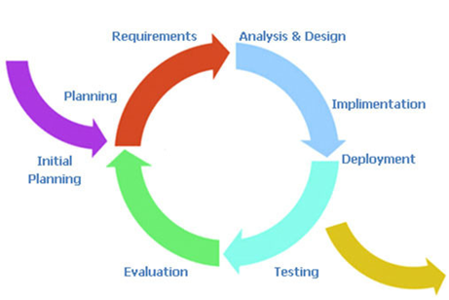

**Figure 9: Iterative process model**

Iterative Development is a cycling development from gathering the requirements until delivering functionality. This process will break down the process into phase then repeat. At each iterative mean new function will be added.

Therefore, The Child Cloud Management System using the iterative process because It is developing software feature to feature. It will release the complete parts to users for using then continue to implement other parts.

## 

## 

## 

**4.6 Schedule & Milestones**

The schedule of the “Child Cloud Management System” is the timeline to guide the team developer for releasing the functionality on time.

**Process 1: Proposal**

**Process 2 (Progress I):**

**Feature #1: Preschool child development data management for organization.**

**Description:** This feature provides the ability to manage and track child development for a preschool child for the organization.

**Details:**

- The User can create child’s development.

- The User can view child’s development skill.

- The User can edit child’s development skill.

**Process3 (Progress II):**

**Feature #2: School age child education data track for the organization.**

**Description:** This feature provide the ability to track child education for school age child for the organization.

**Details:**

- The User can view child’s education.

**Process4 (Final Progress):**

**Feature #3: School age child education data management for school.**

**Description:** This feature provide user to view development and manage education data.

**Details:**

- The User can view child’s development.

- The User can create child’s education.

- The User can view child’s education.

- The User can edit child’s education.

**PROJECT MILESTONE**

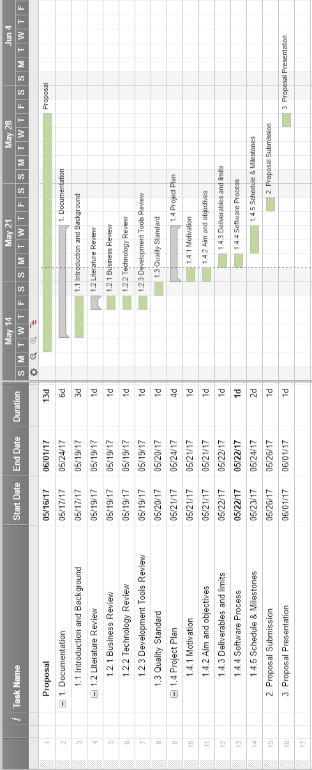

**Figure 10: Proposal milestone**

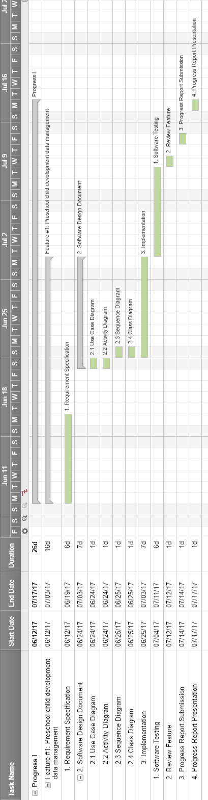

**Figure 11: Progress l Milestone**

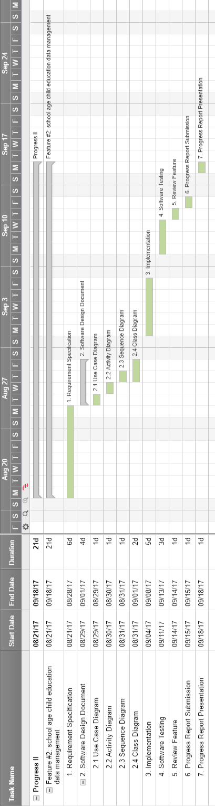

**Figure 12: Progress ll Milestone**

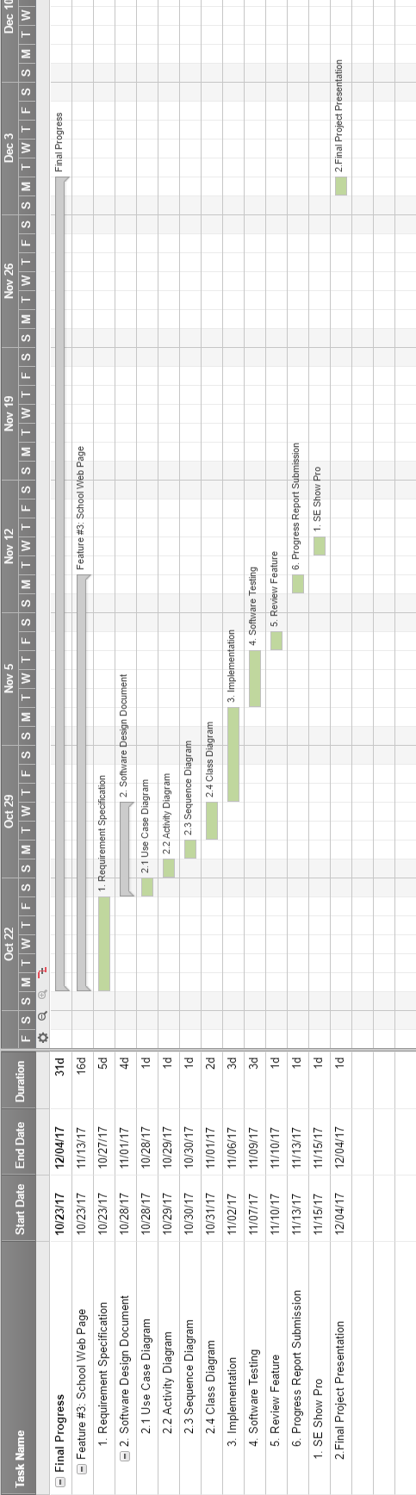

**Figure 13: Final Progress Milestone**

**REFERENCES**

**[1] Baby Connect**

- <https://www.baby-connect.com/>

**[2] Salesforce Framework**

- <https://developer.salesforce.com/page/Application_Framework>

**[3] Apex**

- <https://developer.salesforce.com/docs/atlas.en-us.apexcode.meta/apexcode/apex_intro_what_is_apex.htm>

**[4] SOQL**

- <https://developer.salesforce.com/docs/atlas.en-us.apexcode.meta/apexcode/apex_dynamic_soql.htm>

**[5] Force.com**

- <http://searchsalesforce.techtarget.com/definition/Forcecom>

**[6] ISO 29110 for Very Small Entity (VSE)**

- <https://www.iso.org/standard/51154.html>