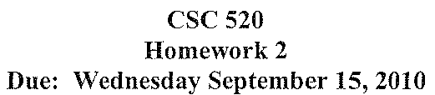
merge(a,b) //where a & b are sorted linked lists
c=nil
while(a.link != nil && b.link != nil)
if(a.data <= b.data)
//where insert() takes the second parameter, inserts it into the linked list specified in the first parameter, and returns a linked list
c=insert(c,a.data)
a=a.link
else
c=insert(c,b.data)
b=b.link
if(a==nil)
while(b!=nil)
c=insert(c,b.data)
b=b.link
else
while(a!=nil)
c=insert(c,a.data)
a=a.link
return a
This algorithm runs in O(N) time where N is the number of elements in the largest list.

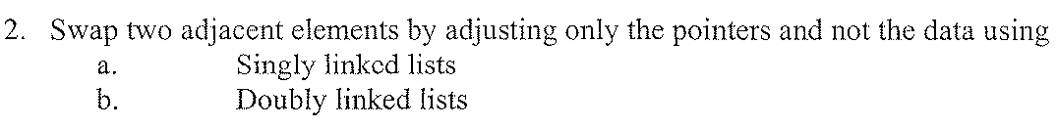

//a – linked list, b – element number to swap
swapSingle(a)
a = a.head
for(int i=0;i<b;i++)
a = a.link
temp = a.link
a.link = a.link.link.link
a = a.link.link
a.link.link = temp

//a is the list, b is the element to swap
swapDouble(a,b)
a = a.head
for(int i=0;i<=b;i++)
a = a.link
temp = a
a = a.link.link
a.prevLink=a.link
a.link = temp

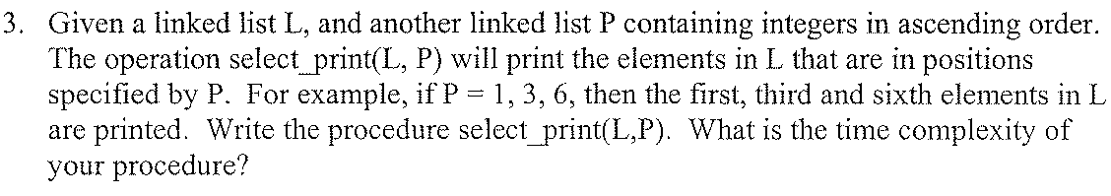
select_print(L,P)
i = 0
a = P
//get number of elements in P
while(a != nil)
i++
a = a.link
for(j=0;j<i;j++)
if(P.data == j)
print(L.data)
P = P.link
L = L.link
The time complexity of this program is O(N) where N = the amount of elements in list P.

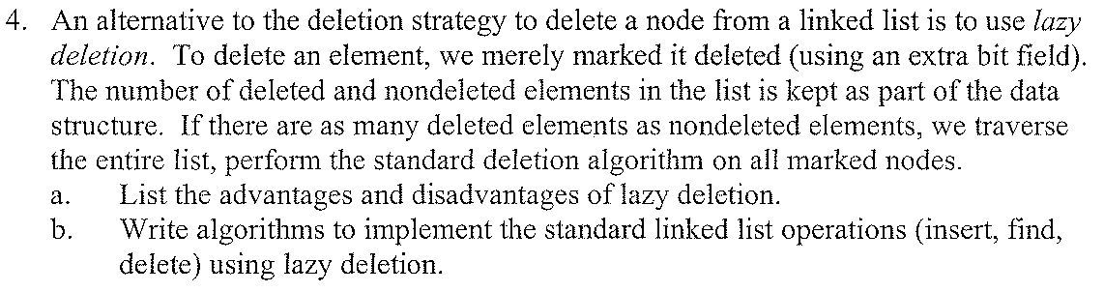
a.)
Advantages:
- Much quicker to mark a node deleted than rearrange pointer values.
- Quicker to insert data into a location if there are no pointer values to change
Disadvantages:
- If not properly handled items could be deleted and those holes never filled in which would make the list larger than necessary
- Slows down insert since you have to loop through whole list
//a – list, x – element to insert
//assumes .deleted is set to 1 to indicated deleted node
insert(a,x)
a=a.head
while(a.deleted != 1 || a.link != nil)
a = a.link
if(a.link == nil)
a.link = x
a.link.link = nil
else
a.data = x
a.deleted = 0

//a – list, x – element to find
find(a,x)
a = a.head
while(a.link != nil)
if(a.data == x && a.deleted == 0)
return 1
a = a.link
return -1

//a – list, x – element number to delete
lazyDelete(a,x)
a = a.head()
for(int i=0;i<x;i++)
a = a.link
a.deleted = 1
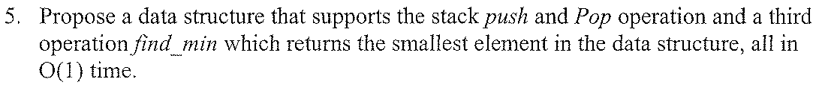

My ADT would simply be what I’ll call a stack with minumum value tracking. The first value on the stack is set to the lowest and every value pushed is checked against that. If that value is less than the current lowest value it is stored as the lowest value. To find the lowest value a query is made to the variable storing the current lowest.

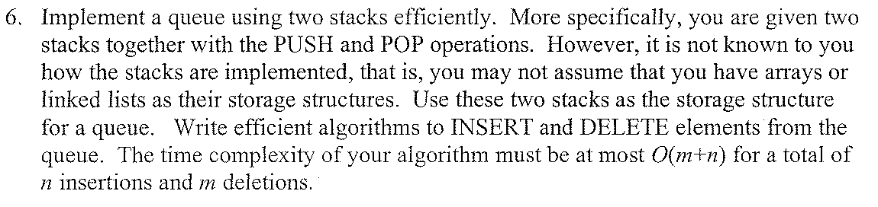

//push1 – push an element onto the first stack
//push2 – push an element onto the second stack
//pop1 – pop an element from the first stack
//pop2 – pop an element from the second stack

//elements are assumed to initially be pushed on to
//the first stack
//a – element to insert, x – location of insertion
insert(a,x)
for(int i=0;i<x;i++)
b=pop1()
push2(b)
push1(a)
for(int i=0;i<x;i++)
b=pop2()
push1(b)

//x - location of element to delete
delete(x)
for(int i=0;i<x;i++)
b=pop1()
push2(b)
pop1()
for(int i=0;i<x;i++)
b=pop2()
push1(b)

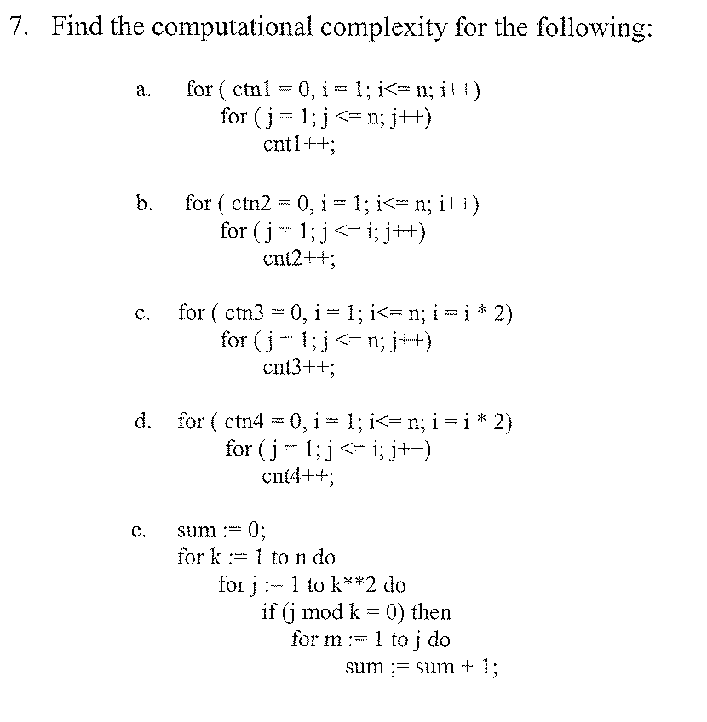
- O(N²)
- O(N²)
- O(NLog(N))
- O(NLog(N))
- O(N³ * (how ever many times j mod k)N²)

