8
The Ubuntu Community
Community is a word often used in discussions of Ubuntu. Early articles about Ubuntu bore subtitles asking, “Would you like some community with that?” The earliest press releases and communiqués from the project emphasized a “community driven approach” to operating system development and distribution. Additionally, the highest level governance board in Ubuntu is called the Community Council. In the book you are reading, the authors made a very conscious decision to dedicate an entire chapter to describing the Ubuntu community. In fact, the book itself is dedicated to the Ubuntu community!
Still, while the Ubuntu community is important, it is not always easy to succinctly describe it. Ubuntu is, in large part, developed and funded by Canonical Ltd.. The community, almost by definition, extends far beyond Canonical Ltd.. The Ubuntu project has members and self-declared activists (Ubunteros, formerly Ubuntites) but the Ubuntu community is more than even those with such explicitly declared relationships. The project contains a wide variety of different venues for participation. But while the community is active in each of these areas, its scope is even wider.
The Ubuntu community is the collection of individuals who build, promote, distribute, support, document, translate, and advocate Ubuntu—in myriad ways and in myriads venues. Most people in the Ubuntu community have never met, talked with, or heard of each other. Members of the community are linked together by their contributions, both technical and nontechnical, and by Ubuntu itself. These contributions have built Ubuntu as a distribution, as a social movement, as a set of support infrastructures, and as a project. In short, they have built Ubuntu as a community. However, while any active software development project has a number of people making contributions, not every project has a community.
Community is also a term that represents a promise by the Ubuntu project to remain inclusive. Community means that volunteers are not only welcome, but essential. It means that Ubuntu is a “place” where individuals can come together to create something that is greater than the sum of its parts. The word community gives a nod to the fact that while much development work is paid for by Canonical Ltd., and while some people contribute more hours, more effort, more code, more translations, more documentation, or more advocacy work to Ubuntu than others, no individual or subgroup can take credit for everything that Ubuntu has become. In Ubuntu, no contribution is expendable. Community also reflects Ubuntu’s goal to provide a low barrier for entry for these contributions. Anyone who cares about Ubuntu can contribute to the project and can, in whatever ways are most appropriate, become a participant in the Ubuntu community.
This chapter will provide a bird’s-eye view of the venues and processes in which the Ubuntu community is active. First, it takes a tour through the venues through which the Ubuntu community communicates. It continues by looking at the way that the community is organized and the processes by which that organization works. Finally it walks readers through the ways that they can participate in the Ubuntu community and contribute to its success.
Venues
As was described in the introduction, transparent and public communication was an early goal of the Ubuntu project. Technical and community decisions are made publicly and are accessible to all interested parties. When this is impossible (e.g., when there is a face-to-face meeting and it’s simply not possible for everyone interested to attend), the community attempts to publish summaries and minutes and to provide avenues for feedback. Ubuntu contains no “member only,” “developer only,” or “decision-maker only” back channels except to preserve individual privacy or security—and the Ubuntu community refuses to create them. All work in Ubuntu occurs in places where everyone can view the work and anyone who agrees to engage constructively and respectfully can participate.
Of course, this activity is only public to those who know where to find it. This section tries to document the venues for communication in Ubuntu as completely as possible. It describes the places where discussions of development, support, and advocacy take place. While nobody can engage in communication in all of the venues described, knowledge of what exists allows participants to be more informed when they need to choose the right place to ask a question or to make a suggestion.
Mailing Lists
The single most important venue for communication in Ubuntu is the Ubuntu mailing lists. These lists provide the space where all important announcements are made and where more development discussions take place. There are, at the time of this writing, 75 public e-mail lists, although this number is constantly growing. A full list of mailing lists (excluding Local Community teams) is included below.
Ubuntu Mailing Lists
An up-to-date, full page of mailing lists for Ubuntu can be found at http://lists.ubuntu.com/ where users can see a list of available lists, view archived discussions, and can subscribe to lists through a Web interface. Tables 8-1 through 8-5 present the mailing lists organized by topic areas.
Table 8-1
General Ubuntu lists
List Name | Description
ubuntu-accessibility | Ubuntu Accessibility Team
ubuntu-announce | Ubuntu Announcements
ubuntu-art | Discussion on Ubuntu artwork
ubuntu-backports | Backports discussions
ubuntu-desktop | Desktop Team co-ordination and discussion
ubuntu-devel | Ubuntu Developer Discussion
ubuntu-devel-announce | Developer-related announcements and information
ubuntu-doc | Documentation team coordination and discussion
ubuntu-doc-commits | Ubuntu documentation team commits
ubuntu-hardened | Ubuntu Linux Proactive Security deployment and development
kernel-bugs | Kernel Bugs tracking
kernel-team | Kernel team discussions
laptop-devel | laptop-specific development
laptop-testing-team | Ubuntu laptop testing
loco-contacts | Ubuntu local community team (LoCo) contacts
ubuntu-marketing | Discussion on community-based marketing of Ubuntu
ubuntu-marketing | Announcements, feedback and discussion for Ubuntu mirror maintainers
ubuntu-mirrors | List for those mirroring Ubuntu FTP archives
ubuntu-mono | Packaging Mono for Ubuntu
ubuntu-motu | mailing list of the Masters Of The Universe
ubuntu-news | interesting news about Ubuntu for users and developers
ubuntu-security-announce | Ubuntu Security Announcements
sounder | Ubuntu community random chit-chat list
technical-board | Technical Board members list
ubuntu-translators | Discussion about translating Ubuntu
ubuntu-users | Ubuntu Help and User Discussions
ubuntu-women | Ubuntu-Women
Table 8-2
Ubuntu bugs and notification lists (not discussion lists)
List Name | Description
ubuntu-changes-auto | Archive upload notification list, for automated uploads to all Ubuntu releases
ubuntu-bugs | Ubuntu bug tracker changes - HIGH VOLUME
desktop-bugs | Desktop bug tracker changes - HIGH VOLUME
kubuntu-bugs | Kubuntu bug tracker changes
universe-bugs | Universe bug tracker changes - HIGH VOLUME
warty-changes | Warty Warthog archive upload notification list
hoary-changes | Hoary Hedgehog archive upload notification list
breezy-changes | Breezy Badger archive upload notification list
dapper-changes | Dapper Drake archive upload notification list
Table 8-3
Subproject lists
List Name | Description
edubuntu-devel | Edubuntu developer discussion
kubuntu-devel | Kubuntu Developer Discussion
kubuntu-users | Kubuntu Help and User Discussions
xubuntu-devel | Xubuntu Development Discussion
Table 8-4
Infrastructure development and support lists
List Name | Description
bazaar | User and development discussion about the bazaar distributed revision control system
bazaar-announce | Announcements for the Bazaar project
bazaar-commits | Bazaar repository commit notification
bazaar-ng | bazaar-ng discussion
hct | Discussion about the Hypothetical Changeset Tool
launchpad-users | Discussion for Launchpad users
rosetta-users | Rosetta user discussion
Table 8-5
Other lists
List Name | Description
security-review | Discussion about resolving security vulnerabilities

Lists are one of the oldest forms of communication by e-mail. A mailing list provides a single e-mail address that, when mailed to, will then relay the received message to a large number of people. In Ubuntu, lists are topical, and individuals can subscribe to a mailing list if they want to receive information on the list’s topic. All mailing lists at Ubuntu are hosted at lists.ubuntu.com. If you would like to send a message to a list, simply e-mail <mailing list name>@lists.ubuntu.com while replacing <mailing list name> with the name of the list you are trying to mail.
With a few exceptions (e.g., the technical-board e-mail list), anybody can subscribe to any Ubuntu list. In most cases, the capability to send e-mail to lists is restricted to list members (membership in lists is, of course, open to anyone). This means that all e-mail sent to a list from someone who is not a member of that list is put into a queue to be reviewed by a human “moderator” before it is broadcast to list members. This is done as an anti-spam measure. Users can subscribe to lists and then configure the system to never send e-mail. For several e-mail lists, all messages are moderated. This is largely to ensure that lists remain “low volume” or “announcement only.”
Ubuntu’s mailing lists are run by the popular Mailman software, which may be familiar to some users. Mailman makes it simple to subscribe to lists, to unsubscribe, and to configure any number of options about mail delivery. One popular option is to receive a daily “digest” of messages rather than a separate e-mail each time a new message is sent. This is all available through a Web interface at http://lists.ubuntu.com. Users can also subscribe to lists by sending an e-mail with “subscribe” in the subject to <mailing list name>-REQUEST@lists.ubuntu.com.
While each list plays an important role in the Ubuntu community, a few central lists warrant a little more detail and may be a good idea for users to consider subscribing to. These are detailed below.
ubuntu-announce
This fully moderated list relays all important announcements for the Ubuntu project and usually contains less than one e-mail per week. It is the first place where new releases are announced and where other important information can be found first. If you use Ubuntu, you may want to consider subscribing to this list. If you only subscribe to one list, this should be it.
ubuntu-devel-announce
This fully moderated list contains announcements related to the development of Ubuntu. It is low volume and contains one to three e-mails per week. If you work with code in Ubuntu, use a development release, or contribute on any technical level, you should be on this list. If you are at all involved in development for Ubuntu, this (in addition to ubuntu-announce) is the list you must subscribe to.
ubuntu-users
This is a primarily support-oriented list for questions and answers that Ubuntu users have. It is a very high-volume list, but it is an excellent place to ask questions and have them answered. It is a useful general purpose list for discussion of any issue that pertains primarily to using Ubuntu.
ubuntu-devel
This list is the primary site for general purpose discussion of Ubuntu development. If you are looking to contribute to Ubuntu in any technical way, you should subscribe to this list and begin to follow the discussion. The list is relatively high volume.
sounder
Sounder is the unmoderated community “chit chat” list. Sounder is the collective noun to describe a group of “Warthogs” and was initially the e-mail list that supported the small, invite-only group of users who tested the Ubuntu 4.10 “Warty Warthog” release before it was announced to the world. The list has been kept for historical reasons under the old name but now provides a venue for the discussion of anything that is “off topic” in the other venues. It frequently hosts discussion of Ubuntu news, events, advocacy, and activism and is an important list for any community member who is participating and contributing to Ubuntu in less technical ways.
Internet Relay Chat (IRC)
While mailing lists provide the primary venue for asynchronous communication (i.e., not at the same time), there is still an important need for synchronous or “real-time” collaboration. Internet relay chat (IRC) fills this niche. While it was designed primarily for group (i.e., many-to-many) communication in “channels,” it is also equipped with private messaging capabilities that facilitate one-to-one communication—all instantaneously. It is very similar to instant messaging or “chat room” style communication. While time zones and a round globe make it difficult for the global Ubuntu community to meet at the same time, many users and developers take advantage of IRC’s capability to let anyone chat about an issue in real time or to ask a question and have it answered immediately.
Like mailing lists, IRC channels provide a venue for a variety of different types of communication in a variety of different subcommunities in Ubuntu. There are many different channels, including channels in a variety of languages. A complete list as of the time of this writing is included below.
IRC Channel List
Table 8-6 presents a list of IRC channels. A complete and up-to-date list can be found at http://wiki.ubuntu.com/InternetRelayChat.
Table 8-6
Ubuntu IRC channels on Freenode
Support and talk channels
#ubuntu | Ubuntu help channel
#ubuntu+1 | Help channel for development versions
#kubuntu | Kubuntu help channel
#edubuntu | Edubuntu channel
#xubuntu | Xubuntu channel
#ubuntu-offtopic | The off-topic channel where everything is on-topic
#kubuntu-offtopic | The off-topic channel where everything is on-topic
Team channels
#kubuntu-devel | Kubuntu development coordination
#ubuntu-accessibility | The Accessibility Team channel
#ubuntu-boot | Boot/Init team
#ubuntu-bugs | Channel for Bugdays
#ubuntu-desktop | The Ubuntu desktop team
#ubuntu-devel | Ubuntu development coordination
#ubuntu-doc | Ubuntu documentation team coordination
#ubuntu-hardened | Discussions on the Ubuntu hardened project
#ubuntu-java | Ubuntu java development coordination
#ubuntu-kernel | Ubuntu kernel team coordination
#ubuntu-laptop | Ubuntu laptop development
#ubuntu-locoteams | Coordination of all local coordination teams
#ubuntu-love | About getting involved with Ubuntu
#ubuntu-meeting | All meetings are held here
#ubuntu-motu | Coordination of the Ubuntu MOTU team
#ubuntu-motu-school | Ubuntu MOTU team schooling channel
#ubuntu-server | Ubuntu server help and discussions
#ubuntu-toolchain | Coordination of the Ubuntu toolchain team
#ubuntu-translators | Coordination and discussions about Ubuntu translations
#ubuntu-women | For Ubuntu women
#ubuntu-xgl | Yes, we all love gooey guis!
Localized channels
#ubuntu-au | Australia
#ubuntu-br | Brazil
#ubuntu-ca  #ubuntu-qc | Canada
#ubuntu-co | Colombia
#ubuntu-cz | Czech
#ubuntu-de  #ubuntu-de-treffpunkt  #kubuntu-de  #edubuntu-de | Germany
#ubuntu-es  #kubuntu-es  #edubuntu-es | Spanish speakers - Latin America
#ubuntu-fi | Finland
#ubuntu-fr  #kubuntu-fr  #ubuntu-fr-meeting | France
#ubuntu-gr | Greece
#ubuntu-hr | Croatia
#ubuntu.hu | Hungary
#ubuntu-il | Israel
#ubuntu-it | Italy
#ubuntu-ko | Korea
#ubuntumexico | Mexico
#ubuntu-nl | The Netherlands
#ubuntu-no | Norway
#ubuntu.pl | Poland
#ubuntu-ph | Philippines
#ubuntu-pt | Portugal
#ubuntu-ru | Russia
#ubuntu.se | Sweden
#ubuntu.tr | Turkey
#ubuntu-tw | Taiwan
#ubuntu-uk | United Kingdom
#ubuntu-zh | Chinese
Unofficial channels
#ubuntuforums | The Ubuntu forums team

All official Ubuntu IRC channels are located on the Freenode IRC network which also hosts a range of other free and open source software projects. Users can connect to IRC using XChat (See Figure 8-1), which is included in the default Ubuntu installation and is included on the Ubuntu Live CD. Upon launching XChat in the default configuration, users are connected to #ubuntu. Like the ubuntu-users e-mail list, #ubuntu is designed for help and support. When joining any channel, users should carefully read the topic as many frequently asked questions are answered in this topic and moderators of the channel can be annoyed by users who ask questions which they have already taken the time to answer in the channels topic.

Insert figure 8-1 08fig01.png
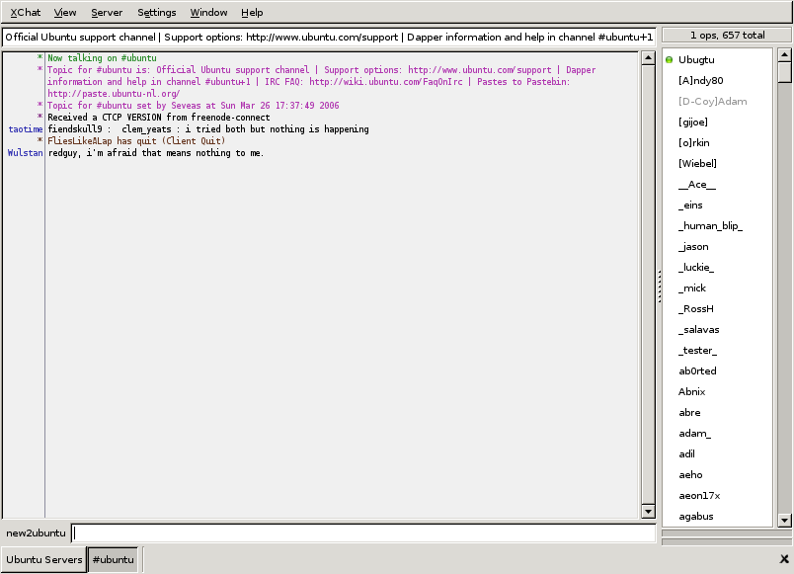
Figure 8-1
Xchat is an IRC client included in Ubuntu that allows Ubuntu users to connect to the Ubuntu IRC channels.
Currently the #ubuntu channel is the third biggest channel on the Freenode network and is growing quickly. In the nine months preceding this writing, the “population” of the channel has almost doubled. Another important channel is #ubuntu-devel which is reserved for discussion of Ubuntu development. Similarly, Kubuntu developers hang out in #kubuntu. To keep #ubuntu focused on support all general chatter has been moved to #ubuntu-offtopic. Similarly, support for development releases has moved to #ubuntu+1. Maintaining channels with specific foci has allowed the support community to stay focused and help as many people as possible.
Web Forums
The official Ubuntu Forums are other frequently used venues for communication in Ubuntu. For a number of reasons, many users prefer to communicate through a Web-based forum or bulletin board. The Ubuntu forums were created to satisfy this group and have done so with amazing success. Figure 8-2 shows an example of forum use.
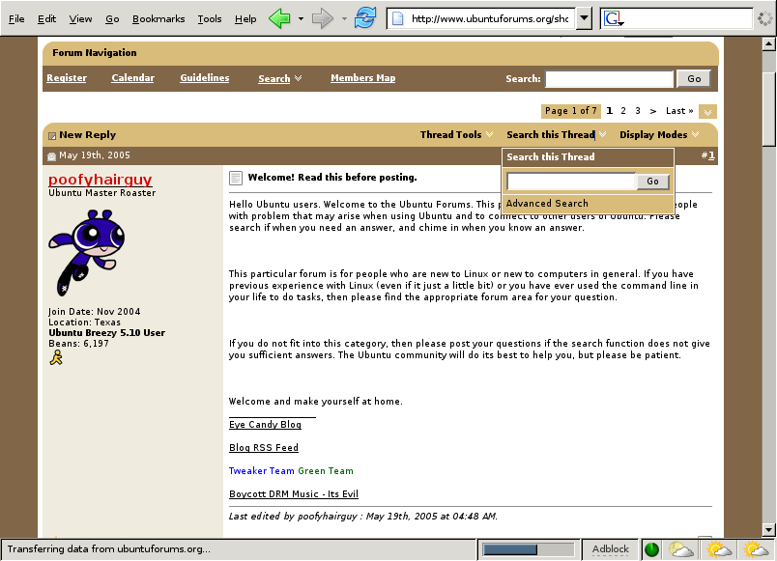
Insert figure 8-2 08fig02.png
Figure 8-2
Example of an open “thread” in the Ubuntu Forums
The forums are accessible online at www.ubuntuforums.org/ and have shown an impressive amount of utilization. Statistics as of the time of writing show activity of more than 860,000 messages on more than 150,000 topics. The forums also boast more than 80,000 users with more than 1,000 active at a given point. The topics that these groups cover run the gamut. These are roughly broken down into the following categories:
Support forums for the latest release of Ubuntu that includes:
User support for Ubuntu
User support for Kubuntu
Help with hardware support for Ubuntu
Installation and upgrade help
A collections of how-to articles, tips, and tricks
Information for people attempting to run the latest games on Ubuntu
A wide variety of other discussion areas provide resources including:
Discussion areas outside of the normal support areas (e.g., artwork, server support)
Support for 3rd Party Ubuntu projects and products
Support for previous releases of Ubuntu
Support venues for developers and programmers
Several other resources that include:
A community chat area for general discussion
Web-based version of all official announcements that go out on the ubuntu-announce and ubuntu-devel-announce mailing lists.
Each of the areas mentioned above include between one and nine different subforums, each of these containing many threads. By covering such ground, the Ubuntu forums provide an impressive support resource. They provide both an excellent venue for asking questions and receiving support as well as for answering questions and making important contributions to the health of the Ubuntu community. If you are interested in either, or both, the forums are a good place to begin.
The only caveat regarding the forums worth mentioning is that they are not frequently used by those developing Ubuntu—although there are exceptions to that rule. If users want to send messages directly to the Ubuntu developers, the forums may not provide the most effective tool. If users want to get involved in technical contributions to the project, they will, in all likelihood, have to augment their forums patronage with use of mailing lists. To help mediate this issue, the forums staff has created several forums that act as two-way gateways between the forums and the mailing list. The ubuntu-users mailing list is one such list. This means that users can read and participate in the ubuntu-users mailing list using the Web by simply participating in the associated Web forum—software makes sure that messages go between the two venues. Similarly, there are one-way forums for the ubuntu-announce and ubuntu-devel-announce mailing lists.
The Ubuntu Forums are representative of the Ubuntu community in another notable way: They were created, and for a long period were wholly funded, by the community itself. The forums founder, Ryan Troy, had no association with Canonical Ltd. when he created the forums. He did so without help or suggestion from Canonical Ltd. or others in the Ubuntu community. Canonical Ltd. and others in the Ubuntu project recognized the extremely valuable contribution that the forums were making and the important niche it was filling, so they invited the project to become an “official” part of the Ubuntu community. To this day, the forums are moderated and maintained entirely by volunteers and supported in large part through financial assistance outside of what is provided by Canonical Ltd..
Wikis
Since nearly day one, a large chunk of Ubuntu documentation and support has taken place in the official Ubuntu “wiki” (see Figure 8-3). For those who don’t already know, a wiki—pronounced “wik-ee”—is a Web site where any viewer can add, remove, or edit content. The first wiki was created by Ward Cunningham in 1995, and wikis have shown themselves to be an extremely effective tool for collaborative writing in recent years. The term is shortened from “wiki wiki”—Hawaiian for “quick.” Many wikis have been created. Most famous among these wikis in the online Encyclopedia “Wikipedia,” which now contains more than a million articles in the English version alone.
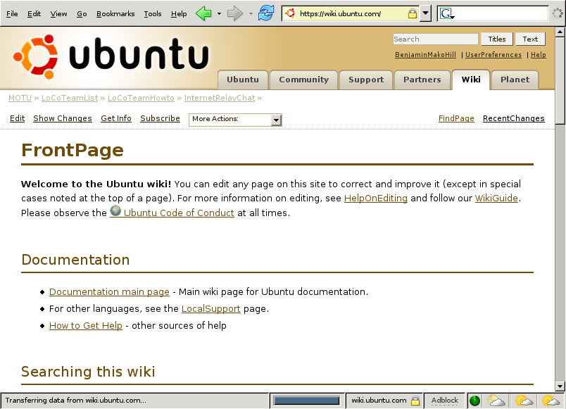
Insert figure 8-3 08fig03.png
Figure 8-3
Front page of the Ubuntu wiki
The primary Ubuntu wiki is at http://wiki.ubuntu.com. It can be edited, added to, or reorganized by anyone in the Ubuntu community. Edits are unrestricted. By requiring registration, each change can be traced to a particular user. The wiki has, over time, grown to include a variety of information useful in support, development, and documentation. Currently, the wiki contains more than 6,000 documents and pages.
Unlike other documentation that ships with Ubuntu, anyone can fix an error, inaccuracy, or out-of-date fact in the wiki. As a result, there is no good way to determine if information in the wiki is correct. It cannot be subjected to the same type of quality assurance workflow that a document such as this book might be. However, it is also much more likely to be up-to-date in the quickly changing world of Ubuntu development where there is a new release every six months. The wiki provides a venue for this level of up-to-date information with a low barrier to entry and, as a result, acts as an invaluable resource for the community.
To use the wiki, one can either search or browse it. Searching is the most commonly used way to get information from the wiki, and users can easily search either titles or the full-text of the wiki. To achieve the best results, it is usually best to search titles and then the text to ensure that you look for more relevant information first. For people who prefer to browse, the wiki is explicitly divided into a number of categories that include:
Documentation
Community
Events
Resources
Releases
Non-English Information
Policies
Most of these categories are relatively self-explanatory. The “policies” section consists primarily of largely technical information that, for the most part, describes the processes by which the Ubuntu archive is divided up. Also worth noting is the section that includes non-English information. While the front page of the Ubuntu wiki is in English, there are also many pages in other languages. The wiki page on language support (http://wiki.ubuntu.com/LocalSupport) provides both links to pages within the wiki that include documentation and information in languages other than English and links to more than a dozen other wikis that are in another language entirely. Users looking for wiki pages in a language other than English are advised to visit this page.
The Fridge
The Fridge (http://fridge.ubuntu.com/) is the young, quirky, community portal for Ubuntu. In many western cultures, refrigerators provide a central sort of “bulletin board” in a family’s home. Because refrigerators are magnetic, children and parents can use magnets to hang pieces of paper that they want to share with the community of people who come in contact with that fridge. For children, this often includes good grades, news reports, or other information that someone is proud or wants to share. The Fridge, bearing the tag line, “It’s fresh. It’s cool. Stick it on The Fridge!” tries to create such a shared resource within the Ubuntu community. The Fridge home page is shown in Figure 8-4.
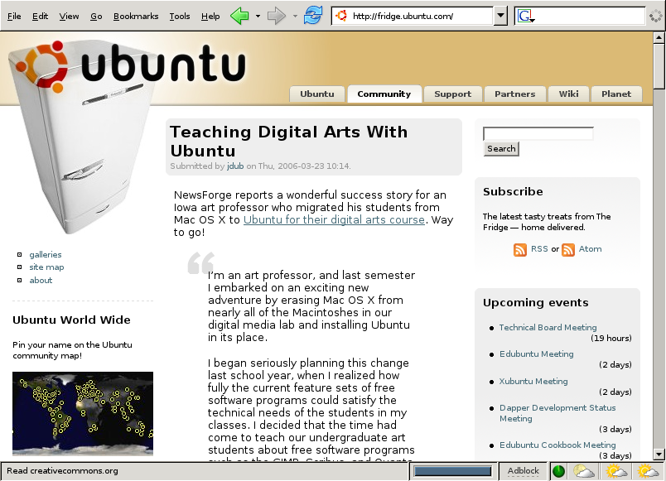
Insert figure 8-4 08fig04.png
Figure 8-4
Example of The Fridge home page
The Fridge is perhaps best described as the community portal for Ubuntu. It is part news site, part grassroots marketing and advocacy site. It hosts developer interviews, news, a picture gallery, a calendar with a list of upcoming events, polls, a list of Ubuntu-in-the-press citations, and much more. The core content on the site is arranged as a Web log. Users frequently set The Fridge as their homepage or subscribe to the site via its RSS feed. The Fridge is unique in the community in that it appeals to a wide variety of different Ubuntu participants—developers, advocates, translators, users—and provides a venue where each group can share information with others. There is a story every two to three days on The Fridge, although this may increase to up to several stories a day with time. Users can comment and discuss each story on The Fridge in an associated forum in the Ubuntu Forums.
Anyone can contribute content to The Fridge. If you would like to contribute, you can do so by sending your suggestion for features, articles, or even a piece of original work (such as an article, photo or event review) to The Fridge Editors at fridge-devel@lists.ubuntu.com.
Conferences and Sprints
While the vast majority of the work of the Ubuntu community takes place online, Ubuntu developers do, from time to time, meet face to face. Since Ubuntu has released, there have been three public conferences organized and funded by Canonical Ltd.:
The Mataró Sessions in Mataró, Catalonia, Spain in December 2004
Ubuntu Down Under in Sydney, Australia, in April 2005
Ubuntu Below Zero in Montreal, Canada, in November 2005
With Canonical Ltd., Ubuntu tries to organize these conferences so that they occur once per release, usually toward the very beginning of a release cycle, so that the specifications and goals for the forthcoming release can be discussed, threshed out, and decided upon. A glance at the previous conferences shows how these conferences move around the globe geographically so that, over a several year period, a large percentage of the Ubuntu community will be able to attend at least one conference and meet with other developers.
While the format changes slightly each time, these conferences have been between one and two weeks in length. Frequently, attendees stay for only one week. At Ubuntu Below Zero, the second week was devoted almost entirely to discussing, implementing, and developing infrastructure related to Launchpad—discussed in detail in Chapter 9. The format of these conferences has changed as the attendees have experimented with different methods for structuring the events and maximizing efficiency of these short periods. One common theme though is a process of writing “specifications.”
At conferences, attendees describe features that they would like to see out in the next Ubuntu release. At an arranged time or in a series of meetings, a small set of interested users and developers work to draft a written specification. This process of drafting involves brainstorming and ends up with a formal, approved “spec” that describes a problem or need and provides a detailed description of how it will be fixed or implemented. While these specifications are often technical in nature, they are also used to describe goals that may pertain to localization, documentation, or community building. For example, both The Fridge and the planning of each conference began as a specification. With time, these specifications are categorized in terms of their priority for the upcoming release. Later, individuals will claim or be assigned some set of these specs. Paid developers at Canonical Ltd. frequently take responsibility for the highest priority technical specs. Each specification is written up and improved on the wiki so that Ubuntu hackers who cannot attend the conference are still able to participate.
These conferences have, so far, occurred in hotels with conference centers and have been attended by up to several hundred people. The conferences have been wholly organized and funded by Canonical Ltd, which ensures that its employees attend and also distributes funds for other active volunteers to travel. This funding tends to be divided up based on the contributions of volunteers over the last release cycle and their geographic proximity to the conference location. This is done to minimize travel expenditure and to ensure that users around the world get a chance to attend a conference when it comes near them.
In addition to the biannual conferences, Canonical Ltd. organizes a number of “sprints” each year. These sprints tend to be one- to three-week long intense collocated work sessions that involve a team or subteam tasked with a well-defined goal. They provide a time where team members can write code, write documentation, make plans, or do whatever else is necessary to fulfill that goal. The sprints attempt to squeeze large amounts of work into a short period of time and have earned a reputation for being exhausting, fulfilling, amazingly productive, fun experiences. These sprints are work sessions and are often limited to a small group of Canonical Ltd. employees. In many situations, they also include volunteer attendees as well.
While conferences act as a site for major technical advances in brainstorming and development, they are also fun and enjoyable experiences. They provide a venue for users to put faces to names, IRC “nicks,” and e-mail addresses, and they provide for enjoyable, humorous, and productive interaction. In addition to work, there are frequent card playing, eating, drinking, and athletic activities. Many Ubuntu users from the local area who’ve attended because they were curious have gone on to become some of the community’s most important contributors. Attending a conference is like taking a drink from an Ubuntu fire hose. It is frequently overwhelming but can ultimately be a useful, productive, and rewarding experience as well.
Planet
It is hardly surprising that most of the Ubuntu community is highly geared toward gathering and distributing information and communication about Ubuntu. Of course, before the Ubuntu community is a group of people working on the project of building, supporting, and spreading a GNU/Linux distribution, it is a first a group of people. For the Ubuntu community to really feel like a community, its members should have some idea of what other members are up to—both in their Ubuntu work and in their life that extends beyond Ubuntu.
Planet Ubuntu (http://planet.ubuntu.com) tries to capture this element of the Ubuntu community (See Figure 8-5). Planet is Web log aggregator and can be thought of as a blog of blogs. Planet retrieves the latest journal or Web log entries from Ubuntu members who have chosen to add their content to the system and then publishes a single Web log that includes, in reverse chronological order, all of the latest entries. Much of the content in Planet Ubuntu is about Ubuntu. Sometimes this is because members choose to include only those entries that directly pertain to Ubuntu. Others publish everything from their life, including things that may not directly pertain to the project. Often, it also includes information from the personal lives of community members so that the community knows what its members are up to. In this way, Planet provides a good way for participants to put their stamp on the Ubuntu community—both technically and nontechnically.
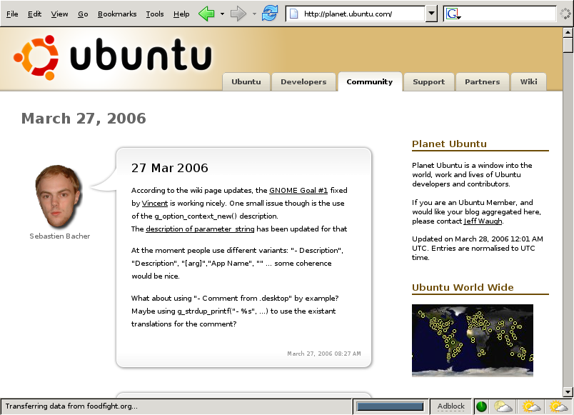
Insert figure 8-5 08fig05.png
Figure 8-5
Example of Planet Ubuntu
Teams, Processes, and Community Governance
Ubuntu operates under the famous hacker mantra of “rough consensus and running code.” The project attempts to forge consensus, to make good technical decisions, and to move forward. It attempts to minimize politicization wherever possible and to distribute power to those who are best at getting good work done. Mark Shuttleworth explains, “This is not a democracy, it’s a meritocracy. We try to operate more on consensus than on votes, seeking agreement from the people who will have to do the work.”
The projects attempts to keep disagreements from spiraling out of control by enforcing mutual respect at all times with its Code of Conduct described in Chapter 1. Disagreements, of course, are inevitable and can be technical or nontechnical in nature. The community needs to be able to deal with these and, toward that end, has created a lightweight governance system that aims to ensure that disagreements are resolved carefully and that the project always has a strong, fair, and responsive direction.
The Ubuntu Web site describes the goals of its community governance system as threefold:
Ensure that a process is defined that allows people to contribute to decisions regarding the Ubuntu community and distribution
Ensure that decisions regarding the Ubuntu distribution and community are made in a fair and transparent fashion
Ensure that necessary decisions are actually made, even when there is no clear consensus amongst the community
With these goals in mind, Ubuntu’s system is based on the delegation of decision-making power to small- and medium-sized teams. When disagreements arise, they are handled within a relevant team. When teams cannot resolve their own disagreements or when there are disagreements between teams, issues are forwarded to either the Community Council or the Technical Board—depending on whether the issue is technical in nature. As the financier and the project’s progenitor, Mark Shuttleworth sits on both boards and occupies a special position as the self-appointed benevolent dictator for life (SABDFL). Users can participate in the Ubuntu governance structure by serving on teams and by approving members of both the Community Council and the Technical Board as Ubuntu members and maintainers.
Teams
Most work in Ubuntu is delegated to a set of teams that are responsible for a particular area of work in Ubuntu. A sample of important teams (which is by no means complete) might include the marketing, documentation, kernel, server, laptop, and translation teams. Anyone with an interest in a particular aspect of the Ubuntu project can join a team’s discussion and contribute to its decisions.
When a group of participants feel that a particular area is underserved, they can go ahead and build a new team by beginning work and writing up a proposal for consideration by the Community Council, which approves the creation of all new teams. Rather than catalyzing work with the creation of a team, the Community Council likes to recognize existing work with official team status. Teams should always involve the participation of several individuals. There are no one-man or one-woman teams in Ubuntu.
Local Community (LoCo) Teams
Local Community Teams, affectionately referred to as LoCo Teams in the community, are a very important type of team. Each LoCo is responsible for promoting, supporting, and representing Ubuntu in a particular locale. These locales are usually geographical and frequently countrywide, although in some situations they may overlap geographically. Ubuntu tries to encourage LoCos to work together whenever it is possible.
LoCos are like Linux User Groups (LUGs) and may often work closely with or be associated with a LUG. LoCos are often involved in localization or translations of Ubuntu into local languages and in advocacy in local schools, public administrations, and communities. The best LoCos meet regularly for social events, talks, and discussion. Often, they meet for “installfests” where team members help new users install Ubuntu onto their computers. Representatives of LoCos are asked to assist with localization matters, to speak on behalf of the Ubuntu project at local conferences and trade shows, and to organize a booth or presence at such events.
Canonical Ltd. provides each team with a mailing list and a domain name (usually in the form of ubuntu-<Community Council>.org where Community Council is the country’s two-letter country code). Canonical Ltd. also is willing to host LoCo Team’s Web pages, wikis, forums, Web logs, download areas, and additional mailing lists. LoCos are open to participation by anyone.
MOTU
Another very special team that deserves an in-depth description in this book is the MOTU. The MOTU are the Maintainer’s of Ubuntu’s universe repository and the phrase stands, jokingly (if not slightly embarrassingly), for Masters of the Universe. MOTUs call themselves, “the brave souls who try to keep the universe section of Ubuntu in shape.” For more information on the universe, please see the description of the different components in Appendix B.
MOTUs are package maintainers. They maintain, as a group, the vast majority of packages in the Ubuntu archive. Several of the packages that have been well maintained by the MOTU have, with time, migrated into the main component and become an official part of the Ubuntu distribution. Because Ubuntu does not make support or quality promises regarding the packages in universe, the MOTU team provides a way for maintainers to sharpen their teeth, and (since it’s sometimes unavoidable) make mistakes before jumping into the higher responsibility packages in main.
The roles and responsibility of the MOTU are many. Two important ones are:
Filing and fixing bugs on Ubuntu packages using Malone
Getting new or updated packages included in Ubuntu’s universe
This work is done largely by full-fledged MOTU members who, as team members, can upload directly into Ubuntu. This group is helped by “MOTU hopefuls,” who work closely with the MOTUs and whose work is then “sponsored” into Ubuntu. Many of these hopefuls graduate to full-fledged MOTUs, and many MOTUs eventually are granted full core developer status. This three-step system is the process by which almost all new maintainers learn to maintain packages in Ubuntu and gain their stripes.
Community Council
The Community Council and the Technical Board are the highest level governance structures within Ubuntu. The Community Council, as it pertains to all Ubuntu members and activities, is arguably the most powerful team within the Ubuntu project. The Community Council is charged with supervising the social structures, venues, and processes of the project.
The Community Council’s day-to-day work involves five major areas in Ubuntu. The first, and the most straightforward, is the maintenance of the Ubuntu Code of Conduct. The Community Council is the only body that can approve revisions to the code. Because the Community Council cannot ask each member to “re-agree” to the code when it is changed, each of these revisions must be fully within the spirit of the previous drafts.
The second charge of the Community Council is the arbitration of disputes that cannot be handled within a particular team or that arise between teams. Very frequently, these are disputes about the Code of Conduct that may require clarification of a part of the Code of Conduct or a description of whether any of the code was in fact violated by a particular action or behavior. However, the Community Council’s purview is not limited to Code of Conduct violations, and the Community Council is available to handle disputes in any nontechnical situation. In most situations, the Community Council does not take action against individuals but, rather, helps groups come to agreement or consensus among themselves. If this fails, the Community Council can ask a maintainer or other member of the community to apologize and refrain from particular behavior or to leave the community. The council promises that nobody will be asked to leave without a substantial review and opportunity to defend themselves.
A third area of council work is the creation and dissolution of teams and the appointment of team leaders. New teams are proposed to the Community Council in the manner described above in the section on teams, and the Community Council either approves the request or asks the proposes to wait. Defunct or inactive teams can similarly be dissolved by the Community Council. In cases where team leadership is requested, the Community Council can appoint leaders of teams or shift leadership to different team members. In most situations, the appointment of team leaders is an internal team matter but, when requested, the Community Council is available to intervene.
Fourth, the Community Council is responsible for approving and welcoming new members to the project. This will be described in more depth in the subsequent section on membership. Finally, the Community Council is responsible for all community related structures and processes. New types of teams, requirements for membership, and core philosophical documents should first be approved by the Community Council. Community members who wish to suggest new structures or processes can submit their proposal to the Community Council for discussion and approval.
The Community Council meets every two weeks on IRC. Any community participant can submit an item or proposal for discussion by the Community Council. Meetings are open to the community, but the Council only seeks consensus or votes from Council members—although it consults representatives from the team that submitted the proposal and other community members. If an open meeting becomes too noisy, the Council reserves the right to move to a private channel for the duration of the meeting. To date, this has never happened. In all situations, full transcripts of meetings are published immediately following a Community Council meeting. The Community Council at the time of this writing consists of Benjamin Mako Hill, Mark Shuttleworth, Colin Watson, and James Troup. Appointments to the board are made by Mark Shuttleworth and subject to confirmation by a vote among all members. Appointments are for a period of two years.
Technical Board
The Ubuntu Technical Board is responsible for the Ubuntu project’s technical direction. By handling all technical matters the Technical Board complements the Community Council as Ubuntu’s highest rung of project governance. In particular, the Technical Board is responsible for three major areas of Ubuntu policy: package policy, release feature goals, and package selection. Additionally, the Technical Board is available to arbitrate any technical disagreements or issues within or between teams in a manner similar toe the one described above in relation to the Community Council.
The Technical Board’s first responsibility is Ubuntu’s Package Policy. The Technical Board maintains the policy document which describe the processes and standard to which all Ubuntu packages are held. Since the policy is constantly evolving, each Ubuntu release is associated with a specific version of the Ubuntu package policy as determined by the Technical Board. Any suggestions or proposals about policy are suggested to and considered by the Technical Board.
Additionally, the Technical Board is responsible for maintaining Ubuntu’s feature goals for each release. During each release cycle, there is a date defined as “Feature Freeze” after which no new features are added. The Technical Board is the body that sets these dates and decides when and if the rules can be bent for a particular feature or piece of software.
Finally, the Technical Board is responsible for maintaining the list of pieces of software (i.e., packages) in Ubuntu. In this capacity, the Technical Board determines which software is installed in the default desktop installation and which packages qualify for full support as part of the main component of Ubuntu (see Appendix B). Users and developers can propose a particular piece of software for inclusion in main, the base install, or in a desktop install. In all cases, the ultimate decision will be made by the Technical Board.
Like the Community Council, the Technical Board meets at least every two weeks on IRC. Also like the Community Council, any user can submit an item or proposal for discussion by the Technical Board ahead of the meeting. Meetings are open to all interested parties, although decision-making and voting is restricted to Technical Board members. Full transcripts and rules about noise, as they pertain to the Community Council, also apply to the Technical Board. The Technical Board at the time of this writing comprises Matt Zimmerman as board chair, Scott James Remnant, Mark Shuttleworth, and Matthew Garrett. Nominations for the Technical Board are considered at the beginning of each release cycle. Like the Community Council, appointments are made by Mark Shuttleworth but are subject to confirmation by a vote among the maintainers instead of all members. Appointments are made for a period of one year.
SABDFL
Mark Shuttleworth jokingly refers to himself as Ubuntu’s SABDFL—“self-appointed benevolent dictator for life.” Mark plays an admittedly undemocratic role as the sponsor of the Ubuntu project and the sole owner of Canonical Ltd. Shuttleworth has the ability, with regard to Canonical Ltd. employees, to ask people to work on specific projects, feature goals, and bugs. He does exactly this.
Mark also maintains a tie-breaking vote on the Technical Board and Community Council but has never used this power and has publicly said that he will not use it lightly. In situations where the boards are split and there is no one “right” answer, the SABDFL will provide a decision instead of more debate. The SABDFL exists to provide clear leadership on difficult issues and to set the pace and direction for the project. In exchange for this power, he has the responsibility to listen to the community and to understand that the use of his SABDFL authority can weaken the project.
Ubunteros and Ubuntu Members
Membership in the Ubuntu project is one official way that the project recognizes sustained and significant contributions. The first level of membership in Ubuntu is as an Ubuntero (formerly, the name was “Ubuntite”). Ubunteros are “Ubuntu activists” and can be any person in the Ubuntu community who has explicitly committed to observe the Ubuntu Code of Conduct. Ubunteros are self-nominated and self-confirmed. Using Launchpad, participants can generate a GPG encryption key and “sign” the Code of Conduct as a way of pledging to uphold it within the Ubuntu community. By doing so, that participant automatically gains status as an Ubuntero.
The next, more significant, step is official membership. Official membership is available to any Ubuntero who has demonstrated a significant and sustained set of contributions to the Ubuntu community. These contributions can be of any kind—technical or nontechnical—but need to be of a form that can be represented to the Community Council which will consider each application individually. A full list of types of contributions that qualify can be found in the following section on getting involved. The Community Council tries to be flexible in the variety of different types of contributions that it accepts in consideration of membership.
Members are responsible for confirming, by voting, all nominations to the Ubuntu Community Council. They also may be asked by the Community Council to vote on resolutions put to the general membership. In exchange, members gain the right to an e-mail address @ubuntu.com and the right to carry Ubuntu business cards. Membership lasts for two years and is renewable. Members who fail to renew their membership will be marked as inactive but, with renewed activity and a simple procedure that involves approval of the Community Council, can be easily reactivated.
The process to become a member is relatively straight forward and is documented in-depth on the Ubuntu Web site. Most importantly, it requires that users document their contributions on a wiki page that includes links to code, mailing list messages, documentation, or other relevant material. Additionally, membership applications should also include testimonials on work and involvement in Ubuntu from current Ubuntu members.
Getting Involved
Users can participate in the Ubuntu community on a variety of different levels and in a multitude of ways. The following list of such ways, adapted largely from a page with links to relevant resources online on the Ubuntu Web site (www.ubuntu.com/community/participate), provides a good list of ways in which people can get a running start in the Ubuntu community. The list is broken down into the major ways to get involved.
Advocacy
The easiest way for someone to contribute to the Ubuntu community is simply by telling others about Ubuntu. Advocacy frequently occurs in a variety of ways. One good method involves joining or starting a LoCo Team. LoCos, described above, provide a method through which you can get involved in Ubuntu activities, talks. If users do not have a LoCo and do not have the critical mass of users to start one, they might help build support by giving a talk about Ubuntu to a local Linux User Group or other technical group. Advocates can also order CDs at no cost to them and can distribute them. Through these and other means, advocacy provides a great way to spread the word about Ubuntu and offers a low-barrier opportunity to make contributions to the community.
Support
One of the most meaningful ways that users can contribute to Ubuntu is by helping others use the software. Users can do this by joining the support-oriented mailing lists, IRC channels, or forums as described in detail earlier in this chapter. By responding to requests for help in each of these venues, users can help others users get up and running on Ubuntu. Even if users are themselves beginners, the knowledge they gain in solving even simple problems enables them to help users who run into the same issues.
Ideas and Feedback
Another way to contribute to Ubuntu is by helping steer the direction of the project by describing a vision or providing ideas. This can be done by participating in discussion and brainstorming sessions at conferences and on the Ubuntu wiki. By monitoring specifications as they are written and creating feedback, especially at early stages, users can make meaningful contributions. However, users contributing ideas should remember that “talk is cheap.” Users are wise to work with others to help turn their vision into reality.
Documentation
When a user is stumped by a problem, chances are good that other users will also be frustrated by it. If a user is not in a position to write code to change the situation, they may be able to help others by writing up their experience and documenting the solution. Ubuntu has a vibrant documentation team and community, and writing documentation is a great low-barrier way to make meaningful contributions to the Ubuntu community.
Users aiming to contribute to Ubuntu’s documentation would be advised to take notes as they puzzle through problems and to document solutions when they find them. Before writing, users should also check to see if documentation for a particular problem already exists. When it does, users would be wise to choose to improve or augment existing documentation over writing a new document. Similarly, users can also make meaningful contributions by reading through existing documentation and fixing factual, technical, stylistic, spelling, and grammar errors. Users who spend a large amount of time working on documentation may, with time, also want to join the Ubuntu Documentation Team, which can help organize and coordinate this work in terms of Ubuntu documentation goals.
Artwork
For those users who feel that their strengths are primarily artistic, there are many ways to improve the style and feel of the Ubuntu desktop through wholly artistic contributions. For example, Ubuntu is always in need of new ideas for wallpapers, icons, and graphical themes. Inkscape, similar in many respects to Adobe Illustrator, is a great piece of free software in Ubuntu that proves useful for this type of work. As with documentation, there is an Ubuntu Art Team that helps coordinate artistic work within the Ubuntu community.
Translation and Localization
The discussion of LoCo Teams should have already made it clear that translation is a great way that anyone with a firm understanding of English and another language can contribute to the Ubuntu community. Translation through Rosetta (described in more depth in Chapter 9) allows users to translate as little as a single string or as much as an entire application. Through its easy interface and Web-based nature, it provides an easy, low-barrier road to contribution. Serious translators should join a local community team and the ubuntu-translators mailing list so that they can stay in touch with other Ubuntu localizers.
Quality Assurance and Bugs
Quality assurance (QA) is something for which many companies hire special engineers. In Ubuntu, the Development Team relies on itself and the community to test software before it is released to let developers know about problems so that the bugs can be squashed before the vast majority of users ever see it. To test software, users merely need to upgrade to the latest development version of Ubuntu and to upgrade regularly. When users helping out with QA find bugs, they should report them in the Ubuntu bug-tracking system Malone (described in depth in Chapter 9). They can also help by “triaging” bugs, closing or merging duplicates, or verifying bugs and adding information to a bug’s description. If you intend to become involved in QA, you should subscribe to the ubuntu-devel-announce mailing list, and you should considering monitoring ubuntu-devel as well.
Programming and Packaging
The final way that users can contribute to the Ubuntu community is through the production of code. Because Ubuntu is free and Open Source software, users can get access to every piece of software that Ubuntu supports. This allows users to package additional software for inclusion in Ubuntu, to fix bugs, and to add features. Developers, like those testing software, should subscribe to the ubuntu-devel-announce mailing list and should consider monitoring ubuntu-devel as well. The best way to begin making contributions is then through the MOTU team as a MOTU hopeful, as described above. Users can also look through a list of specifications to find a project that they find personally interesting. In some situations, there are even “bounties” available—small amounts of money available to those who fulfill a small feature goal that has remained unfilled for some period of time.
Summary
Ubuntu is a vibrant and diverse community that is active around the world and in many languages. Its activities happen primarily online in a variety of virtual venues, including mailing lists, IRC, Web Forums, wikis, and two special Web-based community portals known as The Fridge and Planet Ubuntu. Ubuntu complements this virtual activity with real-life meetings and conferences. The Ubuntu community is broken down into a variety of teams and processes. At the top of this government structure is the Ubuntu Community Council, Technical Board, and SABDFL Mark Shuttleworth. Through a variety of ways, this community is designed to facilitate contributions from the community. Ultimately, these contributions are recognized through a process culminating in official project membership and enfranchisement.

