9
Ubuntu-Related Projects
Ubuntu is not just a complete operating system (OS); it is also the center of a growing ecosystem of GNU/Linux and Solaris-based distributions. Some, referred to as the “partner projects,” work closely with and within Ubuntu. Others prefer to work outside the project and are considered full derivatives. Often, these projects are created in order to highlight a specific selection of software or use case such as the nUbuntu project, which focuses on security and networking tools.
Others derive for reasons connected to the international nature of Linux and Open Source. While most Ubuntu development happens in English, there are large developer and user communities in other languages and countries. Thus, a derived distribution, such as Ufficio Zero in Italy, might spring up to satisfy that need. Should you use any of these over Ubuntu? We can’t answer that question for you. Some of these projects are fully within, and as a result, not mutually exclusively from Ubuntu. Others might be more appropriate if you are a developer and are most comfortable in a particular language. You can mix, match, and sample these distributions until you find one that works great for you. As we mentioned in the introduction, Ubuntu sees these derivatives as a sign of a healthy and vibrant community. One of the goals of the project is to make it easier for this type of distribution to appear. We can all expect to see more of them in the future.
Partner Projects
Partner projects are those projects that work in close relation with Ubuntu. All partner projects are officially supported by Canonical Ltd., the company which currently sponsors most of the Ubuntu, Kubuntu, and Edubuntu work. Partner projects also share a common repository of packages and release in sync with Ubuntu.
Kubuntu
Kubuntu is the first and oldest of all the partner projects. First released alongside Ubuntu 5.04 (Hoary Hedgehog), Kubuntu, which means “toward humanity” in Bemba, builds on the strengths of the K desktop environment (KDE) rather than GNOME as Ubuntu does. The project is lead by Jonathan Riddell, who now works for Canonical, Ltd.
As with Ubuntu, Kubuntu is a complete desktop but one built around KDE and QT. Rather than Ubuntu’s brown theme, Kubuntu opts for a more traditional blue and makes a few other visual changes. Rather than the two panels and three menus of Ubuntu with GNOME, Kubuntu uses two menus and a single lower panel, closer in style to that of Microsoft Windows.
Kubuntu also comes with OpenOffice.org, the same Office suite that is included in Ubuntu. Along with this office suite, Kubuntu also includes Krita, a photo manipulation tool, the K3b CD Kreator, and the media player amaroK, all parts of KDE. Kubuntu is explored in much more depth in Chapter 7 so is not given a full treatment here.
Kubuntu
Kubuntu can be found at www.kubuntu.org
Edubuntu
As the name implies, Edubuntu is a version of Ubuntu for use in schools and other educational environments. Edubuntu uses Linux Terminal Server Project’s (LTSP) thin client technology as well as a number of programs aimed at the educational market such as Gcompris and the KDE Education suite. Oliver Grawert, a Canonical Ltd. employee, leads the Edubuntu development. Like Ubuntu, Edubuntu uses the GNOME desktop environment. The default desktop is show in Figure 9-1.
***insert Figure 9-1 09fig01.tif
Figure 9-1
Default desktop
One of Edubuntu’s unique features is the inclusion of the LTSP in an easy-to-use, out-of-the-box installer. LTSP uses a different methodology of deploying clients over a network than in traditional computer deployments. Instead of full-blown computers, LTSP uses thin clients, computers that connect to a larger server to do all the processing work. In larger deployments it is often more cost effective to have a few more powerful servers serving applications to less powerful thin clients to have a collection of medium-speed computers doing their own processing. Since the thin client ends up being a glorified display, LTSP has become a common use for older machines that are typically not powerful enough to run a full OS. It is common for deployments to remove the hard disks from these machines, which can also result in much quieter computers. Since these clients use the standard X11 protocol, many independent vendors also sell thin clients built just for this purpose.
Figure 9-2 shows a possible wiring layout for an Edubuntu-powered classroom.
***insert Figure 9-2 09fig02.tif
Figure 9-2
Wiring layout
Oliver Grawert has worked with members of the LTSP community with the intention of making the Edubuntu version easy to set up and administer. A teacher with moderate technical skill could easily setup an entire classroom of Edubuntu in under an hour. Additionally, Edubuntu is unlike standard Ubuntu in its inclusion of educational games and activities. For younger children, Gcompris (French Internet slang for “'I understand”) offers a large and growing number of games and activities such as learning how to use the mouse and type, reading, geography, mathematics, (See Figure 9-3) and others.
***insert Figure 9-3 09fig03.tif
Figure 9-3
Gcompris
Edubuntu also includes the KDE Education suite, aimed at a wider age range of 3 to 18. Some notable programs include the planetarium program KStars, the periodic table program Kalzium (See Figure 9-4), and KEduca, a program to create and give tests. There are also a number of programs to help with learning languages and mathematics.
***insert Figure 9-4 09fig04.tif
Figure 9-4
KStars
Edubuntu
Edubuntu can be found at www.edubuntu.org
Derived Distributions
Derived distributions usually work outside of the Ubuntu community and usually have their own package repositories. They may not release at the same time as Ubuntu. In the past, several derived distributions have been built upon other distributions such as Arch or Debian. The list of derivative distributions is quickly growing, and this list will be both incomplete and out-of-date by the time you read it.
Guadalinex
Guadalinex is the GNU/Linux distribution promoted by the regional government of Andalusia, the most populated autonomous community in Spain with almost 8 million inhabitants. It is currently one of the biggest free software implementations worldwide, with more than 200,000 desktops—and increasing. The project is a consequence of the unanimous support of the Andalusian Parliament on the Information Society and Innovation policies approved in 2002 and 2003, urging all the regional institutions to promote and use free software and open licenses. This makes the Guadalinex initiative unique in the world.
Guadalinex was initially released in 2003, and the first two versions were based in Debian. In 2005 the Guadalinex project decided to develop the third version deriving from Ubuntu. Guadalinex V3 was released in January 2006 based on Ubuntu 5.10 (Breezy Badger), and the Andalusian upgrade to this most recent version is being done during the year. The project is part of a government plan to implement free software as the default option in the public schools. At the beginning of 2006 this project involved 500 schools and an approximate total of 200,000 desktops equipped with Guadalinex and free software only. These numbers are increased every year as new courses start every September and new computers are purchased (about 40,000 planned for 2006). This initiative alone puts Guadalinex in the top position as the biggest free software implementation worldwide. Additionally, the software is used in public Internet access centers, senior centers, libraries, women’s associations, as well as direct to citizens for use at home.
Guadalinex
Guadalinex can be found at www.guadalinex.org/
Xubuntu
Xubuntu takes Ubuntu and places the Xfce desktop environment on top (See Figure 9-5). The Xfce desktop is primarily designed for older machines because it uses much less memory than it’s bigger cousins, GNOME, and KDE. Unlike the other derived distributions listed here, Xubuntu uses Ubuntu repositories as its base. As a result, the kernel and other underlying pieces are security supported, but the graphical and desktop pieces driven by Xfce are not. Figure 9-5 shows the default desktop of Xubuntu.
***insert Figure 9-5 09fig05.tif
Figure 9-5
Xubuntu uses the Xfce desktop environment
Xubuntu
Xubuntu can be found at www.xubuntu.org
Nexenta
Nexenta is unique among the derived distributions in that it does not use the Linux kernel but bases its work on OpenSolaris, a version of Unix, which is developed by Sun Microsystems. The word Nexenta is a contraction of “next” and “cento.” The latter is a Roman poetic form meaning “stitched together.” Each line of the poem is taken from a different source. In appearance, Nexenta differs little from Ubuntu due to both using GNOME. Nexenta was created by and is supported by Nexenta Systems, based in San Francisco, California.
As Nexenta uses the OpenSolaris kernel over the Ubuntu one, there have been a number of issues that have been raised, both technical and legal. Technically, the Linux and Solaris kernels are quite different with corresponding changes in other layers. This means that programs generally need to be ported to the Solaris kernel.
.
Nexenta
Nexenta can be found at www.gnusolaris.org/
nUbuntu
nUbuntu is a collection of security and networking tools that was first released in January 2006. Created by a group of three developers from the United States and the United Kingdom, nUbuntu is aimed at security and networking professionals.
nUbuntu
nUbuntu can be found at www.nubuntu.org/
Ufficio Zero
Ufficio Zero is an Italian distribution funded by CreaLabs. It includes only a live CD version. Ufficio Zero only changes the default language (from English to Italian) and the default theme. The idea behind Ufficio Zero is to showcase a Linux desktop for the modern office environment. Until 0.6, Ufficio was based on Arch Linux. Recent versions switched to Ubuntu as the base.
Ufficio
Ufficio can be found at www.ufficiozero.org/
The Open CD
The Open CD is a set of Open Source programs that can be installed on Microsoft Windows, such as The GIMP, OpenOffice.org, Battle for Wesnoth, Firefox, and Thunderbird. The project is lead by Henrik Omma, who works for Canonical Ltd. It is actually a modified and rebranded Ubuntu live CD and, thus, can be booted into Ubuntu as well.
The Open CD
The Open CD can be found at www.theopencd.org
Baltix
Baltix is a Lithuanian and Latvian distribution. It also includes support for Estonian, Russian, English, and Norwegian languages. As with Ubuntu, Baltix uses the GNOME desktop environment and many of the same programs.
Baltix
Baltix can be found at baltix.akl.lt
ImpiLinux
ImpiLinux is a South African distribution designed as a commercial derivative of Ubuntu. Charging money allows ImpiLinux to ship software that Ubuntu cannot legally ship, such as MP3 and DVD support. Originally based on Debian for version 1, it was then built from scratch for version 2. The next version, not yet released as of this writing, will be based on Ubuntu after it was announced that in 2005 that Mark Shuttleworth had invested 10M South Africa rand in ImpiLinux (Pty) Inc. ImpiLinux will be available in English, Xhosa, and Afrikaans, and there are plans to add more languages.
ImpiLinux
ImpiLinux can be found at www.impilinux.org/
The Launchpad
As was mentioned in the introduction to the book, a majority of Canonical Ltd.’s technical employees do not work on Ubuntu. Rather, they work on infrastructure. The majority of this infrastructure is a large collection of services which, together, provide the framework through which Ubuntu is built. This superstructure of related applications is, collectively, referred to as the Launchpad. While it has several non-Web based systems, it is almost wholly accessible over the Web.
While Launchpad is primarily used to develop Ubuntu, the infrastructure was designed to be useful for any free software project. It aims to provide these projects with the code, bug, and translation tracking software necessary to more easily and more powerfully collaborate with others and to develop free and Open Source software. Each of these functions (code, bug, and translation tracking) are highly integrated making it much more ambitious, and potentially much more powerful, than traditional Web-based solutions with similar goals. The Launchpad Web page describes the project as:
A collection of services for projects in the Open Source universe. You can register your project, and then collaborate with the Open Source community on translations, bug tracking, and code.
In addition to code, bug, and translation tracking, Launchpad also provides the ability to deal with code not just on a per-package or per-project level but on the distribution level as well. If a bug has been reported against a piece of software in Ubuntu, that is visible to both the “upstream” and “downstream” projects. The project can track how its software evolves over time and see, at a glance, whether bugs apply or not. Developers can track translations in a similar way.
A source of controversy in the free and Open Source software world is the fact that the source code to Launchpad is not distributed. This has led to fear by some about the risk of enclosure or dependence that comes from using a tool which developers cannot change, update, or copy. Additionally, while all code and history can be fully copied, some information (such as bug information and metadata) stays within the Launchpad system. Some developers have felt insecure about providing this data to Canonical Ltd. in such a way that they cannot copy or replicate it. Mark Shuttleworth has replied to these fears saying that the goals of Launchpad required that he build a community before the code allowing forking is distributed but that with time, the code to all of Launchpad will be distributed.
The best way to understand Launchpad is to see it in action and to look at the specifics. This section will walk through the individual pieces of Launchpad in more depth. Much of the Ubuntu infrastructure is highly integrated into Launchpad. If you have created an account for the wiki or to order CDs at http://shipit.ubuntu.com, you already have a Launchpad account.
Launchpad
Launchpad can be found at www.launchpad.net/
Soyuz
Soyuz is the distribution and archive management software that is integrated into Launchpad. It handles all of the automatic building of software in Ubuntu on each of the architectures and the integration of successfully built software into the archive. Soyuz means “Union” in Russian and is the name of the spacecraft that Mark Shuttleworth traveled in during his voyage to space.
Soyuz works almost entirely behind the scenes. It was first activated in early February of 2006 but had no initial effect on the way that software was uploaded or downloaded in Ubuntu. What Soyuz does is to integrate the process by which software is built and inserted into different parts of the Ubuntu archive. The building of software cannot be tracked using the Launchpad Web infrastructure. For example, this URL shows the status of recent builds of software in Ubuntu:
https://launchpad.net/distros/ubuntu/+builds
Rosetta
Rosetta is a Web-based translation system integrated into Launchpad. It was the first piece of Launchpad to be publicly released. It was named after the Rosetta Stone, the famous piece of dark grey granite with the same text in three scripts that led to the deciphering of Egyptian hieroglyphics.
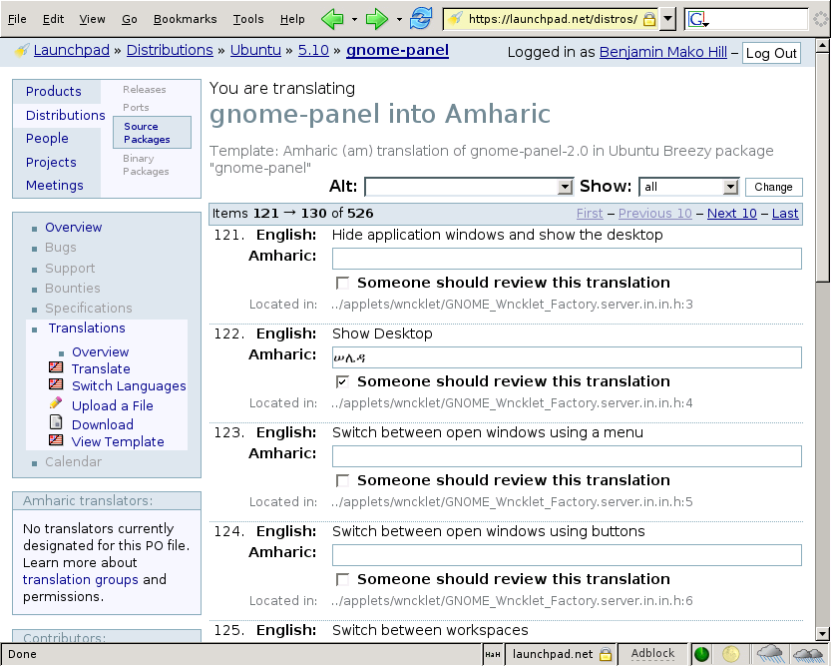
Rosetta is a Web-based version of a “PO” file editor. In other words, it provides a simple mechanism by which translators can view a list of untranslated phrases or “strings” and then translate each of them into their language. At the moment, the system only works with translations from English. Rosetta’s non-Web-based predecessors including Kbabel and Gtranslate—both of which can be downloaded and installed on Ubuntu. By putting this functionality on the Web and integrating it into the archive management scripts, Rosetta lowers the barrier of entry for translation and lowers the chance that a translation will not make it into the distribution.
Rosetta includes each of the translatable strings contained in every application in Ubuntu. When new software is uploaded into Ubuntu, Rosetta will check to see if any strings have changed or been added. Changes to a string which that has previously been translated will result in the translation being marked as “fuzzy” until a translator can check the translation and the new string, make any necessary changes, and then mark the translation as no longer fuzzy. By tracking new strings, Rosetta can easily prompt translators with new strings to translate as they appear as well as statistics on the percentage of strings within a particular application or within all of Ubuntu that have been translated into a particular language.
As users translate strings, they build up positive “karma” within the system. Users are also able to work together in localization teams (called “l10n teams” because the word “localization” has ten letters between its first and last letter). Rosetta provides a great way for Ubuntu users to get involved in the distribution. Anybody who knows English and another language can begin contributing. Because the system is integrated into Launchpad, users do not need to “submit” their translation to have it included in Ubuntu—the project already has them. Several days later, new translations for untranslated strings are pushed out to Ubuntu users who use Ubuntu in the translator’s language.
Rosetta
Rosetta can be found at www.launchpad.net/rosetta
Malone
Malone is a Web-based bug system like the Mozilla projects “Bugzilla,” which might be familiar to some users. It provides a location for users to file bugs that they find in their Ubuntu software using easily accessible pieces of software such as Bug Buddy and the command-line reportbug or over the Web. Malone’s name is a reference to the gangster movie musical Bugsy Malone.
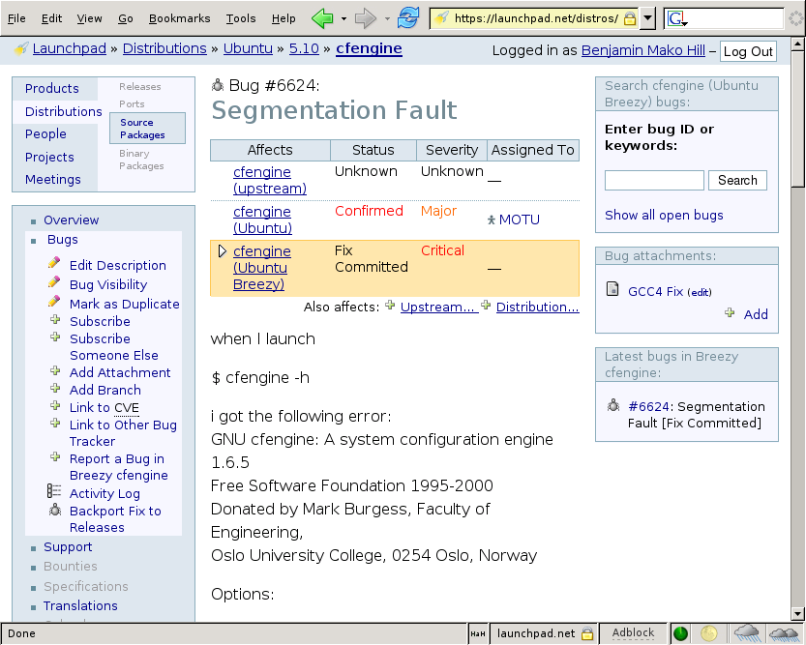
Malone’s first role is to provide a location where users can submit bugs. Malone’s role is not just in collecting complaints though. Rather, its job is to track and record a bug through its full life cycle from report to close. Bugs can be assigned to a particular developer or reassigned. If the bug is, in fact, with another application, the bug can be reassigned to another package. Bugs can be rated according to severity or “tagged” and categorized in any number of useful manners. Information, files, and “patches” that fix a bug can be uploaded into Malone. When the bug has been resolved, it can be closed. The Malone bug report provides a single venue in which to collect information from the bug submitter, the bug fixer, the upstream maintainer if necessary, and any other involved party.
All of this, of course, is exactly what you would expect from any usable modern bug tracker. Where Malone aims to distinguish itself from its competitors is through its integration in Launchpad. First and foremost, this means that users of Malone can track the status of a bug as it relates to a particular patch or a particular piece of code. Because Ubuntu supports every release for 18 months and some releases, such as Ubuntu 6.06, for much longer, it’s important that Ubuntu be able to track which bugs show up in which releases. As derivative works of Ubuntu are created in Launchpad, Malone also allows these derivatives to use Malone to see if bugs submitted against Ubuntu or other distributions apply to their code and, if so, to quickly grab a fix. As can be seen below (figure XX), a bug in cfengine has been confirmed in Ubuntu generally, fixed in the Breezy or 5.10 release of Ubuntu and not yet confirmed by the actual developers of cfengine itself.
As with Rosetta, Launchpad “karma” can be built up by fixing, reporting, and interacting with bugs over time. Bug “triage” that involves closing irreproducible bugs and merging duplicate bugs is one way that users can build up their karma. Of course, simply running developer versions and submitting new bugs is another great way to build good karma.
Malone
Malone can be found at www.launchpad.net/malone
Other Functionality
In addition to Malone and Rosetta, the two visible flagship products within Launchpad and Soyuz, (the hidden but diligent workhorse that allows Ubuntu to work), Launchpad has several other important uses. We’ve already alluded to the fact that Launchpad handles all the authentication for all the Ubuntu Web sites. If you want to edit or create a Web page in the Ubuntu wiki or even order a CD in Ubuntu, you must first create an account in Launchpad. In addition to just creating a username and password, it can contain rich information about each individual including their GNU Privacy Guard encryption key, wiki pages, contact information, and more. More importantly, it also contains representations of every team and group within Ubuntu and handles permission within the entire Ubuntu world. For example, the only people who are allowed to upload core packages to Ubuntu are people who are part of the Ubuntu Core Developers team in Launchpad.
Note
The system is also playing an increasingly important role in coordinating sprints, tracking events in a calendar, and tracking the status of specifications that describe work in Ubuntu that were detailed in the section on conferences above. With time, Launchpad’s functionality is only likely to grow and its help in supporting the new type of development with it.
Bazaar
Bazaar is a distributed revision control system. What does that really mean? A revision control system is a program that tracks how the source code of a program changes. It tracks what the specific change was, such as addition of a new piece of code, as well as who made the change. It also allows a developer to roll back to a previous version or create a branch to try out a new idea.
The second key piece about Bazaar is that it is distributed. Traditional revision control systems have a single place that the code is stored. Only certain people can access this place and change the code there. A distributed revision control system is different in that there is no single place that code is stored. Each branch that a developer is working on is equal, and they all take code from each other. This system is much like a number of equal merchants at a bazaar, hence the name.
Bazaar started out as a fork of the Arch distributed revision control system. A fork means that the developers disagree on where to take the program and break into different groups to work toward each group’s different goals. However, Bazaar 2 was completely rewritten, as it was found that the current code did not work in the long-term.
Bazaar
Bazaar can be found at www.bazaar-ng.org/
Summary
In addition to building a great OS that many use, Ubuntu has grown into an OS that those building other OS use as a basis to build from. This has come in the form of both internal partner projects and external derivative distributions. Together, these span languages, continents, and markets, and their list is quickly growing. Additionally, Ubuntu is tightly linked to Canonical Ltd.’s other projects, Launchpad and Bazaar. While Bazaar provides a compelling version control system, the Launchpad provides a one-stop show for bugs, translations, and much more.

