A New Computer Aided Detection Approach Based on Analysis of Local and Global Mammographic Feature Asymmetry

Adam Kelder1, Dror Lederman1,2, Bin Zheng3, and Yaniv Zigel1

1 Department of Biomedical Engineering, Ben-Gurion University of the Negev, Beer-Sheva, Israel

2 Department of Electrical Engineering, Holon Institute of Technology, Holon, Israel

3 School of Electrical and Computer Engineering, University of Oklahoma, Oklahoma, USA

Corresponding Author:

Dror Lederman, PhD

Faculty of Electrical Engineering

52 Golomb St.

Holon Institute of Technology,

Holon, Israel

E-mail: [drorl@hit.ac.il](mailto:drorl@hit.ac.il)

**ABSTRACT**

**Purpose**: This study aims to develop and test a new computer-aided detection (CAD) approach and scheme, assessing the likelihood of a subject harboring breast abnormalities. **Methods**: The proposed scheme is based on the analysis of both local and global bilateral mammographic feature asymmetries. The level of local or global asymmetry is assessed by analyzing mammographic features extracted from the bilaterally matched regions of interest (ROIs), or from the entire breast, respectively. The selected local and global feature vectors are combined and classified using a maximum likelihood obtained from a naïve Bayes classifier. This scheme was evaluated using a leave-one-case-out cross-validation method that was applied to 243 subjects from mini-MIAS and INbreast databases. In addition, the result is compared with a conventional unilateral (or single) image-based CAD scheme. **Results**: Using a case-based evaluation approach and an area under curve (AUC) of the receiver operating characteristic (ROC) as a performance index, the new scheme yielded AUC = 0.79±0.07, an 8.2% increase compared with AUC = 0.73±0.08 obtained using the unilateral image-based CAD scheme. **Conclusions**: This work demonstrates that applying bilateral asymmetry analysis increases the discriminatory power of CAD schemes while optimizing the likelihood assessment of breast abnormalities presence. Therefore, the proposed CAD approach provides the radiologist with beneficial supplementary information and can indicate high-risk cases.

**Key Words:** Bilateral mammographic feature asymmetry analysis, Breast cancer risk assessment, Computer aided detection (CAD), Medical image analysis.

**I. INTRODUCTION**

Breast cancer is the most common cancer among women. Early detection of breast cancer is associated with better prognosis, and is crucial for increasing the patient survival rate and treatment efficacy1. Due to the high heterogeneity of breast cancer, detection of early breast cancer from asymptomatic women is quite difficult. As a result, mammography has been considered to be one of the major clinically acceptable imaging modalities in the screening environment to detect early stage breast cancer. However, the sensitivity of screening mammography is substantially lower relative to other imaging methods, such as ultrasonography or magnetic resonance imaging (MRI), because a large fraction of breast lesions are completely or partially occluded by overlapped dense breast fibroglandular tissues in two-dimensional projection images2. On the other hand, increasing the sensitivity might come at the expense of higher false positive recall rates, which, in turn, create long term psychosocial side effects in women who routinely participate in mammography screening3. Moreover, reading and interpreting screening mammograms by radiologists is associated with large inter-observer variability, leading to inconsistent and subjective diagnosis results4.

In order to overcome these difficulties and assist radiologists' decision making while reading screening mammograms, a variety of computer aided detection (CAD) schemes have been developed and tested since the 1980s. Several commercialized CAD schemes of mammograms are currently available, and they have been implemented in many mammographic imaging systems. However, studies5,6 have shown that the performance of current CAD schemes was disappointing in terms of assisting radiologists to improve cancer detection yield and specificity, and adding value to clinical practice. Exploring and developing new CAD approaches is required to improve this state of affairs7.

The existing, conventional CAD schemes of mammograms are lesion-based. These schemes have a number of pitfalls that reduce their effectiveness to assist radiologists in reading mammograms, including a high false positive detection rate in a single mammogram-based scheme8 and a high correlation with radiologists’ visual detection results due to the domination of the “easy” lesions in CAD training databases9. In order to overcome these pitfalls, we have explored a new case-based CAD approach, relying on the assessment of global and local bilateral mammographic asymmetry without segmentation of suspicious lesions. A preliminary version of this work has been reported10.

High levels of bilateral mammographic tissue asymmetry indicate increased risk for developing breast cancer. High asymmetry levels are also one of the key diagnostic features that radiologists look for when examining mammograms11, 12. Bilateral asymmetry is expressed as a global (i.e., in the entire breast) and/or local (i.e., in a particular breast region) difference in tissue type or density between bilateral mammograms of the left and right breasts.

Several studies13-20 have been conducted in order to assess bilateral asymmetry automatically, using two main approaches. One is based on the analysis of the residual image obtained from bilateral image subtraction after image registration. The other approach, feature asymmetry, is based on comparative difference (or asymmetry) analysis of the image features, which are computed separately from two different bilateral mammograms. These approaches can be computed and analyzed in several ways: (1) global-based analysis, considering features extracted from the entire breast area, (2) local-based analysis, considering features extracted from a specified region of interest (ROI), or (3) combining both global and local analyses.

For example, following the first, residual image approach, Karnan et al.13 used bilateral asymmetry to detect microcalcifications. The breast border and nipple position were detected and used to align the images. Then, bilateral image subtraction was applied, followed by thresholding and detection of suspicious regions. In order to detect masses, Bovis et al.14 aligned the bilateral images using the nipple location, subtracted them, and extracted textural features from the residual image. Ferrari et al.15 used Gabor filters in a variety of frequencies and orientations, and arranged their filter responses in rose diagrams, representing each mammogram by its linear directional components. Then, they analyzed the rose diagram differences for each bilateral mammogram pair, assessing breast tissue asymmetry. The same approach was extended in 16, where morphological features and image moments were added.

Following the second, feature asymmetry approach, Wang et al.17 extracted global image features that have been previously investigated and found effective in assessing breast tissue patterns or density. They used the absolute feature differences, computed from left and right mammograms, for assessing women's risk of developing breast cancer in the near future, after a negative screening mammography of interest. In a later study19, Wang et al. extracted the same computerized features from an adjusted size square region, located behind the nipple, in order to detect breast abnormalities and predict the risk of developing cancer. Similarly, in 18, the authors extracted region-based features from eight vertical strip shaped regions, uniformly dividing the breast area horizontally. Later, they bilaterally subtracted the features, resulting in eight difference values for each feature. The feature differences average, standard deviation, skewness, and kurtosis were computed as final region-based features. Recently, Casti et al.20 also applied a feature asymmetry method, using spherical semivariogram descriptors and correlation-based structural similarity indices, classifying 47 asymmetric cases and 47 normal cases.

In this study, we developed and tested a new CAD scheme which integrates both global and local approaches, i.e., combined both single image-based analysis and bilateral-image asymmetry analysis. On the other hand, the proposed scheme automatically detects arbitrary size ROIs while providing case-based scores.

The rest of the paper is arranged as follows: Section II presents the proposed method and the database used to evaluate its performance. Section III presents the results. Discussion and conclusions appear in Sections IV and V, respectively.

**II. MATERIALS AND METHODS**

**An Overview of CAD Scheme and Testing Image Database**

Our CAD scheme, presented in the block diagram in Fig. 1, can be briefly described as follows. First, in order to remove nuisances and irrelevant areas, each mammogram undergoes a preprocessing and segmentation phase. Second, each bilateral image pair is aligned using a simple image registration technique. Third, ROIs are detected in each mammogram, and mapped into the corresponding bilateral counterpart mammogram. Fourth, image features are computed separately from each of the matched ROIs, and their difference values are also computed. Fifth, each ROI receives a detection score based on the linear classifier posterior probability, computed by a machine learning classifier. Finally, the maximum detection score of all the ROIs detected in two bilateral mammograms is calculated to represent the final case-based detection score.

We used publically available mammography databases (mini-MIAS21 and INbreast22) for training and testing the proposed CAD scheme. The mini-MIAS database contains 322 bilateral mammograms acquired from 161 women in medio-lateral oblique (MLO) view. This database provides information related to the mammographic tissue density of each case. In addition, if any abnormality exists in the image, the abnormality type, malignancy, and position are provided. Of the 161 cases, 56 are normal and 105 are abnormal, of which 61 include verified benign and 49 have malignant abnormalities (some cases contain both benign and malignant abnormalities).

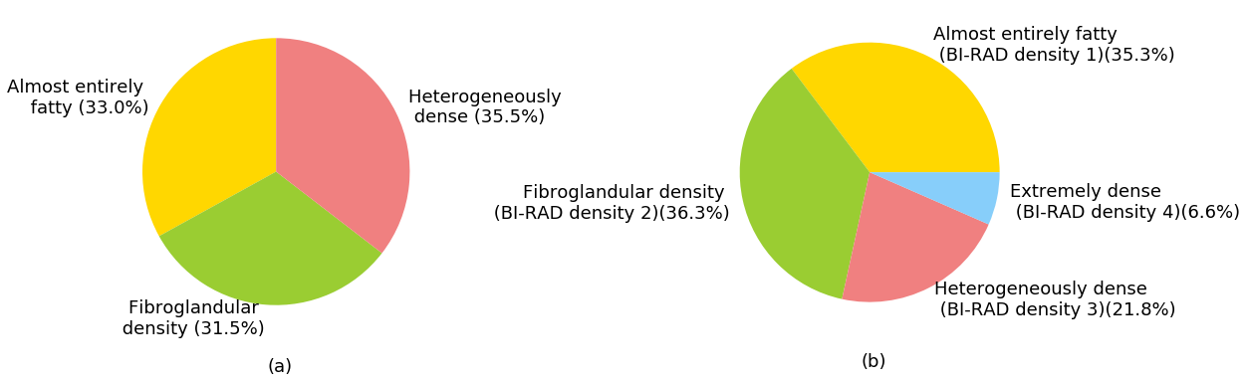

**Figure 2**: BI-RAD density score distribution for the two mammogram database: (a) mini-MIAS three-grade distribution; (b) INBreast BI-RAD density distribution.

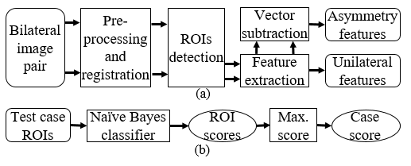

**Figure 1**: Block diagram of the proposed method: (a) Generation of asymmetry feature vectors from a bilateral image pair. (b) Computation of case score.

The INbreast database contains 410 full field digital mammograms (FFDMs) acquired at the Breast Centre in the Center Hospitalar de S. João (CHSJ), Porto. A total of 115 cases were collected, from which 90 have two images (MLO and cranial-caudal (CC)) of each breast, and the remaining 25 cases are from women who had a mastectomy and two views of only one breast were included. These cases are irrelevant for this study and were therefore omitted. A biopsy was performed on 56 cases, of which 11 were found to be benign and the remaining 45 were found to be malignant. The database contains all the relevant information for each case, including mammographic tissue density and accuracy contours made by specialists. The anomaly annotation in this database ranges from 0 to 6, according to the BIRADS rating. Fig 2. presents the distribution of breast densities in the two database. Note that the densities in these two databases were determined in different scales, i.e., the densities in the mini-MIAS database are categorized into three density categories: fatty, fatty-grandular and dense-grandular, whereas the densities in the INBreast database are categorized in the standard four-level BIRAD density rating. Fig 3. presents the BIRAD classification distribution of the INbreast database.

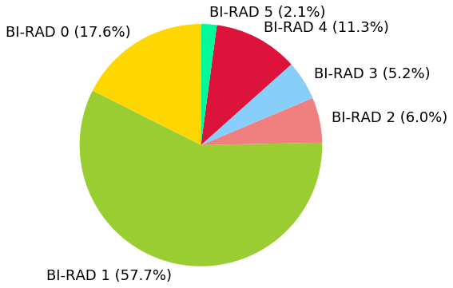

**Figure 3**: BI-RAD classification distribution for the INBreast database.

**Image Preprocessing**

A preprocessing phase is required in order to eliminate the mammogram image background, including air background, the pectoral muscle, and various annotations or labels (Fig. 3(a)). First, a 3×3 median filter is applied to reduce noise while preserving edges. Next, by applying a threshold, a binary image is created, including the breast area, possibly with some noisy pixels and background artifacts. A connected component labeling (CCL) is then applied in order to separate and label different groups of connected pixels in the binary image. The presumption is that the binary group representing the breast area is larger than the groups representing artifacts or noisy pixels. Therefore, the number of pixels in each group is computed, and all the groups, except for the largest one, are eliminated.

The pectoral muscle appears in most of the MLO mammograms. Usually, it appears roughly as a triangle located in the inner upper corner of the image, as shown in Fig. 4(a). In the last preprocessing step, we remove the pectoral muscle using an algorithm described in 23. The preprocessing phase yields an image containing the breast area alone, as shown in Fig. 4(b).

**Bilateral Image Registration**

Following the image preprocessing, we perform image alignment in order to spatially match every pair of corresponding images and enable efficient comparison between two matched ROIs depicting on two bilateral mammograms. The registration process transforms the image pixels' spatial coordinates, so that the image will optimally match to a reference image in a sense of a predefined similarity measure. Mismatches between two images of a bilateral mammogram pair can arise from several sources. First, the breasts may not be perfectly symmetrical in the sense of size and shape. Second, screening mammography involves physically compressing a flexible 3D structural volume to acquire 2D projection images, possibly leading to elastic deformations that are expressed in the mammograms. Third, while digitizing screen film cassettes or directly performing digital mammography, the breast location in the digital image may vary between bilateral images. These location mismatches may occur due to the location of the film in the scanner or location of the breast during acquisition. Some of these bilateral differences, including rigid location variation of the breast, are relatively easy to model and transform, while others, such as elastic deformations of the breast tissue projected at the image, are difficult or practically impossible to cope with.

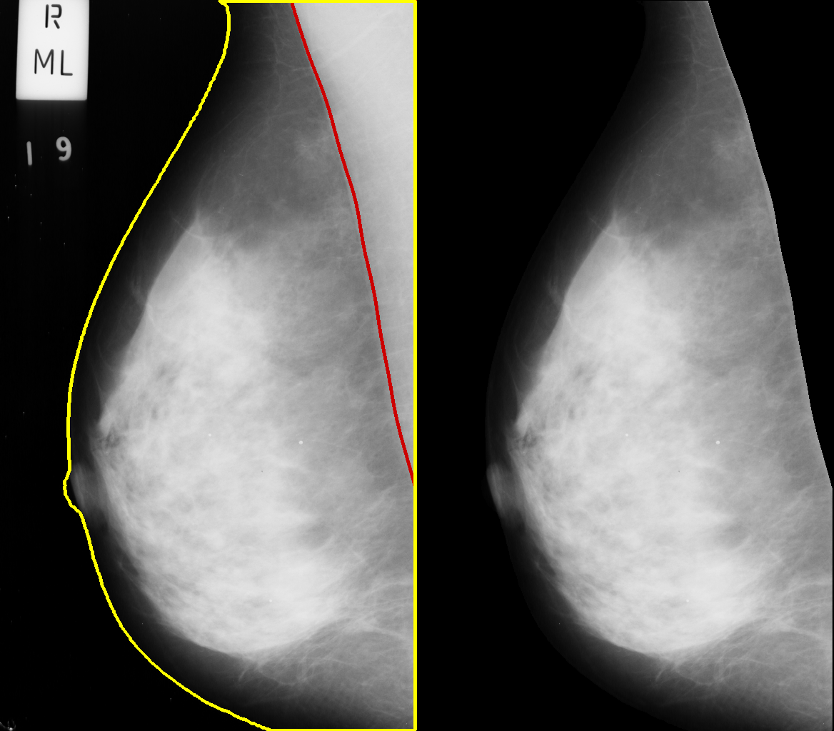

(a) (b)

**Figure 3**: Preprocessing phase illustration (file mdb004, mini-MIAS database). (a) Image before preprocessing. The breast border and pectoral muscle are annotated in yellow and red, respectively. In addition, a label is visible in the upper left corner. (b) The image after preprocessing.

The image registration is performed in two main steps. First, a similarity or a distance measure is computed between the reference image and the transformable image, either globally or locally. Then, the transformable image is warped globally, using a rigid transformation, or locally, using a non-rigid transformation. Each transformation technique is better suited for a different type or types of bilateral mismatches. The rigid transformation is more compatible with global mismatches, such as different scaling, orientation, or position. In addition to its simplicity and computation efficiency, it is relatively robust to noise, due to entire image application. Non-rigid transformation is more suitable for elastic distortions expressed as local mismatches. Nonetheless, this transformation is more complex to implement, it contains many parameters, and it is more sensitive to noise.

To obtain a robust image registration algorithm, we used a rigid image registration method, composed of rotation and translation. This method utilizes image cross-correlation24 as a similarity measure for the translation problem. It aims to minimize the normalized mean square error  between a reference image *f(x,y)* and a transformable image *g(x,y)*, where  is defined as follows:

 (1)

where is the 2D cross-correlation of *f(x,y)* and *g(x,y)*, defined by:

 (2)

In order to detect orientation differences, this method utilizes the Radon transform and its rotation property as follows. The Radon transform is given by:

 (3)

The Radon rotation property can be demonstrated by applying the transformation on a rotated image *(x',y')= f(xcosϕ+ysinϕ,ycosϕ-x sinϕ)*, which yields:

 (4)

Let:

 (5)

The Jacobian of the variables *x, y* equals 1 because the determinant of any rotation matrix equals 1. Substituting (5) into (4) yields:

 (6)

Next, we can find an approximation for the orientation angle *ϕ*, using *θ*n which minimizes the expression  given by:

 (7)

where  is the 1D cross-correlation term, given by:

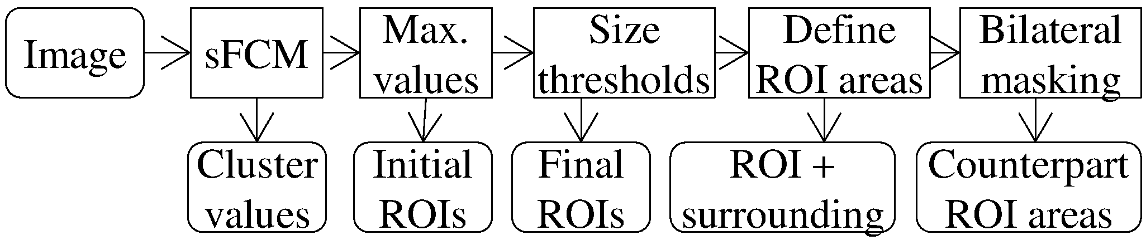

**Figure 4**: ROIs detection and bilateral mapping flowchart.

 (8)

Applying this method on the images in the database shows that none of the image pairs contains any substantial orientation difference. Specifically, the angular resolution was 1 degree, and the deviation range was mostly zeros and generally in the range of -1 to 1.

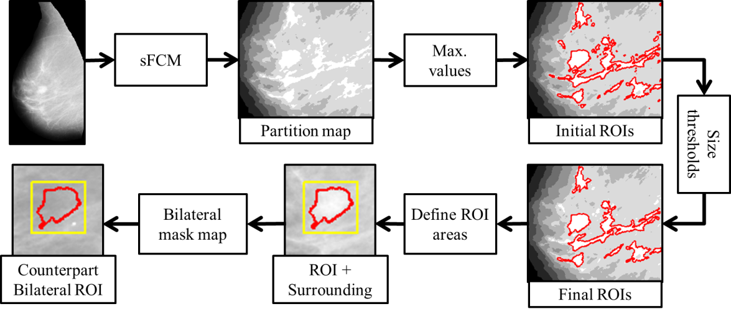

**Figure 5:** Demonstration of ROIs detection and bilateral mapping (file: mdb010, mini-MIAS database).

Therefore, we omit the orientation alignment part and focus on the translation problem, hence only shifting is applied. At the end of this process, each bilateral image pair is aligned. As a result, given the limitations of the transformation, the breasts' anatomical structures are aligned as well. The registration results are used to identify a matched ROI pair depicted on the bilateral mammograms of the left and right breasts, and computing asymmetrical image features.

**Detection of Suspicious ROIs**

Suspicious ROIs detection is a substantial phase of the CAD scheme. We define an ROI as a high density (intensity) region with respect to its surroundings, aimed to represent the fibroglandular tissue or breast abnormalities. Fig. 5 shows a suspicious ROI detection and bilateral image ROI mapping flowchart. We apply a threshold and a clustering method for detecting the dense breast tissue ROIs. The clustering algorithm we use, spatial fuzzy C-means (sFCM)25, is a variant of the K-means algorithm, which accepts both pixel intensities and spatial information into the clustering procedure. This method considers the pixel's neighbors while computing its classification. We initialize the cluster centers as levels that are distributed uniformly between the minimum and maximum levels in the image. After initialization, the algorithm iterates over the image pixels, eventually converging and outputting one of the *N* cluster indexes for each pixel, where *N* found empirically to be in the range of 5 to 10. The cluster indexes (*i=1,…,N*) are sorted by the cluster intensity value. Subsequently, the pixels holding the highest quantification level *N* are marked as initial regions. Each initial region is then tested according to its size. Based on our experimental results, two empirically determined threshold values are selected and applied to set up the size range of the ROIs. The minimum and maximum ROI sizes are 300 and 15,000 pixels, respectively. ROIs beyond the size range threshold are either ignored, if they are too small, or split into several ROIs, if they are too big. It should be noted that in this work we focused on detection of masses rather than microcalcifications, which are typically easy to detect.

**Feature Extraction and Computation**

After detecting a suspicious ROI, as shown in Fig. 5, we define three areas for feature computation: the amorphous shaped ROI itself (AROI), its surroundings AS, defined as all pixels in a rectangle box bounding the region, and the region's background (ABG), defined as all the pixels belonging to the surroundings but not to the ROI. We then compute image features that include both global features, extracted from each mammogram, and local features, extracted from the three areas defined for each ROI. The global features are divided into two groups. The first group includes statistical features of the image gray levels: mean, histogram peak value, mode, STD, skewness and kurtosis. The second group contains features extracted from the local pixel value fluctuation (LPF) image defined as follows.

 (9)

where *pi,j* is the intensity of the *i*th, *j*th pixel. The features extracted from the LPF image are mean, STD and skewness.

The local features are divided into five groups, the first group contains LPF and contrast features as follows. Contrast is defined by:

 (10)

where *N* is the number of pixels in an area, and ROI and BG denote the region and its background, respectively. Conspicuity is defined as follows:

 (11)

where *NS* denotes number of pixels in the surrounding. The other features in the first group are mean, STD, skewness and kurtosis of the *LPFROI* and *LPFBG*.

For the second group, we first define the radial lengths by:

 (12)

where *Ci* are the coordinates of the *i*th contour pixel, and *COGROI* is the region's center-of-gravity (COG), defined by:

 (13)

The gradients on the contour, denoted ∇i, are defined as the gray level gradients of each contour pixel, facing outwards. The second group contains the mean, STD, skewness and min-max ratio of the radial lengths and contour gradients.

The third group is composed of morphological features, such as size, solidity, and eccentricity. The fourth group contains intensity-based features of the region and its background, including STD, skewness, and kurtosis. The last group consists of features relating to a pixel ratio, defined by:

 (14)

where *Nmin-val* is the number of pixels whose value is the same as the minimum value in the region. Other features in this group, in addition to their average depth, include the distance between the minimum pixels COG and the entire ROI COG. The depth of a pixel is defined as the minimum distance between the pixel and the region contour.

The features presented above are extracted for each region, resulting in a vector of 36 unilateral features, as listed in Table 1.

**Table 1**: the extracted features

|  |  |
| --- | --- |
| **Feature name** | **Details** |
| Global Features | |
| 1. Mean image gray level | , where is the number of pixels in the breast region |
| 2. Histogram counts normalized peak value |  |
| 3. Histogram normalized peak value's gray level |  |
| 4. Gray levels standard deviation |  |
| 5. Gray levels skewness |  |
| 6. Gray levels kurtosis |  |
| 7. Mean image LPF value | , computed similarly to feature no.1 |
| 8. Image LPF standard deviation | , computed similarly to feature no.4 |
| 9. Image LPF skewness | , computed similarly to feature no.5 |
| Local Features | |
| 10. Contrast | Eq. (10) |
| 11. Conspicuity | Eq. (11) |
| 12. Mean region LPF value | , computed similarly to feature no.1 |
| 13. Region LPF standard deviation | , computed similarly to feature no.4 |
| 14. Region LPF skewness | , computed similarly to feature no.5 |
| 15. Mean background LPF value | , computed similarly to feature no.1 |
| 16. Background LPF standard deviation | , computed similarly to feature no.4 |
| 17. Background LPF skewness | , computed similarly to feature no.5 |
| 18. Mean radial length value | , computed similarly to feature no.1 |
| 19. Radial length standard deviation | , computed similarly to feature no.4 |
| 20. Radial length skewness | , computed similarly to feature no.5 |
| 21. Radial length min-max ratio |  |
| 22. Mean gradient value | , computed similarly to feature no.1 |
| 23. Gradient standard deviation | , computed similarly to feature no.4 |
| 24. Gradient skewness | , computed similarly to feature no.5 |
| 25. Region size |  |
| 26. Eccentricity | , where and are the lengths of the major and minor axes of an ellipse with the same second moments as the region |
| 27. Solidity | , where is the number of pixels inside the convex hull of the region |
| 28. Region gray level standard deviation | , computed similarly to feature no.4 |
| 29. Region gray level skewness | , computed similarly to feature no.5 |
| 30. Region gray level kurtosis | , computed similarly to feature no.6 |
| 31. Background gray level standard deviation | , computed similarly to feature no.4 |
| 32. Background gray level skewness | , computed similarly to feature no.5 |
| 33. Background gray level kurtosis | , computed similarly to feature no.6 |
| 34. Minimum value pixels quantitative ratio | Eq. (14) |
| 35. Center position shift |  |
| 36. Mean depth of minimum value pixels | , where are the coordinates of the minimum value pixels |

Next, the ROI detected in a mammogram is used as a region mask. When this ROI is directly mapped to its aligned bilateral counterpart mammogram, it produces a matched ROI. In the same manner, a set of image features are extracted from the matched ROI, generating a matching unilateral feature vector. Then, an asymmetrical image feature vector is generated by subtracting the matching feature vector from the original feature vector. Finally, the asymmetrical image features for each ROI are concatenated with its unilateral features.

After generating a features matrix, we apply feature selection (FS) using a sequential forward floating selection (SFFS) algorithm26 in order to select optimal features and reduce the feature space dimensionality. Due to the differences between the density categories, different features may best characterize an abnormality in each category.

Feature selection methods can be divided into two types: wrapper methods and filter methods27. Wrapper methods use a predictive model to score feature subsets based on cross-validation. As wrapper methods train a new model for each subset, they are very computationally intensive. Moreover, though they usually provide the best performing feature set for that particular type of model, they are prone to over-fitting.

Filter methods analyze intrinsic properties of data, independent of classifier output, thus using a proxy measure instead of the error rate to score a feature subset. This measure is chosen to be fast to compute, while still capturing the usefulness of the feature set. Filter methods are usually less computationally intensive than wrappers, and produce a feature set which is not tuned to a specific type of predictive model26. Hence, they are more useful for exposing the relationships between the features. Therefore, utilizing this approach is usually considered as another preprocessing phase, and even when applied to the entire dataset is robust to overfitting27, 28.

Given the sizes of the available datasets, and for the sake of robustness, we used the SFFS algorithm which implements a filter approach. In particular, the SFFS algorithm finds the features that maximize the following optimization criterion29:

, (15)

where is the within-class scatter matrix: . is the covariance matrix for the *i*th class, and **x** is the feature vector.

, is the number of samples in the *i*th class out of a total of samples.

is the mixture scatter matrix given by:

Hence, is actually the covariance matrix of the feature vector with respect to the global mean vector, . In this way, the algorithm captures the intrinsic properties of the feature space, independently of the classifier.

The 161 MIAS cases were divided into three categories according to their density labels. However, each of these categories contains approximately 54 cases, thus to decrease the risk of overfitting a subset of only five features was selected for each category. Feature subsets with less than five features were tested but did not provide sufficient characterization and were therefore omitted. Similarly, a five features subset was selected from each of the four density categories in the INbreast database.

The feature selection phase yielded several feature subsets (three or four, depending on the specific database used), which were then combined to produce the final feature set as the union of these subsets. Since some features repeated in multiple subsets, the final feature set included less features than the sum of all subsets.

The MIAS final feature set included ten features: two local unilateral features (size and gray-STD); eight asymmetry features, of which one global (mean-LPF) and seven local features (contrast, mean-LPF, gradient-skew., solidity, gray-STD, gray-skew., and gray-BG-skew.). The INbreast final feature set included eleven features: eight unilateral features, of which one global (histogram peak) and seven local features (conspicuity, size, contrast, mean and STD of radial length, eccentricity, and gray-ROI-skew); three global asymmetry features (histogram peak, gray-STD, and LPF-STD). It should be noted that these differences in the selected feature sets for the two datasets, are reasonable due to the significant differences between the two datasets, particularly the differences in acquisition methods and quality of images.

**A Machine Learning Classifier and Two Scoring Methods**

In order to calculate a likelihood score of each detected ROI harboring a suspicious breast lesion, we trained and optimized a naïve Bayes linear classifier30. This classifier was chosen as it does not incorporate any hyper-parameters fine-tuning and hence is very robust. By fusion of the selected image features, the classifier generates a prediction score *ϕj*, ranging from 0 to 1 for each testing ROI *xj*. This score specifies the posterior probability for a sample *xj* belonging to the positive (abnormal) class *C1*, given by:

. (16)

Two naïve Bayes classifiers were trained for comparing detection performance between the proposed CAD scheme and a unilateral (single image) CAD scheme, using identical training and testing methods. The image features exploited in our CAD scheme are both unilateral image features and bilateral image feature differences, whereas the unilateral CAD scheme exploits solely unilateral image features.

We use and compare two final CAD cueing or scoring methods. The first is an ROI-based cueing method similar to the conventional CAD schemes, which may cue multiple suspicious regions (with or without including the true positive lesions). The second is a case-based cueing method, in which the CAD scheme only provides one prediction score for each testing case , as in 31. In the case-based cueing method, we sort the scores of all the detected ROIs in each case and select the maximum score as the final case-based CAD prediction score. The performance levels and the different characteristics of these two scoring methods are compared and discussed in the sequel.

**CAD Performance Assessment**

In order to minimize the potential case selection bias in the classifier training and testing process, the performance of our CAD scheme is evaluated using a leave-one-case-out (LOCO) cross-validation method32, applied to all cases in each database. During this process, the detected ROIs from all cases but one are used to train the classifier. The optimized classifier is then applied to ROIs detected in the remaining testing case. This process is iteratively repeated for all cases, thus each case is used once as an independent testing case. Each ROI and each case have one prediction score, specifying the likelihood of harboring a true positive breast lesion. Two evaluation methods were applied to assess ROI-based and case-based CAD performance. The ROI-based performances are processed using free-response receiving operating characteristic (FROC) curves33. The *x* axis of the FROC curve, annotated non-lesion localization fraction (NLF), corresponds to the number of false positives per image (FPPI). The FROC *y* axis is annotated lesion localization fraction (LLF), identical to sensitivity. The true positive ROI detection sensitivities can be assessed under different false positive rates, using varying operating thresholds. Statistical analysis of the FROC curves was performed using a freely available R package[1], based on the JAFROC method34.

The case-based performance is evaluated using a conventional ROC data analysis method, processing all case-based prediction scores in our testing dataset. The area under the ROC curve (AUC) is used as a performance assessment index to evaluate the final case-based CAD scheme performance. Statistical analysis of the ROC curves was performed using our in-house-developed Matlab package, based on bivariate Chi-square analysis.

**III. RESULTS**

Fig. 7 and Fig. 8 present and compare the FROC and ROC performance levels, generated by the bilateral asymmetry CAD scheme and by the single image unilateral CAD scheme, respectively. Fig. 7(a) and Fig. 8(a) show the FROC curves computed for the ROI-based CAD cueing method, whereas Fig. 7(b) and Fig. 8(b) show the ROC curves and AUC values computed for the case-based and mammogram-based cueing methods.

**Table 2**: Performance comparison between unilateral (Uni.) and fused features approaches. The first two columns specifies the database and the dataset used: MIAS database is tested for each density category individually and for the entire data; INbreast database is tested in mammogram-based and case-based approaches where in one experiment any lesion considered positive (Any anomaly), and in the other only lesions with BIRADS rating equal or above 4 considered positive. This table shows AUC of ROC curves including p-value of the two approaches difference, in addition to LLF value where NLF=1 of the FROC curves.

|  |  |  |  |  |  |  |  |
| --- | --- | --- | --- | --- | --- | --- | --- |
| Database | Dataset | AUC | | | LLF (NLF = 1) | | |
| Fused | Uni. | p-value | Fused | Uni. | p-value |
| MIAS  (case-based) | Fatty | 0.81 | 0.79 | 0.77 | 0.76 | 0.81 | 0.45 |
| Glandular | 0.81 | 0.68 | 0.18 | 0.84 | 0.64 | 0.03 |
| Dense | 0.73 | 0.72 | 0.91 | 0.68 | 0.55 | 0.04 |
| All densities | 0.80 | 0.74 | 0.25 | 0.73 | 0.63 | 0.05 |
| INBreast  (mammogram-based) | BIRADS≥4 | 0.85 | 0.78 | 0.15 | 0.79 | 0.72 | 0.45 |
| Any anomaly | 0.82 | 0.75 | 0.08 | 0.75 | 0.72 | 0.72 |
| INBreast  (case-based) | BIRADS≥4 | 0.79 | 0.72 | 0.35 | 0.79 | 0.72 | 0.45 |
| Any anomaly | 0.76 | 0.73 | 0.72 | 0.75 | 0.72 | 0.72 |

Table 2 shows the lesion detection sensitivities (LLF values) at one FPPI (NLF=1) when using the ROI-based CAD cueing method in the two last columns. Applying the proposed bilateral asymmetry CAD scheme to three categories of fatty, glandular, and dense mammograms yielded detection sensitivities of 0.76, 0.84 and 0.68, respectively. In comparison, the detection sensitivity at NLF=1, obtained using the unilateral CAD scheme, were 0.81, 0.64 and 0.55, respectively, with p-values of 0.45, 0.03 and 0.04, respectively. When applying the proposed CAD scheme on fatty (less dense) mammograms, the scheme does not perform better than the conventional unilateral CAD scheme. However, as the mammographic density increases, the proposed scheme yields significantly higher detection performance. When we merged all 161 cases into one group, the detection sensitivity at one FPPI increased by 15.9%, from 0.63 using the unilateral CAD scheme, to 0.73 using the bilateral CAD scheme (p-value of 0.05). The INbreast experiment reveals similar trend where the bilateral approach obtains higher sensitivity, although the differences are not statistically significant.

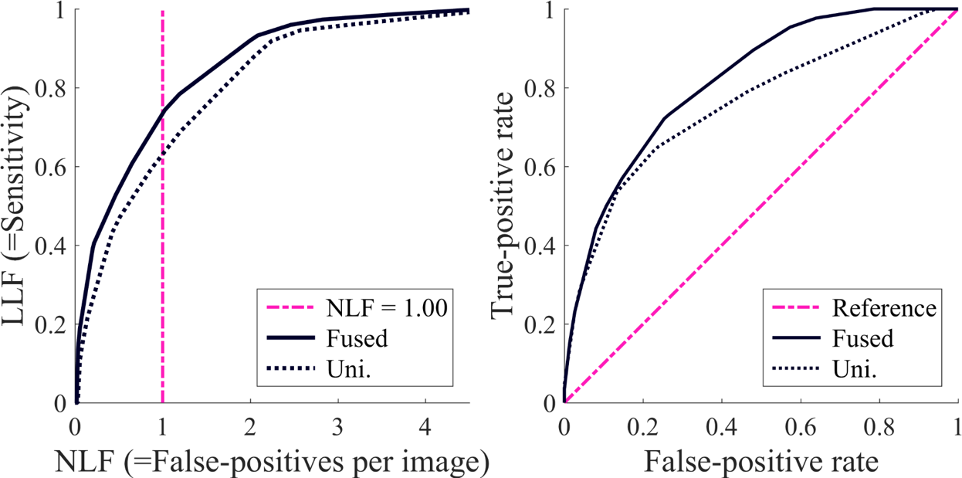

(b)

**Figure 7:** Performance curves for fused and unilateral features CAD schemes on MIAS database: (a) FROC curves of the ROI-based approach. (b) ROC curves of the case-based approach, AUC values are 0.80 and 0.74 for fused and unilateral approaches, respectively.

Case-based ROC curves, obtained using two schemes, are compared in the middle columns of Table 2. On the one hand, the proposed bilateral CAD scheme performance, applied separately to three density categories, obtains AUC values of 0.81, 0.81, and 0.73, respectively. On the other hand, using the unilateral CAD scheme, AUC values were reduced to 0.79, 0.68, and 0.72, respectively. When applying the two CAD schemes to all 161 cases merged into one group, the AUC values were 0.79 and 0.73 for the bilateral CAD scheme and unilateral CAD scheme, respectively. This is an 8.2% detection rate increase obtained by using the bilateral scheme relative to the unilateral scheme.

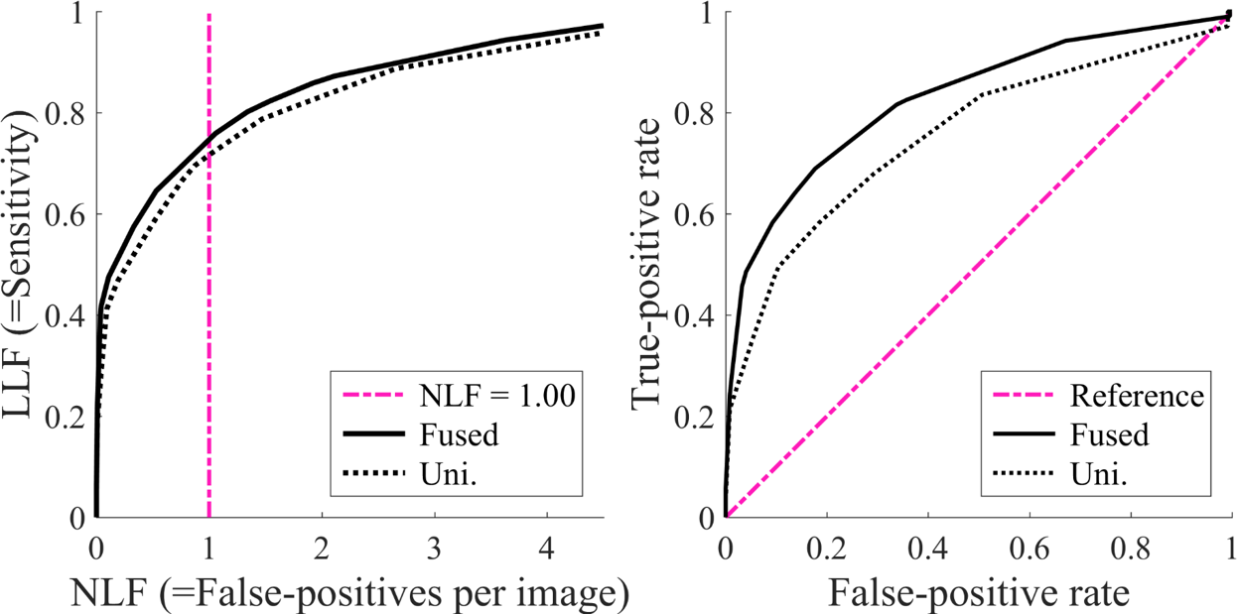

(a) (b)

**Figure 7:** Performance curves for fused and unilateral features CAD schemes on INbreast database: (a) FROC curves of the ROI-based approach. (b) ROC curves of the mammogram-based approach, AUC values are 0.82 and 0.75 for fused and unilateral approaches, respectively.

Examining the schemes performance on the INbreast database where considering any anomaly as positive provide AUC values of 0.76 and 0.73 when using case-based approach, and 0.82 and 0.75 when using mammogram-based approach, for bilateral and unilateral schemes, respectively. Interestingly, when considering only the highly suspicious lesions (BIRADS≥4) as positive, the performances increased to AUC values of 0.79, 0.72, 0.85, and 0.78, respectively. Figs. 9-10 present some typical examples of bilateral mammograms and the classification results. Fig. 9 presents typical examples of false positive and false negative cases, whereas Fig. 10 presents some positive cases that were correctly identified.

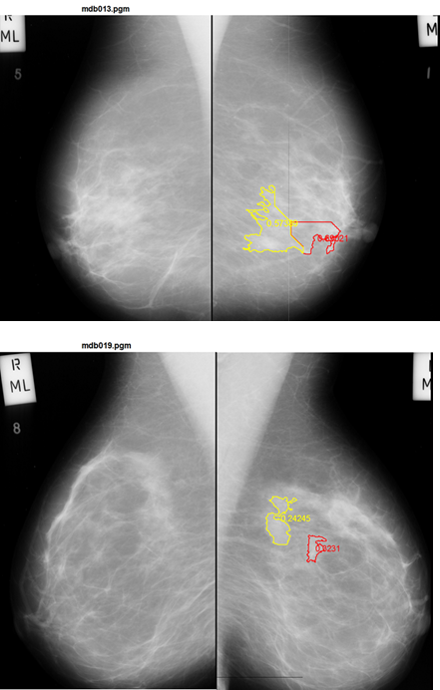

**Figure 9:** Examples of incorrectly classified mammograms. Red contours- false positive ROI; yellow contours- false negative ROIs.

**IV. DISCUSSION**

Bilateral mammographic tissue asymmetry is a substantial indicator for radiologists in detection of suspicious mammographic lesions that may indicate having breast cancer or developing cancer in the near future. However, such information has not been exploited efficiently in development of CAD schemes to date. Most previously reported two image-based CAD schemes use two ipsilateral (CC and MLO) view images8, 35. These schemes aim to match suspicious lesions detected on CC and MLO view mammograms acquired from one breast. Only few schemes have used two bilateral images of the left and right breasts39. The results reported for the schemes proposed in the literature, for the same databases used in this work, range between an AUC of 0.74 and 0.9436-38. However, since different studies utilize totally different pre-processing techniques, different features and different classifiers, comparison between the different approaches is not straitforward. Therefore, in this paper, we compared our approach, namely fusion of bilateral and unilateral features, with the classical approach, using the same pre-processing method, same features and same classifier, and showed the potential of using a combination of the two.

The proposed scheme has the following unique characteristics that have not been tested and reported in previous studies. First, due to the difficulty and unreliability of automated segmentation of breast lesions partially occluded by fibro-glandular tissues40, our CAD scheme does not use lesion segmentation. Second, unlike other non-lesion segmentation CAD schemes, which use fixed size ROIs (e.g., 41), our scheme automatically detects and selects suspicious ROIs with varying sizes. This attribute makes the computed image features more sensitive and accurate in representing suspicious lesions42. Third, previous schemes analyze either global or local bilateral image features, aiming to predict cancer risk15-19 or to detect cases with tissue asymmetry20. In contrast, our CAD scheme combines both local and global bilateral information. In addition, the local features are computed using three ROI areas. This approach can provide more detailed characteristics of the suspicious ROI, whereas previous methods extract image features only from the ROI. Fourth, since cueing a high percentage of false positive detections is likely to reduce radiologists’ reading and interpreting screening mammograms performance43, we investigated a case-based cueing method.



**Figure 9:** Examples of typical positive cases that were correctly identified; Blue contours- the detected (true positive) ROI.

Despite the possible detection of multiple suspicious ROIs in one case, this method generates a single detection score per case. This approach is similar to a final BIRADS rating score assigned by the radiologist for each case, regardless of how many suspicious lesions are visually detected in it. Although using a case-based method does not mark a lesion location, it provides a risk score. This score serves as a warning signal meant to draw radiologists' attention to high risk cases without wasting resources while discarding a large number of vague false positive detections. Based on the ROC concept and the fact that a large fraction of “missed” cancers are detectable in a retrospective review44, a case-based cueing method is a promising one in future clinical applications. Lastly, we systematically compared the potential advantages and limitations of our bilateral CAD scheme with those of the conventional unilateral CAD scheme. These two CAD schemes were trained and tested using the same image dataset, classifier, LOCO validation method, and image features (with and without using bilateral matched ROIs). Thus, any difference in performance of these two approaches is solely due to the fundamental differences between them.

While carrying out the experiment, we observed a number of interesting phenomena, which have not yet been reported in CAD related literature. For example, when applying a CAD scheme on fatty mammograms, there is no advantage to using a bilateral image-based scheme. The results show that in a mostly fatty mammogram, abnormalities (or suspicious ROIs) are easier to detect, regardless of the counterpart bilateral mammogram. As a result, the unilateral CAD scheme in our study yielded better performance (e.g., higher AUC value) than the proposed bilateral CAD scheme.

As previously mentioned, the results were not statistically significant, probably due to the small datasets at hand and the resulting AUC STD, that requires even larger AUC value difference to produce a significant difference. Nevertheless, as the mammographic density increases, the performance of our scheme shows better performance. Despite this limitation with fatty mammograms, developing and using bilateral image-based CAD can clinically assist radiologists in interpreting mammograms, since their sensitivity in detecting breast cancer decreases as mammographic density increases45.

Another interesting phenomenon was revealed when we compared both ROI-based and case-based cueing methods, as shown in Fig. 7 and Fig. 8. Although ROI-based and case-based CAD performance patterns (or FROC and ROC curves) are not identical, the new bilateral image-based CAD scheme is overall superior. Specifically, comparing the AUC values, presented in Table 2, shows higher AUC values when applying the proposed CAD scheme to the entire dataset, as well as to each of the three density subgroups. This result suggests that developing the bilateral image-based CAD scheme may be more suitable for implementing a new case-based CAD cueing approach in the future clinical application.

Although all tested scenarios show the new bilateral image-based CAD scheme outperforms the unilateral image-based one, none of the performance differences (AUC values) are significant (p<0.01). This may be due to dataset size, where the MIAS database includes 161 cases, which are approximately 54 cases per tissue density category. The INbreast database is even smaller, thus having similar problem. A small dataset generates large AUC value STD, requiring even larger AUC value difference to produce a significant result. Nonetheless, despite the dataset used in this work being larger than datasets used in other works13,15,16, its size is not enough to provide the desired significance level. In order to increase the system robustness, and due to the dataset size limitation, the classifier used in this study is the naïve Bayes classifier. This is a linear discriminant analysis classifier which assumes independency between features. This assumption is generally incorrect, but it reduces the number of classifier parameters. In addition, it is much simpler than other widely used classifiers, consequently more robust and tends to show less overfitting. Therefore, the new CAD concept and scheme reported in this paper can be further optimized and tested in future studies, with large and more diverse image databases, possibly as compared with radiologists’ performance.

**V. CONCLUSIONS**

The proposed scheme automatically assesses the level of bilateral asymmetry, indicates the risk of having a breast abnormality, and can alert the radiologist if an intensive examining is required. Thus, it is applicable to digital mammography CAD systems.

**V. ACKNOWLEDGEMENT**

This work is supported in part by Grant ISF 1337/14 to the Holon Institute of Technology, Holon, Israel from the Israeli Science Foundation.

**VI. DISCLOSURE OF CONFLICTS OF INTEREST**

No benefits in any form have been or will be received from a commercial party related directly or indirectly to the subject of this manuscript.

**REFERENCES**

1 R. Siegel, J. Ma, Z. Zou, A. Jemal, "Cancer statistics, 2014.," CA: a cancer journal for clinicians **64**, 9-29 (2014).

2 W. Berg, L. Gutierrez, M. NessAiver, "Diagnostic accuracy of mammography, clinical examination, US, and MR imaging in preoperative assessment of breast cancer 1," Radiology **233**, 830-849 (2004).

3 J. Brodersen, V.D. Siersma, "Long-term psychosocial consequences of false-positive screening mammography," Ann Family Medicine **11**, 106-115 (2013).

4 W.A. Berg, C. Campassi, P. Langenberg, M.J. Sexton, "Breast imaging reporting and data system: inter-and intraobserver variability in feature analysis and final assessment‏." American Journal of Roentgenology **174**, 1769–1777 (2000).

5 J.J. Fenton, L. Abraham, S.H. Taplin, B.M. Geller, P.A. Carney, C. D’Orsi, J.G. Elmore, W.E. Barlow, B.C.S. Consortium, "Effectiveness of computer-aided detection in community mammography practice‏," Journal of the National Cancer Institute **103**, 1152-1161 (2011).

6 D. Gur, J.H. Sumkin, H.E. Rockette, "Changes in breast cancer detection and mammography recall rates after the introduction of a computer-aided detection system," J. Natl. Cancer Inst. **96**, 185-190 (2004).

7 R.M. Nishikawa, D. Gur, "CADe for early detection of breast cancer-current status and why we need to continue to explore new approaches.," Academic radiology **21**, 1320-1321 (2014).

8 B. Zheng, J.K. Leader, G.S. Abrams, A.H. Lu, L.P. Wallace, G.S. Maitz, D. Gur, "Multiview-based computer-aided detection scheme for breast masses," Med. Phys. **33**, 3135-3143 (2006).

9 B. Zheng, X. Wang, D. Lederman, J. Tan, D. Gur, "Computer-aided detection- the effect of training databases on detection of subtle breast masses," Academic Radiology2010).

10 A. Kelder, Y. Zigel, D. Lederman, B. Zheng, "A new computer-aided detection scheme based on assessment of local bilateral mammographic feature asymmetry-a preliminary evaluation," in Engineering in Medicine and Biology Society, Vol. 1 (2015), pp. 6394–6397.

11 P. Samardar, E.d. Paredes, M. Grimes, J. Wilson, "Focal asymmetric densities seen at mammography: US and pathologic correlation 1," Radiographics **22**, 19-33 (2002).

12 R. Blanks, "Observer variability in cancer detection during routine repeat (incident) mammographic screening in a study of two versus one view mammography," Journal of medical screening **6**, 152-158 (1999).

13 M. Karnan, K. Thangavel, "Automatic detection of the breast border and nipple position on digital mammograms using genetic algorithm for asymmetry approach to detection of microcalcifications," Computer methods and programs in biomedicine **87**, 12-20 (2007).

14 K. Bovis, S. Singh, "Detection of masses in mammograms using texture features," in ICPR, Vol. 2 (2000), pp. 267-270.

15 R.J. Ferrari, R.M. Rangayyan, J.L. Desautels, A.F. Fre`re, "Analysis of asymmetry in mammograms via directional filtering with Gabor wavelets," IEEE Transactions on Medical Imaging **20**, 953-964 (2001).

16 R.M. Rangayyan, R.J. Ferrari, A.F. Fre`re, "Analysis of bilateral asymmetry in mammograms using directional, morphological, and density features‏," Journal of Electronic Imaging **16**, 013003-013001-013003-013012 (2007).

17 X. Wang, D. Lederman, J. Tan, X. Wang, B. Zheng, "Computerized detection of breast tissue asymmetry depicted on bilateral mammograms: a preliminary study of breast risk stratification‏," Academic radiology **17**, 1234-1241 (2010).

18 X. Wang, D. Lederman, J. Tan, "Computerized prediction of risk for developing breast cancer based on bilateral mammographic breast tissue asymmetry," Medical engineering & physics **33**, 934-942 (2011).

19 X. Wang, D. Lederman, J. Tan, X.H. Wang, B. Zheng, "Computerized prediction of breast cancer risk: comparison between the global and local bilateral mammographic tissue asymmetry‏," in SPIE Medical Imaging‏ (International Society for Optics and Photonics, 2011), pp. 79631L - 79631L.

20 P. Casti, A. Mencattini, M. Salmeri, R.M. Rangayyan, "Analysis of structural similarity in mammograms for detection of bilateral asymmetry‏," IEEE Transactions on Medical Imaging **34**, 662 - 671 (2015).

21 J. Suckling, J. Parker, D. Dance, S. Astley, I. Hutt, C. Boggis, I. Ricketts, E. Stamatakis, N. Cerneaz, S. Kok, "The mammographic image analysis society digital mammogram database," Exerpta Medica. International Congress Series **1**, 375 - 378 (1994).

22 I.C. Moreira, I. Amaral, I. Domingues, A. Cardoso, M.J. Cardoso, J.S. Cardoso, "INbreast: toward a full-field digital mammographic database," Academic radiology **19**, 236-248 (2012).

23 S.M. Kwok, R. Chandrasekhar, Y. Attikiouzel, M.T. Rickard, "Automatic pectoral muscle segmentation on mediolateral oblique view mammograms," IEEE Transactions on Medical Imaging **23**, 1129 - 1140 (2004).

24 M. Guizar-Sicairos, S.T. Thurman, J.R. Fienup, "Efficient subpixel image registration algorithms," Optics Letters **33**, 156-158 (2008).

25 K. Chuang, H. Tzeng, S. Chen, "Fuzzy c-means clustering with spatial information for image segmentation," Computerized Medical Imaging and Graphics **30**, 9-15 (2006).

26 P. Pudil, J. Novovicova, J. Kittler, "Floating search methods in feature selection," Pattern Recognition Letters **15**, 1119-1125 (1994).

27 S. Das, "Filters, wrappers and a boosting-based hybrid for feature selection," in International Conference on Machine Learning, Vol. 1 (2001), pp. 74-81.

28 I. Guyon, A. Elisseeff, "An introduction to variable and feature selection‏," The Journal of Machine Learning Research **3**, 1157 - 1182 (2003).

29 S. Theodoridis and Koutroumbas, "Pattern Recognition", 4ed., Academic Press, 2009.

30 I. Rish, "An empirical study of the naive Bayes classifier‏," IJCAI 2001 workshop on empirical methods in artificial intelligence **3**, 41-46 (2001).

31 M. Tan, W. Qian, J. Pu, H. Liu, B. Zheng, "A new approach to develop computer-aided detection schemes of digital mammograms‏," Physics in medicine and biology **60**, 4413-4427 (2015).

32 M. Esterman, B.J. Tamber-Rosenau, Y.C. Chiu, S. Yantis, "Avoiding non-independence in fMRI data analysis: leave one subject out," NeuroImage **50**, 572-576 (2010).

33 P.C. Bunch, J.F. Hamilton, G.K. Sanderson, A.H. Simmons, "A free response approach to the measurement and characterization of radiographic observer performance," in Application of Optical Instrumentation in Medicine VI (International Society for Optics and Photonics, 1977), pp. 124-135.

34 D. P. Chakraborty, “A brief history of FROC paradigm data analysis,” Acad. Radiol. **20**(7), 915-919 (2013).

35 S. van Engeland, N. Karssemeijer, "Combining two mammographic projections in a computer aided mass detection method," Medical Physics **34**, 898-905 (2007).

36 H.S. Sheshadri, A. Kandaswamy, "Computer aided decision system for early detection of breast cancer," Indian J Med Res **124**, 149-154 (2006).

37 T. Ritu, M. Ankit Kumar, "Breast Cancer Detection Technique and a Way to Data Provenance," International Journal of Innovative Research in Computer and Communication Engineering **5**, 1-6, 2017.

38 G. AmitSharbell, S. Hashoul, P. Kisilev, B. Ophir, E. Walach, A. Zlotnick, "Automatic Dual-View Mass Detection in Full-Field Digital Mammograms," International Conference on Medical Image Computing and Computer-Assisted Intervention (MICCAI), 44-52, 2015.

39 Y.-T. Wu, J. Wei, L.M. Hadjiiski, B. Sahiner, C. Zhou, J. Ge, J. Shi, Y. Zhang, H.-P. Chan, "Bilateral analysis based false positive reduction for computer-aided mass detection," Medical Physics, **34**, 3334-3344, 2007.

40 A. Oliver, J. Freixenet, J. Marti, E. Perez, J. Pont, E.R. Denton, R. Zwiggelaar, "A review of automatic mass detection and segmentation in mammographic images," Medical Image Analysis **14**, 87-110 (2010).

41 G.D. Tourassi, R. Vargas-Voracek, D.M. Catarious Jr, C.E. Floyd Jr, "Computer-assisted detection of mammographic masses: A template matching scheme based on mutual information," Medical Physics **30**, 2123-2130 (2003).

42 X.-H. Wang, S.C. Park, B. Zheng, "Improving performance of content-based image retrieval schemes in searching for similar breast mass regions: an assessment," Physics in medicine and biology **54**, 949 - 961 (2009).

43 R. Hupse, M. Samulski, M.B. Lobbes, R.M. Mann, R. Mus, G.J. den Heeten, D. Beijerinck, R.M. Pijnappel, C. Boetes, N. Karssemeijer, "Computer-aided detection of masses at mammography: interactive decision support versus prompts," Radiology **266**, 123-129 (2013).

44 R.L. Birdwell, D.M. Ikeda, K.F. O’Shaughnessy, E.A. Sickles, "Mammographic Characteristics of 115 Missed Cancers Later Detected with Screening Mammography and the Potential Utility of Computer-aided Detection," Radiol. **219**, 192-202 (2001).

45 P.A. Carney, D.L. Miglioretti, B.C. Yankaskas, K. Kerlikowske, R. Rosenberg, C.M. Rutter, B.M. Geller, L.A. Abraham, S.H. Taplin, M. Dignan, "Individual and combined effects of age, breast density, and hormone replacement therapy use on the accuracy of screening mammography," Annals of internal medicine **138**, 168-175 (2003).

1. Available at http://www.devchakraborty.com/.