Accidents Wheel Happen

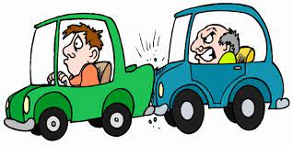
Imagen: publicdomainpictures.net
By: Alexa Ott, Andrew Nguyen, Deautaun Ross, Maria Diaz-Eltgroth

Introduction:
Here in the United States, cars are a part of the daily routine for most adults. Aside from the necessity that they provide for many, cars are also associated with freedom and thrills. However, often people forget about the potential consequences of driving; accidents. Even if an accident doesn’t result in any fatalities or major injuries car accidents are expensive both initially and long term. In this article, we're going to examine what common factors contribute to car accidents.

Overview of the Data:
The dataset used in the article was collected from Kaggle and can be found here. The data was collected from 49 states in the US from January 2016 through December 2021. We edited the dataset down from 47 columns to 31 (each representing a variable such as location, time, weather, etc.). The number of rows: 2,841,185(each representing an accident) stayed the same. We further focused on variables concerning time (day, month, and year), location, and weather conditions. We excluded columns with information such as ID and the descriptions of each accident.

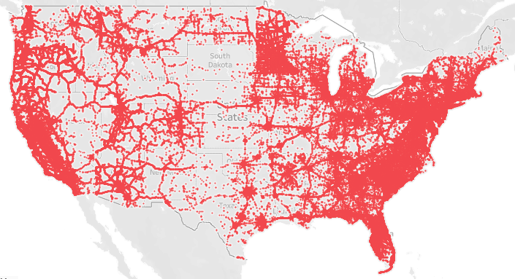
Map of all accidents across the states.

As seen in the map above, the locations of most accidents line up pretty well with the population densities of the United States, which makes sense as more people means more cars and greater potential for accidents. The line patterns are seen align with the major interstate highways, which also is not very surprising as these highways are known for constant dense and fast traffic.

By Timezone:
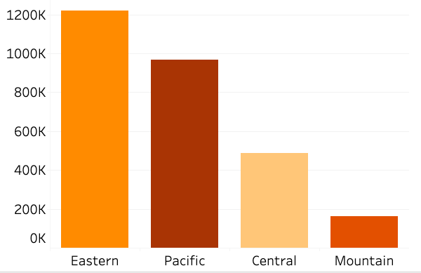
Number of accidents per US time zone.

When breaking up the accidents by time zone the Eastern and Pacific time zones have the majority. The Eastern time zone aligns with the previous graphs as it is the densest population-wise. On the other hand, the number of Pacific accidents is odd as the Central time zone is actually more populous.

Day vs Night:
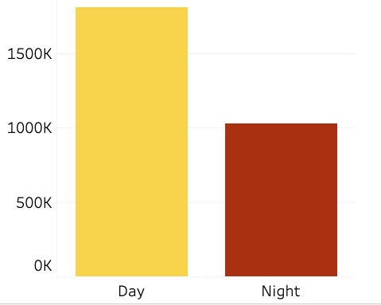
Number of accidents that occurred during the day and at night.

When comparing the number of accidents by day and night, the daytime actually had more accidents. This is probably because the majority of people drive during the daytime.

Day of the Week:
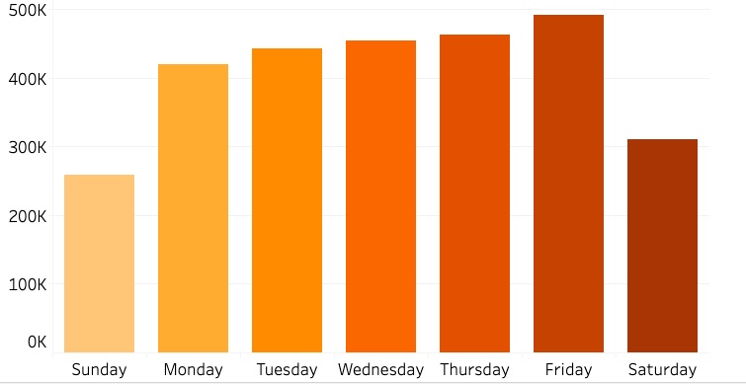
Number of accidents per day of the week
As seen in the graph above there are more accidents during the week. This is probably due to work and or school commutes, as these tend to happen during the week. While on the weekends there is a lot less work commute, and chances are many probably don’t go out on the weekends in general.

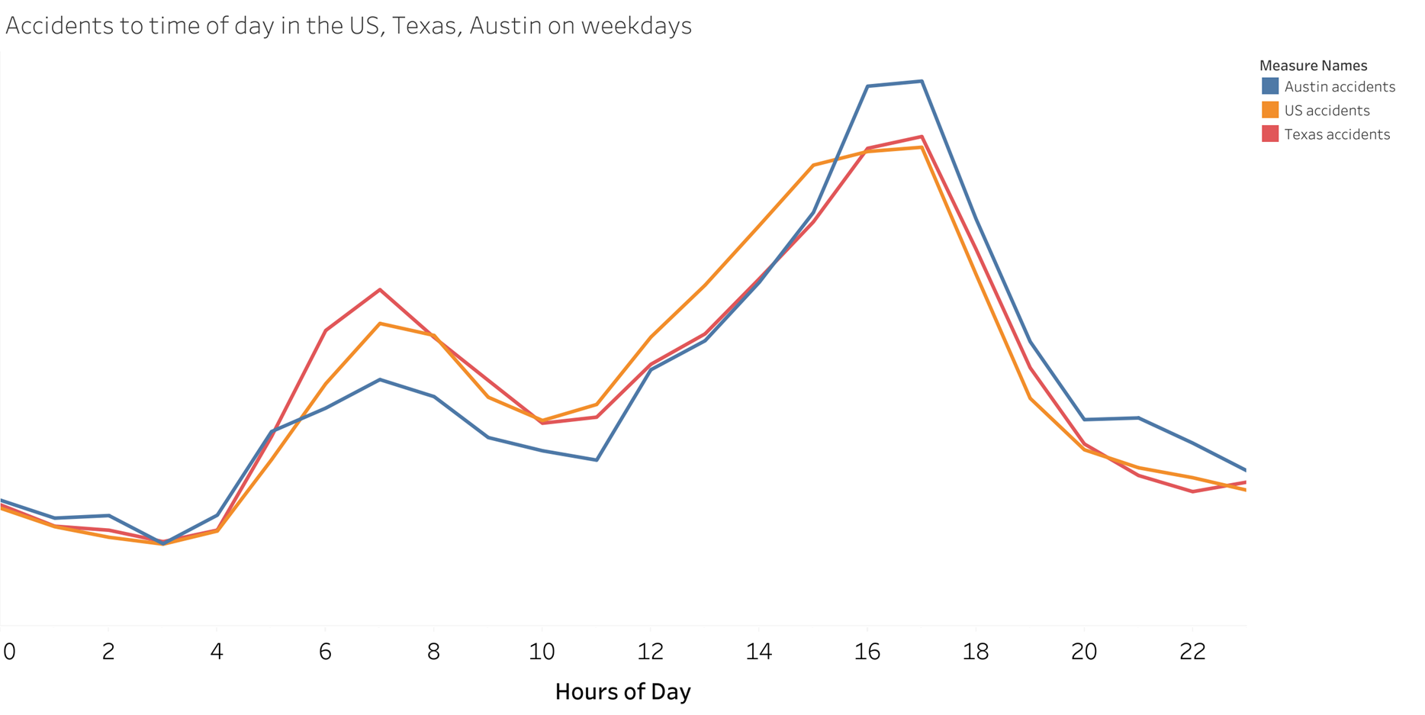
Number of accidents based on hours of the day on the weekdays.

In the graph above, there are obvious spikes in accidents during the ‘rush hours’ on the weekdays, we can see that there are two spikes in the graph during the morning rush hour and the evening rush hour. This can be explained by the increase of drivers during this time since most people leave for work/school during the morning rush hour and they drive home down the evening rush hour.

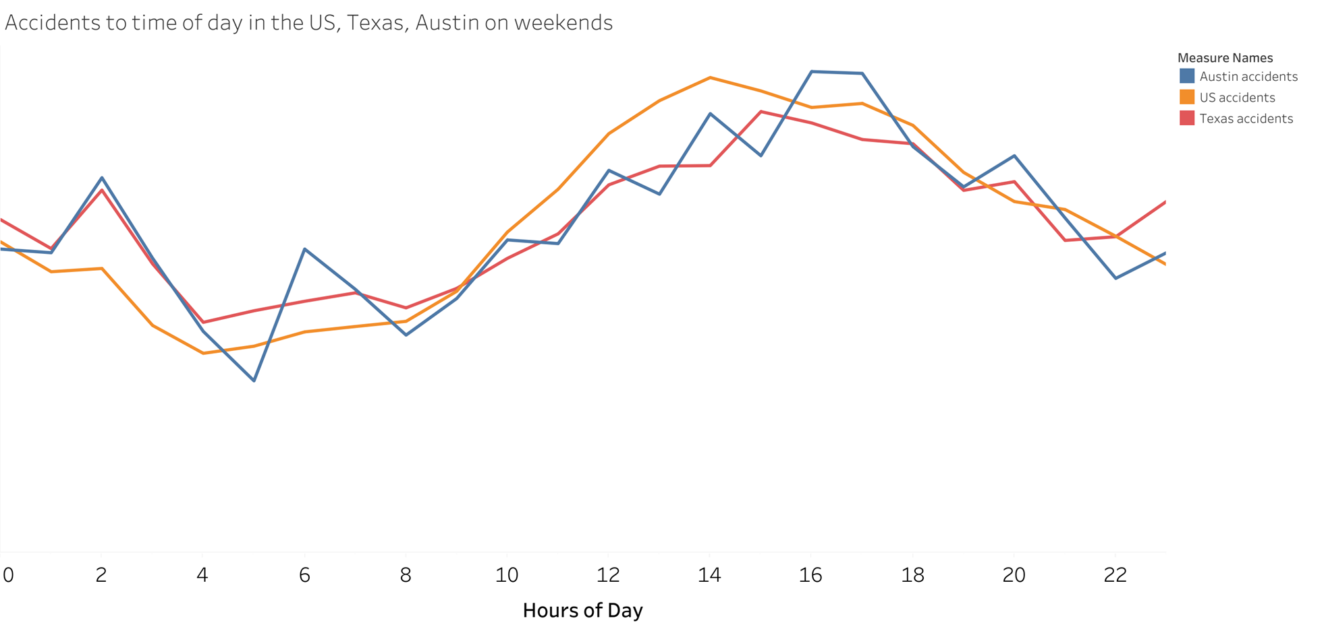
Number of accidents based on hours of the day on weekends.

In the graph above, there are obvious spikes in accidents during the ‘rush hours’ on the weekdays, we can see that there are two spikes in the graph during the morning rush hour and the evening rush hour. This can be explained by the increase in drivers during this time since most people leave for work/school during the morning rush hour and they drive home during the evening rush hour.

Number of accidents per month:

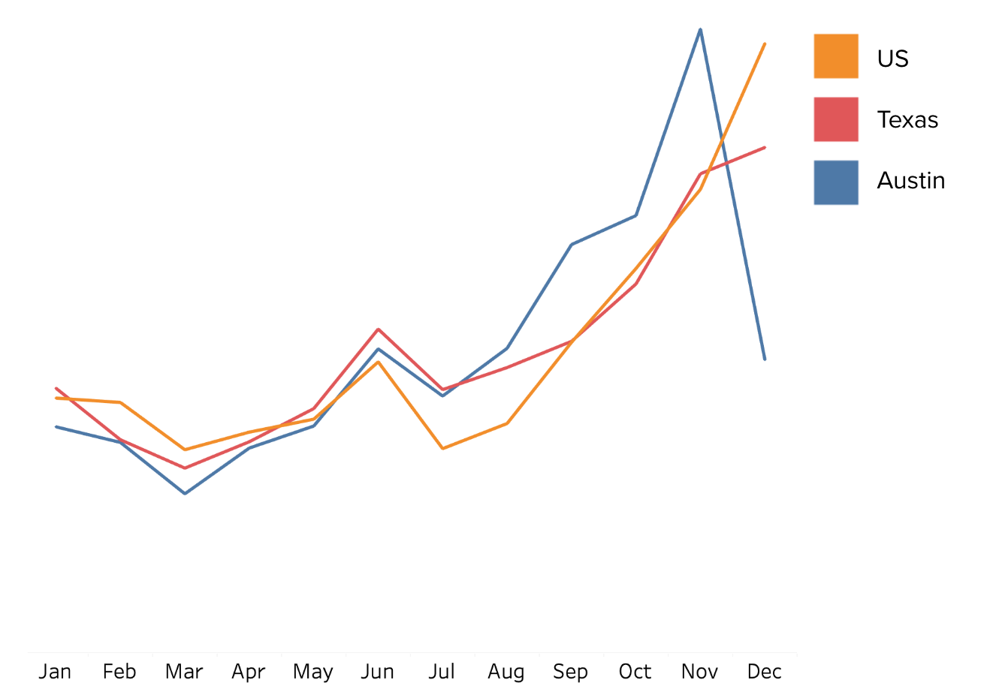
Number of accidents by month in the US, Texas, and Austin from 2016 to 2021.

For the US, Texas, and Austin there seems to be an increase in accidents from September through December. This may be due to back to school in the early fall and of course generally more traveling around the holiday season. Although it looks like Austin actually had fewer accidents in December, this was probably due to a lack of data actually collected as this was towards the end of the collection period.

Accident layout per year: United States
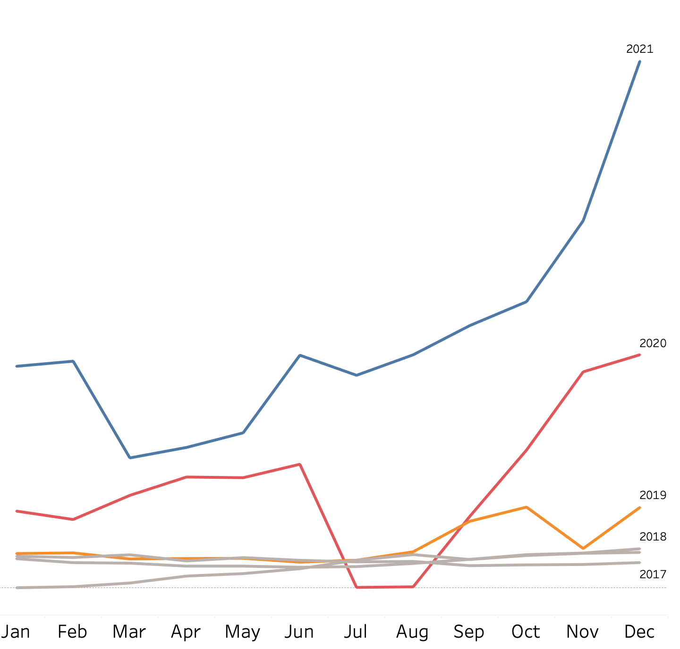
Accident monthly layout per year of the United States.

When examining the years 2016 through 2018 there seems to be a pretty constant number of accidents per month. The main reason why 2016 seems to have fewer accidents is that there just was not a lot of data collected yet (we doubt only 7 accidents happened in the entire United States in January). 2019 is fairly similar to previous years, except starting in August there seems to be a steady increase in the number of accidents. However, this does not compare to 2020 and 2021.
The early months of 2020 saw a huge increase in the number of accidents compared to previous years. Then when the pandemic lockdown began there was a sharp decline in the number of accidents in the summer months as very few people were on the roads around this time. Then starting from August there is a pretty consistent increase in the number of accidents through the end of the year. This is probably due to more people being forced back into work and school again.
Somehow 2021 was even more chaotic than 2020. The initial number of accidents is even higher than in 2020. Although there was a drop from February to March potentially due to some late severe winter weather, which in turn repelled people from the roads. As pandemic restrictions were lifted and the vaccine became available, there was a sharp increase in the number of accidents from May through June. However, when more variants were popping up and people were more cautious again there was a short decrease from June to July. Again though at around the time school starts there is a continued sharp increase in accidents through to the end of the year.

Accident layout per year: Texas
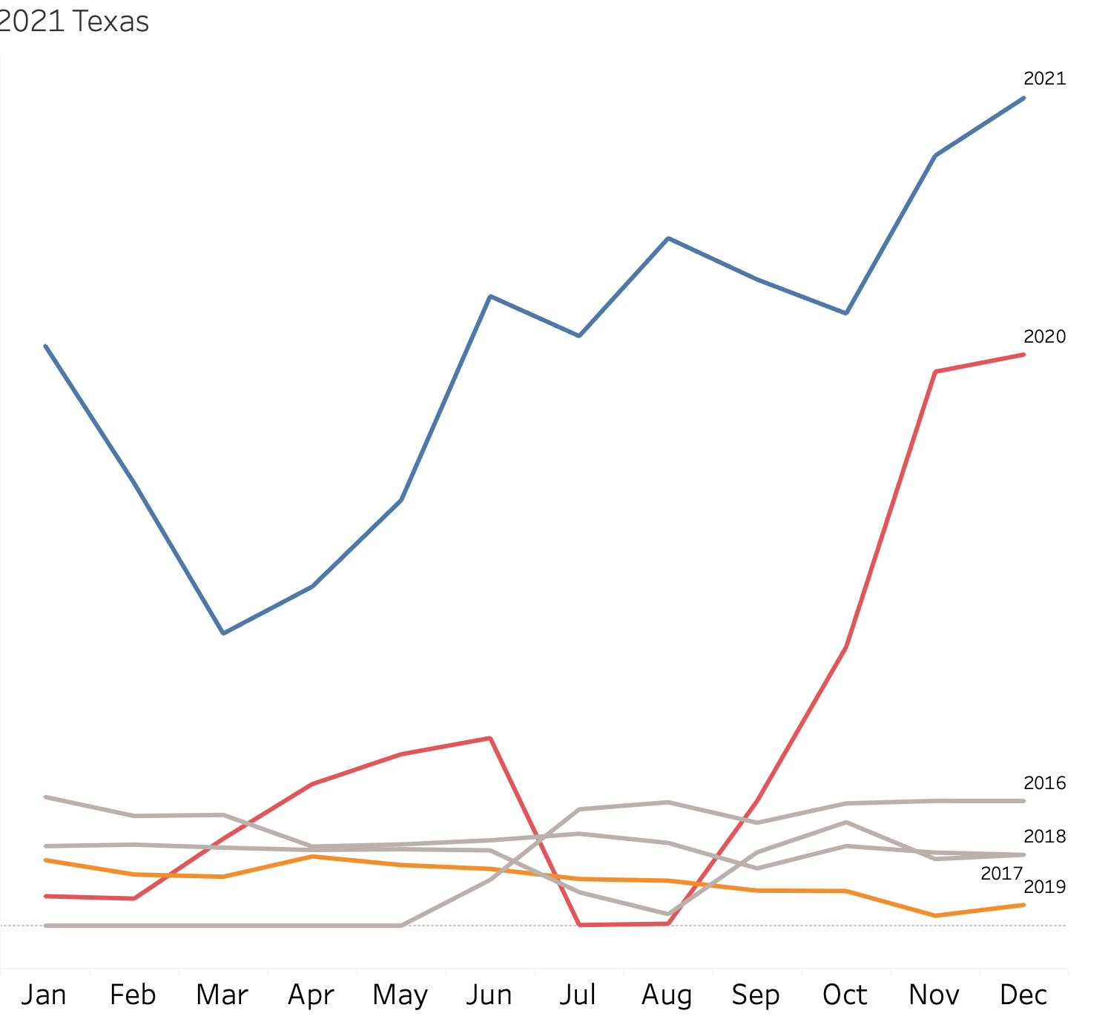
Accident monthly layout per year in Texas.

Similar to the previous graph of the United States, 2016 to 2018 was fairly consistent, but 2019 was also stagnant unlike the US as a whole. 2020 was initially normal, and then gradually increased until the lockdown was taken seriously around June in Texas. Then similarly to the rest of the country, there was a drop in the number of accidents until the end of summer during the lockdown. Then again starting from August there is a pretty consistent increase through the end of the year more than likely due to school and work obligations. Overall 2021 in Texas was fairly reflective of the rest of the country, except during the summer there was no real cooldown period this time.

Accident layout per year: Austin
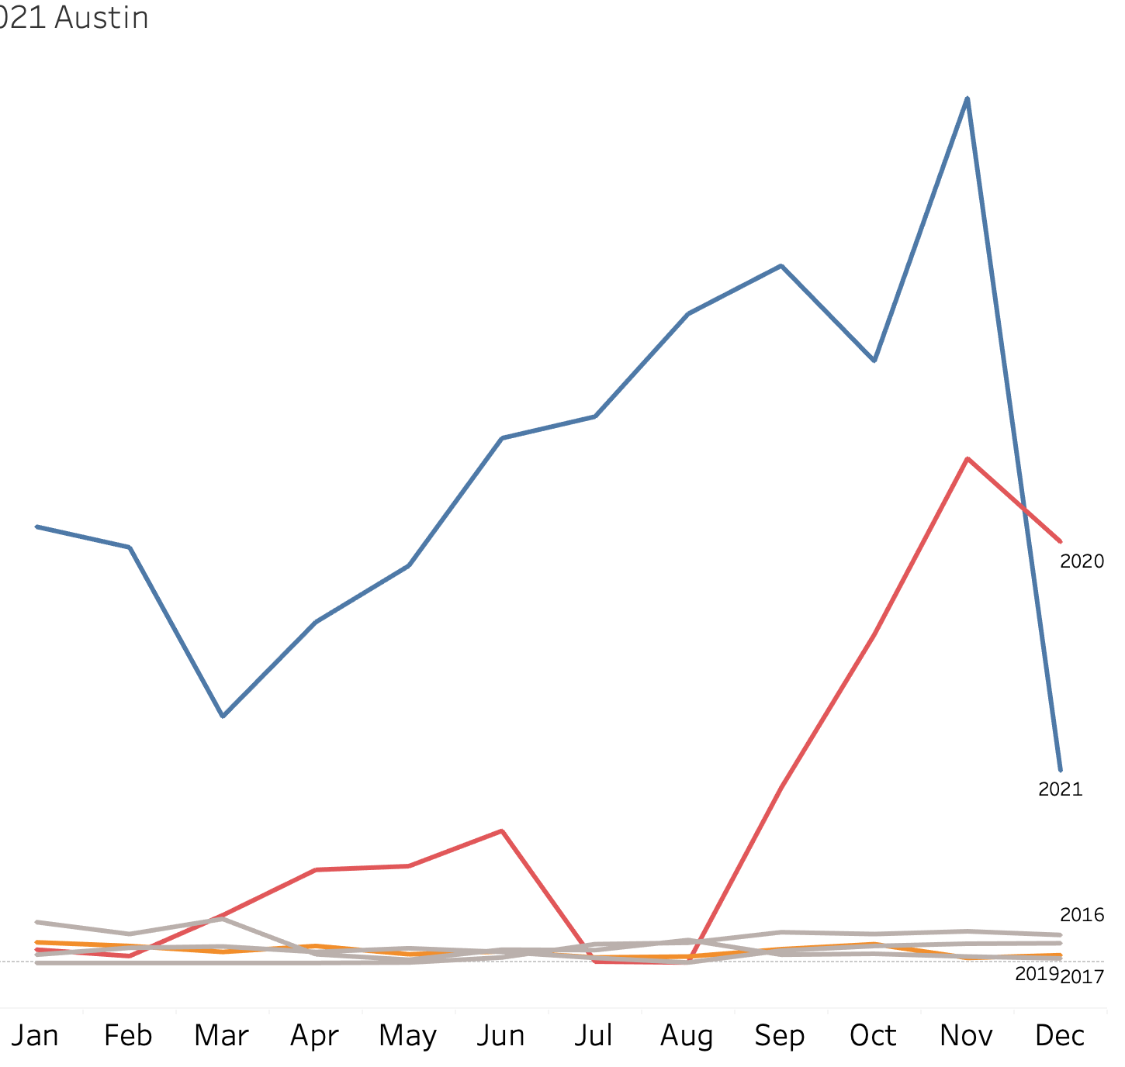
Accident monthly layout per year in Austin.

Austin generally reflects the state of Texas as a whole. The years 2016 through 2019 were fairly constant each month. The trends in 2020 were also similar to Texas with a drop in accidents during the lockdown and an increase in accidents from August to the end of the year. 2021 was not much different either with an increase in incidents after restrictions were lifted. However, in December there were much fewer accidents.

Accidents by year:
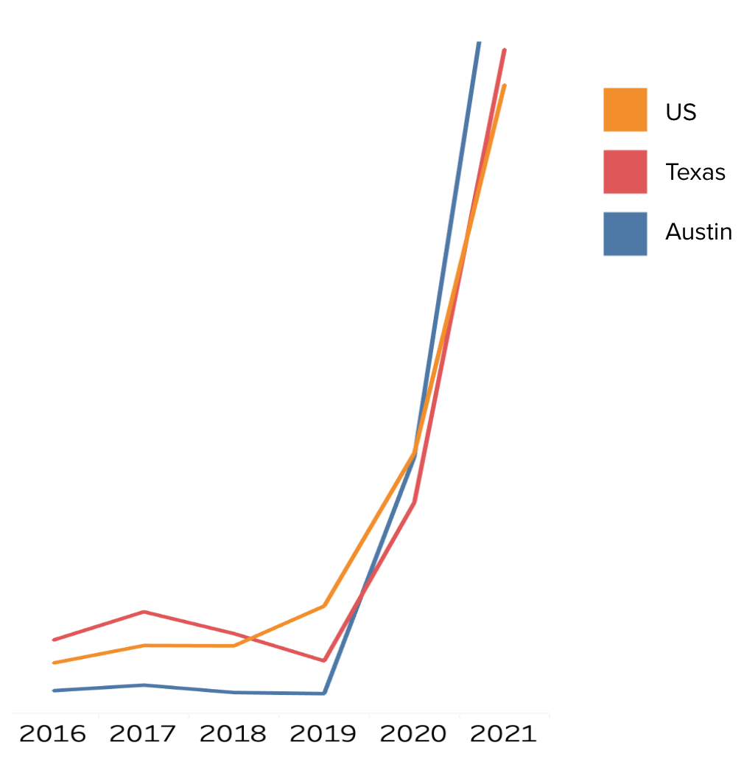
Accidents per year in the US, Texas, and Austin.

Across the country, states of Texas, and the city of Austin there was a huge spike in accidents in 2020 and 2021. The pandemic started and continued through these 2 years, but what does that have to do with increased car accidents?

How the pandemic made risky driving normal:
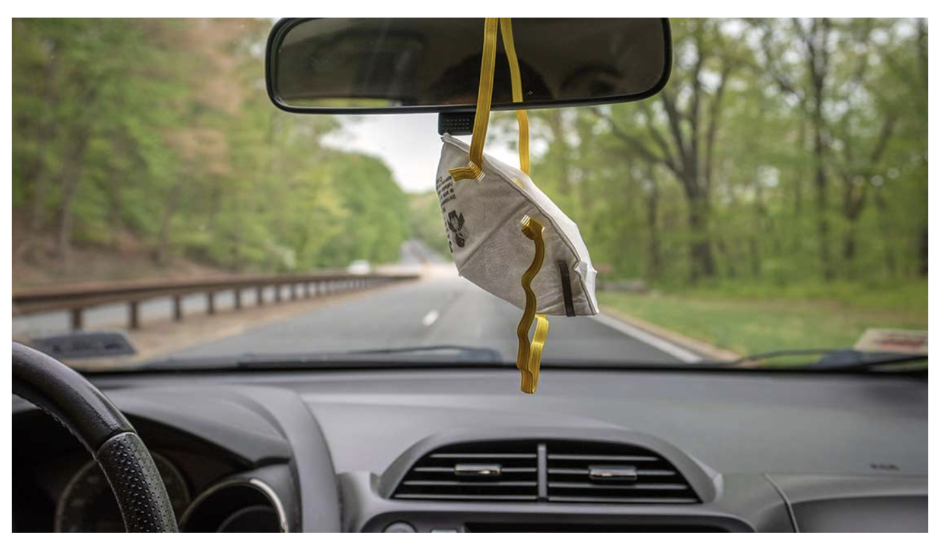

According to the article “Pandemic lockdowns made rush-hour speeding, risky driving the new normal,” from the Insurance Institute for Highway Safety risky driving such as speeding or distracted driving became normal. The article explains that during lockdown “the empty roads probably tempted” drivers to “put the pedal down,” as explained by Jessica Cicchino, the vice president of research at the institute. The article further explains that weekdays in 2020 frequently saw an increase in divers going 10 mph or more over the speed limit. This was especially true during the morning and afternoon rush hours. The article further states that 2021 saw a 5% increase in speeding-related fatalities.
To make a long story short, during lockdown the drivers still on the road got too comfortable not obeying basic traffic safety. Then when everyone else resumed driving and the reckless drivers continued their behavior, coupled with people getting used to driving more again, this was a recipe for disaster.

Weather:
The weather data was cleaned and grouped to analyze any possible patterns. For example “rain” is “drizzle'', “light rain”, “heavy rain”, etc. combined. The graph below shows a higher percentage of accidents in the US happen when the weather is fair or cloudy (though this is probably because there are much more of these days in general). The color of the map is based on the number of accidents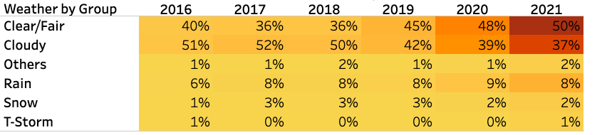
Clear and cloudy weather was filtered out in the graph below. During bad weather, the percentage of car accidents during the rain is three times higher than when snow or ice is involved. That might be because people avoid driving when it snows, but are less concerned when it’s raining.
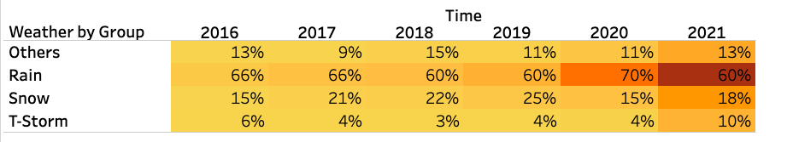
Based on the heatmap above a higher number of accidents happen when it rains. For each year roughly 60% to 70% of the time it rains, there are accidents. Compared to snow, which only had accidents 15% to 22% of the time. Again the color of the map is based on the number of accidents. Hence why 2020 and 2021 are much darker. As established earlier both years constantly had many more accidents.
The article "Wet Weather Driving tips'' by AAA which can be found here; states that drivers feel confident when driving in light rain, and treat the road as if it were dry. When the driver hits the brakes, it could cause the vehicle to hydroplane, lose control and cause an accident that could have been prevented if the driver had been more cautious.

Main Takeaways:
To conclude, no one expects to get in a car accident, but everyone should do their part to keep themselves and other drivers safe. Accidents are common in major cities and highways, and tend to occur more often on weekdays. This is especially true during the morning and evening rush hours. As such, during those times it is important that everyone driving should be paying more attention to the road and traffic signals. Drivers should also be extra careful when driving in the rain and on wet roads. Not only for the potential of hydroplaning, but also to be wary of other drivers' behavior. No one wants to become another statistic.

