Pretty Protected Passwords



By: Natalia Walls, Sami Elakhras, Deautaun Ross

Written by Deautaun Ross

Introduction:

In this day and age, almost everyone uses some form of string-based authentication for an online account like a password. One problem that arises from this is that very often do people not make proper efforts to create a secure password. This allows hackers to very easily figure out most weak passwords within a day.

To propose a possible solution to this problem, we wanted to answer the question, "How should a password be made such that it is both secure and memorable?" We tried answering this question using a dataset we sourced from Kaggle, which has been modified by us to contain additional parameters that will help with our analysis.

The original dataset consisted of the top 200 most common passwords from 49 different countries, totaling 9800 rows, with 4255 unique passwords which was collected from 350 million users. The attributes used for the analysis were: password length, required time to crack a password using brute force, number of people that use a specific password, whether that password contains upper/lowercase letters, symbols, or numbers, and how many wordlists contain a specific password.

We have structured our analysis into three parts. The first part consists of analyzing the characteristics of weak passwords by looking at the keyboard/language patterns, character length character types, and brute force time. The second part consists of assessing popularity of passwords by using 50 wordlists collected from Weakpass (totaling around 500 gigabytes) and looking at the advantages and disadvantages of using wordlists in password cracking. The last part consists of maintaining password uniqueness while also accounting for memorability.

Weak password characteristics:

Starting our analysis, we want to first find common characteristics in weak passwords to identify what might need to be considered for making a good password.

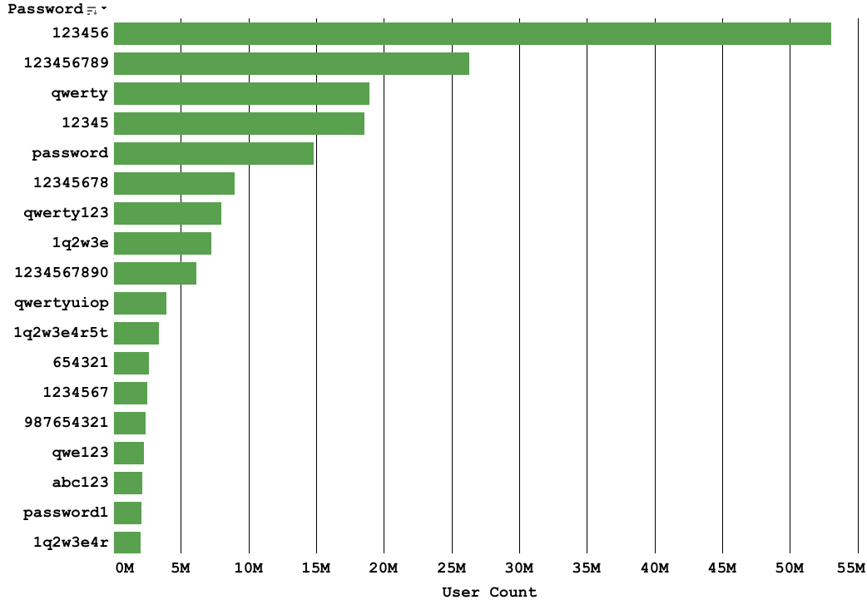
Figure 1: Bar graph of most widely-used passwords by user count.

As shown in the graph above, keyboard patterns are by far the most common password choice in any country. Numeric patterns could also count, since a typical keyboard has the 10 digits aligned in order, which also could count as a keyboard pattern. Notice how there are also common passwords that use a combination of the two, for exmaple, "qwerty123" and "1q2w3e". Another thing to note is that some words are very common. "password" is the most common password in many countries, despite it being an English word.

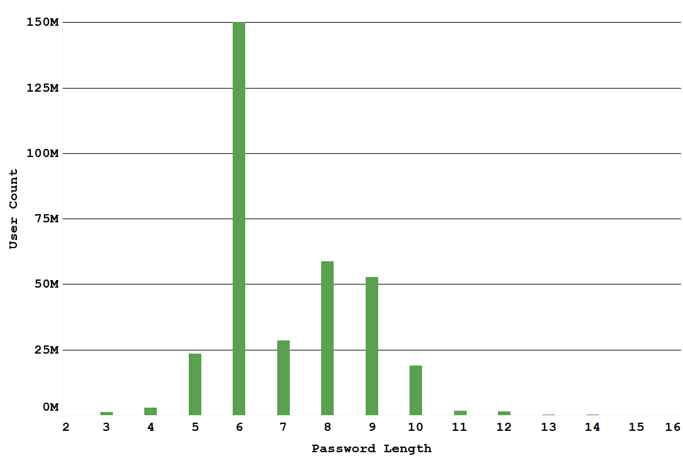
Figure 2: Bar graph of user count by password character length.

Shown in the graph above, most common password lengths are within the 6 to 9 character range. While there are some passwords outside of this range, the short passwords are obviously insecure, but the longer passwords are not completly safe from attacks either.

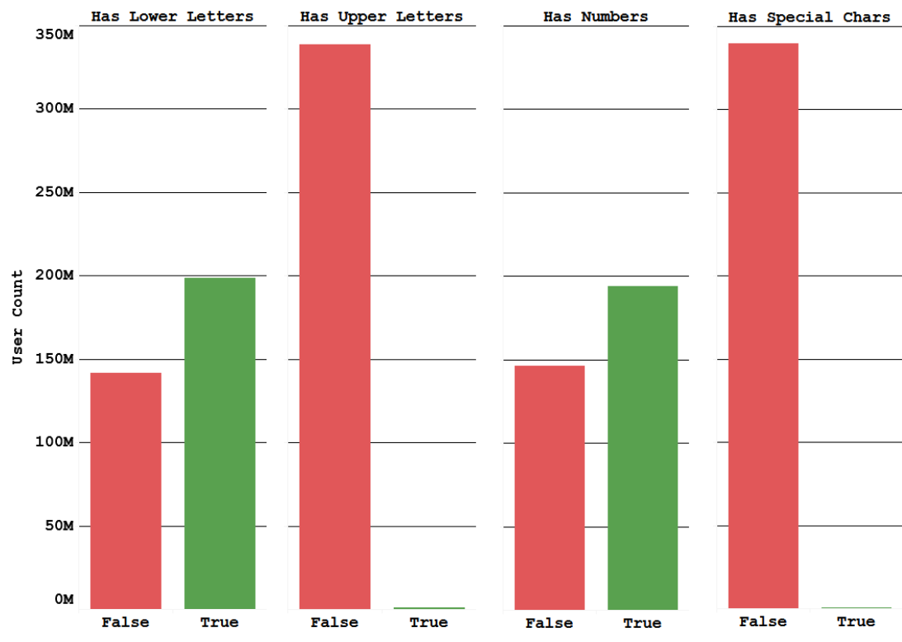
Figure 3: Four true/false bar graphs for password character composition.

Shown in the figure above, the character composition of almost all common passwords are lowercase letters and numbers. We found that 41% of all passwords had only lowercase letters, 40% of all passwords had only numbers, and 14% had both lowercase letters and numbers. What this means is that most common passwords only use a few groups of characters, which could allow a well-implemented brute force attack to skip certain characters that are unlikely to be in a password.

The four groups mentioned in the figure above are the main categories of sets of characters that almost all passwords, weak and strong, are comprised of. For uppercase and lowercase characters, they both have a charset size of 26, numbers have a charset size of 10, and special characters have a charset size of around 32. By only using one or two of these four categories to make a password, the risk for a successful brute force attack on the password becomes significantly higher.

In order to brute force a password, it would require a computer to try every single combination of the characters in a charset. The general formula for determining the amount of attempts required for a brute force attack is the size of the charset to the power of the password length. By increasing these two values, using a brute force attack becomes less practical for a hacker to attempt.

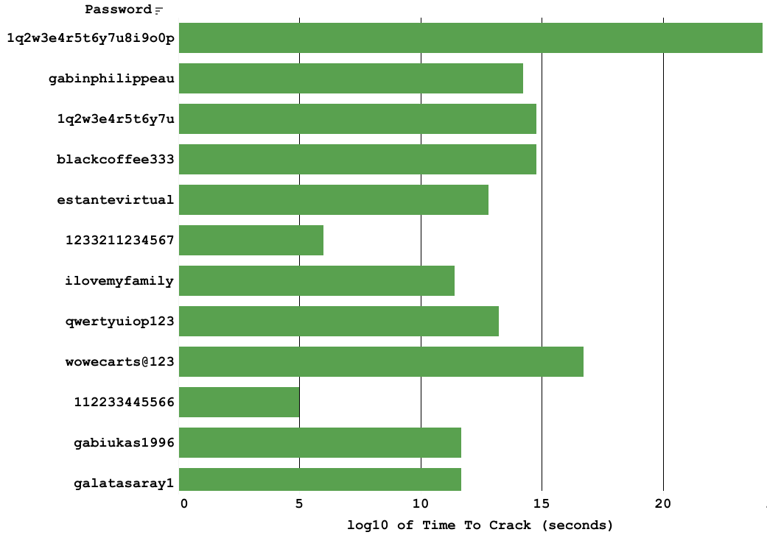
Figure 4: Bar graph of long passwords with differing charset sizes.

Shown in the bar graph above, it becomes apparent how important it is to increase the charset for a password's security even disregarding password length. Notice for the two passwords, "112233445566" and "gabiukas1996", they both have the same password length of 12, which is quite good. However, the former password only has a charset size of 10, since it only uses numbers. By introducing not just numbers, but also lowercase letters as well, the time required to crack the password by brute force increased by 7 orders of magnitude, changing the required time from around a day, to well over 1000 years.

Popularity using Word lists:

While knowing the strengths and weaknesses of using a brute force attack to crack a password is important, this is not the only practical attack vector available. Wordlists also play a big role in password cracking methods and it would be beneficial to also understand the benefits and weaknesses of them.

Put simply, a wordlist is just a text file that contains passwords, usually one per line. There are many wordlists available online, and their sizes can range from just a few kilobytes to several terabytes. Wordlists help mitigate the weakness brute forcing long passwords has by skipping many of the potential passwords that people probably don't use. For example, "1q2w3e4r5t6y7u8i9o0p" is a password of length 20, however, it was included in the data for top 200 most common passwords by country. This means that it is possible that we could crack this password just by guessing it in around a day, rather than spending an enrmous amount of time trying to brute force it. Of course, since wordlists are not generated on the spot, it does take storage space to use it, so in exchange for more practical password candidates for matching a password, it will require some space on a computer.

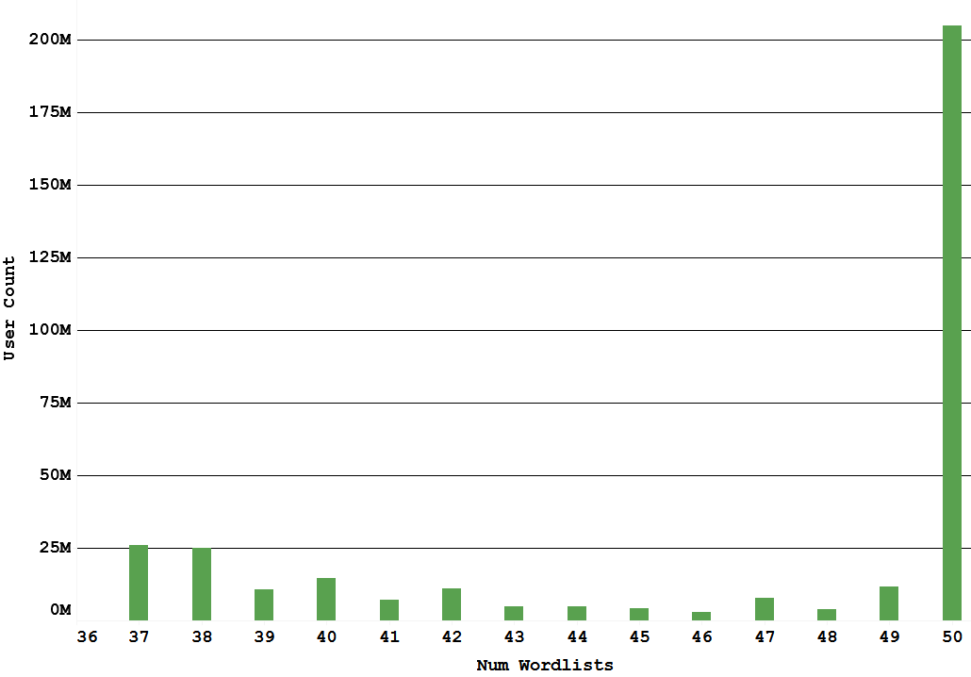
Figure 5: Bar graph showing how likely a password will be included in a dataset from Weakpass.

To find out how common the passwords in our dataset were, we downloaded 50 wordlists from Weakpass to find out how many wordlists would contain a password from the dataset. The graph above shows that almost all of the wordlists contained the passwords from the dataset. Every single password in the dataset was included in at least 37 wordlists, which shows how popular these common passwords are.

If we take the previous password example of "1q2w3e4r5t6y7u8i9o0p", we found that it was included in 37 out of the 50 wordlists used, which means that there is a 74% chance that any of the wordlists would contain this password. This would make that password very strong against brute force, but very weak against a wordlist attack. However, it it quite simple to mitigate wordlist attacks by making sure that a password is unique.

Password memorability:

With what we have analyzed so far, it might seem that just using a random password generator would be the simplest and fastest way to get a secure password. While this is true because it is randomly generated, the password might prove difficult to remember because of there being very few ways to easily associate your password with a memory.

Using the previous example of "" as a password, while it is long, it is easy to remember because it is a simple pattern. One way to try to keep this memorability is by using composite characters by representing one character by using multiple. An example of this would be "`/" for the letter "y" and "|-|" for the letter "h". While this might take some time to get used to, it will be possible to increase the length of a password without as much effort needed for rote memorization.

Another way to keep a password memorable is to try other keyboard patterns. While all the simple ones have been taken, there are still many patterns like "/z'a]q.x;s[w" or "1zm02xn93cb84vv6" that are not as common, and while they might be slightly more difficult to remember, it still might prove easier than a purely random string of characters. Of course, those patterns cannot be used as passwords solely by themselves, as they are still common, but not as common as "qwerty" or "qwe123".

By using the two methods described previously on perserving password memorability while maintaining or increasing security, it should be possible to create a password that is both easy to remember, and is quite secure. A few examples would be: "p4$5\/\/0Rc|s_", which has a 20 digit second brute force crack time and is not included in any of the 50 wordlists. "5er3|\||)1/>I7`/" is also quite secure at at 24 digit second crack time and 0/50 wordlists have it. It is also possible to reduce the charset size and use passphrases instead, for example, "7h15 15 4 5up3r l0ng p455w0rd" has a brute force time of 45 digits in seconds and is not included in any of the wordlists used.

Conclusion:

To conclude, we have determined that a strong, memorable password should have some of the following characteristics: double digit password length, mix of numbers and special/lower/upper characters, uncommon keyboard/language patterns seldom found in wordlists, possible use of composite characters, or use of a passphrase instead of a password. By using a majority of the characteristics found in strong passwords, it become easier to create a password that is both more secure, and is easy to remember.

