

Paradisi Research Lab
David Roura Padrosa
October 2020

Contents
WHAT IS CAPIPY? 4
DEPENDENCIES AND INSTALLATION 6
External software: 6
Installation 8
Uninstall: 8
RUNNING CAPIPY 9
MODULE 1: BLAST AND MODELLER 9
MODULE 1.1: QUATERNARY ASSEMBLY 11
MODULE 2: ACTIVE SITE ID 12
MODULE 3: SURFACE AND CLUSTER ANALYSIS 14
MODULE 3.1: CLUSTER DISTANCE CALCULATION 16
MODULE 4: IMMOBILIZATION PAPERS RETRIEVAL 17
Troubleshooting: 18

WHAT IS CAPIPY?

CapiPy (Computer Assistance for Protein Immobilisation – Python) is a small collection of 4 main packages to retrieve useful information for the immobilisation of a query protein. The workflow is depicted in the next image.
Information from each module, specially the Blast and modeller is preferentially used by the others. In case no such information is given, the user will have to input the necessary information.
MODULE 1: BLAST and MODELLER: this module only requires the 1 letter amino acid sequence of the query protein. This will be blasted against the protein data base to identify the protein with the highest similarity and a model will be created. If the protein is multimeric, the option to model the quaternary structure is also given via superposition of the monomeric model onto the other chains.
MODULE 2: ACTIVE SITE ID: the identification of the active site from the query protein is performed using the information present in UNIPROT and/or the M-CSA database. If the protein is annotated to use any cofactor, this information is also given.
MODULE 3: SIZE AND CLUSTERS IDENTIFICATION: this is the most important module regarding immobilisation. First, the surface and volume of the model of the query protein (or a user specified PDB) are calculated. Secondly, all protein residues are classified according to their solvent exposure and from the exposed ones, clusters formed by residues important for immobilisation identified. The output can easily be visualised in PyMOL.
MODULE 4: IMMOBILISATION PAPER RETRIEVAL: to complement the information given by the other modules, in this last module 20 immobilisation papers related to the query protein are retrieved. To do so, the query used in the previous modules (or input here by the user) is blasted against the SwissProt database to identify the best hit. The information of this best hit, such as protein name or identifiers, is extracted and used as keywords to submit a search into the Pubmed database. The 20 most relevant publications (by citation) are listed in an excel file.
In addition, two stand-alone functionalities of the first and third module are also available:
MODULE 1.1: QUATERNARY STRUCTURE DETERMINATION: with a monomeric model created, this module allows the user to select a template from the PDB dataset to create a different quaternary assembly.
MODULE 3.1: CLUSTER DISTANCE: once the clusters have been identified, similar to the last part of the third module, this allows the calculation of the distance between the clusters and any user-specified position in the query protein.
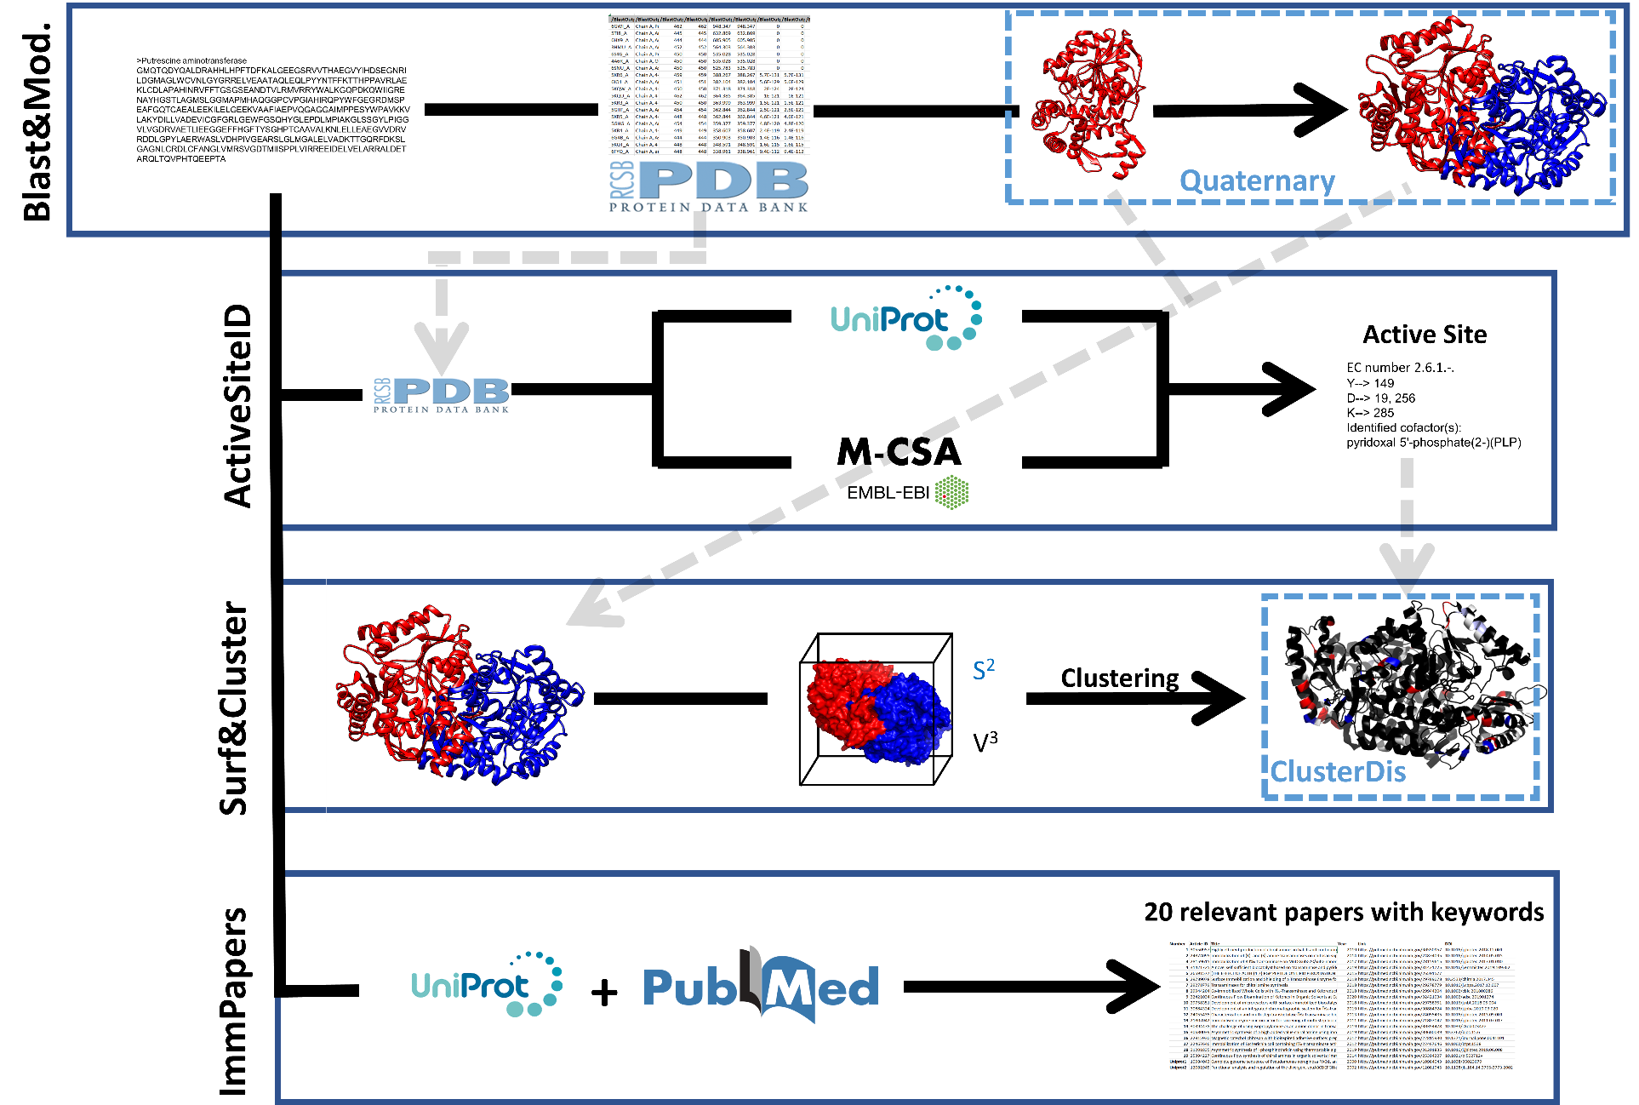

DEPENDENCIES AND INSTALLATION

External software:
For CapiPy to work fully, there are a few software required:

- Anaconda (miniconda or anaconda): download and install the latest version on https://www.anaconda.com/products/individual. When installing, select the option to put Anaconda in your PATH variables. Once installed, make sure anaconda is in the environmental variables of your PC:

- PyMOL (https://pymol.org/2/ (free for Educational purposes) or https://sourceforge.net/projects/pymol/files/latest/download (open source)).

- Visual studio (Windows - https://visualstudio.microsoft.com/downloads/): required for the correct installation of python-levenshtein module.
After installation, install the C++ module.

- Modeller: It is necessary to register for a license, which is free of charge for academic purposes. (https://salilab.org/modeller/registration.html)

- ClustalW (http://clustal.org/clustal2/):
  - Windows: install it in the default location (C:\Program Files (x86)\ClustalW2\clustalw2.exe). If it’s not there, when necessary the program will prompt you to enter the location.
  - MACOS: download clustalw-2.1-macosx.zip file from https://www.genetyx.co.jp/oss/genetyx-mac-20. Unpack and copy ONLY clustalw2 into the Applications folder.
  - UBUNTU: follow the instructions in the README file.
- Local blast (https://www.ncbi.nlm.nih.gov/books/NBK279671/) – Optional but strongly recommended to speed up blast searches.
Ideally, blast should be installed in a path that doesn’t contain any spaces to avoid future problems.
Ex: C:\Users\Username rather than C:\Program Files(x86).
- In order to allow blast to search against the pdb database, download “nt.23.tar.gz” and “pdbaa.tar.gz” from https://ftp.ncbi.nlm.nih.gov/blast/db/.
- Create a folder named “db” on the CapiPy folder and unpack “nt.23.tar.gz” and “pdbaa.tar.gz” in a folder named “db” (for example, C:\..\CapiPy\db in windows and, recommended, HOME\db for UNIX systems).
- Just to finish with the setup, we need to indicate to blast where to find the databases (https://www.ncbi.nlm.nih.gov/books/NBK279695/).
  - Windows: open the ncbi.ini file with notepad or similar and change the highlighted text with your path to the db.
Copy it C:\...\blast-X.X.X+\bin with the following content:
If your path contains spaces, type the directory as C:\\PATH\\blast-2.10.0+\\db
  - MACOS and LINUX: open the ncbi.ini file with a text editor and change the highlighted text with your path to the db (Ex. /Users/XXX/Desktop/CapiPy/db ).
Once added, copy it in the HOME directory: open a terminal where ncbi.ini is located (Finder → Services → Open terminal at current folder, and type “cp ncbi.ini ~/.ncbirc ”.
; Start the section for BLAST configuration
[BLAST]
; Specifies the path where BLAST databases are installed
BLASTDB=C:/Your/Pathto/blast-2.10.0+/db or C:\\blast-2.10.0+\\db
OR
/Users/XXX/Desktop/CapiPy/db (MAC)
; Specifies the data sources to use for automatic resolution
; for sequence identifiers
DATA_LOADERS=blastdb
; Specifies the BLAST database to use resolve protein sequences
BLASTDB_PROT_DATA_LOADER=pdb
; end of file
*If using backslashes, the path should have double \\
To avoid future problems, check that the installed packages are part of the path in environment variables.

Once all the external software and packages have been installed, you can proceed now with the installation.

Installation:
Windows:
- Double click on the installation.bat, inside the installation folder and follow the instructions.
- It is important to check in the installation.log for errors.
MACOSX:
- Open terminal in the CapiPy installation folder and make Install_CapiPy.sh executable.
  - To do so, open the Installation folder of CapiPy, go to Terminal → Services → Open Terminal in folder.
  - Type on the terminal “chmod u+x Install_CapiPy.sh”
  - Close the terminal.
- Make terminal as default program for .sh files.
  - Right click in the Install_CapiPy.sh file → Open with… → All applications → Utilities → Terminal and make it default for similar files by ticking the box Always Open With.
- Double click in the Install_CapiPy.sh and follow the instructions.
Note: Once installed, you will have the different executables in CapiPy main folder. To execute them, the first time you will have to select terminal as the default application.
(Right click in the.sh file → Open with… → All applications → Utilities → Terminal and make it default for similar files by ticking the box Always Open With.)
Ubuntu:
In ubuntu, the installation has to be done with the terminal:
- Go to CapiPy folder and open terminal in the folder.
- Make Install_CapiPy.sh executable (chmod +x Install_CapiPy.sh)
- Run the installation (./Install_CapiPy.sh)

Uninstall:
Just run Uninstall.bat or .sh depending on your system, following the same instructions as with the installation. This will remove the environment and all related packages, but not your produced data.

RUNNING CAPIPY

To make the program available to as many people as possible, a simple user interface has been created for all modules. To open CapiPy, execute the CapiPy.bat (Windows) or CapiPy.sh (MACOSX and Linux).
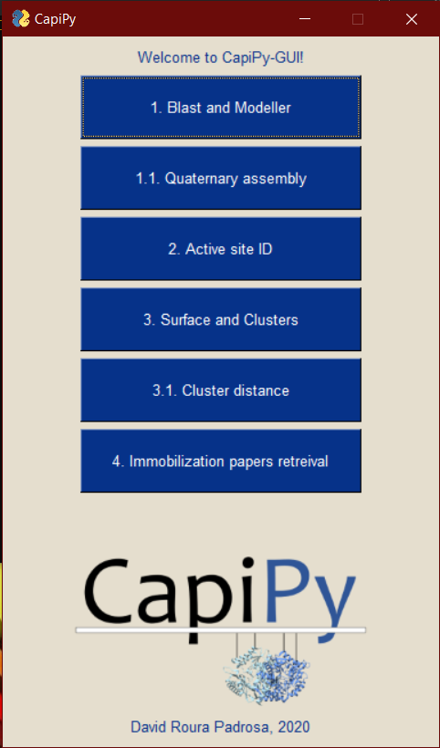
As an example, the run of each of the modules with HeWT (PDB id: 6GWI) is shown.

MODULE 1: BLAST AND MODELLER
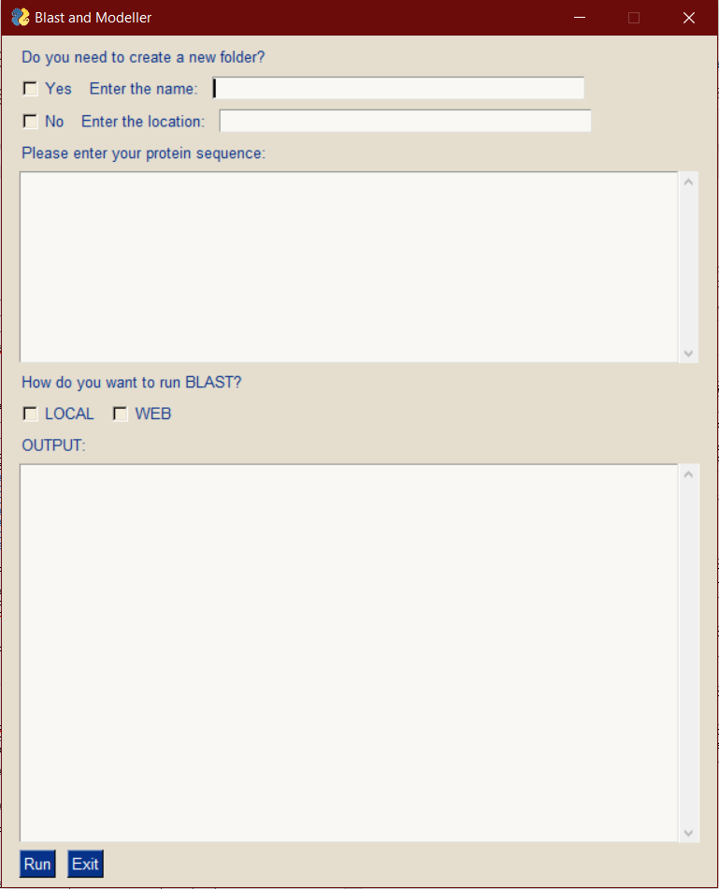
Indicate the folder or create a new one.
Enter the protein sequence in one letter code.
Select if you want to run BLAST locally or through the website.
Output window.

OUTPUT WINDOW AFTER SUCCESFULL RUN:
Module running, be patient. This can take a couple of minutes...

Directory test created.
Blast search running locally...
Your blast returned the following as the best hit:
Query: query
Hit: pdb|6GWI|A Chain A, Putrescine aminotransferase [Halomonas elong...
Query range: [0:462] (0)
Hit range: [0:462] (0)
Quick stats: evalue 0; bitscore 948.35
Fragments: 1 (462 columns)
Query - GMQTQDYQALDRAHHLHPFTDFKALGEEGSRVVTHAEGVYIHDSEGNRILDGMAGLWCV~~~EEPTA
GMQTQDYQALDRAHHLHPFTDFKALGEEGSRVVTHAEGVYIHDSEGNRILDGMAGLWCV~~~EEPTA
Hit - GMQTQDYQALDRAHHLHPFTDFKALGEEGSRVVTHAEGVYIHDSEGNRILDGMAGLWCV~~~EEPTA.
Visit https://www.rcsb.org/structure/6GWI for more information about the model.
Downloading PDB structure '6GWI'...

MODELLER 9.25, 2020/09/03, r11894

PROTEIN STRUCTURE MODELLING BY SATISFACTION OF SPATIAL RESTRAINTS

Copyright(c) 1989-2020 Andrej Sali
All Rights Reserved

Written by A. Sali
with help from
B. Webb, M.S. Madhusudhan, M-Y. Shen, G.Q. Dong,
M.A. Marti-Renom, N. Eswar, F. Alber, M. Topf, B. Oliva,
A. Fiser, R. Sanchez, B. Yerkovich, A. Badretdinov,
F. Melo, J.P. Overington, E. Feyfant
University of California, San Francisco, USA
Rockefeller University, New York, USA
Harvard University, Cambridge, USA
Imperial Cancer Research Fund, London, UK
Birkbeck College, University of London, London, UK

Kind, OS, HostName, Kernel, Processor: 4, WinNT 10.0 build 18363, DROU-PC, SMP, unknown
Date and time of compilation : 2020/09/03 08:23:39
MODELLER executable type : x86_64-w64
Job starting time (YY/MM/DD HH:MM:SS): 2020/10/09 11:18:32

Alignment of template and query for modelling successfull.
0 atoms in HETATM/BLK residues constrained
to protein atoms within 2.30 angstroms
and protein CA atoms within 10.00 angstroms
0 atoms in residues without defined topology
constrained to be rigid bodies

>> Summary of successfully produced models:
Filename molpdf
----------------------------------------
query.B99990001.pdb 2089.17188

First model created succesfully

Refining the model for chain A...
Perfect for chain A.

Finished running the module Blast&Modeller module!
Creation of your model was succesfull. You can find it in F:\CapiPy_GUI\test\Blast&Modeller in a file named query_multimeric.pdb along with the monomeric modelled structure (query_monomeric.pdb), the sequences in fasta format, the blast result and the alignment. You can continue now running the ActiveSiteID!

Output files:
Blast_result.xml | XML file containing the results of the BLAST of the query protein against the protein data base.
Model.fasta | FASTA sequence of the template protein.
pdbXXXX.ent | Structure file of the template protein.
Query.fasta | FASTA sequence of the query protein.
Query_monomer.pdb | Structure file for the monomeric model of the query protein.
Query_multimeric.pdb | Structure file for the multimeric (if applicable) of the query protein.

MODULE 1.1: QUATERNARY ASSEMBLY
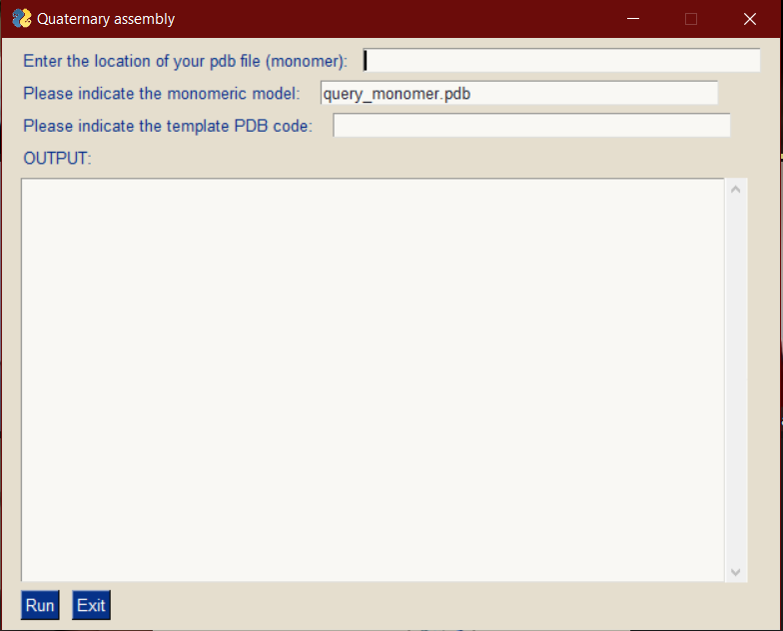
Indicate the folder
Indicate the name of the pdb file. By default, it’s query_monomer.pdb
Output window.
OUTPUT WINDOW AFTER SUCCESFULL RUN:
Module running, be patient. This can take a couple of minutes...

6S4G is going to be used as the template for your model.
Structure exists: '.\pdb6s4g.ent'

MODELLER 9.25, 2020/09/03, r11894

PROTEIN STRUCTURE MODELLING BY SATISFACTION OF SPATIAL RESTRAINTS

Copyright(c) 1989-2020 Andrej Sali
All Rights Reserved

Written by A. Sali
with help from
B. Webb, M.S. Madhusudhan, M-Y. Shen, G.Q. Dong,
M.A. Marti-Renom, N. Eswar, F. Alber, M. Topf, B. Oliva,
A. Fiser, R. Sanchez, B. Yerkovich, A. Badretdinov,
F. Melo, J.P. Overington, E. Feyfant
University of California, San Francisco, USA
Rockefeller University, New York, USA
Harvard University, Cambridge, USA
Imperial Cancer Research Fund, London, UK
Birkbeck College, University of London, London, UK

Kind, OS, HostName, Kernel, Processor: 4, WinNT 10.0 build 18363, DROU-PC, SMP, unknown
Date and time of compilation : 2020/09/03 08:23:39
MODELLER executable type : x86_64-w64
Job starting time (YY/MM/DD HH:MM:SS): 2020/10/09 11:28:40

Refining the model for chain A...
Perfect for chain A.

Refining the model for chain B...
Perfect for chain B.

Refining the model for chain C...
Perfect for chain C.

Refining the model for chain D...
Perfect for chain D.

Finished running the module Blast&Modeller module!
Creation of your model was succesfull. You can find it in F:\CapiPy_GUI\test\Blast&Modeller in a file named query_multimeric.pdb along with the monomeric modelled structure (query_monomeric.pdb), the sequences in fasta format, the blast result and the alignment. You can continue now running the ActiveSiteID!
* Note that in this case, the model is composed of 4 chains but it does not mean it’s a tetramer. In fact, the model is actually two dimers.

Output files:
quaternary_assembly.pdb | Structure file for the multimeric of the query protein.

MODULE 2: ACTIVE SITE ID
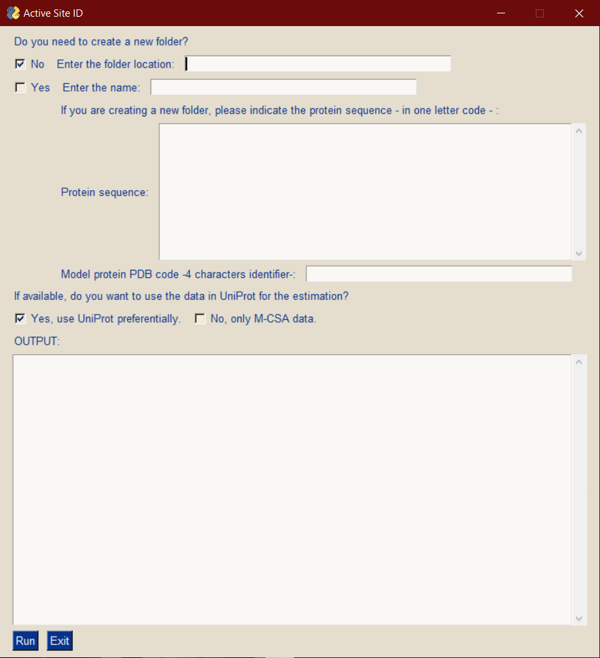
Enter the folder or create a new one.
If you need to create a new folder, indicate the protein sequence as one letter code and PDB model with the PB code.
Select if you want to use UniProt or just the M-CSA database.
Output window.
OUTPUT WINDOW AFTER SUCCESFULL RUN:
Module running, be patient. This can take a couple of minutes...

Downloading the curated data from the Mechanism and Catalytic Site atlas - www.ebi.ac.uk -.
Searching for the uniprot equivalent of your pdb file...
Uniprot id found. Extracting information...

Your model protein, 6GWI, has been identified as a Putrescine aminotransferase with EC number 2.6.1.-.

Your model protein does not have an active site identified in UniProt. Proceeding to check in the M-CSA database...
The best hit for your protein is uniprotID: P12995.

Percentage of identity = 27

Identifying the predicted catalytic residues in your protein...

The predicted active site is formed by:
Y--> 150
D--> 256
K--> 285
F--> 19*

* : Residue predicted in the query but not present as part of the active site of the model.

Identified cofactor(s):
pyridoxal 5'-phosphate(2-)(PLP)

Finished running the ActiveSiteID!
. Your results can be found in F:\CapiPy_GUI\test\ActiveSite, in a file named Active_site.txt, together with the alignment and the fasta files for your sequences. You can run now the Surface&Clusters module!

Output files:
Active_site.txt | Text file with the active site and cofactor information.
Alignmen_output.txt | Text file with general information on the alignment between the query protein and the best hit either in Uniprot or M-CSA.
XXXXXX.fasta | FASTA sequence of the best hit in Uniprot or M-CSA.
Query.fasta | FASTA sequence of the query protein.
Refsequp.aln | Alignment file of the query and the best hit.

MODULE 3: SURFACE AND CLUSTER ANALYSIS
Indicate the folder or create a new one.
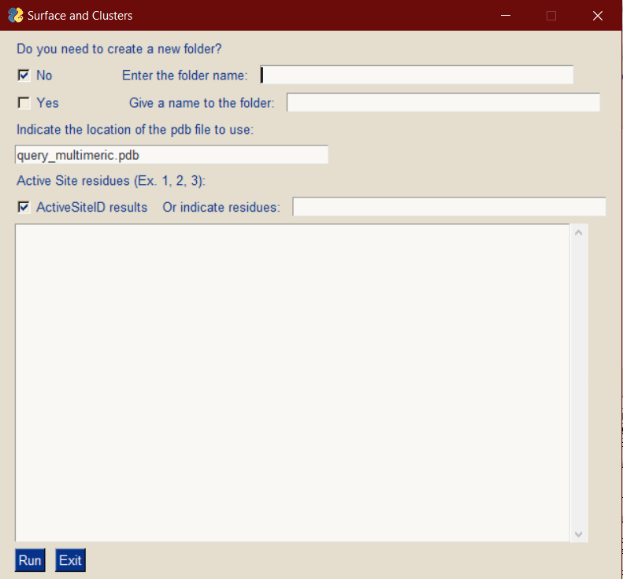
Indicate the PDB file to use. By default, it’s set to query_multimeric.pdb.
Indicate the active site or use the one calculated with the second module.
Output window.
OUTPUT WINDOW AFTER SUCCESFULL RUN:
Module running, be patient. This can take a few minutes...

Measuring the minimum bounding box...

Your protein, formed by 1 chains, has an aproximate dimensions of: 48.414 A, 57.312 A, 72.341995 A.
Giving an aproximate volume of: 200727.58 A³

Calculating the exposure of each residue in the structure...
Sorting the residues depending on their exposure...

As for the surface, the calculated exposed surface is 60652 A²

The contribution of each aminoacid is:
Aminoacid Surface(%) Total number
ALA 6.58% 33
ARG 8.30% 19
ASN 2.16% 7
ASP 6.17% 20
CYS 1.22% 5
GLU 12.70% 36
GLN 4.94% 14
GLY 5.12% 32
HIS 4.99% 14
ILE 3.22% 10
LEU 10.71% 34
LYS 4.93% 13
MET 1.67% 5
PHE 4.14% 11
PRO 4.82% 19
SER 2.36% 10
THR 4.84% 18
TRP 1.75% 4
TYR 5.05% 12
VAL 4.35% 16
Total number of surface residues: 332 out of 462
Measuring distances and identifying clusters...
Clusters can be found in Clusters.txt

Clusters can be visualised in PyMOL opening PyMol_clusters.pml

Default colours are:
Positive: Blue
Negative: Red
Histidine: Cyan
Lysine: LightBlue
Cysteine: Yellow
Hydrophobic: White
Calculating contacts between chain A and it's neighbours...
Distance to the multimeric interface successful. Your results can be found in Cluster_interface.txt

Finished running the Surface&Clusters module!
You can find your result files in F:\CapiPy_GUI\test\Size&Clustersin the folder Size&Clusters. For more information, check the tutorial.
OH, and make sure to check out PyMol_clusters.pml!
Creating a copy in the current directory...

Output files:

Clusters.csv | Excel-compatible file containing the clusters identified.
Clusters.txt | Text file with the clusters identified.
General_info.txt | Text file with the information printed in the console as per the volume and surface information for the model.
Model.pdb | Copy of the pdb used for the analysis.
PyMol_clusters.pml | PyMOL session with the clusters coloured as specified in the command line.
Residues_interface.txt | Residues identified as part of the protein interface.
Interface_contacts.txt | Text file with the clusters identified close to the interface highlighted with a message.
Cluster_ActiveSite.txt | Text file with the clusters identified close to the active site highlighted with a message.
XXXX.txt | Text file with the clusters identified close to the user defined positions highlighted with a message.

MODULE 3.1: CLUSTER DISTANCE CALCULATION
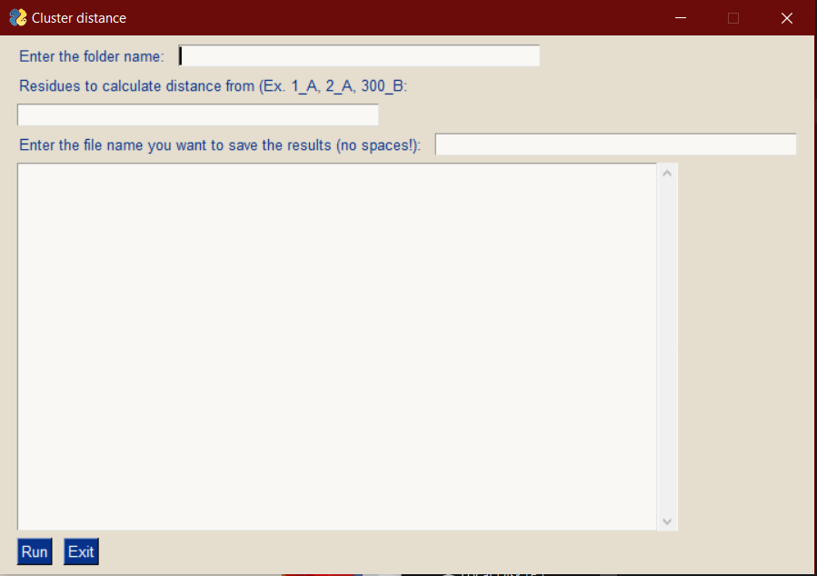
Enter the folder name.
Indicate the residues you want to calculate the distance to.
Name the output file.
Output window.

OUTPUT WINDOW AFTER SUCCESFULL RUN:
Module running, be patient. This can take a few minutes...

ALL DONE, you can find your results files in F:\CapiPy_GUI\test\Size&Clusters in the folder Size&Clusters

Output files:
SPECIFIC_TEXT.txt | Text file with the clusters identified close to the user defined positions highlighted with a message.

MODULE 4: IMMOBILIZATION PAPERS RETRIEVAL
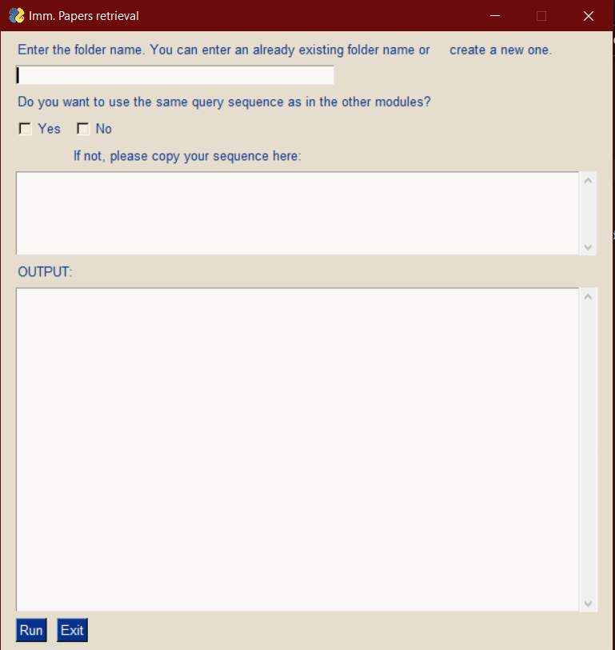
Output window.
If not using the same query, indicate the sequence as one letter code.
Indicate if you want to use the same query as in the other modules or not.
Indicate the folder name or create a new one.
OUTPUT WINDOW AFTER SUCCESFULL RUN:
Module running, be patient. This can take a few minutes...

Blast search running online... This migth take a while.
Blast succesfull!
Uniprot id found (Q9I6J2). Extracting information...
Search on PubMed database is going to start with: "Putrescine--pyruvate OR aminotransferase OR Putrescine--pyruvate OR transaminase AND immob*" as the keywords.
Retrieving the information...
Finished running the module Reference retrieval module!
You can find your result files in test in the RelevantPapers folder.
The papers are organized in the csv file named "relevant_papers.csv!

Output files:
blast_result.xml | File containing the results of the blast search against UniProt database.
Query.fasta | Fasta sequence of the query used.
Relevant_papers.csv | List of 20 relevant papers containing the key words organized in an excel compatible file.
Uniprot_papers.txt | Text file containing the papers linked to the Uniprot ID identified as the query.

Troubleshooting:
General issues:
Modeller license is missing | Make sure during the installation you entered a valid license. If not, search for config.py under modlib/modeller/. Open the file with a text editor and edit the license.
Modeller cannot find the specified location | Locate the __init__.py file in modeller (../modlib/modeller/__init__.py).  Make sure in line 68 the content is the following:  dpath = config.install_dir + '\\modlib\\'

Windows:

Installation fails with error related to Python Levenshtein | Make sure you have installed Microsoft Visual Studio and downloaded the C++ modules.
Local BLAST search does not work | Check that the databases are in the correct location and the ncbi.ini file is in the blast/bin folder.
Web BLAST search does not work or takes long time | Try again in a few minutes. Online BLAST depends on the server availability. If it does not work at all, consider using the local BLAST (Requirements and installation).

MACOSX:
Clustalw2 not recognized | Make sure clustalw2 is in the Applications folder and this in the PATH variables. To check so:  Open Terminal; type clustalw2:  If an error indicating command not found appears: type  env; PATH should contain /Applications; if not, type in the terminal  path+=(/Applications)  and  export PATH

Linux (Ubuntu 20.02LTS):
Cannot execute .sh files | In ubuntu, to execute the files you need to make them executable first.  Open a terminal in the folder and type in:  chmod +x scritpname.sh  Replace scriptname by the name of the module you want to make executable.  Now, try and run the script by typing in:  ./scritpname.sh

