Git and Github User Documentation Guide for PyGEM

Quick Overview:
Simplest
git clone http_link make local repository
git add --all add/stage edits
git commit -m “enter message” commit changes with message
git push push changes to remote

Create branch, make changes, push to remote branch, push to master
git checkout -b develop create new branch named develop
git branch list available branches
git add --all add/stage edits
git commit -m “enter message” commit changes with message
git push origin develop push local changes to remote branch on git
git checkout master switch branch to master
git fetch origin develop fetch edits from develop branch
git merge origin/develop merge changes
(resolve conflicts)
git add --all
git commit -m “enter message”
git push origin master push local master changes to remote master on git
(good idea to delete branch after resolving conflicts and pushing changes)
Fetch changes from remote master
git fetch origin master
(for other users need to fetch from “upstream” repo, i.e., from my repo)
git merge origin/master
(resolve conflicts)
git add --all
git commit -m “enter message”
git push
Delete branch after pushing to remote master
git branch -D develop delete local branch
git push --delete origin develop delete remote branch
git checkout -b develop recreate local branch

Introduction:

This document is being built in a scattered way as we learn things, but the idea is to structure it in the order that you would encounter these concepts as you work on the pyGEM project (or any other project, for that matter) We start with signing up for a github account, forking repos and doing initial configuration. Then we go into the basics of tracking changes.

We also need still need to go into the details behind development and pull requests, and how to structure your branches to make contributing to the master repository easiest.

Signing up for a Github account.

The PyGEM project uses Github, and creating an account is free (though Microsoft did just buy it…) and straightforward. Here is a link to information on how to sign up.

How to Fork a Repo (for example forking David’s repo)

Link here.

Go to David’s PyGEM repo (which he should have given you permission to access). Here is the link to his repo.

Click Fork on the upper right corner. See image below.

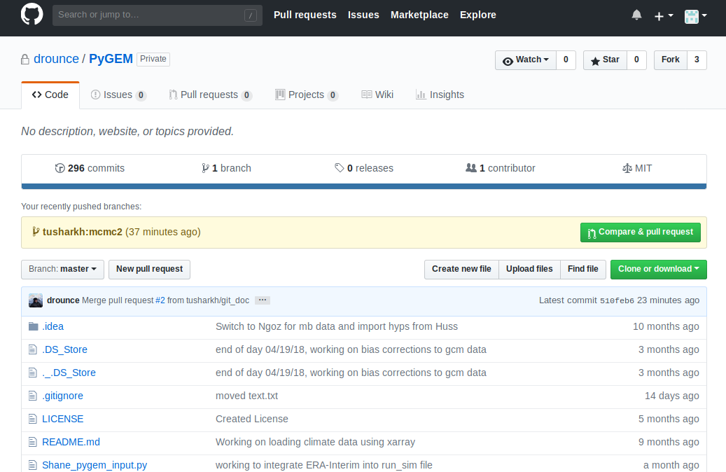

How to create a local clone of your forked Repo.

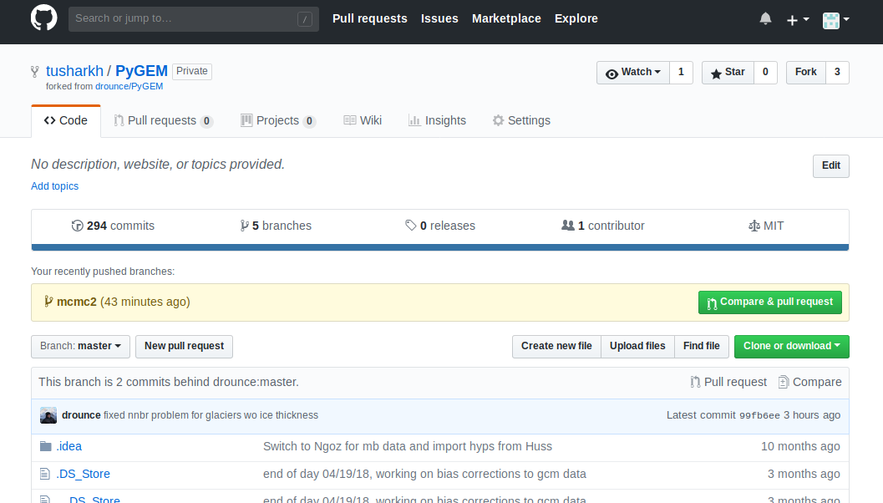

1. Go to your fork of David’s repo, for example, tusharkh/PyGEM. You should be in the master branch (default setting) This is shown in the picture above.

2. Click the green Clone of Download button.

3. Copy the URL given in the drop down window.

4. Open a terminal.

5. Type git clone, then paste the URL copied in step 2, as shown below. Click enter.

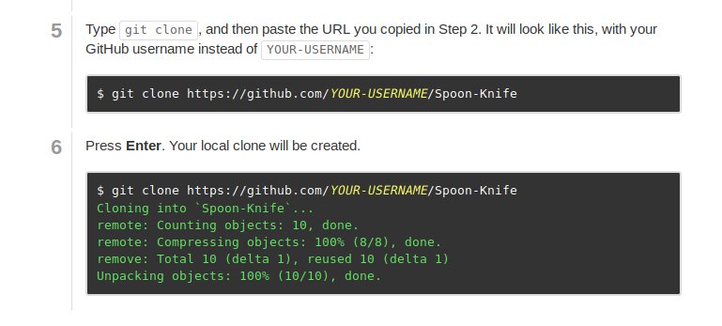

Initial Configuration (Adding remotes)

Typically, each git repository and branch has an online version (on github, for example) and a local version (on your computer) Much of the confusion about git comes from the fact that these two repositories are not always the same. A remote is any online repository, and ideally it should be kept up to date with the local version of the repo.

Any remotes that you are interested in need to be ‘added’ to your computer. For example you definitely want to add your own online repository (which should happen by default once you clone it), but also probably the repository that you forked from, if you plan to contribute to it.

‘Adding’ a remote means linking it to your computer. This way, you can bring in changes from a remote, and update a remote, without having to explicitly type in the URL.

A link for further information about adding remotes is here.

IMPORTANT:

For initial configuration, you will want to add at least two remotes, one for the online version of your repository, and one for the online version of David’s repository.

1. To add a remote for your repository, go to your fork on github (for example tusharkh/PyGEM) and make sure you are in the master branch. Copy the url from the clone or download button.

Then open a terminal, go to your local repository and type

git remote add origin <url-copied-from-your-repository>

This adds a remote named origin which links to your repository. Origin is the standard name for your personal remote.

2. Next, add a remote to David’s repository. Go to David’s master branch on github, click on clone or download, and get the url.

Type

git remote add upstream <url-copied-from-david’s-repo>

Upstream is the most commonly used name for the remote from which you forked your repo.

3. Then, type:

git remote -v

this lists the remotes, so you can confirm that they have been added. See the image below.

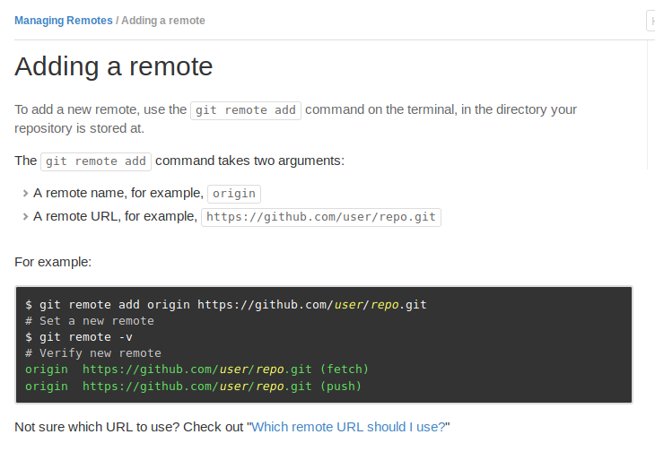

RENAMING REMOTES:

See the image below for explanation:

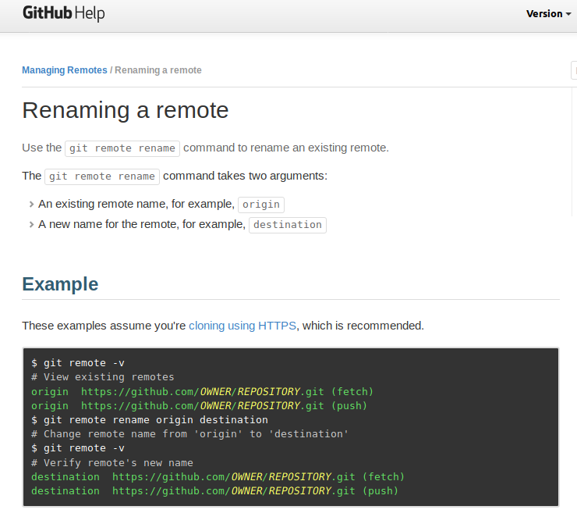

BRANCHES: (VERY IMPORTANT)

How to create a new branch: Link here

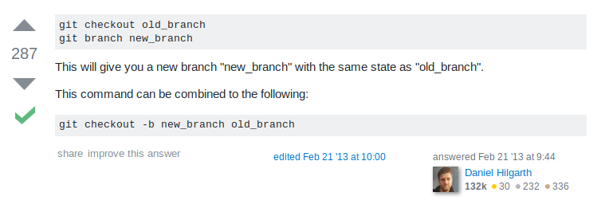
How to rename a branch

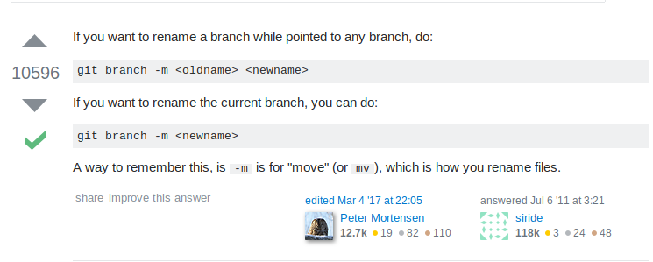

Note: This only renames the branch on local repository. To to rename on your remote (online repository) first push your branch

git push origin <newname>

Then, delete the branch with the old name on git. See below.

How to delete a branch:

To delete local branch:

git branch -d <branch-name>

or force delete:
git branch -D <branch-name>

How to delete remote branch

git push - -delete <remote_name> <branch_name>

Ex:

git push delete --delete origin develop

See image below for further details.

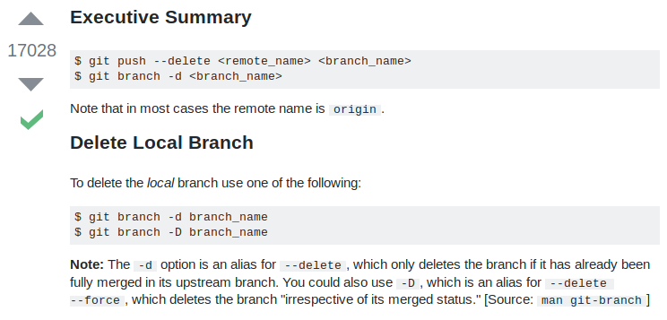

Updating changes: commiting and pushing

Everytime you make a change to your files, while the files may be saved on your local device, they are not tracked on git.

Using the command:

git status

Is useful because it tells you which branch you are on, and which files have been modified since you last commited your files (a commit essentially saves changes to git, allowing it to track those changes)

See the picture below:

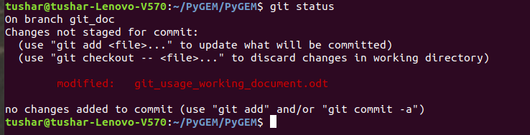

As indicated in the picture, you can use the command

git add <file-name>

To stage a file for commiting. This tells git that you want changes made to this file to be tracked.

You can also use the command:
git add --all
or

git add *

to stage all files that have been modified.

Then use the command

git commit -m “type a message here”

This is like a checkpoint, it saves all changes and allows you to revert back to this point if you would like to in the future.

Now, this only saves changes to the local version of your repository (what is saved on your computer). To save any changes to the online github repository, (also known as a remote) we need to push the changes using the following command:

git push <remote-name> <branch-name>

for example,

git push origin git_doc

This saves changes to files on the online repository, and adds new files to the online repository that have been added to the local repository. However, to remove files on the online repository, we need to make the additional step of

git rm <file-name>

before pushing the changes. See the image below
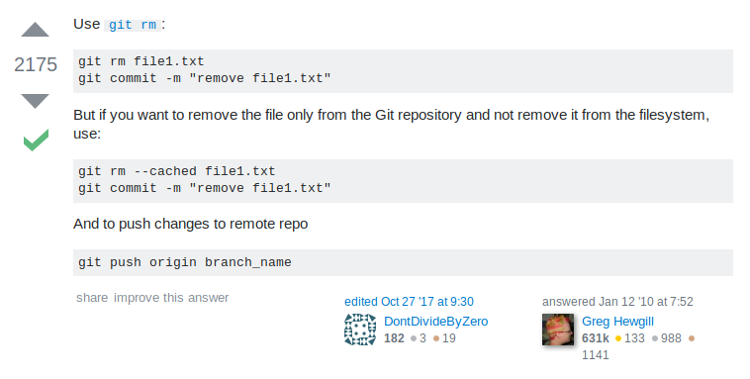

How to pull changes from upstream branch/repository (or any other remote or local branch)

Note: you may have a merge conflict when you do this. If so, see below:

1. Checkout the branch that you want to update.

git checkout <your-branch-name>

2. Fetch the branch that you want to get changes from

git fetch <remote_name> <other_branch_name>

Ex:

git fetch upstream <upstream-branch-name>

If you want to fetch from a local branch:

git fetch <local_branch_name>

3. Merge the branch that you want changes from

git merge <remote_name>/<other_branch_name>

Ex:

git merge upstream/<upstream-branch-name>

Or for the local branch:

git merge <local_branch_name>

With the merge command, most of the time git allows you to merge automatically. For extensive changes, you may need to do a address a merge conflict. See below for this.

4. Commit changes to your branch

git commit -m “commit message”

5. Push these changes to your remote repository

git push origin <your-branch-name>

For example, to merge david’s master branch to a branch of mine named develop:

git checkout origin develop

git fetch upstream master

git merge upstream/master

git commit -m “merged changes from david’s repo”

git push origin develop

You may encounter merge conflicts, which can be addressed using the information here.

You can also use git pull, which combines the commands fetch and merge. See the below example. It is recommended that you use the fetch and merge separately.
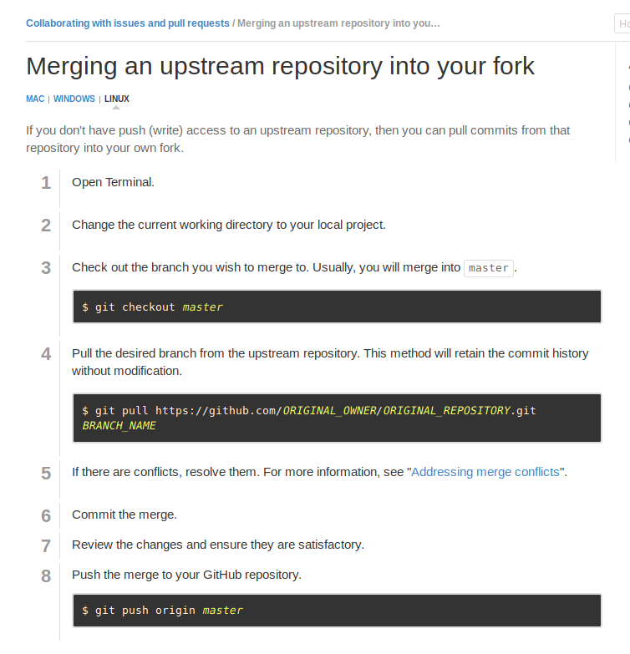

How to resolve merge conflicts: (IMPORTANT)

In some cases, when you try to merge, git will tell you there is a merge conflict. Addressing this is usually very easy. It is recommended that you do this on your local machine.

After typing git merge, you will get a message like the one below:

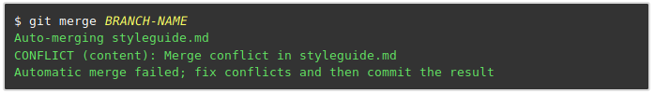

Type

git status

To see which files have conflicts. It will look like the image below:

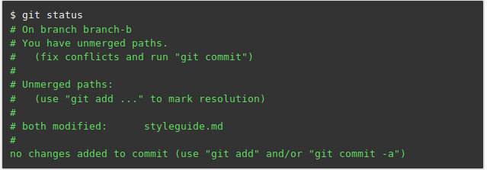

Now, open the files with conflicts in your editor of choice: (This may be Spyder for many PyGEM users, but whatever it is you use)

You will see areas of conflict in the file where the file has sections such as

>>>>>>HEAD

or

>>>>>>>origin/master

which represent changes from different branches

All you need to do it delete the lines you want, keep the lines you don’t want.

When you are done fixing the conflicts and your file is the way you want it to be, commit the changes, and then push the changes to your remote repository.

How to pull changes from a single file in an any branch (local or remote)

1. 1. Checkout the branch that you want to update.

git checkout <your-branch-name>

2. Fetch the branch you want to pull the file from. This could be a local branch, for example, if I want to fetch from my develop branch:

git fetch develop

Or it could be a remote branch. For example if I want to pull from David’s master branch (I have called David’s remote ‘upstream’:

git fetch upstream master

3. Checkout the file from the branch that you want to get changes from. If it is the local branch:

git checkout develop <file_name>

If it is the remote branch:

git checkout upstream/<upstream-branch-name> <filename>

4. Commit the changes to your branch

git commit -m “commit message”

5. Push these changes to your remote repository

git push origin <your-branch-name>

For example, to pull changes from the file git_usage_working_document.odt from david’s master branch to a branch of mine named develop:

git checkout origin develop

git checkout upstream/master git_usage_working_document.odt

git commit -m “pulled changes to git doc”

git push origin develop

How to reset your master branch to upstream branch. Link Here.
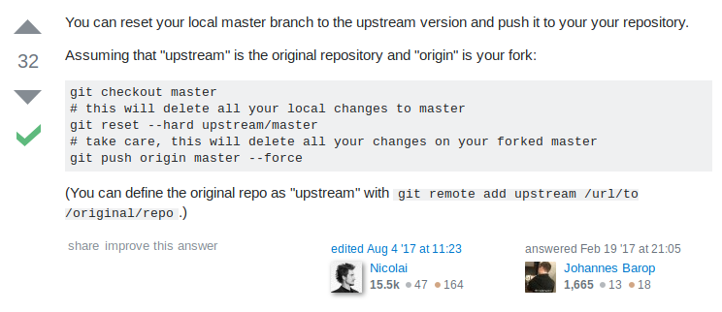

Reverting to previous copies/checkoints.:
Find information here
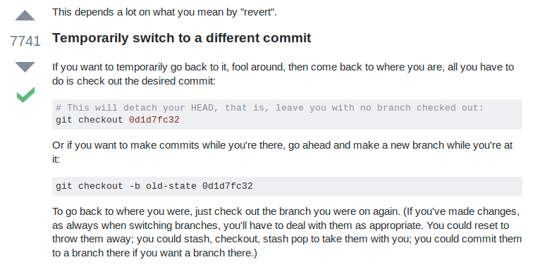
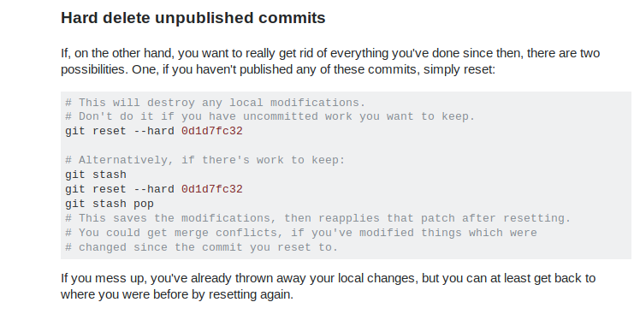

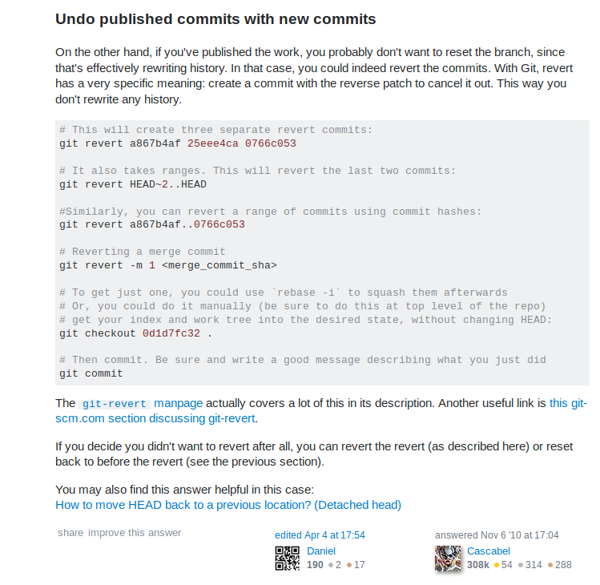

MANAGING BRANCHES AND PULL REQUESTS:

Structuring your branches and your workflow in an optimal way will make working with git significantly easier.
1. By default, you will have a master branch. It is recommended that the master branch is always kept stable (no unfinished code). In addition, if your repo is forked from a different one, it is also recommended that you keep your master branch the same as the repo you forked from.
2. For each change you want to make, it is best to create a different branch. This way, when you create a pull request for your code to be accepted into the main project, the reviewer only needs to look at one relevant change, and not many at the same time. For example, when I want to add updates to this git user document on the main repository, I clone David’s master branch (or my master branch) to a new branch called git_doc. Then, after making the changes, I commit and submit a pull request, so the reviewer only looks at the git document changes.

