
Regnbuevei
Build your rainbow!

Regnbuevei is a map-building game in which you place tiles to form a rainbow road. You may play Regnbuevei either cooperatively or competitively, and there are a range of scoring options to accommodate a variety of skill levels.

Objective
The goal is to build a large and beautiful rainbow road. The width of the road should be the entire width of a rainbow.

Components
The game consists of 120 square rainbow tiles, printed on both side with mirror image rainbow portions.

Setup
Begin by mixing up the rainbow tiles and forming them into two draw piles. The draw piles should be located in a draw pile area that can accommodate a dozen or more draw piles. Note: because the cards are double-sided, the top tile in each draw pile will be visible.

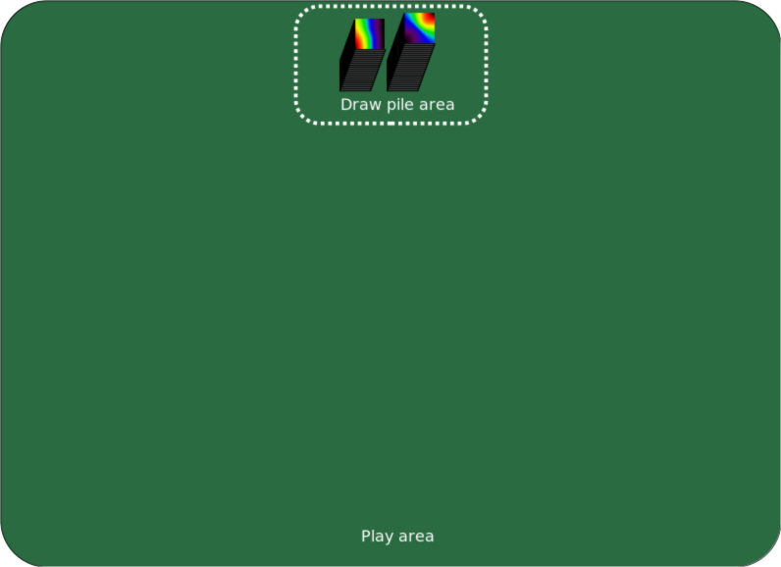
The play begins with the youngest player and proceeds clockwise around the table.

Starting The Game
The game begins with each player in turn selecting a tile from the top of a draw pile and placing it on the play area. The location on the table matters, because tiles may not be moved once placed.

The Second Turn And Beyond
Each subsequent turn a player has two choices, they may either:

- draw a tile from the top of a draw pile and play it onto their road such that it shares at least one edge with the road, and that any shared edges match in color,
or
- split a draw pile by picking up the top half and setting it down in the draw pile area.

Finishing The Game
The game ends when one player during their turn is able to play a tile, and also cannot split a draw pile because all remaining draw piles consist of just one tile. See other side for scoring alternatives.
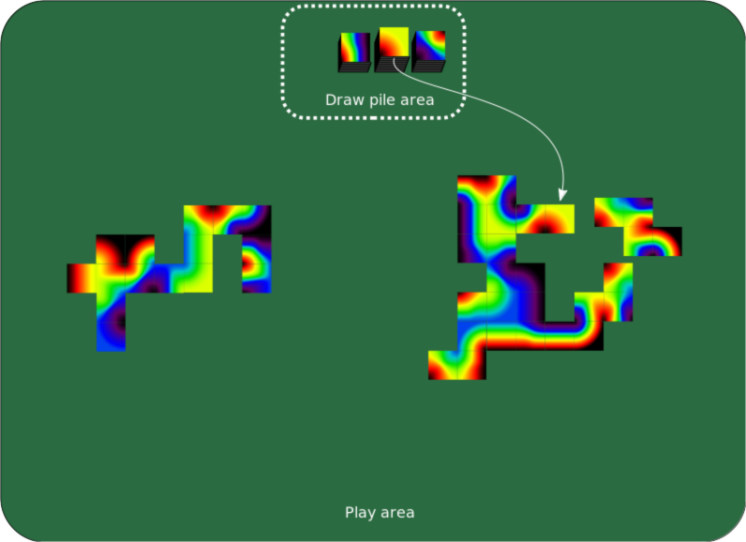

Scoring
There are a number of ways to score the game, and when playing with very young players it may be wise to use a different scoring rule for different players.

Prettiest road
The player with the prettiest road wins. Or alternatively, players do not worry about who wins, but just enjoy building their roads.

Largest road
The score of each player is the total number of tiles played on their road.

Longest road
The score is the total number of tiles forming a contiguous “complete” road, where completeness is defined as containing all the colors of the rainbow along the width. This differs from largest road in that any “stray” tiles that do not connect to the main road are omitted.

Largest loop
The score is for the largest loop of road formed, measured in terms of the number of tiles used in that loop. The loop must be complete in that it must be surrounded by a connected ring of each color.

Team play
As an alternative, players may select teams prior to the start of the game. Players on the same team will play tiles onto the same road and will be scored together.

Cooperative play
Cooperative play is the same as team play with all players on the same team.

Legal
Regnbuevei ©2019 David Roundy. All rights reserved.

