Oakland Inconvenience Tracker

Sprint Review Report

Sprint 3

1.0

11/26/18

Dylan Sporrer

David Rowan

Brandon Donahue

Adam Farabaugh

Software Engineers

Prepared for

CS 1530

Fall Term 2018

University of Pittsburgh

# Revision History

|  |  |  |  |
| --- | --- | --- | --- |
| **Date** | **Description** | **Author** | **Comments** |
| 11/20/18 | Initial Creation | Dylan Sporrer |  |
| 11/21/18 | Story Updates | David Rowan |  |
| 11/21/18 | Final Version | Dylan Sporrer |  |
| 11/26/18 |  | Brandon Donahue |  |

# Document Approval

The following Software Requirements Specification has been accepted and approved by the following:

|  |  |  |  |
| --- | --- | --- | --- |
| **Signature** | **Printed Name** | **Title** | **Date** |
|  | Dylan Sporrer | Software Eng. |  |
|  | David Rowan | Software Eng. |  |
|  | Brandon Donahue | Software Eng. |  |
|  | Adam Farabaugh | Software Eng. |  |

**Table of Contents**

Revision History ii

Document Approval ii

1. Introduction iV

2. Specific Goals iV

3. AnalTICS V

4. CONCLUSION VI

# 

# 1. Introduction

This sprint’s primary goal was to complete the disparate actors developed in Sprint 2 and connect these actors together into a system which can carry out the main functions of the project. To this end, the stories covered in this sprint were: making the backing SQL database more robust with a set of triggers and procedures, further developing the class to handle all queries to the SQL database, and finishing development of the live map feature. These stories total 8 points.

Of the planned stories, all three were able to be completed, though the fact that many included work initially planned for the previous sprint leave the project slightly behind schedule. Additionally, the image storage solution applied to listing class developed in Sprint 2 was found to be untenable and thus the image capabilities of the map and listing system were cut from the final project.

While this sprint met a majority of its goals, it also revealed weaknesses in a previous sprint solution and led to a decrease in project scope. Ultimately, a fully connected system did not result from the sprint, but the project was moved closer to this goal and the individual actors started in sprint 2 were finalized. With this progress, the next and final sprint will be able to complete the actor integration and cover testing of the system.

# 2. Specific Goals

***2.1* Develop Database Triggers and Common Procedures (SID: 08)**

***2.1.1 Story Description:***

This story covers the creation of several triggers and procedures which will make the SQL database which stores listing, user, and tag information more robust.

***2.1.2 Story Acceptance Criterion:***

This story is considered complete when triggers and procedures to remove irrelevant listings, update user listing counts, and connect listings to the correct tags are written, implemented and tested in the database.

***2.1.3 Story Dependencies:***

This story is dependent on the existence of the AWS SQL database and requires that a definite form for user, listing, and tag data input be understood

***2.1.4 Story Challenges:***

No major issues arose during this story

***2.1.5 Story Assigned to:*** Dylan Sporrer

***2.1.6 Story Points:* 1**

***2.1.7 Status:* Complete**

***2.2* Develop Database Class to Run Queries (SID: 09)**

***2.2.1 Story Description:***

Create a database class that connects to the database and inserts and modifies data

***2.2.2 Story Acceptance Criterion:***

Have class that successfully completes queries in a normalized way.

***2.2.3 Story Dependencies:***

Dependent on the completed of the database schema and have the database up and running.

***2.2.4 Story Challenges:***

Diagnosing connection issues and ensuring it is designed in a professional way.

***2.2.5 Story Assigned to:*** David Rowan and Adam Farabaugh

***2.2.6 Story Points:*****5**

***2.2.7 Status:* Mostly Completely, minor alterations needed.**

***2.3* Complete Live Map Feature** (**SID: 09)**

***2.3.1 Story Description:***

This story covers the completion of the live map feature started in the previous sprint. The primary features finished here are the communication to the database class and the representation of listing data in a hover-over window form.

***2.3.2 Story Acceptance Criterion:***

This story is considered complete when other classes of the system can communicate with the

map and send it data which it will then update visually for the user.

***2.3.3 Story Dependencies:***

Dependent on the Listing and Database Classes

***2.3.4 Story Challenges:***

Uncertainty over the method of communication with the database halted progress on this story in the previous sprint. This uncertainty was cleared up early this sprint but still delayed progress slightly.

***2.3.5 Story Assigned to:*** Brandon Donahue

***2.3.6 Story Points:*****2**

***2.3.7 Status:*** Complete

# 3. Analytics

## 3.1 Sprint/Product Burndown Chart

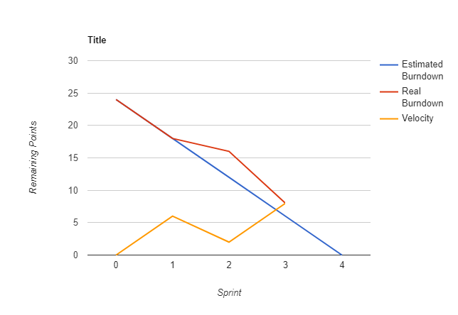

## 3.2 Sprint Velocity

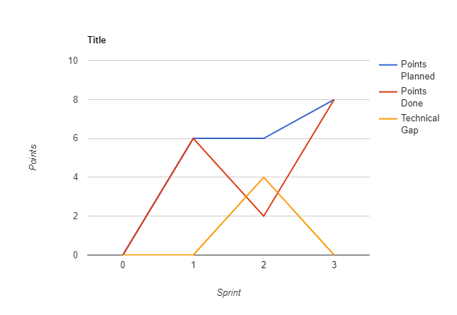

# 4. Conclusion

This third sprint did not quite achieve its goal of creating a fully functioning system in need of only testing and polish, but it did come very close and ensured that any reductions of project scope would affect only cosmetic features. In the upcoming final sprint, the team will complete the integration of systems and test that all core operations can be carried out without error. Aesthetic improvements will only be covered if this primary goal is completed with development time still available.