Census Income Dataset Classification Task
Wu Yuqian, G2501241A
IN6227-2023-Assignment-1

INTRODUCTION

This assignment uses two classification models, a decision tree and a KNN,Trained and tested these two models on the Census Income dataset, and visually evaluated the results. Hopefully,these process can deepen the understanding of the principles of classification models and deeply practice the data mining process.

METHODS OR PROCEDURES

Dataset preparation
In order to have a better understanding of the data set and to better process it later, some data exploration methods were applied.
The info function defined in the pandas library is used to obtain basic information about the dataset, including features, feature type, and its counts.Then uses describe method to view feature distribution,and use histograms to make data features clearer
Counting the missing values of different features in the data set,and the results are shown in the follow figure.
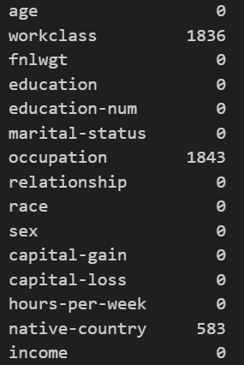
The result shows that only few categorical features contain missing value.In order to avoid missing data, fill the missing values with the mode of each feature to handle problem in this task.
In addition,the strings are cleaned and formatted by removing leading and trailing spaces to avoid errors caused by formatting issues.
While reviewing the dataset,I also found that the income feature in the test dataset had an extra”.” character compared to the training set,so some special procession is used for the test set.
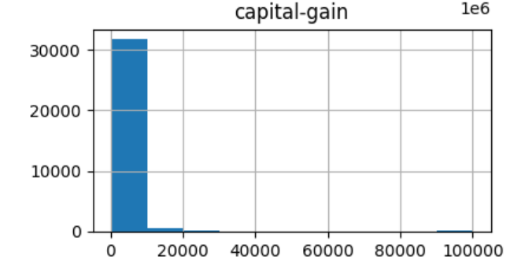
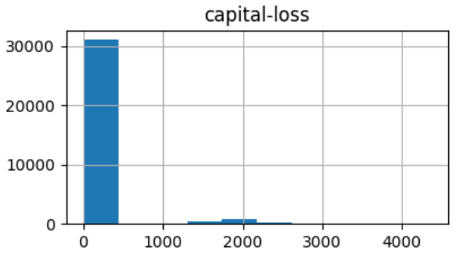
Then for feature engineering,based on the analysis in the data exploration section,the feature “capital-loss”and “capital-gain” have very extreme values, either 0 or larger, with almost no intermediate values,as the follow figure shows.

As the result,considering convert this numerical feature to categorical feature.That is, converting sparse continuous variables into more informative binary features.
For age and work-time features,using banning method to process,also convert this numerical feature to categorical feature,simplify complexity and improve explainability.
Finally, feature encoding, feature alignment, and standardization were applied in the hope of improving the performance of the model when the classification algorithm is applied in the following steps.
Model setup
In this assignment,I use decision tree and k-NN methods to complete the classification task
First, I introduced the decision tree model through the scikit-learn library.Using the default parameter settings for the decision tree and adjust the maximum depth to 5 to avoid the tree being too complex and difficult to visualize.
Then I used a decision tree hyperparameter optimization strategy based on Grid Search and combined with cross-validation.This method exhaustively searches a predefined parameter space to find the hyperparameter combination that performs best on the validation set.There are four main parameters to adjust: max_depth, min_samples_leaf, min_samples_split, criterion．Finally get the desired hyperparameter combination that can achieve the highest accuracy on the validation set.
k-NN was selected as the second classification model.Introduce the model through the scikit-learn library, too.In the k-NN method, the hyperparameter that needs to be adjusted is mainly the value of k. Here I still use the exhaustive method to obtain the optimal k.Train the model and plot the accuracy change curve of the model on the training set and test set under different k values.Finally get the best k value and the best accuracy.

RESULTS

Decision tree:
The classification result of the decision tree model with the default hyperparameters is:
Evaluation Dimension | Metric Name | Score
Efficiency Metrics | Training Time | 0.16s
Efficiency Metrics | Prediction time | 0.02s
Classification Quality | Accuracy | 85.20%
Classification Quality | Precision | 77.95%
Classification Quality | Recall | 52.11%
Classification Quality | F1-Score | 62.46%
Comprehensive Discrimination | ROC-AUC | 88.31%
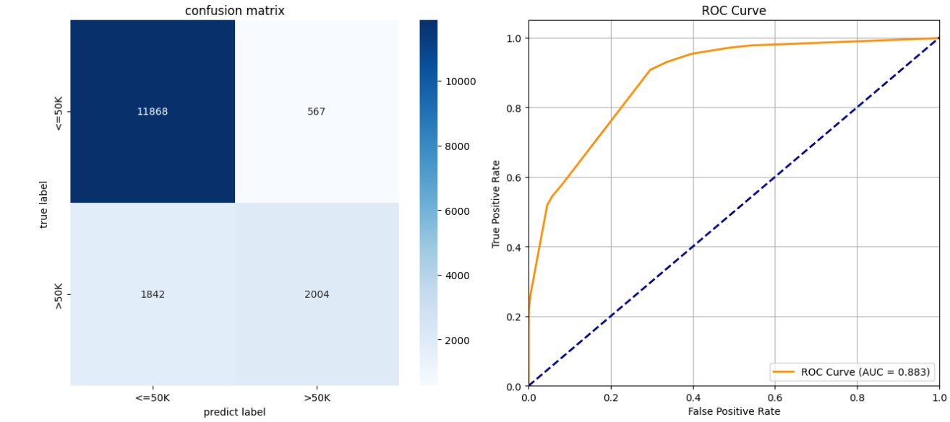
The classification result of the decision tree model with the optimized hyperparameters is:
Evaluation Dimension | Metric Name | Score
Efficiency Metrics | Training Time | 0.25s
Efficiency Metrics | Prediction time | 0.02s
Classification Quality | Accuracy | 86.26%
Classification Quality | Precision | 77.3%
Classification Quality | Recall | 59.3%
Classification Quality | F1-Score | 67.09%
Comprehensive Discrimination | ROC-AUC | 90.65%

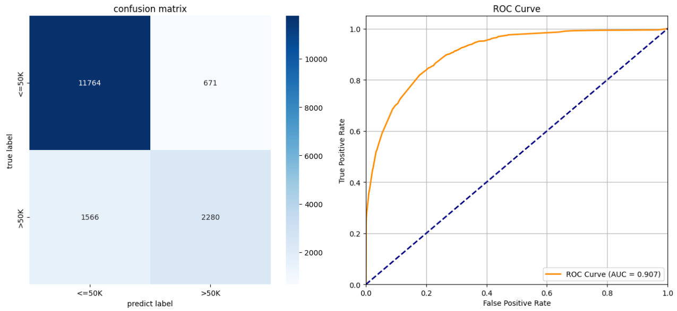
- NN:
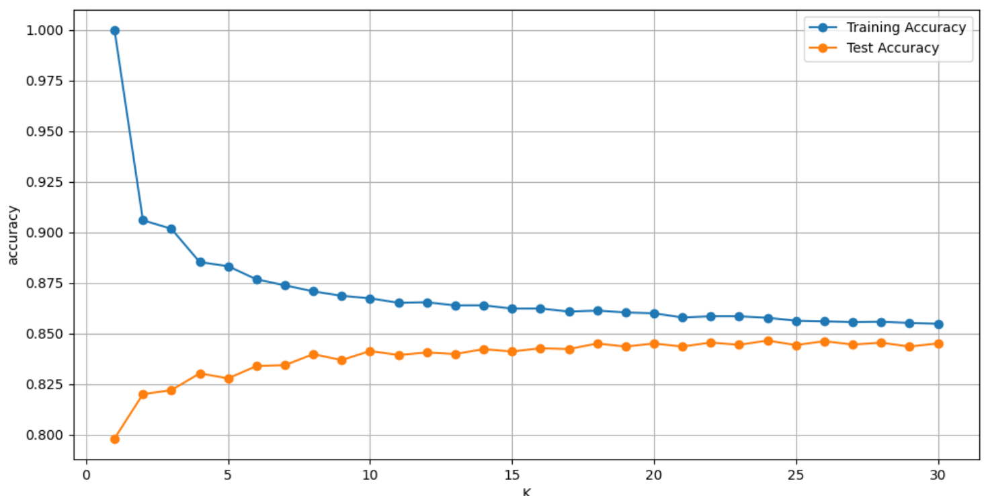
- Accuracy curve changing with k value:
Finally, the optimal k value was set to 24.
The classification evaluation results are as follows:
Evaluation Dimension | Metric Name | Score
Efficiency Metrics | Training Time | 0.0712s
Efficiency Metrics | Prediction time | 5.4383s
Classification Quality | Accuracy | 84.64%
Classification Quality | Precision | 70.10%
Classification Quality | Recall | 61.02%
Classification Quality | F1-Score | 65.25%
Comprehensive Discrimination | ROC-AUC | 89.63%

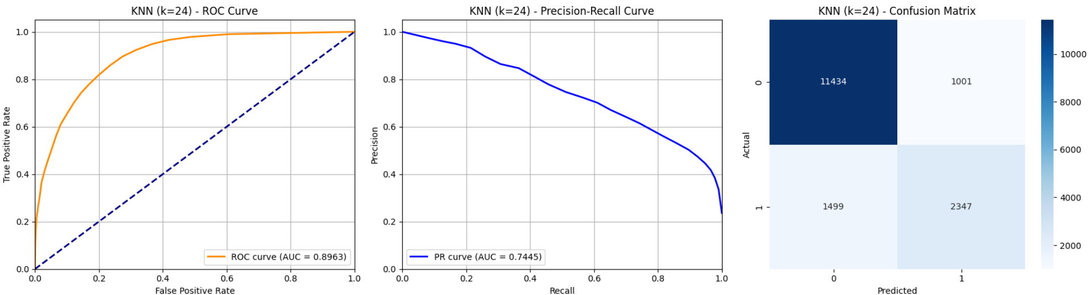

DISCUSSION

According to the evaluation metrics, in terms of training and prediction time,k-NN has a shorter training time but a longer prediction time, while decision tree has the opposite.This is because k-NN needs to calculate the distance to all training samples when making predictions.
For the classification quality, decision tree has a litter bit better accuracy than k-NN.And decision trees focus more on prediction accuracy, while K-NN is slightly better at capturing positive examples as it has a higher recall rate.In addition, the decision tree's accurate identification of positive examples and overall discrimination ability perform better than k-NN.

CONCLUSION

In conclusion,in this case,decision tree have a better performance than k-NN. Probably is due to the uneven distribution of feature importance in the dataset used in the experiment and the clear, rule-based separability it has,which allows the decision trees capture key features and generate rules.In contrast, k-NN treats all features equally when calculating distances.

