Zeke Caskey

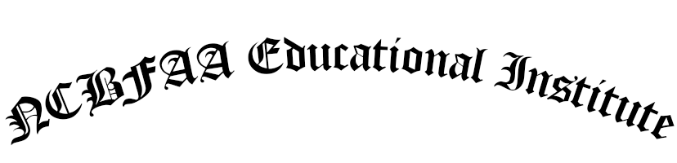

hereby certifies that

One Second

has fulfilled the requirements for the designation of

Certified Customs Specialist

2018