Practical – 2
Aim of the practical: Creating a network using switches, routers, and
gateway routers in the Cisco packet tracer.
Questions
- Write about what is Router & Router Gateway and why gateway is important in router.
Router is one of the crucial devices used in network. It connects multiple networks and manages the flow of data between them. It determines the best route for data to take, ensuring it reaches correct destination point. Routers are crucial in any type of the network be it local or wide-area network.
A gateway is an important component of router. It acts as the entry and exit point for data traveling between different networks. The gateway ensures that devices on a local network, such as computers and phones, can communicate with external networks, such as the internet or other remote servers. The gateway functions as a "translator," enabling communication between networks that use different protocols. Without a gateway, devices within a local network would not be able to access external resources or communicate with devices on other networks.

- Difference between Hub, Switch and Router.
Hub | Switch | Router
Connects multiple devices in a network, broadcasting data to all ports. | Connects multiple devices and forwards data only to the specific device (port) it is intended for. | Connects multiple networks and forwards data between them, typically connecting a local network to the internet.
Works on Physical Layer (Layer 1). | Works on Data Link Layer (Layer 2). | Works on Network Layer (Layer 3).
Broadcasts data to all devices (one-to-all). | Sends data to a specific device (one-to-one). | Routes data between different networks (network-to-network).
 | Can filter and forward data to specific devices using MAC addresses. | Uses IP addresses to intelligently route data between networks.
  No intelligence, just repeats signals.
Shared bandwidth across all ports (causes congestion). | Dedicated bandwidth per port. | Not applicable (as it connects different networks).

- Create a network using switches, routers, and gateway router in Cisco packet tracer. Show message transmission between two devices on different networks.
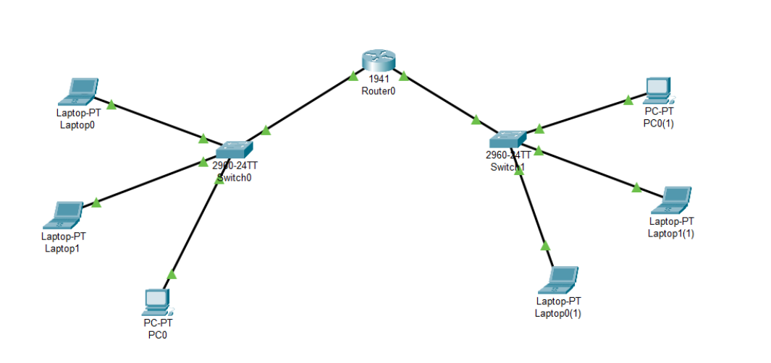
Simulation list:
Source Device:
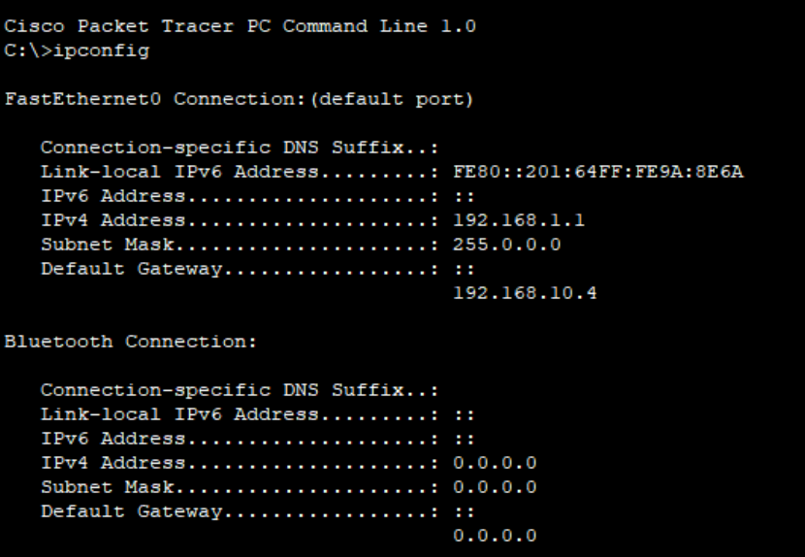
Destination device:
