Practical – 3
Aim of the Practical :- Configuration of an Web Server in Cisco packet tracker.
- Create a single network using switch, End Devices and Server. Create a Web page on server and open it on Web Browser.
Ans:
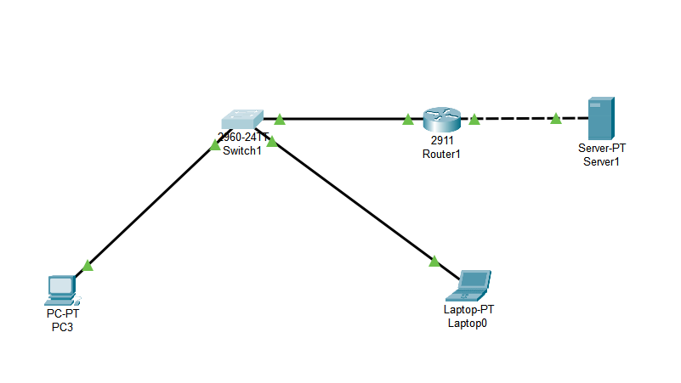

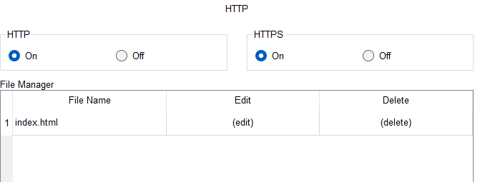

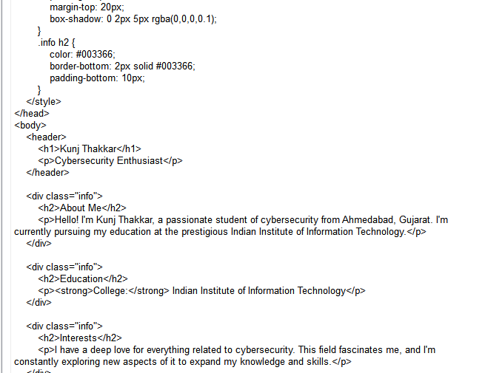

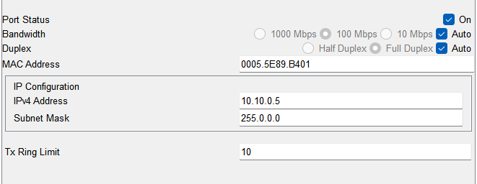

Connection Established, shown by green mark:
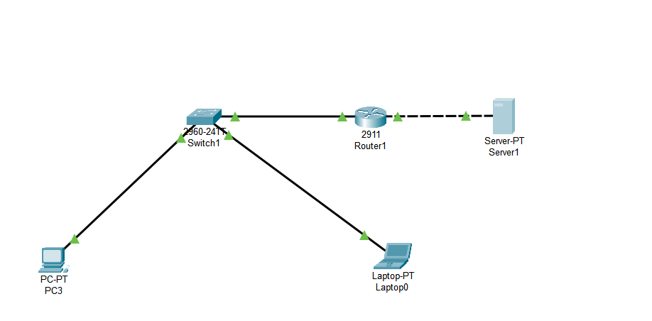

The IPv4 of the server is put in a browser of the PC. Which shows the webpage that was designed:
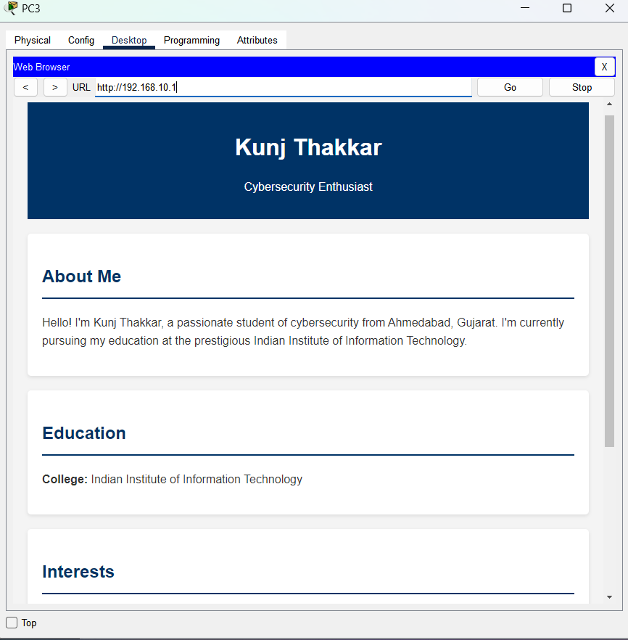

- Create a two network using router, switch, End Devices and Server (End Devices and server will be connect in different network). Create a Web page on server and open it on Web browser.
Ans.
Diagram of the connection:
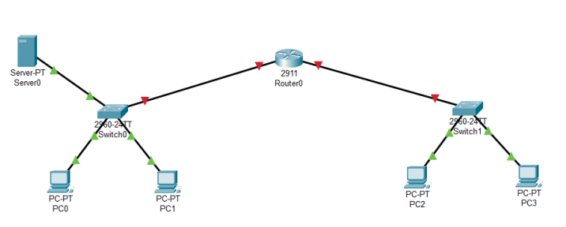

Setting the IPv4 of the End Devices, and the default gateway of the End Devices as well:
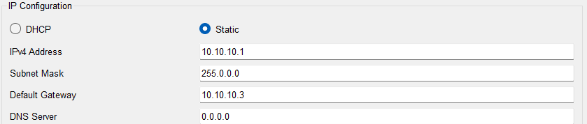
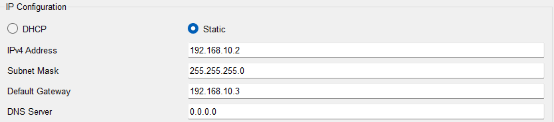
Note: PC0 and PC2 are in separate networks, denoted by different subnet mask.

Enabling the http and https services of the server and also designing the webpage:
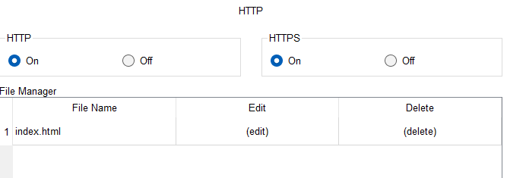
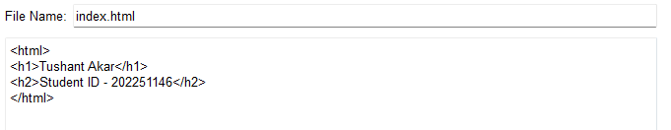

Setting the Gigabit Ethernet 0/0 and 0/1 ports for connecting the End Device and the router.
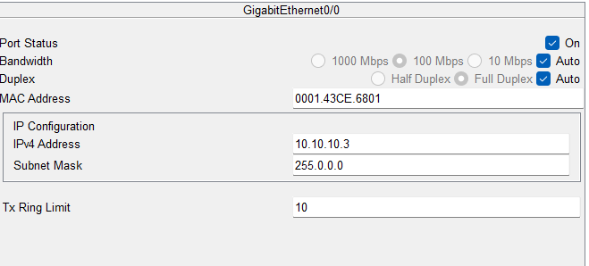
Connection established, shown by green mark:
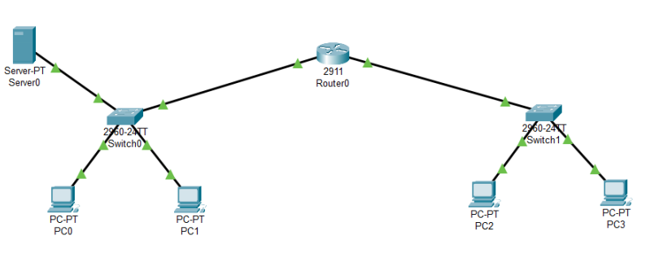

The IPv4 of the server is put in a browser of the PC of a different network, which shows the webpage that was designed:

