Practical – 4
Aim of the Practical: Configuration of an Email server in Cisco packet tracer.
Question-1: What are the key steps to configure PCs on the same network?
- Setup a basic network topology with necessary servers, pcs, switches, and routers
- Assign IPs to each end system and configure router and switches with default gateways
For example: 192.168.1.1/24 and so on
- Setup a default gateway for switches in order to talk between servers
- Configure SMTP server using server (end-system) available in cisco packet tracer
- After setting up this IPs and SMTP service check if topology is working perfectly or not.
Question-2: How would you configure the PCs to send and receive emails using the server?
- User servers in network and then setup the servers to provide SMTP (Simple Mail Transfer Protocol) service
- Setup Email accounts provided by email server.
  - Use server’s SMTP for sending mail and IMP/POP3 for receiving
  - Setup users and password in Server’s configuration for authentication
- In PC setup email configurations with incoming and outgoing email servers
- Test the setup by sending an email to another user in same network

Question-3: Steps to configure a server to host email in a medium-sized network
Step-1
- Setup a basic topology with necessary end-systems, switches and routers
- Connect the network in proper manner
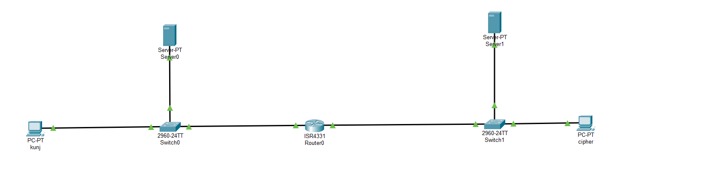
- Setup initial configuration in router with default gateways in order to establish effective communication
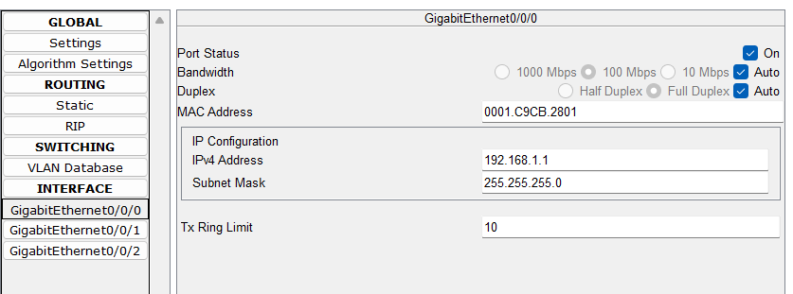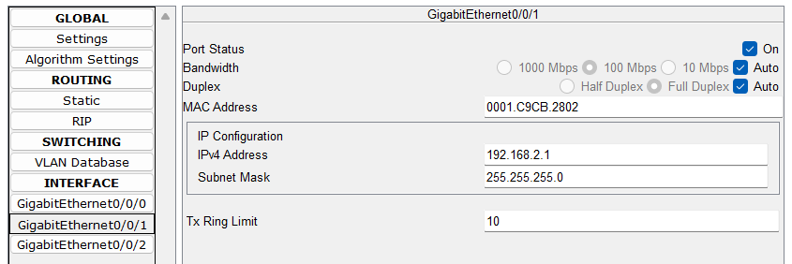
- Assign IPs to servers and PCs
  - PC (kunj) – 192.168.1.2
  - Server0 – 192.168.1.3
  - PC (cipher) – 192.168.2.2
  - Server0 – 192.168.2.3

- Setup Email server at server0
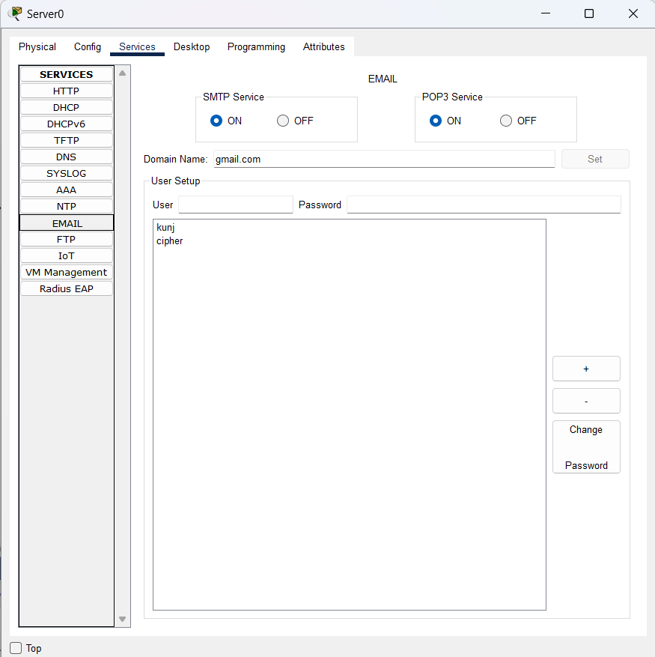
- Setup gmail.com as DNS service in server1
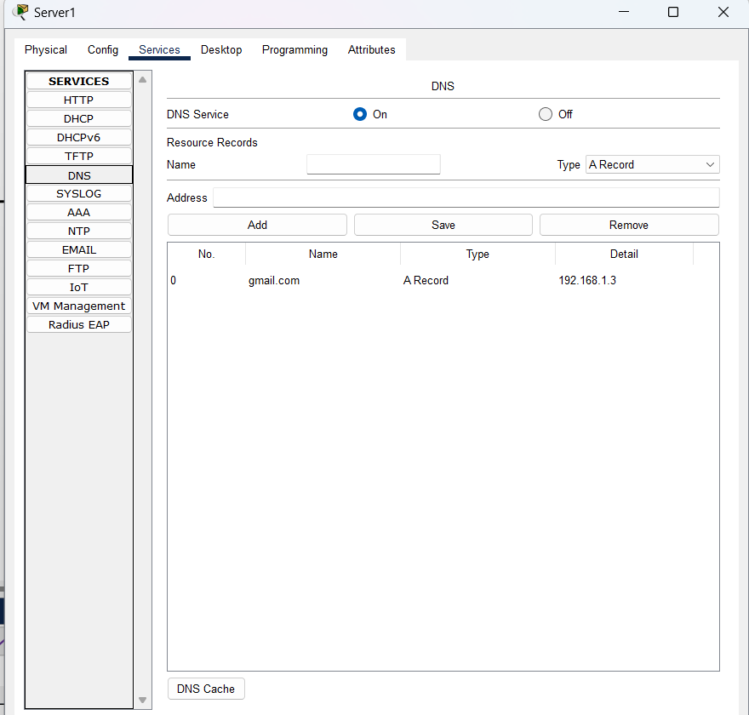
- Set this server’s IP 192.168.2.3 as default DNS for each end-system (PTO)

- Setup email service in PC0 and PC1 and then test by sending email from one PC to another PC
