Practical – 1
- Create a simple network containing an access point, switch, router, printer, PC connected through wire and wireless PC. Then see whether the message transferred from one device to other is successful or not.
Single network (wired PC to wireless PC):
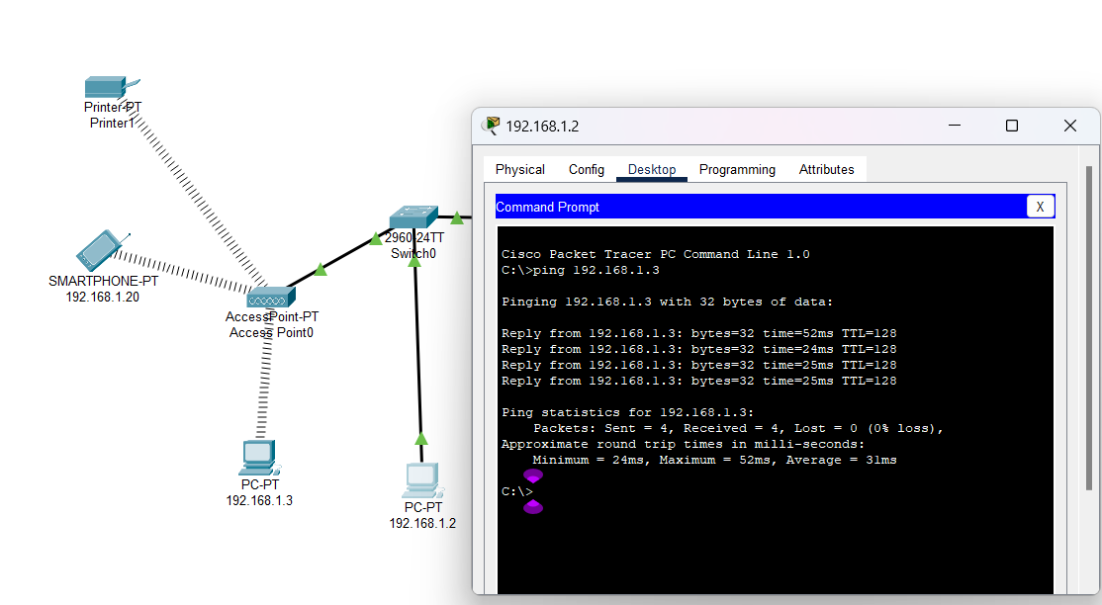
Multiple network (wired PC to wireless PC):
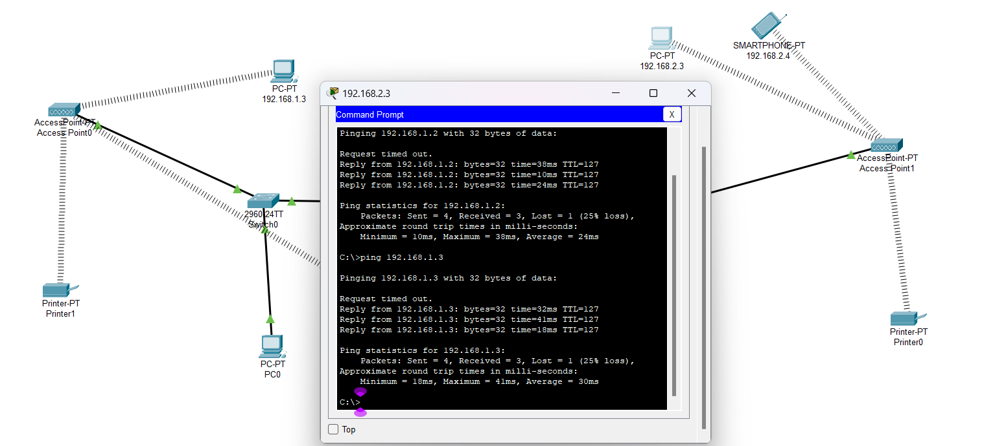
- In addition to the above network connect different smart devices to the network like smart phones, wireless tablets, laptops. Then again see whether the message transferred from one device to other is successful or not.
Single network (wireless smartphone to wireless PC):
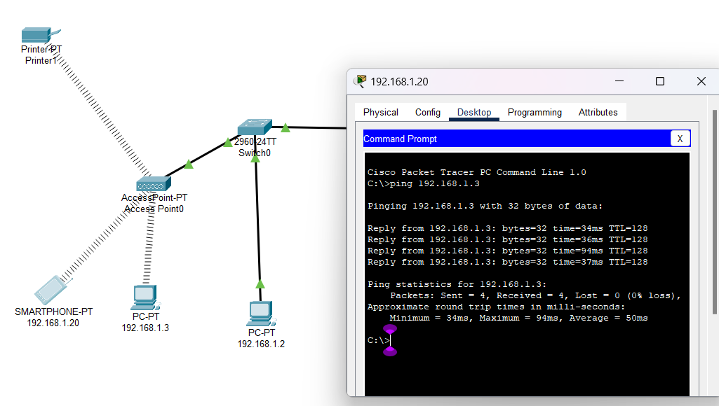
Multiple network (wireless smartphone to wireless PC):
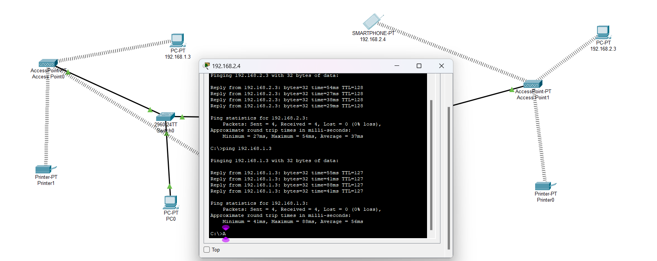
- Explain the role of the access point in enabling communication between wired and wireless devices.
An Access Point (AP) plays a crucial role in enabling communication between wired and wireless devices, acting as a bridge that connects these two different network types. Here's how the AP facilitates this process:
- Establishing a Wireless Network:
  - The access point (AP) creates a wireless local area network (WLAN).
  - Wireless devices like smartphones, laptops, and tablets connect via Wi-Fi signals.
  - In Cisco Packet Tracer, the AP provides connectivity to devices equipped with wireless adapters (NICs) or smartphones.
  - A wireless environment is created where data can be transmitted without using physical cables.
- Linking to the Wired Network:
  - The AP connects to the wired network using an Ethernet cable.
  - The wired network can include devices like servers, desktop computers, and printers.
  - These devices are part of the LAN (Local Area Network).
  - The AP integrates wired devices with the broader network, facilitating communication between the wired and wireless segments.
- Functioning as a Bridge:
  - The AP serves as a bridge between wireless and wired devices.
  - When wireless devices send data, the AP converts the wireless signals into a format compatible with the wired network.
  - Data from wired devices is also converted into wireless signals for transmission to wireless devices.
  - For example, a laptop connected wirelessly can ping a server on the wired network, with the AP handling signal translation.
- Managing Network Traffic:
  - The AP not only connects devices but also manages data traffic between them.
  - It ensures efficient communication by regulating traffic between devices.
  - It handles wireless-to-wireless communication within the same WLAN.
  - The AP directs wireless-to-wired communication, ensuring data reaches the correct destination.
- Expanding Network Coverage:
  - Strategically placed APs can extend the network’s coverage area.
  - This allows more wireless devices to connect from various physical locations.
  - It provides flexibility in terms of network access and connectivity.
  - Both wired and wireless devices can interact seamlessly across the extended network.
- What steps would you follow to test this communication?
To test the communication between wired and wireless devices, several steps can be followed. First, a ping test can be used to verify connectivity between devices. By opening the command prompt on each device and typing the ping command followed by the target device’s IP address, users can confirm whether data is successfully being transmitted. For instance, pinging from a wired PC to a wireless PC check if the access point is functioning properly. Pinging from a wired PC to a printer ensures proper communication within the wired network, while pinging from a wireless PC to the router tests the connection between the wireless and wired segments.

Additionally, a Protocol Data Unit (PDU) check can be performed in Cisco Packet Tracer to send data packets between devices. By selecting one device, such as a wireless smartphone, and sending a PDU to another device, such as a wired PC, users can verify if the message is successfully delivered. This indicates whether the network is functioning as expected. For example, sending a PDU from a wireless smartphone to a wired PC or from one wireless PC to other helps confirm the integrity of the network and the proper functioning of communication channels.
- How would you confirm the printer and other devices are also properly connected to the network?
Ping the printer:
