Practical – 6
- Extend the network that you created in Lab-5 using wireless devices by adding SERVER. Now open web page through a smart device. Also send a mail from one smart device to another.
Extended network
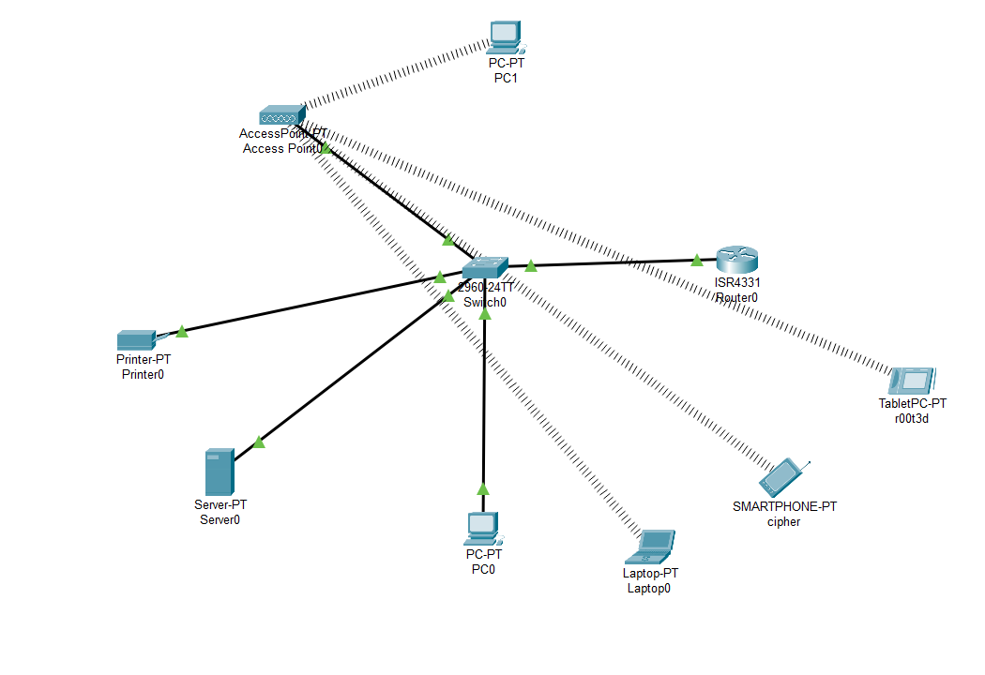
Accessing webpage through a smart phone named cipher
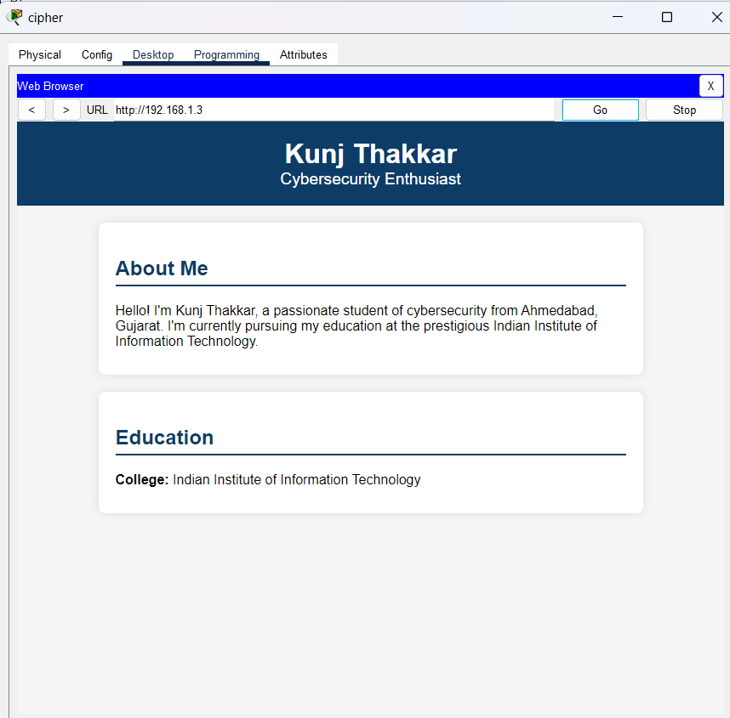
Using email service between smartphone(cipher) and smart tablet(r00t3d)
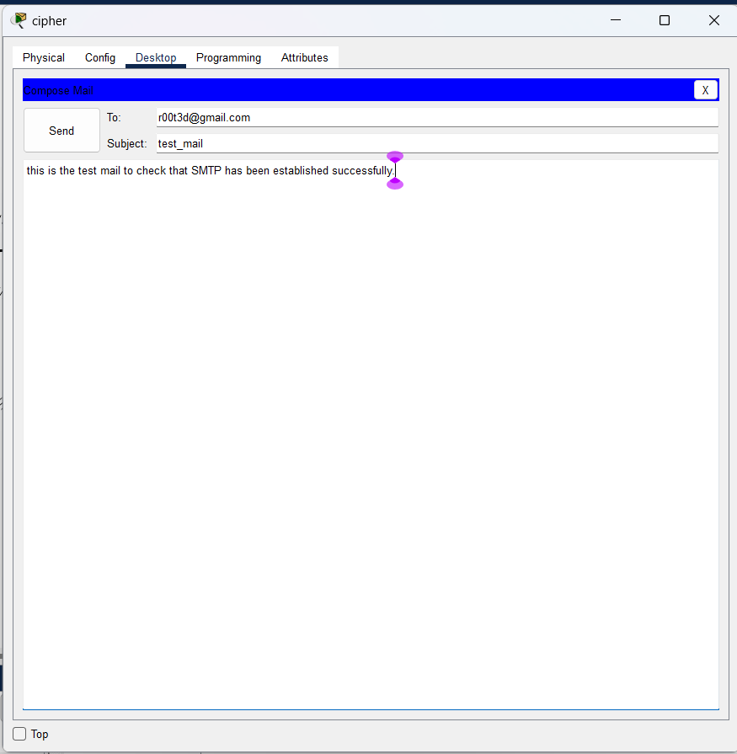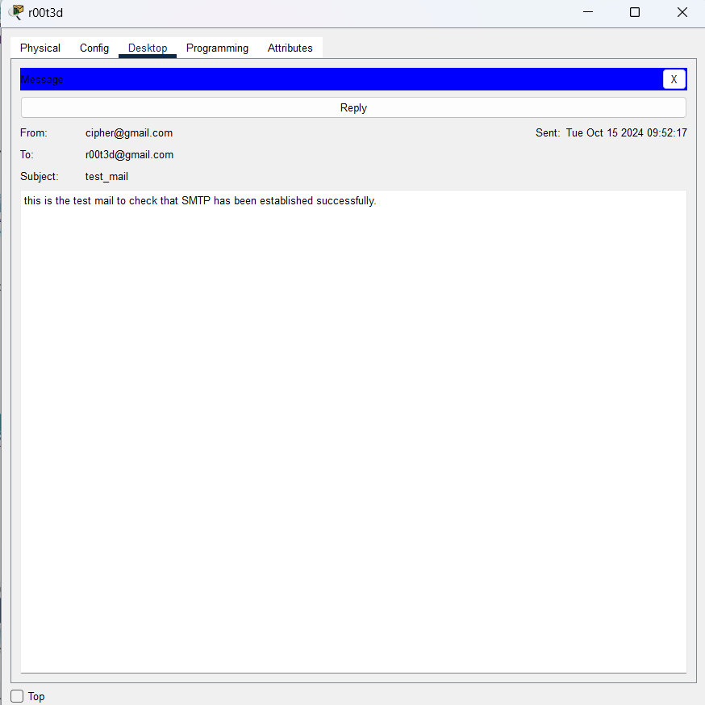
- How do you verify if the message transfer between wired and wireless devices is successful? What tools in Cisco Packet Tracer can be used?
To verify if message transfer between wired and wireless devices is successful, you can use the following tools in Cisco Packet Tracer:
Ping Command
From the Command Prompt of a device, use the ping command to check connectivity.
- For example, on a smart device, open the command prompt and type: ping 192.168.1.7 (IP address of the smart tablet).
- If you receive replies, it means the network connectivity is functioning properly between the devices.

(P.T.O)
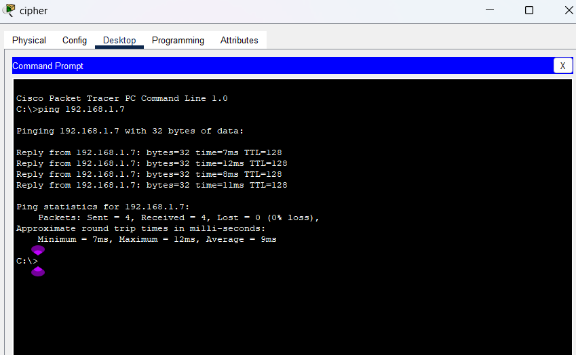
Web Browser Test
- Open a web browser on a smart device and enter the IP address of the server (e.g., http://192.168.1.2).
- If the server's web page loads, this verifies successful HTTP communication between wired (server) and wireless (smart device) devices.
- What role does the router play in facilitating communication between wired and wireless devices?
The router plays a critical role in enabling communication between wired and wireless devices in a network:
Functions of the Router
- Routing Data Packets: The router forwards data packets between different segments of the network, ensuring that data can travel between wired devices (like PCs and servers) and wireless devices (like smartphones and tablets).
- Network Address Translation (NAT): The router helps convert private IP addresses to a public IP address if needed, facilitating communication between devices on different networks.
- Dynamic Host Configuration Protocol (DHCP): If configured, the router can act as a DHCP server, automatically assigning IP addresses to both wired and wireless devices.
In a network scenario, the router ensures that data packets from a wired PC can reach a wireless smartphone and vice versa. It also manages the data paths to avoid conflicts and ensure efficient delivery.

- How would you configure the server to provide email services (SMTP and POP3) to allow smart devices to send and receive emails?
To configure the server to provide email services for smart devices, follow these steps:
Step 1: Enable Email Services on the Server
- Select the server in Cisco Packet Tracer.
- Go to the Services tab, then choose Email.
- Enable both SMTP (Simple Mail Transfer Protocol) and POP3 (Post Office Protocol 3).
  - SMTP is used for sending emails.
  - POP3 is used for retrieving emails from the server.
Step 2: Create User Accounts
- Still in the Email service tab, create user accounts by specifying usernames and passwords.
  - Example:
    - Username: cipher, Password: 1234
    - Username: r00t3d, Password: 1234
- Each smart device will use these accounts to send and receive emails.
Step 3: Configure Smart Devices to Use the Email Service
- Open each Smart Device and go to its Email Client application.
- Configure the Email Client settings:
  - SMTP Server: Set to the server’s IP address (e.g., 192.168.1.2).
  - SMTP Port: Use the default SMTP port 25.
  - POP3 Server: Set to the server’s IP address (e.g., 192.168.1.2).
  - POP3 Port: Use the default POP3 port 110.
  - Username: Enter the username created on the server (e.g., cipher).
  - Password: Enter the password associated with the username (e.g., 1234).
Step 4: Send and Receive Emails
- On Smart Device 1, compose an email and send it to the email address configured on Smart Device 2.
- On Smart Device 2, open the email client and check for new messages to receive the email.
- Verify that the email is successfully sent and received, confirming that the SMTP and POP3 configurations are working correctly.

