Practical – 7
Aim of the Practical:
Our institute has four blocks, UG block contains 126 Hosts, PG block 63 Hosts, Admin block 32 Hosts, Faculties block 30 Hosts. Assume that the original IP address that has been assigned to this complete network is 192.168.1.0
- Calculate the subnet mask, network address, first host IP address, last host IP address, range, and broadcast address for each block (UG, PG, Admin, and Faculties).
Ans:

Subnet Mask Calculation for UG Block (126 Hosts)
- Host Requirement: 126 hosts
- 126 hosts require 7 bits for host addresses (2^7 = 128 hosts)
- Therefore, the subnet mask should be 255.255.255.128 (/25)
- Network Address: 192.168.1.0
- Usable IP Range: 192.168.1.1 to 192.168.1.126
- Broadcast Address: 192.168.1.127

Subnet Mask Calculation for PG Block (63 Hosts)
- Host Requirement: 63 hosts
- 63 hosts require 6 bits for host addresses (2^6 = 64 hosts)
- Therefore, the subnet mask should be 255.255.255.192 (/26)
- Network Address: 192.168.1.128
- Usable IP Range: 192.168.1.129 to 192.168.1.190
- Broadcast Address: 192.168.1.191

Subnet Mask Calculation for Admin Block (32 Hosts)
- Host Requirement: 32 hosts
- 32 hosts require 5 bits for host addresses (2^5 = 32 hosts)
- Therefore, the subnet mask should be 255.255.255.224 (/27)
- Network Address: 192.168.1.192
- Usable IP Range: 192.168.1.193 to 192.168.1.222
- Broadcast Address: 192.168.1.223

Subnet Mask Calculation for Faculties Block (30 Hosts)
- Host Requirement: 30 hosts
- 30 hosts require 5 bits for host addresses (2^5 = 32 hosts)
- Therefore, the subnet mask should be 255.255.255.224 (/27)
- Network Address: 192.168.1.224
- Usable IP Range: 192.168.1.225 to 192.168.1.254
- Broadcast Address: 192.168.1.255
- Implement all blocks IP addresses and subnetting in Cisco Packet Tracer (Note that, connect only two PCs to each block).
Ans:
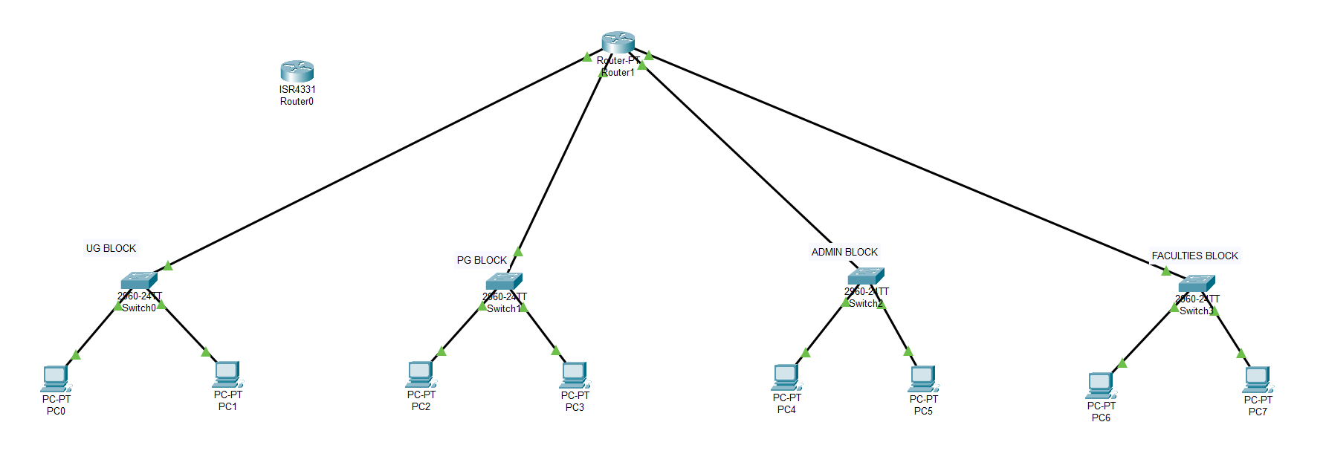

Setting up UG block
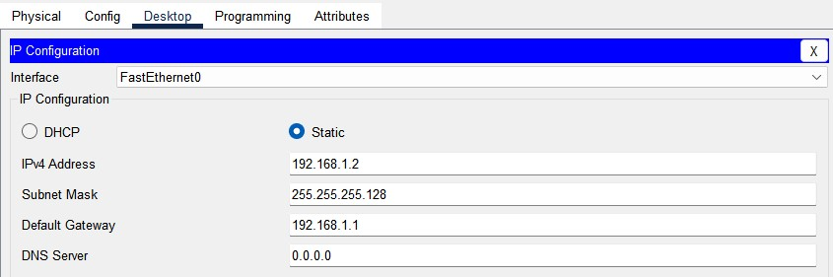
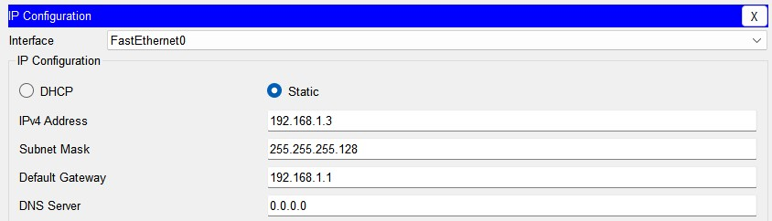
Setting up PG block
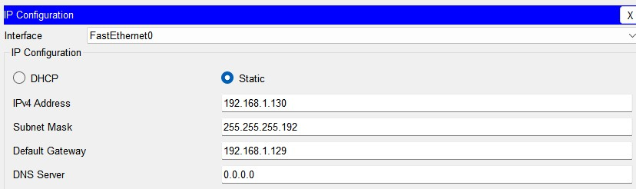
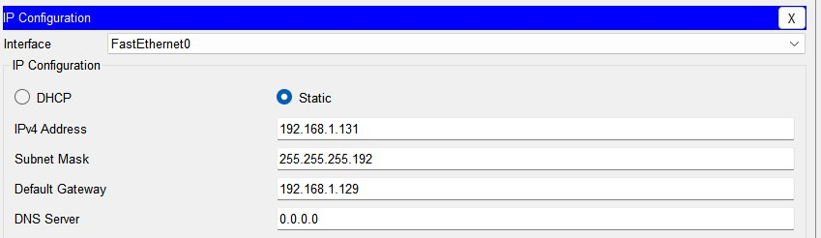

Setting up Admin block
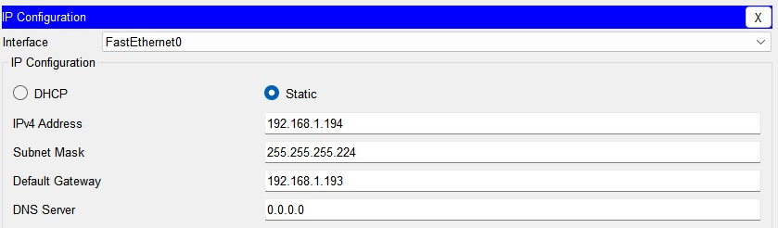
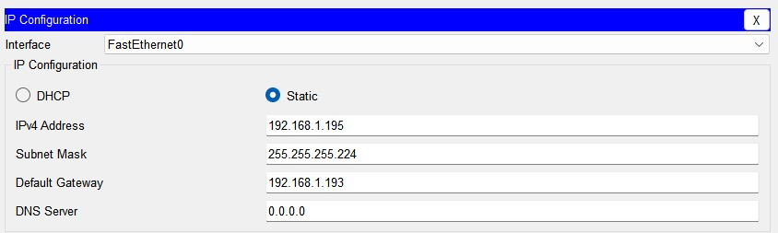
Setting up faculties block
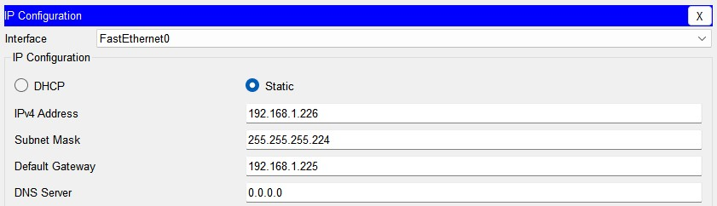
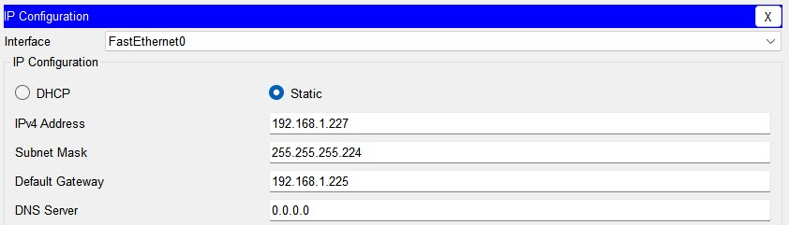

Connection established successfully
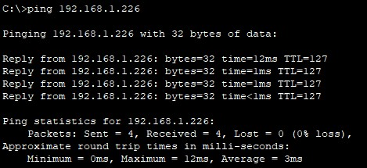
- What is the original IP address assigned to the entire network of the institute?
Ans. The original IP address assigned to the entire network of the institute is 192.168.1.0

