Practical – 8
What is IoT?
- The Internet of Things (IoT) refers to a broad network of connected devices that interact and collaborate seamlessly.
- These devices are embedded with sensors, software, and advanced technologies to enable sophisticated functions.
- IoT devices are capable of collecting data from their surroundings through integrated sensors.
- They exchange information with other devices or systems via the internet.
- Data collected by IoT devices is analysed to derive meaningful insights.
- Devices can communicate with each other or central systems to coordinate actions.
- Automation is a key feature, allowing processes to occur with minimal human involvement.
- Intelligent decision-making is supported, leveraging real-time and historical data for efficient operations.
- IoT drives innovation by enabling smarter systems and enhancing efficiency in various industries.

What are IoT Devices?
IoT devices are physical objects equipped with sensors, software, actuators, and connectivity modules that enable them to collect and share data with other systems or devices over a network. These technologies empower the devices to interact with their environment, make intelligent decisions, and automate various processes.

Examples of IoT Devices
- Smart Home Devices:
- Smart Thermostats: Learn user preferences and adjust home temperatures to optimize comfort and energy savings.
- Smart Lights: Allow control of brightness, color, and on/off functions through apps or voice commands.
- Home Security Cameras: Provide remote monitoring, motion detection, and real-time alerts for enhanced security.
- Smart Appliances: Devices like refrigerators or washing machines that can monitor usage and provide maintenance alerts.
- Wearable Devices:
- Smartwatches: Monitor health metrics like heart rate and fitness activity while providing notifications.
- Fitness Trackers: Help track exercise routines and sleep quality, offering insights into overall well-being.

- Industrial IoT Devices:
- Predictive Maintenance Sensors: Monitor machinery for signs of wear and predict failures to prevent downtime.
- Connected Equipment: Machines that share data to optimize manufacturing or production processes.

IoT technology has diverse applications ranging from smart homes and healthcare to industrial automation and agriculture, showcasing its transformative potential across many industries.

Why Use IoT?
- Automation IoT systems can automate repetitive or routine tasks, reducing the need for constant human intervention. This is evident in smart homes (e.g., automated lighting systems) and industries (e.g., production line monitoring), enhancing convenience and consistency​
- Efficiency: By integrating IoT, businesses and homes can optimize processes such as resource allocation, energy use, and maintenance schedules. For instance, smart grids optimize electricity distribution based on real-time demand, while industrial IoT improves workflow management​
- Data Insights: IoT devices generate and analyse large volumes of data, offering actionable insights that help in decision-making. For example, predictive maintenance sensors provide early warnings about equipment failures, preventing costly downtimes
- Remote Access: IoT allows users to control and monitor devices from anywhere via internet-connected applications. This is especially useful in scenarios like remote healthcare monitoring and home security systems
- Cost Savings: IoT optimizes energy use, reduces wastage, and cuts operational costs. Examples include smart thermostats that lower heating/cooling bills and predictive tools that minimize unplanned industrial maintenance costs
Practical Demonstration: Connecting IoT Devices Across Two Houses
Scenario:
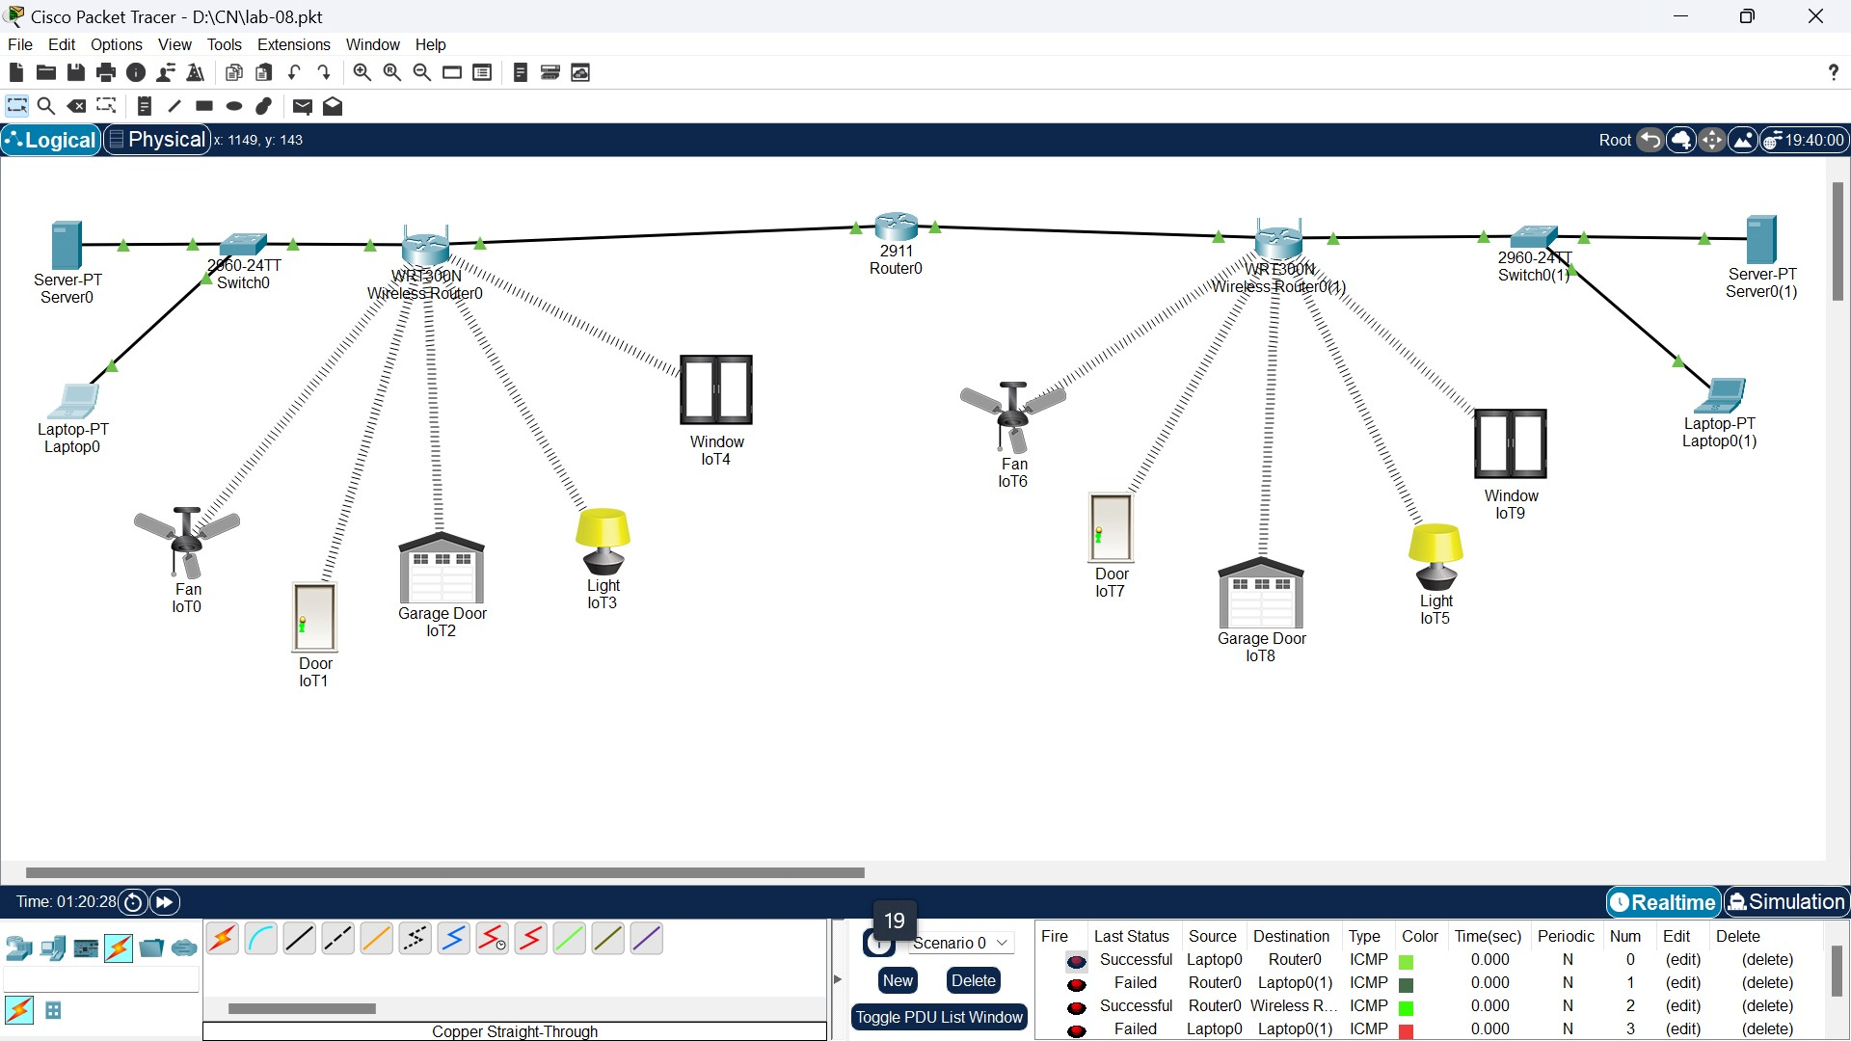
- House 1: IoT server and devices (smart bulbs, thermostats).
- House 2: IoT server and devices (smart cameras, smart locks).
- Goal: Control the IoT devices in House 1 from a laptop/PC located in House 2.
- IoT Devices of One House Controlled from Another House
Components Used:
- IoT Servers: Each house has a local IoT server managing its devices.
- Wireless Routers: Provide internet connectivity to IoT devices and servers
- Switch: Extends the number of devices connected within a network (if necessary)
- Router: Connects the two networks securely over the ethernet

Steps to Enable Control Across Houses:
- House A Setup:
- IoT devices are connected to a local IoT server via the wireless router.
- The router is configured with port forwarding for the IoT server. For example, open port 8080 and forward it to the IoT server's internal IP.
- Alternatively, set up the router as a VPN server to allow remote access to the entire network.
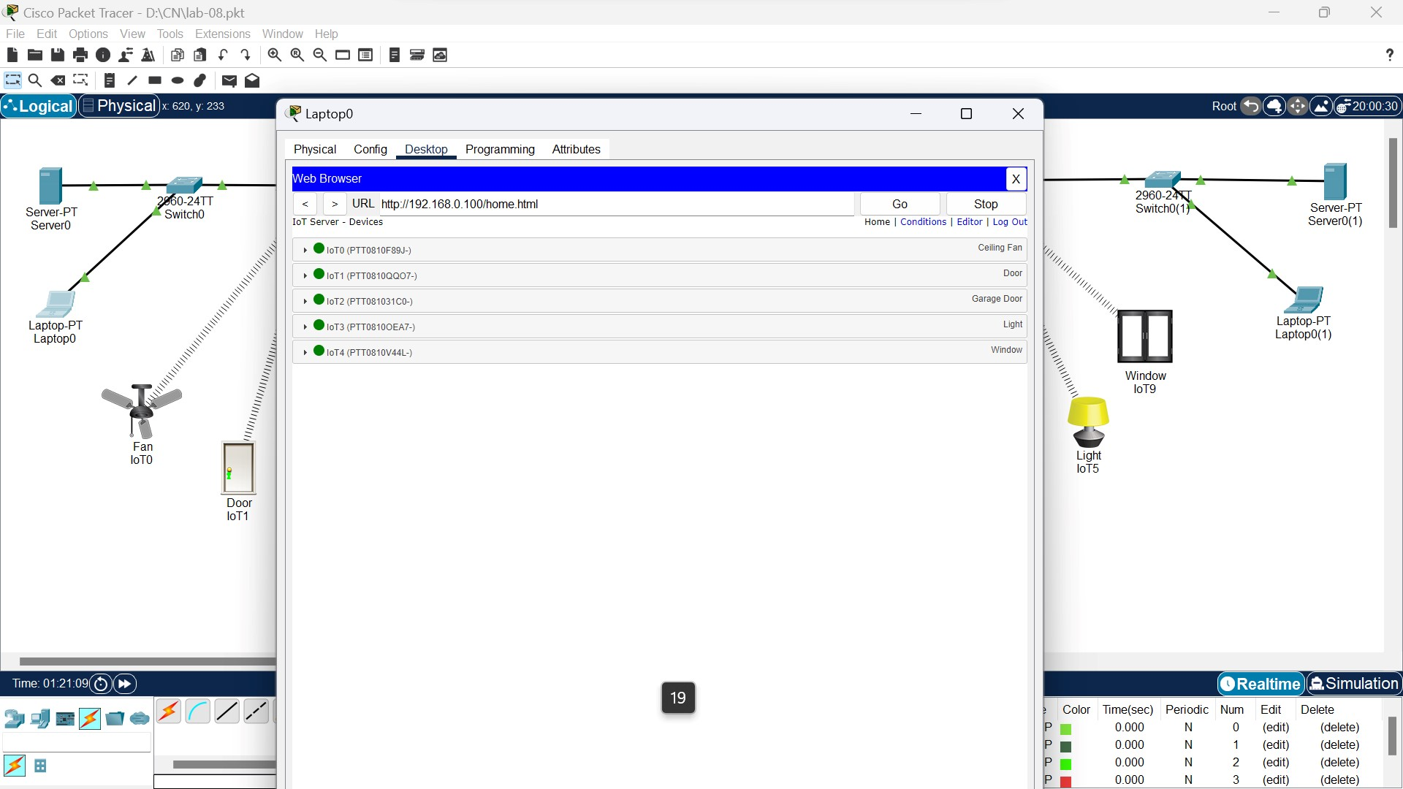

- House B Setup:
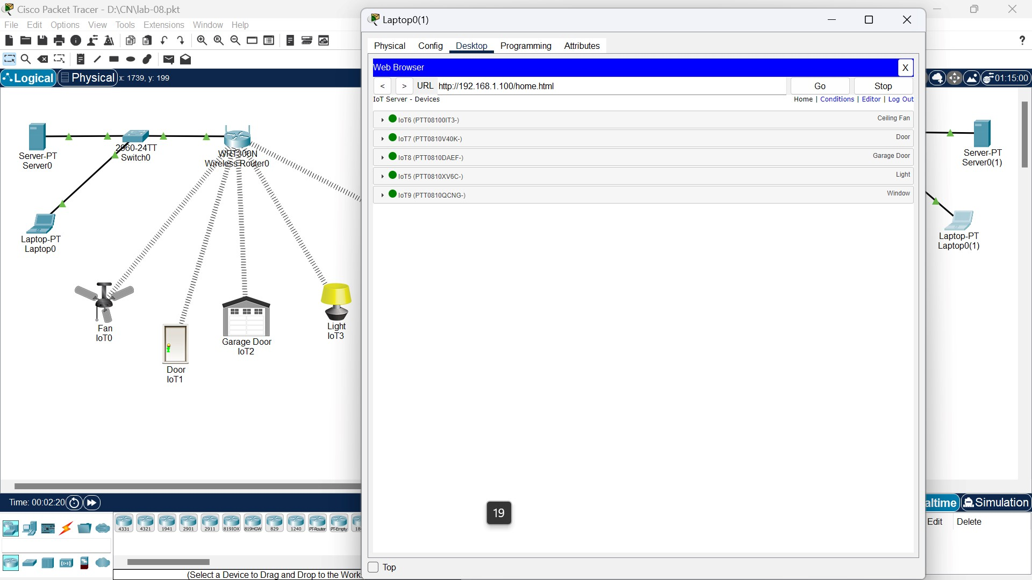
- Testing Control:
- On the laptop in House B, open the IoT server’s control dashboard using the VPN-secured connection (e.g., http://<IoT-server-IP>:8080).
- Control the devices (turn on lights, adjust thermostat, etc.) in House A from House B.
2. Purpose of Each Component
IoT Server:
- Acts as the central hub for managing IoT devices.
- Handles device registration, communication, and command execution.
- Provides APIs or dashboards for remote monitoring and control.
Wireless Router:
- Connects the IoT server and devices to the internet.
- Enables communication between the local network and external devices.
- Facilitates VPN connections for secure remote access.
Switch:
- Extends the number of devices that can connect to the local network.
- Especially useful in scenarios with many IoT devices requiring Ethernet connections.

