Total number of bijective mapping from Z26 to Z26 are 26!
- Hill Cipher
In this cipher, we choose our secret key as a n*n invertible matrix A and our message M is broken down into components m1, m2, m3,……mn
So, secret key A = (aij)n*n where A is invertible matrix
Plaintext M = m1m2m3……mn
Ciphertext C = A.M
Now this C is calculated using Ci = summation (j=1 to n) aij*mj
For decryption, we use the inverse of matrix A to decode the ciphertext back into plaintext
M = A^-1 C

- Symmetric Key Ciphers
Symmetric Key ciphers are those in which the same key is used for both encryption and decryption. If you know the key for encryption then you can calculate the key for decryption. There is no concept of private key and public key in symmetric key ciphers.
There are two types of ciphers-
- Block Cipher
- Stream Cipher

- Block Ciphers-

In block cipher, the plaintext M is broken down into r number of blocks each of fixed block size n.
len(M) = n*r
len(mi) = n

It is important to note here that Block Size l is very important in terms of block ciphers. So,
Plaintext M = m0 || m1 || m2 || m3 || ……|| mr

For example, we can divide a 32-bit message into 4 blocks of size 8 each. Here, n = 8 and r = 4.

Now, we apply the encryption function E(mi, k) on each of this block separately to calculate our ciphertext C and similarly, we apply decryption function D(Ci, k) on each block separately to get back our plaintext P.

Encryption: C = E(m0, k) || E(m1, k) || …… || E(mr, k)
Hence, C = c0||c1||…..||cr
Decryption: P = D(c0, k) || D(c1, k) || …… || D(cr, k)
Now there can be two cases which can arise while breaking our plaintext into blocks-
Case 1 –
Length of plaintext P is exactly divisible by block size n: Here, there would not be an issue and the process remains the same as described in the above section.
Case 2-
Length of plaintext P is not divisible by block size n: Here, we would not be able to divide the message into blocks of equal size because the last block will have characters which are less than the fixed block size. Lets consider the below example where M is divided into m0 (size = n), m1 (size =n), m2(size = l, which is less than n). Total length of the message = 2n+l where l<n.
M = m0 || m1 || m2
Now we would pad our m2 and add extra 0s to last so that we attain block size n for last block. Lets say we add r 0s to the last block,
So, l+r = n
Now we would follow the encryption process as usual as described above –

C = c0 || c1||c2
c0 = E(m0,k)
c1 = E(m1,k)
c2 = E(m2||0^n-l,k)

m2||0^n-l since we did padding with 0s

Now, similarly for decryption, we would simply perform decryption block by block and then remove the last r characters from our decoded plaintext to get actual plaintext.

- Note
This was ECB (Electronic Control Board) mode of operation –
The method we studied above is referred to as ECB mode of operation. There are other modes of operation as well. This ECB mode is not secure due to the following reasons –
- If two blocks are same then their corresponding encrypted blocks would also be same. This reveals the information that we have 2 blocks of plaintext which are same. Hence, there is an information leakage here.
- As we saw that we need to add extra 0s if the length of plaintext M is not exactly divisible by block size n, we would also need to share that how many 0s we padded in the last block in order to subtract that many number of 0s while decryption. This sharing of information regarding number of 0s padded is also a kind of leak of information.
Types of block ciphers –
- Product Cipher-
Product cipher combines two or more transformations in a manner intending that the resulting cipher is more secure than the individual components. Basically it incorporates multiple cipher techniques to come up with a new more secured one!
Now, any product cipher falls into any one of the following two types –
- Substitution-Permutation Network (SPN) –
Here the advantage of both – Substitution cipher (S-box) and Permutation Cipher is considered. First, the one or more s-boxes operate on each block of plaintext and then one or more permutation cipher permutes these substituted blocks to come up with the encrypted text.
Encryption:
S: {0,1}^n -> {0,1}^m
P: {0,1}^mr -> {0,1}^mr

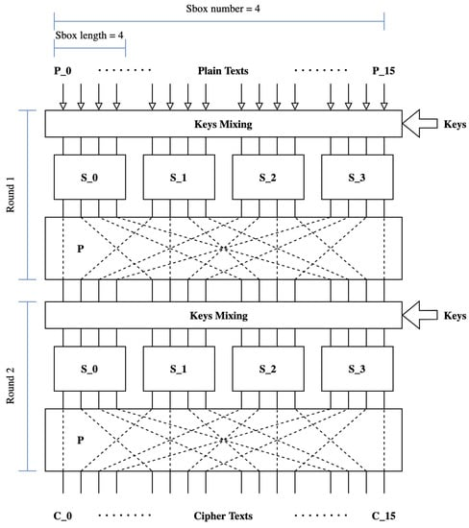

https://www.mdpi.com/2410-387X/6/4/60?type=check_update&version=2

Here, we have r blocks of size n each, the output of each box is a block of size m (m<n according to s-box definition), then these r blocks of size m are combined into mr length and then permutated using permutation cipher. This marks the completion of 1 round of encryption. In practical, there can be many such rounds. In round 2, again this mr length is broken down into blocks of size n and the process is repeated r1 number of times. Repetition r1 number of times denotes that this SPN is of r1 rounds.

For decryption: We would simply backtrack and apply reverse permutation and apply S-1 s-box (usually S-boxes are invertible in nature) on each of the block to get back our plaintext M.
- Feistel Network-
This is the second type of product cipher and here the plaintext M is broken down into 2 blocks, each of size n. If the plaintext M is of odd length, then we pad an extra 0 in the end to make it divisible by 2 and hence we can split it equally into two halfs. In both the cases, the length of final plaintext is 2n. Now, these two blocks are referred to as L0 (left block) and R0 (right block). We perform some basic operation using secret key k and an encryption function f on these blocks to come up with encrypted blocks L1 and R1 which is again of size 2n.

Encryption:
F: {0,1}^n X {0,1}^k -> {0,1}^n
L1: R0
R1: L0 + f(R0,k)
Here + is xor operation

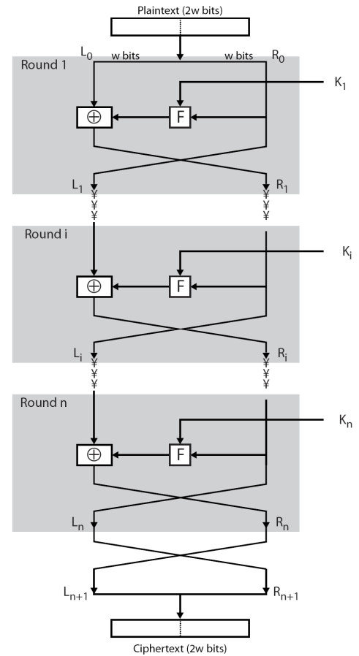

https://iasbs.ac.ir/~farajian/slides/network%20security/ns_session3.pdf

Here, we have our plaintext of size 2w, which is broken down into two blocks of size w each. Now we have L0 and R0 with us. Now, to get L1, we simply copy paste R0 and to get R1 we will perform L0 (xor) f(R0,k1) here f is some encryption function and k1 is secret key for round 1. Like SPN, we can have multiple rounds of encryption with ki representing the secret key used in each round. Performing this r1 number of times, we call it to be as a r1 round Feistel network (here n is used instead of r1 to denote number of rounds). At the end, we obtain a ciphertext C of same length as that of the plaintext M.

Decryption:
For decryption, we simply backtrack and we can obtain L0 and R0 from L1 and R1 as follows-
L0 = R1 (xor) f(L1,k)
R0 = L1
Similar approach can be applied to r1 round Feistel network.
The advantage which is to be noted here is that even if function f is not invertible, we are able to decrypt our ciphertext C because in decryption also the same function f is used which was used for encryption and not its inverse unlike other techniques.

- Iterated Block Cipher –
An iterated block cipher is a block cipher involving sequential repetition of an internal function called as round function. The parameters include the number of rounds r1, the block size n and the bit size k of the input key from which r subkeys ki (round keys) are derived. Lets consider the following example, to understand it better –

Encryption: F(k1,P) -> C1 -> F(k2,c1) -> C2 -> final ciphertext
This encryption illustrated above is a 2 round Iterated block cipher. Here the secret keys od each rounds (ki) can be generated by a Key scheduling algorithm as follows –
K -> G(K) -> k1, k2
Here, K is the master Key
G is the key scheduling algorithm
And, k1 and k2 are the round keys derived from the above algorithm

Decryption: C -> F^-1(C, k2) -> C1 -> F^-1(C1,k1) -> P

Do note that here F^-1 means a function which reverses the effect of F and not the actual mathematical inverse of function F.

- DES (Data Encryption Standard) –
This method of encryption was designed by IBM. The design is based on the Feistel network which we studied above. Here, we use a 64 bit secret key and the block size of each plaintext is also 64 bit. The output of each round of encryption is also a 64 bit cipher text. Similar are the properties for decryption. The block diagram of encryption and decryption is as follows –

Encryption: P (64 bit) + k (64 bit) -> [DES] -> C (64 bit)
Decryption: C (64 bit) + k (64 bit) -> [DES]^-1 -> P (64 bit)
Secret Key: The secret key k is of 64 bit of which 8 are the parity bits and are used to verify the rest 56 bits against transmission.
Let us understand how this 64 bit key is made-

Lets consider the below example of a secret key

01110111 11001010 10101010 …….
The secret key is divided into 8 chunks of 8 bit each. The last bit in each chunk is the parity bit of that chunk of 7 bit. Consider chunk 1 – 0111011 we have five 1s and hence the parity bit (8th bit of chunk 1) would be 1. Hence we obtain 01110111.

Therefore, if you know 56 bits then you can easily derive the rest 8 bits hence obtaining the complete 64 bit secret key k.

Let us understand the properties of DEC-
- DES is based on Feistel Network
- It is an Iterated Block Cipher
- Number of rounds (r1) = 16
- Key scheduling algorithm is used which generates 16 keys (k1, k2, ….. k16) for each of the 16 rounds in the network.
Key scheduling algo takes a master key K of 64 bits and generates k1, k2, k3,….k16
- Each ki s are of 48 bits
K (64 bit) -> [G] -> k1, k2, …. k16 (48 bits each)

Encryption network –
IP (Initial Permutation): {0,1}^64 -> {0,1}^64
f: {0,1}^32 X {0,1}^48 -> {0,1}^32
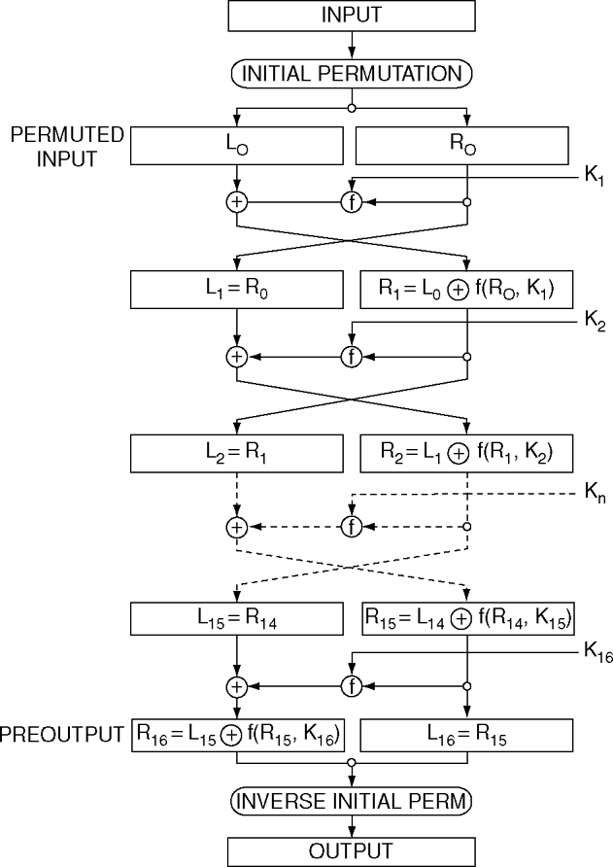
https://link.springer.com/referenceworkentry/10.1007/0-387-23483-7_94
We take the input plaintext M of 64 bits and apply an Initial Permutation over it. After that, we will split it into two equal halves – L0 and R0, each of 32 bits, then we perform operations just like in a Feistel network where,
L1 = R0
R1 = L0 (xor) f(R0, k1)
These kis are generated by the key scheduling algorithm.
The above Feistel network is followed 15 times hence a 15 round Feistel network. The 16th round is little bit different and is given by
L16 = R15
R16 = L15 (xor) f(R15, k16)
Note that this time, L16 is the right side block and the R16 is the left side block. This was just a notation strategy which was followed by the creators. Also a small note that the keys are different is each round. After these 16 rounds are completed, both the blocks are concatenate and an inverse initial permutation is applied to reverse the effect of the initial permutation which was applied at the start. Once, this is done we obtain our final ciphertext C which is again of 64 bits.
Decryption: For decryption, we just backtrack and reverse each of the effects by applying appropriate reversal strategies as we discussed in the Feistel network section.

