- Decryption in DES –
Ciphertext is first processed using IP (since at the end of DES encryption network we had an IP^-1), then further the inversion is done as follows –
R15 = L16
L15 = R16 (xor) f(L16, k16)
This process continues until we reach L1 and R1, after getting L1 and R1, we perform the following to obtain R0 and L0
R0 = L1
L0 = R1 (xor) f(L1, k1)
At last, we perform an IP^-1 (since at the start of DES encryption network we had an IP)
After successful completion of the above mentioned process, we finally get the plaintext!

- Elements used in DES-

- Initial Permutation (IP) -
The Initial Permutation (IP) design involves rearranging the bit positions in the data using the table presented below. The bits are permuted according to the specified table, resulting in two halves: L0 and R0, with a 32-bit split.

In mathematical terms, IP: {0,1}64 → {0,1}64 can be expressed as
IP(m1, m2, m3, ..., m64) = m58m50m42...m7.

The IP matrix illustrates the bit positions that replace the actual bit positions during this permutation process. Calculating the inverse of IP is straightforward; it involves populating the matrix with position values that correspond to the actual bit positions in the plaintext message matrix.
For instance, the 1st bit in the plaintext occupies the 40th position, the 2nd bit is in the 8th position, and the 3rd bit is in the 48th position of the IP matrix. Consequently, the first three entries of the IP^(-1) matrix will be 40, 8, and 48, respectively.

- Round function (f)-
The function F(Ri, Ki) is defined as Xi+1, where Ri and Xi+1 are both 32 bits in length, and Ki is 48 bits.

Mathematically, F: {0,1}32 x {0,1}48 → {0,1}32 is expressed as:
F(Ri,Ki)=Xi+1 ,where Ri and Xi+1 are of 32 bits and Ki is of 48 bits
F:{0,1}³² x {0,1}⁴⁸ {0,1}³²
Further elaborating on the expression, we have:
F(R(i-1),Ki)=P(S(E(R(i-1) ⊕Ki))
Here, E maps a 32-bit input to a 48-bit output, and P involves permuting the positions of 32 bits. The S-Box takes a 48-bit input and produces a 32-bit output.

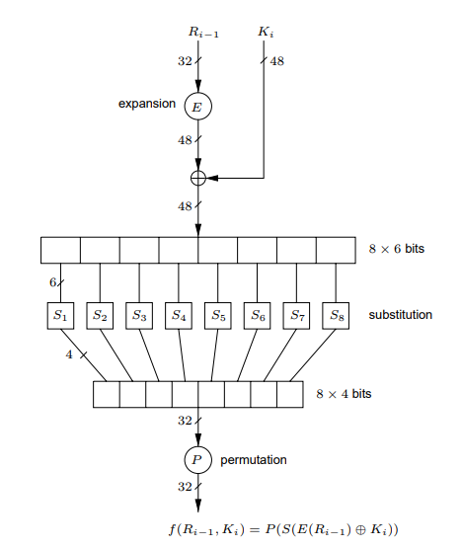

E -
E is just a mapping which is shown by the below diagram-
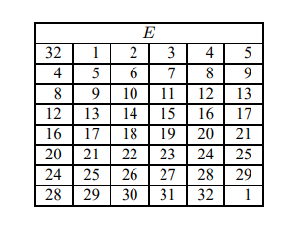
It's observed that the last two column values are repeated. For instance, in the second row, the values 4 and 5 from the last two columns of the first row are duplicated. This repetition pattern is illustrated as:

- E:{0,1}³² {0,1} ⁴⁸
E(x1x2x3….x32} =y1y2y3…y8
E(x1x2x3….x32) =(x32 x1 x2 x3 x4…x32 x1)
S-box-
Certainly! Here's the text without formatting so that you can easily copy and paste the mathematical formulas:

The S-Box in function f is responsible for mapping 48 bits of data to 32 bits, denoted as:

S: {0,1}^48 -> {0,1}^32

For a given 48-bit input X = B1B2B3B4B5B6B7B8, where each Bi represents a block of length 6 bits, the S-Box function is defined as S(X) = Y, where Y is a 32-bit output.

Each Bi is further broken down into b1b2b3b4b5b6, where bi belongs to {0,1}. The mapping for each Si from 6 bits to 4 bits is expressed as:

Si: {0,1}^6 -> {0,1}^4 for i = 1,2,3,...,8

The mapping function Si(Bi) = Ci, where Ci is a 4-bit output.

The overall S-Box operation for the 48-bit input X is given by:

S(X) = (S1(B1), S2(B2), ..., S8(B8))

In Figure below, the S-Boxes in DES are fixed. Each Si is represented as a matrix with 4 rows (0 to 3) and 16 columns (0 to 15). The values aij in the matrix range from 0 to 15, and the table in Figure 10 associates these values with x in the range from 0 to 15. The calculations for r and c are specified as:

r = (2 * b1 + b6) where 0 <= r <= 3
c = integer representation of (b2b3b4b5) where 0 <= c <= 15

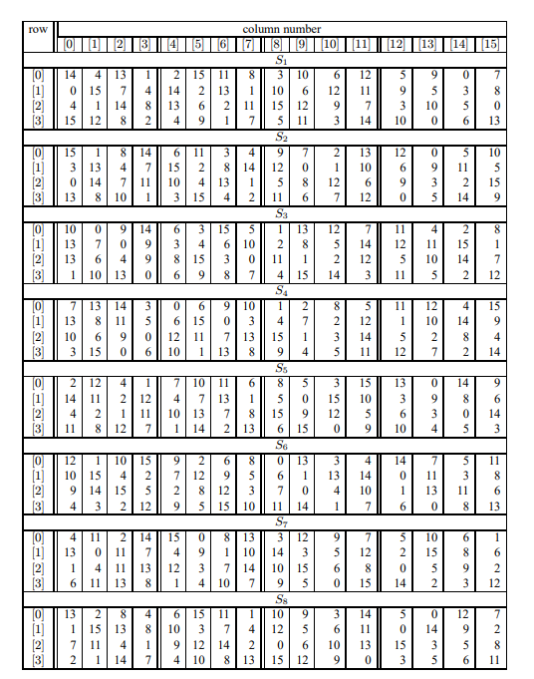

Permutation (P) –

The Permutation function in DES performs the permutation of 32 bits of data and outputs 32 bits. The specific permutation applied in DES is illustrated in Figure 11.

P: {0,1}^32 -> {0,1}^32

For a given input x1x2x3..x32, the permutation function is defined as:

P(x1x2x3..x32) = (x16x7x20x21....x4x25)

In this permutation, the output rearranges the input bits based on the specified order outlined below.
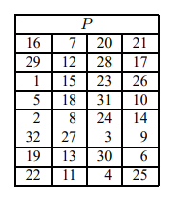
- Key scheduling algorithm –
Key K is a 64-bit sequence, denoted as k1 ...k64, inclusive of 8 odd-parity bits. The desired outcome involves generating 16 round keys, Ki (1 ≤ i ≤ 16), each with a length of 48 bits.

Here's the algorithm breakdown:

a. Define vi, where 1 ≤ i ≤ 16, as follows: vi is set to 1 for i belonging to {1, 2, 9, 16}; otherwise, vi is set to 2. These values represent the left-shift amounts for 28-bit circular rotations.

b. Discard the 8 parity check bits from K, resulting in k~.

c. Represent T as 28-bit halves (C0, D0) after applying the permutation choice PC1 to k~. PC1 maps {0,1}56 to {0,1}56.

d. Utilize PC1 (refer to the table in Figure 12) to select bits from K, obtaining C0 = k57k49 ...k36 and D0 = k63k55 ...k4. Both C0 and D0 are 28 bits in length.

e. For each i from 1 to 16, compute Ki as follows:
- Ci undergoes left circular shift by vi, denoted as Ci ← (Ci−1 ←֓ vi).
- Di undergoes left circular shift by vi, denoted as Di ← (Di−1 ←֓vi).

Perform the left circular shifts using ←֓. Ci and Di represent the left and right components, respectively. PC2, detailed in the table from Figure 12, is used to select 48 bits from the concatenation b1b2 ...b56 of Ci and Di, resulting in Ki = b14b17 ...b32.

Lastly, compute Ki using PC2(Ci, Di), where Ki is the round key for the ith round. PC2 maps as follows
PC2: {0,1}56 to {0,1}48.

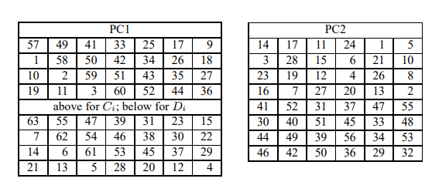

BOXX-
The application of PC1 to the key K1K2K3...K63K64 involves a permutation of positions, excluding the parity bits. The resulting sequence is K57 K49 K41 K33….K4.

Notably, in PC1, the operation is solely focused on rearranging positions. If the keys are complemented, the output will also be complemented.

Expressed in a general form, PC1(K1_, K2_.... K64_) yields K57_ K49_.... K9_, equivalent to PC1(K)_.

Regarding PC2, according to the information in Figure 12, the input bit at the 14th position is transferred to the 1st position in the output during the permutation.

Complement properties-
The DES encryption operation, denoted as DES(M, K) = C, and its complemented counterpart, DES(M_, K_) = C_, are linked by the equation (1).

Key scheduling, denoted as KS(K), produces round keys K1, K2, ..., K16, while the complemented key scheduling, KS(K_), yields round keys K1_, K2_, ..., K16_. This complementation is consistent across PC1, PC2, and left shifts.

The rationale behind the result in equation (1) is explained as follows:

Consider the initial setup:
M M_
L0 R0 LO_ R0_
L1 R1 L1⁻ R1

In the first round:
M: R1=L0 ⊕ F(R0,K1)

M_: R1=L0_ ⊕ F( R0_,K1_)

If we compare the uncomplemented case (L1, R1) to (L0, R0), the complementation of both plaintext and key results in complemented inputs for the XOR before the S-boxes. This double complementation cancels out, yielding S-box inputs and the overall result f(R0, K1). The result is then XORed with L0_ (previously L0), resulting in L1_.

This effect continues in subsequent rounds. For instance, in the next step:
M_: E(R0_) = (E(R0))_ ⊕ K1_
= E(R0) ⊕ K1
R1 = L0_ ⊕ f(E0, K)
R1 = R1_
Thus, R1 will also be complemented. The next step involves the initial permutation (IP), which is also complemented. Consequently, the ciphertext will be the complement, consistent with equation which we saw above.

**Exhaustive Search or Brute-force Attack in DES:**
- The key size in DES is 56 bits, leading to a total of possible keys (S) denoted as K1, K2, ..., K2^56.
- The time complexity of a brute-force attack on DES is 2^56, exploring all potential keys.

**Chosen-Plaintext Attack in DES:**
- In this attack, the attacker selects specific plaintexts for which the corresponding ciphertexts are to be provided.
- The total possible keys (S) are K1, K2, ..., K2^56.
- Assuming the attacker chooses two plaintexts, M and M_, and uses the secret key K to generate the corresponding ciphertexts:
- DES(M, K) = C1
- DES(M_, K) = C2
- Leveraging the complement property in DES, we have DES(M_ _, K_) = C2_, where M_ _ = M.
- The attacker employs a test key, Ki, to attempt decryption of M using Ki to obtain a ciphertext C. According to the complement property, decrypting the complement of M with the complement of Ki yields the complement of C.
- If the equality holds true (C ≠ C1), discard Ki from S as Ki is not equal to K.
- If the complemented equality holds true (C complement ≠ C2), discard Ki complement from S as Ki_ is not equal to K.
- This approach enables finding the key in 2^55 attempts, one less than the total keys, as two keys are discarded during the process.

- Types of attacks-
- **Ciphertext Only Attack:**
- The attacker possesses only the ciphertext and aims to recover either the plaintext or the secret key.

- **Known-Plaintext Attack:**
- The attacker has knowledge of certain plaintexts and their corresponding ciphertexts. The objective is to either find a plaintext corresponding to a different ciphertext or uncover the secret key.

- **Chosen-Plaintext Attack:**
- In this attack, the assailant selects specific plaintexts and is allowed to obtain the corresponding ciphertexts. The goal is to generate a new plaintext/ciphertext pair or discover the secret key.

- **Chosen-Ciphertext Attack:**
- The attacker chooses certain ciphertexts and is provided with their corresponding plaintexts. The aim is to create a different valid plaintext/ciphertext pair or reveal the secret key.

It is worth noting that in public-key cryptography, the Chosen-Ciphertext Attack is considered the strongest, given the pivotal role of the decryption secret key. In symmetric key cryptography, both Chosen-Plaintext and Chosen-Ciphertext attacks are nearly equally potent since the same key is employed for both encryption and decryption.

- Double DES-
To enhance the security of DES, a common practice is to perform double encryption. However, the assumption that this would provide 2 * 56 = 112 bits of security is proven incorrect, and a Meet-in-the-Middle attack illustrates this.

In double encryption, a key K is represented as 128 bits (K0, K1), with 16 parity check bits among them. The encryption process involves two stages using different keys. The diagram depicts plaintext (P) of 64 bits undergoing encryption with DES.

Exhaustive search on double encryption would imply a time complexity of 2^112, but this is refuted by the Meet-in-the-Middle attack:

Meet-in-the-Middle Attack:

With one valid plaintext and ciphertext pair in a known-plaintext model, the attacker performs encryption in reverse order on key K1 (right to left) and encryption on key K0 (left to right). If the results match, the keys are found.
Let Enc DES(P, Ki) = Xi, and store (Xi, Ki) in Table 1.
Similarly, let Enc DES(C, Kj) = Yj, and store (Yj, Kj) in Table 2.
If Xi equals Yj, then (Ki, Kj) is the secret key.
The time complexity is approximately 2^57 (~2^56), as Table 1 and Table 2 are independent, and the attacker needs to search 2^56 possibilities for both.
Key Length Increase:

Increasing the length of the secret key from m bits to 2m bits, even in an encryption algorithm providing n bits of security, does not proportionally increase security to 2n.
Therefore, using two secret keys in double encryption does not result in a complexity of 2^2n but rather maintains a complexity of almost 2^n.

- Triple DES-
In the context of triple DES, where two secret keys K0 and K1 are employed, and three encryptions are performed, a diagram illustrates the process:

[Diagram not provided]

In a Meet-in-the-Middle attack on triple DES, decryption on K1 is conducted for every possible value of K0, as depicted in the figure. This approach multiplies the time complexity, resulting in 2^(2n) bit security, where 'n' is the size of the key.

- Few Mathematical Things-

Let’s say we have an algorithm which claim n-bit of security using exhaustive search (2^n).But if we have Quantum or super computers, time complexity will reduce to 2^n/2.

To get n bit security in this setup, we will use 2n length key or triple encryption setup.

Binary Operator:

R ⊆ X X Y

A binary operator * on a set S is a mapping from S × S to S. In other words, * is a rule that assigns to each ordered pair of elements from S an element of S.

* : S × S → S
*(a, b) = c, where a, b, c ∈ S
*(b, a) = d, where d ∈ S

It is not necessary that d = c.

Groups:
A group (G, ∗) consists of a set G with a binary operation ∗ on G satisfying the following three axioms.

(i) Associativity: a ∗ (b ∗ c) = (a ∗ b) ∗ c for all a, b, c ∈ G.

(ii) Identity Element: There is an element 1 ∈ G, called the identity element, such that a ∗ 1 = 1 ∗ a = a for all a ∈ G.

(iii) Inverse: For each a ∈ G, there exists an element a^{-1} ∈ G, called the inverse of a, such that a ∗ a^{-1} = a^{-1} ∗ a = 1.

A group G is abelian (or commutative) if, furthermore,

(iv) a ∗ b = b ∗ a for all a, b ∈ G.

Examples:

1. Matrix multiplication over square matrices of order n × n:
- It is not commutative: A * B is not equal to B * A.
- (G, *) = {set of all invertible matrices}
- It satisfies all three group axioms but is not abelian.
- A*(B*C)=(A*B)*C
- A*I_{n}=I_{n}= I_{n}*A
- A*A⁻¹= I_{n}=A⁻¹*A
So, it is a group with multiplication operator but it is not abelian(commutative).

2. (Z, +) : \(\mathbb{Z}\): set of integers with the operation of addition

- It is commutative.
- Identity element: 0
- Inverse of a ∈ \(\mathbb{Z}\): -a
- It forms a group under addition.
- a+(b+c)=(a+b)+c for all a,b,c ∈ Z
- 0:identity element
a+0=a=0+a , for all a∈Z
- For every a∈Z, there exists -a ∈Z such that:
a+(-a)=0
(-a)+a=0

3. (Z, *) : \(\mathbb{Z}\): set of integers with the operation of multiplication
- It is not a group as there is no inverse for every element.
- ax(bxc)=(axb)xc for all a,b,c ∈ Z
- a x1=1xa
- for a∈Z, there does not exist 1/a (a⁻¹) ∈Z
So,set of integers Z with the operation of multiplication is not a group.

4. (Z, -) : \(\mathbb{Z}\): set of integers with the operation of subtraction
- It is not a group due to lack of associativity.
- (a-(b-c)) ≠ (a-b)-c
So, it is not a group.

5. (Q, *) : \(\mathbb{Q}\): set of all rational numbers with multiplication operation
- Additional information or example is needed to analyze its group properties.

